qonto-einvoice-ready
Ready for France's September 2026 e-invoicing mandate? The audit that measures the gap, then closes it
Qonto × Anthropic MCP Hackathon · Receiving mandatory 2026-09-01 · SIRENs recovered from the public registry · Confirmed writes, never bulk

🎯 Why this matters
On September 1st, 2026, every French VAT-registered company must be able to RECEIVE electronic invoices (issuing: 2026 for large companies and mid-caps, 2027 for SMEs). The trap isn't the date — it's the client file: no SIREN, no intra-EU VAT number, no structured address = no valid Factur-X. The skill turns the Qonto account into a readiness check-up:
- 1. Readiness score — client file complete for Factur-X (SIREN/SIRET, intra-EU VAT, structured address), quality of issued invoices, timeline known, e-reporting exposure — transparent formula, before/after
- 2. Your timeline — company size fetched from the public registry (large/mid-cap/SME) or asked, never guessed → your issuing date, 2026 or 2027
- 3. E-reporting exposure — foreign and consumer (B2C) clients spotted in the records AND the real money flows: outside e-invoicing, but data to transmit
- 4. Live fix — SIRENs recovered from the public French company registry API (no key), line-by-line preview → update_client only after confirmation, never in bulk
Would someone run this on a Monday morning? With a legal deadline counting down for every French business, it's the Monday-morning question of 2026.
📋 Prerequisites
Prerequisite | Detail | Required
Qonto production account | Adapts to any organization — get_organization first, nothing hardcoded | ✅ Yes
Country | French reform. Other Qonto countries (DE, ES, IT…): generic client-file completeness audit, never an invented deadline | ℹ️ Detected
Qonto MCP connected | Official connector (claude.ai / Claude Desktop), OAuth login | ✅ Yes
Client records in Qonto | The raw material of the audit; with none, the skill explains the reform reference and stops there | ⭕ Optional
Public registry API reachable | recherche-entreprises.api.gouv.fr — no key; if down, the audit still runs, only the live fix waits | ⭕ Optional
Company size | Fetched from the registry (categorie_entreprise) or asked — sets the issuing date (2026 or 2027) | ℹ️ Detected

⚙️ How it works
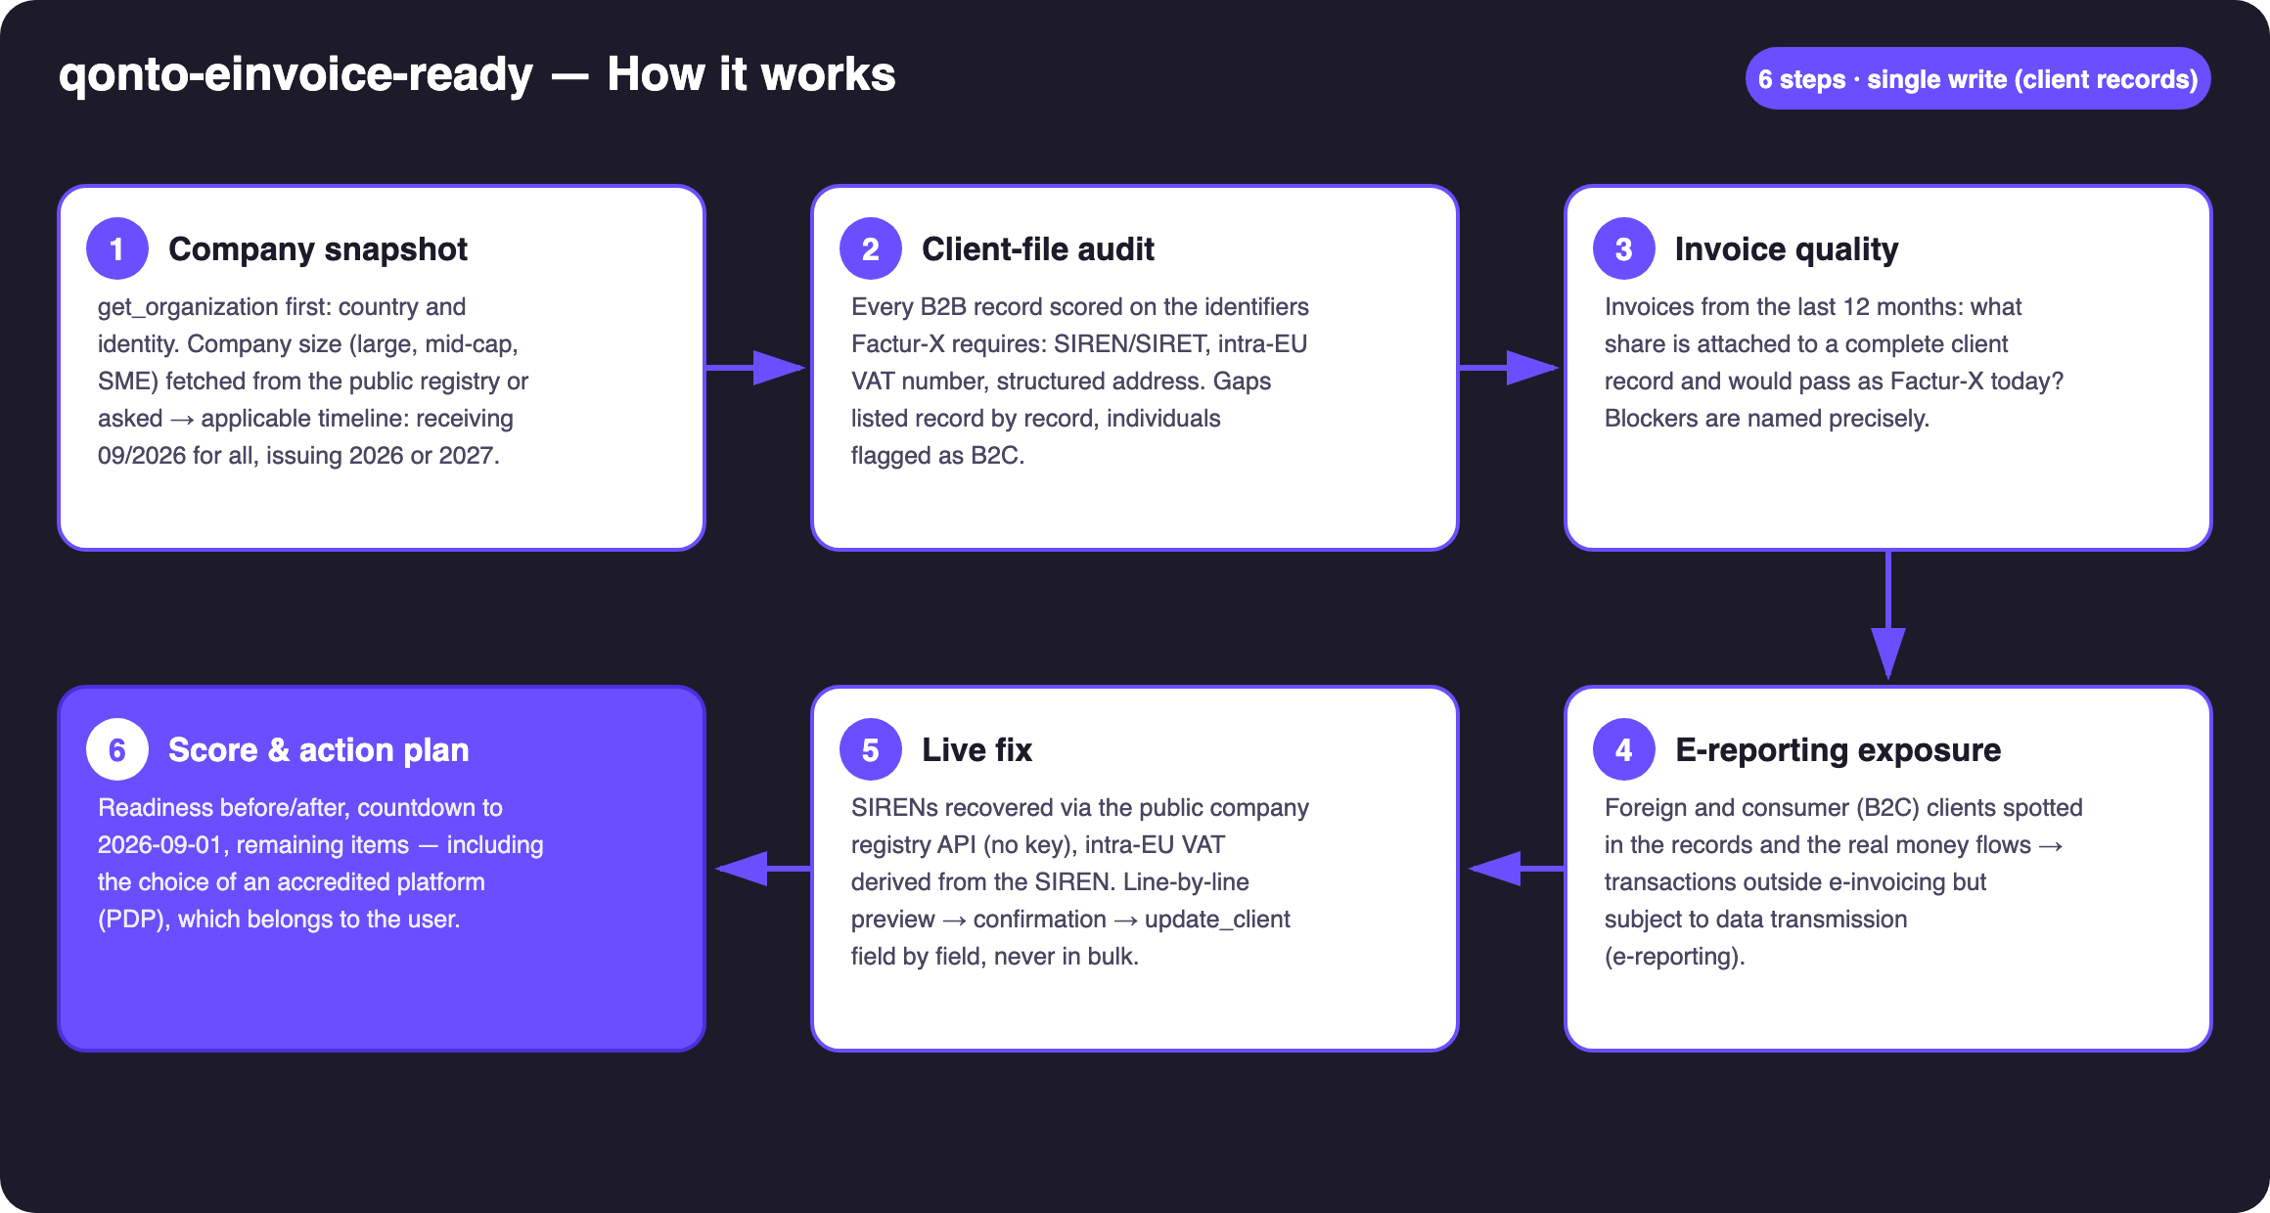
Diagram 1 — How it works, 6 steps (single write: client records)
Holds up on messy data
- Trade name ≠ legal name: registry search by name + zip code; no match → the skill asks for the SIREN or skips the record — never an auto-match
- Registry homonyms: candidates shown (name, city, SIREN), the user picks — systematically
- Intra-EU VAT derived from the SIREN (FR key + 2 digits): always labeled “derived — to be confirmed”, never presented as verified
- Address dumped as one text blob → counted as incomplete, flagged for restructuring
- No client records, registry down, non-FR country: the skill says what it can and can't do, inventing nothing
- Pagination ≤ 50 everywhere · get_organization always first (list_transactions requires bank_account_id/iban)

🏗 Functional diagram
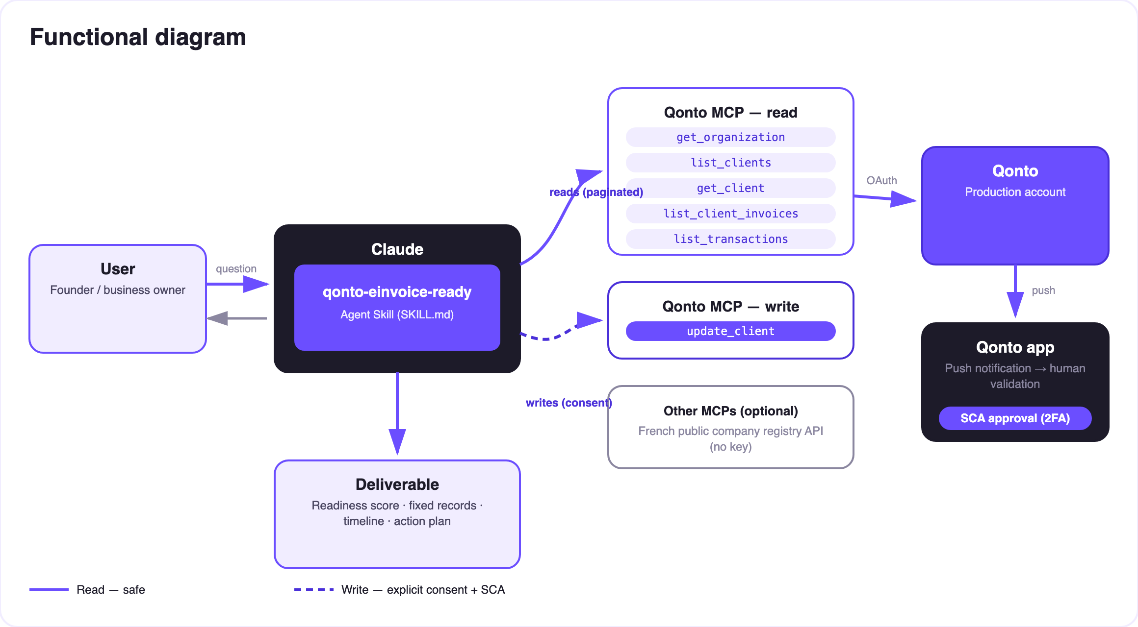
Diagram 2 — Actors and flows: risk-free reads (solid), client-record write behind confirmation (dashed)
🔒 A write that never touches money: reads are risk-free; the write is update_client — client records only. Full preview (current → proposed value, with its source), explicit confirmation in the conversation, then field-by-field writes. Never a silent bulk update.
📅 Embedded reform reference (as of July 2026 — verify for later changes)
Date | Obligation | Who
2026-09-01 | RECEIVE electronic invoices | All French VAT-registered companies
2026-09-01 | Issue electronic invoices | Large companies & mid-caps (ETI)
2027-09-01 | Issue electronic invoices | SMEs & micro-enterprises
Same as issuing | E-reporting (B2C + cross-border transaction data) | All, per their issuing date

- Formats: Factur-X (PDF/A-3 + embedded CII XML), UBL 2.1, CII — EN 16931 semantic core; buyer identification (SIREN/SIRET) is mandatory in each
- Exchange model: invoices flow through accredited platforms (PDP); a central directory maps each SIREN/SIRET to its platform — the PDP choice belongs to the user
- Mentions already required (2022 decree): client's SIREN, delivery address when it differs, nature of the operation, “VAT on debits” option
🔎 The live fix (the heart of the skill)
Step | What happens
Lookup | recherche-entreprises.api.gouv.fr by name + zip — public data.gouv API, no key
Homonyms | Several plausible candidates → name, city, SIREN shown, the skill asks
Intra-EU VAT | Derived from the SIREN — always labeled “derived, to be confirmed”
Preview | One table: client · field · current → proposed value · source (registry / derived / user)
Write | After explicit confirmation: update_client field by field, outcome reported honestly

Example (fictional, invented numbers): “Readiness: 62%. 9 of your 14 clients have no SIRET — I found 7 in the national registry. Line-by-line preview, do you confirm?” → after the writes: 91%.

📤 Output formats
Output | Format | When
Conversation reply | Markdown tables: detailed score, incomplete records, timeline, e-reporting exposure | Always — the baseline
Fix preview | One table: client · field · current → proposed · source, pending confirmation | Every proposed fix
Readiness report | HTML file/artifact: before/after gauge, countdown, action plan | When the host renders files; fallback to tables

🎬 Demo video
The ≤ 3-minute demo attached to the PR walks through: the 2026-09-01 wall → audit and score → the live fix (public registry → preview → confirmation) → the after-score and action plan. It runs live on a real production account. (The detailed shooting script is kept internal, out of the repo.)
💡 Roadmap ideas
Idea | Effort | Note
Recurring check-up (“re-scan my client file monthly”) | Low | The score decays with every new incomplete client
Intra-EU VAT validation via the public VIES service | Medium | Same “public API, no key” pattern
Supplier-side audit (purchase records) | Medium | Reuses the scoring engine as-is
Country modules (DE XRechnung · IT SdI · ES Verifactu…) | Medium | Qonto is pan-European; v1 = France + country detection
Pairs with qonto-vat-return and qonto-meeting-invoice | — | The reform feeds VAT data; clean invoices from day one

🛡 Guardrails
- An audit, not legal or tax advice — stated in every report; edge cases → the company's accountant
- The PDP choice belongs to the user: criteria provided, decision never made for them
- Registry homonyms → confirmation, always; derived VAT numbers labeled as derived
- update_client: full preview + explicit confirmation, field by field, never a silent bulk update; failures reported, never presented as done
- Report examples invented and stated as such · pagination ≤ 50 everywhere · graceful degradation (empty account, non-FR country, registry down)
qonto-einvoice-ready · English documentation · Qonto × Anthropic MCP Hackathon · July 2026 · PR deliverable: SKILL.md · French version: doc-qonto-einvoice-ready.fr.docx

