qonto-fraud-sentinel
The account's bodyguard — 30 seconds every morning, the latest transactions screened
Qonto × Anthropic MCP Hackathon · 6 anomaly signals · Single write: card lock, behind confirmation

🎯 Why this matters
Fraudulent or abnormal debits usually get discovered too late — on the statement, or never. The skill screens the latest transactions against a numbered baseline built from the account's real history:
- 1. Six anomaly signals — never-seen beneficiary, amount 3×+ the counterparty's average, duplicate direct debit, unusual hour or channel, burst of small card debits (stolen-card testing pattern), first SEPA direct debit from a new creditor
- 2. Every alert is explained — the transaction, the numbered why (“€612 vs €148 average over 14 debits = ×4.1”), the recommended action, a severity tag 🔴🟠🟡
- 3. A signal is not a fraud — the skill says “unusual, worth verifying”, never “fraud detected”. False positives are assumed; trusted counterparties are marked in one message
- 4. One safe action — a card lock (change_card_status) proposed when a card is implicated, executed only after explicit confirmation; unlocking and opposition stay in the app
Would someone use this on a Monday morning? It IS the Monday morning — 30 seconds, coffee in hand, before the inbox.
📋 Prerequisites
Prerequisite | Detail | Required
Qonto production account | Adapts to any organization — get_organization first, nothing hardcoded | ✅ Yes
Country | Behavioral, SEPA-universal signals: identical across all Qonto countries (FR, DE, ES, IT, AT, NL, BE, PT) — only wording adapts | ℹ️ Detected
Qonto MCP connected | Official connector (claude.ai / Claude Desktop), OAuth login | ✅ Yes
≥ 3 months of history | Below that: cautious mode announced — thinner baseline, more false positives, tentative wording (3–6 months to calibrate) | ⭕ Recommended
Gmail MCP | Optional enrichment: a daily digest email draft — detected dynamically, the core runs without it | ⭕ Optional

⚙️ How it works
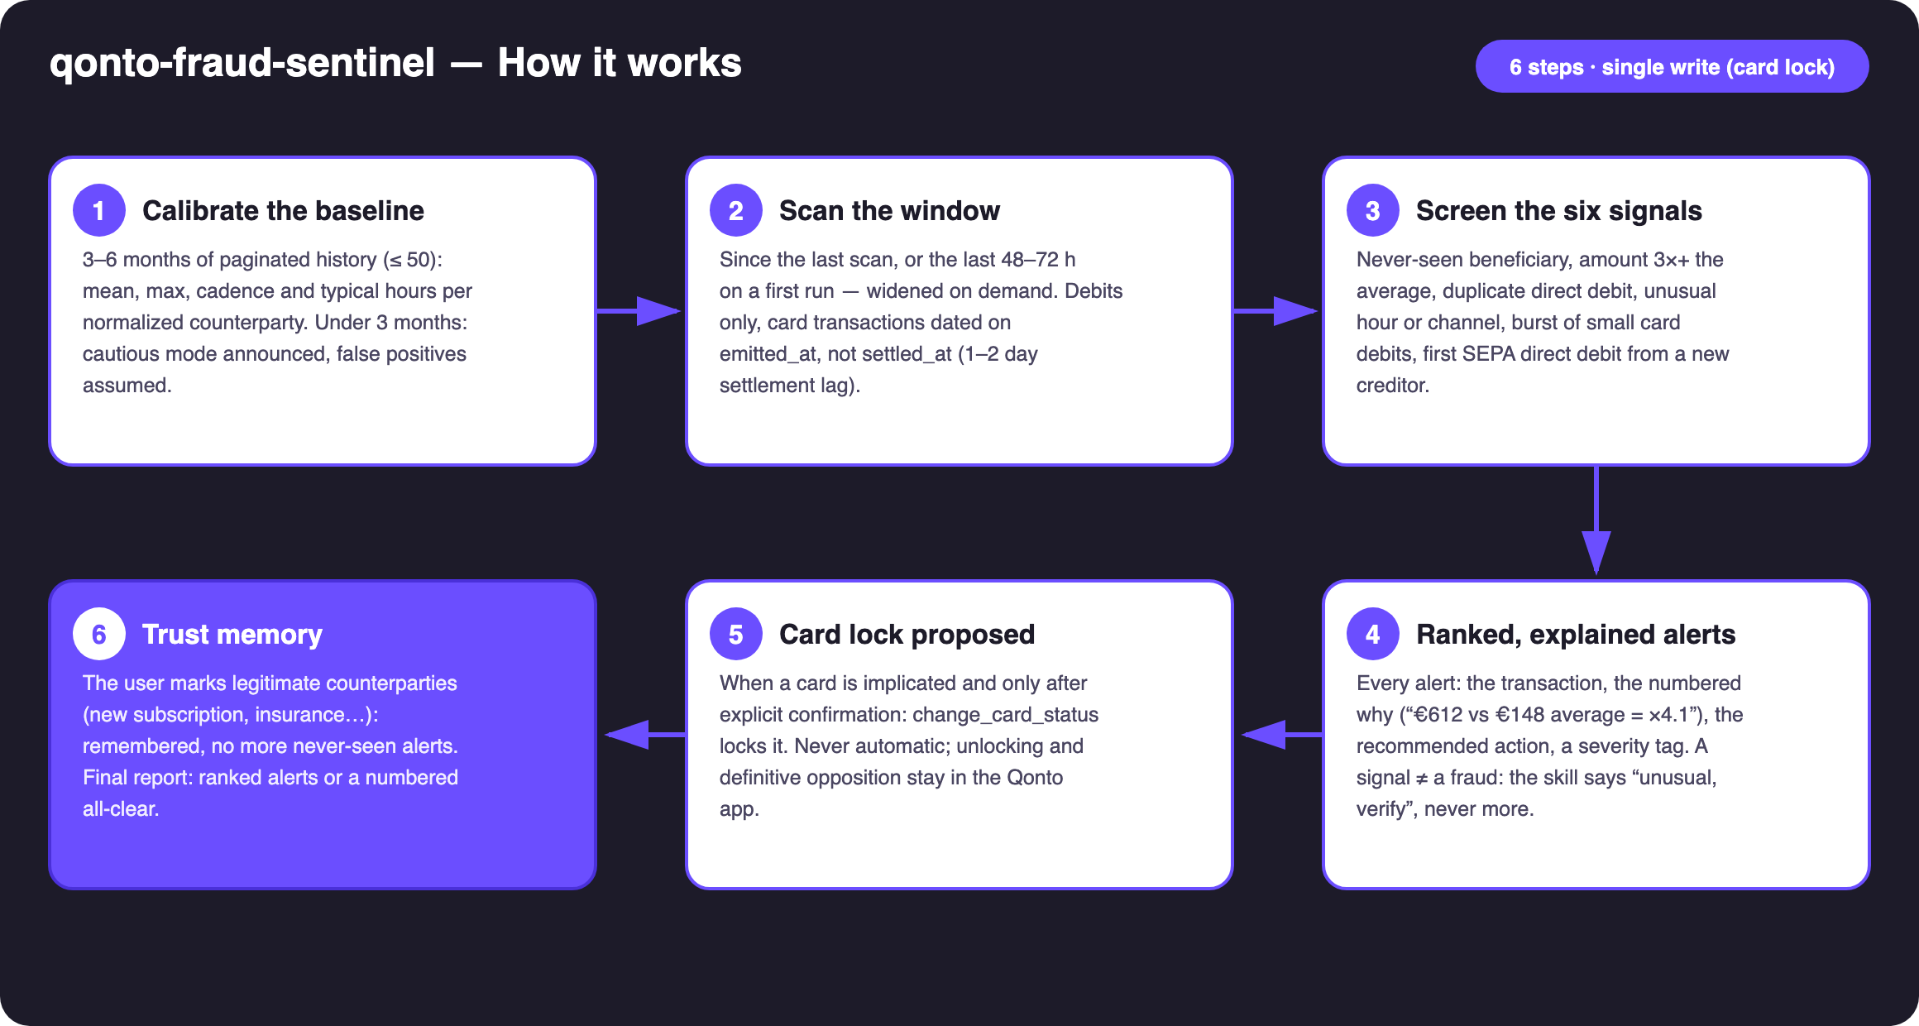
Diagram 1 — How it works, 6 steps (single write: card lock, behind confirmation)
Holds up on messy data
- Numbered baseline, never intuition: per normalized counterparty (uppercased, references and dates stripped from labels) — occurrences, mean and max, cadence, first/last seen, typical hours
- Card timing on emitted_at, not settled_at: the 1–2 day settlement lag would corrupt duplicate and timing detection
- Under 3 months of history → cautious mode announced: more false positives, tentative wording — never fake confidence
- A legitimate new supplier is “never seen” by design — the skill says so and offers trust-marking, it never cries wolf
- Empty scan window or empty account: “nothing to scan”, with the facts · one baseline and one scan per account · pagination ≤ 50 everywhere

🏗 Functional diagram
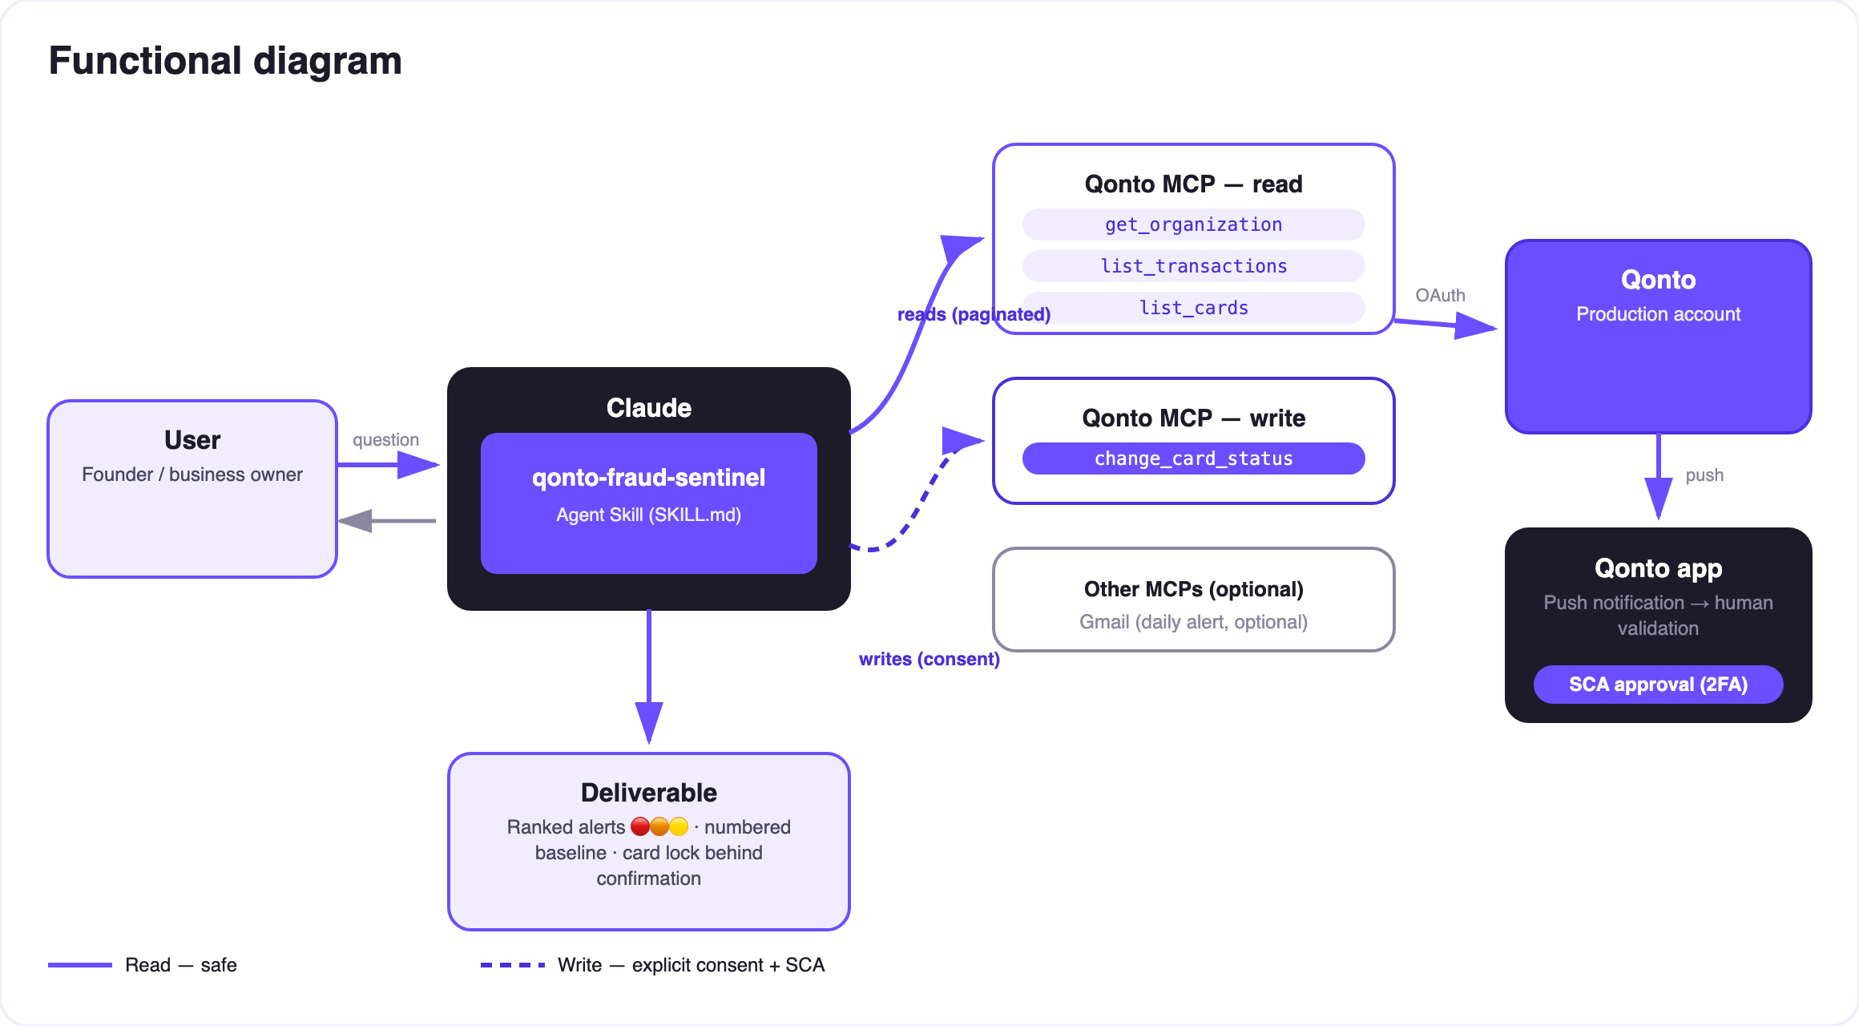
Diagram 2 — Actors and flows: risk-free reads (solid), card lock behind explicit confirmation (dashed)
🔒 The security model, not a limitation: reads are risk-free; the write is a card lock — reversible, proposed in reaction to a card alert, executed only after explicit confirmation in the conversation. Unlocking, definitive opposition, SEPA mandate revocation and card replacement stay in the Qonto app. No money moves, under any scenario.
🚨 The six reference signals
Signal | Criterion (numbered baseline) | Recommended action
Never-seen beneficiary | First outgoing occurrence of a counterparty over 3–6 months | Verify — a legitimate new supplier? Mark it trusted
Unusual amount | ≥ 3× that counterparty's average (or the category's, when new) | Check the matching invoice / contract
Duplicate debit | Same counterparty, same amount (±1 %), 1–5 days apart | Verify; dispute the duplicate with the creditor or via the app
Unusual hour / channel | Card payment at an hour never seen; a never-used operation type | Verify; suspicious card → lock proposed
Small-debit burst | ≥ 3 small debits (bottom decile or < €10) within minutes/hours | Stolen-card testing pattern → lock proposed
First SEPA from a new creditor | First direct debit from a creditor absent from the baseline | Check the mandate; oppose via the app if unrecognized

📤 Output formats
Output | Format | When
Conversation reply | Markdown alert table (transaction · signal · baseline · action · severity) or a numbered all-clear | Always — the baseline
Morning report | Compact HTML file/artifact: ranked alerts, baseline, card status | When the host renders files; fallback to the table
Email digest | Gmail draft of the daily scan | Only when a Gmail MCP is detected — optional

🎬 Demo video
The ≤ 3-minute demo attached to the PR walks through: the problem → the baseline → the signals in action → the morning routine, live (a “first SEPA from a never-seen creditor, €249” alert — it's the new insurance contract, trust-marked in one message) → wrap-up. It runs live on a real production account.
💡 Roadmap ideas
Idea | Effort | Note
Scheduled scan (the morning prompt becomes an automated routine) | Low | The daily check runs itself
User-tunable thresholds (×2, ×5, amount floor) | Low | The baseline stays the smart default
Per-counterparty 12-month risk score | Medium | Reuses the baseline engine
Telegram/Slack alert when the MCP is present | Low | Same optional multi-MCP logic as Gmail

🛡 Guardrails
- Never the word “fraud” — “unusual, worth verifying”. A first payment to a new supplier is normal business life, not an incident
- NEVER calls change_card_status without explicit confirmation in the current conversation; never presented as done if the call failed
- Under 3 months of history: cautious mode announced; empty window → the skill says so, invents nothing
- Masked IBANs and card numbers (last 4 digits) · pagination ≤ 50 · card timing on emitted_at
- See also: qonto-supplier-detective (skill #13) — historical invoices and money recovery; Sentinel is its security-focused sibling, real-time and daily
qonto-fraud-sentinel · English documentation · Qonto × Anthropic MCP Hackathon · July 2026 · PR deliverable: SKILL.md · French version: doc-qonto-fraud-sentinel.fr.docx

