qonto-support-cashdesk
The billing counter of customer support — check Qonto, prove, act, reply
Qonto × Anthropic MCP Hackathon · 3 counters: invoice · link · duplicate · Proof from transactions · Every write confirmed

🎯 Why this matters
"I never received my invoice." "The payment link expired." "You charged me twice." Three support messages that pull the founder away from real work — while the answer already sits in Qonto. The skill turns the account into a billing counter:
- 1. Conversation read — pulled from Intercom when that MCP is connected, otherwise pasted into the chat: claim, identity clues and quoted amounts extracted
- 2. Client matched, never guessed — list_clients by email first, then name/company; candidates shown and confirmed by the user before anything happens
- 3. Reality checked — invoices (status, dates), the payment link's real state, incoming payments in the transactions: every conclusion cites its evidence
- 4. Fix attached — resend the invoice, fresh payment link, or a credit note when the double collection is proven by two dated credits — every write confirmed, the customer reply delivered as a draft to review
Would someone use this on a Monday morning? Support inboxes fill up over the weekend — Monday morning is exactly when these three messages are waiting.
📋 Prerequisites
Prerequisite | Detail | Required
Qonto production account | Adapts to any organization — get_organization first, nothing hardcoded | ✅ Yes
Country | Universal — clients, invoices, payment links and transactions exist in every Qonto country (FR, DE, ES, IT…); no local tax rule involved | ℹ️ All countries
Qonto MCP connected | Official connector (claude.ai / Claude Desktop), OAuth login | ✅ Yes
Qonto invoicing in use | Client invoices and payment links issued through Qonto — otherwise nothing to verify | ✅ Yes
Intercom MCP | Pull support conversations directly; otherwise paste the conversation, same verifications | ⭕ Optional
Gmail MCP | Reply created as a draft (never sent by the skill); otherwise copy-paste text | ⭕ Optional

⚙️ How it works
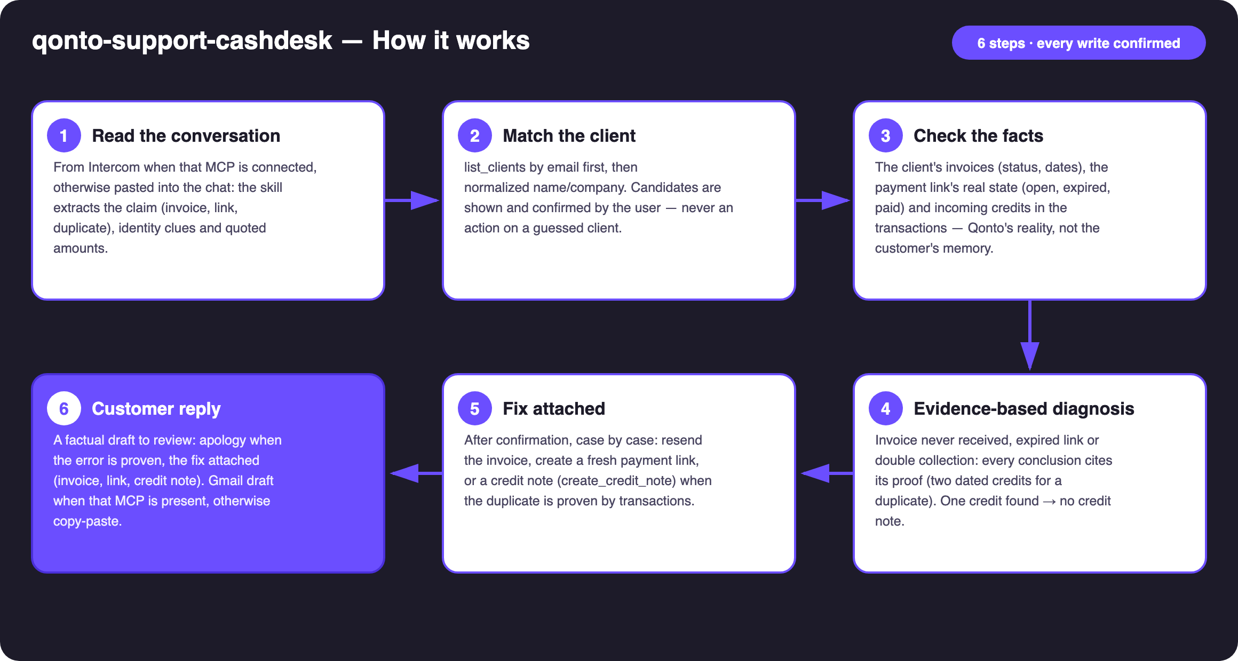
Diagram 1 — How it works, 6 steps (every write confirmed)
Holds up on messy data
- Customer email not in the clients list → search by normalized name/company (case, accents), candidates listed — never a silent "closest match"; two look-alikes → both shown
- "Charged twice" but only one credit found → no credit note; a factual report of what exists, however hard the customer insists
- Amounts that don't line up (partial payment, currency) → the discrepancy is cited, not smoothed over; link claimed expired but actually paid → flagged, no pointless new link
- Card settlement lag: matching on emitted_at, not settled_at (1–2 days apart)
- Intercom or Gmail MCP absent → said once, then the skill continues in pure Qonto mode
- Pagination ≤ 50 everywhere · masked IBANs · date windows around the invoice

🏗 Functional diagram
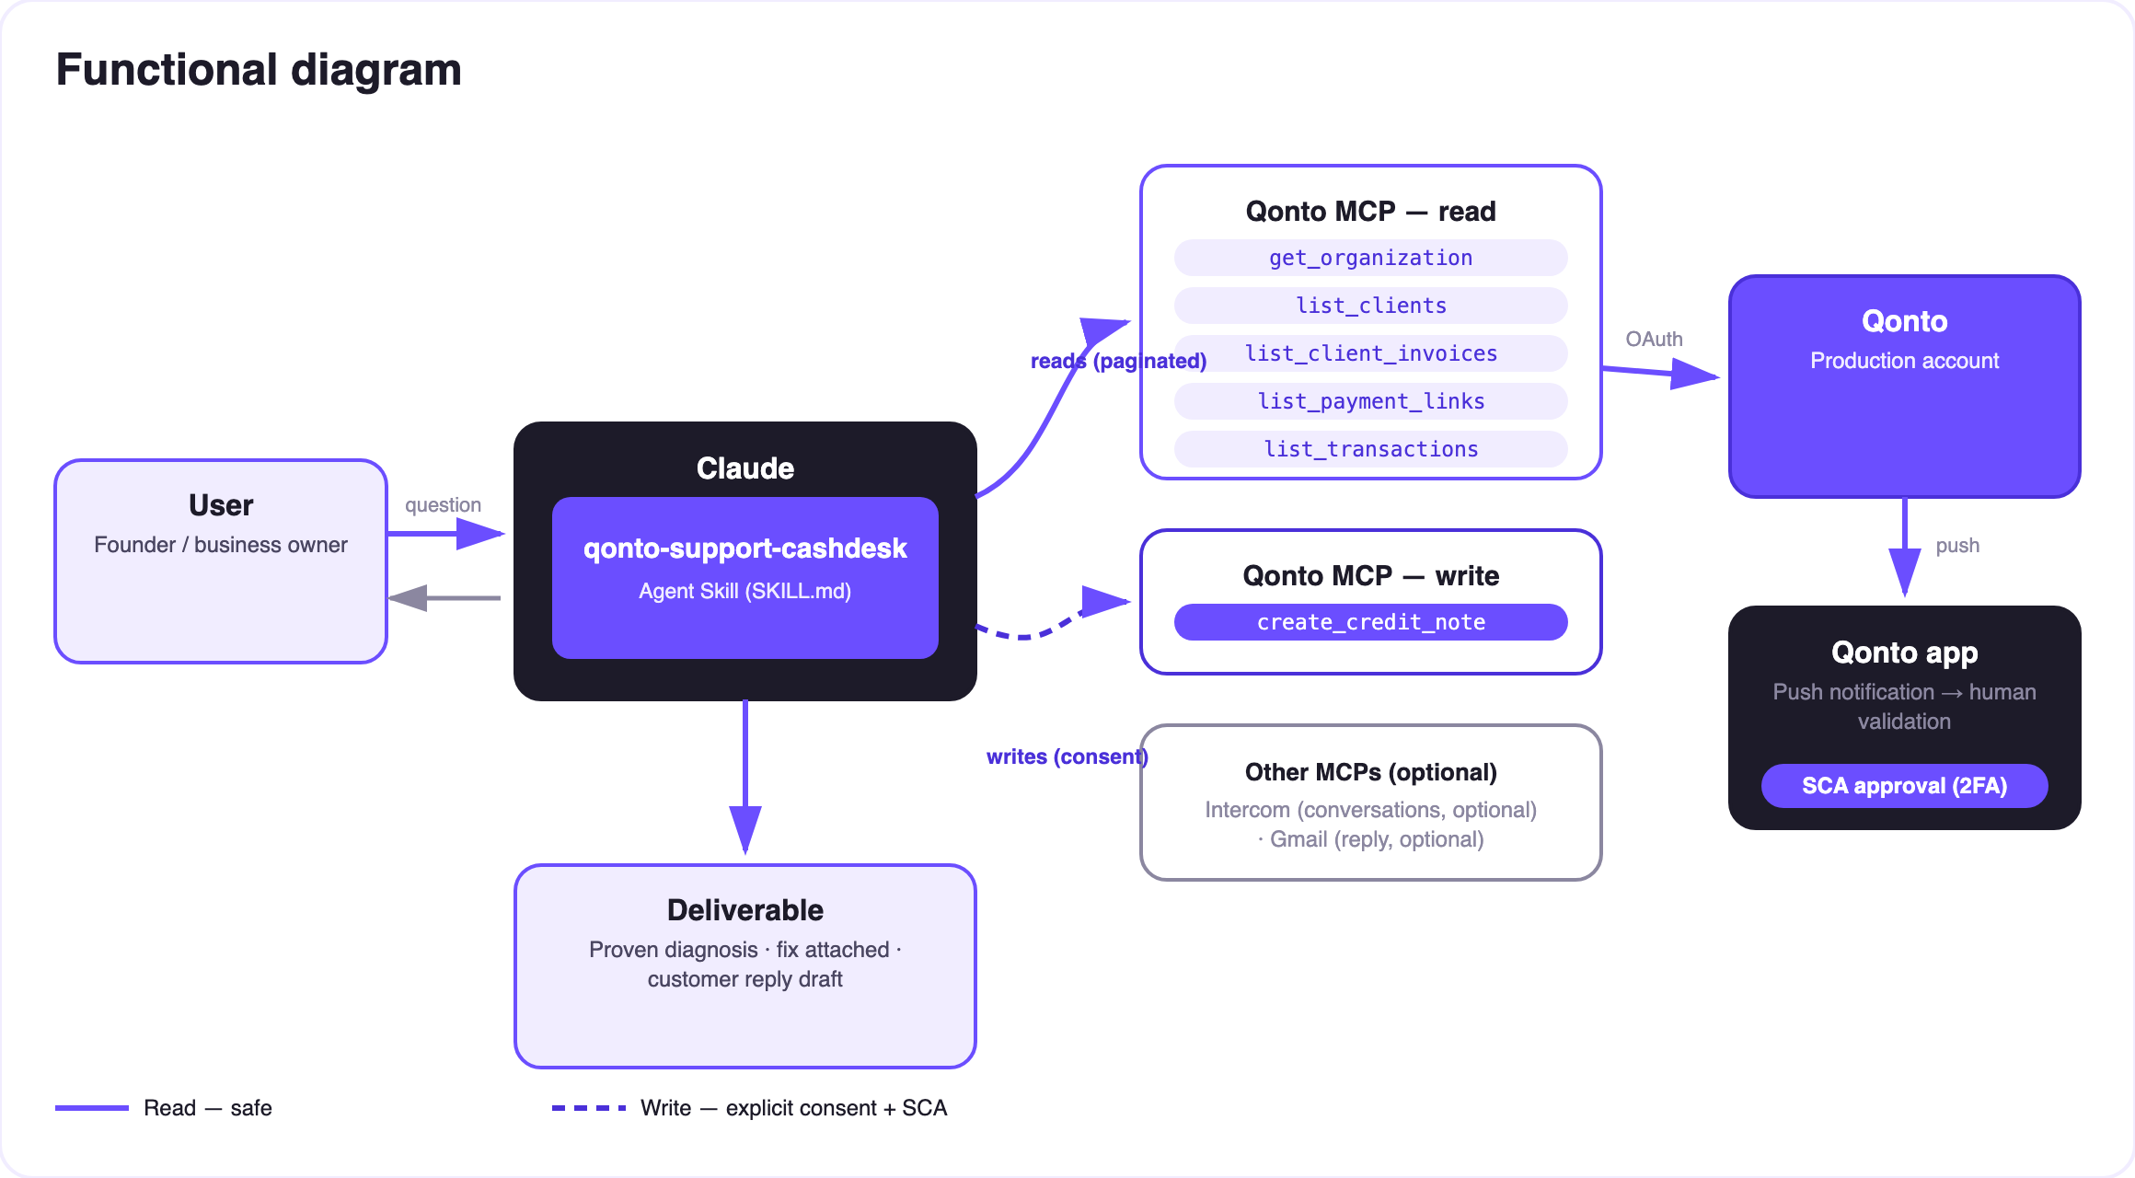
Diagram 2 — Actors and flows: risk-free reads (solid), writes behind confirmation (dashed)
🔒 Every write confirmed, every credit note proven: resend, link and credit note each require explicit confirmation in the conversation. A credit note is a real accounting document — only proposed with the proof on the table (two dated credits), never as a "commercial gesture" decided by the skill. The customer reply stays a draft: the user sends it. Any refund is a transfer made in the Qonto app (SCA) — the skill never moves money.
🧾 The three counters
Customer says | The skill checks | Honest outcome
"Never received the invoice" | Invoice exists? Status? Recipient email correct on the client record? | Found → resend proposed (email fixed first if wrong) · no invoice → nothing to resend, said as is
"The payment link expired" | Real link status (get_payment_link): open, expired, paid | Expired → fresh link proposed · already paid → flagged, no new link
"You charged me twice" | Two credits for the same invoice: same amount, close dates — both cited with date + amount | Duplicate proven → credit note proposed (create_credit_note) · one credit → no credit note

Example (invented): invoice INV-2026-042 for €480, two €480 credits collected one day apart → duplicate proven, a €480 credit note proposed with both dates cited in the reply. Purchase-side duplicates belong to qonto-supplier-detective; proactive payment links to qonto-pay-me-now.
📤 Output formats
Output | Format | When
Conversation reply | Diagnosis + cited evidence + recap table (claim → evidence → action → status) | Always — the baseline
Customer reply draft | Ready-to-review text; Gmail draft when that MCP is present (never sent by the skill) | Every conversation handled
Qonto documents | Invoice resent · payment link · credit note (numbered accounting document) | Case by case, after confirmation

🎬 Demo video
The ≤ 3-minute demo attached to the PR walks through: the three support messages → the confirmed client match → the duplicate proven in the transactions, then the credit note and the apology draft in one pass → the two other counters at speed. All demo data is invented. (Shooting script kept internal, out of the repo.)
💡 Roadmap ideas
Idea | Effort | Note
Proactive duplicate-collection detection (periodic scan) | Medium | The sales-side twin of qonto-supplier-detective
Per-client dispute history (repeat complaints, average resolution time) | Low | Reuses the client matching
Reply in the customer's language, detected from the conversation | Low | Qonto is pan-European
Guided refund: preparing the transfer request for SCA approval in the app | Medium | Same security model as qonto-tax-pilot

🛡 Guardrails
- NEVER acts on an unconfirmed client match; never presents a write as done when it is pending or failed
- Credit note = proof + confirmation: two dated credits cited and an explicit yes in the current conversation — otherwise no credit note, however hard the customer insists
- The skill never sends the customer reply itself: draft only, the user reviews and sends
- Refunds are transfers made in the Qonto app (SCA) — the skill never moves money, and says so
- Masked IBANs (last 4 digits) · pagination ≤ 50 · rehearsals on a fictional client (MCP invoices are real → draft, then delete)
qonto-support-cashdesk · English documentation · Qonto × Anthropic MCP Hackathon · July 2026 · PR deliverable: SKILL.md · French version: doc-qonto-support-cashdesk.fr.docx

