qonto-carbon-ledger
Your bank statement is secretly a carbon ledger — an approximate footprint from real spending
Qonto × Anthropic MCP Hackathon · 100% read-only · ±50% printed everywhere · Sourced & dated factors

🎯 Why this matters
Small businesses never do a carbon assessment — not because they don't care, but because they have no data, no time, and no budget for a consultant. Here's the thing: bank debits ARE data. Every euro spent has a footprint, and the skill reads it straight from the Qonto account:
- 1. Approximate annual footprint — spend-based method: debits classified into emission categories × monetary emission factors (kgCO2e/€, ADEME-style monetary ratios), embedded, sourced and dated — with the ±50% uncertainty printed on every figure
- 2. Dominant categories — the 2-3 categories concentrating most emissions, matched to the amounts actually spent
- 3. Trend — year over year across 24-36 months of history
- 4. Top-3 levers — the most effective actions given real spending (lever #1 is often free), and never a carbon offset for sale
An orientation pre-assessment, not a regulatory report — and the skill says so itself, loudly. The first carbon number most small businesses will ever see — for two minutes of their Monday morning.
📋 Prerequisites
Prerequisite | Detail | Required
Qonto production account | Adapts to any organization — get_organization first, nothing hardcoded | ✅ Yes
Country | Factors calibrated for France / EU. Other Qonto countries (DE, ES, IT…): identical method, factors flagged as needing adaptation (electricity mix, prices) — stated plainly, estimate still produced and tagged | ℹ️ Detected
Qonto MCP connected | Official connector (claude.ai / Claude Desktop), OAuth login | ✅ Yes
≥ 6 months of history | Below that: annualization with an explicit warning. 24-36 months for the trend | ⭕ Optional
Datagouv MCP | Optional — cross-checks against current ADEME datasets; otherwise embedded (sourced, dated) factors | ⭕ Optional
Qonto labels | Optional — sharpen the classification of ambiguous debits | ⭕ Optional

⚙️ How it works
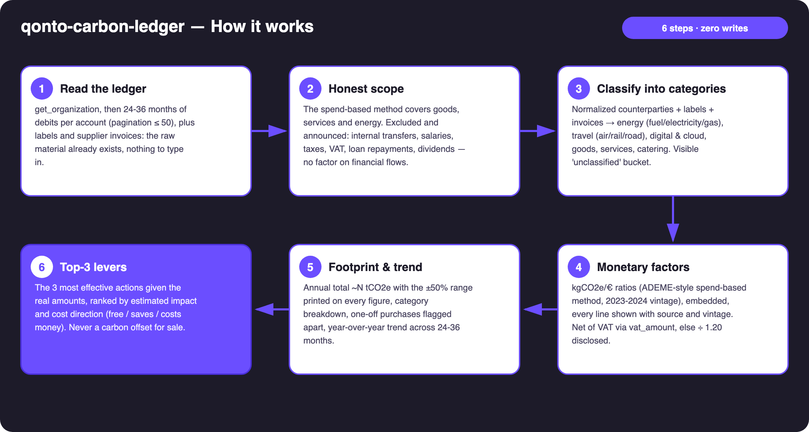
Diagram 1 — How it works, 6 steps (zero writes, 100% read)
Holds up on messy data
- Honest scope, announced: goods, services and energy. Excluded and said to be excluded: internal transfers, salaries, taxes, VAT payments, loan repayments, dividends — financial flows carry no emission factor
- Normalized counterparties (case, accents, spellings merged) + labels + supplier invoices; list_cash_flow_categories returns 403 on the claude.ai connector → labels are the fallback
- Visible 'unclassified' bucket with its share; above ~20% of spend the estimate is declared weak and the skill suggests labelling the top counterparties
- Excl-VAT amounts: vat_amount when present, else ÷ 1.20 — count of estimated lines disclosed
- One-off purchases flagged apart (≥ ~€5,000): a vehicle bought once doesn't masquerade as a recurring emission
- Short history → annualized with a warning · empty account → the skill explains the method and stops there · pagination ≤ 50 everywhere

🏗 Functional diagram
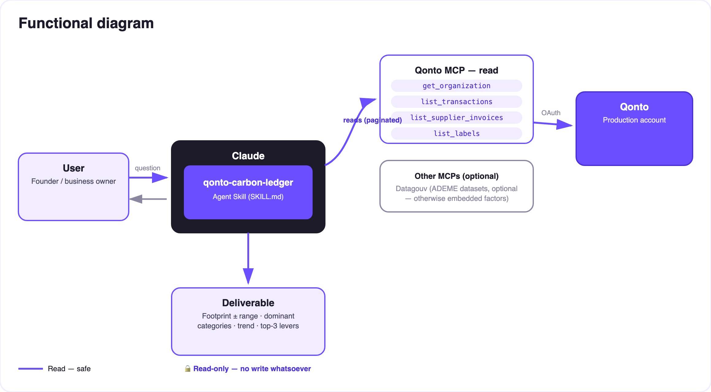
Diagram 2 — Actors and flows: 100% read, no write, nothing to approve
🔒 Solid arrows only: this skill is 100% read. No write, no transfer request, no payment — there is literally nothing to approve. The only deliverable is information: tables and a dashboard. And it never sells carbon offsets.
🧮 Embedded emission factors (indicative, spend-based method)
Category | Factor (kgCO2e/€ excl. VAT, indicative central value)
Energy — vehicle fuel | ~1.5
Energy — electricity (FR mix) | ~0.25
Energy — gas / heating | ~1.9
Travel — air | ~1.2
Travel — rail (FR) | ~0.05
Travel — road, taxi/VTC, freight | ~0.5
Digital, cloud & SaaS | ~0.3
Purchased goods & equipment | ~0.5
Services & professional fees | ~0.15
Catering & food | ~0.7
Insurance & banking fees | ~0.1

ADEME Base Empreinte-style monetary ratios, 2023-2024 vintage, ±50% and more — inherent to the monetary method (a cheap flight ≠ low emissions). Every displayed line carries its factor, source and vintage; a Datagouv cross-check is offered when that MCP is present.
📤 Output formats
Output | Format | When
Conversation reply | Markdown tables: footprint + range, categories (factor + source + vintage per line), trend, top-3 levers | Always — the baseline
Interactive dashboard | HTML file/artifact: gauge with uncertainty band, category bars, trend, levers | When the host renders files; fallback to tables

🎬 Demo video
The ≤ 3-minute demo attached to the PR walks through: the problem (small businesses "have no data") → reading and classifying the account → the honesty about uncertainty → the "your footprint in two minutes" moment → the dashboard and the levers. It runs live on a real production account. (Shooting script kept internal, out of the repo.)
💡 Roadmap ideas
Idea | Effort | Note
Automatic Datagouv cross-check (up-to-date ADEME datasets) | Low | Optional multi-MCP — detected dynamically, embedded factors otherwise
Per-country factor packs (DE · ES · IT · AT · NL · BE · PT) | Medium | Qonto is pan-European; same method, local electricity mix and prices
Sector comparison of the footprint | Low | Natural pairing with qonto-sector-benchmark (same spirit: your real flows × public reference data)
Monthly lever tracking | Medium | Is the footprint actually going down? Re-runs on the same categories
Line-item refinement from rich supplier invoices | Medium | When supplier invoices carry detail

🛡 Guardrails
- Order-of-magnitude estimate, not a regulatory carbon report (BEGES / CSRD / GHG Protocol) — repeated in every report; for an official assessment: a specialized provider
- Every factor shown with its source and vintage; every figure with its range — no false precision ("~9 tCO2e (4.5–13.5)", never "9.37")
- Never sells or recommends carbon offsets
- 100% read-only · IBANs masked (last 4 digits) · pagination ≤ 50 everywhere
- Country ≠ FR: identical method, factors flagged as needing adaptation — no fake local calibration
qonto-carbon-ledger · English documentation · Qonto × Anthropic MCP Hackathon · July 2026 · PR deliverable: SKILL.md · French version: doc-qonto-carbon-ledger.fr.docx

