qonto-crm-truth
The CRM that stops lying — the bank as the source of truth, written into HubSpot or Airtable
Qonto × Anthropic MCP Hackathon · Multi-MCP: Qonto + HubSpot/Airtable · Matching always confirmed · Zero Qonto writes

🎯 Why this matters
In every CRM, a deal marked “Closed Won” looks like revenue. Until the money hits the account, it's fiction — and sales teams prioritize on numbers the bank never confirmed. The skill reconciles CRM records (HubSpot or Airtable) with the Qonto account:
- 1. Won-but-never-cashed deals — every won deal with no matching euro on the account, listed with amount and age
- 2. Real revenue, LTV & observed delays — cash actually collected (not declared), cash LTV, the observed “pays at day +X” delay, the last payment date
- 3. A/B/C payer reliability score — computed from bank data, formula disclosed, never a guessed score (fewer than 2 paid invoices → unrated)
- 4. Write-back into the CRM — HubSpot custom properties or Airtable columns, after a CRM-record ↔ Qonto-client matching that is always shown and confirmed, never silent
Would someone use this on a Monday morning? It's the sales pipeline review — with the bank's numbers.
📋 Prerequisites
Prerequisite | Detail | Required
Qonto production account | Adapts to any organization — get_organization first, nothing hardcoded | ✅ Yes
Country | Universal — no local tax rule involved: identical for all Qonto countries (FR, DE, ES, IT, AT, NL, BE, PT) | ℹ️ Detected
Qonto MCP connected | Official connector (claude.ai / Claude Desktop), OAuth login | ✅ Yes
HubSpot or Airtable MCP | The CRM — required for writes. Without it: degraded mode, a “Qonto clients, scored” report in the conversation | ⭕ Required for writes
Client invoices in Qonto | Anchor delays and matching; without them, counterparty-level analysis of credits, stated as such | ⭕ Recommended
≥ 6 months of history | Below that: honest degradation (unrated scores + warning) | ⭕ Optional

⚙️ How it works
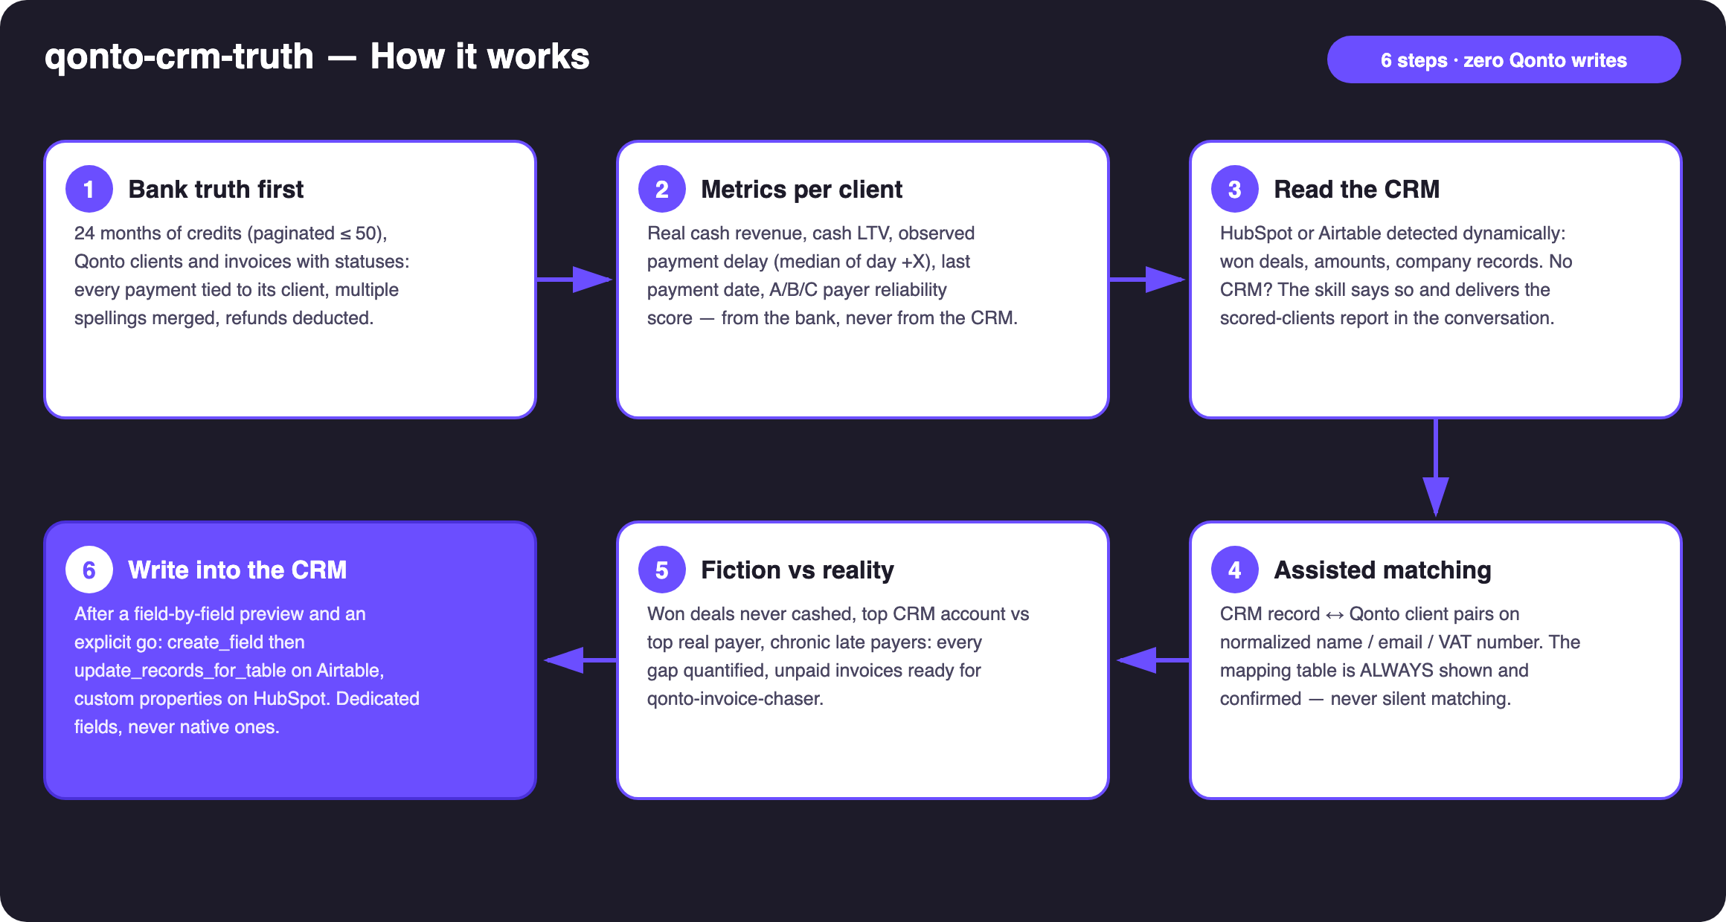
Diagram 1 — How it works, 6 steps (zero Qonto writes, confirmed CRM write-back)
Holds up on messy data
- Multiple spellings merged: “ACME STUDIO”, “Acme Studio SARL”… normalized (case, accents, legal suffixes) and shown as ONE client in the mapping table
- CRM record with no Qonto counterpart (or vice versa) → listed as unmatched, excluded from writes, never force-matched
- Deals without amounts → flagged as unquantified instead of guessed · partial payments cumulated per invoice · refunds deducted from revenue
- Fewer than 2 paid invoices → unrated, with the reason — never an invented grade
- No CRM connected → stated plainly; the scored-clients report is delivered in the conversation (already useful)
- Empty account: nothing invented — the skill says what it cannot compute · pagination ≤ 50 everywhere

🏗 Functional diagram
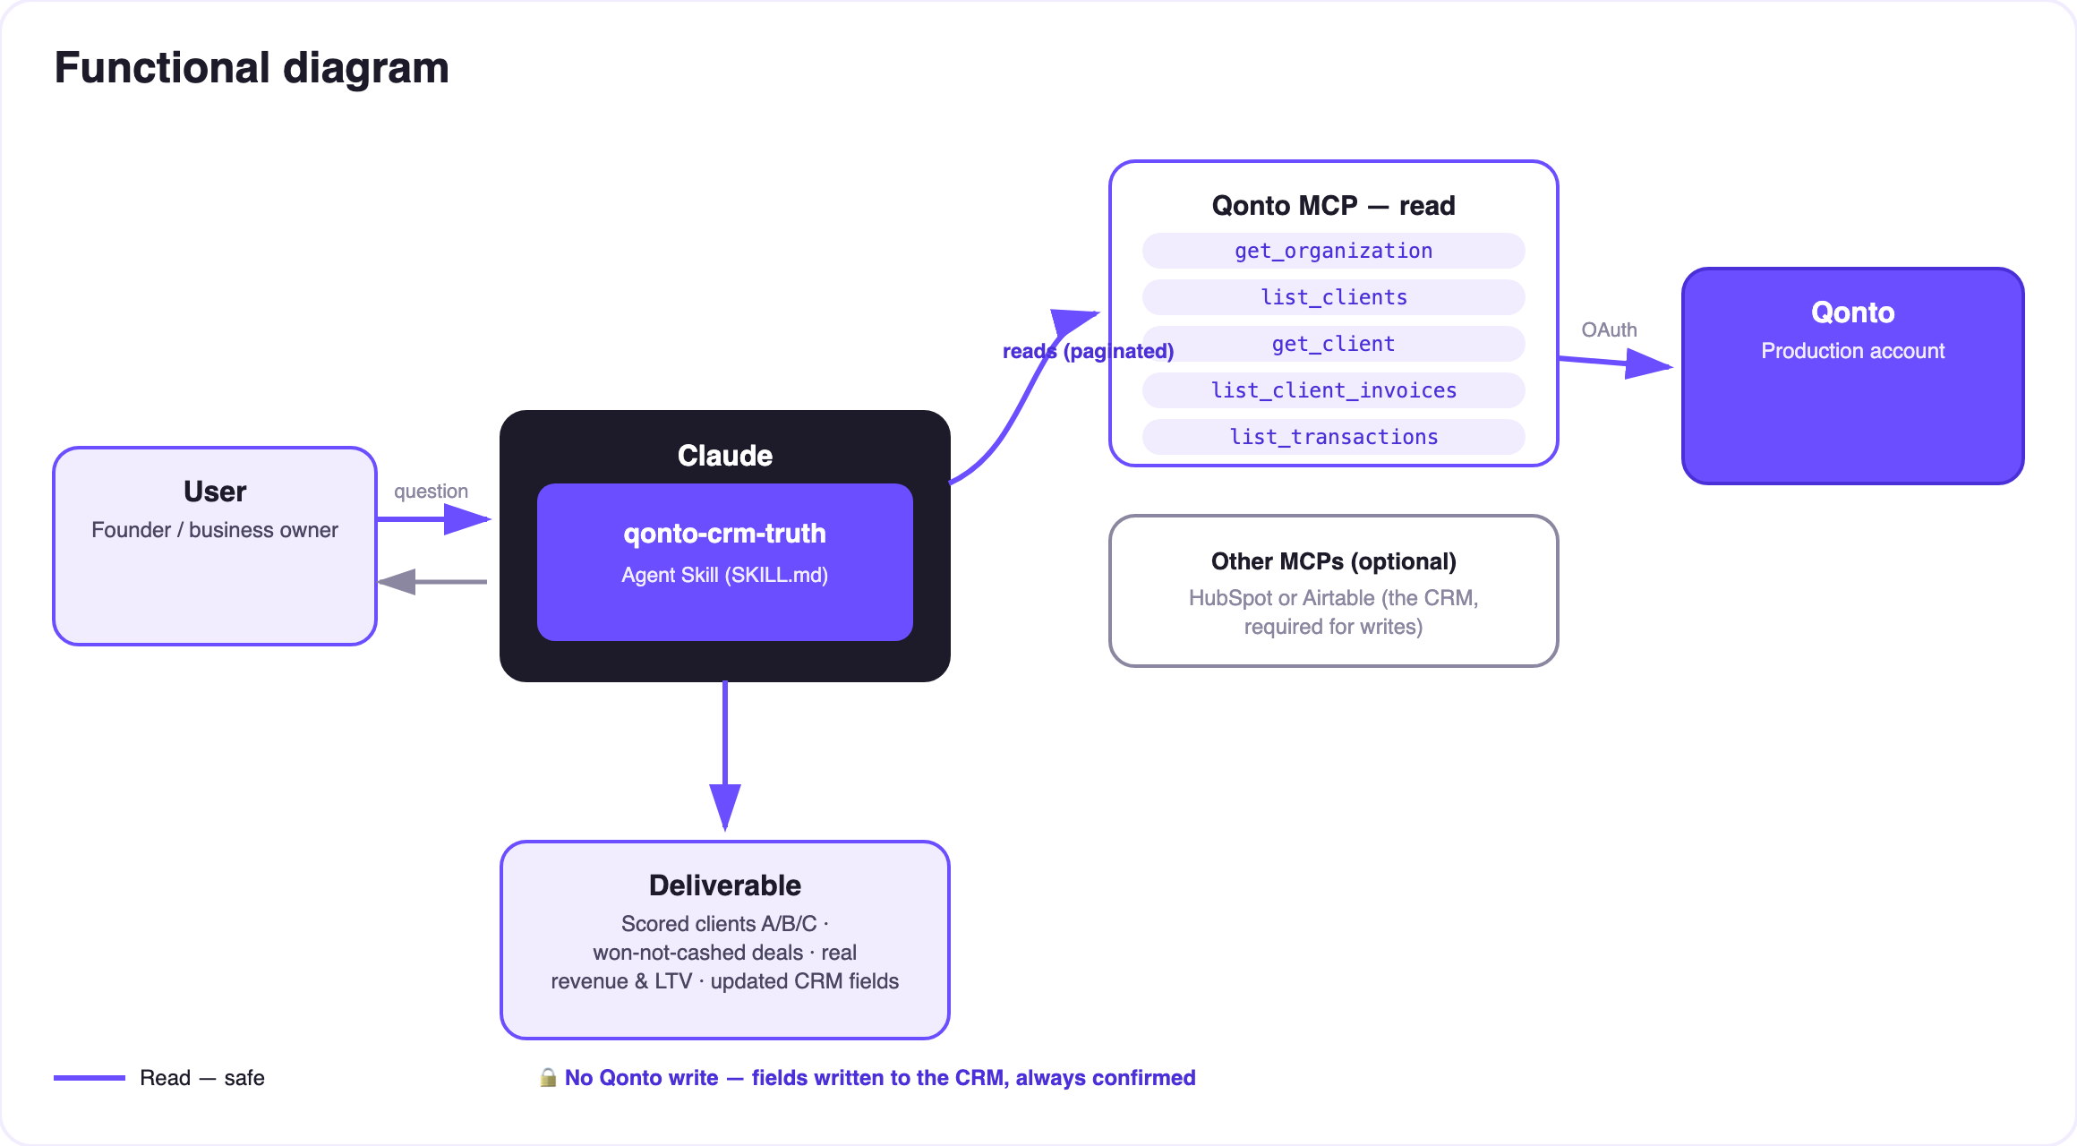
Diagram 2 — Actors and flows: risk-free Qonto reads, CRM write behind confirmed matching + approved preview
🔒 Zero bank writes: on the Qonto side the skill is pure read — it cannot touch money. The only writes target the CRM, behind two locks: the CRM-record ↔ Qonto-client matching, always shown and confirmed (never silent), then the exact preview of every value, explicitly approved in the conversation.
🅰️ The payer score (disclosed formula, never a black box)
Score | Definition
A | Median settlement within 5 days of the due date, nothing currently overdue
B | Always pays, but late — median lateness ≤ 30 days past due
C | Median lateness > 30 days, or an invoice unpaid > 60 days, or a won deal never cashed
— | Fewer than 2 paid invoices → unrated (never a guessed score)

⚠️ The score describes payment behavior observed on this account — not general creditworthiness; restated in every report.
✍️ What the skill writes into the CRM (dedicated fields, invented examples)
Field | Content | Example (invented)
Real revenue (bank) | Cash collected over the period | €24,300
LTV (bank) | All-time collected cash | €61,750
Avg payment delay | Median of day +X (issue → settlement) | day +38
Payer score | A / B / C / unrated | C
Last payment | Date of the last attached credit | 2026-05-12
Won not cashed | Flag + cumulated amount | ⚠️ 2 deals · €9,800

On Airtable: create_field for missing columns, then update_records_for_table in batches. On HubSpot: equivalent custom properties. CRM-native fields are never overwritten.
📤 Output formats
Output | Format | When
Conversation reply | Markdown tables: scored clients, won-not-cashed deals, mapping table, write-back summary | Always — the baseline
CRM write-back | HubSpot custom properties / Airtable columns (dedicated fields) | After confirmed matching + explicit go
HTML one-pager | CRM ranking vs bank ranking, score distribution | When the host renders files; fallback to tables

🎬 Demo video
The ≤ 3-minute demo attached to the PR walks through: the CRM lie → bank truth & confirmed matching → scores and gaps → the write-back after confirmation → degraded mode without a CRM. All demo records are invented. (Shooting script kept internal, outside the repo.)
💡 Roadmap ideas
Idea | Effort | Note
Chase won-but-never-cashed deals via qonto-invoice-chaser | Low | Natural cross-skill — one discovers, the other acts
Payer score at quote time (list_quotes) | Medium | Warn before signing a C payer — the truth when it matters most
Score history (dated column) | Low | Spot clients drifting from A to C; same write guardrail
More CRMs (Notion, Salesforce…) via dynamic detection | Medium | Same logic: read, match, confirm, write

🛡 Guardrails
- Zero Qonto writes — pure read on the bank side; the only writes target the CRM
- NEVER writes to the CRM without (a) a confirmed mapping table and (b) an explicit go on an exact preview; never presented as done if it failed or was partial
- Assisted matching, never silent — ambiguous pairs become questions
- Honest degradation: unrated under 2 paid invoices · counterparty-level without invoices · conversation report without a CRM
- IBANs masked (last 4 digits) · pagination ≤ 50 · rehearse writes on a duplicated Airtable base or test properties (CRM writes are real)
qonto-crm-truth · English documentation · Qonto × Anthropic MCP Hackathon · July 2026 · PR deliverable: SKILL.md · French version: doc-qonto-crm-truth.fr.docx

