qonto-project-pnl
Your project docs finally tell the economic truth — a living, per-project P&L inside Notion
Qonto × Anthropic MCP Hackathon · The P&L lives in Notion · Zero Qonto writes · Idempotent — re-run = update

🎯 Why this matters
Studios, agencies and indie hackers run their projects in Notion: the docs look great, the specs are current… but per-project profitability stays a mystery. The revenue is in the bank, the costs are in the bank — and the doc knows nothing. The skill closes the loop:
- 1. Real revenue — cashed money only: paid client invoices matched to incoming bank transactions (matching shown and confirmed), attributed to their project
- 2. Attributed costs — Qonto labels ↔ projects (mapping confirmed once, then remembered), refunds deducted, a 24-36-month scan so annual renewals show up
- 3. Margin & monthly burn — per project: margin in € and %, 3-month average burn, confidence tags 🟢🟡
- 4. The P&L lives in Notion — a dedicated “Finance” database, one entry per project, refreshed on every run (never a duplicate), with alerts ⚠️ overdue invoice · unusual cost · negative margin
Would someone use this on a Monday morning? It answers the Monday-morning question: which projects deserve your week.
🆚 Don't confuse: qonto-project-burn vs qonto-project-pnl
 | qonto-project-burn | qonto-project-pnl (this skill)
The question | “Are we within budget?” | “Is this project making money?”
Scope | Costs vs declared budget, projected overrun date | Revenue AND costs → margin, burn
Destination | Linear / Jira — the product team | Notion — the project documentation
Alerts | Budget thresholds (80% / 100%) | Overdue invoice, unusual cost, negative margin

They complement each other; for the company-wide view (runway, all-costs cockpit), see qonto-ceo-cockpit.
📋 Prerequisites
Prerequisite | Detail | Required
Qonto production account | Adapts to any organization — get_organization first, nothing hardcoded | ✅ Yes
Country | Universal — labels + invoices + transactions, no tax rules: every Qonto country (FR, DE, ES, IT, AT, NL, BE, PT) works identically | ℹ️ Detected
Qonto MCP connected | Official connector (claude.ai / Claude Desktop), OAuth login | ✅ Yes
Notion connector | The official connector — required for writing the Finance database. Without it: clean degraded mode (tables + HTML dashboard) | ⭕ Recommended
Qonto labels per project | The account's “project” dimension. No labels: mapping proposed from recurring counterparties, everything tagged 🟡 | ⭕ Recommended
Client invoices in Qonto | For cashed revenue and overdue alerts. Without: fallback to labelled credits (🟡) | ⭕ Optional

⚙️ How it works
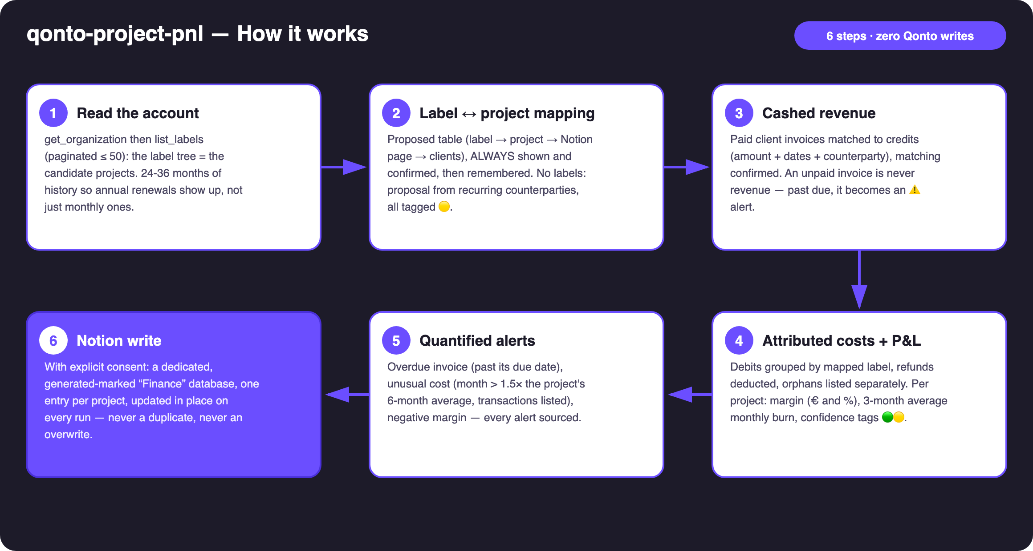
Diagram 1 — How it works, 6 steps (zero Qonto writes, Notion write behind consent)
Holds up on messy data
- No labels at all → mapping proposed from recurring counterparties, everything tagged 🟡, plus how to label in the Qonto app
- No client invoices in Qonto → revenue falls back to labelled credits (🟡), overdue detection declared unavailable
- Unlabelled debits that look like a project's suppliers → listed as orphans, never silently attributed
- A transaction carrying several labels → counted once, under the mapping's first matching label — and the skill says so
- Project renamed between runs → matched by name: the skill asks to confirm the rename instead of creating a twin entry
- Pagination ≤ 50 everywhere · card timing (emitted_at vs settled_at) · list_cash_flow_categories never called (403 on the claude.ai connector)

🏗 Functional diagram
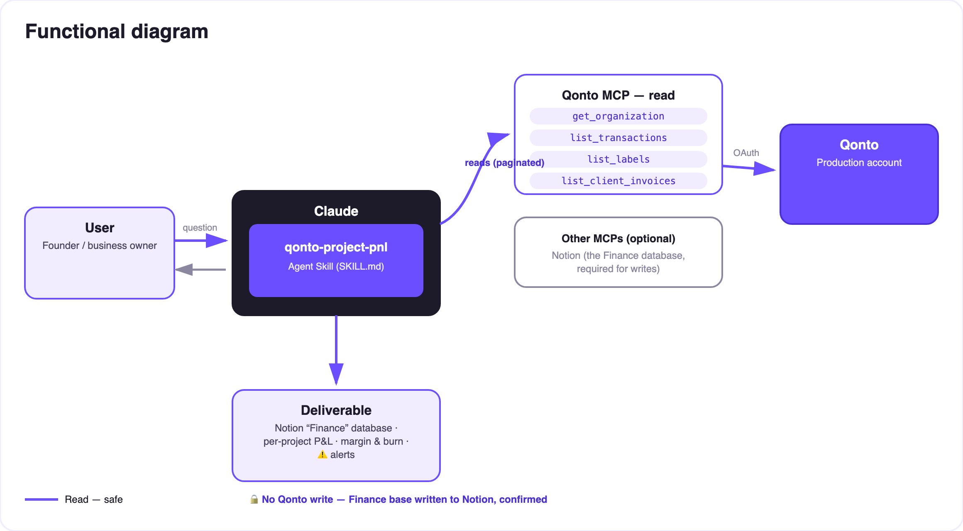
Diagram 2 — Actors and flows: risk-free Qonto reads (solid), Notion write behind consent (dashed)
🔒 Zero Qonto writes — no money moves, anywhere. The single write lives on the Notion side: explicit consent in the conversation, a dedicated database marked as generated, existing Notion content never modified. Re-run = in-place update, never a duplicate.
📓 The “Finance” database in Notion (one entry per project)
Property | Content | Example (invented)
Project | Project name — the idempotent update key | Aurora
Cashed revenue | Sum of matched paid invoices | €18,400
Attributed costs | Labelled debits, refunds deducted | €7,150
Margin | € and % | €11,250 · 61%
Monthly burn | Average of the last 3 full months | €2,380/month
Alerts | ⚠️ plain-language, quantified and sourced | ⚠️ 1 overdue invoice (INV-2026-042, 12 days)
Period · Updated | Window covered · timestamp of the last run | 2024-08 → 2026-07 · 1 min ago

📤 Output formats
Output | Format | When
Conversation reply | Markdown tables (per-project P&L, alerts, orphans) | Always — the baseline
“Finance” database in Notion | Dedicated database, one entry per project, refreshed on every run | Notion connector present + explicit consent
Interactive dashboard | HTML file/artifact: revenue vs costs bars, margin, burn, alerts | When the host renders files; fallback to tables

🎬 Demo video
The ≤ 3-minute demo attached to the PR walks through: the profitability mystery → the confirmed mapping → the computed P&L → the Notion project page showing “updated 1 min ago” → the idempotent re-run. All figures on screen are invented demo data. (Shooting script kept internal, out of the repository.)
💡 Roadmap ideas
Idea | Effort | Note
Monthly history per project (a sub-table per entry) | Medium | The Finance database gains a time dimension
Open quotes (list_quotes) as a “pipeline” column | Low | Signed vs cashed revenue, never conflated
Hand overdue invoices to qonto-invoice-chaser | Low | Detection here, follow-up there
Implicit hourly rate (margin ÷ declared time) | Medium | Time stays user-declared — never invented

🛡 Guardrails
- Zero Qonto writes; the single write is the dedicated, clearly marked Notion database — after a preview and an explicit “yes”, never presented as done if the call failed
- Idempotent: re-run = in-place update (key: project name), never a duplicate, never a deletion
- The label → project mapping and the invoice ↔ transaction matching are always shown and correctable — no silent attribution
- Revenue is matched cash only; every fallback or estimate carries a 🟡 tag; no invented amounts
- Masked IBANs (last 4 digits) · pagination ≤ 50 everywhere · honest degradation (no labels, no invoices, no Notion, short history)
qonto-project-pnl · English documentation · Qonto × Anthropic MCP Hackathon · July 2026 · PR deliverable: SKILL.md · French version: doc-qonto-project-pnl.fr.docx

