qonto-subscription-audit
The complete recurring-spend audit — what you pay, what you forgot, what quietly went up, and what just started.
Qonto × Anthropic MCP Hackathon · Pure Qonto, read-only · Zero Qonto writes

🎯 Why this matters
Subscriptions pile up, prices creep up silently, trials convert, nobody cancels. Most founders can't name their real annual subscription spend within 50 %. The skill runs the COMPLETE audit over 24–36 months:
- 1. The full inventory — every recurring charge (cards AND direct debits), monthly/quarterly/YEARLY cadence, the TOTAL annualized cost (the shock number) and a status per line: ✅ active · 👥 duplicate · 🧟 zombie (always user-confirmed) · 🎣 trial gone paid
- 2. The newborns 🌱 — every recent counterparty is scored: notorious subscription merchants recognized at the very first charge (SaaS, AI, course platforms, hosting/domains — no history needed), round amounts, label hints, 2nd occurrence ~30 d → "probable subscription, to confirm". Early detection: catch the trial before it becomes rent
- 3. Every hike detected — price plateaus (≥ 2 charges within ±2 %, a jump persisting ≥ 2 cycles), FX and VAT excluded (excl-VAT comparison via supplier invoices), tags 🟢 ≤ inflation · 🟡 above · 🔴 aggressive · ⚪ variable usage — plus the cumulated annual overcost of all hikes
- 4. The dashboard + the emails — a dashboard built directly in Claude, exportable as a self-contained HTML file in Qonto colors; an argued renegotiation email (tenure, volume, hike record) and a monthly digest — Gmail drafts, never sent without the user
Would someone use this on a Monday morning? It's the audit every founder postpones because it means opening 30 months of statements. Here it's one prompt — with the fix one skill away (qonto-subscription-guardian owns the capped virtual card).
📋 Prerequisites
Prerequisite | Detail | Required
Qonto production account | Adapts to any organization — get_organization first, nothing hardcoded | ✅ Yes
Country | Country-agnostic core: inventory, statuses and hike detection work on every Qonto country (FR, DE, ES, IT…). Only the inflation benchmark is localized, reference always stated | ℹ️ Detected
Qonto MCP connected | Official connector (claude.ai / Claude Desktop), OAuth login | ✅ Yes
≥ 24 months of history | A YEARLY subscription only shows with 2 occurrences: on a 12-month window, annual renewals fly under the radar. Below that: honest degradation | ⭕ Recommended
Gmail MCP | Detected dynamically: present → monthly digest + negotiation drafts; absent → copy-paste text. The core needs Qonto only | ⭕ Optional

⚙️ How it works
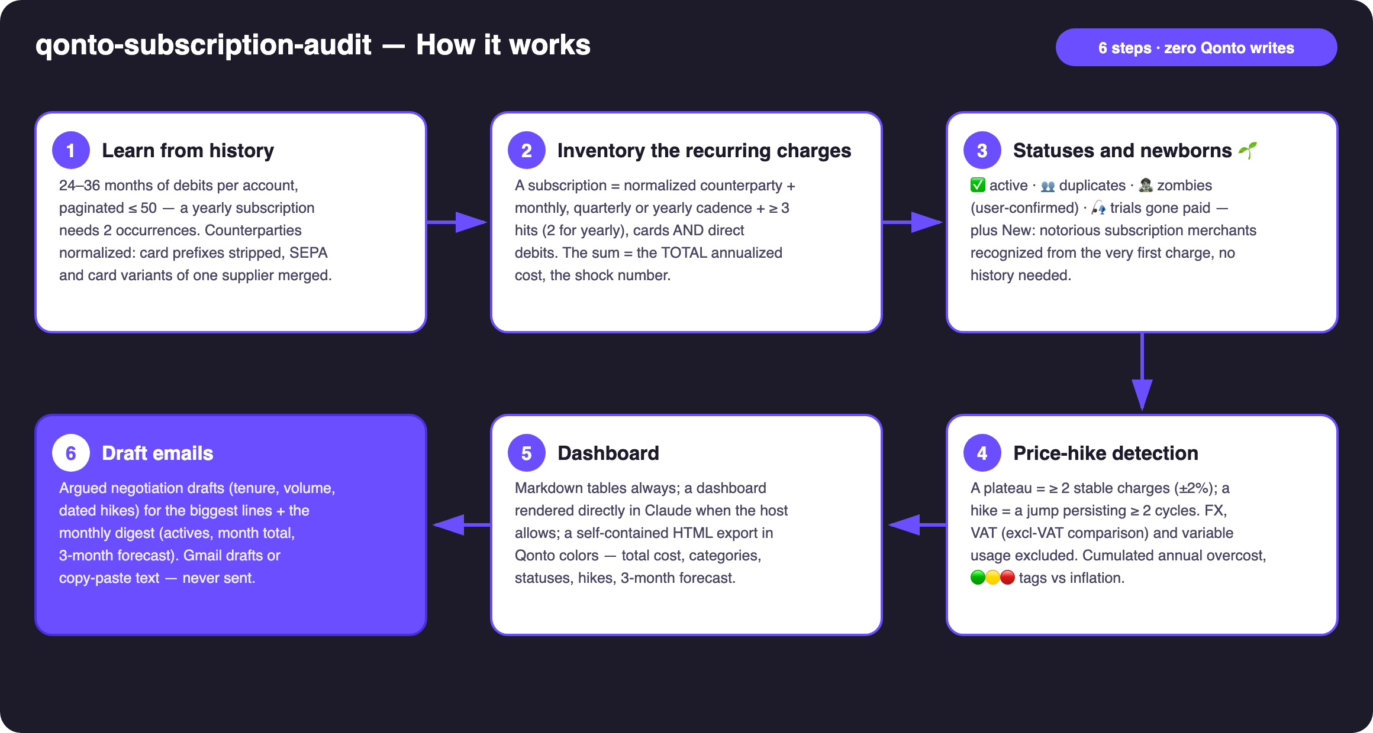
Diagram 1 — How it works, 6 steps (zero Qonto writes)
Holds up on messy data
- Counterparty normalization: references, dates and card-processor prefixes (PAYPAL *, SUMUP *…) stripped; SEPA and card variants of the same supplier merged into one line
- Yearly lines no longer fly under the radar: 24–36 month target window, the 350–380 d cadence is recognized — below 24 months the skill says yearly lines may be missing instead of pretending
- Steps, not noise: a plateau = ≥ 2 stable charges (±2%); a hike = a jump persisting ≥ 2 cycles — single outliers, prorated months, FX wobble and VAT changes excluded by design
- VAT neutralized: excl-VAT comparison when list_supplier_invoices has the matching invoice — a tax change is never blamed on the supplier
- Variable usage said plainly: 'implicit price not isolable from payment data' rather than a fake conclusion; 🌱 and 🧟 are hypotheses to confirm, never verdicts
- Short history, empty account, no recurring charges: the skill states what it can see and what it can't yet · cadence math on emitted_at · pagination ≤ 50 everywhere

🏗 Functional diagram
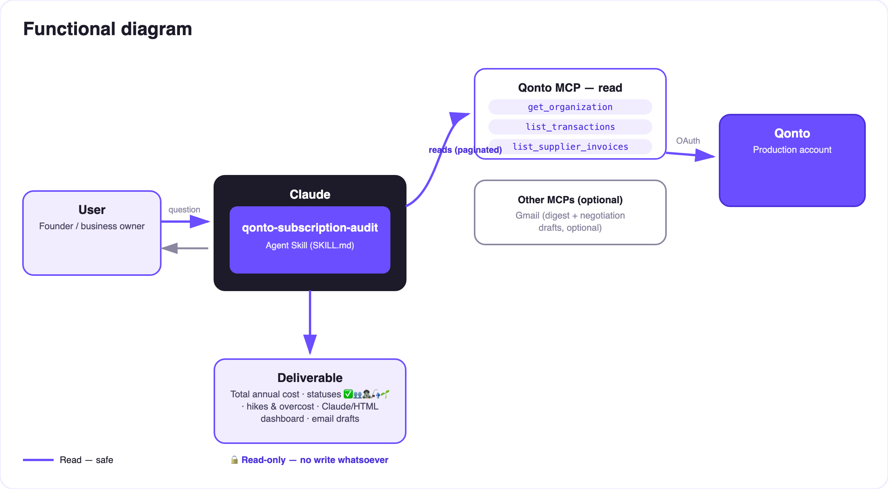
Diagram 2 — Actors and flows: risk-free Qonto reads; the only outbound artifacts are email drafts
🔒 Zero Qonto writes: this skill only reads — risk-free by construction. The only outbound artifacts are email drafts (negotiation, digest) that the user reviews, edits and sends (or not) themselves. To protect a subscription with a capped virtual card: the qonto-subscription-guardian skill.
📊 Portfolio statuses
Status | Criterion | Meaning | Proposed action
✅ Active | Regular cadence, usage confirmed by the user | The budget's backbone | Watch, alert on the next hike
👥 Duplicate | Two suppliers in the same tool category (2 meeting tools, 2 hosts…) | One of the two is extra | Keep one, quantify the saving
🧟 Zombie | Charged ≥ 6 months, zero variation, dormant category — a hypothesis | Probably unused | Cancel after user confirmation
🎣 Trial gone paid | Recent first full-price charge, preceded by nothing or a token amount | Silent conversion | Immediate decision: keep or cut
🌱 New (probable) | Notorious merchant recognized from the 1st charge (no history) · round amount · label · 2nd occ. ~30 d | A subscription being born, to confirm | 'New' section — catch it early
⚪ Variable usage | High variability (API, cloud, ads) | A rising bill ≠ a rising price | Implicit price when isolable, said plainly otherwise

Hikes vs inflation: 🟢 ≤ inflation (normal indexing) · 🟡 above (drift worth watching) · 🔴 ≥ 3× inflation or ≥ 10 % in one step (negotiation email proposed by default). Cross-cutting alerts: 💥 double charge < 72 h · 🔁 cadence switch (often a disguised repricing).
📤 Output formats
Output | Format | When
Conversation reply | Markdown tables: shock number, portfolio by status, New 🌱 section, hikes, variable usage kept separate | Always — the baseline
Dashboard in Claude | Rendered directly in the conversation (artifact): annual cost, categories, statuses ✅👥🧟🎣🌱, hikes with deltas, 3-month forecast | When the host allows it
HTML export | The same dashboard as one self-contained file, Qonto palette (violet #6B4EFF / black #1D1B29 / white, light/dark) | On request — keep it or share it
Emails | Gmail draft (MCP present + explicit consent) or copy-paste text: negotiation + monthly digest | Never sent without the user

🎬 Demo video
The ≤ 3-minute demo attached to the PR walks through: the problem → the live inventory and statuses → the hikes and the overcost → the dashboard building itself in Claude with the shock number, and the 🌱 New section catching a fresh trial → wrap-up. It runs live on a real production account.
💡 Roadmap ideas
Idea | Effort | Note
Continuous watch: alert on the first charge of a confirmed 🌱 or a new plateau | Low | The monthly ritual becomes automatic
Public-price benchmark: compare to the supplier's published pricing | Medium | Also catches over-paying grandfathered plans
Auto-label detected subscriptions in Qonto | Low | The portfolio reads in the app too
Post-negotiation follow-up: verify the price actually dropped | Low | Closed loop — the price series already exists
Capped-card bridge: chain into qonto-subscription-guardian | Low | The audit finds, the guardian protects

🛡 Guardrails
- ZERO Qonto writes — reads only; the capped card is qonto-subscription-guardian territory
- 🧟 is a hypothesis, always user-confirmed; 🌱 is 'probable, to confirm', never asserted
- Never accuses a supplier when the data says usage, FX or VAT — doubtful lines go to variable usage with the reason
- Emails are drafts: never sent, no recipient added without the user; payment-data estimates ≠ contract audit
- Honest degradation under 24 months of history (yearly lines may be missing — and the skill says so) · masked IBANs (last 4 digits) · pagination ≤ 50 everywhere
qonto-subscription-audit · English documentation · Qonto × Anthropic MCP Hackathon · July 2026 · PR deliverable: SKILL.md · French version: doc-qonto-subscription-audit.fr.docx

