qonto-pay-me-now
From quote to cash, no friction — accepted quote, invoice, payment link, money in
Qonto × Anthropic MCP Hackathon · Payment links verified via MCP · Nothing leaves without you

🎯 Why this matters
The freelance black hole: the client says yes to your quote… and then nothing happens. The invoice waits, the payment waits even longer — every day between the handshake and the money is cash you've earned but can't touch. The skill runs the whole cycle in one conversation:
- 1. Accepted quote detected — list_quotes cross-checked against list_client_invoices: only the accepted, never-invoiced quotes surface, with client, amount and date
- 2. Invoice generated from the quote — draft first, a REAL document: nothing goes out without explicit confirmation
- 3. Qonto payment link — card or bank-transfer payment in one click; trackable Short.io short link + a QR code for printed invoices
- 4. Follow-up & gentle nudge — link clicked but unpaid after 48 h → a soft reminder is proposed, never sent on its own
Would someone use this on a Monday morning? It's what you run the second a client says yes.
📋 Prerequisites
Prerequisite | Detail | Required
Qonto production account | Adapts to any organization — get_organization first, nothing hardcoded | ✅ Yes
Country | The quote → invoice → payment link cycle is identical for every Qonto country (FR, DE, ES, IT, AT, NL, BE, PT). Reminder wording: France fully covered; elsewhere adapted, never invented legal mentions | ℹ️ Detected
Qonto MCP connected | Official connector (claude.ai / Claude Desktop), OAuth login | ✅ Yes
Payment links activated | One-time activation in the Qonto app. If create_payment_link is refused, the skill says so and continues invoice-only | ⭕ Recommended
Quotes created in Qonto | The skill starts from list_quotes; without quotes it can also start from any existing unpaid invoice | ⭕ Optional
Short.io / Gmail MCP | Optional enrichments, detected dynamically: short link + click stats / sending. Absent: raw Qonto link + copy-ready text | ⭕ Optional

⚙️ How it works
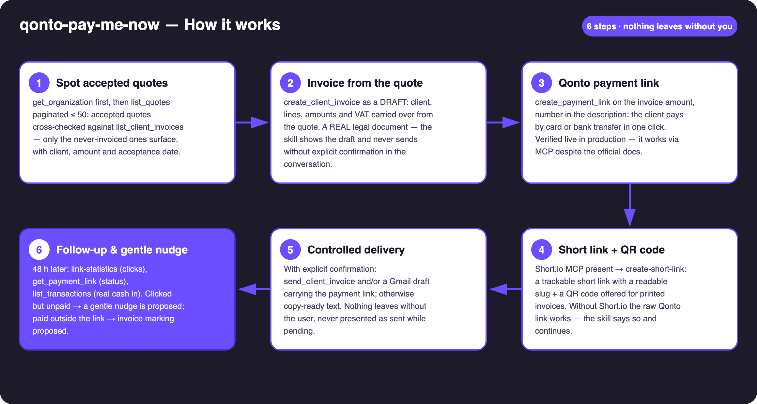
Diagram 1 — How it works, 6 steps (nothing leaves without the user)
Holds up on messy data
- The differentiator: the official MCP docs list payment links as unsupported — they WORK (verified against the live API on a production account). The skill calls create_payment_link directly instead of trusting the doc
- No accepted quotes → the skill says so and offers to start from any existing unpaid invoice; payment links not activated → one-time activation explained, cycle continues invoice-only
- Short.io or Gmail absent → raw Qonto link + copy-ready text, stated plainly — no tracking silently faked
- Client paid by plain transfer outside the link → matched in list_transactions (amount ± 0.01, counterparty, reference) and mark_client_invoice_as_paid proposed with evidence
- Pagination ≤ 50 everywhere · invoice numbering left to the organization's settings · amounts always from the quote, never invented

🏗 Functional diagram
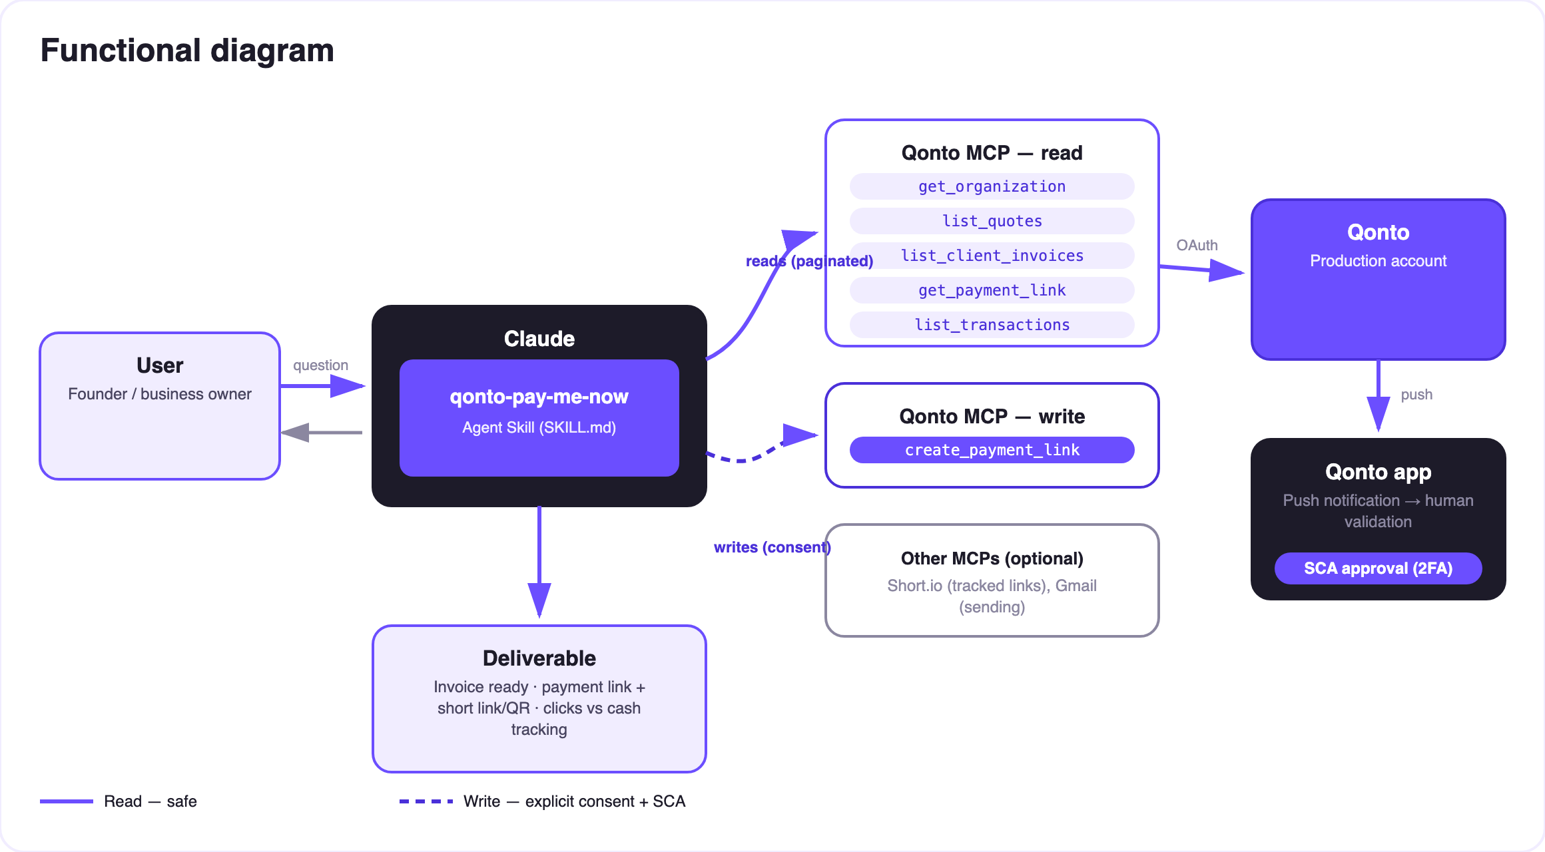
Diagram 2 — Actors and flows: risk-free reads, two harmless writes (draft invoice, payment link)
🔒 This skill cannot move money out: a payment link is a way to RECEIVE a payment from the client — it has nothing to do with outbound transfers (impossible through the MCP anyway: any transfer request requires the user's own SCA in the Qonto app). The only three writes: an invoice (draft first, sent after an explicit go), a payment link deactivatable anytime, and a paid-marking — always proposed, never automatic.
📊 The follow-up matrix (D+2)
Link clicked? | Payment received? | Proposed action
❌ No | ❌ No | Check delivery; offer to resend through another channel
✅ Yes | ❌ No (> 48 h) | Gentle nudge — “the link is still active” — drafted, never auto-sent
✅ Yes | ✅ Yes | Loop closed ✅ — confirmed in the report
❌ No | ✅ Yes | Paid by plain transfer → reconciliation + mark_client_invoice_as_paid proposed

📤 Output formats
Output | Format | When
Conversation reply | Markdown tables: quote → invoice → link pipeline, follow-up matrix | Always — the baseline
The payment link (+ short link) | Qonto URL + Short.io short URL, ready to share | Every cycle
QR code | Image file/artifact encoding the link, for print | When the host renders files
Follow-up report | Clicks vs cash + proposed nudges | On demand / at D+2

🎬 Demo video
The ≤ 3-minute demo attached to the PR walks through: the black hole → detection & invoice → payment link + short link → the QR code scanned on a phone, the Qonto payment page appearing → follow-up & nudge. It runs live on a real production account. The invoice is out, the payment link is live — before the handshake ends.
💡 Roadmap ideas
Idea | Effort | Note
Deposit at signature: a partial payment link (e.g. 30%) the moment the quote is accepted | Medium | The same cycle, even earlier
D+2 follow-up reminder in the calendar (calendar MCP detected dynamically) | Low | Optional multi-MCP enrichment, in the spirit of the kickoff
Multilingual client messages (client's language detected) | Low | Qonto is pan-European
Collection dashboard: click-to-payment rate per client | Medium | Reuses link-statistics + list_transactions
Local legal mentions per country (DE · ES · IT…) | Medium | v1 = identical cycle everywhere, v2 = local wording

🛡 Guardrails
- Invoices via MCP are REAL: draft first, sent only after explicit confirmation; rehearsals on a fictional client + delete_client_invoice afterwards
- No outbound payments: the payment link receives, it never debits — unrelated to outbound transfers (always behind the user's own SCA in the app, outside the MCP)
- Nothing is sent (invoice, email, nudge) without confirmation in the current conversation; never presented as sent/paid while pending
- Amounts from the quote or invoice, never invented · masked IBANs (last 4 digits) · pagination ≤ 50 everywhere
qonto-pay-me-now · English documentation · Qonto × Anthropic MCP Hackathon · July 2026 · PR deliverable: SKILL.md · French version: doc-qonto-pay-me-now.fr.docx

