qonto-asset-registry
Your account knows what you own — the asset register nobody keeps
Qonto × Anthropic MCP Hackathon · 100% read-only — zero writes · Configurable €500 pre-tax threshold · Insurance inventory ready

🎯 Why this matters
Nobody keeps the fixed-asset register. And the day something gets stolen or the office floods, the insurer asks for the inventory with purchase values and receipts — which nobody has. Yet the Qonto account already knows everything the company owns. The skill reads it:
- 1. Equipment detection across 24–36 months of real purchases (transactions + supplier invoices) — IT, furniture, machines, vehicles, tools, telephony, recognized from the first occurrence
- 2. €500 pre-tax threshold — French practice: below = expense, above = fixed asset (configurable); leasing flagged "financed, not capitalized here", never counted
- 3. The asset register — date, supplier, description, pre-tax/incl-tax amount, linked receipt, status — with a receipt-completeness gauge
- 4. Two golden outputs — indicative depreciation (straight-line, estimated net book value, for the accountant to validate) and the insurance inventory, ready to send
Would someone use this on a Monday morning? Ask anyone who just got the insurer's email after a break-in.
📋 Prerequisites
Prerequisite | Detail | Required
Qonto production account | Adapts to any organization — get_organization first, nothing hardcoded | ✅ Yes
Country | Universal mechanics. €500 threshold + depreciation lives = French practice; other Qonto countries (DE, ES, IT…) → register and inventory without local tax suggestions | ℹ️ Detected
Qonto MCP connected | Official connector (claude.ai / Claude Desktop), OAuth login | ✅ Yes
24–36 months of history | Below that: partial register, covered period stated | ⭕ Optional
Receipts attached to transactions | The more there are, the stronger the inventory; missing ones listed 📎 (pointer to qonto-receipt-hunter) | ⭕ Optional

⚙️ How it works
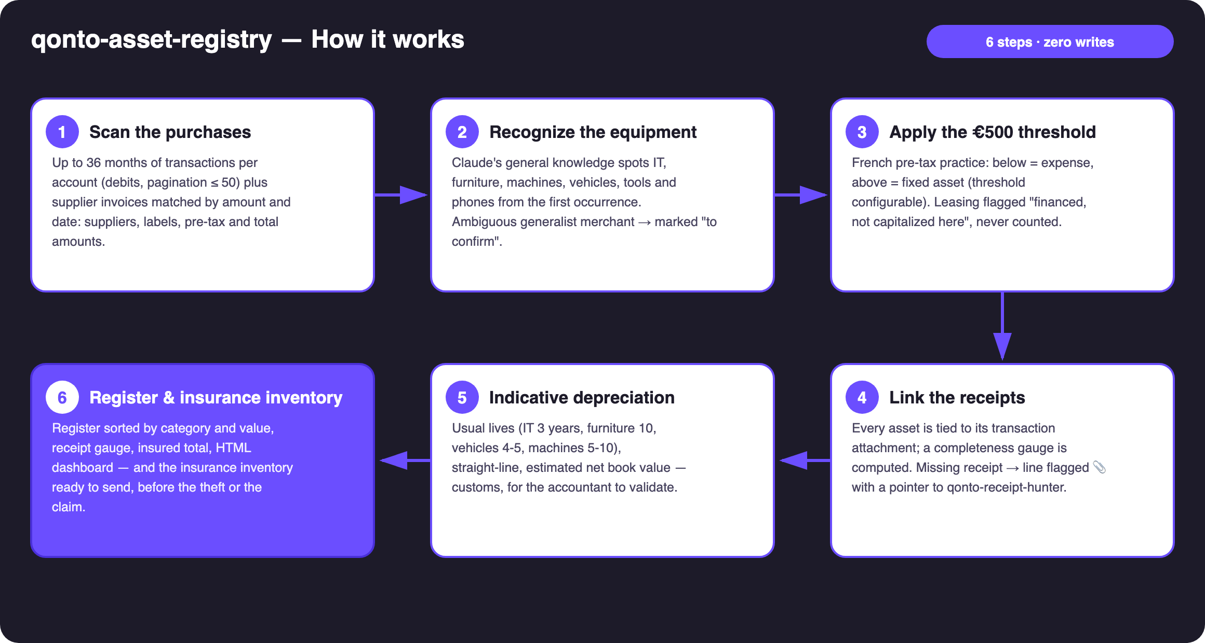
Diagram 1 — How it works, 6 steps (100% read-only, zero writes)
Holds up on messy data
- Cryptic transaction labels → supplier invoices, matched by amount and date, carry the clean description and the pre-tax amount
- Generalist merchant (marketplace, supermarket) → line "to confirm" unless the label or the attached receipt makes the nature clear — never guessed
- Installment purchases → equal payments to the same vendor merged into one asset at full value
- Leasing / hire-purchase → recurring monthly payments to a financer: "financed, not capitalized here", excluded from totals
- Card purchases dated by emitted_at (settlement lags 1–2 days) · untagged VAT → estimated pre-tax amount, disclosed as such · pagination ≤ 50 everywhere

🏗 Functional diagram
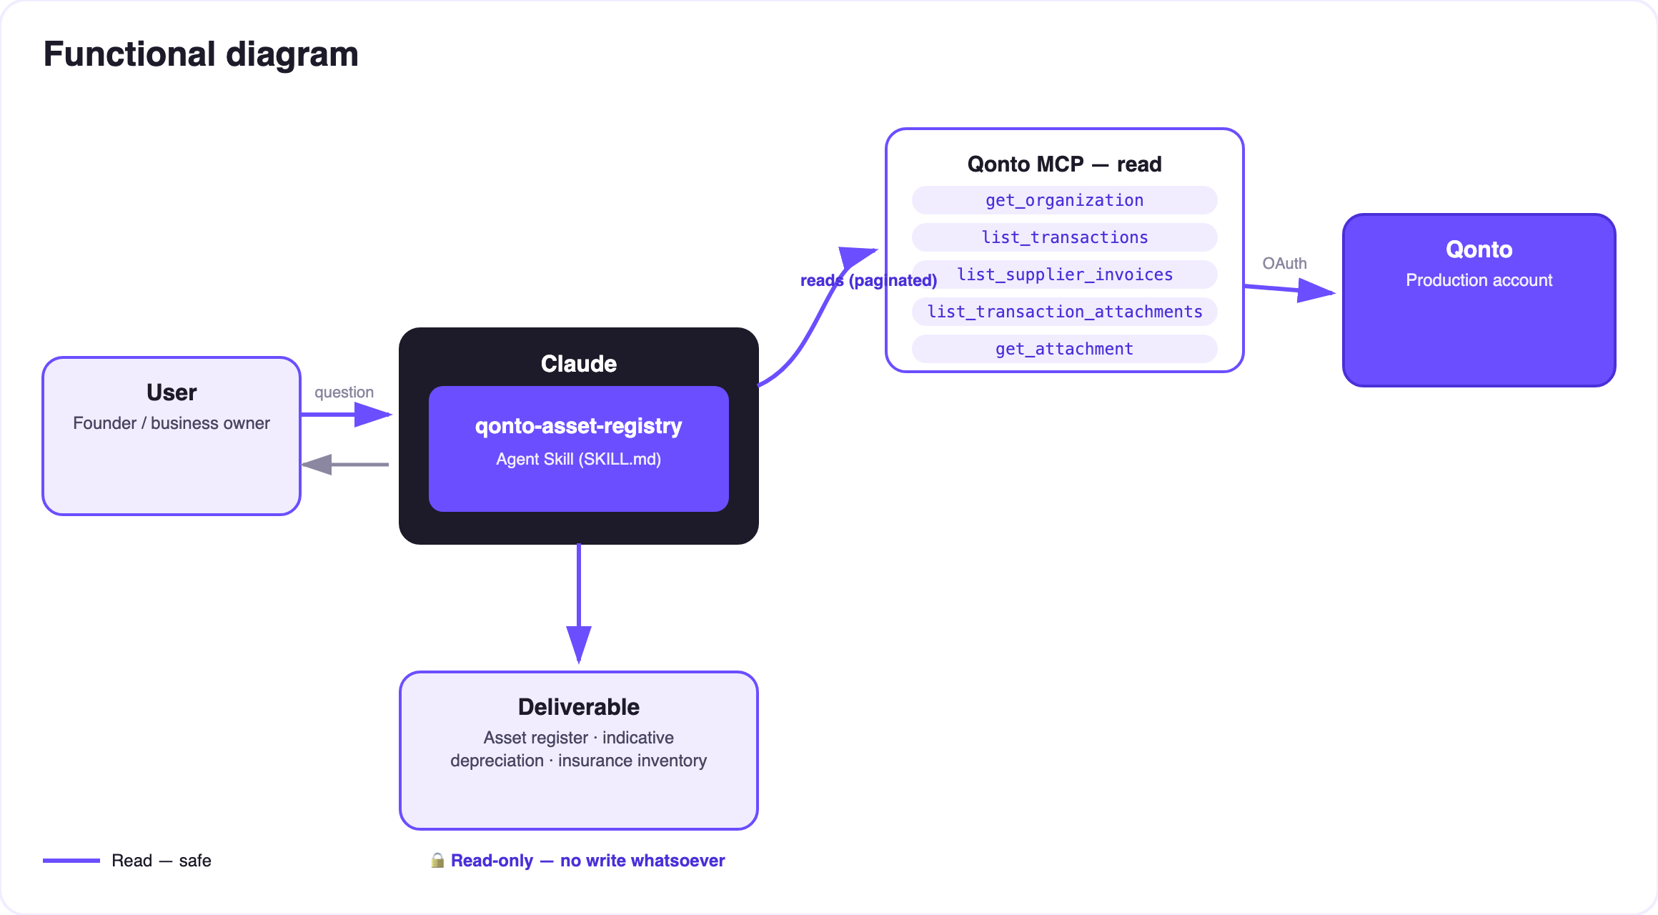
Diagram 2 — Actors and flows: read-only, no writes at all
🔒 100% read-only — the strongest guarantee: no write tool is ever called. No category changed, no document uploaded, no request created. The register writes itself; the accountant keeps the pen — the €500 threshold and the depreciation lives are customary indications, not accounting entries.
📅 Usual depreciation lives (French practice, indicative)
Category | Usual life | Examples
IT hardware | 3 years | Computers, monitors, servers, printers
Telephony | 3 years | Smartphones, switchboard, pro headsets
Tools | 5 years | Workshop tools, power tools
Machines | 5–10 years | Production machinery, heavy equipment
Vehicles | 4–5 years | Cars, vans, two-wheelers
Furniture | 10 years | Desks, chairs, shelving

Register statuses
Status | Meaning
✅ Fixed asset | Equipment ≥ threshold (€500 pre-tax by default), registered and depreciated
💰 Expensed | Below the threshold: expensed, listed for the record
❓ To confirm | Generalist merchant, nature undeterminable — the user decides
🔁 Financed | Leasing detected: flagged, never counted in the total
📎 Missing | No linked receipt — pointer to qonto-receipt-hunter

Disposals and write-offs are declared by the user, never assumed.
📤 Output formats
Output | Format | When
Conversation reply | Markdown tables: register sorted by category/value, depreciation, summary (N assets · total value · receipt gauge) | Always — the baseline
Dashboard / export | Self-contained HTML file/artifact in the Qonto palette: register by category, completeness gauge, insured total | When the host renders files; fallback to tables
Insurance inventory | Ready-to-send table: description, purchase date, value, receipt | On demand — ideally before the claim

🎬 Demo video
The ≤ 3-minute demo attached to the PR walks through: the problem (the inventory your insurer demands and nobody has) → the scan → the register with linked receipts → the "it was all already there" moment → the dashboard and the insurance inventory. It runs live on a real production account.
💡 Roadmap ideas
Idea | Effort | Note
Country modules (DE · ES · IT · AT · NL · BE · PT thresholds and lives) | Medium | The mechanics are already universal; only local practice is missing
Disposal detection from incoming credits (resale) | Medium | Always proposed for confirmation, never assumed
Reconciliation with a physical inventory (photos, asset tags) | Medium | Makes the insurance inventory defensible
End-of-depreciation alerts (renewal budgeting) | Low | Reuses the end-of-life dates already computed
CSV export for the accounting firm | Low | Alongside qonto-accountant-handoff

🛡 Guardrails
- 100% read-only — no write tool is ever called
- €500 threshold and depreciation lives = customary indications, not accounting entries — the accountant makes the final call, restated in every report
- Ambiguous nature → "to confirm", never invented; disposals declared by the user, never assumed
- Example figures are invented and presented as such · IBANs masked (last 4 digits) · pagination ≤ 50 everywhere
qonto-asset-registry · English documentation · Qonto × Anthropic MCP Hackathon · July 2026 · PR deliverable: SKILL.md · French version: doc-qonto-asset-registry.fr.docx

