qonto-chargeback-defender
Payment disputes end-to-end: detection, debit found, sourced defense file, deadline — you submit
Qonto × Anthropic MCP Hackathon · Works Qonto-only · Sourced evidence, never fabricated · Universal — every Qonto country

🎯 Why this matters
A chargeback is a triple hit: the money pulled back out of the account, a fee on top (often €15–20, indicative), and a short response window (7–21 days) — and most merchants never respond at all. That's revenue lost by default, not by decision. The skill turns a Qonto account into a defense desk:
- 1. Open disputes detected — via the Stripe/PayPal MCP when connected (reasons, amounts, real deadlines); otherwise clawback debits spotted in Qonto (dispute / chargeback / reversal labels + the paired fee)
- 2. The debit found — the clawback matched to the original incoming payment: full money trail, charge → payout → clawback → fee
- 3. A sourced defense file — Shopify order, proof of delivery when available, Gmail customer threads: every piece with its source, missing ones with where to find them
- 4. Accounting traceability — with explicit consent, a dated synthesis memo is attached to the clawback transaction in Qonto (upload confirmed)
Would someone use this on a Monday morning? A chargeback notification is the Monday morning email you dread — this makes it a ten-minute task with a deadline you won't miss.
📋 Prerequisites
Prerequisite | Detail | Required
Qonto production account | Adapts to any organization — get_organization first, nothing hardcoded | ✅ Yes
Country | Universal: chargebacks follow card-network and PSP rules, not national tax law — identical behavior for every Qonto country | ℹ️ Detected
Qonto MCP connected | Official connector (claude.ai / Claude Desktop), OAuth login | ✅ Yes
Stripe / PayPal MCP | Authoritative source for disputes and deadlines. Without it: Qonto-only mode — detection + money trail + checklist, already useful | ⭕ Recommended
Shopify · Gmail MCPs | File enrichment (order, tracking, threads) — detected dynamically, announced when absent | ⭕ Optional

⚙️ How it works
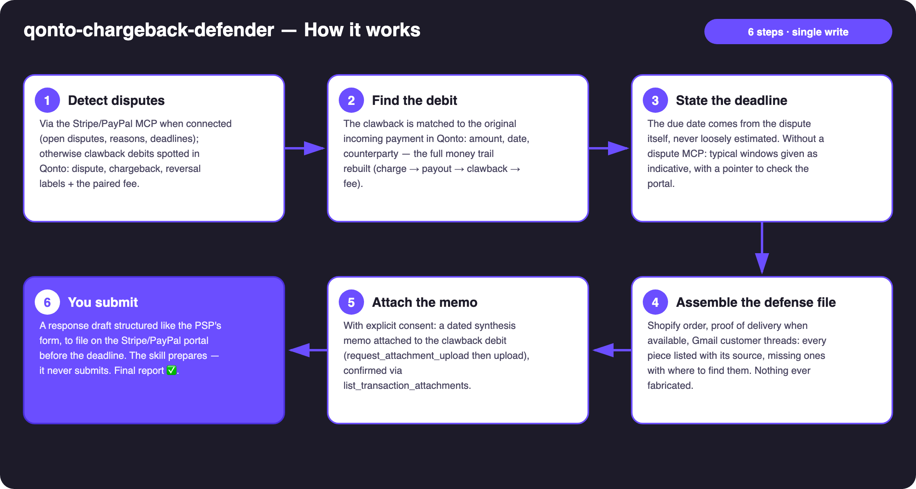
Diagram 1 — How it works, 6 steps (single write: the attached memo)
Holds up on messy data
- Two modes, stated plainly: Stripe/PayPal MCP present → authoritative disputes, reasons and deadlines; otherwise Qonto-only — clawback debits (dispute / chargeback / reversal), usually paired with a same-day fee debit from the same PSP
- The Stripe quirk, owned: disputes are often netted inside the next payout — no separate debit line. The skill flags unusually low payouts as candidates and recommends the Stripe MCP instead of guessing
- Card matching on emitted_at, not settled_at (1–2 days of drift)
- Missing piece → listed as missing, with where to look — a checklist, not a shrug
- No disputes found → the skill says so and never invents one; unknown deadline → typical windows labeled indicative + pointer to the portal
- Pagination ≤ 50 everywhere · list_transaction_attachments checked before any upload is reported as done

🏗 Functional diagram
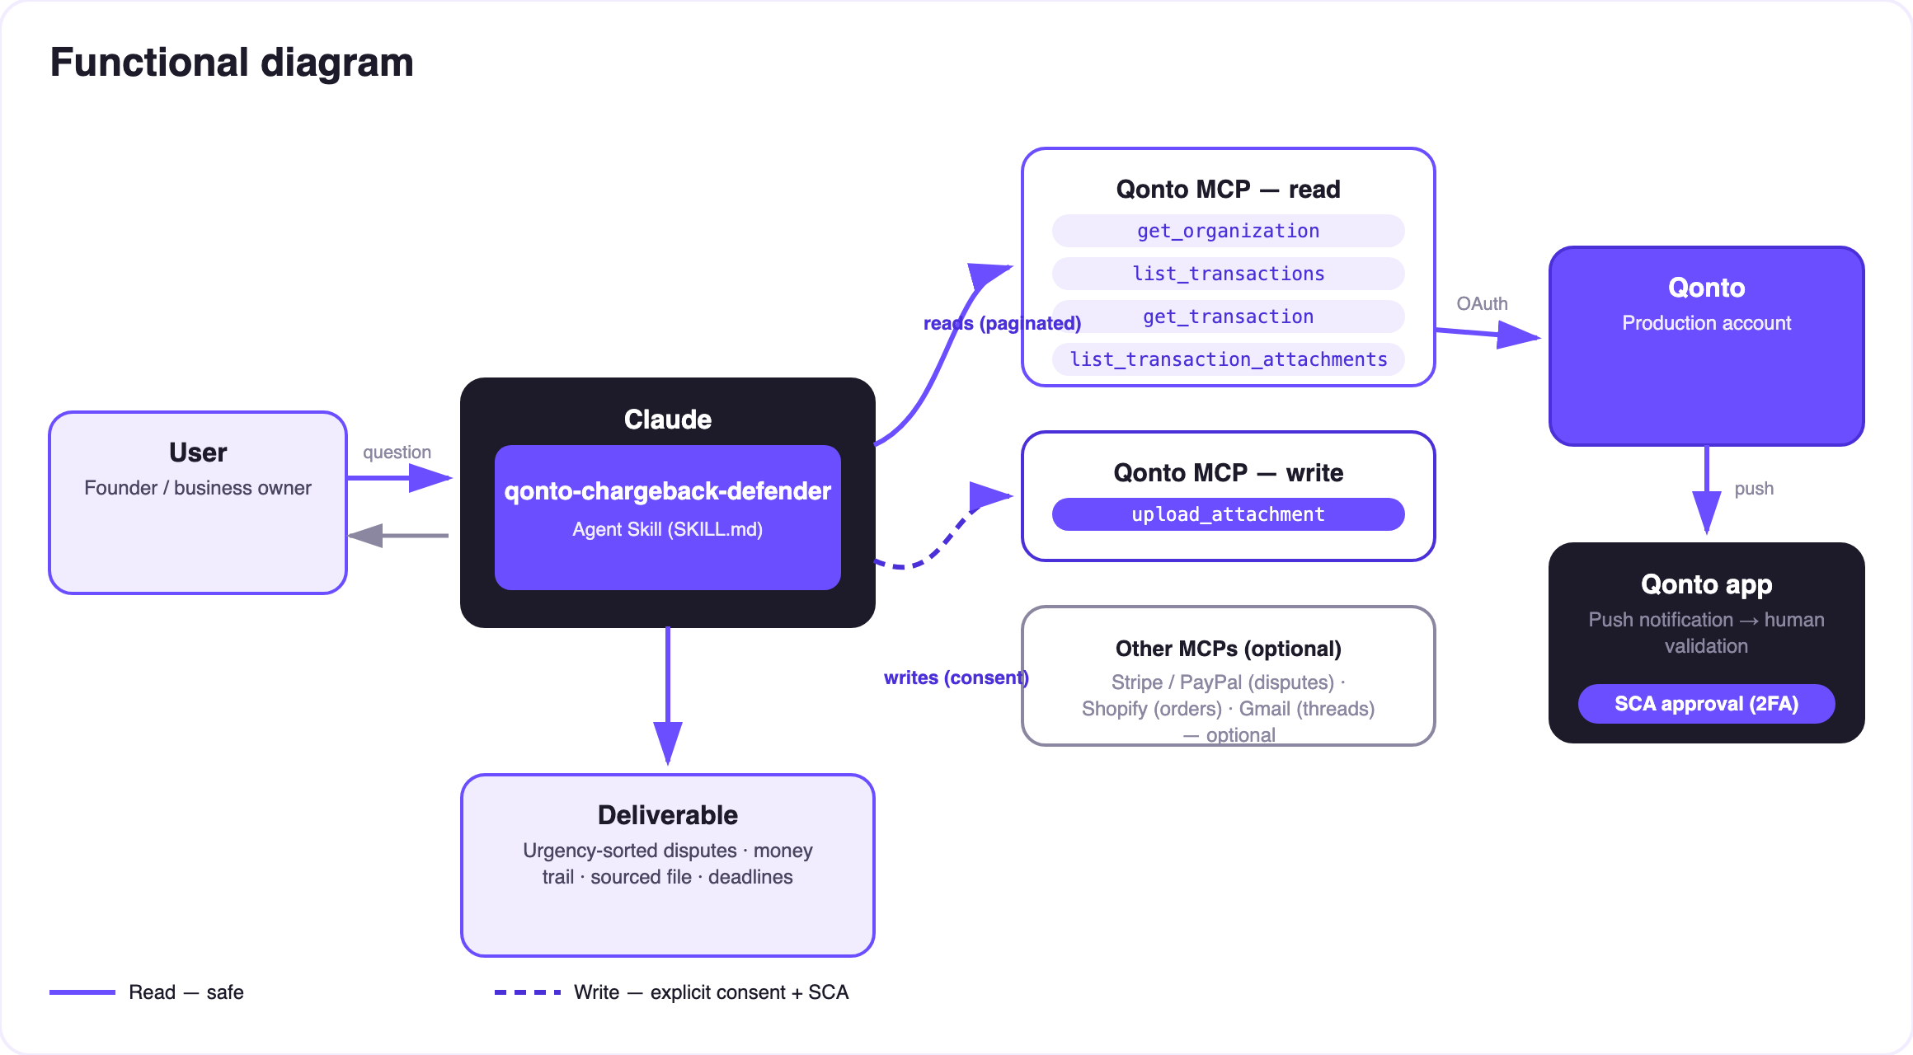
Diagram 2 — Actors and flows: risk-free reads (solid), write behind consent (dashed), human submission on the PSP portal
🔒 The integrity model: the attached memo is a dated synthesis citing the source pieces (system · identifier · date · what each piece proves) — never a fabricated document. And submission stays human: the skill prepares everything, the user submits on the Stripe/PayPal portal. Never presented as filed.
⚖️ Dispute reasons × what wins
Reason code | What wins | Where the skill finds it
Product not received | Proof of delivery / “delivered” tracking | Shopify (fulfillment + tracking)
Fraudulent / unrecognized | Matching billing-shipping addresses, returning customer, order history | Shopify + Stripe (charge details)
Product not as described | Product listing, customer threads, return policy offered | Shopify + Gmail
Duplicate / already refunded | The refund already issued — the strongest possible answer | Qonto (refund transaction) + Stripe
Subscription canceled | Cancellation date vs charge date, terms, threads | Stripe + Gmail

📤 Output formats
Output | Format | When
Conversation reply | Markdown tables: disputes (urgency-sorted), money trail, checklist ✅/⚠️ | Always — the baseline
Defense memo | Dated, sourced synthesis attached to the clawback transaction in Qonto | Per dispute, explicit consent only
Response draft | The argument structured like the PSP's response form, ready to paste | As soon as the reason is known

🎬 Demo video
The ≤ 3-minute demo attached to the PR walks through: the problem (money pulled back + fee + deadline) → detection → a four-piece defense file, assembled and sourced → the memo attached to the transaction → “all that's left is to submit”. (Shooting script kept internal, out of the repo.)
💡 Roadmap ideas
Idea | Effort | Note
Winnability hints per reason code (typical success rates) | Medium | Helps prioritize when several disputes land at once
Post-dispute follow-up: detect the re-credit when won and close the memo | Low | Reuses the detection engine
Deadline reminders through a calendar MCP (detected dynamically) | Low | Optional multi-MCP enrichment, in the spirit of the kickoff
Synergy with qonto-shopify-bridge (order-to-payout reconciliation) | Low | The original debit is already matched
Synergy with qonto-fraud-sentinel (unusual debits as clawback candidates) | Low | Cross-detection

🛡 Guardrails
- NEVER fabricates evidence: the memo is a dated synthesis citing the originals — the distinction is written into the memo
- NEVER says “response submitted” or “dispute won”: submission happens on the Stripe/PayPal portal, by the user
- Deadlines come from the dispute itself; generic windows are always labeled indicative
- Upload only with explicit consent, reported after list_transaction_attachments confirms it
- IBANs masked (last 4 digits) · pagination ≤ 50 · every example amount is invented
qonto-chargeback-defender · English documentation · Qonto × Anthropic MCP Hackathon · July 2026 · PR deliverable: SKILL.md · French version: doc-qonto-chargeback-defender.fr.docx

