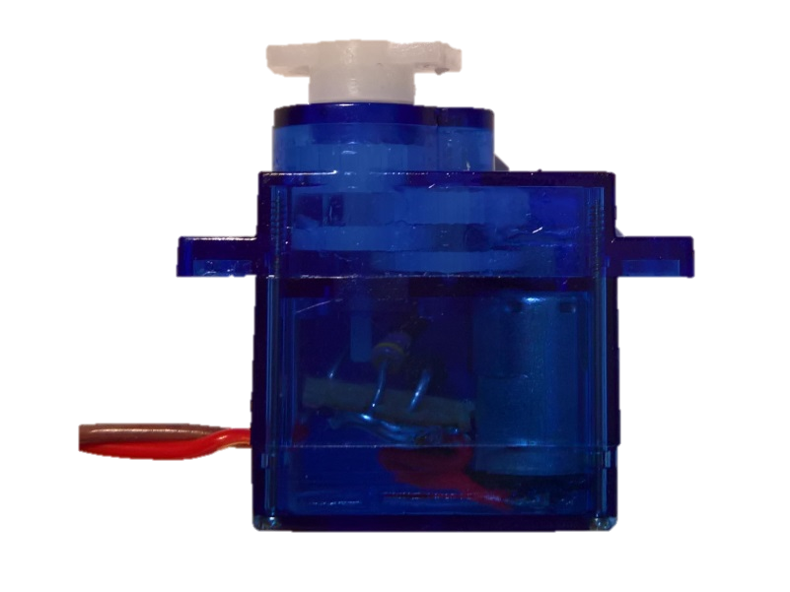

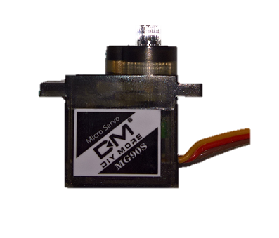

shaft_d

shaft_dist

shaft_h

mount_dist

mount_l

servo_l

servo_h

arm_dist

arm_h

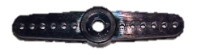

arm_w2

arm_w1

arm_d

arm_l

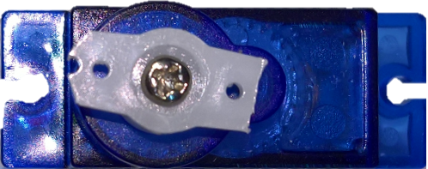

servo_w

hole_dist