Infrastructure risk analyzer: Quick start guide
Contents
About the tool 1
Who is this guide for? 2
Before you begin: Data checklist 3
Understanding the workflow 3
Step-by-step guide 4
Step 1: Upload your infrastructure data 4
Step 2: Select hazard type and scenario 5
Step 3: Set exposure thresholds 9
Step 4: Review exposure results 11
Step 5: Enable vulnerability analysis and upload a damage curve 12
Step 6: Enter replacement costs 15
Step 7: Review vulnerability and damage results 16
Step 8: Export maps and results 18
Use cases 19
Limitations and important caveats 20
Troubleshooting 21

About the tool
The Infrastructure Risk Analyzer is a secure web-based application developed by the World Bank that automates climate and natural‑hazard risk analysis for (digital) infrastructure assets. It is designed to help task teams and clients, infrastructure specialists, and consultants rapidly assess how exposed or vulnerable a portfolio of assets is to hazards such as flooding, tropical cyclone winds, earthquakes, landslides or drought, without requiring specialist GIS skills. This guide walks you through everything you need to get started: from uploading your first dataset to interpreting risk results on the map.
The World Bank does not guarantee the accuracy or completeness of the data and does not assume responsibility for any errors or liability with respect to the use of the information or conclusions set forth. Results are indicative only. Exposure estimates, damage costs, and vulnerability curves are derived from global datasets and climate scenarios that carry inherent uncertainties and may not reflect local conditions. This analysis should be complemented with locally validated data and expert judgment, and should not serve as the sole basis for investment decisions or engineering design.
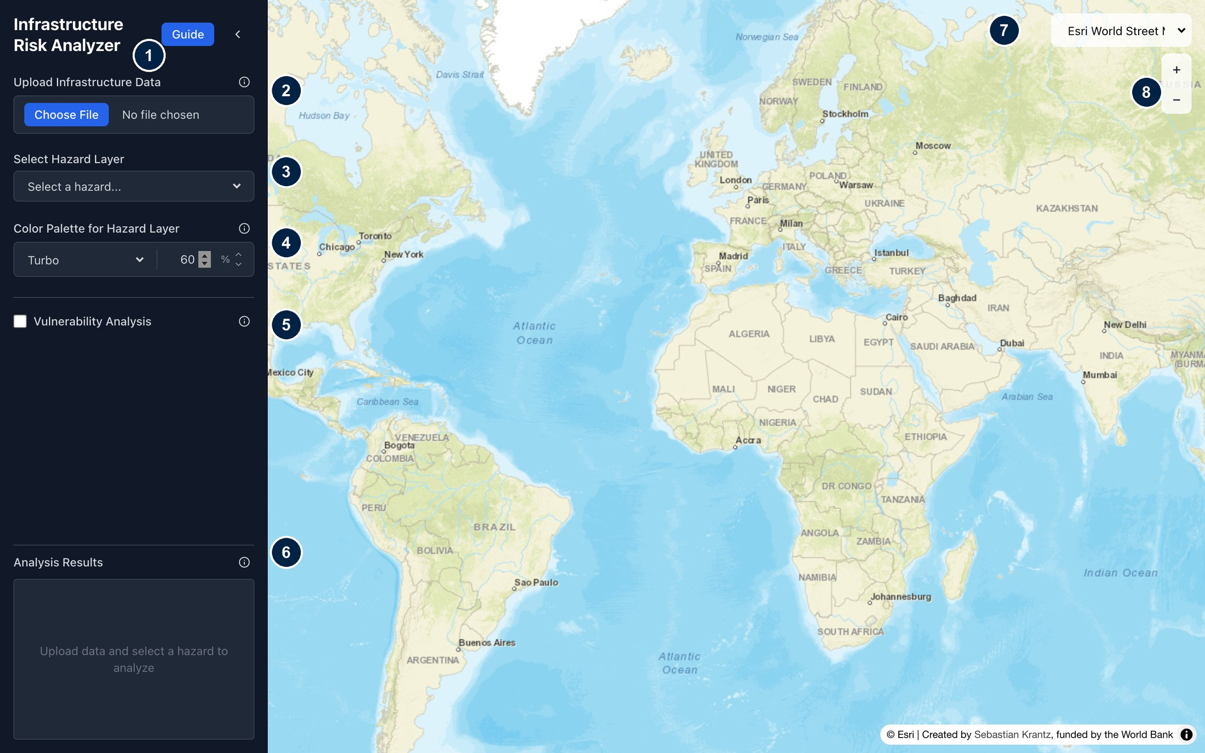
Note: the interface of the online application. (1) Guide opens this guide. (2) Upload your infrastructure data. (3) Select a hazard layer. (4) Color palette and opacity of the hazard layer. (5) Switch on vulnerability analysis. (6) Results chart and export buttons. (7) Basemap selector. (8) Zoom.

The tool supports two types of analysis:
- Exposure Analysis identifies which infrastructure assets are located in areas where hazard intensity reaches or exceeds a threshold you define. This is a binary, spatial assessment: it tells you where assets are at risk, but does not estimate damage ratio or potential costs. It is a useful first-pass screening tool to flag high-risk assets early in project preparation.
- Vulnerability and Damage Assessment goes further by applying damage curves to estimate the economic cost of potential damage and losses. This approach produces asset-specific damage cost estimates that can inform investment prioritization and risk disclosure.

Who is this guide for?
This guide is written for infrastructure practitioners who want to conduct a rapid climate risk screening or more detailed risk analysis. You do not need a GIS background to use the tool, but you should have access to basic location data for your infrastructure assets and a general understanding of the project context and planning horizon. If you are unfamiliar with any of the concepts in this guide (such as damage curves or hazard scenarios), the explanatory notes within each section will help orient you. For complex or high-stakes assessments, consider consulting or engaging a climate risk specialist to review your inputs and interpret results.

Before you begin: Data checklist

Gather the following before opening the tool. Having these ready will make the process significantly faster.
What you need | Where to get it | Required for
Infrastructure asset data (location of assets as points or lines) | Your project team, national utility, or spatial planning agency | Exposure and vulnerability analysis
A clear sense of project design life (e.g., 20 years, 50 years) | Project documentation | Selecting appropriate hazard scenarios
Damage curves for your asset type (CSV format, ideally with lower and upper bounds) | See Step 5 for guidance | Vulnerability analysis only
Replacement cost estimates per unit of asset (e.g., per meter of cable, per tower) | Engineering cost estimates, World Bank unit cost databases, or regional benchmarks | Vulnerability analysis only

Understanding the workflow

The tool follows a logical two-phase workflow. You can complete Phase 1 alone if you only need an exposure screening, or continue into Phase 2 for a full damage assessment.
- Phase 1, Exposure Analysis: Upload your assets → Select hazard and scenario → Set threshold → Review results
- Phase 2, Vulnerability and Damage Assessment: Enable vulnerability mode → Upload damage curve → Enter replacement costs → Review results. The threshold set in Phase 1 still applies: only assets at or above it take damage
Both phases end with a map interface showing results, which can be explored in detail by zooming in and out and by clicking on assets to see their details, as well as an export step for maps, charts and the underlying data.
Help is built in. Every control in the sidebar has an ⓘ icon that opens a short explanation of what it does, and the Guide button at the top of the sidebar opens this guide.

Step-by-step guide

Step 1: Upload your infrastructure data
Click 'Choose File' and select your infrastructure dataset. The maximum file size is 100 MB. Once uploaded, your assets appear as points or lines on the map, the map zooms to them, and the sidebar shows the file name and number of features. Check that they appear in the correct location before proceeding. Files that carry their own coordinate reference system (a shapefile with a .prj file, a GeoPackage or a GeoJSON) are automatically converted to WGS84 (EPSG:4326), the system used by GPS and most online maps. Coordinates in a CSV file must already be longitude and latitude in WGS84. To start again with another dataset, click Clear Data.
Accepted file formats:
Format | Notes
Shapefile (.shp) | Must be uploaded as a ZIP file containing all required components: .shp, .shx, .dbf, and optionally .prj
GeoPackage (.gpkg) | Single-file geospatial format. If the file contains several layers, only the first layer is read, so save the layer you want to analyze in its own file
GeoJSON (.geojson) | Standard open format for geographic data
CSV (.csv) | Comma- or semicolon-delimited file with coordinate columns. Supported column name pairs: lat/lon, lat/lng, latitude/longitude, y/x (case-insensitive); these are read as points. Alternatively, a column named geometry, geom or wkt holding POINT or LINESTRING values in WKT format can be used, which also allows lines

Supported geometries: points (e.g. towers, data centers) and lines (e.g. fiber routes, roads), including multi-part lines. Polygons such as building footprints are converted to their center points, because the hazard layers (about 90 m resolution for flood) are too coarse to resolve most buildings. A file must contain a single geometry type: points and lines cannot be mixed.
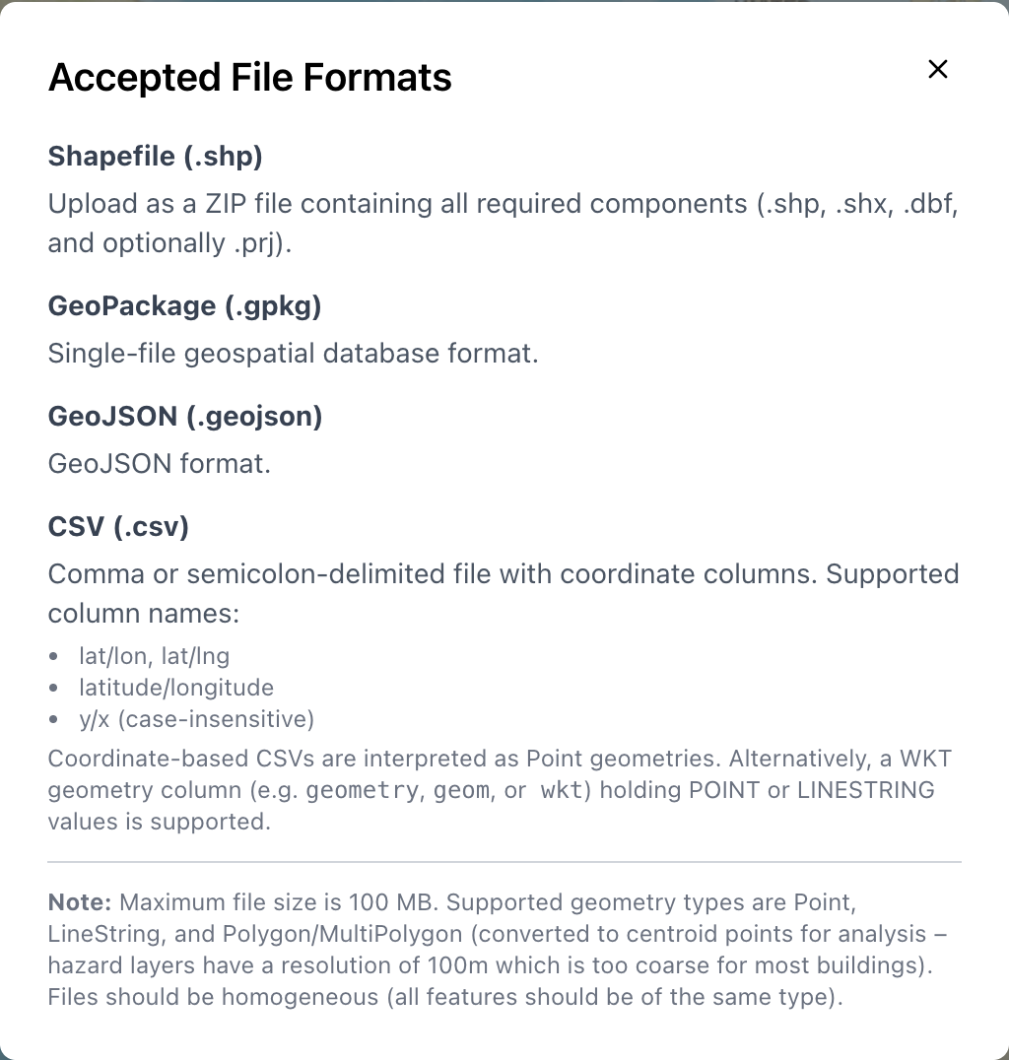
Note: click ⓘ next to Upload Infrastructure Data for the list of accepted formats.

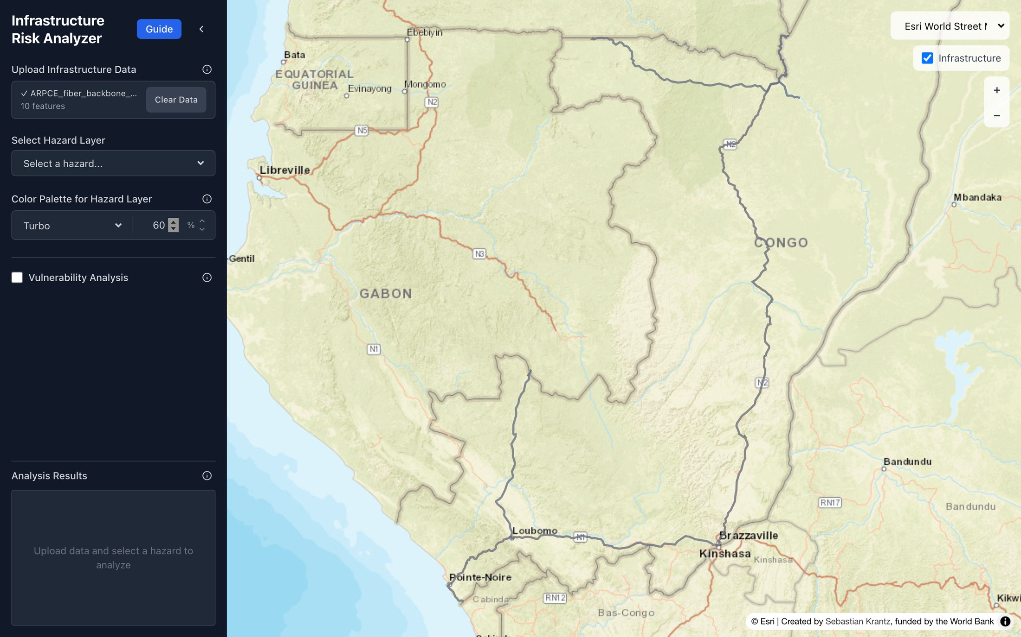
Note: after upload, the map zooms to the dataset (here the existing national fiber backbone of the Republic of Congo) and the sidebar shows the file name and number of features. Please ensure the data is available in the correct format; otherwise, it will not display on the map, and an error message will be generated.

Step 2: Select hazard type and scenario
Select the hazard layer relevant to your analysis from the Select Hazard Layer dropdown. Layers are grouped by hazard, and each entry names the return period and, where available, the climate scenario. The tool offers a range of hazard layers (from https://giri.unepgrid.ch/) and scenarios representing different warming pathways and time periods. The scenario you select should reflect your project's planning horizon and risk appetite. As a general guide:
Project design life | Recommended scenarios to include, e.g. flood
Up to 20 years | Existing climate (baseline) + SSP1 Lower bound, return period: 25-year and 50-year, and 100-year
20–50 years | Existing climate + SSP1 Lower bound + SSP5 Upper bound, return period: 50-year, and 100-year
50 years or more | SSP1 Lower bound + SSP5 Upper bound, return period: 100-year

Always run the tool under at least two scenarios to understand the range of possible risks. A result that shows high exposure under the current baseline requires immediate attention, while exposure that only becomes significant under a high-warming scenario indicates a medium-term risk to monitor.
The tool currently offers 29 layers from the Global Infrastructure Risk Model and Resilience Index (GIRI). Each hazard is measured in its own unit, which the app shows next to the threshold box. Resolution ranges from about 90 m for flood and landslide to about 4 km for drought and 11 km for cyclone wind; the earthquake model is coarser still, so these layers describe regional conditions rather than conditions at a specific site.
Table: Hazard layers available in the tool
Hazard | Layers | Unit | What the value means
Flood | 25-, 50- and 100-year return periods; existing climate, SSP1 lower bound and SSP5 upper bound (9 layers) | mm | Flood water depth (500 mm = 0.5 m)
Tropical cyclone | 25-, 50- and 100-year return periods; existing climate and climate change (6 layers); tropical cyclones only, so zero outside the cyclone belt | km/h | Wind speed (72 km/h = 20 m/s)
Earthquake | 250-, 475- and 975-year return periods (3 layers) | cm/s² | Peak ground acceleration (981 cm/s² = 1 g)
Landslide | Susceptibility to landslides triggered by precipitation (existing climate, lower and upper bound) and by earthquakes (4 layers) | class 1–5 | Susceptibility class from 1 (lowest) to 5 (highest); a ranking, not a physical intensity
Drought | SPI-6 drought hazard, 5-year return period (existing climate, SSP1, SSP5); average duration and number of drought events (5 layers) | index, days, count | Indicators based on the six-month Standardised Precipitation Index; higher values mean more intense, longer or more frequent drought
Socioeconomic | Building Exposure Model (total building value) and population in 2020 (2 layers) | USD, people | Not hazards: use them to find assets in densely built-up or populated areas

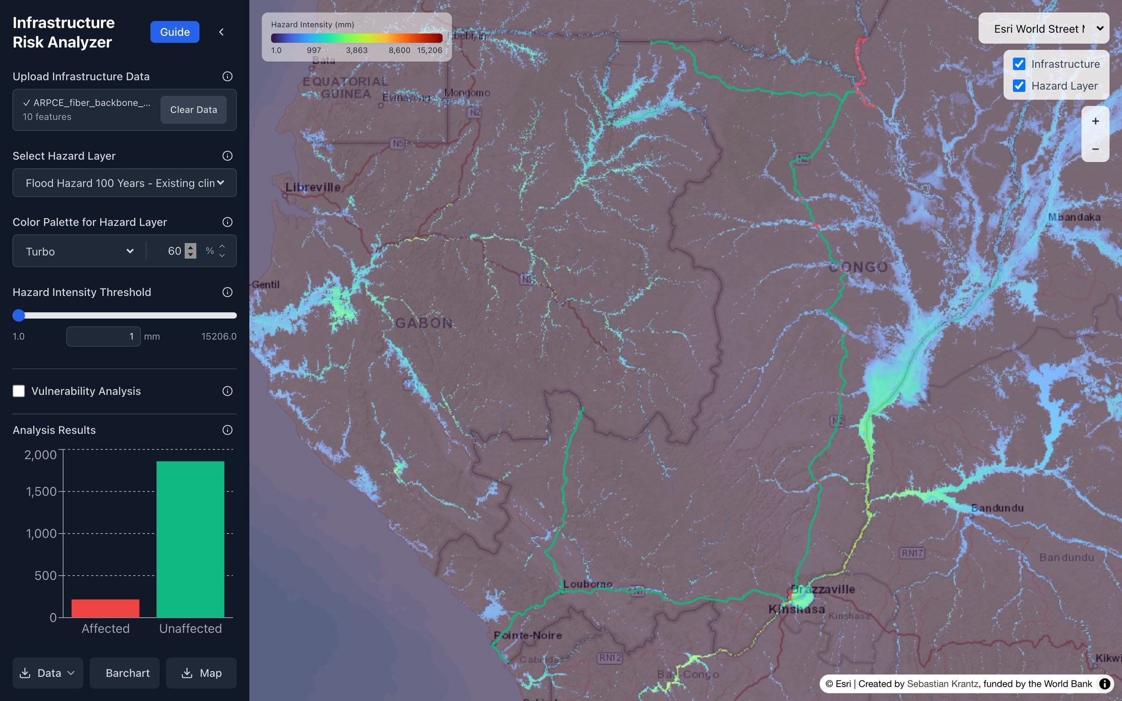
Note: the 100-year flood layer (existing climate) drawn over the backbone, with its color scale in the top-left corner. Change the palette and transparency under Color Palette for Hazard Layer.

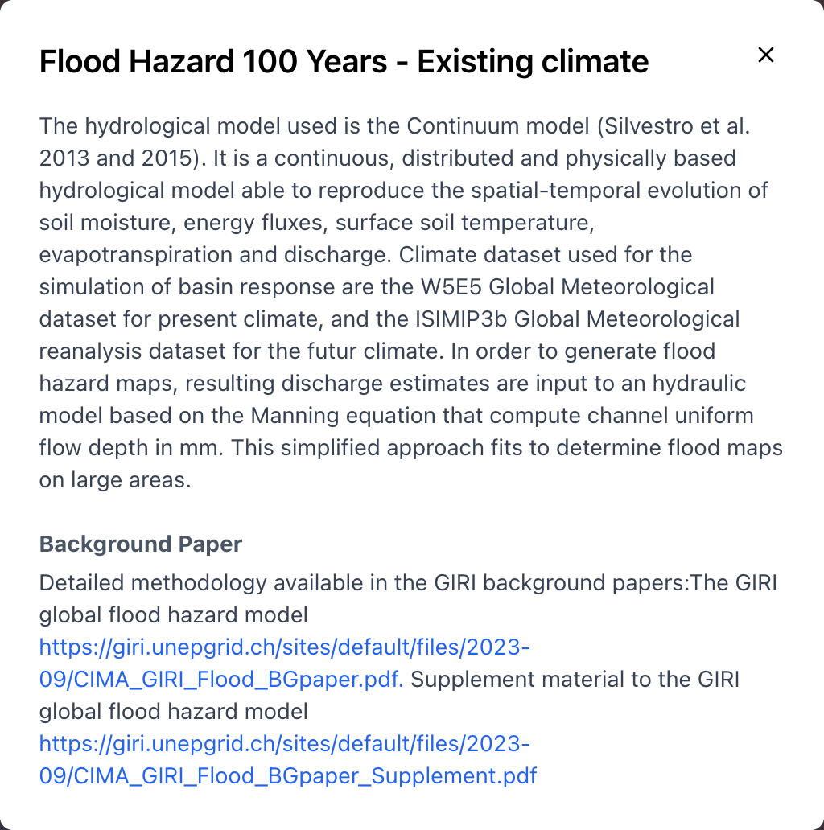
Check what a layer shows before you use it. Click ⓘ next to Select Hazard Layer to read how the selected dataset was produced and to open its background paper.

Table: Hazard terminology
Types of hazards: Hazards can be natural (e.g., floods, earthquakes, droughts, cyclones, landslides) or human-induced (e.g., industrial accidents, pollution, conflict). They are characterized by their location, intensity, frequency, and probability of occurrence. In risk analysis, hazards are typically assessed across multiple severity levels to capture a range of plausible scenarios.

Return Period (Frequency): Represents the average time interval between events of a specific magnitude (e.g., a 100-year flood). A higher-severity event (e.g., a 100-year flood) is rarer (longer return period) and more severe than a lower-severity event (e.g., a 25-year flood). Return period estimation is based on the study of historical data of a specific event.

Note that climate change is altering the frequency and intensity of many hazard types, meaning that return periods derived from historical data may no longer reliably represent future risk. As global temperatures rise, what was once a 100-year flood event is projected to occur far more frequently in many regions, in some cases becoming a 20- or 30-year event by mid-century under high-emission scenarios. In other words, the same physical event becomes more probable, even if its label does not change. This has direct implications for project design: infrastructure or systems dimensioned against historical hazard data may be systematically under-protected against future conditions.

Probability: A 100-year return period means a 1% chance of occurring in any given year, not that it occurs exactly every 100 years. Importantly, this also means there is approximately a 26% chance of at least one such event occurring over a 30-year project lifetime, underscoring why low-probability events still warrant serious consideration in project design.

What the scenarios mean: Each scenario (e.g., 25-year, 50-year, 100-year return period) represents a different combination of likelihood and severity. Lower return period scenarios are more frequent but less intense; higher return period scenarios are rarer but potentially catastrophic. Analyzing multiple scenarios allows project teams to understand the range of possible impacts, identify thresholds at which assets or systems may fail, and design risk mitigation measures that are proportionate to both the probability and the consequence of a hazard event.
Risk analysis typically examines hazards across three climate scenarios:

- Existing climate (baseline): Reflects current climatic conditions, generally derived from observed historical data (typically 1970–2020 or similar reference period). This serves as the baseline against which future change is measured, and is the minimum basis for any hazard assessment.
- Lower-bound scenario, SSP1-2.6: Represents an optimistic future in which global emissions are sharply reduced and warming is limited to approximately 1.5–2°C above pre-industrial levels by 2100. It represents the lower bound of plausible future hazard intensification and is used to assess risk under a relatively favorable, but not guaranteed, trajectory.
- Upper-bound scenario, SSP5-8.5: Represents a high-emission, fossil-fuel-intensive future with warming potentially exceeding 4°C by 2100. This scenario reflects limited climate mitigation action and is used as a stress-test or worst-case bound. While considered an unlikely central estimate, it remains a relevant planning scenario for long-lived infrastructure and projects in highly climate-sensitive contexts, where the consequences of under-preparation would be severe and irreversible.

Step 3: Set exposure thresholds
The threshold is an important judgement you make in the tool. It sets the intensity at which an asset counts as exposed, so it decides the exposure percentage, the length of network or number of assets flagged in red, and, when vulnerability analysis is on, which assets can take damage at all. The tool starts at the minimum of the layer, so every asset the hazard reaches counts as exposed. That is a reasonable first look, but it is rarely the right final setting.

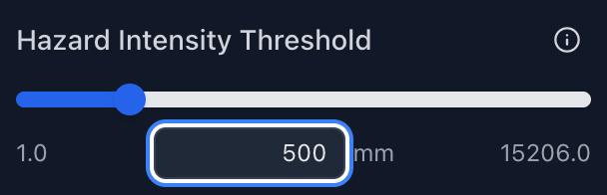

The threshold should represent the hazard intensity at which the asset begins to lose function or take damage. That depends on the asset, not only on the hazard. Two assets in the same flood zone can have very different thresholds, because of how they are built and installed. Use the guidance below to set a threshold from data, from expert judgement, or from both.
Why this matters: The threshold you choose determines what counts as "exposed." Too low a threshold will flag nearly all assets; too high will miss genuine risks. The right threshold depends on the engineering characteristics of your asset type. The threshold also applies when vulnerability analysis is switched on: only assets at or above it take damage (see Step 7).

Worked example: tower with raised base station equipment
The suggested flood threshold of 500 mm for a telecom tower in the table assumes that ground-level equipment and foundations are at risk. Suppose that in your project the base station electronics are mounted on a platform 0.5 m above the ground, and only the foundation is at ground level.
- The electronics are not affected until the water is more than 0.5 m deep. A threshold of 500 mm would flag towers whose electronics would be at risk.
- The foundation and any ground-level components can still be affected by shallow water. If they matter to the service, a lower threshold applies to them.
- A reasonable approach is to run two cases. Case 1 uses no threshold for the foundation and ground-level components, while case 2 uses a threshold at or above the raise height for the electronics. Report both.
- Add a margin. The flood layers have a resolution of about 90 m and do not capture local terrain, so the modelled depth at a tower can differ from the real depth. A threshold slightly above the raise height is more prudent than one exactly at it.

Three ways to set a threshold
- From the damage curve (data-based). If you plan to run a vulnerability analysis, find where your damage curve starts to rise above zero and set the threshold there. A higher threshold removes the lower part of the curve and lowers the total damage cost, so only choose one if you have a reason, such as a protective feature of the asset, and document that reason.
- From the sensitivity of the asset (expert judgement). Identify the most vulnerable component, where it sits, and what intensity it can tolerate. Use engineering specifications, manufacturer data or design standards where available, and consult an engineer or specialist where they are not. Useful questions: Is the sensitive equipment at ground level, raised, or inside a building? Is the asset designed for a specific wind speed, flood level or ground acceleration? Is it buried (more tolerant of shallow flooding) or aerial (more exposed to wind)? Has it been raised, reinforced or anchored?
- By testing several thresholds (sensitivity analysis). If the right value is uncertain, run a low, a central and a high threshold and report the range. If results barely change, the choice matters little. If they change a lot, say so in the report.
Suggested default thresholds by asset type (illustrative, adjust based on engineering specifications):

Asset type | Hazard | Suggested threshold | Rationale
Fiber optic cable (buried) | Flood depth | ≥ 100 mm, or ≥ 500 mm as a second case | Buried cables are generally tolerant of shallow flooding
Telecom tower | Flood depth | ≥ 500 mm | Risk to ground-level equipment and foundations
Fiber optic cable (aerial) | Wind speed | ≥ 72 km/h (20 m/s) | Aerial lines at risk of structural failure above this range
Telecom tower | Wind speed | ≥ 108 km/h (30 m/s) | Standard design load thresholds for lattice towers
Any asset | Landslide susceptibility | Class ≥ 4 | Terrain in the two highest susceptibility classes
Any asset | Earthquake | ≥ 0.1g (100 cm s²) as a screening value; run ≥ 0.2 g (about 196 cm/s²) as a second case

Step 4: Review exposure results
The Analysis Results chart shows how much of your infrastructure is affected (red) and unaffected (green) at your threshold (see Step 3): the number of assets for point data, or kilometers of network for line data. Hover over a bar for the exact value. On the map, affected features are drawn in red and unaffected ones in green. Lines are split into short segments, so only the stretches that cross the hazard turn red. Click a point or segment to see its length, whether it is affected, the maximum and average hazard intensity along it, and the attributes from your file.
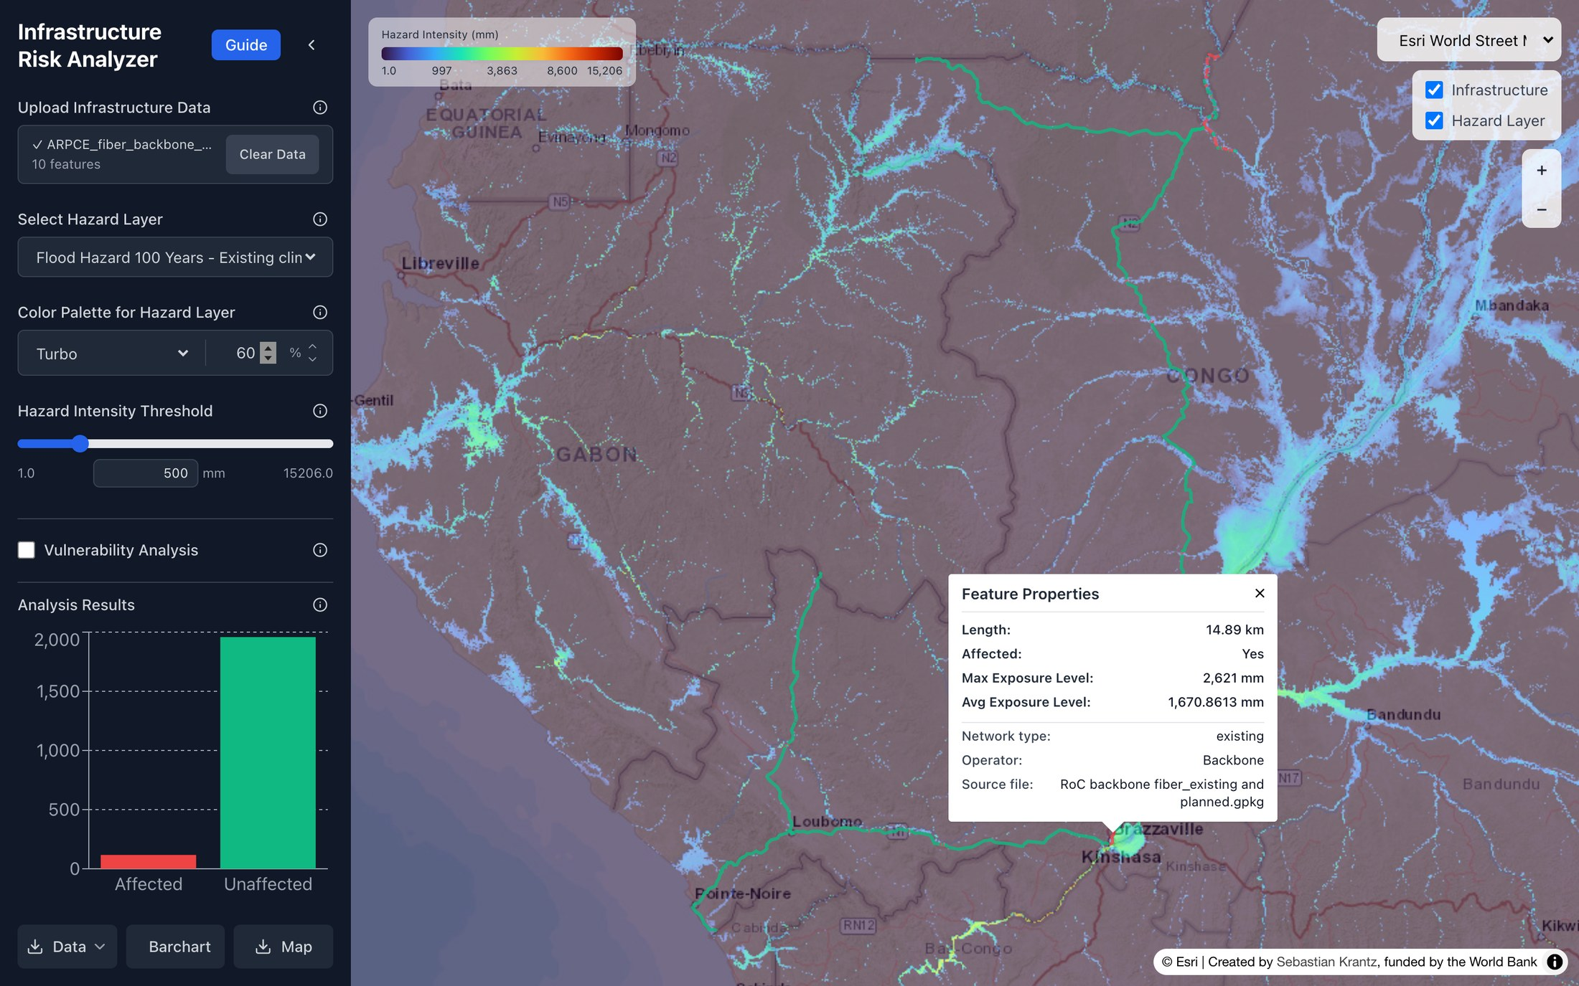
Note: 100-year flood (existing climate) at a 500 mm threshold. The popup shows a 14.9 km segment near Brazzaville with a maximum flood depth of 2.6 m.
Map controls sit in the top-right corner. Choose a basemap (street, topographic, terrain, satellite and others), switch the infrastructure and hazard layers on or off, and zoom in or out; the mouse wheel also zooms. The < arrow at the top of the sidebar hides it to enlarge the map.
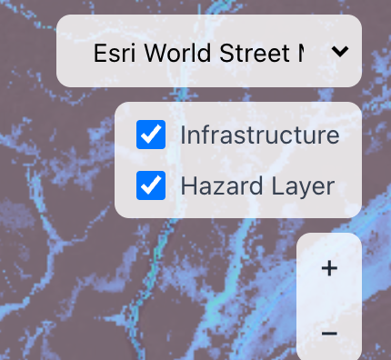
Interpreting your results:
- A significant exposure rate (e.g. >5 percent) under the existing climate suggests that assets face significant risk from present-day hazards, not just future climate change. This may require immediate engineering or siting responses.
- A significant exposure rate only under future high-warming scenarios suggests a medium- to long-term risk that should be tracked and factored into adaptive design or maintenance planning.
- A low exposure rate across all scenarios provides evidence that the asset portfolio is relatively well-located with respect to the hazard in question, though this should always be cross-checked against other hazard types.
Note: Exposure analysis is binary. An asset is either above or below the threshold, the tool does not differentiate between an asset that is just over the threshold and one that is deeply in the hazard zone. Use the vulnerability analysis to capture the magnitude of risk and potential cost.

Step 5: Enable vulnerability analysis and upload a damage curve
To estimate potential economic losses, tick the Vulnerability Analysis box. Two required fields appear: Vulnerability Curve (a CSV file) and Replacement Value (USD, see Step 6). An amber note lists whatever is still missing, and the analysis runs as soon as both are filled in. The threshold slider stays in place, because it still decides which assets are exposed.
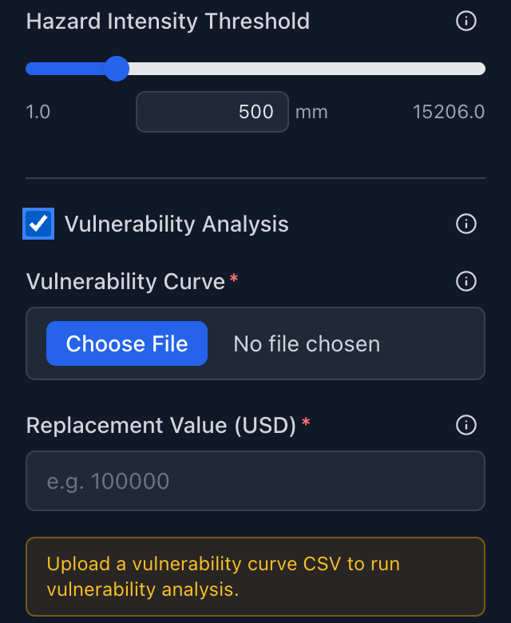 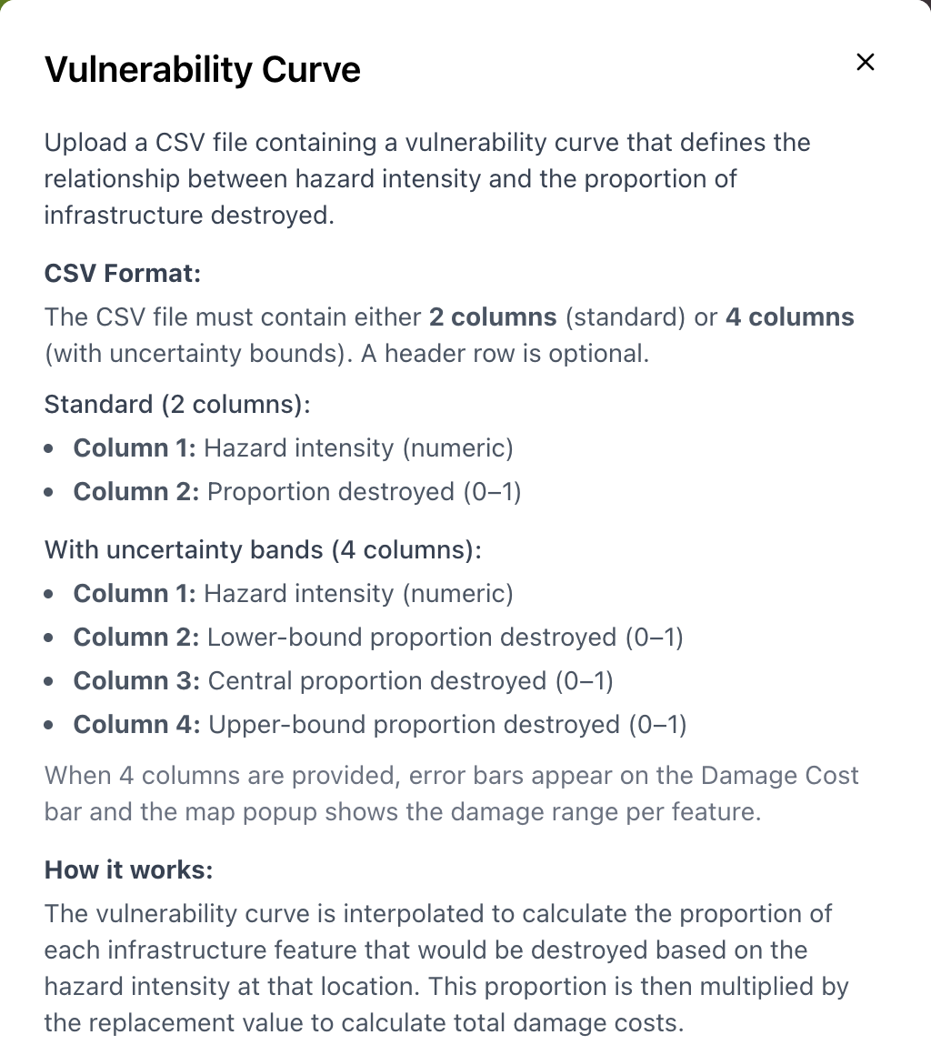
Note: left, the vulnerability inputs; right, the file format, shown by clicking ⓘ next to Vulnerability Curve.

What is a damage curve?
A damage curve (also called a fragility or vulnerability curve) describes the relationship between hazard intensity (e.g., flood depth in millimeters) and the proportion of an asset's value that is damaged (expressed as a ratio from 0 to 1). For example, a damage ratio of 0.3 at 500 mm flood depth means that an asset is expected to lose 30% of its replacement value when inundated to that depth.
File format: a CSV file with two columns (hazard intensity; damage ratio from 0 to 1) or four columns (intensity; lower bound; central estimate; upper bound). With four columns the damage cost bar gets error bars and each map popup shows a damage range. A header row is optional. Between the points of the curve the damage ratio is interpolated linearly; below the first point and above the last point, the first and last values are used. Four columns are recommended: see Uncertainty bounds below this box.
Use the same unit as the hazard layer. The intensity column must be in the unit of the layer you selected, for example millimeters for flood depth. A flood curve given in meters applied to a layer in millimeters puts every flooded asset at the top of the curve.
Where to obtain damage curves:
- The curves supplied with this guide (see Recommended curves below) cover fiber-optic cable and telecom towers for flood, landslide, wind and earthquake, each with lower and upper bounds.
- Navigate to https://github.com/SebKrantz/VulnerabilityCurves, which contains curves from Nirandjan, S. et al: A spatially-explicit harmonized global dataset of critical infrastructure vulnerability curves, Nat. Hazards Earth Syst. Sci., 24, 4341–4369, 2024. DOI: 10.5194/nhess-24-4341-2024. Download the repository by clicking Code → Download ZIP, and use the CSV files in its curves_csv folder.
- The World Bank's GFDRR and affiliated teams have developed standard damage curves for several infrastructure types. Contact your regional DRM or infrastructure specialist. Find useful insights and references here: https://gfdrr.github.io/CCDR-tools/docs/global-vulnerability.html
- The JRC (Joint Research Centre) Global Flood Depth-Damage Functions database provides open-access curves for a range of asset types and regions: https://publications.jrc.ec.europa.eu/repository/handle/JRC105688
- If no standard curve exists for your asset type, a simple linear or piecewise function based on engineering judgment is a reasonable starting point, document the assumption clearly in any outputs you share.
If you do not have a damage curve and cannot obtain one, you can still use the exposure analysis from Phase 1 to support risk disclosure or investment prioritization.
Uncertainty bounds: low and high damage estimates
Damage curves are the largest single source of uncertainty in a damage estimate. Studies of global infrastructure risk find that the choice of curve explains more of the spread in losses than the replacement cost, and curves for the same asset from different sources often differ by a factor of two or more. A single damage figure therefore claims more precision than the analysis has. Upload curves with four columns (intensity; lower; central; upper) and report the range with the central estimate.
How the bounds are set. Where a second published curve exists for the same asset type, use it as the lower or upper bound: the range should never be narrower than the disagreement between published curves. Where none exists, apply a standard band around the central curve: plus or minus 0.15 or 35% of the damage ratio, whichever is larger, kept between 0 and 1, and zero wherever the central curve is zero. For a curve built on judgement, such as the landslide curve below, say that its bounds are judgement too.
Keep the two kinds of bound apart. The low and high estimates express uncertainty about vulnerability: how much damage a given intensity causes. The SSP1 Lower bound and SSP5 Upper bound hazard layers express uncertainty about the climate. Report them separately, for example “USD 4.4 million under the SSP5 100-year flood (range USD 0.05–6.3 million from the damage curves)”, and do not merge them into one range.
Recommended curves for digital infrastructure
The curves below are supplied with this guide as CSV files ready to upload, each with lower and upper bounds. They were prepared for the Republic of Congo assessment and extended to wind and earthquake. Choose the curve that matches the hazard layer and asset, and read its assumptions before reporting results.
Table: Curves with lower and upper bounds supplied with this guide
Hazard | Asset | Curve: central, low and high | Assumptions
Flood | Fiber-optic cable, buried | Central: F12.1, generic telecom curve (Kok et al. 2005)  Low: FEMA F6.2, flooded cable ends (close to zero)  High: standard band | Submergence alone rarely damages buried cable; washouts at crossings, the main failure, are not modelled, so the range is wide
Flood | Telecom tower site | Central: F10.1 (Vanneuville et al. 2006)  Low and high: standard band | Equipment at ground level; raise the threshold where cabinets are elevated (Step 3)
Landslide | Fiber cable and tower sites | Central: class 2 = 0.25, 3 = 0.50, 4 = 0.75, 5 = 1.00  Low and high: standard band | Judgement: damage given that a slope fails at the asset. The expected loss of one rainfall event is far lower, since a landslide hits only 2–10% of susceptible locations
Wind (cyclone) | Telecom tower, lattice or monopole | Central: Reinoso et al. (2020) transmission tower, design wind speed 180 km/h  Low: design 200 km/h  High: design 160 km/h | Proxy, no telecom tower curve is published. Use the curve for your towers’ design wind speed where known
Wind (cyclone) | Fiber-optic cable, aerial | Constructed: damage starts at 110 km/h and reaches half at 230 km/h  Low: 130 and 270 km/h  High: 90 and 200 km/h | Judgement, anchored on tree-fall outages (about 150 km/h) and pole failure (266–283 km/h). Buried cable takes no wind damage
Earthquake | Telecom tower site | Central and low: HAZUS communication facility, anchored (E12.1)  High: unanchored components (E12.2) | Proxy: equipment and shelters fail first; steel towers are governed by wind
Earthquake | Fiber-optic cable, buried | Constructed from the HAZUS repair rate for buried pipelines (ductile), capped at 0.70  Low and high: soil type and repair cost | Ground shaking only; liquefaction, lateral spreading and fault crossings, which cause most damage, are not included
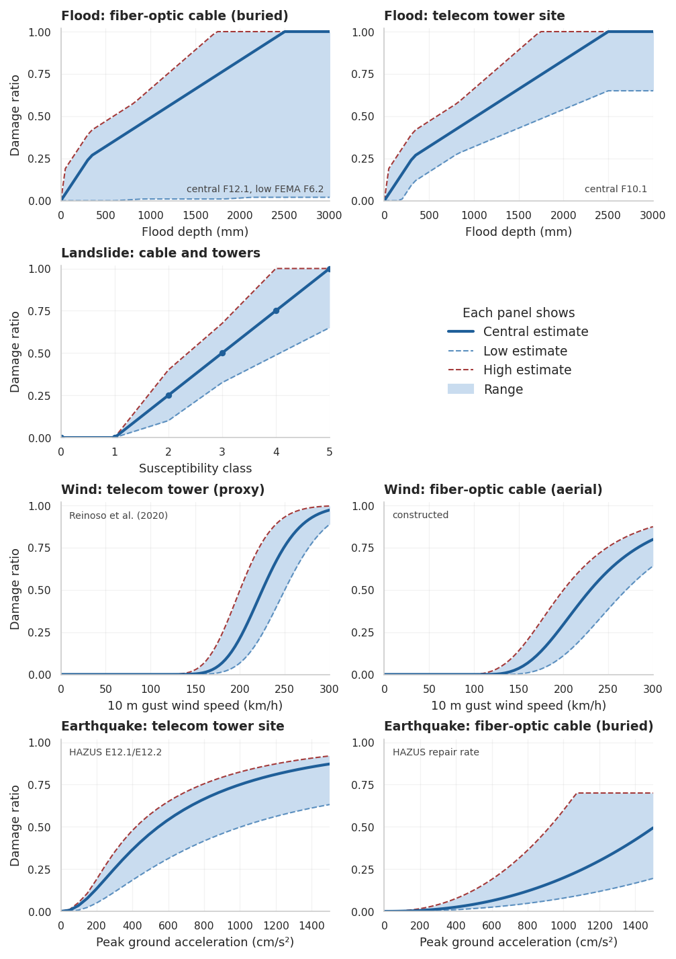
Note: the curves supplied with this guide. Solid line: central estimate; dashed lines: low and high estimates; shading: the range between them. The flood and landslide curves are the ones used in the Republic of Congo assessment.

Step 6: Enter replacement costs
In this step, enter a replacement cost estimate for the type of assets under assessment. This is the estimated cost required to restore an asset to its original condition following damage or destruction. When combined with a damage ratio (see previous step) the replacement cost allows the tool to translate physical risk into economic loss estimates. In simple terms: how much would it cost to fix or replace what the hazard damages?
Replacement cost estimates are inherently approximate. Infrastructure replacement costs vary widely depending on geography, asset type, local labour and materials markets, and engineering specifications. Enter the unit replacement cost for your asset type in USD per unit (per meter for linear assets such as cables or roads; per unit for discrete assets such as towers or substations). Where possible, use project-specific engineering cost estimates. This figure is multiplied by the damage ratio from the curve (and, for lines, by the length of each affected segment in meters) to estimate economic losses per asset. The analysis updates a moment after you stop typing. Results are sensitive to cost assumptions, hence running the analysis with a low and high cost estimate will show you the range of potential losses.
Reference cost ranges (illustrative, verify against project-specific estimates):
Asset type | Approximate unit cost
Fiber optic cable (buried) | USD 20–50 per meter
Fiber optic cable (aerial) | USD 10–25 per meter
Telecom tower (greenfield, monopole/lattice) | USD 70,000–120,000 per tower
Telecom tower (guyed mast, rural) | USD 30,000–60,000 per tower
Telecom tower (roof top, small cell) | USD 10,000–30,000 per tower
Base transceiver station | USD 20,000–80,000 per unit
Network node / aggregation point | USD 100,000–500,000 per unit
Central office / exchange building | USD 2,000,000–10,000,000 per facility
Data center (edge, small) | USD 1,000,000–5,000,000 per facility
Data center (regional, mid-tier) | USD 10,000,000–50,000,000 per facility
Cable landing station | USD 5,000,000–20,000,000 per facility
Note: BTS equipment costs are separated from tower costs since they are often assessed independently, a tower may survive a hazard while the electronic equipment it carries does not, and vice versa. Data center costs vary enormously with tier classification (I–IV), power capacity, and cooling infrastructure. The ranges given reflect facility construction and fit-out rather than IT equipment inside, which depreciates separately. Cable landing stations are included given their strategic importance in coastal and island contexts where they are frequently exposed to cyclone and flood hazard.

Building back better scenarios: Replacement cost estimates in this tool reflect the cost of restoring an asset to its pre-damage condition. In practice, however, recovery is often an opportunity to rebuild to a higher standard, e.g. upgrading materials, relocating assets away from high-hazard zones, or incorporating redundancy and climate-resilient design. These measures typically carry a cost premium over like-for-like restoration, commonly estimated at 15–30% above standard replacement cost depending on the asset type and intervention. If your project or client is evaluating build-back-better scenarios, consider running a parallel analysis using an uplifted cost figure to capture the incremental investment required for resilience. Note that build-back-better costs are highly context-specific and should be grounded in engineering assessments rather than generic uplift factors where possible.

Step 7: Review vulnerability and damage results
With vulnerability analysis on, the chart shows three bars: Damage, the total damage cost in USD (left axis); Exposure, the share of assets or network length at or above the threshold; and D. Ratio, the average damage ratio of the exposed assets, weighted by length for lines (both on the right axis, in percent). The chart covers one hazard layer at a time; select other layers to compare scenarios. On the map, features are colored by damage ratio from green (none) through amber to red (highest), with the scale in the bottom-left corner. Click an asset to see its damage ratio and damage cost.
Only assets at or above the intensity threshold take damage. Most damage curves already assign some damage at low intensities, but anything below the threshold is treated as not exposed and costs nothing. Raising the threshold therefore lowers the total damage cost, while the average damage ratio usually rises, because it is averaged over fewer, more severely exposed assets. To count every asset the hazard reaches, leave the threshold at the layer minimum.
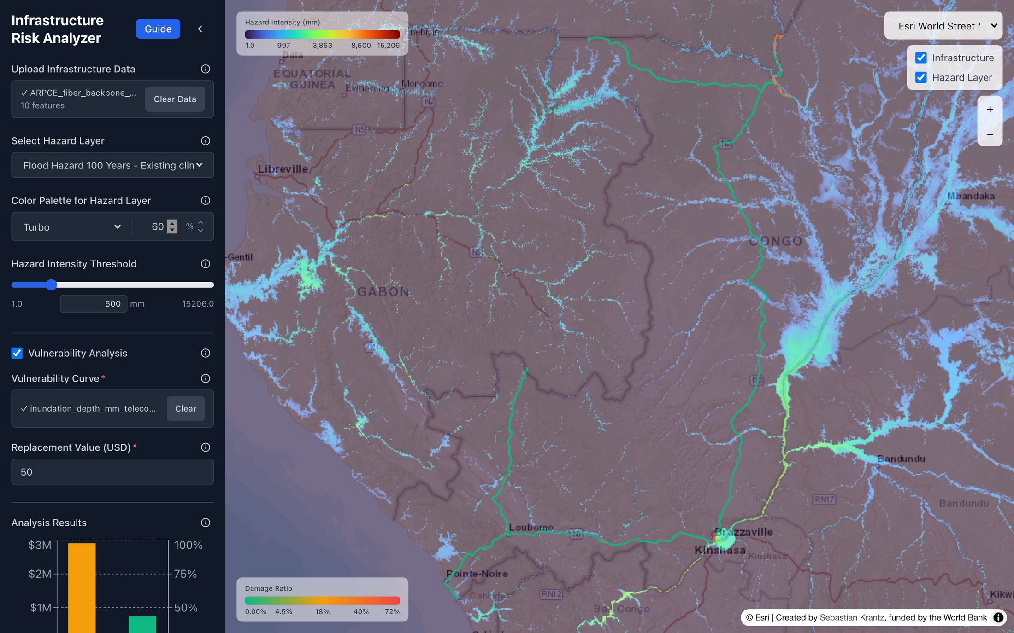
Note: same analysis with vulnerability switched on, using the flood curve F12.1 for communication systems (Nirandjan et al., 2024) and USD 50 per meter.

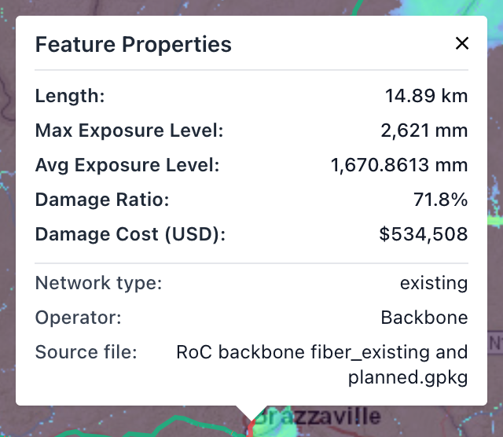
Note: the Brazzaville segment from Step 4 now shows a damage ratio of 71.8% and a damage cost of USD 534,508.

Interpreting your results:
- Review results across hazard scenarios to understand how damage costs change as climate conditions intensify. A large jump between the existing and future climate scenarios indicates that climate change is a major driver of future risk, rather than the asset simply being poorly located today.
- Pay attention to which individual assets drive the highest damage costs. These are priority candidates for design adaptation, relocation, or enhanced protection measures.
- Treat damage cost estimates as order-of-magnitude figures rather than precise valuations. They are derived from generalized damage curves and average cost estimates, and should be interpreted as indicative of relative risk across assets rather than as engineering-grade loss estimates.
- If you used a four-column curve, the damage bar carries an error bar, hovering over it shows the range of the total, and each asset’s popup shows its own range (see below). Report the range with the central estimate, and keep it apart from the SSP1 Lower bound and SSP5 Upper bound scenarios (Step 5).
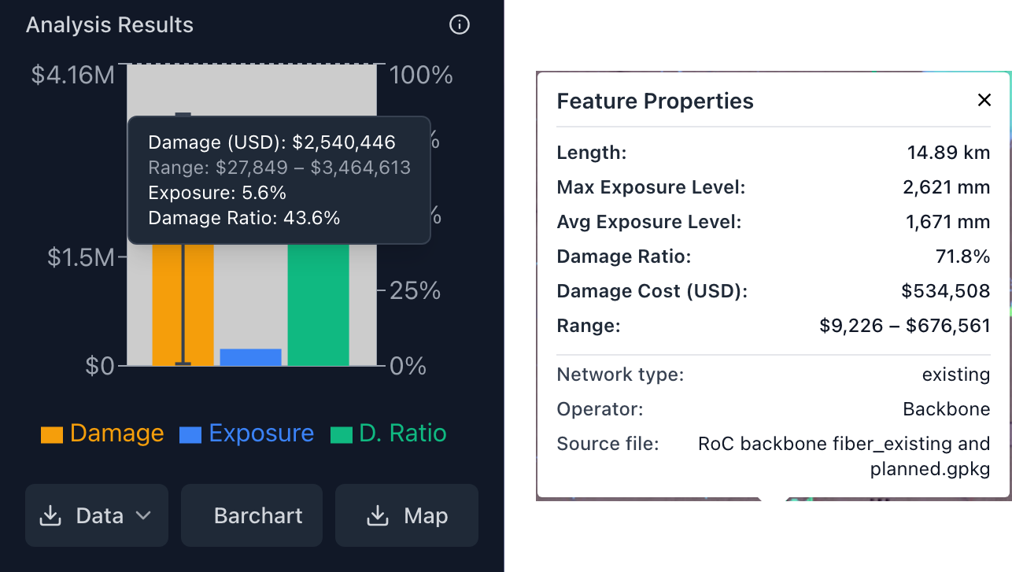
Note: the analysis above repeated with the four-column version of curve F12.1 supplied with this guide. Hovering over the damage bar shows the range of the total damage cost, USD 27,849 to 3,464,613 around a central USD 2,540,446 (left); the popup for the Brazzaville segment shows its own range (right).

Step 8: Export output from the analysis
Use the three buttons below the chart to download results: Data, Barchart and Map. Outputs can be used directly in technical reports, climate risk screenings, or project presentations. Exports use the hazard layer and threshold currently selected.
- Map: a high-resolution PNG of your assets over the hazard layer and the selected basemap, with color legends. The hazard is drawn at full opacity.
- Barchart: a PNG of the current chart, labelled with exact values.
- Data: for points, a CSV with coordinates, your attributes, the hazard intensity and, with vulnerability analysis, the damage ratio and damage cost (plus lower and upper bounds with a four-column curve). For lines, the button opens a menu: CSV (aggregate) gives one row per line with length-weighted intensity and damage ratio and the total damage cost; GPKG (split) gives the individual segments with their hazard intensity and damage, ready for GIS.
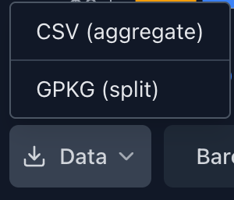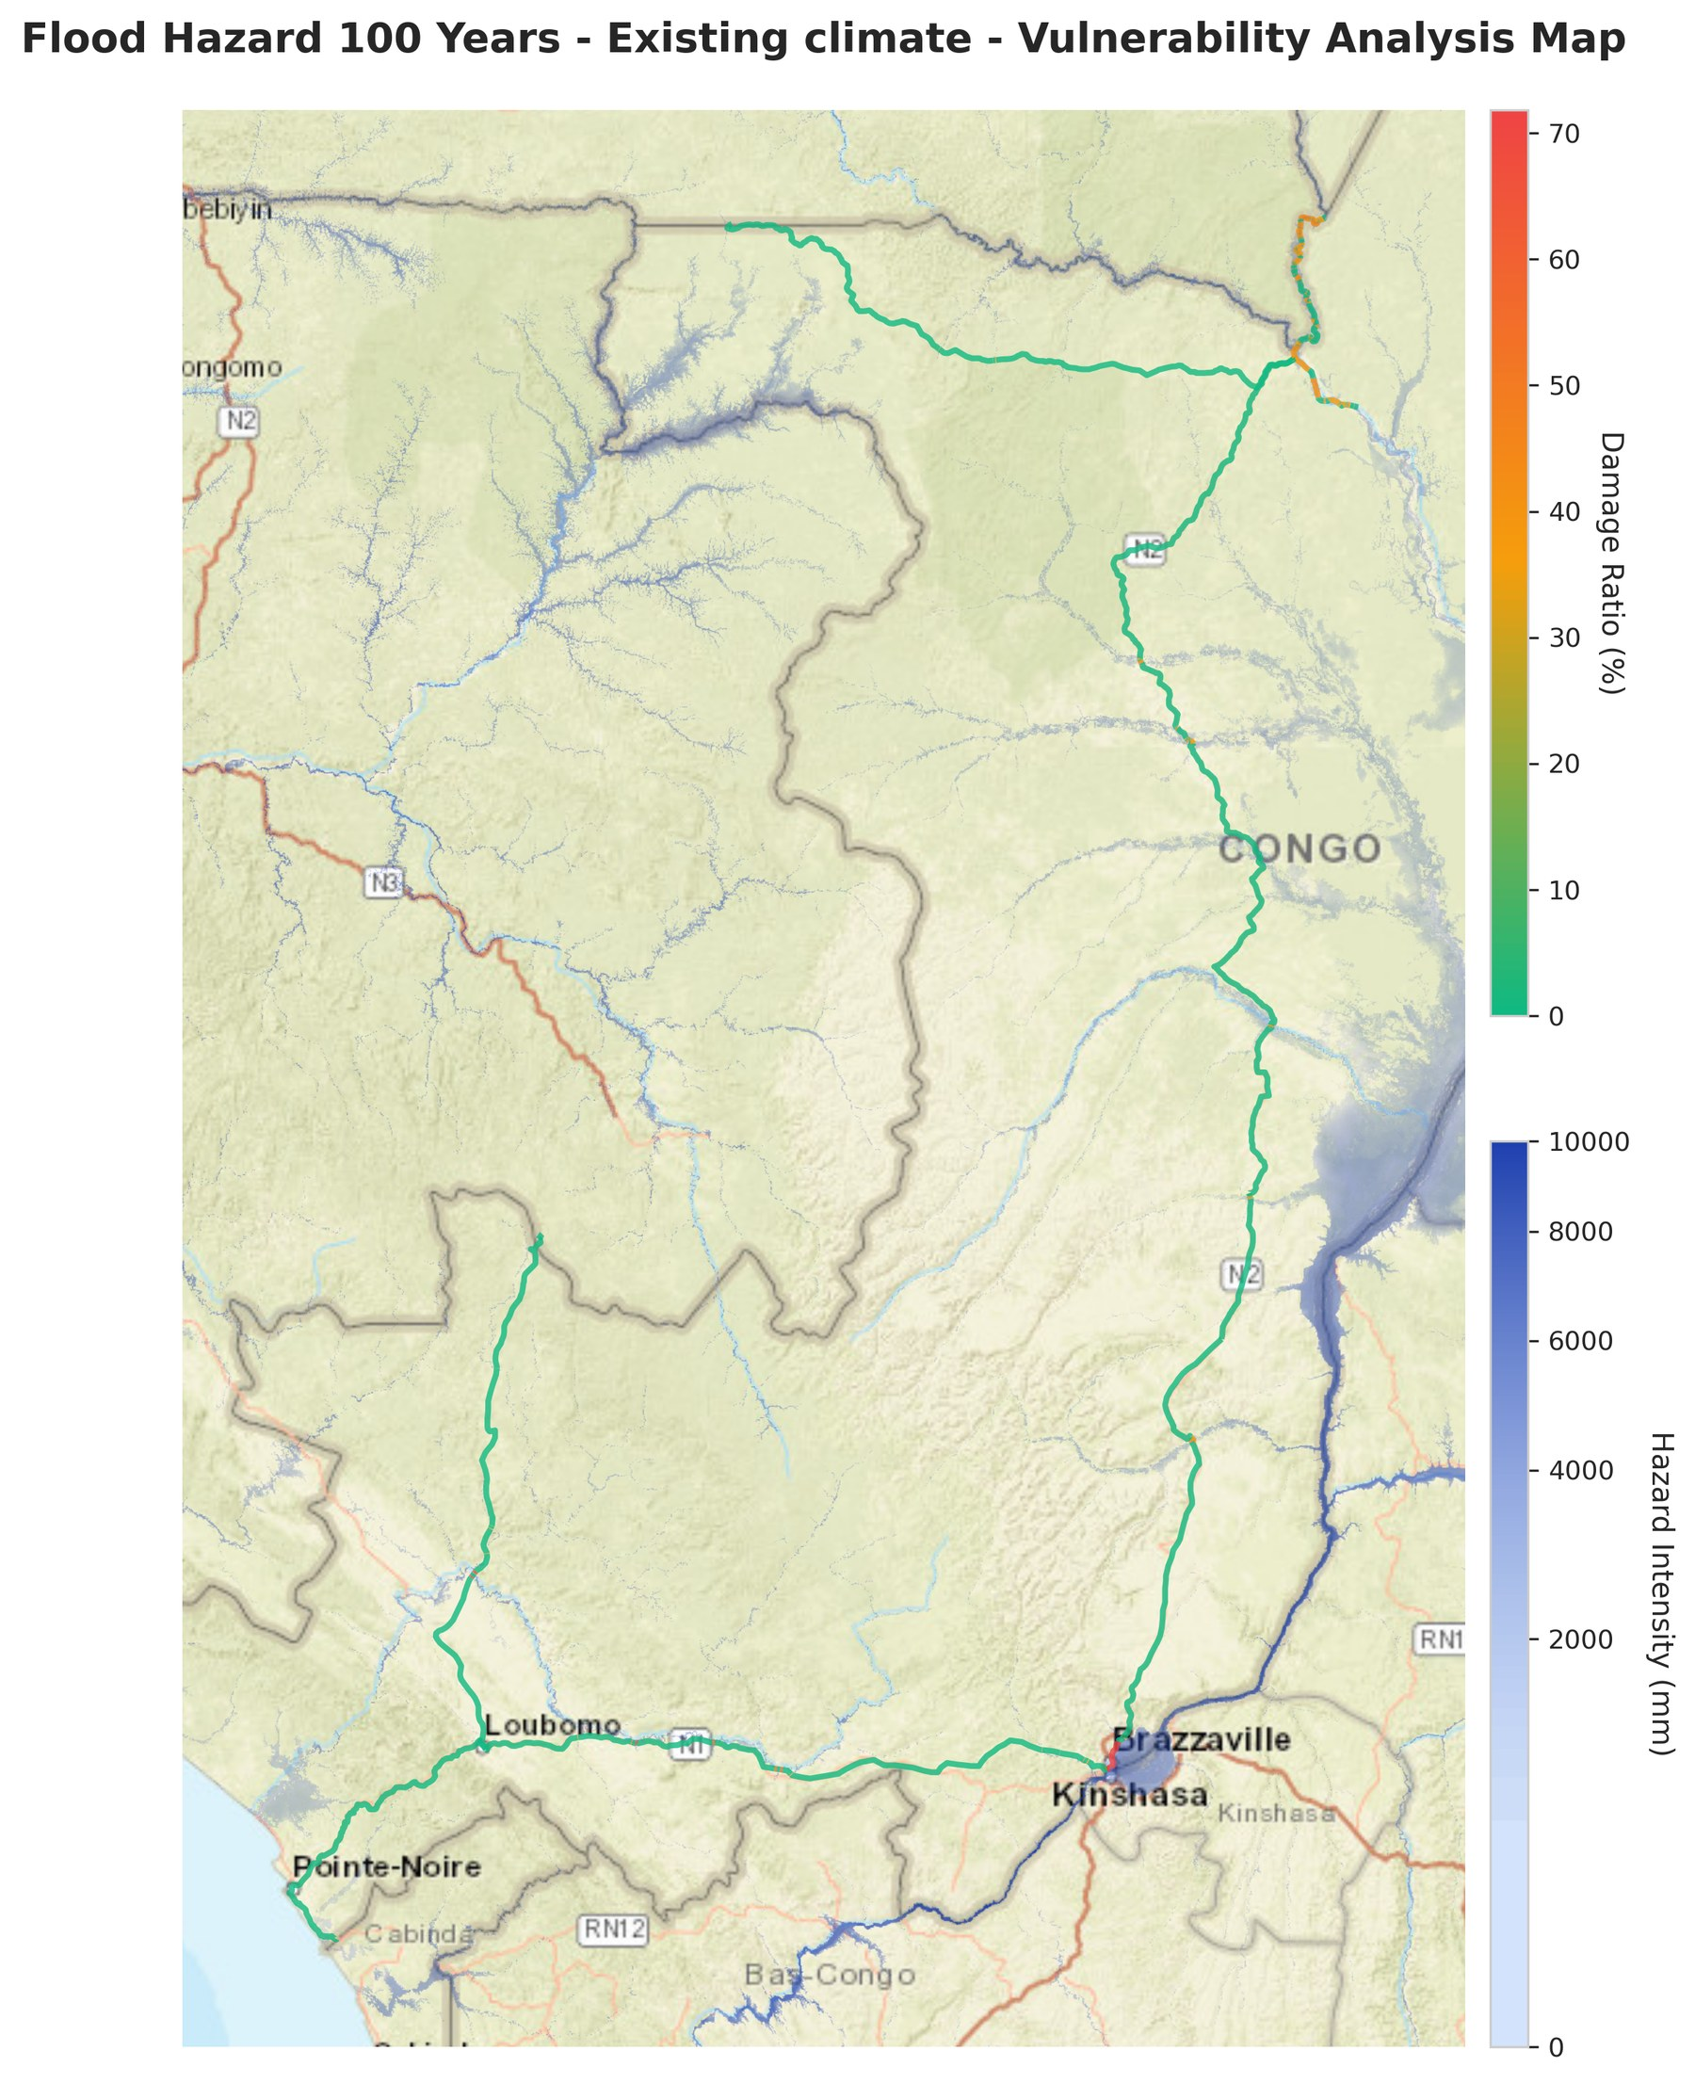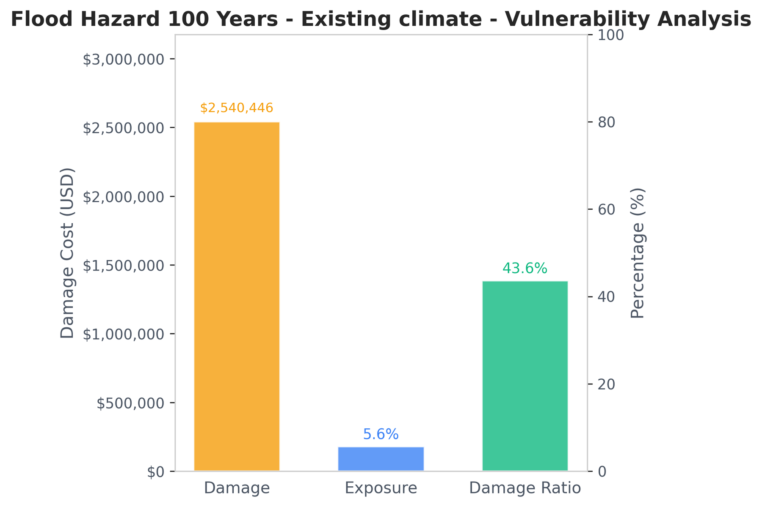
Note: exported data (left) map (middle) and bar chart (right) for the analysis above.

Tips for using outputs in project documents:
- Always document the hazard scenarios, thresholds, damage curves, and cost assumptions used in your analysis so that results can be interpreted and reproduced.
- Label exported maps clearly with the hazard type, scenario, and threshold.
- Where results are presented to non-technical audiences, accompany bar charts with a brief narrative explaining what the exposure or damage percentages mean for the project.

Use cases
The following examples illustrate how the tool can support different stages of the project cycle.
Pre-feasibility screening for infrastructure projects: A project task team preparing a digital connectivity project can use the exposure analysis to screen proposed tower and fiber route locations against flood and cyclone hazard layers before commissioning detailed engineering studies. Early identification of high-risk sites allows the team to explore alternative routings or designs at low cost, before significant resources are committed.
Climate risk disclosure in project documents: The tool supports a rapid, documented screening that produces exportable maps and charts suitable for inclusion in project documents, Environmental and Social Assessments, or climate risk annexes. The structured workflow also helps teams demonstrate that a systematic assessment was conducted.
Investment prioritization for rehabilitation portfolios: For a digital infrastructure project with a portfolio of existing assets, the vulnerability-based damage assessment can help prioritize which assets to rehabilitate first, based on expected economic losses under current and future climate conditions, rather than relying solely on engineering condition surveys or ad hoc judgment.
Adaptive design for long-lived infrastructure: A task team designing a coastal or riverine infrastructure asset (such as a backbone fiber route) with a design life of 30–50 years can run the tool under multiple climate scenarios to understand how risk evolves over time. This can inform decisions about incorporating climate-adaptive design features, increasing engineering tolerances, or phasing investments.
Scenario comparison for climate-informed siting decisions: When a project involves choosing between two or more candidate sites, the tool can generate comparable exposure and damage estimates for each, providing a structured, evidence-based input into siting decisions that goes beyond engineering and cost criteria alone.
Support to post-disaster rapid assessments: Following a major weather event, the tool can be used to rapidly estimate which assets in an affected area were likely exposed above damage thresholds, based on pre-existing hazard data. This can help prioritize field assessment missions and support early loss estimation before teams are deployed.

Limitations and important caveats
Users should be aware of the following limitations when interpreting and communicating results.
- Exposure analysis is binary. The tool classifies each asset, or line segment, as above or below the threshold. The popups report the maximum and average intensity, but the exposure statistics do not reflect how far above the threshold an asset lies.
- Damage estimates are indicative, not precise. Results are sensitive to the choice of damage curve and replacement cost assumptions. They should be treated as relative risk indicators rather than engineering-grade loss estimates. Use curves with lower and upper bounds and report the range (Step 5).
- Hazard data quality varies by region. Global hazard datasets perform better in some geographies than others. In data-sparse regions, results should be interpreted with particular caution and ideally validated against local knowledge or higher-resolution data.
- The tool does not capture all dimensions of risk. It does not assess cascading failures, service disruption costs, or social impacts. It should be used as one input among several in a broader climate risk assessment.
- Damage curves are asset-type-specific. Using a damage curve calibrated for a different asset type or region can produce misleading results. Document your sources clearly.
- Wind and earthquake layers have narrow coverage. The wind layers describe tropical cyclones only, so they are zero outside the cyclone belt, including most of Central Africa, and say nothing about other windstorms. The earthquake layers describe regional ground shaking at coarse resolution; buried cable is damaged mainly by ground failure (liquefaction, landslides, fault crossings), which they do not capture.
- One hazard at a time. Each run uses a single hazard layer and return period. The tool does not combine hazards or compute expected annual damage across return periods; run the layers separately and combine the results outside the tool if needed.
- Landslide and drought layers are indicators. They give a susceptibility class or index values, durations and counts rather than the physical intensity that standard damage curves use. Exposure screening with these layers is meaningful, but damage estimates need a curve built for that indicator and should be treated with particular caution. The landslide curve supplied with this guide gives the damage when a slope fails at the asset, not the expected loss of one rainfall event.
- Uploaded data is not stored permanently. Files are held in the server's working memory and removed when you click Clear Data or when the application restarts, after which you need to upload them again.

Troubleshooting
Common problems and how to solve them.
What you see | What to do
"Upload failed" or another error after choosing a file | Check that the file is in an accepted format and contains only points or only lines; zip all parts of a shapefile together. If a valid GeoPackage still fails, the security filter of the hosting network may be blocking it, since a GeoPackage is a small database whose contents can resemble database commands. Save the layer as GeoJSON or as a zipped shapefile and upload that instead
Only part of a GeoPackage appears | Only the first layer of a multi-layer GeoPackage is read. Save the layer you need in its own file
No hazard appears on the map after selecting a layer | Layers are streamed from a remote server and can take a few seconds to load, especially when zoomed out. Check that Hazard Layer is ticked in the map controls and that the opacity is above 0%
No vulnerability results appear | Read the amber note under the inputs: a curve and a replacement value above zero are both required
Damage cost is zero or unexpectedly low | The threshold may be above the intensities at your assets, so lower it. Also check that the curve uses the same unit as the layer
No error bars on the damage bar | The curve has two columns. Upload a four-column curve (intensity; lower; central; upper) to get a damage range
Every exposed asset shows the maximum damage ratio | The curve is probably in a different unit from the layer, for example meters against a layer in millimeters
Your dataset has disappeared | The application was restarted, which clears uploaded data. Upload the file again

