Supervisor Workflow Guide
MES Head · Technical Services · Odoo 18
Last updated: April 22, 2026 · techservices database · localhost:8069

About This Guide
This document walks the MES Head (Supervisor role) through the complete end-to-end workflow for a new client service request. Screenshots are taken from a live Odoo 18 instance.
- Login: meshead@chem.ubc.ca
- Role permissions: Supervisor inherits Technician rights, plus Sales, Timesheet Approver, and Account Invoicing access.
- Worktag validation: A Manager must validate a worktag before an invoice can be posted.
⚠️ | Permissions note: Settings, product creation, and worktag validation are restricted to the Manager role. The Supervisor creates and manages orders; the Manager approves worktags and posts invoices.

Workflow at a Glance
# | Action | Location | Key Field / Button
1 | Login as MES Head | /odoo/login | Email: meshead@chem.ubc.ca
2 | Open CRM Pipeline | CRM → Pipeline | Main menu grid
3 | Create Opportunity | CRM → New (list view) | Opportunity title
4 | Add Contact & Internal Notes | Opportunity form | Contact → Create and edit… / Internal Notes tab
5 | Create Quotation | Opportunity → New Quotation | New Quotation button
6 | Set Service Type | Quotation form | Service Type dropdown (required)
7 | Select Worktag | Quotation form | Worktag field (auto-fills Speedchart)
8 | Add Labor Product | Order Lines tab | Add a product → one of 4 labor products
9 | Confirm → Sales Order | Quotation form | Confirm button
10 | Open Repair Order | Sales Order → Repairs button | Repairs N smart button
11 | Assign to Technician | Repair Order form | Responsible field
12 | Create Invoice Draft | Sales Order → Create Invoice | Create Invoice → Create Draft

1 | Log In as MES Head  Navigate to Odoo and authenticate with the Supervisor account.

How To
- Go to http://localhost:8069 and select the techservices database.
- Enter email meshead@chem.ubc.ca and the assigned password, then click Log In.
- The app opens at Discuss → Inbox. The top-right corner shows MES confirming the correct account.
ℹ️ | The Supervisor role grants access to CRM, Sales, Repairs, Timesheets, and Invoicing. Settings and inventory product creation are restricted to the Manager role.

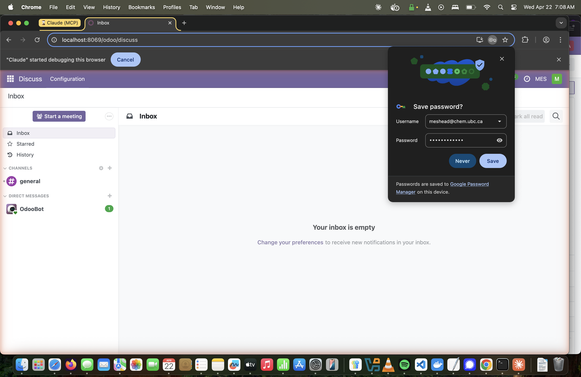
Step 1 — Logged in as MES Head. Discuss inbox confirms correct session.

2 | Open the CRM Pipeline  Navigate to CRM to view and manage service opportunities.

How To
- Click the main menu grid (top-left) and open CRM, or navigate to /odoo/crm.
- The Kanban pipeline shows stages: New, Needs information or actions, and Won.
- The default filter is My Pipeline — showing only your assigned opportunities.
💡 | Tip: Switch to List view (icon top-right) for a faster overview when managing many opportunities at once.

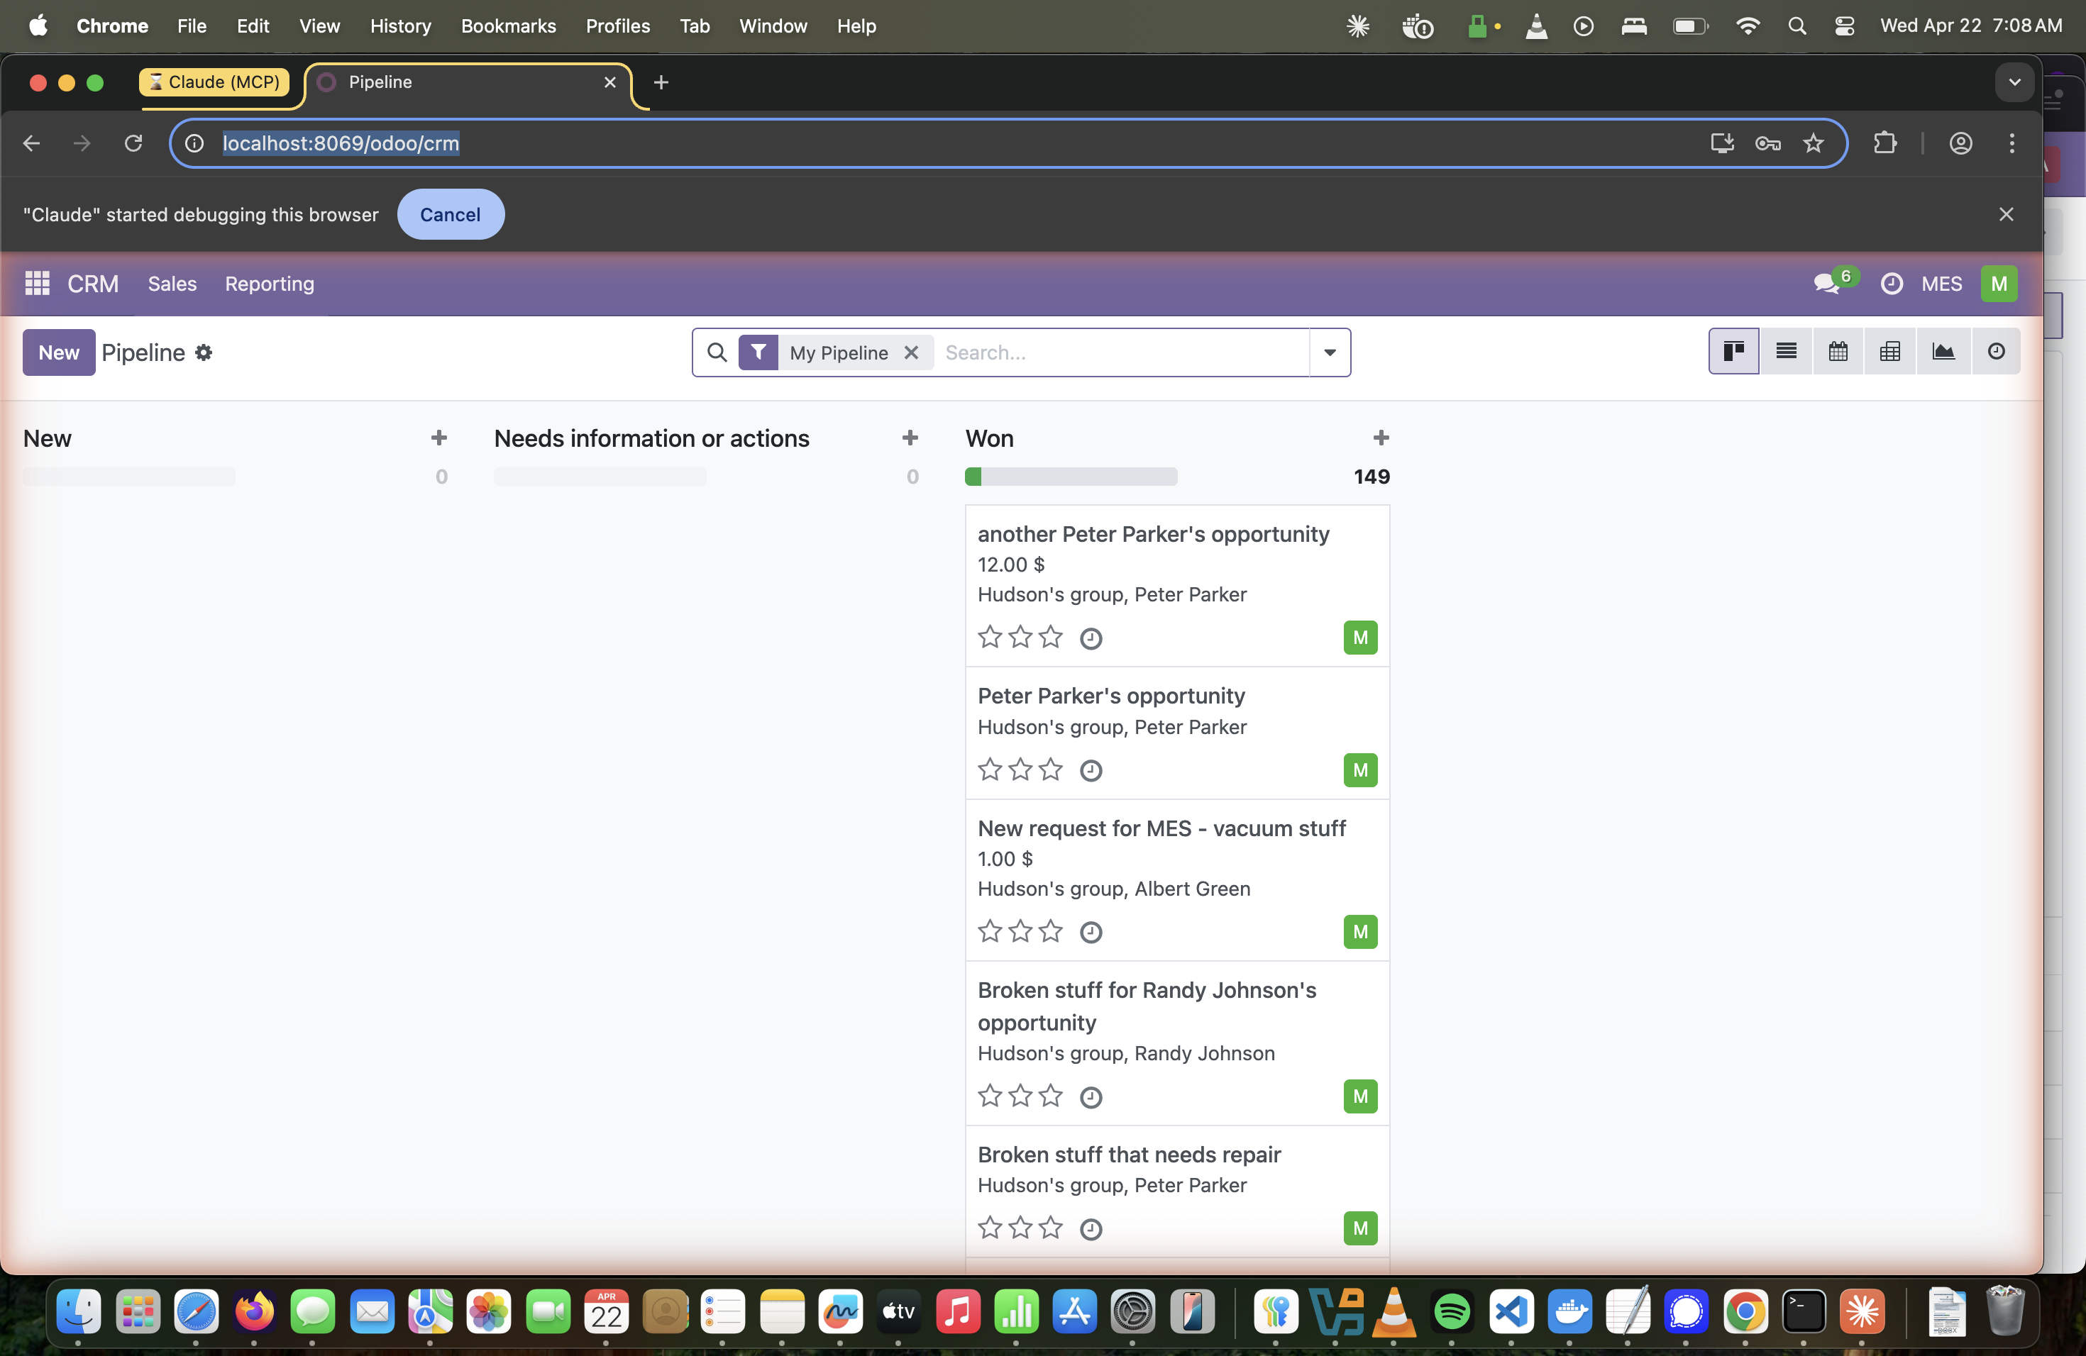
Step 2 — CRM Pipeline in Kanban view showing current opportunities.

3 | Create a New Opportunity, Add Contact & Internal Notes  Open the full form, create a new client contact, and record intake details.

New Opportunity
- Switch to List view and click New (top-left) to open the full opportunity form.
- Enter a descriptive title (e.g. “Instrument Calibration & Repair Request”).
- The Salesperson is auto-set to MES Head.

Add a New Contact
- Click the Contact field and type the new client's name.
- Select Create and edit… from the dropdown to open the contact dialog.
- Select Individual, fill in Name, Phone, and Email, then click Save & Close.
- The contact's email and phone populate back on the opportunity form.
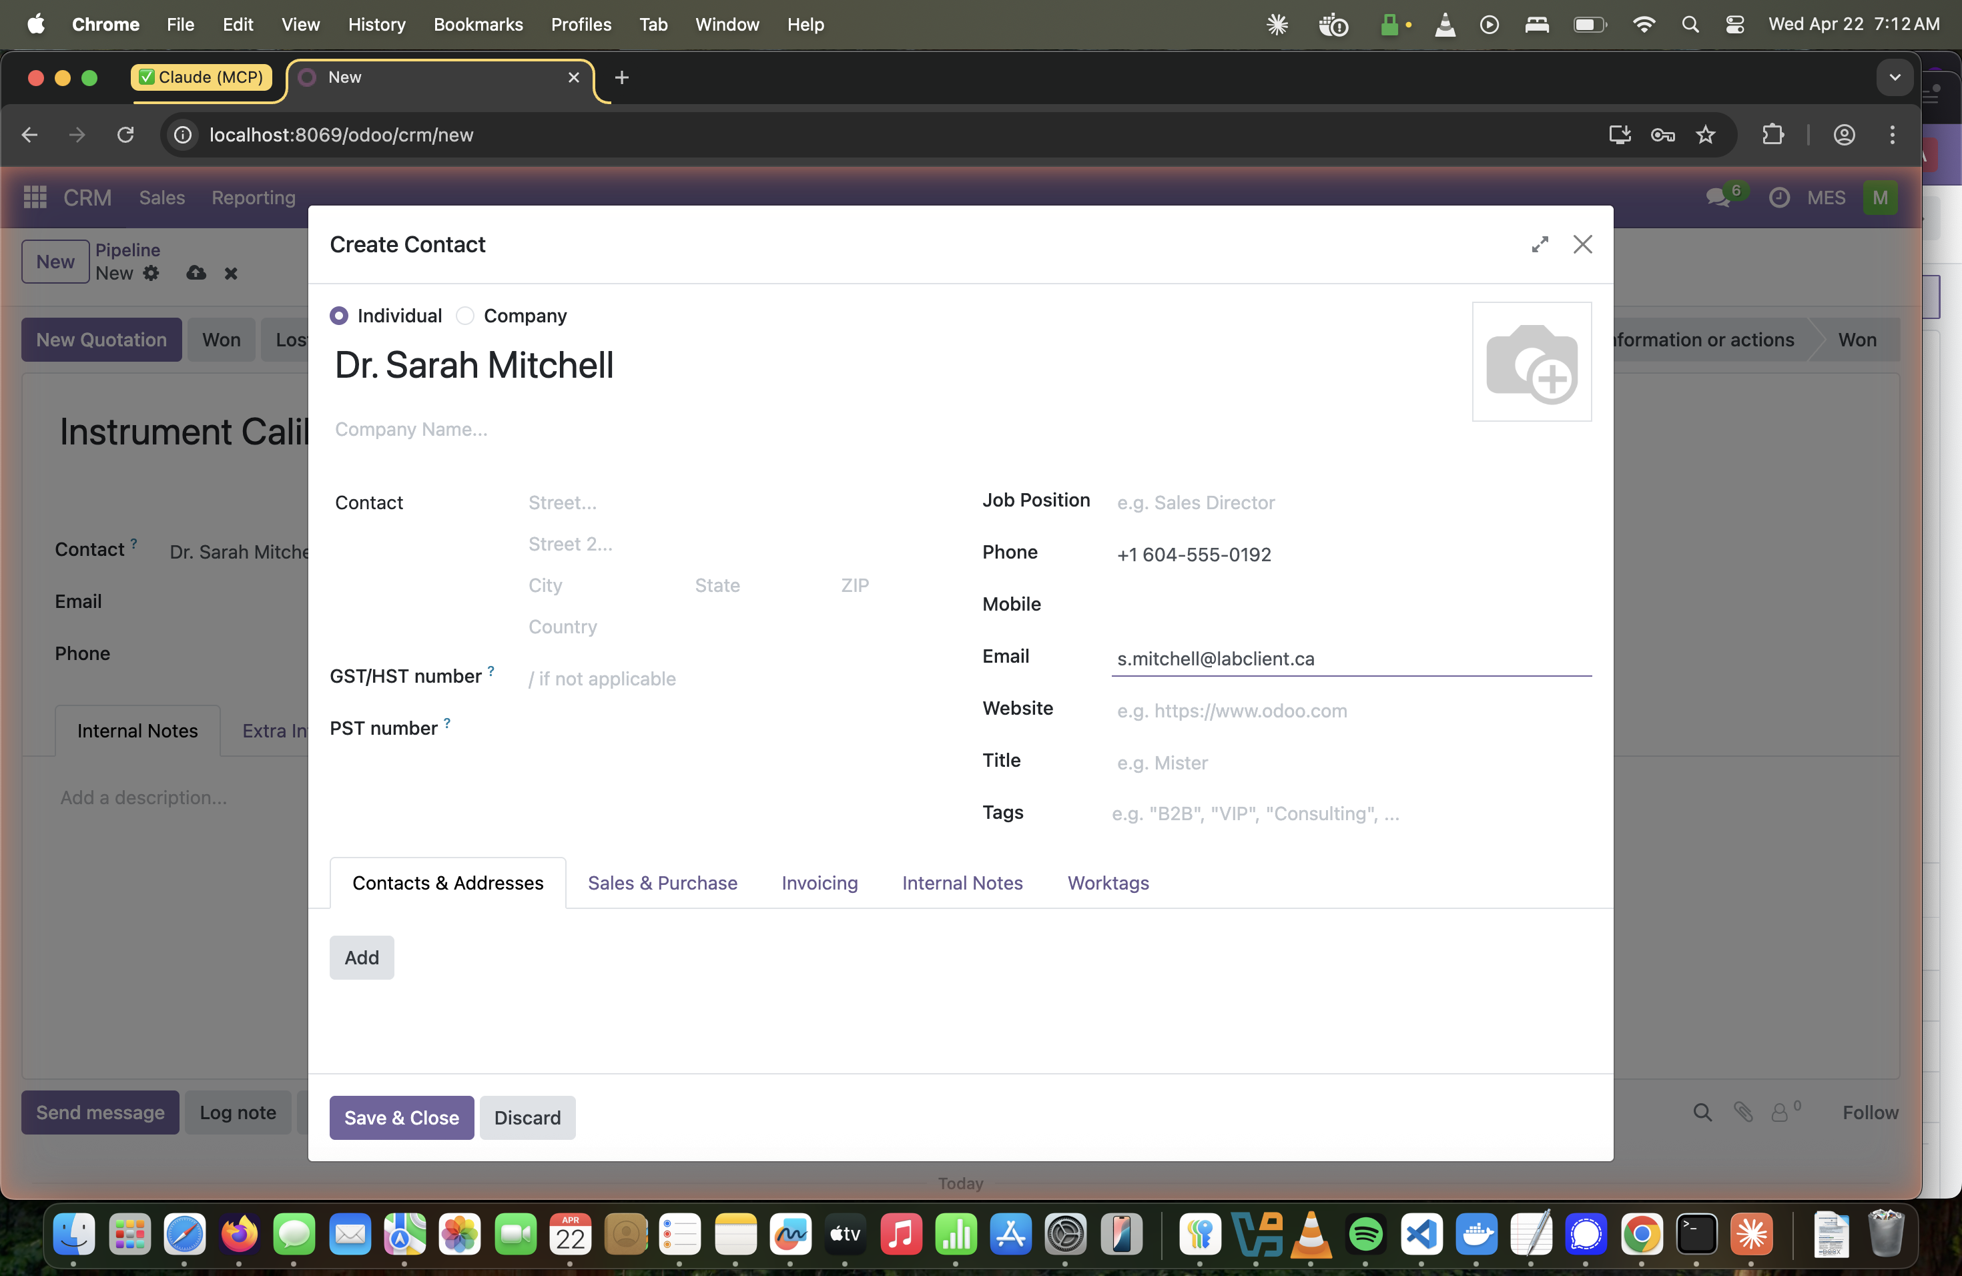
Step 3a — Creating a new Individual contact with phone and email from within the opportunity.

Add Internal Notes
- Click the Internal Notes tab on the opportunity form.
- Type your intake notes — instrument details, priority, timeline, pre-authorised spend.
- Click the cloud save icon in the breadcrumb to save.
⚠️ | Internal Notes are private: Visible only to Odoo users, not to the client. Use the Send message button for client-facing communication.

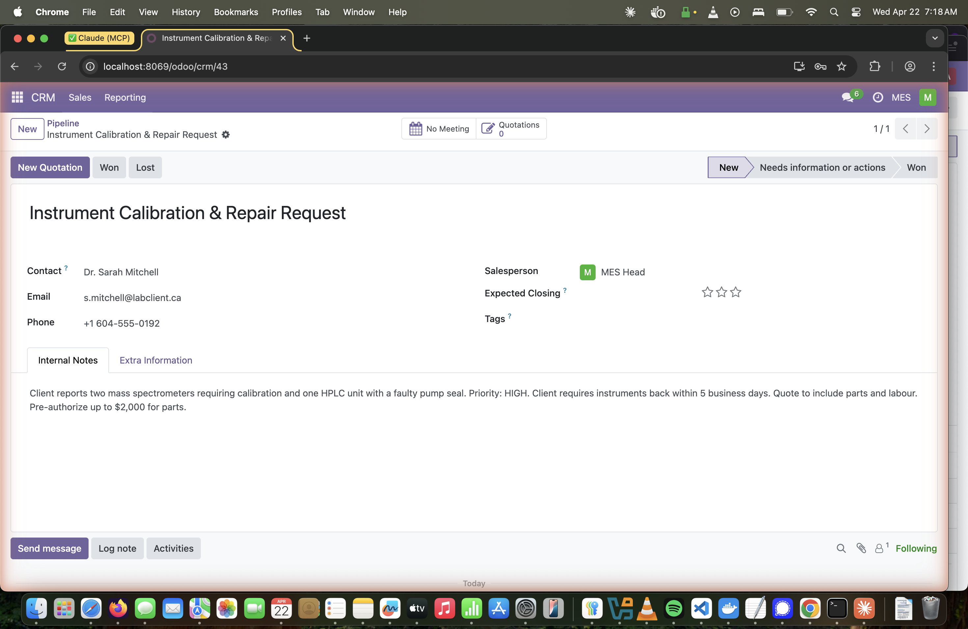
Step 3b — Opportunity form with new contact (Dr. Sarah Mitchell) and internal intake notes.

4 | Create a Quotation  Generate a quotation directly from the opportunity.

How To
- From the saved opportunity, click New Quotation in the action bar.
- The quotation opens pre-filled with the customer and opportunity name.
- The Expiration date defaults to 30 days out.
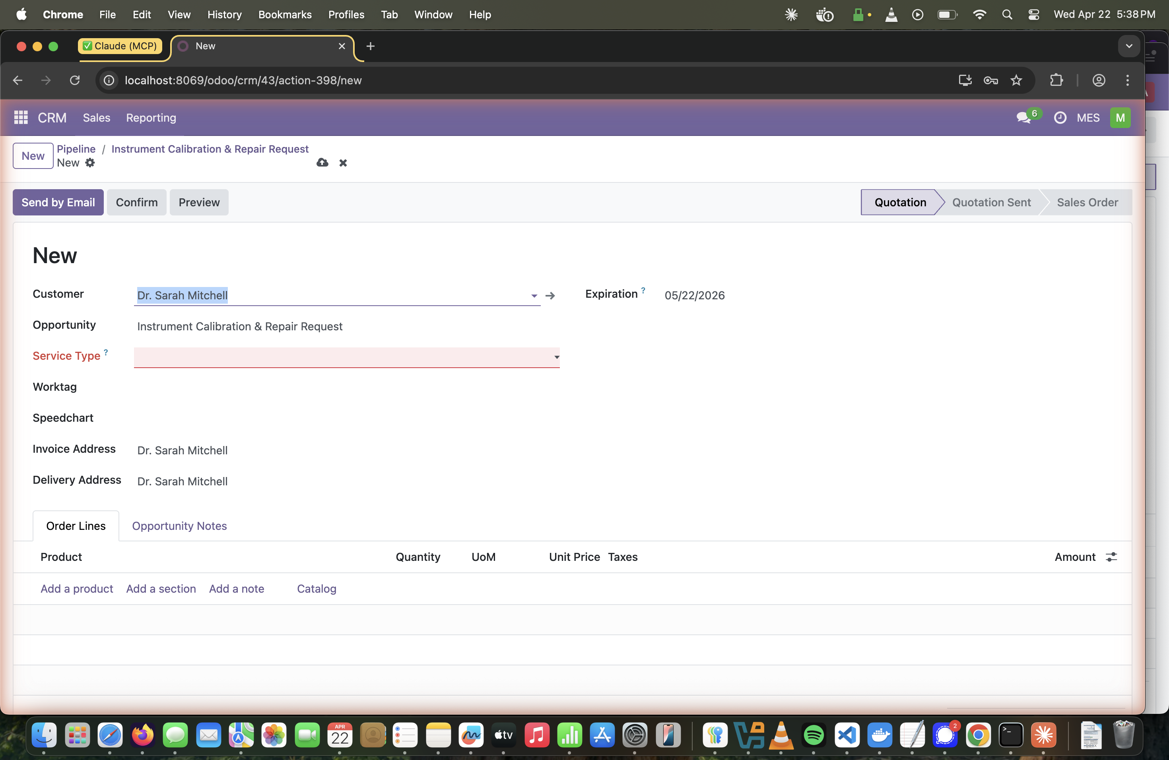
Step 4 — New Quotation form. Service Type is required (highlighted in red if missing).

5 | Add Service Type, Worktag & Labor Product  Classify the service, select the billing worktag, and add the labor line.

Service Type (required)
Click the Service Type dropdown and choose the appropriate category:
Option | When to use
Repair | Fixing or restoring a faulty instrument
Manufacturing | Building or fabricating a component
Move | Relocating equipment between labs
Installation | Setting up new equipment on-site
Maintenance | Scheduled preventive maintenance

Worktag
- Click the Worktag field and type the code (e.g. CALREP-2026-001).
- Worktags are filtered to those linked to the customer's commercial partner.
- When selected, the Speedchart field auto-populates from the worktag record.
- Worktags must be validated by a Manager before an invoice can be posted.
ℹ️ | No worktags showing? The worktag's Company field must match the customer's commercial partner. Ask the Manager to create the worktag if none exist.

Labor Product (Order Lines)
Click Add a product and select the labor product matching the client's category:
Product | Client Category
Work order / repair order for Chemistry client – Labor | UBC Chemistry department
Work order / repair order for UBC (external) client – Labor | Other UBC departments
Work order / repair order for External to UBC or private client – Labor | Non-UBC / private clients
Work order / repair order for Departmental service client – Labor | Internal MES department service

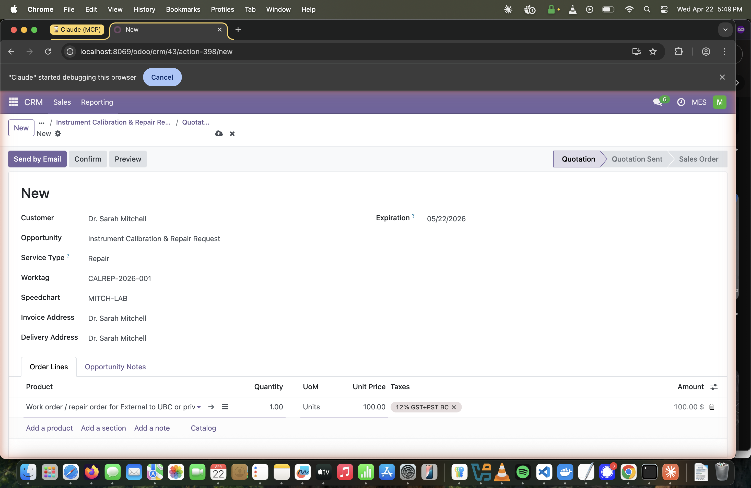
Step 5 — Quotation complete: Service Type = Repair, Worktag = CALREP-2026-001, Speedchart auto-filled, labor product added with 12% GST+PST BC tax.

6 | Confirm Quotation → Sales Order  Lock in pricing and generate the sale order and linked repair order.

How To
- Review all fields, then click Confirm in the action bar.
- The status bar moves to Sales Order and the record gets a number (e.g. S00081).
- A Repairs smart button appears — the system auto-creates a linked repair order.
💡 | Tip: Once confirmed, pricing is locked. To make changes, cancel and recreate, or use Lock/Unlock controls (visible to managers).

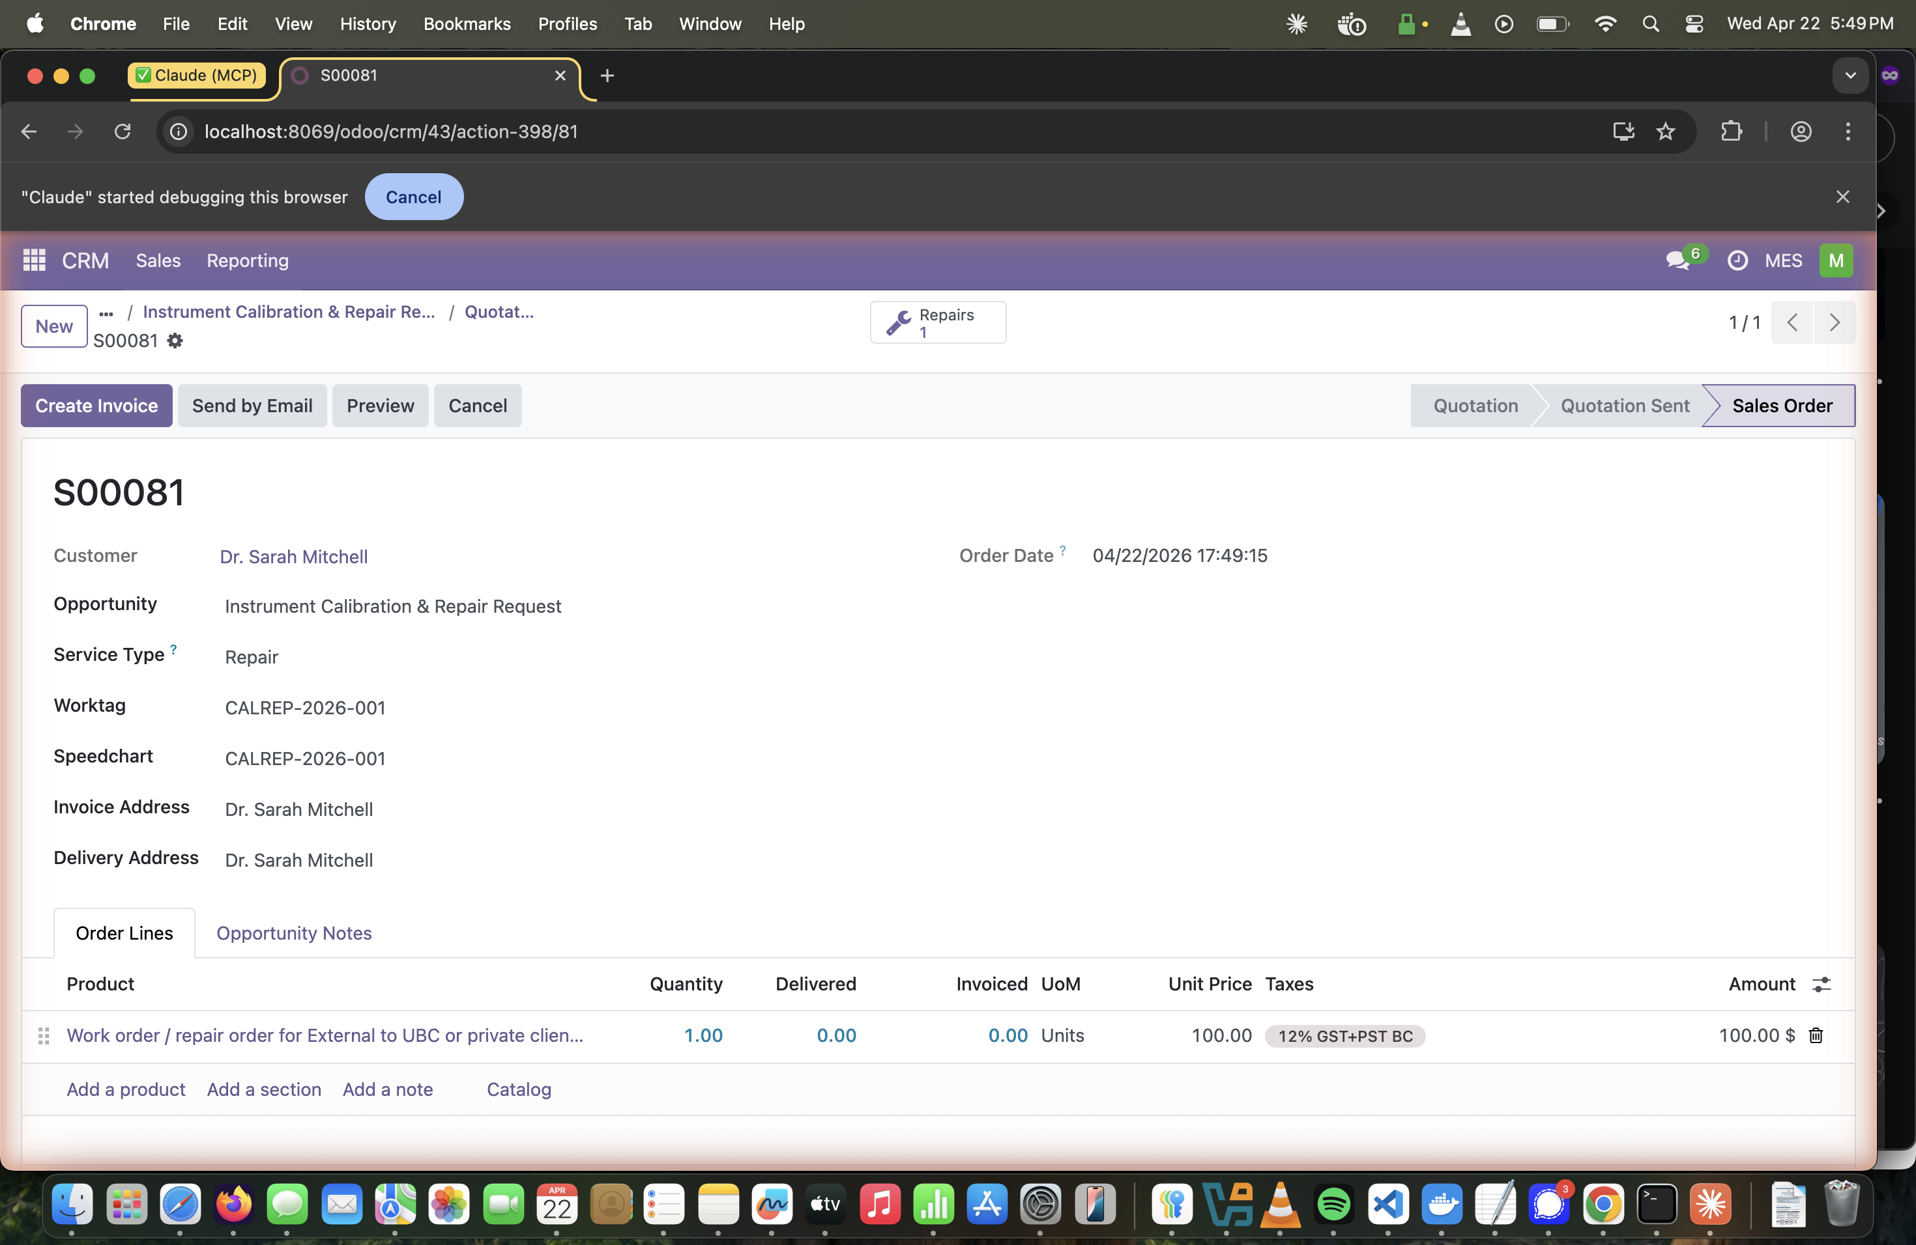
Step 6 — Sales Order S00081 confirmed. The Repairs smart button shows 1 linked repair order.

7 | Open the Repair / Work Order  Access the auto-created repair order and review its details.

How To
- From the confirmed sales order, click the Repairs smart button (top bar).
- The repair order opens pre-filled with customer, opportunity, service type, and scheduled date.
- Stage bar: New → Confirmed → Under Repair → Repaired. New repair orders land in Confirmed.
- The Parts tab is where technicians add physical components used during the repair.
- The Timesheets tab records labour hours against this order.
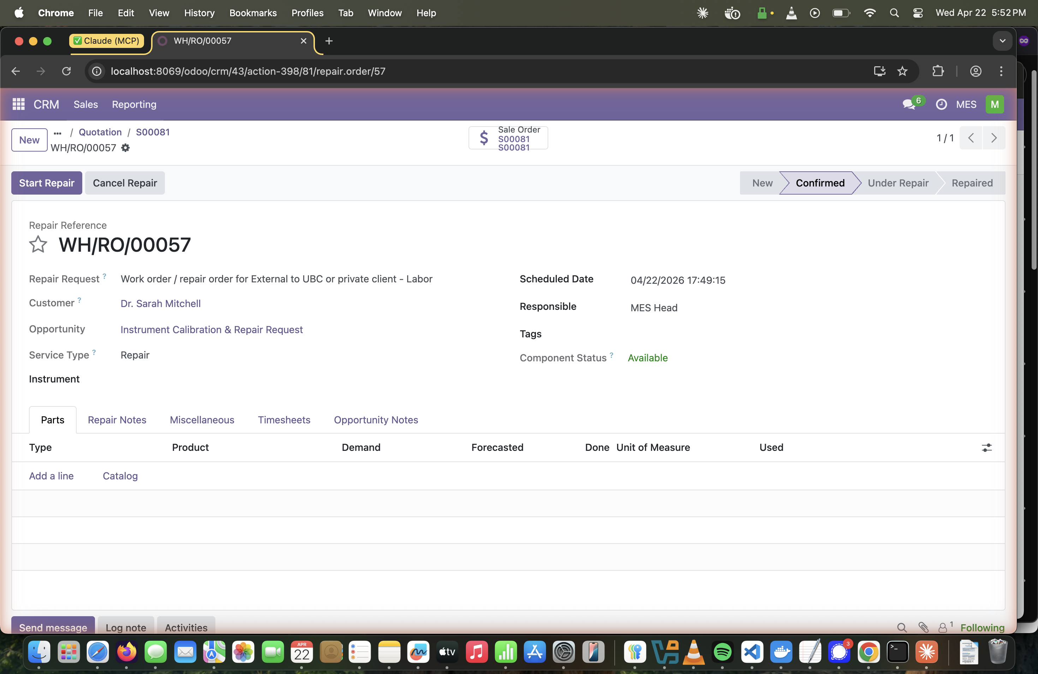
Step 7 — Repair Order WH/RO/00057 in Confirmed state, linked to Sale Order S00081.

8 | Assign the Repair Order to a Technician  Change the Responsible field to the staff member who will carry out the work.

How To
- Click the Responsible field (right column of the repair order header).
- Clear the current value and type the technician's name (e.g. Tech 1).
- Select the correct user from the dropdown and save using the cloud save icon.
💡 | Tip: The assigned technician will see this repair order in their own queue. They can log timesheet entries directly from the repair order's Timesheets tab.

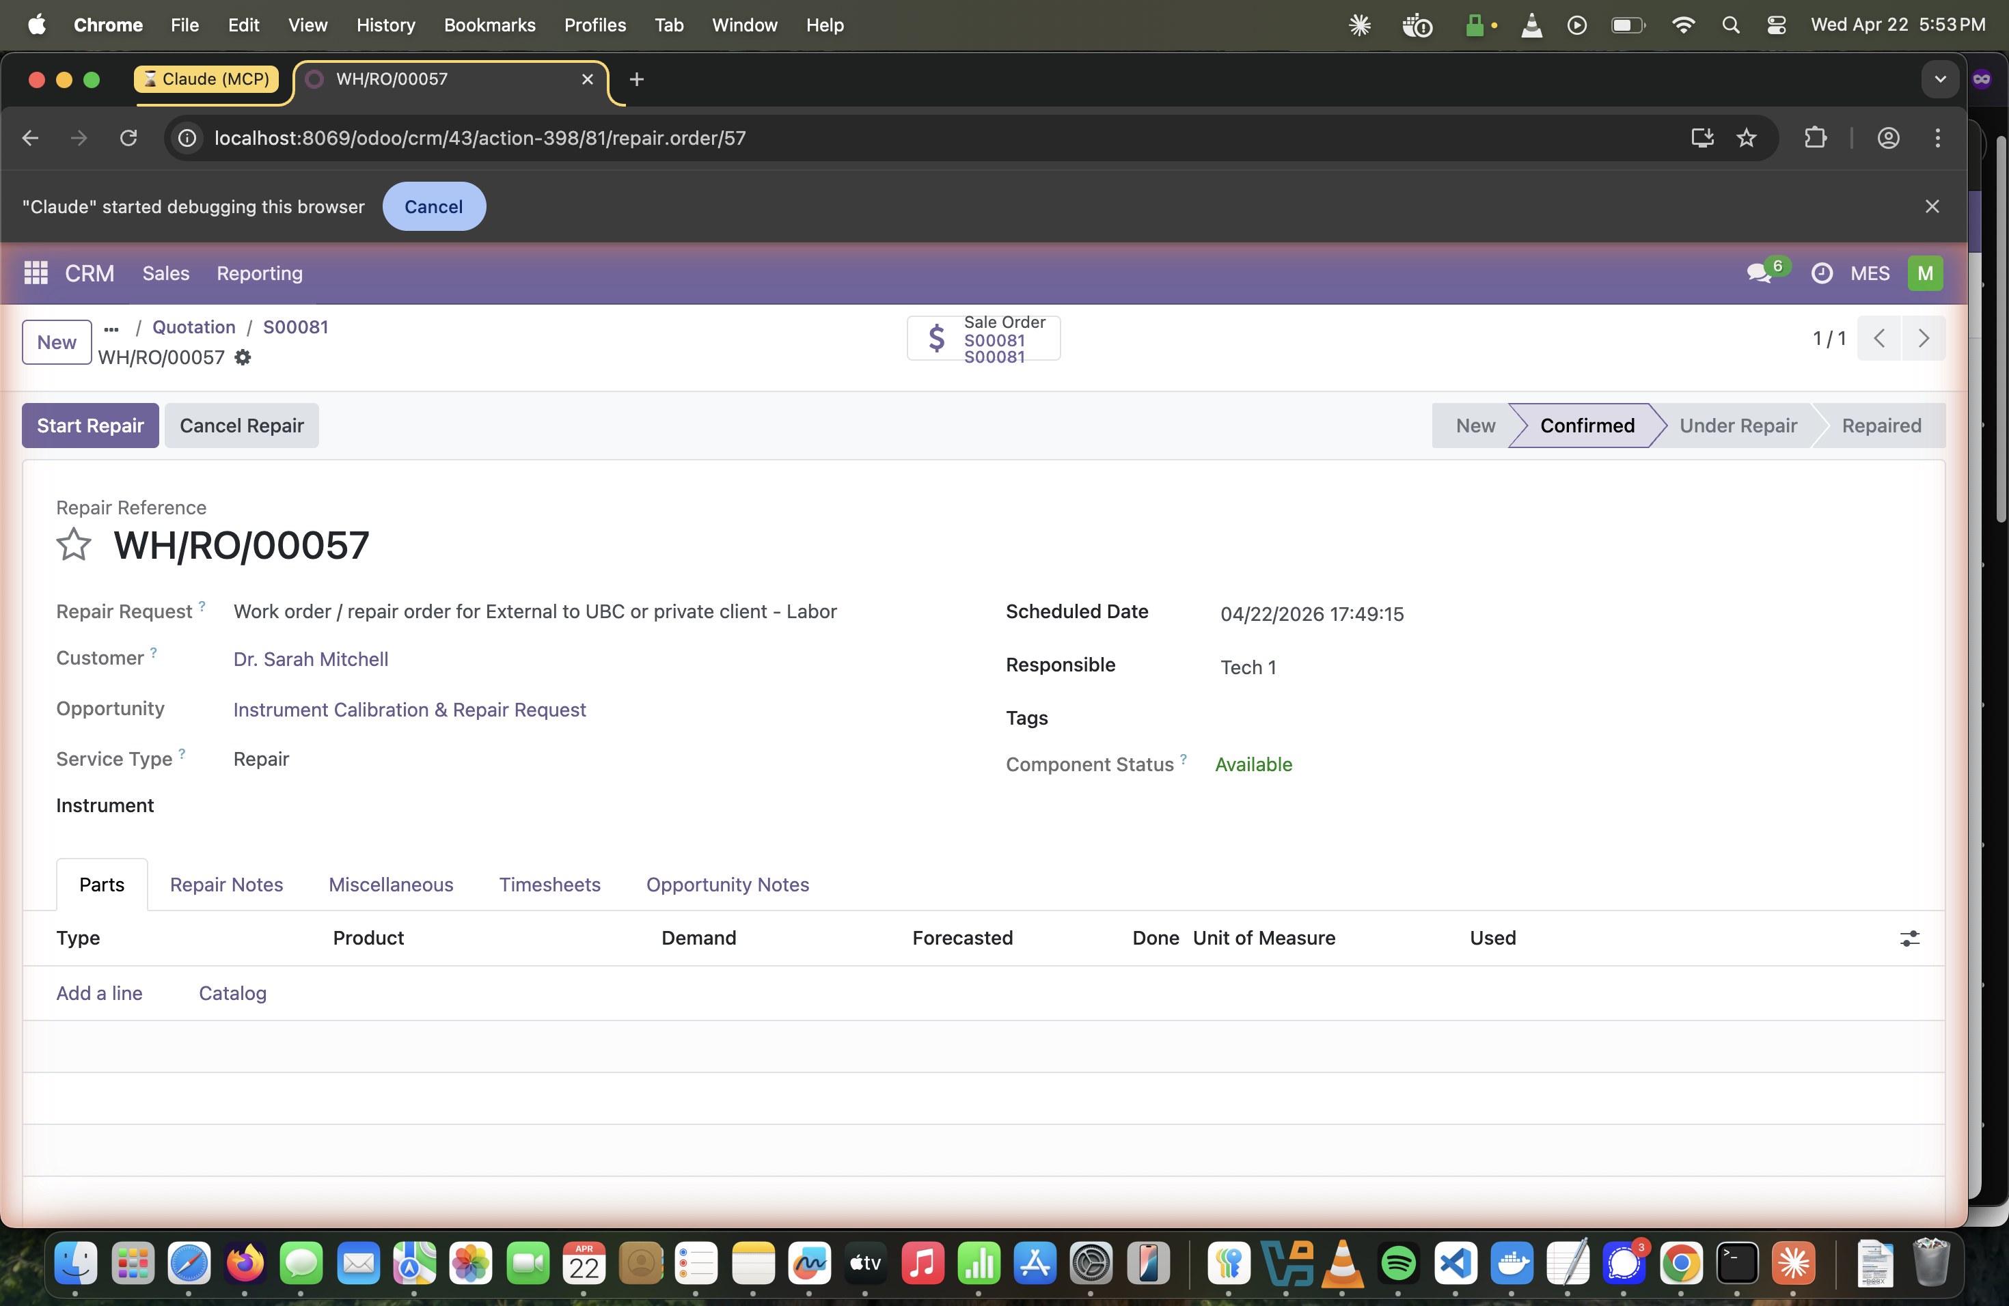
Step 8 — Repair order WH/RO/00057 assigned to Tech 1.

9 | Create Invoice Draft  Return to the sales order and generate a draft invoice for Manager review.

Pre-requisite: Worktag Validation
⚠️ | Manager action required: A Manager must check the Validated field on the worktag before this step succeeds. Otherwise Odoo blocks invoice creation: "worktag has not been validated — a manager must check the Validated field on the worktag first."

How To
- Click the breadcrumb sales order link or use the Sale Orders smart button to return to S00081.
- Click Create Invoice (top-left action bar).
- The dialog defaults to Regular invoice — leave this selected.
- Click Create Draft.
- The draft invoice opens with all lines, taxes, worktag, and customer details pre-populated.
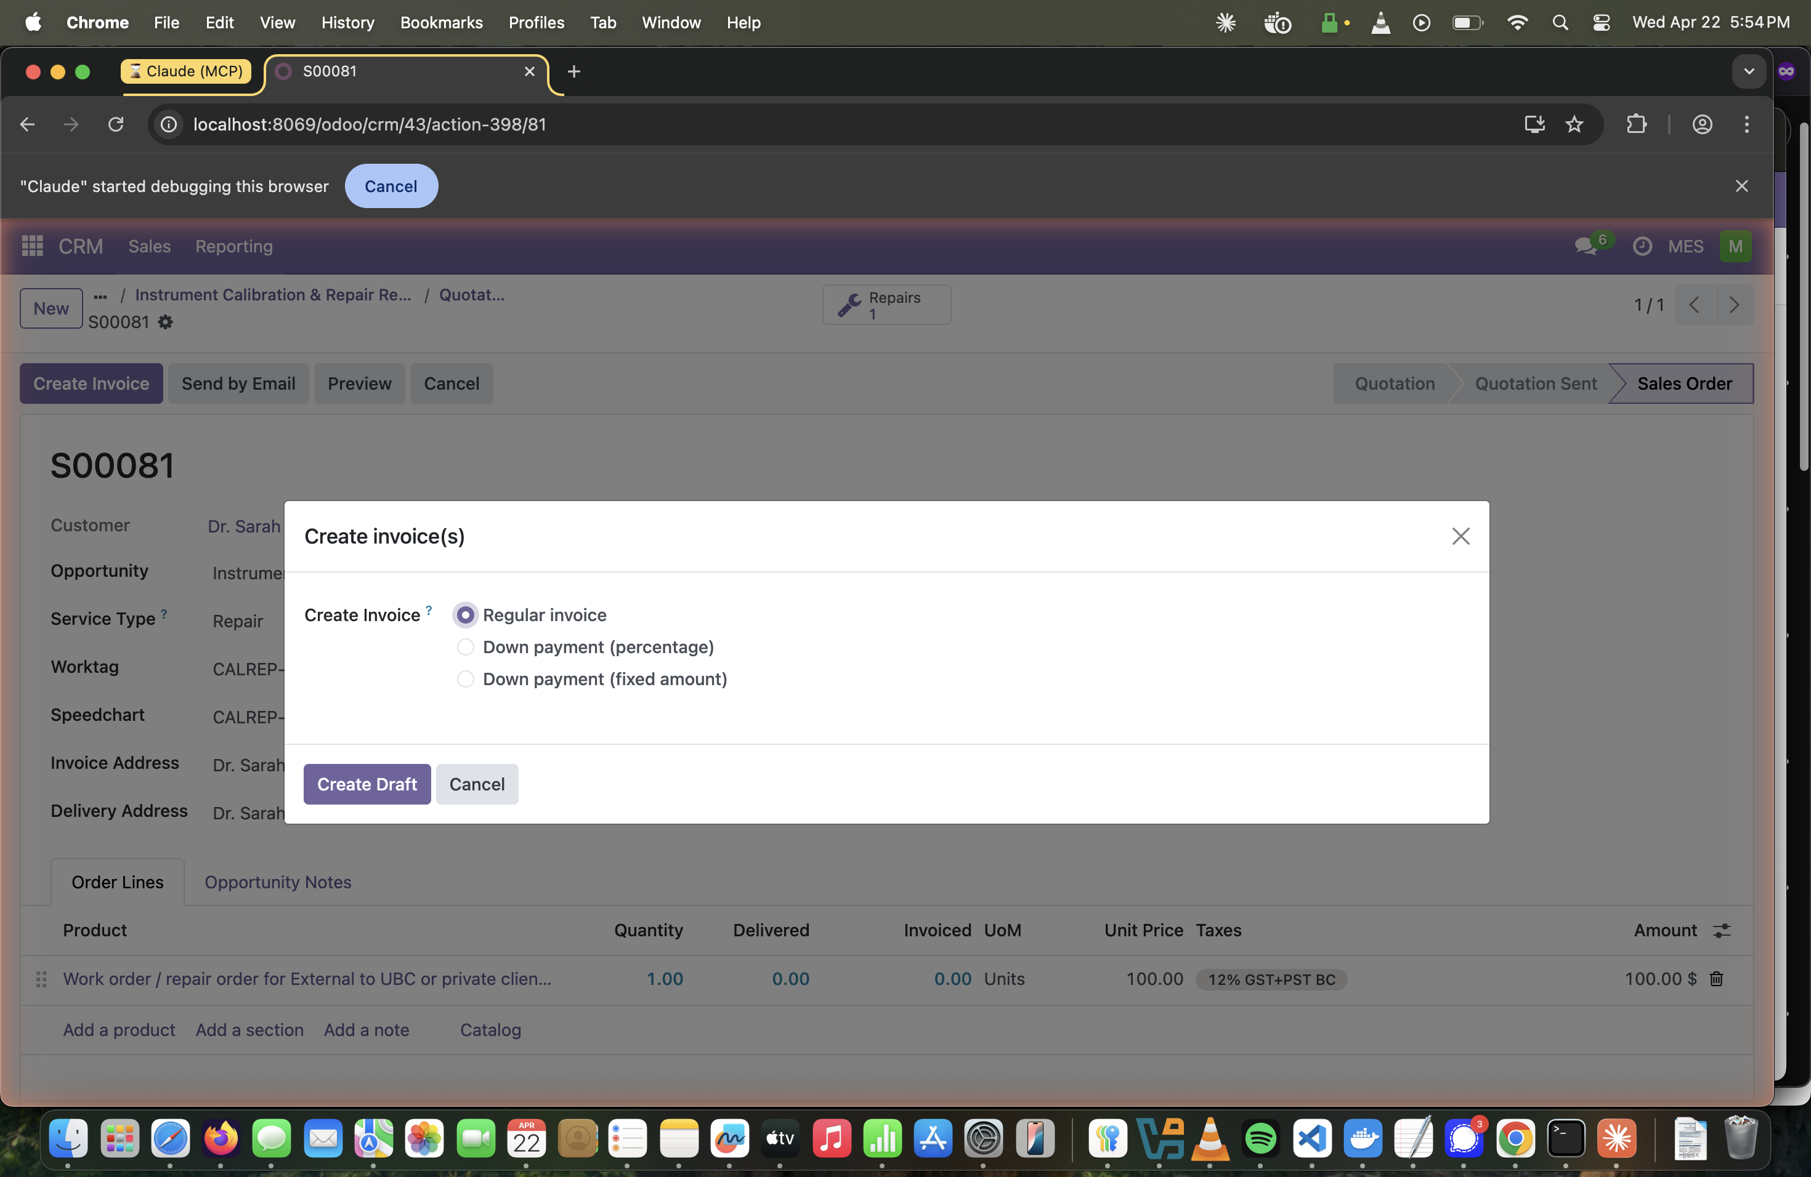
Step 9a — Create Invoice(s) dialog. Select Regular invoice and click Create Draft.
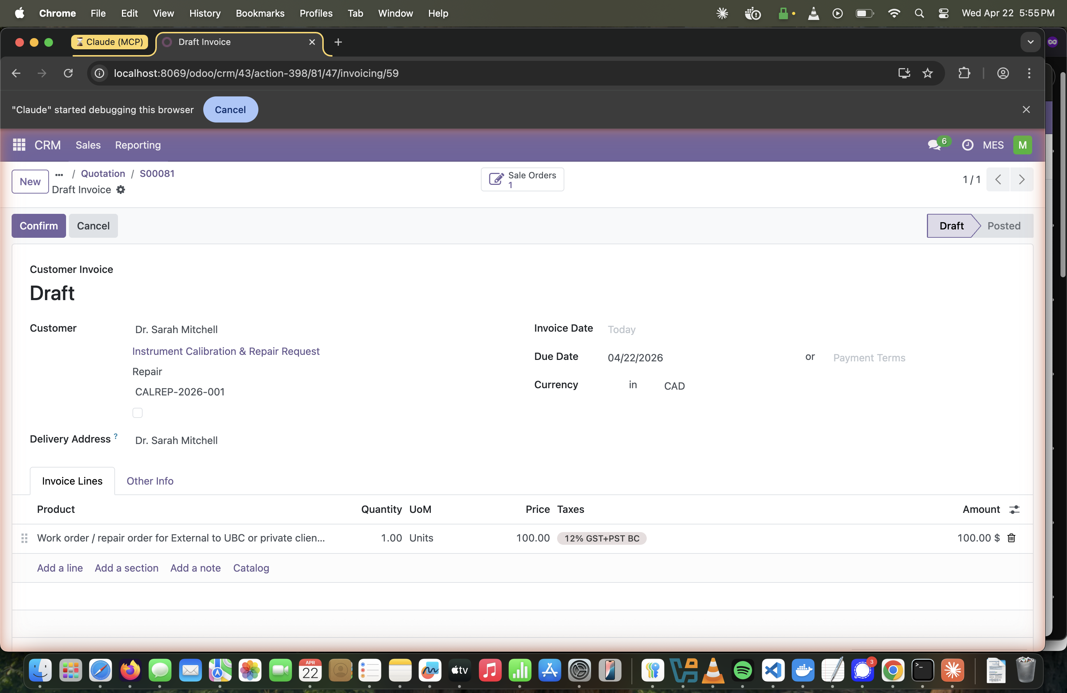
Step 9b — Draft Customer Invoice. Shows labor line at $100 + 12% GST/PST BC. Ready for Manager review and posting.

What Happens Next
- The Supervisor's job ends here — the draft sits in Accounting → Customer Invoices with status Draft.
- A Manager reviews and clicks Confirm to post the invoice and generate journal entries.
- Once posted, the invoice can be emailed to the client directly from Odoo.

