MAXR Python Bot — Project Documentation
External AI opponent for M.A.X. Reloaded via a JSON bridge
Status: 6 June 2026 — Document 1 (findings phase). This document is continued in parallel with development.

1. Project goal
The goal is an AI opponent for M.A.X. Reloaded (MAXR) that acts as a standalone bot. MAXR is an open-source remake of the strategy game M.A.X. (Interplay, 1996) and supports multiplayer matches over TCP/IP, but offers no built-in AI opponent. The bot is meant to fill this gap.
Core requirements:
- The bot is written in Python.
- The bot logic works entirely with JSON.
- Each turn of the bot is stored as its own JSON file, so that decisions are transparent and traceable.
- The MAXR game itself should stay as unchanged as possible.

2. Starting point: MAXR
Property | Value
Project | M.A.X.R. (Mechanized Assault & eXploration Reloaded)
Repository | github.com/maxr-dot-org/maxr (branch: develop)
Language | C++ (~96%), C, some Lua
License | GPL v2 (code), CC BY-SA 3.0 (parts of the assets)
Platforms | Linux, macOS, Windows (SDL2 + CMake/premake5)
JSON library | nlohmann/json
AI status | No built-in AI opponent; topic open in the forum
The forum discussion on the AI originally dates from 2013. It is technically outdated today; the chosen approach goes its own way.

3. Architecture decision: bridge variant
Two ways for an external bot were examined:

3.1 Pure Python (rejected)
A pure Python bot would have to rebuild MAXR's binary network format itself. That is fragile: every change to a data structure in the C++ code would silently break the Python mapping, and the bot would be strongly version-dependent.

3.2 Bridge variant (chosen)
A thin C++ bridge connects as a real client to the game, uses MAXR's own serialization code and exchanges only JSON with the Python bot. Advantages:
- The binary wire format does not have to be rebuilt by hand — MAXR's own code handles that.
- Version-safe: the bridge uses the same structures as the game.
- The Python bot stays fully decoupled, in pure Python and JSON.
- Clean separation: if the bot crashes, the game does not crash.

3.3 Component overview
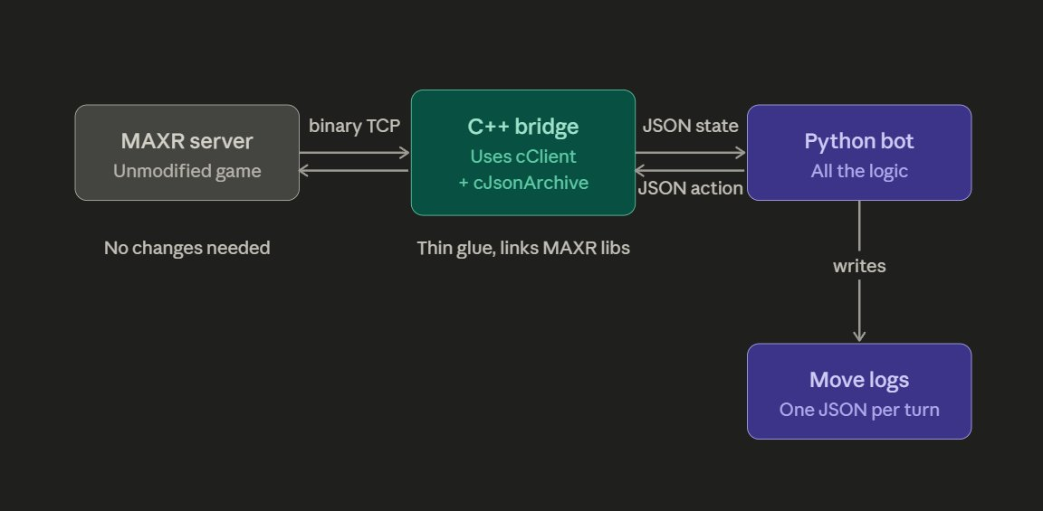
Figure 1: Architecture of the MAXR bot bridge. The MAXR server stays unchanged and speaks binary over TCP. The C++ bridge translates between binary and JSON. The Python bot contains the entire logic and writes one JSON file per turn.
Component | Role
MAXR server | Unchanged game. Speaks binary over TCP.
C++ bridge | Thin glue. Uses cClient + cJsonArchive. Translates between binary (game side) and JSON (bot side).
Python bot | Entire game intelligence. Reads the JSON state, makes decisions, returns JSON actions.
Turn logs | One JSON file per turn, written by the Python bot.

4. Findings from the source code

4.1 Network protocol
The network transport is binary (cBinaryArchive), not JSON. The message types are defined in src/lib/game/protocol/netmessage.h as enum eNetMessageType. Particularly relevant is the type ACTION, which the code explicitly describes as the set of actions a client (AI or player) can trigger. AI and human thus share the same mechanism.
Important message types:
- TCP_HELLO / TCP_WANT_CONNECT / TCP_CONNECTED — the three-stage connection handshake.
- ACTION — all game actions of a participant.
- RESYNC_MODEL / REQUEST_RESYNC_MODEL — complete copy of the game model to clients.
- MULTIPLAYER_LOBBY — lobby and game preparation.

4.2 The class cClient — the docking point
src/lib/game/logic/client.h is the central interface for the bridge. It is considerably more convenient than expected:
- getModel() returns the complete, already-deserialized game state (cModel).
- getActivePlayer() returns the own player.
- For every game action there is a ready-made high-level method: endTurn(), attack(), startMove(), startBuild(), transfer(), upgradeVehicle(), changeResearch() and more.
These methods internally build the matching cAction, serialize it correctly and send it to the server. All the binary detail is thereby already encapsulated by the game itself — the bridge does not have to touch any byte format.
There are 28 action types (cAction::eActiontype), among others InitNewGame, StartMove, Attack, StartBuild, EndTurn, Transfer, ChangeResearch, UpgradeVehicle, UpgradeBuilding.

4.3 cModel as JSON — confirmed
The central open question was whether the game state can be serialized completely as JSON. The check shows: yes, unambiguously.
- cModel has a template-generic save() method (template <ArchiveOut Archive>). The same code works for binary and JSON archives.
- MAXR already stores the complete game model as JSON in its savegames today (src/lib/game/data/savegame.cpp).
- The savegame code uses archive << NVP(model) followed by json.dump(2) — i.e. indented, human-readable JSON.
Key code location from savegame.cpp:
nlohmann::json json;
cJsonArchiveOut archive (json);
archive << NVP (model);
file << json.dump (2); // 2 = indentation, readable JSON
The data package contained in the model comprises, among others: gameId, gameTime, random generator, gameSettings, map, unitsData, players (player list), moveJobs, attackJobs, neutral buildings and vehicles, turnCounter and casualtiesTracker.

4.4 Template: dedicatedserver
Under src/dedicatedserver MAXR already contains a complete, GUI-less program (~820 lines) that connects via the connectionmanager and processes network messages. It is the ideal blueprint for the bridge — we merely replace the server role with a client (cClient) that logs in as a player.

5. Open points and risks
- Size of the JSON state: a complete model can become large. Performance and possibly filtering to the data visible to the bot are to be checked.
- Lobby phase: the bridge must first navigate through player setup, map selection and initNewGame before the actual game begins. The dedicatedserver code shows the flow.
- Transport bridge<->Python: still to be chosen (stdin/stdout or a local socket).
- Synchronization: gametime sync and freeze modes must be served correctly so that the connection stays stable.

6. Join and start flow
The flow from connecting to game start was verified in the source code (lobbyclient.cpp) and is divided into four phases. A large part runs automatically; the bot only has to intervene actively at a few points.

6.1 Phase 1: handshake (automatic)
After connectToServer(address) the 3-way handshake runs by itself: the server sends TCP_HELLO (with a version check), the client automatically answers with TCP_WANT_CONNECT (name, color, ready), the server confirms with TCP_CONNECTED and assigns a player number. Then the signal onLocalPlayerConnected fires. On an error TCP_CONNECT_FAILED comes (signal onConnectionFailed).

6.2 Phase 2: lobby
The server sends PLAYERLIST (signal onPlayersList) and OPTIONS including the map (signal onOptionsChanged). The bot sets its properties via changeLocalPlayerProperties(name, color, ready) and reports ready via tryToSwitchReadyState(). Important pitfall: tryToSwitchReadyState does NOT set to ready as long as no valid map is present. The bot must therefore wait until onOptionsChanged has delivered the map.

6.3 Phase 3: preparation and landing
START_GAME_PREPARATIONS delivers unitsData and clanData (signal onStartGamePreparation). Then the landing-site choice follows: enterLandingSelection(), then selectLandingPosition(cPosition). The server confirms via LANDING_STATE (signal onLandingDone).

6.4 Phase 4: game start
MU_MSG_START_GAME is the decisive message. In the handler the cClient is created, wired with setPlayers and setLocalClient, setPreparationData is called, and it is handed to the bridge via the signal onStartNewGame(client). From here the bridge holds the cClient and is in the game. Note: client->initNewGame(...) is commented out in the handler; the sending of the init data (incl. clan) happens via the preparation phase.

7. Clan selection
The clan sits in sInitPlayerData.clan (an int) and is sent to the server via client->initNewGame(initPlayerData) as a cActionInitNewGame. There are 8 clans, indexed internally 0-based (0 to 7). The code validates: clan less than 0 or clan greater/equal to the number of clans is invalid. The default -1 means "no clan".
Clan indices: 0 The Chosen, 1 Crimson Path, 2 Von Griffin, 3 Ayer's Hand, 4 Musashi, 5 Sacred Eights, 6 7 Knights, 7 Axis Inc.
Configuration schema (1-based, user-friendly):
- clan = 0: RNG, random choice internally from 0 to 7.
- clan = 1 to 8: the respective clan, mapped internally to 0 to 7 (internal value = config.clan - 1).

8. Landing-site choice
There are two separate validations, at different places.

8.1 Terrain check (client-side)
Whether a position lies on water or on blocked terrain is checked by cStaticMap::isWater() and isBlocked() in map.cpp. In the real game this happens client-side in the selection window before a position is sent. The server therefore possibly does not validate the terrain again at landing. The bot must thus perform this check itself and send only positions on valid land. The staticMap is available via lobbyPreparationData.

8.2 Distance check (server-side)
The cLandingPositionManager checks the distances to other players on the server and answers with MU_MSG_LANDING_STATE (signal onLandingDone). Distances: tooCloseDistance = 10 fields, warningDistance = 28 fields. States: Unknown (no choice yet), Clear (free), Warning (within the warning distance), TooClose (too close, rejected), Confirmed (warning deliberately confirmed).

8.3 Warning confirmation by repetition
Important mechanic: a warning is not confirmed by a flag, but by re-sending THE SAME position. If the player is in the Warning state and chooses the same position again (distance to the last position less/equal to tooCloseDistance), the state switches to Confirmed and further warnings are ignored.

8.4 Configuration
- starting_location_x / starting_location_y: fixed position. If both are 0, the bot rolls via RNG.
- ignore_starting_location_warning = true: on Warning the bot re-sends the same position (leads to Confirmed).
- ignore_starting_location_warning = false: on Warning the bot chooses a new position.
Flow logic: determine the position (config or RNG), check isWater/isBlocked locally (re-roll on water), send to the host, wait for LANDING_STATE. On TooClose a new position; on Warning according to the flag; on Clear or Confirmed accepted.

8.5 Coordinates and map size
Coordinates are cPosition (cFixedVector with data type int, access via x() and y()). Maps are always square (otherwise the loader aborts with "Map must be quadratic!") with a minimum size of 16. A position is valid according to isValidPosition exactly when 0 <= x < size and 0 <= y < size. The valid interval is thus [0, size-1] in both axes.
Example sizes of shipped maps: Mushroom 60, Lava 64, Three Isles 64, Donuts 70, Delta 112. On the wire the size is stored as uint16 (theoretically up to 65535), in practice maps are small. The RNG logic fetches the actual size at runtime via staticMap getSize().x() and rolls in the range [0, size-1] (uniform_int_distribution(0, size-1)). The upper end is size-1, not size (mind the off-by-one).
Attempt limit: max_landing_attempts (default 1000) bounds the RNG attempts to find a valid landing position, and prevents endless loops on water-rich maps. On exceeding it the bot aborts with an error.

9. Pump cadence (main loop)
The message cadence in the MAXR code is realized not as an interval timer, but as a tight main loop. cLobbyClient::run() is non-blocking: it drains the message queue (cConcurrentQueue) in a while loop and processes each message. Once the game runs, run() delegates internally to client->run(). In the GUI, cApplication::execute() calls this run() in a loop that pauses only SDL_Delay(1), i.e. about one millisecond, per pass. The real join client (menucontrollermultiplayerclient.cpp) registers exactly as such a runnable.
Important: do not use a long polling interval. The game tick is 10ms (GAME_TICK_TIME) and the client may lag at most 15 ticks behind (MAX_CLIENT_LAG). A 500ms interval would immediately produce 50 ticks of lag, far above the limit, which the sync mechanism would interpret as a connection problem. In the lobby phase (no game tick) a slow interval would be uncritical, but not in the game phase.
Implementation in the bridge: the run() loop follows the MAXR pattern. Per pass lobbyClient->run() is called and at the end SDL_Delay(kPumpDelayMs) with kPumpDelayMs = 1. That keeps the bot in sync and at the same time avoids busy-spinning. It remains open whether client->handleNetMessages()/runClientJobs() is additionally needed in the game or whether client->run() (via lobbyClient->run()) already does everything.

10. Next steps
Completed:
- Architecture decision (bridge variant).
- Check of the cModel JSON serialization (confirmed).
Next:
- Design the skeleton of the C++ bridge (based on dedicatedserver + cClient).
- Set up the Python bot skeleton with JSON turn logging.
- Define the transport channel between the bridge and Python.

