**Use Case 0: Home Page/Landing Page**

**Scenario:** Visitor views Landing Page

**Description:** Landing Page consists of details of the application, user reviews and founder profiles.

Machine generated alternative text:
C:) TUM Nostradamus 
C localhost:8080/#/Ianding 
Apps Google Translate C?] CHIP - Styleguide 5.2 
TUM NOSTRADAMUS 
mongo Shell Quick 
C:) My Resume HTML Bc 
C?] FEA Getting Started • Acce 
Spotify Web Player How to make Youtub, 
Segrec.. 
Team Escape - emplc How to Style WordPl'i 
Other bookmarks 
What is Nostradamus? 
The goto tool for pattern identification for your use cases. The importance of the Design Phase in every Software Lifecycle cannot be underestimated.considering the importance of the 
Design Phase in every Software Lifecycle, the application can be used as asupport tool to significantly reduce the time invested in choosing the right design to be implemented. 
Why Nostradamus? 
In the modern day, the presence and influence of software applications in all industries is extensive. Inevitably, this leads to the requirement of patterns to ease the design, 
development, deployment and maintenance of software applicatons. However, with the presence of numerous technologies and methodologies, the various stakeholders involved in a 
project have to ensure that the right pattern is chosen based on the results of the requirements engineering phase. 
The Team 
Akash Says: 
Akash Says: 
Akash Says: 
Akash Says: 
prateek Says: 
Not Ioæed in 
Testimonials 
'Excellent!" 
'Excellent!" 
'Excellent!" 
"Nice Application! " 
Akash Manjunath 
Developer 
VIEW PROFILE 
Gopala Krishna 
Developer 
VIEW PROFILE 
Prateek Bagrecha 
Developer 
VIEW PROFILE 
Shankar Mohan 
Developer 
VIEW PROFILE 
"Amazing, It helped me out great! " 
prateek Says: 
"Nice Application! " 

**Use Case 1: Identify Pattern**

**Scenario:** Add User Story

**Description:** Add your use case name and description for maintaining history and feedbacks. User are recommended to always give relevant names and description that makes sense for the current requirement in hand.

Machine generated alternative text:
C:) TUM Nostradamus 
C localhost:8080/#/pattern 
Apps Google Translate C?] CHIP - Styleguide 5.2 
TUM NOSTRADAMUS 
Add User Story 
mongo Shell Quick 
C:) My Resume HTML Bc 
DASHBOARD 
FEA Getting Started • Acce Spotify Web Player How to make Youtub, 
Segrec.. 
Team Escape - emplc How to Style WordPl'i 
Other bookmarks 
IDENTIFY PATTERN 
IDENTIFY ANTIPATTERN 
LEARNING CENTER 
ADD YOUR USER STORY 
DETERMINE PATTERN 
Add a User Story Name and User Story Description that is relevant to you requirement e.g. requirement jd, requirement description 
Requirment_id 
Stroy 
Requirement Description 
Desktop 
Hello, prateek 
(D) e:] ENG 
1 i44 

**Use Case 1: Identify Pattern**

**Scenario:** Phases to ask questions about the current requirement.

**Description:** Users are requested to answers some questions that figure out the intent of the requirement. Questions are asked in phases. On completion of each phase certain branches of Pattern Classification tree are eliminated and certain are selected. Questions are also considering the role that you're assuming during this process. A progress bar that shows the progress of the all phases is displayed. Once all phases are complete, the results are added to the user’s history first and then displayed to the user.

Machine generated alternative text:
C:) TUM Nostradamus 
C localhost:8080/#/pattern 
Apps Google Translate C?] CHIP - Styleguide 5.2 
TUM NOSTRADAMUS 
mongo Shell Quick 
C:) My Resume HTML Bc 
DASHBOARD 
FEA Getting Started • Acce Spotify Web Player How to make Youtub, 
Segrec..„ 
Team Escape - emplc How to Style WordPl'i 
Other bookmarks 
IDENTIFY PATTERN 
IDENTIFY ANTIPATTERN 
LEARNING CENTER 
Hello, prateek 
Phase 1 : Determine Pattern 
ADD YOUR USER STORY 
DETERMINE PATTERN 
Please select a relevant goal 
O As a Developer, you are trying to implement a particular requirement and looking for existing solution 
O As a Solution Architect, you are looking design a high-level system using existing solution 

Machine generated alternative text:
C:) TUM Nostradamus 
C localhost:8080/#/pattern 
Apps Google Translate C?] CHIP - Styleguide 5.2 
TUM NOSTRADAMUS 
mongo Shell Quick 
C:) My Resume HTML Bc 
DASHBOARD 
FEA Getting Started • Acce Spotify Web Player How to make Youtub, 
Segrec.. 
Team Escape - emplc How to Style WordPl'i 
IDENTIFY PATTERN 
IDENTIFY ANTIPATTERN 
LEARNING CENTER 
Other bookmarks 
Hello, prateek 
Phase 2 : Determine Design 
ADD YOUR USER STORY 
DETERMINE PATTERN 
DETERMINE DESIGN 
What is the main objective or essence of 
the requirement ? 
Instantaton of Class - How Objects are created ? 
O Composition of the Class and Objects - How the Classes are composed ? 
O 
Communication between Objects - How objects communicate with each other ? 
Desktop 
(D) e:] ENG 
11•55 

**Use Case 1**: **Identify Pattern**

**Scenario:** Display Results

**Description:** Depending on the options selected by the user, all possible pattern results for the current requirement are displayed in a tabular format. Each result tab displays pattern name, context, problem statement, structure of the pattern with image and related patterns. On clicking finish button the user is redirected to his dashboard, wherein he can see his history.

Machine generated alternative text:
C:) TUM Nostradamus 
C localhost:8080/#/resuIt 
Apps Google Translate C?] CHIP - Styleguide 5.2 
TUM NOSTRADAMUS 
mongo Shell Quick 
STATE 
C?] My Resume HTML Bc FEA Getting Started • Acce Spotify Web Player How to make Youtub, 
Segrec..„ 
Team Escape - emplc How to Style WordPl'i 
DASHBOARD 
IDENTIFY PATTERN 
Other bookmarks 
He 110, %atee k 
IDENTIFY ANTIPATTERN 
FINISH 
LEARNING CENTER 
COMMAND 
STRATEGY 
COMMAND 
Pattern Hierarchy 
Design Pattern 
o Behavioural Pattern 
Com m and 
Context 
Encapsulate a request as an object, thereby letting you param eterize clients with different requests, queue or log requests, and support undoable operations. 
Promote "invocation of a method on an object" to full object status. An object-oriented callback 
Problem Statement 
Need to issue req uests to objects without knowing anyth ing about the operation being requested or the receiver of the request. 

Machine generated alternative text:
C:) TUM Nostradamus 
C localhost:8080/#/resuIt 
Apps Google Translate C?] CHIP - Styleguide 5.2 
TUM NOSTRADAMUS 
COMMAND 
Pattern Hierarchy 
commmd 
Context 
mongo Shell Quick 
C:) My Resume HTML Bc 
FEA 
Getting Started • Acce 
Spotify Web Player 
How to make Youtub, 
Segrec..„ 
Team Escape - emplc How to Style WordPl'i 
Other bookmarks 
with 
Problem Statement 
nßhing the being 
Structure 
This in timing and 
in a like 
Related Patterns 

Machine generated alternative text:
C:) TUM Nostradamus 
C localhost:8080/#/dashboard 
Apps Google Translate C?] CHIP - Styleguide 5.2 
mongo Shell Quick 
C?] My Resume HTML Bc FEA Getting Started • Acce Spotify Web Player 
How to make Youtub, 
Segrec..„ 
Team Escape - emplc How to Style WordPl'i 
Number of days left: 
Nev.'s Feed: 
p arte m Adapt« 
Click to fid 
Have a new pattem in mind? 
Nostradamus Success Ratio : 
Other bookmarks 
TUM NOSTRADAMUS 
Your History 
Jul 3, 2016 
3, 201E 
3, 2018 
3, 2018 
3, 2018 
3, 2018 
3, 2018 
3, 2018 
3, 2018 
id-4 
id 
id 
id 
id 
NS HBOARD 
AIEtract Fa 
IDENTIFY PATTERN 
IDENTIFY ANTIPAITERN 
Click to rate 
Click to rate 
Click to rate 
Click to rate 
Click to rate 
Click to rate 
Click to rate 
LEARNING CENTER 
jdsjkfrEkj 
jdsjkfrEkj 
Co 
TO BE RATED 
TO BE RATED 
TO BE RATED 
TO BE RATED 
TO BE RATED 
TO BE RATED 
TO BE RATED 
Nice 
Amazing, 't 

**Use Case 2 : Identify Anti Pattern**

**Scenario:** Add User Story

**Description:** Add your use case name and description for maintaining history and feedbacks. User are recommended to always give relevant names and description that makes sense for the current requirement in hand.

Machine generated alternative text:
C:) TUM Nostradamus 
C localhost:8080/#/antipattern 
Apps Google Translate C?] CHIP - Styleguide 5.2 
TUM NOSTRADAMUS 
mongo Shell Quick 
C?] My Resume HTML Bc FEA Getting Started • Acce Spotify Web Player How to make Youtub, 
Segrec..„ 
Team Escape - emplc How to Style WordPl'i 
DASHBOARD 
IDENTIFY PATTERN 
IDENTIFY A rrERN 
LEARNING CENTER 
Other bookmarks 
He 110, %atee k 
Please give a brief description of your use case : 
An Patten UseCaseName 
An ti n secaseDesd 
PRCEEED! 

**Use Case 2 : Identify Anti Pattern**

**Scenario:** Select applicable options for your scenario

**Description:** User is requested to selected options that might be relevant to current condition of application. This scenarios represent the possible conditions an application might be in. Once the user clicks "Find the Anti-Pattern" button, a history is created with the results and a dialog containing results is displayed.

Machine generated alternative text:
C:) TUM Nostradamus 
C localhost:8080/#/antipattern 
Apps Google Translate C?] CHIP - Styleguide 5.2 
TUM NOSTRADAMUS 
mongo Shell Quick 
C?] My Resume HTML Bc FEA Getting Started • Acce Spotify Web Player How to make Youtub, 
DASHBOARD 
IDENTIFY PATTERN 
IDENTIFY A rrERN 
Segrec..„ 
Team Escape - emplc How to Style WordPl'i 
Too much time spent in design phase 
resulting in a very complex design. 
Too many people involved in design 
ph ases. 
Project was implemented initially by 
vendorsand then modified by 
developers in house. 
Too many systems are involved and is 
tco dficult to change the —ructure of 
the 9,'stem. 
Other bookmarks 
He 110, %atee k 
Choose the options related to your current scenario : 
Many components not being used. 
Development was done isa very short 
time frame in an ad hoc manner. 
Project was migrated to a di<ributed 
environment. 
Too much time wasspend idly and 
development was done in the end in a 
haste. 
System design in changing constantly in 
the presence of dead code. 
AND THE AMI-PATTERN! 
Large pats of code copéd from existing 
cade base. 
Developers lack experience in Object 
Oriented Programming Languages and 
have used modular programming. 
Single classes reg•onsible for large 
nu m ber of tag«s. 
Raw emaiS were used for 
communicaäon in place of prcject 
managem ent softwares. 
Prcject was implemented by vendors. 
Developers know a very limted set of 
technobgies. 
Classes having less responsibliäeswith a 
limited ife cvcle exi<. 
Req uire ments prese nted in docu ments 
are very general and not precise. 
LEARNING CENTER 
Too much time was spent in de—gn 
phase and there was an absence of 
ite rative process. 
Sy<em Developers were isolated from 
the end users. 
Entire project coded from the scratch 
when simi>r project existed. 
Meetings are dominated from managers 
with lack of respect towerds others 
op•mons. 

**Use Case 2 : Identify Anti Pattern**

**Scenario:** Display Results

**Description:** Depending on the options selected by the user, all possible pattern results for the current requirement are displayed in a dialog. Each result is displayed with anti-pattern name, statement, context and solution. On clicking "Finish" button the user is redirected to his dashboard, wherein he can see his history.

Machine generated alternative text:
C:) TUM Nostradamus 
C localhost:8080/#/antipattern 
Apps Google Translate C?] CHIP - Styleguide 5.2 
TUM NOSTRADAMUS 
Choose the options related to yo 
Many 
Programming and 
m±ular 
with a 
V"tfnss dominaté.zl fmm 
with lack of 
FIND THE 
mongo Shell Quick 
C) My Resume HTML BC 
FEA Getting Started • Acce Spotify Web Player 
IDENTIFY LEARNING CENTER 
How to make Youtub, 
Segrec..„ 
Team Escape - emplc a How to Style WordPl'i 
Hello, 
in ad manner. 
nts in 
not 
Other bookmarks 
DASHBOARD 
IDENTIFY PATTERN 
Possible antipatterns present : 
LAVA FLOW 
Statement 
System design in changing constantly in the presence of dead code. 
Context 
Dead code and forgotten design information is frozen in an ever-changing design. 
Solution 
Configuration management process that eliminates dead code and evolves or refactors design toward increasing 
quality. 
FIRE DRILL 

Machine generated alternative text:
C:) TUM Nostradamus 
C localhost:8080/#/antipattern 
Apps Google Translate C?] CHIP - Styleguide 5.2 
TUM NOSTRADAMUS 
Choose the options related to yo 
Many 
Programming and 
m±ular 
with a 
V"tfnss dominaté.zl fmm 
with lack of 
FIND THE 
mongo Shell Quick 
C?] My Resume HTML Bc FEA Getting Started • Acce Spotify Web Player How to make Youtub, 
Segrec..„ 
Team Escape - emplc a How to Style WordPl'i 
Hello, 
in ad manner. 
of tasks 
nts in 
not 
Other bookmarks 
DASHBOARD 
IDENTIFY PATTERN 
IDENTIFY LEARNING CENTER 
Have short term and long term goals and spread the deliverables over time. 
POLTERGEISTS 
Statement 
Classes having less responsibilities with a limited life cycle exist. 
Context 
Class has responsibilities with a limited life cycle. 
Solution 
Reallocate responsibilities to longer-lived objects that eliminate the Poltergeists. 
#t-tems anti—pat-tems, visit Iæming 

Machine generated alternative text:
C:) TUM Nostradamus 
C localhost:8080/#/dashboard 
Apps Google Translate C?] CHIP - Styleguide 5.2 
TUM NOSTRADAMUS 
mongo Shell Quick 
C?] My Resume HTML Bc FEA Getting Started • Acce Spotify Web Player How to make Youtub, 
Segrec.. 
Team Escape - emplc How to Style WordPl'i 
Number of days left : 
N ews Feed : 
New pattern Adapter was created recently. 
Click here to find out! 
Have a new pattern in mind? 
Suggest Here! 
Nostradamus Success Ratio : 
Other bookmarks 
He 110, %atee k 
DASHBOARD 
Resu 
Lava Flow 
Fire Orin 
Polte rge Sts 
Com mand 
State 
Strategy 
Com m and 
State 
Strategy 
Com m and 
State 
Strategy 
Com m and 
Com m and 
Com m and 
Abstract Factory 
Com mand 
Com mand 
IDENTIFY PATTERN 
IDENTIFY A rrERN 
Your History 
Search 
Juls, 2016 
Juls, 2016 
Juls, 2016 
Juls, 2016 
Juls, 2016 
Juls, 2016 
Juls, 2016 
Juls, 2016 
Juls, 2016 
Juls, 2016 
Use Case 
Anti Patten UseCaseName 
Req uirment 
Requirment 
Requirment 
Req uirm ent 
Req uirm ent 
Req uirm ent 
Req uirm ent 
jdsjkflnakj 
jdsjkflnakj 
id4 
id4 
id4 
id 
id 
id 
id 
Rati ng 
Click to rate 
Click to rate 
Click to rate 
Click to rate 
Click to rate 
Click to rate 
Click to rate 
Click to rate 
LEARNING CENTER 
Com ments 
TO BE RATED 
TO BE RATED 
TO BE RATED 
TO BE RATED 
TO BE RATED 
TO BE RATED 
TO BE RATED 
TO BE RATED 
Nice Application! 
Amazing, It helped me out great! 

**Use Case 3: Dashboard for History Management and Suggestion**

**Scenario:** View Dashboard

**Description:** User views dashboard containing primary objects History table, Subscription days left, Application success ratio for his historical data and news feed. Within the History table(below: First) , user can provide review for particular results and provide feedbacks(below: Second). User can also suggest as new pattern to the administrator in the dashboard(below: Third).

Machine generated alternative text:
C:) TUM Nostradamus 
C localhost:8080/#/dashboard 
Apps Google Translate C?] CHIP - Styleguide 5.2 
mongo Shell Quick 
C?] My Resume HTML Bc FEA Getting Started • Acce Spotify Web Player 
How to make Youtub, 
Segrec.. 
Team Escape - emplc How to Style WordPl'i 
Number of days left: 
Nev.'s Feed: 
p arte m Adapt« 
Click to fid 
Have a new pattem in mind? 
Nostradamus Success Ratio : 
Other bookmarks 
TUM NOSTRADAMUS 
Your History 
3, 2018 
3, 2018 
3, 2018 
3, 2018 
3, 2018 
3, 2018 
3, 2018 
3, 2018 
3, 2018 
3, 2018 
NS HBOARD 
IDENTIFY PATTERN 
IDENTIFY ANTIPATTERN 
Click to rate 
Click to rate 
Click to rate 
Click to rate 
Click to rate 
Click to rate 
Click to rate 
Click to rate 
Click to rate 
LEARNING CENTER 
id 
id 
id 
id 
Cde 
Fire Drill 
AIEtract Fa 
j dsjkfrE kj 
TO BE RATED 
TO BE RATED 
TO BE RATED 
TO BE RATED 
TO BE RATED 
TO BE RATED 
TO BE RATED 
TO BE RATED 
TO BE RATED 
Nice 

Machine generated alternative text:
C:) TUM Nostradamus 
C localhost:8080/#/dashboard 
Apps Google Translate C?] CHIP - Styleguide 5.2 
TUM NOSTRADAMUS 
mongo Shell Quick 
C?] My Resume HTML Bc FEA Getting Started • Acce Spotify Web Player How to make Youtub, 
Segrec..„ 
Team Escape - emplc a How to Style WordPl'i 
Number of days left : 
News Feed: 
New pattern Adapter was created recent tv. 
Click here to find cut! 
Have a new pattern in mind? 
Sugges Here! 
Nostradamus Success Ratio : 
Other bookmarks 
DASHBOARD 
Resu 
Spaghetti Cade 
rge Sts 
IDENTIFY PATTERN 
IDENTIFY A rrERN 
LEARNING CENTER 
Com ments 
TO BE RATED 
TO BE RATED 
TO BE RATED 
TO BE RATED 
TO BE RATED 
TO BE RATED 
TO BE RATED 
TO BE RATED 
TO BE RATED 
Nice Application! 
Hello, 
Your History 
Search 
Date 
Juls, 2016 
Juls, 2016 
Juls, 2016 
Juls, 2016 
Juls, 2016 
Juls, 2016 
Juls, 2016 
Juls, 2016 
Juls, 2016 
Juls, 2016 
Tem p Requ 
Anti Patten UseCaseName 
Req uirm ent 
Req uirm ent 
Req uirm ent 
Req uirm ent 
Req uirm ent 
Req uirm ent 
Req uirm ent 
jdsjkfln akj 
id4 
id4 
id4 
id 
id 
id 
id 
Mushroom Management 
Lava Flow 
Fire 
Polte rge Sts 
Command 
State 
Strategv 
Command 
State 
Strategv 
Command 
State 
Strategv 
Command 
Command 
Command 
Abstract Factory 
Command 
Rati ng 
Clicktc rate 
Feedback 
CANCEL 
Click to rate 
Click to rate 
Click to rate 
Click to rate 
7/sco 
SAVE 

Machine generated alternative text:
C:) TUM Nostradamus 
C localhost:8080/#/dashboard 
Apps Google Translate C?] CHIP - Styleguide 5.2 
TUM NOSTRADAMUS 
mongo Shell Quick 
C:) My Resume HTML Bc 
DASHBOARD 
Spaghetti Code 
Poltergeists 
Mushroom Mana 
Lava Flow 
Fire Drill 
Poltergeists 
Command 
State 
Strategy 
Command 
State 
Strategy 
Command 
State 
Strategy 
Command 
Command 
Command 
Abstract Factory 
Command 
C?] FEA Getting Started • Acce Spotify Web Player How to make Youtub, 
Segrec..„ 
Team Escape - emplc a How to Style WordPl'i 
Other bookmarks 
IDENTIFY PATTERN 
IDENTIFY ANTIPATTERN 
LEARNING CENTER 
Search 
Date 
Jul 3, 2016 
Jul 3, 2016 
Jul 3, 2016 
Jul 3, 2016 
Jul 3, 2016 
Jul 3, 2016 
Jul 3, 2016 
Jul 3, 2016 
Jul 3, 2016 
Jul 3, 2016 
use Case 
TempRequ 
AntiPattenuseCaseName 
Please select the type and provide the necessary details 
Pattern 
Hello, prateek 
News Feed: 
New pattern Adapter was created recently. 
Click here to find out! 
Have a new pattern in mind? 
Suggest Here 
Nostradamus Success Ratio : 
Requirment 
Requirment 
Requirment 
Requirment 
Requirment 
Requirment 
Requirment 
jdsjkftakj 
id-4 
id-4 
id-4 
id 
id 
id 
id 
New Pattern 
New Pattern Description 
http://sourcemaking.com/newpatternl 
11/20 
23/500 
TED 
Nice Application! 
2 star 
S star 

**Use Case 4: Administrator Dashboard**

**Scenario:** Pattern & Anti Pattern usage overview

**Description:** The overview page provides the usage and popularity statistics of patterns and anti patterns in an easy-to-understand, graphical format. This information is key to the administrator to know the most popular patterns and anti-patterns and hence adjust the questionnaire options appropriately.

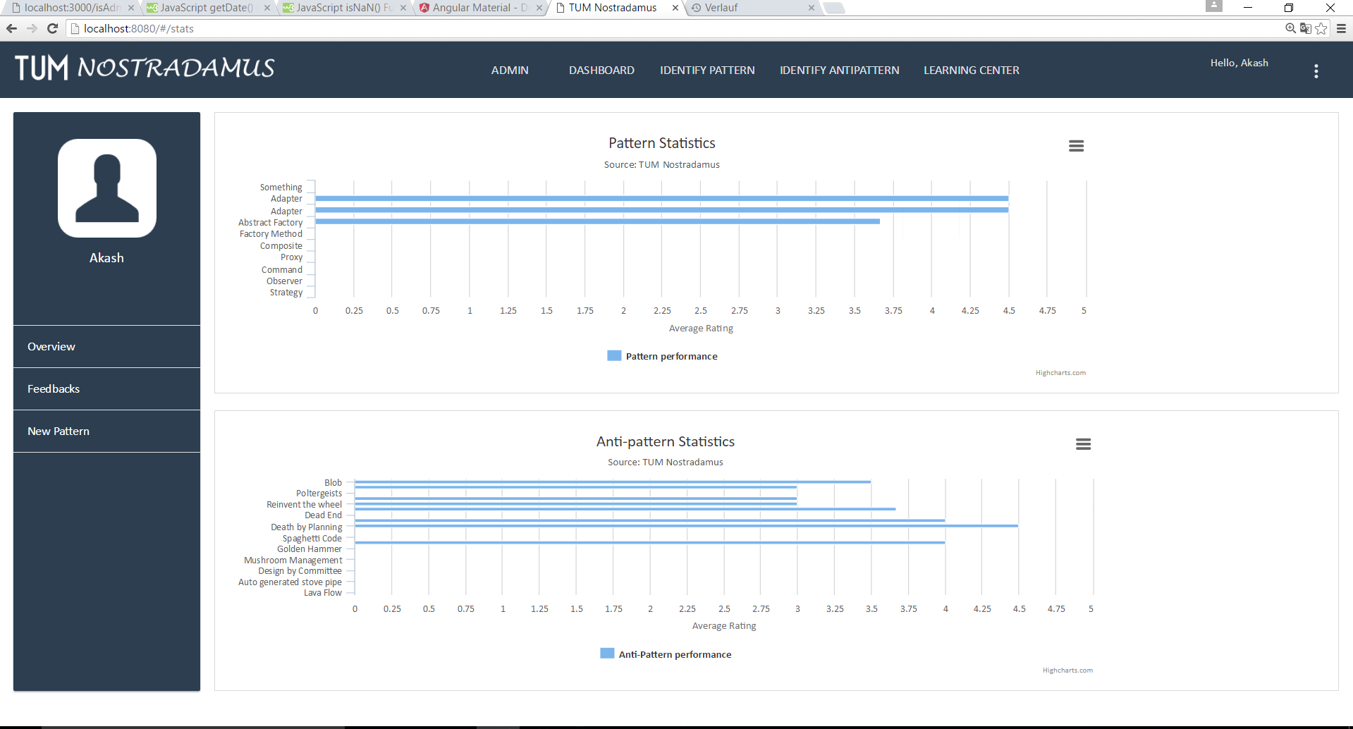

**Scenario:** User Feedback View

**Description:** The Feedback view page enables the administrator to check the latest feedbacks provided by the users of the application. This information allows the administrator to understand the kind of use cases the application is working well and also the ones for which the result was not to the satisfaction to the user.

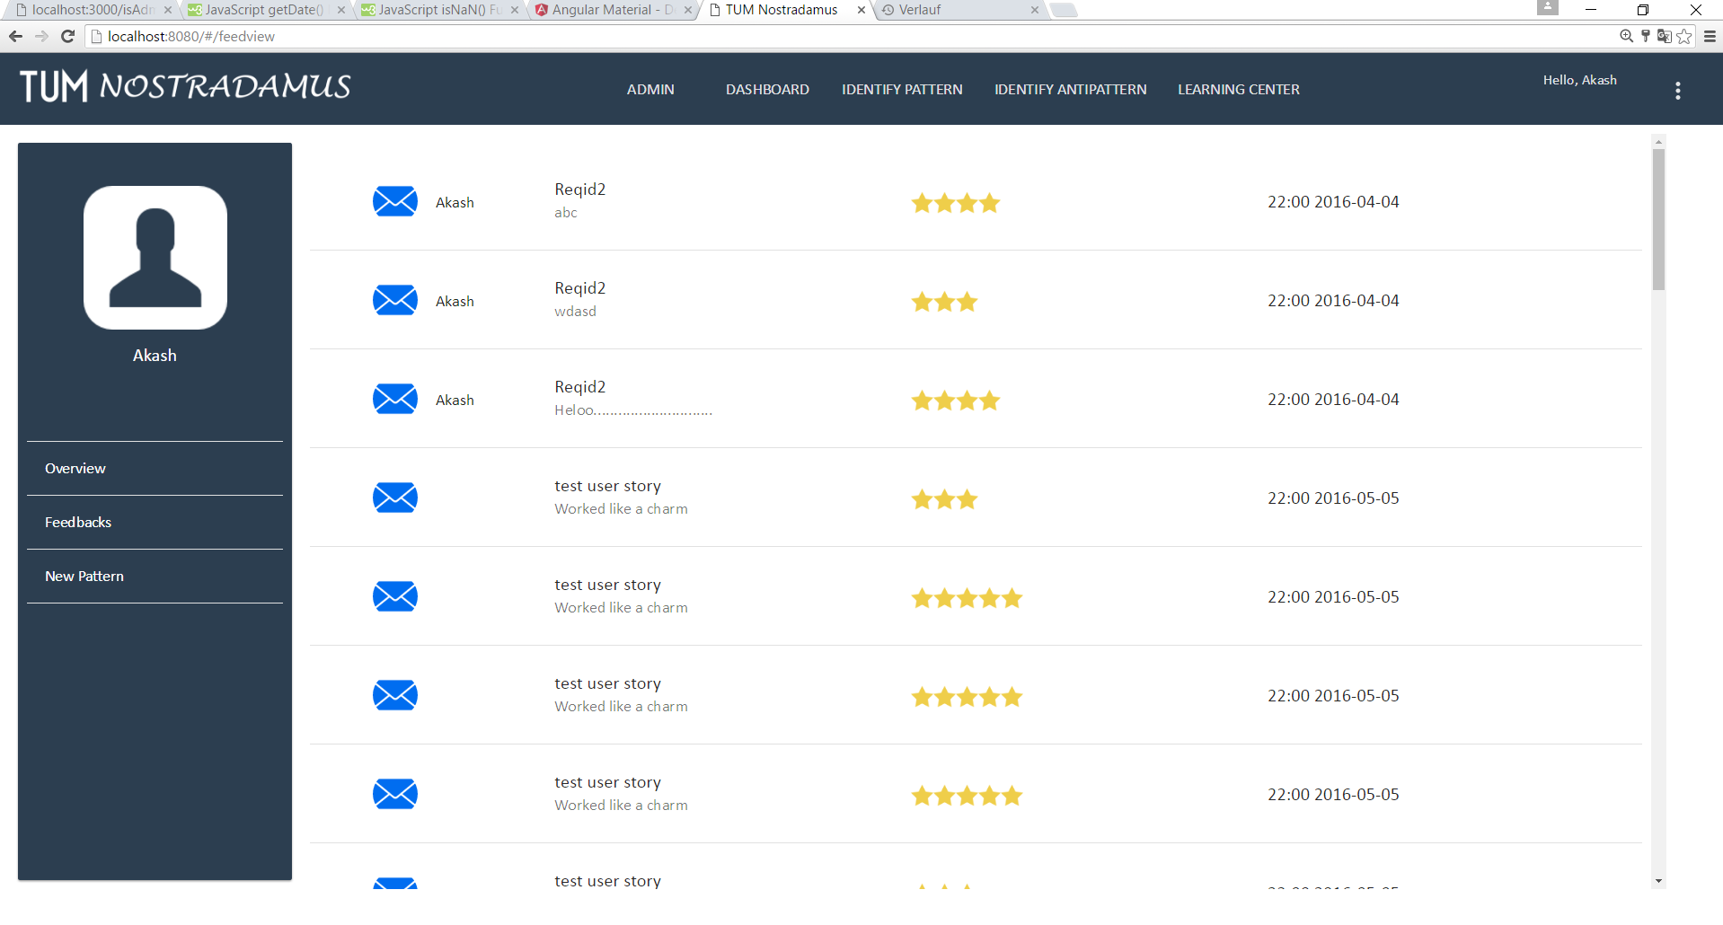

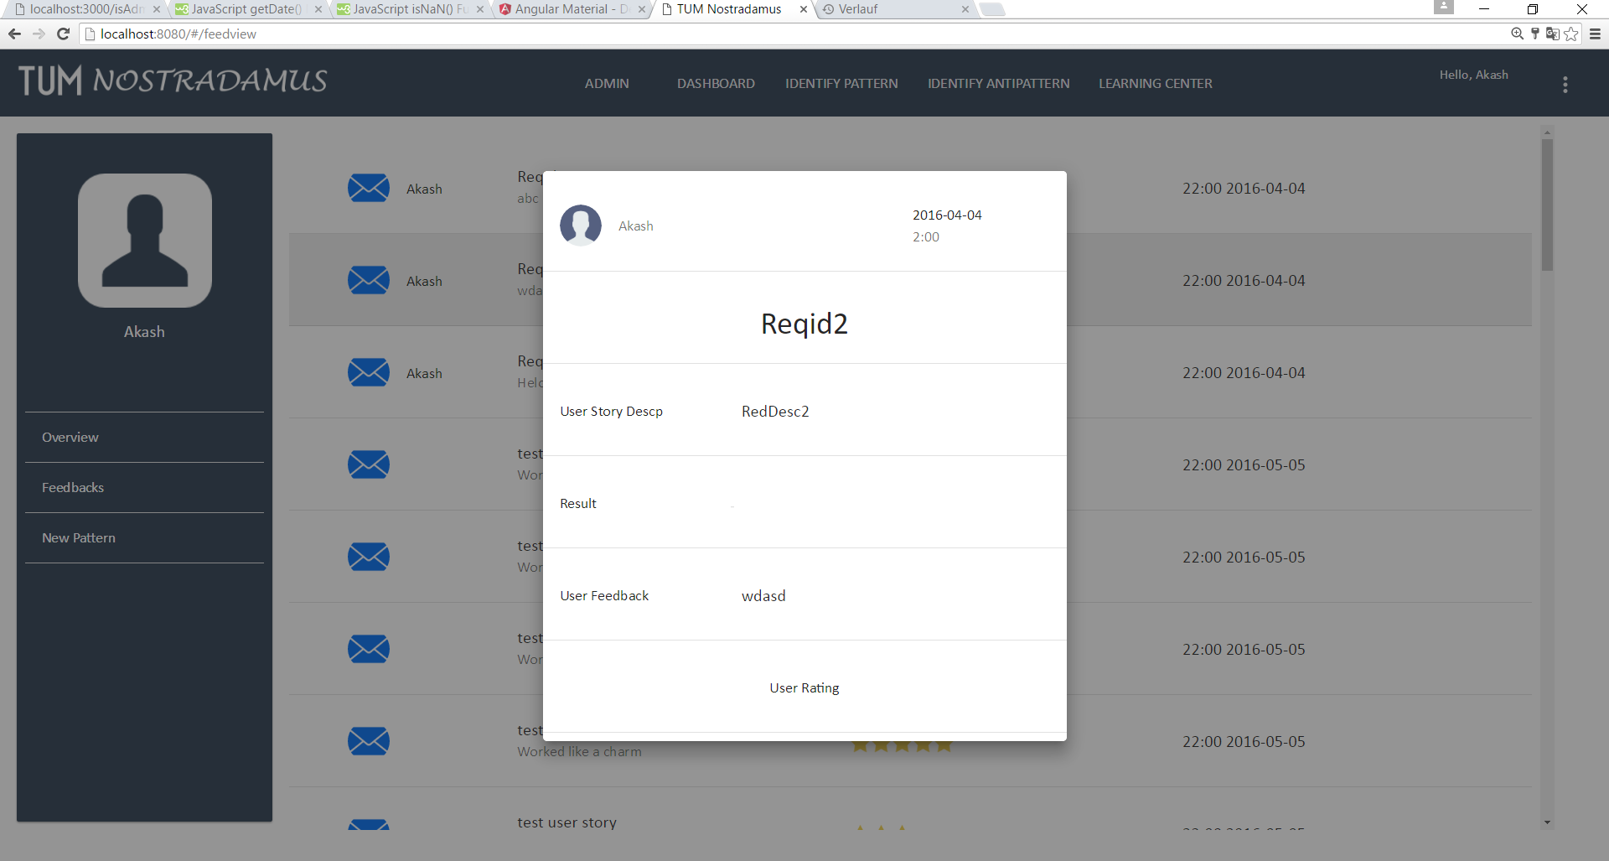

**Scenario:** New Pattern Suggestion View

**Description:** The Suggestion view page allows the administrator to access the new pattern suggestions provided by the users of the application. This information allows the administrator to understand the users perspective and to make changes to the existing business logic to add new patterns.

