📊 Resultados del Modelo VAR con Dummy Exógena

1️⃣ Información del Modelo
Lags óptimos (según AIC): 4
Variables incluidas: N_IPC, N_TCRM, N_PBI, N_TIR, N_S&P
Variable exógena incluida: Dummy de quiebre estructural (2021Q3 en adelante)

2️⃣ Resumen del Modelo VAR
Summary of Regression Results
==================================
Model: VAR
Method: OLS
Date: Fri, 24, Oct, 2025
Time: 01:27:57
--------------------------------------------------------------------
No. of Equations: 5.00000 BIC: -18.9047
Nobs: 35.0000 HQIC: -22.1055
Log likelihood: 278.062 FPE: 1.40178e-10
AIC: -23.7929 Det(Omega_mle): 1.22362e-11
--------------------------------------------------------------------
Results for equation N_IPC
================================================================================
coefficient std. error t-stat prob
--------------------------------------------------------------------------------
const 0.000318 0.001076 0.295 0.768
dummy_quiebre -0.001119 0.001720 -0.651 0.515
L1.N_IPC -0.112219 0.200762 -0.559 0.576
L1.N_TCRM -0.008348 0.038693 -0.216 0.829
L1.N_PBI 0.008755 0.011705 0.748 0.455
L1.N_TIR -0.000491 0.000315 -1.557 0.120
L1.N_S&P -0.012926 0.010324 -1.252 0.211
L2.N_IPC 0.501171 0.199719 2.509 0.012
L2.N_TCRM 0.093183 0.034722 2.684 0.007
L2.N_PBI 0.000306 0.015609 0.020 0.984
L2.N_TIR 0.000321 0.000375 0.858 0.391
L2.N_S&P -0.002536 0.010718 -0.237 0.813
L3.N_IPC 0.260060 0.201473 1.291 0.197
L3.N_TCRM 0.025918 0.039709 0.653 0.514
L3.N_PBI -0.004111 0.015418 -0.267 0.790
L3.N_TIR 0.001067 0.000379 2.816 0.005
L3.N_S&P -0.004543 0.013704 -0.332 0.740
L4.N_IPC 0.011582 0.140756 0.082 0.934
L4.N_TCRM 0.159501 0.042268 3.774 0.000
L4.N_PBI 0.003575 0.014655 0.244 0.807
L4.N_TIR 0.000708 0.000405 1.749 0.080
L4.N_S&P -0.003042 0.011493 -0.265 0.791
================================================================================
Results for equation N_TCRM
================================================================================
coefficient std. error t-stat prob
--------------------------------------------------------------------------------
const 0.006169 0.007652 0.806 0.420
dummy_quiebre -0.015921 0.012232 -1.302 0.193
L1.N_IPC -2.464844 1.427980 -1.726 0.084
L1.N_TCRM 0.096540 0.275212 0.351 0.726
L1.N_PBI 0.122926 0.083257 1.476 0.140
L1.N_TIR -0.004934 0.002243 -2.200 0.028
L1.N_S&P -0.071164 0.073430 -0.969 0.332
L2.N_IPC 1.693889 1.420562 1.192 0.233
L2.N_TCRM -0.024895 0.246968 -0.101 0.920
L2.N_PBI 0.099347 0.111020 0.895 0.371
L2.N_TIR 0.001320 0.002665 0.495 0.620
L2.N_S&P 0.230177 0.076235 3.019 0.003
L3.N_IPC 0.117931 1.433035 0.082 0.934
L3.N_TCRM 0.397179 0.282438 1.406 0.160
L3.N_PBI -0.146421 0.109665 -1.335 0.182
L3.N_TIR 0.002827 0.002697 1.048 0.295
L3.N_S&P -0.104933 0.097473 -1.077 0.282
L4.N_IPC -0.712332 1.001167 -0.712 0.477
L4.N_TCRM -0.439320 0.300641 -1.461 0.144
L4.N_PBI -0.086774 0.104237 -0.832 0.405
L4.N_TIR -0.003180 0.002879 -1.105 0.269
L4.N_S&P 0.010432 0.081744 0.128 0.898
================================================================================
Results for equation N_PBI
================================================================================
coefficient std. error t-stat prob
--------------------------------------------------------------------------------
const 0.001576 0.021566 0.073 0.942
dummy_quiebre -0.003968 0.034476 -0.115 0.908
L1.N_IPC -5.821048 4.024667 -1.446 0.148
L1.N_TCRM -0.443006 0.775666 -0.571 0.568
L1.N_PBI -0.231685 0.234655 -0.987 0.323
L1.N_TIR -0.009586 0.006321 -1.517 0.129
L1.N_S&P -0.651942 0.206959 -3.150 0.002
L2.N_IPC 5.179154 4.003759 1.294 0.196
L2.N_TCRM 0.715662 0.696064 1.028 0.304
L2.N_PBI -0.048434 0.312903 -0.155 0.877
L2.N_TIR -0.010226 0.007512 -1.361 0.173
L2.N_S&P 0.492039 0.214865 2.290 0.022
L3.N_IPC 4.596171 4.038914 1.138 0.255
L3.N_TCRM 0.649266 0.796033 0.816 0.415
L3.N_PBI -0.504642 0.309084 -1.633 0.103
L3.N_TIR 0.013817 0.007600 1.818 0.069
L3.N_S&P -0.205923 0.274720 -0.750 0.454
L4.N_IPC -1.903794 2.821722 -0.675 0.500
L4.N_TCRM 1.451856 0.847337 1.713 0.087
L4.N_PBI -0.624218 0.293785 -2.125 0.034
L4.N_TIR -0.000309 0.008114 -0.038 0.970
L4.N_S&P -0.057222 0.230390 -0.248 0.804
================================================================================
Results for equation N_TIR
================================================================================
coefficient std. error t-stat prob
--------------------------------------------------------------------------------
const 0.171764 0.939688 0.183 0.855
dummy_quiebre 0.144207 1.502185 0.096 0.924
L1.N_IPC 177.323202 175.364654 1.011 0.312
L1.N_TCRM -11.488485 33.797689 -0.340 0.734
L1.N_PBI -8.865818 10.224486 -0.867 0.386
L1.N_TIR -0.302325 0.275421 -1.098 0.272
L1.N_S&P 2.612215 9.017703 0.290 0.772
L2.N_IPC -56.961715 174.453627 -0.327 0.744
L2.N_TCRM 21.040524 30.329232 0.694 0.488
L2.N_PBI -5.187651 13.633971 -0.380 0.704
L2.N_TIR -0.164114 0.327321 -0.501 0.616
L2.N_S&P -3.649820 9.362181 -0.390 0.697
L3.N_IPC 90.914026 175.985428 0.517 0.605
L3.N_TCRM 31.367421 34.685129 0.904 0.366
L3.N_PBI 0.232841 13.467539 0.017 0.986
L3.N_TIR -0.201368 0.331161 -0.608 0.543
L3.N_S&P 4.682552 11.970239 0.391 0.696
L4.N_IPC 115.219423 122.949395 0.937 0.349
L4.N_TCRM 45.074217 36.920580 1.221 0.222
L4.N_PBI -4.994613 12.800951 -0.390 0.696
L4.N_TIR -0.081665 0.353541 -0.231 0.817
L4.N_S&P -1.519287 10.038647 -0.151 0.880
================================================================================
Results for equation N_S&P
================================================================================
coefficient std. error t-stat prob
--------------------------------------------------------------------------------
const 0.005257 0.025990 0.202 0.840
dummy_quiebre -0.021455 0.041548 -0.516 0.606
L1.N_IPC -0.307649 4.850300 -0.063 0.949
L1.N_TCRM -0.712301 0.934789 -0.762 0.446
L1.N_PBI 0.517733 0.282793 1.831 0.067
L1.N_TIR -0.002824 0.007618 -0.371 0.711
L1.N_S&P 0.484991 0.249415 1.945 0.052
L2.N_IPC -6.306229 4.825102 -1.307 0.191
L2.N_TCRM -0.855842 0.838857 -1.020 0.308
L2.N_PBI 0.359692 0.377093 0.954 0.340
L2.N_TIR 0.008508 0.009053 0.940 0.347
L2.N_S&P -0.173020 0.258943 -0.668 0.504
L3.N_IPC 1.540065 4.867469 0.316 0.752
L3.N_TCRM 1.245513 0.959334 1.298 0.194
L3.N_PBI 0.285823 0.372490 0.767 0.443
L3.N_TIR 0.001587 0.009159 0.173 0.862
L3.N_S&P 0.278892 0.331077 0.842 0.400
L4.N_IPC 0.937823 3.400579 0.276 0.783
L4.N_TCRM -0.580798 1.021163 -0.569 0.570
L4.N_PBI 0.040940 0.354053 0.116 0.908
L4.N_TIR 0.003906 0.009778 0.399 0.690
L4.N_S&P -0.454395 0.277653 -1.637 0.102
================================================================================
Correlation matrix of residuals
N_IPC N_TCRM N_PBI N_TIR N_S&P
N_IPC 1.000000 -0.234275 0.064833 -0.138788 0.433619
N_TCRM -0.234275 1.000000 0.252933 -0.068445 -0.377498
N_PBI 0.064833 0.252933 1.000000 -0.028444 -0.076280
N_TIR -0.138788 -0.068445 -0.028444 1.000000 -0.354710
N_S&P 0.433619 -0.377498 -0.076280 -0.354710 1.000000

3️⃣ Matriz de Correlación entre Variables
N_IPC N_TCRM N_PBI N_TIR N_S&P
N_IPC 1.000000 -0.467670 -0.081097 0.166909 0.171329
N_TCRM -0.467670 1.000000 0.426192 -0.290281 -0.096098
N_PBI -0.081097 0.426192 1.000000 -0.023605 -0.332080
N_TIR 0.166909 -0.290281 -0.023605 1.000000 -0.086081
N_S&P 0.171329 -0.096098 -0.332080 -0.086081 1.000000

4️⃣ Prueba de Multicolinealidad (VIF)
- N_IPC: VIF = 1.36 → ✅ Bajo riesgo de multicolinealidad
- N_TCRM: VIF = 1.72 → ✅ Bajo riesgo de multicolinealidad
- N_PBI: VIF = 1.43 → ✅ Bajo riesgo de multicolinealidad
- N_TIR: VIF = 1.12 → ✅ Bajo riesgo de multicolinealidad
- N_S&P: VIF = 1.19 → ✅ Bajo riesgo de multicolinealidad

5️⃣ Prueba de Causalidad de Granger
Hipótesis nula (H₀): la variable de la fila NO causa a la variable de la columna.
Periodo F_stat p_value
0 2017Q3 1.373890 0.262938
1 2017Q4 1.378086 0.261411
2 2018Q1 1.465963 0.231251
3 2018Q2 1.654530 0.177265
4 2018Q3 1.804098 0.143323
5 2018Q4 2.039843 0.102415
6 2019Q1 2.169514 0.085140
7 2019Q2 2.164072 0.085802
8 2019Q3 2.229153 0.078215
9 2019Q4 2.216015 0.079690
10 2020Q1 2.329192 0.067859
11 2020Q2 2.276870 0.073089
12 2020Q3 2.082901 0.096318
13 2020Q4 1.064134 0.400292
14 2021Q1 1.028446 0.419457
15 2021Q2 1.289501 0.295445
16 2021Q3 5.345978 0.001333
17 2021Q4 3.688809 0.010494
18 2022Q1 0.876578 0.508976
19 2022Q2 0.606007 0.695831
20 2022Q3 0.361180 0.870768
21 2022Q4 0.367463 0.866642
22 2023Q1 0.267323 0.927269

6️⃣ Estabilidad del Modelo VAR
Raíces del polinomio AR: 3.102-0.000j, 1.831-0.000j, -1.472-0.279j, -1.472+0.279j, -0.794-1.069j, -0.794+1.069j, -0.578-1.036j, -0.578+1.036j, 0.714-0.917j, 0.714+0.917j, 1.045-0.482j, 1.045+0.482j, 0.823-0.787j, 0.823+0.787j, 0.486-1.023j, 0.486+1.023j, -0.917-0.628j, -0.917+0.628j, -0.647-0.882j, -0.647+0.882j
✅ El modelo es estable (todas las raíces están fuera del círculo unitario).

7️⃣ Pruebas de Diagnóstico de Residuos
🔹 Prueba de Autocorrelación (Ljung–Box):
- N_IPC: p-value = 0.7649 → ✅ Sin autocorrelación
- N_TCRM: p-value = 0.8786 → ✅ Sin autocorrelación
- N_PBI: p-value = 0.5918 → ✅ Sin autocorrelación
- N_TIR: p-value = 0.9097 → ✅ Sin autocorrelación
- N_S&P: p-value = 0.6613 → ✅ Sin autocorrelación
🔹 Prueba de Heterocedasticidad (ARCH):
- N_IPC: F p-value = 0.1520, LM p-value = 0.1499 → ✅ Varianza constante
- N_TCRM: F p-value = 0.9552, LM p-value = 0.9733 → ✅ Varianza constante
- N_PBI: F p-value = 0.5578, LM p-value = 0.6309 → ✅ Varianza constante
- N_TIR: F p-value = 0.9713, LM p-value = 0.9835 → ✅ Varianza constante
- N_S&P: F p-value = 0.9929, LM p-value = 0.9962 → ✅ Varianza constante
🔹 Prueba de Normalidad (Jarque–Bera):
- N_IPC: JB = 1.344, p-value = 0.5107 → ✅ Normalidad no rechazada
- N_TCRM: JB = 0.352, p-value = 0.8387 → ✅ Normalidad no rechazada
- N_PBI: JB = 0.729, p-value = 0.6945 → ✅ Normalidad no rechazada
- N_TIR: JB = 15.057, p-value = 0.0005 → ⚠️ Residuos no normales
- N_S&P: JB = 1.143, p-value = 0.5648 → ✅ Normalidad no rechazada

8️⃣ Funciones Impulso-Respuesta (N_S&P)
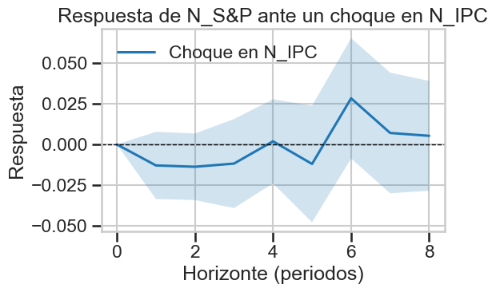
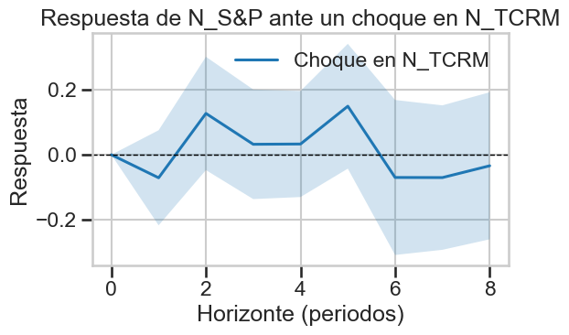
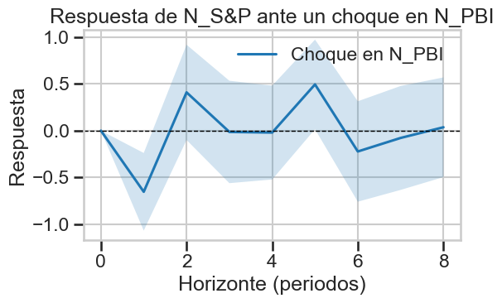
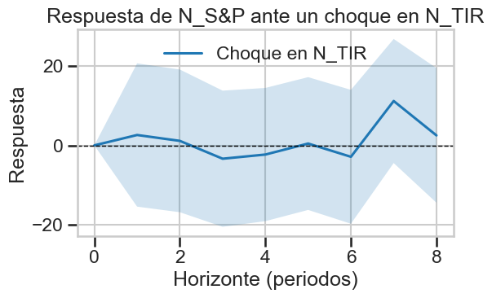

9️⃣ Prueba de Quiebre Estructural (Chow)
Periodo con mayor F: 2021Q3, F = 5.346, p-value = 0.0013
❌ Se rechaza H₀ → Cambio estructural detectado en 2021Q3

