📊 Resultados del Modelo VAR

1️⃣ Información del Modelo
Lags óptimos (según AIC): 4
Variables incluidas: N_IPC, N_TCRM, N_PBI, N_TIR, N_S&P

2️⃣ Resumen del Modelo VAR
Summary of Regression Results
==================================
Model: VAR
Method: OLS
Date: Tue, 21, Oct, 2025
Time: 21:28:57
--------------------------------------------------------------------
No. of Equations: 5.00000 BIC: -19.1683
Nobs: 35.0000 HQIC: -22.2236
Log likelihood: 273.786 FPE: 1.13089e-10
AIC: -23.8343 Det(Omega_mle): 1.07850e-11
--------------------------------------------------------------------
Results for equation N_IPC
============================================================================
coefficient std. error t-stat prob
----------------------------------------------------------------------------
const -0.000164 0.000764 -0.215 0.830
L1.N_IPC -0.098167 0.195446 -0.502 0.615
L1.N_TCRM -0.000293 0.035897 -0.008 0.993
L1.N_PBI 0.007466 0.011297 0.661 0.509
L1.N_TIR -0.000488 0.000309 -1.582 0.114
L1.N_S&P -0.012758 0.010106 -1.262 0.207
L2.N_IPC 0.534957 0.188843 2.833 0.005
L2.N_TCRM 0.097966 0.033229 2.948 0.003
L2.N_PBI -0.003198 0.014346 -0.223 0.824
L2.N_TIR 0.000366 0.000361 1.014 0.310
L2.N_S&P -0.002750 0.010490 -0.262 0.793
L3.N_IPC 0.259235 0.197278 1.314 0.189
L3.N_TCRM 0.028443 0.038696 0.735 0.462
L3.N_PBI -0.007557 0.014179 -0.533 0.594
L3.N_TIR 0.001071 0.000371 2.885 0.004
L3.N_S&P -0.006545 0.013076 -0.501 0.617
L4.N_IPC -0.002281 0.136241 -0.017 0.987
L4.N_TCRM 0.155582 0.040966 3.798 0.000
L4.N_PBI 0.002292 0.014220 0.161 0.872
L4.N_TIR 0.000680 0.000394 1.725 0.085
L4.N_S&P -0.002500 0.011224 -0.223 0.824
============================================================================
Results for equation N_TCRM
============================================================================
coefficient std. error t-stat prob
----------------------------------------------------------------------------
const -0.000685 0.005687 -0.120 0.904
L1.N_IPC -2.264966 1.454466 -1.557 0.119
L1.N_TCRM 0.211127 0.267137 0.790 0.429
L1.N_PBI 0.104596 0.084067 1.244 0.213
L1.N_TIR -0.004897 0.002297 -2.131 0.033
L1.N_S&P -0.068774 0.075205 -0.914 0.360
L2.N_IPC 2.174466 1.405331 1.547 0.122
L2.N_TCRM 0.043142 0.247284 0.174 0.862
L2.N_PBI 0.049499 0.106757 0.464 0.643
L2.N_TIR 0.001953 0.002685 0.727 0.467
L2.N_S&P 0.227141 0.078066 2.910 0.004
L3.N_IPC 0.106201 1.468100 0.072 0.942
L3.N_TCRM 0.433102 0.287970 1.504 0.133
L3.N_PBI -0.195440 0.105518 -1.852 0.064
L3.N_TIR 0.002876 0.002762 1.041 0.298
L3.N_S&P -0.133409 0.097312 -1.371 0.170
L4.N_IPC -0.909523 1.013873 -0.897 0.370
L4.N_TCRM -0.495060 0.304863 -1.624 0.104
L4.N_PBI -0.105030 0.105819 -0.993 0.321
L4.N_TIR -0.003585 0.002932 -1.223 0.221
L4.N_S&P 0.018136 0.083526 0.217 0.828
============================================================================
Results for equation N_PBI
============================================================================
coefficient std. error t-stat prob
----------------------------------------------------------------------------
const -0.000133 0.015085 -0.009 0.993
L1.N_IPC -5.771232 3.857739 -1.496 0.135
L1.N_TCRM -0.414447 0.708537 -0.585 0.559
L1.N_PBI -0.236253 0.222974 -1.060 0.289
L1.N_TIR -0.009577 0.006094 -1.572 0.116
L1.N_S&P -0.651346 0.199470 -3.265 0.001
L2.N_IPC 5.298930 3.727417 1.422 0.155
L2.N_TCRM 0.732619 0.655882 1.117 0.264
L2.N_PBI -0.060858 0.283156 -0.215 0.830
L2.N_TIR -0.010069 0.007121 -1.414 0.157
L2.N_S&P 0.491282 0.207057 2.373 0.018
L3.N_IPC 4.593248 3.893900 1.180 0.238
L3.N_TCRM 0.658219 0.763794 0.862 0.389
L3.N_PBI -0.516859 0.279869 -1.847 0.065
L3.N_TIR 0.013829 0.007327 1.887 0.059
L3.N_S&P -0.213020 0.258104 -0.825 0.409
L4.N_IPC -1.952941 2.689136 -0.726 0.468
L4.N_TCRM 1.437963 0.808600 1.778 0.075
L4.N_PBI -0.628768 0.280667 -2.240 0.025
L4.N_TIR -0.000409 0.007777 -0.053 0.958
L4.N_S&P -0.055302 0.221539 -0.250 0.803
============================================================================
Results for equation N_TIR
============================================================================
coefficient std. error t-stat prob
----------------------------------------------------------------------------
const 0.233847 0.657183 0.356 0.722
L1.N_IPC 175.512785 168.065149 1.044 0.296
L1.N_TCRM -12.526370 30.867913 -0.406 0.685
L1.N_PBI -8.699789 9.714026 -0.896 0.370
L1.N_TIR -0.302660 0.265475 -1.140 0.254
L1.N_S&P 2.590574 8.690039 0.298 0.766
L2.N_IPC -61.314613 162.387555 -0.378 0.706
L2.N_TCRM 20.424268 28.573949 0.715 0.475
L2.N_PBI -4.736141 12.335898 -0.384 0.701
L2.N_TIR -0.169843 0.310237 -0.547 0.584
L2.N_S&P -3.622327 9.020597 -0.402 0.688
L3.N_IPC 91.020277 169.640545 0.537 0.592
L3.N_TCRM 31.042038 33.275246 0.933 0.351
L3.N_PBI 0.676837 12.192683 0.056 0.956
L3.N_TIR -0.201816 0.319196 -0.632 0.527
L3.N_S&P 4.940475 11.244484 0.439 0.660
L4.N_IPC 117.005503 117.154132 0.999 0.318
L4.N_TCRM 45.579094 35.227237 1.294 0.196
L4.N_PBI -4.829250 12.227444 -0.395 0.693
L4.N_TIR -0.078000 0.338809 -0.230 0.818
L4.N_S&P -1.589071 9.651506 -0.165 0.869
============================================================================
Results for equation N_S&P
============================================================================
coefficient std. error t-stat prob
----------------------------------------------------------------------------
const -0.003979 0.018356 -0.217 0.828
L1.N_IPC -0.038292 4.694179 -0.008 0.993
L1.N_TCRM -0.557883 0.862163 -0.647 0.518
L1.N_PBI 0.493031 0.271320 1.817 0.069
L1.N_TIR -0.002774 0.007415 -0.374 0.708
L1.N_S&P 0.488211 0.242719 2.011 0.044
L2.N_IPC -5.658596 4.535599 -1.248 0.212
L2.N_TCRM -0.764155 0.798091 -0.957 0.338
L2.N_PBI 0.292515 0.344550 0.849 0.396
L2.N_TIR 0.009360 0.008665 1.080 0.280
L2.N_S&P -0.177110 0.251952 -0.703 0.482
L3.N_IPC 1.524257 4.738181 0.322 0.748
L3.N_TCRM 1.293924 0.929401 1.392 0.164
L3.N_PBI 0.219765 0.340550 0.645 0.519
L3.N_TIR 0.001653 0.008915 0.185 0.853
L3.N_S&P 0.240518 0.314066 0.766 0.444
L4.N_IPC 0.672086 3.272198 0.205 0.837
L4.N_TCRM -0.655914 0.983922 -0.667 0.505
L4.N_PBI 0.016337 0.341521 0.048 0.962
L4.N_TIR 0.003361 0.009463 0.355 0.722
L4.N_S&P -0.444013 0.269573 -1.647 0.100
============================================================================
Correlation matrix of residuals
N_IPC N_TCRM N_PBI N_TIR N_S&P
N_IPC 1.000000 -0.156535 0.069437 -0.141260 0.447597
N_TCRM -0.156535 1.000000 0.248619 -0.073393 -0.303344
N_PBI 0.069437 0.248619 1.000000 -0.029269 -0.070947
N_TIR -0.141260 -0.073393 -0.029269 1.000000 -0.354776
N_S&P 0.447597 -0.303344 -0.070947 -0.354776 1.000000

3️⃣ Pruebas de Diagnóstico
🔹 Prueba de Autocorrelación (Ljung-Box):
- N_IPC: p-value = 0.9055 → ✅ Sin autocorrelación
- N_TCRM: p-value = 0.7840 → ✅ Sin autocorrelación
- N_PBI: p-value = 0.5891 → ✅ Sin autocorrelación
- N_TIR: p-value = 0.8996 → ✅ Sin autocorrelación
- N_S&P: p-value = 0.7486 → ✅ Sin autocorrelación
🔹 Prueba de Heterocedasticidad (ARCH):
- N_IPC: F p-value = 0.1379, LM p-value = 0.1320 → ✅ Varianza constante
- N_TCRM: F p-value = 0.9483, LM p-value = 0.9687 → ✅ Varianza constante
- N_PBI: F p-value = 0.5512, LM p-value = 0.6240 → ✅ Varianza constante
- N_TIR: F p-value = 0.9712, LM p-value = 0.9834 → ✅ Varianza constante
- N_S&P: F p-value = 0.9967, LM p-value = 0.9983 → ✅ Varianza constante
🔹 Prueba de Normalidad (Jarque–Bera):
- N_IPC: JB = 3.265, p-value = 0.1955 → ✅ Normalidad no rechazada
- N_TCRM: JB = 0.381, p-value = 0.8265 → ✅ Normalidad no rechazada
- N_PBI: JB = 0.782, p-value = 0.6765 → ✅ Normalidad no rechazada
- N_TIR: JB = 14.168, p-value = 0.0008 → ⚠️ Residuos no normales
- N_S&P: JB = 1.846, p-value = 0.3972 → ✅ Normalidad no rechazada

4️⃣ Estabilidad del Modelo VAR
¿El modelo es estable?: ✅ Sí
Raíces del polinomio AR: 3.138-0.000j, 1.561-0.000j, -1.504+0.323j, -1.504-0.323j, -0.820-1.040j, -0.820+1.040j, -0.575-1.048j, -0.575+1.048j, 0.733-0.914j, 0.733+0.914j, 0.831-0.789j, 0.831+0.789j, 0.483+1.033j, 0.483-1.033j, 1.023+0.478j, 1.023-0.478j, -0.917+0.623j, -0.917-0.623j, -0.650-0.887j, -0.650+0.887j
⚠️ Algunas raíces fuera del círculo unitario → modelo inestable.

5️⃣ Funciones Impulso-Respuesta (IRF)
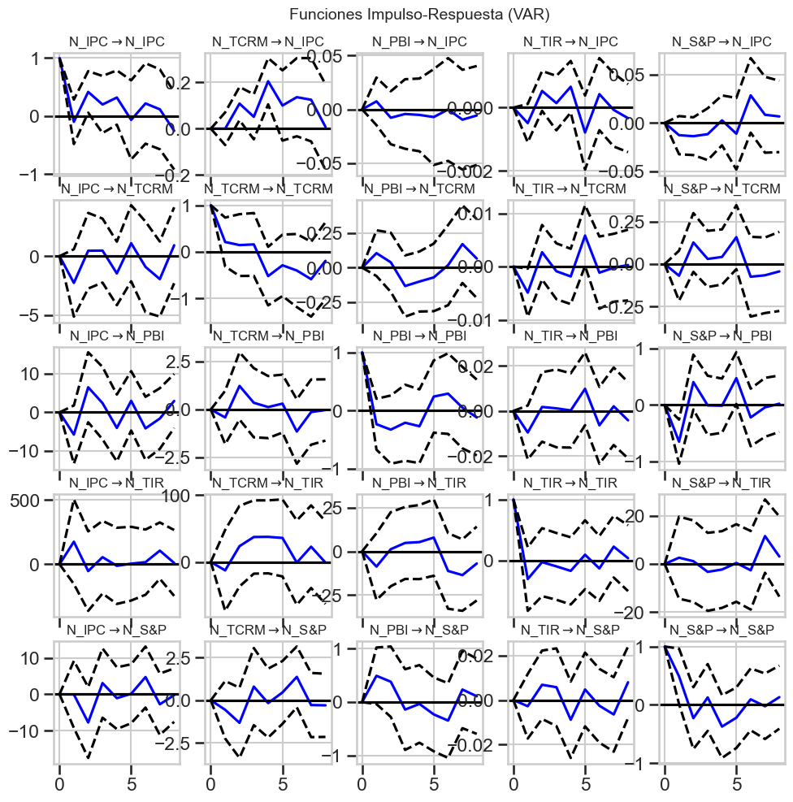
Nota: Gráfico IRF con horizonte de 8 períodos.

