datos

Autogenerated data summary from dataMaid

2025-03-25 10:11:20.505109

# Data report overview

The dataset examined has the following dimensions:

| Feature | Result |
| --- | --- |
| Number of observations | 631 |
| Number of variables | 41 |

### Checks performed

The following variable checks were performed, depending on the data type of each variable:

|  | character | factor | labelled | haven labelled | numeric | integer | logical | Date |
| --- | --- | --- | --- | --- | --- | --- | --- | --- |
| Identify miscoded missing values | × | × | × | × | × | × |  | × |
| Identify prefixed and suffixed whitespace | × | × | × | × |  |  |  |  |
| Identify levels with < 6 obs. | × | × | × | × |  |  |  |  |
| Identify case issues | × | × | × | × |  |  |  |  |
| Identify misclassified numeric or integer variables | × | × | × | × |  |  |  |  |
| Identify outliers |  |  |  |  | × | × |  | × |

Please note that all numerical values in the following have been rounded to 2 decimals.

# Summary table

|  | Variable class | # unique values | Missing observations | Any problems? |
| --- | --- | --- | --- | --- |
| Depart | character | 2 | 0.00 % |  |
| Provincia | character | 3 | 56.58 % |  |
| Distrito | character | 4 | 56.58 % |  |
| Localidad | character | 13 | 0.00 % |  |
| Estación | character | 11 | 0.00 % |  |
| DAP | numeric | 310 | 0.00 % |  |
| Diam_copa | numeric | 306 | 0.00 % | × |
| Altura_ram | numeric | 110 | 0.16 % | × |
| Altura_total | numeric | 123 | 0.00 % | × |
| Num_ramas_XX | numeric | 16 | 56.89 % | × |
| Forma_arbol | factor | 3 | 0.00 % |  |
| Forma_leg | factor | 3 | 0.00 % |  |
| Calidad_tronco | factor | 3 | 0.00 % |  |
| Cal_tronq_leg | factor | 3 | 0.00 % |  |
| Produccion_frutos | factor | 5 | 0.00 % |  |
| Prod_fru_leg | factor | 5 | 0.00 % |  |
| Calidad_frutos | factor | 4 | 0.00 % |  |
| Cal_fru_leg | factor | 4 | 0.00 % |  |
| Calidad_follaje | factor | 3 | 0.00 % |  |
| Cal_foll_leg | factor | 3 | 0.00 % |  |
| Bifurcacion | factor | 3 | 0.00 % |  |
| Bif_leg | factor | 3 | 0.00 % |  |
| fito_IIhEd _k | factor | 8 | 93.66 % | × |
| fito_IIhHt_l | factor | 8 | 93.66 % | × |
| fito_IIhM_m | factor | 8 | 93.66 % | × |
| fito_IItM_n | factor | 3 | 93.66 % | × |
| fito_IItcbB_o_XX | factor | 3 | 96.35 % | × |
| fito_IItssHC_p_XX | factor | 4 | 96.35 % | × |
| fito_IIrssHC_q_XX | factor | 3 | 96.35 % | × |
| fito_PsCh_r | factor | 5 | 93.66 % | × |
| fito_PsAh_s_XX | factor | 6 | 96.20 % | × |
| fito_PsLtr_t | factor | 4 | 93.66 % |  |
| Parasitos_XX | factor | 2 | 92.39 % | × |
| Carbonatos | numeric | 10 | 0.00 % | × |
| CE | numeric | 13 | 0.00 % | × |
| Fosforo | numeric | 13 | 0.00 % | × |
| Mat_Org | numeric | 13 | 0.00 % |  |
| Nitrogeno | numeric | 6 | 0.00 % | × |
| Potasio | numeric | 13 | 0.00 % | × |
| pH | numeric | 12 | 0.00 % |  |
| Suelo | factor | 2 | 0.00 % |  |

# Variable list

## Depart

| Feature | Result |
| --- | --- |
| Variable type | character |
| Number of missing obs. | 0 (0 %) |
| Number of unique values | 2 |
| Mode | “Piura” |

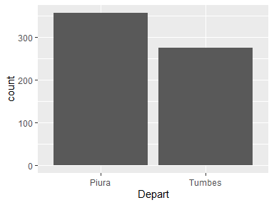

## Provincia

| Feature | Result |
| --- | --- |
| Variable type | character |
| Number of missing obs. | 357 (56.58 %) |
| Number of unique values | 2 |
| Mode | “Tumbes” |

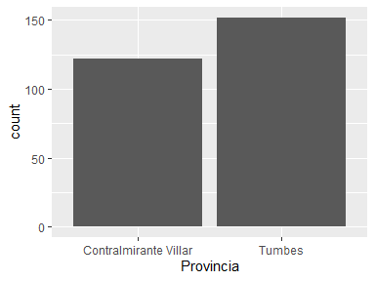

## Distrito

| Feature | Result |
| --- | --- |
| Variable type | character |
| Number of missing obs. | 357 (56.58 %) |
| Number of unique values | 3 |
| Mode | “Zorritos” |

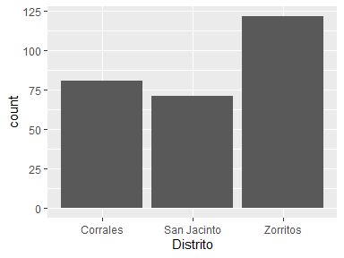

## Localidad

| Feature | Result |
| --- | --- |
| Variable type | character |
| Number of missing obs. | 0 (0 %) |
| Number of unique values | 13 |
| Mode | “INIA” |

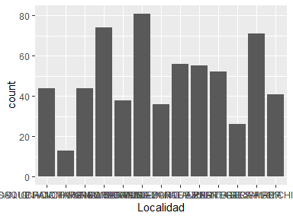

## Estación

| Feature | Result |
| --- | --- |
| Variable type | character |
| Number of missing obs. | 0 (0 %) |
| Number of unique values | 11 |
| Mode | “EM 03” |

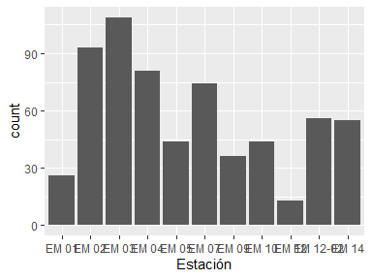

## DAP

| Feature | Result |
| --- | --- |
| Variable type | numeric |
| Number of missing obs. | 0 (0 %) |
| Number of unique values | 310 |
| Median | 24.51 |
| 1st and 3rd quartiles | 16.55; 40.66 |
| Min. and max. | 10.19; 150.24 |

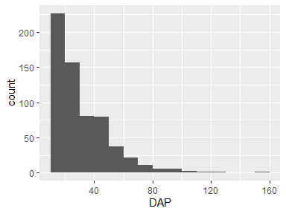

## Diam_copa

| Feature | Result |
| --- | --- |
| Variable type | numeric |
| Number of missing obs. | 0 (0 %) |
| Number of unique values | 306 |
| Median | 8.85 |
| 1st and 3rd quartiles | 6.47; 13.03 |
| Min. and max. | 1.7; 48.8 |

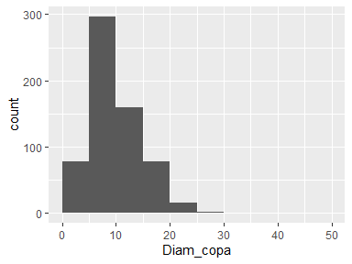

* Note that the following possible outlier values were detected: "1.7", "2.25", "2.4", "2.45", "2.55", "2.95", "36.25", "48.8".

## Altura_ram

| Feature | Result |
| --- | --- |
| Variable type | numeric |
| Number of missing obs. | 1 (0.16 %) |
| Number of unique values | 109 |
| Median | 2.1 |
| 1st and 3rd quartiles | 1.7; 3.4 |
| Min. and max. | 0.15; 11.1 |

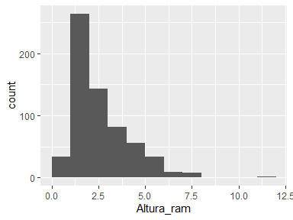

* Note that the following possible outlier values were detected: "0.15", "0.3", "0.4", "0.5", "0.53", …, "0.7", "0.8", "1", "1.1", "1.2" (1 values omitted).

## Altura_total

| Feature | Result |
| --- | --- |
| Variable type | numeric |
| Number of missing obs. | 0 (0 %) |
| Number of unique values | 123 |
| Median | 9.5 |
| 1st and 3rd quartiles | 7.5; 11.95 |
| Min. and max. | 3.2; 28 |

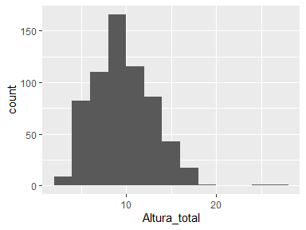

* Note that the following possible outlier values were detected: "25", "28".

## Num_ramas_XX

| Feature | Result |
| --- | --- |
| Variable type | numeric |
| Number of missing obs. | 359 (56.89 %) |
| Number of unique values | 15 |
| Median | 5 |
| 1st and 3rd quartiles | 4; 7 |
| Min. and max. | 2; 16 |

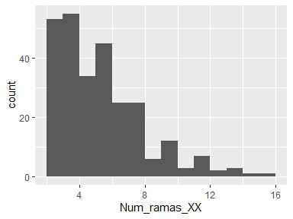

* Note that the following possible outlier values were detected: "16".

## Forma_arbol

| Feature | Result |
| --- | --- |
| Variable type | factor |
| Number of missing obs. | 0 (0 %) |
| Number of unique values | 3 |
| Mode | “2” |
| Reference category | 1 |

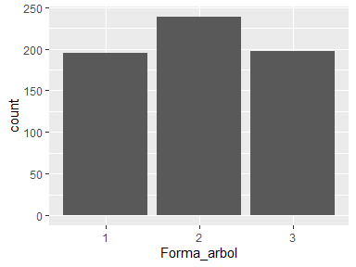

## Forma_leg

| Feature | Result |
| --- | --- |
| Variable type | factor |
| Number of missing obs. | 0 (0 %) |
| Number of unique values | 3 |
| Mode | “intermedios” |
| Reference category | intermedios |

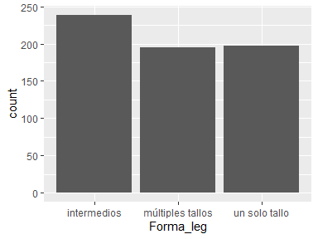

## Calidad_tronco

| Feature | Result |
| --- | --- |
| Variable type | factor |
| Number of missing obs. | 0 (0 %) |
| Number of unique values | 3 |
| Mode | “2” |
| Reference category | 1 |

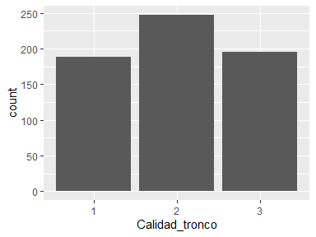

## Cal_tronq_leg

| Feature | Result |
| --- | --- |
| Variable type | factor |
| Number of missing obs. | 0 (0 %) |
| Number of unique values | 3 |
| Mode | “regular defectos” |
| Reference category | defectuoso |

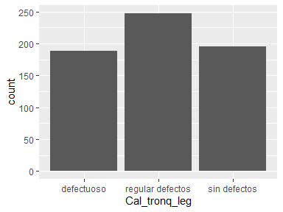

## Produccion_frutos

| Feature | Result |
| --- | --- |
| Variable type | factor |
| Number of missing obs. | 0 (0 %) |
| Number of unique values | 5 |
| Mode | “0” |
| Reference category | 0 |

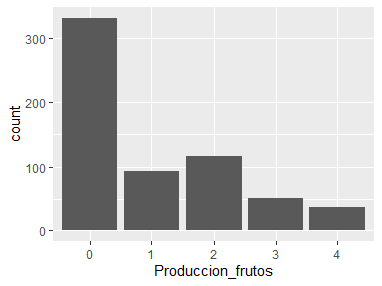

## Prod_fru_leg

| Feature | Result |
| --- | --- |
| Variable type | factor |
| Number of missing obs. | 0 (0 %) |
| Number of unique values | 5 |
| Mode | “Sin frutos” |
| Reference category | 100% de las ramas |

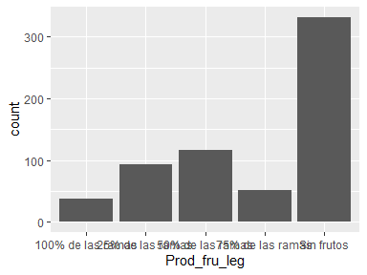

## Calidad_frutos

| Feature | Result |
| --- | --- |
| Variable type | factor |
| Number of missing obs. | 0 (0 %) |
| Number of unique values | 4 |
| Mode | “0” |
| Reference category | 0 |

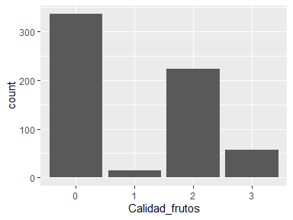

## Cal_fru_leg

| Feature | Result |
| --- | --- |
| Variable type | factor |
| Number of missing obs. | 0 (0 %) |
| Number of unique values | 4 |
| Mode | “amargo” |
| Reference category | amargo |

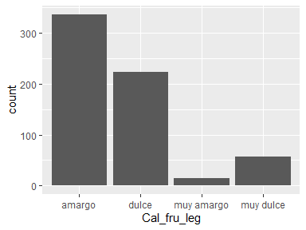

## Calidad_follaje

| Feature | Result |
| --- | --- |
| Variable type | factor |
| Number of missing obs. | 0 (0 %) |
| Number of unique values | 3 |
| Mode | “2” |
| Reference category | 1 |

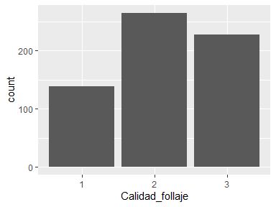

## Cal_foll_leg

| Feature | Result |
| --- | --- |
| Variable type | factor |
| Number of missing obs. | 0 (0 %) |
| Number of unique values | 3 |
| Mode | “2/3 de las ramas” |
| Reference category | 1/3 de las ramas |

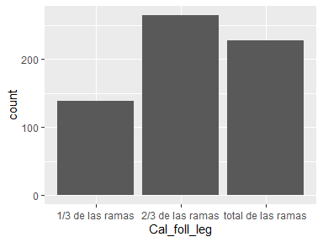

## Bifurcacion

| Feature | Result |
| --- | --- |
| Variable type | factor |
| Number of missing obs. | 0 (0 %) |
| Number of unique values | 3 |
| Mode | “3” |
| Reference category | 1 |

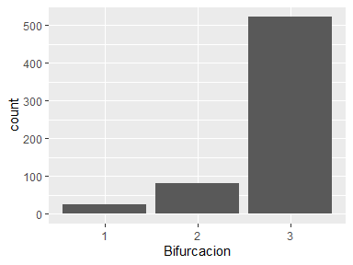

## Bif_leg

| Feature | Result |
| --- | --- |
| Variable type | factor |
| Number of missing obs. | 0 (0 %) |
| Number of unique values | 3 |
| Mode | “no presenta bifurcación” |
| Reference category | bifurcado a la altura del DAP |

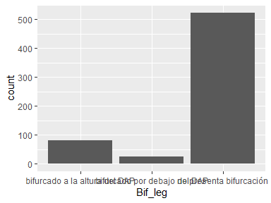

## fito_IIhEd _k

| Feature | Result |
| --- | --- |
| Variable type | factor |
| Number of missing obs. | 591 (93.66 %) |
| Number of unique values | 7 |
| Mode | “8” |
| Reference category | 4 |

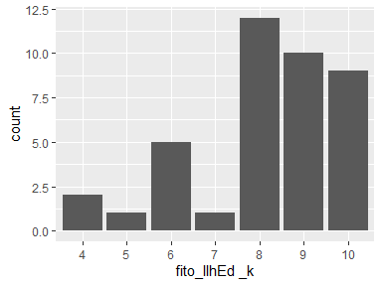

* The following suspected missing value codes enter as regular values: "8", "9".
* Note that the following levels have at most five observations: "4", "5", "6", "7".

## fito_IIhHt_l

| Feature | Result |
| --- | --- |
| Variable type | factor |
| Number of missing obs. | 591 (93.66 %) |
| Number of unique values | 7 |
| Mode | “8” |
| Reference category | 4 |

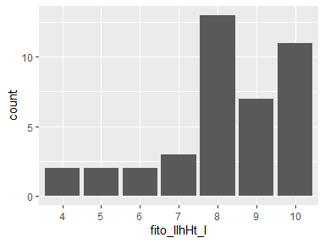

* The following suspected missing value codes enter as regular values: "8", "9".
* Note that the following levels have at most five observations: "4", "5", "6", "7".

## fito_IIhM_m

| Feature | Result |
| --- | --- |
| Variable type | factor |
| Number of missing obs. | 591 (93.66 %) |
| Number of unique values | 7 |
| Mode | “9” |
| Reference category | 4 |

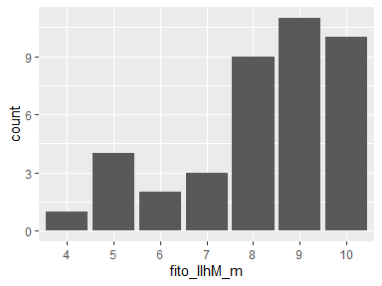

* The following suspected missing value codes enter as regular values: "8", "9".
* Note that the following levels have at most five observations: "4", "5", "6", "7".

## fito_IItM_n

| Feature | Result |
| --- | --- |
| Variable type | factor |
| Number of missing obs. | 591 (93.66 %) |
| Number of unique values | 2 |
| Mode | “4” |
| Reference category | 3 |

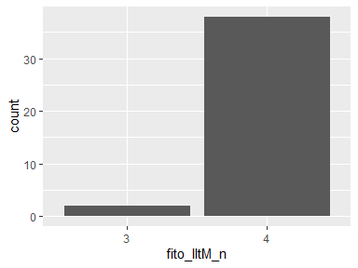

* Note that the following levels have at most five observations: "3".

## fito_IItcbB_o_XX

| Feature | Result |
| --- | --- |
| Variable type | factor |
| Number of missing obs. | 608 (96.35 %) |
| Number of unique values | 2 |
| Mode | “4” |
| Reference category | 3 |

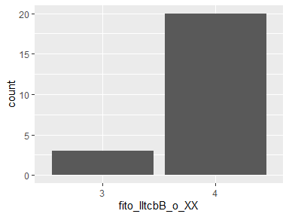

* Note that the following levels have at most five observations: "3".

## fito_IItssHC_p_XX

| Feature | Result |
| --- | --- |
| Variable type | factor |
| Number of missing obs. | 608 (96.35 %) |
| Number of unique values | 3 |
| Mode | “4” |
| Reference category | 2 |

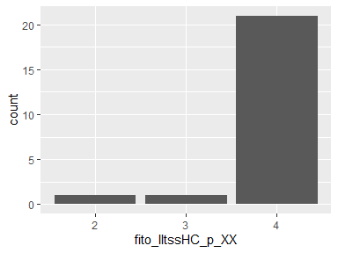

* Note that the following levels have at most five observations: "2", "3".

## fito_IIrssHC_q_XX

| Feature | Result |
| --- | --- |
| Variable type | factor |
| Number of missing obs. | 608 (96.35 %) |
| Number of unique values | 2 |
| Mode | “4” |
| Reference category | 3 |

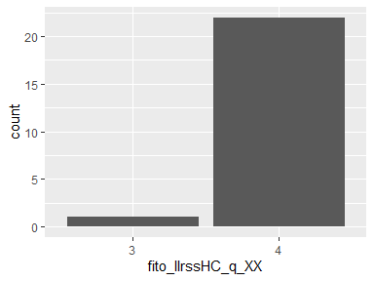

* Note that the following levels have at most five observations: "3".

## fito_PsCh_r

| Feature | Result |
| --- | --- |
| Variable type | factor |
| Number of missing obs. | 591 (93.66 %) |
| Number of unique values | 4 |
| Mode | “5” |
| Reference category | 2 |

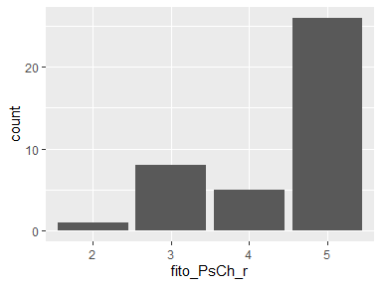

* Note that the following levels have at most five observations: "2", "4".

## fito_PsAh_s_XX

| Feature | Result |
| --- | --- |
| Variable type | factor |
| Number of missing obs. | 607 (96.2 %) |
| Number of unique values | 5 |
| Mode | “5” |
| Reference category | 0 |

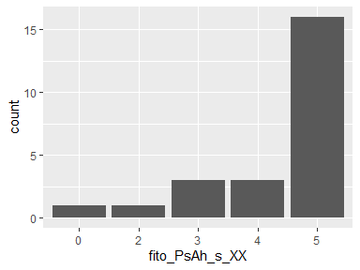

* Note that the following levels have at most five observations: "0", "2", "3", "4".

## fito_PsLtr_t

| Feature | Result |
| --- | --- |
| Variable type | factor |
| Number of missing obs. | 591 (93.66 %) |
| Number of unique values | 3 |
| Mode | “5” |
| Reference category | 3 |

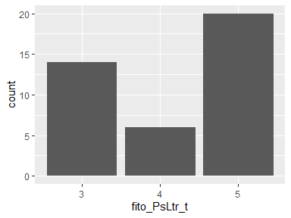

## Parasitos_XX

* The variable only takes one (non-missing) value: "Loranthaceae". The variable contains 92.39 % missing observations.

## Carbonatos

| Feature | Result |
| --- | --- |
| Variable type | numeric |
| Number of missing obs. | 0 (0 %) |
| Number of unique values | 10 |
| Median | 1.27 |
| 1st and 3rd quartiles | 0.09; 1.55 |
| Min. and max. | 0.09; 2.1 |

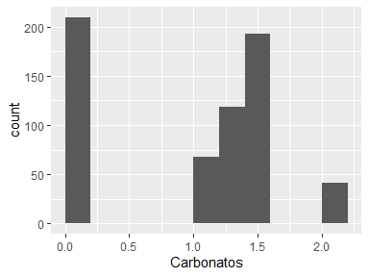

* Note that the following possible outlier values were detected: "2.1".

## CE

| Feature | Result |
| --- | --- |
| Variable type | numeric |
| Number of missing obs. | 0 (0 %) |
| Number of unique values | 13 |
| Median | 0.18 |
| 1st and 3rd quartiles | 0.11; 0.32 |
| Min. and max. | 0.03; 7.69 |

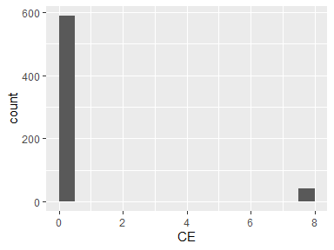

* Note that the following possible outlier values were detected: "0.03", "7.69".

## Fosforo

| Feature | Result |
| --- | --- |
| Variable type | numeric |
| Number of missing obs. | 0 (0 %) |
| Number of unique values | 13 |
| Median | 38.12 |
| 1st and 3rd quartiles | 27.82; 211 |
| Min. and max. | 8.42; 250.1 |

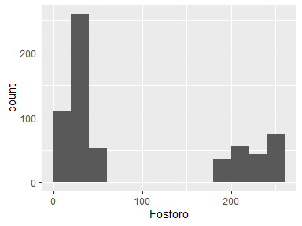

* Note that the following possible outlier values were detected: "8.42", "8.43", "8.89".

## Mat_Org

| Feature | Result |
| --- | --- |
| Variable type | numeric |
| Number of missing obs. | 0 (0 %) |
| Number of unique values | 13 |
| Median | 0.97 |
| 1st and 3rd quartiles | 0.48; 4.1 |
| Min. and max. | 0.19; 6.7 |

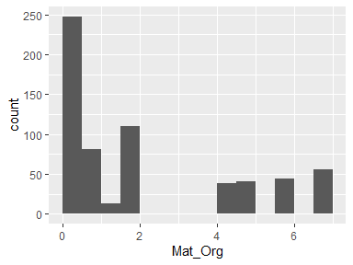

## Nitrogeno

| Feature | Result |
| --- | --- |
| Variable type | numeric |
| Number of missing obs. | 0 (0 %) |
| Number of unique values | 6 |
| Median | 0.09 |
| 1st and 3rd quartiles | 0.09; 0.1 |
| Min. and max. | 0.03; 0.2 |

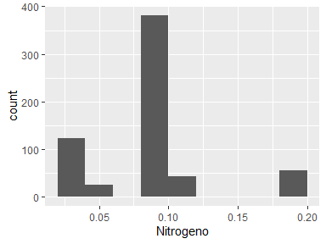

* Note that the following possible outlier values were detected: "0.03", "0.06", "0.12", "0.2".

## Potasio

| Feature | Result |
| --- | --- |
| Variable type | numeric |
| Number of missing obs. | 0 (0 %) |
| Number of unique values | 13 |
| Median | 267.4 |
| 1st and 3rd quartiles | 221.5; 465.85 |
| Min. and max. | 11.1; 1321.13 |

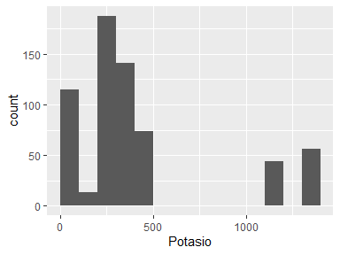

* Note that the following possible outlier values were detected: "11.1", "74.4".

## pH

| Feature | Result |
| --- | --- |
| Variable type | numeric |
| Number of missing obs. | 0 (0 %) |
| Number of unique values | 12 |
| Median | 7.51 |
| 1st and 3rd quartiles | 6.39; 8.42 |
| Min. and max. | 5.59; 8.68 |

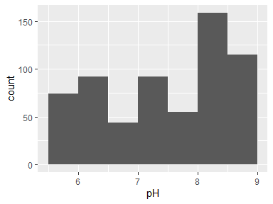

## Suelo

| Feature | Result |
| --- | --- |
| Variable type | factor |
| Number of missing obs. | 0 (0 %) |
| Number of unique values | 2 |
| Mode | “Franco Arenoso” |
| Reference category | Arenoso |

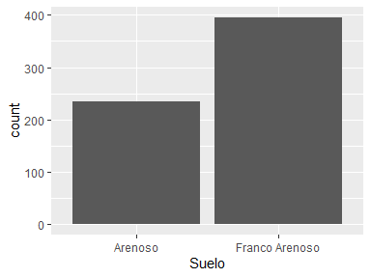

Report generation information:

* Created by: Sebas (username: SEBASTIAN).
* Report creation time: mar. Mar. 25 2025 10:11:21
* Report was run from directory: C:/Users/SEBASTIAN/Desktop/INIA EE EL CHIRA/GIT/INIA_algarrobo
* dataMaid v1.4.1 [Pkg: 2021-10-08 from CRAN (R 4.4.3)]
* R version 4.4.3 (2025-02-28 ucrt).
* Platform: x86_64-w64-mingw32/x64(America/Lima).
* Function call: makeDataReport(data = datos)