Agronomic performance and water-use efficiency of rice under reduced irrigation volumes in the Chira Valley, Peru
Lesly Alberca¹; Sebastian Casas-Niño^{1*}; Max Ramirez Rojas¹; José Luis Vilela Pingo¹.
1 Dirección de Servicios Estratégicos Agrarios - Estación Experimental Agraria El Chira, Instituto Nacional de Innovación Agraria (INIA), Piura 20120, Perú.
* Corresponding author: 20140231@lamolina.edu.pe
ORCID IDs:
Author | ORCID | email
Lesly Alberca | 0009-0003-3359-6189 | leslyalbercaordinola@gmail.com
Sebastian Casas-Niño | 0000-0002-6576-8761 | 20140231@lamolina.edu.pe
Max Ramirez Rojas | 0000-0003-3322-0838 | proyectochira@inia.gob.pe
José Luis Vilela Pingo | 0009-0000-1830-4625 | joseluisvilelap@gmail.com
Highlights
- Rice yield was maintained with up to 23.5% less irrigation water.
- Water-use efficiency increased by up to 26% under reduced irrigation.
- Grain quality was not affected by lower irrigation water volumes.
- Optimized irrigation improved water productivity in northern Peru.

Declarations
Funding
This work was funded by the National Institute of Agricultural Innovation (INIA), Peru, through investment project No. 2472190 ‘El Chira’.
Conflict of Interest
The authors declare no conflicts of interest.
Author Contributions
Conceptualization, J.L.V.; methodology, L.A. and J.L.V.; formal analysis, S.C-N.; investigation, L.A.; data curation, S.C-N.; writing—original draft preparation, L.A. and S.C-N.; writing—review and editing, S.C-N.; visualization, S.C-N. Supervision: J.L.V.; resources, M.R.R.; project administration, M.R.R.; funding acquisition, M.R.R. All authors have read and agreed to the published version of the manuscript.
Acknowledgments
The authors express their gratitude to the Soil, Water, and Foliar Laboratory of the El Chira Agricultural Experimental Station of the National Institute of Agrarian Innovation (INIA) for their support in soil analysis and to the National Water Authority (ANA) for their assistance in the development of the field experimentation. The authors gratefully acknowledge the contribution of the students and thesis assistants involved in field sampling, irrigation monitoring, and agronomic evaluations conducted during the study. We are especially grateful to Gerson La Rosa for his guidance and support in the statistical analyses.
We also express our sincere appreciation to Ph.D. Héctor Alonso Escobar García for his careful review of the manuscript and for his insightful suggestions, constructive criticism, and continuous scientific guidance throughout the development of this work.
Data availability
The original contributions presented in this study are included in the article and supplementary material. Reproducible datasets and data analysis are available in Supplementary File 1 and can be accessed via the GitHub repository at: https://github.com/Sebass96/INIA_arroz

ABSTRACT
Increasing pressure on water resources and the impacts of climate change have intensified the need to optimize water use in rice (Oryza sativa L.) cultivation. In this context, the present study aimed to evaluate the influence of different irrigation volumes on the agromorphological performance, grain quality, and water use efficiency of rice under the agroclimatic conditions of the Chira Valley, Peru. The experiment was conducted at three locations within the Chira Valley using a randomized complete block design, evaluating four irrigation treatments: T0 (17,000 m³ ha⁻¹), T1 (15,000 m³ ha⁻¹), T2 (14,000 m³ ha⁻¹), and T3 (13,000 m³ ha⁻¹). The results showed that moderate reductions in irrigation volume did not significantly affect agromorphological traits, grain quality, or crop yield. Grain yields ranged from 11,304.42 to 11,812.58 kg ha⁻¹, with no significant differences among treatments. However, water use efficiency was significantly affected by irrigation volume (p < 0.001), increasing as the amount of applied water decreased. Treatments T2 and T3 exhibited approximate increases of 22% and 26%, respectively, compared with the conventional irrigation treatment. Significant differences were also observed among locations, highlighting the influence of edaphoclimatic conditions on crop response. These findings demonstrate that moderate reductions in irrigation volume represent a viable strategy to optimize water use and promote more sustainable rice production systems in northern Peru.
Keywords: Rice, irrigation management, water-use efficiency, deficit irrigation, sustainable agriculture.

INTRODUCTION
Rice (Oryza sativa L.) is a fundamental pillar of global food security, serving as the staple food for more than half of the world’s population (Zahra et al. 2022). Global rice production for the 2025–2026 season is estimated at approximately 541.28 million tonnes (Mt) (U.S. Department of Agriculture, Foreign Agricultural Service 2026), with projections indicating an increase to 567 Mt by 2030 (Mohidem et al. 2022). In this context, Peru is no exception to the crop’s importance, as rice is both a dietary staple and an increasingly significant economic commodity. Since 1960, the cultivated area has expanded by 81%, while yields have increased by 49%. Nevertheless, despite having one of the highest average rice yields in Latin America, the country remains a net importer of rice (White et al. 2020).
Currently, rice production in Peru is carried out on approximately 400,000 ha (Goigochea-Pinchi et al. 2024). In 2023, national production reached 3.37 Mt of paddy rice, with an average yield of 8.08 t ha⁻¹. The Piura region stands out as one of the country’s main rice-producing areas, contributing 0.47 Mt, which accounts for approximately 14.05% of national production (Ministerio de Desarrollo Agrario y Riego 2025).
Rice has a high water demand due to its physiological characteristics and the traditional management practices based on continuous flooding systems. Its water requirements are determined by factors such as phenological stage, cultivar, crop physiology, and evapotranspiration, whereas irrigation demand is also influenced by management practices, soil characteristics, and climatic conditions (Djaman et al. 2021; Arouna et al. 2023).
Water is the most critical resource for rice cultivation due to its high water demand compared with other agricultural production systems (Arouna et al. 2023). Traditionally, rice has been grown under continuous flooding systems, which, although effective in weed control and yield stabilization, involve excessive water consumption and substantial losses through evaporation, seepage, and percolation (Shao et al. 2015; Wu et al. 2017). Studies conducted in China have reported water use exceeding 15,000 m³ ha⁻¹, highlighting the low water-use efficiency of conventional rice production systems (Islam et al. 2020).
This situation is further exacerbated by the global context. Although global water consumption remains within certain limits, water scarcity is primarily a local and regional issue that directly affects agricultural production (Lan et al. 2021). Rice accounts for approximately 40% of global irrigation water use while occupying only 18% of the world’s cultivated land (He et al. 2020). More than 75% of global rice production relies on flooded cultivation systems, the sustainability of which is increasingly threatened by irregular precipitation patterns and rising abiotic stress associated with climate change (Nawaz et al. 2022). Under these circumstances, water limitation has become one of the major constraints on crop growth and productivity, particularly during critical phenological stages of crop development (Chen et al. 2023).
To address this challenge, several strategies have been developed to improve water-use efficiency, including alternate wetting and drying (AWD), the System of Rice Intensification (SRI), aerobic rice cultivation, and drip irrigation. These approaches have proven effective in reducing water consumption while maintaining crop productivity (Mallareddy et al. 2023). In parallel, advances in irrigation water quantification through the assessment of water balance components, such as evapotranspiration, drainage, and percolation, have demonstrated that a substantial proportion of the applied water is not effectively utilized by the crop (Wu et al. 2024).
For more precise water management, flow-measurement devices such as Parshall flumes, weirs, and gates are commonly used in surface irrigation systems, whereas flow meters are employed in pressurized irrigation systems (Kumar and Sarangi 2022). In addition, the use of soil moisture sensors, groundwater level monitoring, and weather stations facilitates the estimation of water balance components and supports irrigation decision-making in the field (Masseroni et al. 2018). However, the implementation of these precision technologies is not without challenges, as it may lead to changes in crop yields and production costs (Monaco et al. 2016).
Despite these advances, there is still limited knowledge regarding the optimal irrigation volume required to maximize rice productivity and grain quality under specific agroclimatic conditions. In the Chira Valley (Piura), where rice production is highly dependent on irrigation and water resources are becoming increasingly scarce, optimizing water use represents a major challenge for the sustainability of the production system.
Therefore, the main objective of this study was to determine the influence of irrigation volume on the agromorphological performance and grain quality of rice (Oryza sativa L.) under the agroclimatic conditions of the Chira Valley, Piura. The specific objectives were to evaluate the effects of irrigation volume on: (i) the agromorphological response of the crop, (ii) the quality of the final product, and (iii) water-use efficiency in rice production.

MATERIALS AND METHODS

Study Area
The study was conducted during 2025 at three locations in the provinces of Paita and Sullana, within the Piura Department, Peru. In the province of Paita, the experiment was established in the town of Viviate, located in the district of La Huaca (4°55’22.66”S; 80°55’17.27”W). In the province of Sullana, two experimental sites were established: one at the El Chira Agricultural Experimental Station of the National Institute of Agricultural Innovation (INIA), located in the district of Marcavelica (4°51’21.34”S; 80°44’7.28”W), and another in the village of Cerro Mocho, district of Ignacio Escudero (4°51’4.87”S; 80°52’24.63”W). All three locations are situated within the Chira Valley, one of the main rice-producing regions of Piura (Figure 1).
The experiment was conducted during the 2025-I and 2025-II growing seasons. The experimental site at El Chira Agricultural Experimental Station was established during the 2025-I season, with sowing carried out in February 2025, whereas the Viviate and Ignacio Escudero sites corresponded to the 2025-II season, with sowing conducted in August 2025. At each location, a 0.5-ha experimental field was established, within which four irrigation treatments were arranged in a randomized complete block design with three replications. The experimental area was divided into three blocks distributed in parallel rows, each containing the four irrigation treatments randomly assigned to experimental subplots. Adjacent subplots were separated by 1-m buffer strips to minimize water movement between treatments. In addition, two secondary irrigation canals connected to a main canal crossed the experimental area between blocks, allowing independent water distribution and monitoring of the irrigation treatments.
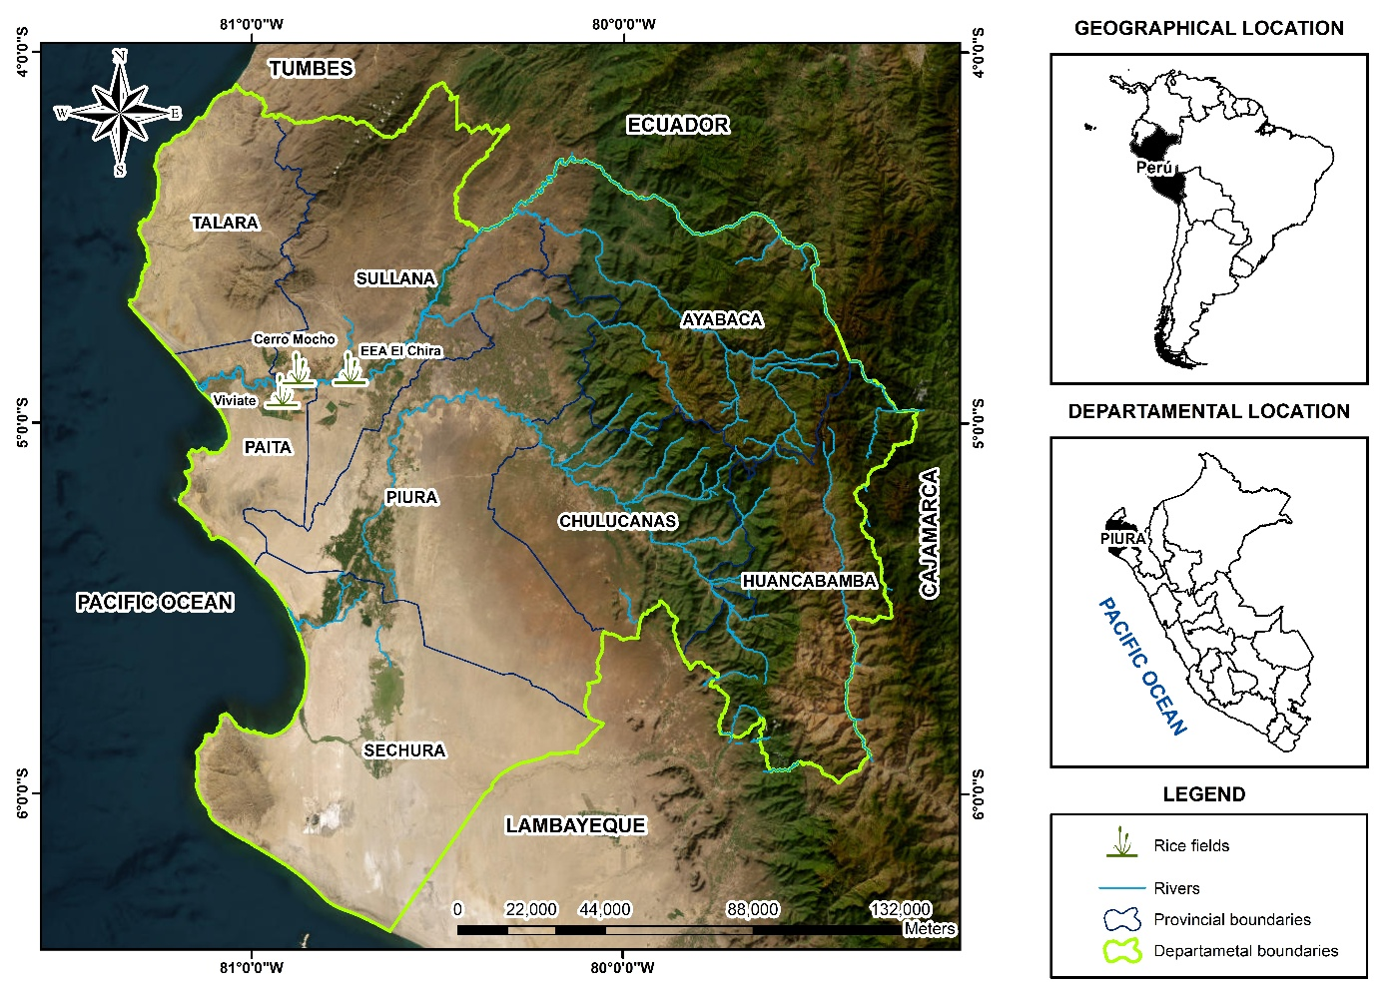
Figure 1: Geographical location of the study sites in the Chira Valley, Piura, Peru.

Climatic conditions
According to climatological records from the National Service of Meteorology and Hydrology of Peru (SENAMHI), the Chira Valley generally experiences average maximum temperatures of 34.64 °C in January and 35.00 °C in February, while the lowest temperatures occur in August, ranging from 15.26 to 15.45 °C. Annual relative humidity ranges between 64% and 68%. Precipitation is concentrated mainly between February and March, with recorded values of 1.53 mm, 2.24 mm, and 1.00 mm, respectively. Average sunshine duration varies from 5.54 h in February to a maximum of 7.34 h in October, whereas wind speed ranges from 2.0 to 3.5 km day⁻¹ (Servicio Nacional de Meteorología e Hidrología del Perú 2026). The main climatic conditions recorded during the experimental period are presented in Figure 2.
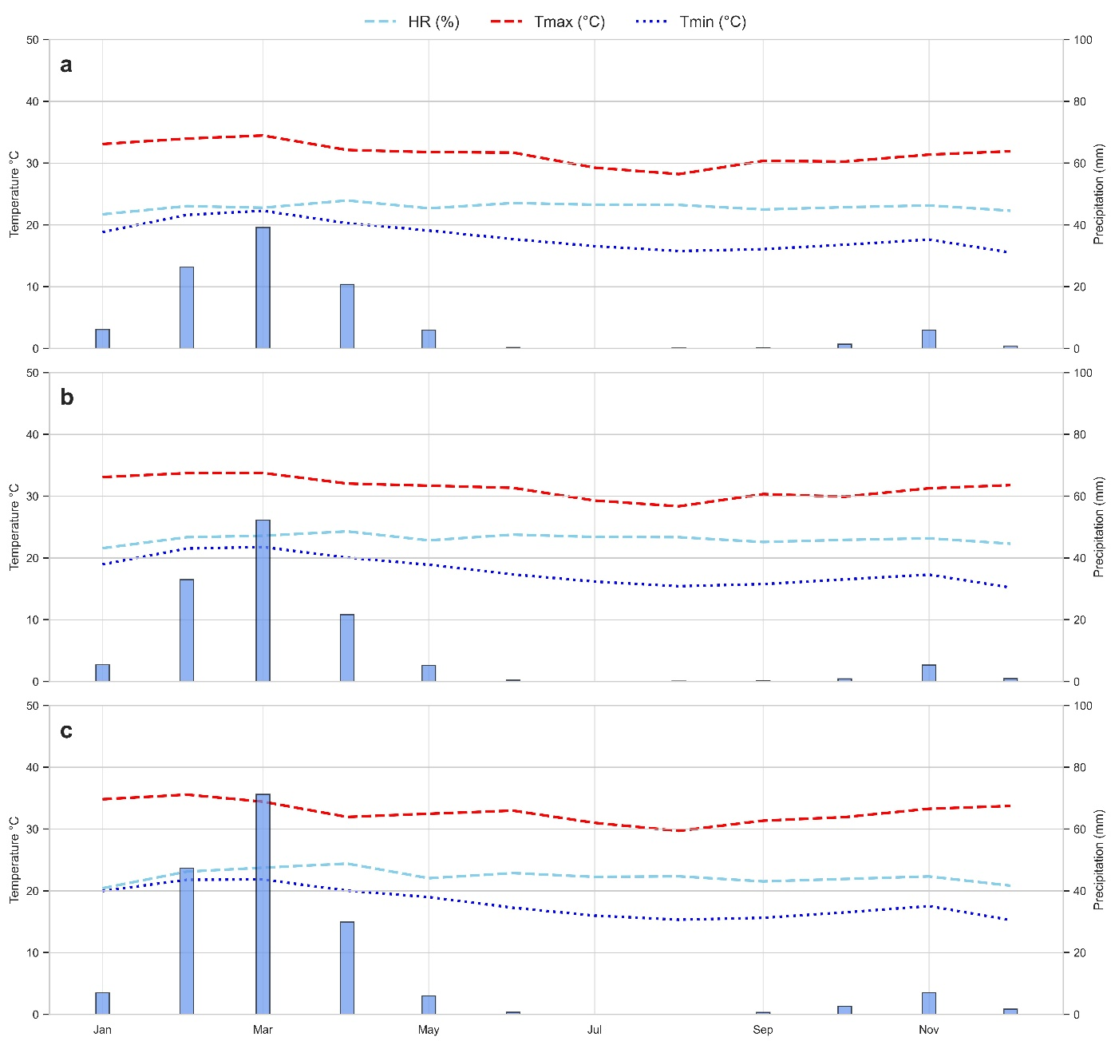
Figure 2: Meteorological conditions of the field experimental sites during the 2025 growing season. (a) Climatic conditions for the Viviate site, (b) climatic conditions for the Ignacio Escudero site and (c) climatic conditions for the E.E.A. El Chira. Data obtained from the Copernicus Climate Change Service ERA5-Land Monthly, based on satellite observations and atmospheric models. Precipitation is represented by blue bars.

Soil conditions
The analysis of soil samples collected from the evaluation sites was conducted at the Soil, Water, and Foliar Analysis Laboratory of the El Chira Agricultural Experimental Station of the National Institute of Agricultural Innovation (INIA). Soil analyses were performed in accordance with the Mexican Official Standard NOM-021-RECNAT-2000 (Secretaría de Medio Ambiente y Recursos Naturales (SEMARNAT) 2002). The evaluated soil properties included pH, electrical conductivity (EC), organic matter (OM), available phosphorus (P) and potassium (K), soil texture, and exchangeable bases (Ca, Mg, and Na), using the standardized methods established by the aforementioned standard. The results of the physical and chemical soil analyses for each study site are presented in Table 1.
Table 1: Physical and chemical soil properties of the experimental sites in the Chira Valley, Piura, Peru.
Parameter | Viviate | Ignacio Escudero | El Chira AES
Sand (%) | 51.6 | 35.6 | 50.3
Clay (%) | 17 | 37.1 | 31
Silt (%) | 31.4 | 27.3 | 18.7
EC (mS m⁻¹) | 15.3 | 11.6 | 22.7
pH | 7.5 | 6.5 | 7.9
OM (%) | 2.7 | 2.8 | 2
Available P (mg kg⁻¹) | 14.4 | 19.4 | 6.5
Ca (cmol(+) kg⁻¹) | 13.6 | 20.3 | 120.2
Mg (cmol(+) kg⁻¹) | 2.3 | 4.9 | 5.6
Na (cmol(+) kg⁻¹) | 0.8 | 1.4 | 3.1
K (cmol(+) kg⁻¹) | 0.1 | 0.4 | 0.7
Textural class | Loam | Clay loam | Sandy clay loam

Plant material
The plant material used in this study was the rice cultivar INIA 515–CAPOTEÑA, developed by the National Institute of Agricultural Innovation (INIA) through a cross between the varieties IR 1529-ECIA and Fedearroz 2000. This cultivar has an average plant height ranging from 90 to 102 cm, a panicle length of approximately 25.8 cm, and an estimated average of 215 filled grains per panicle (Instituto Nacional de Innovación Agraria 2020). It is characterized by its high genetic quality, which translates into high productive capacity and a yield potential of up to 12 t ha⁻¹ (Ramos-Fernández et al. 2024). In addition, the cultivar is resistant to damage caused by rice whorl maggot (Hydrellia spp.), planthoppers, leaf and stem rots, and rice hoja blanca virus, thereby reducing the need for pesticide applications. It has an intermediate growth cycle, requiring approximately 150 days from sowing to maturity, and produces grains with thin and translucent husks. This cultivar was selected due to its widespread adoption by farmers in the region, attributed to its high yield potential and good adaptation to the edaphoclimatic conditions of the Chira Valley.

Irrigation management
Irrigation flow rates were estimated based on the crop water requirements, defined as the amount of water that must be supplied through irrigation or precipitation to compensate for losses due to evaporation and transpiration (FAO 2026). The experiment included the establishment of a nursery for 25 days. Subsequently, seedlings were transplanted at a spacing of 25 cm between hills, with a density of 20 hills m⁻² and 5–7 seedlings per hill. A distance of 1 m was maintained between subplots to ensure adequate separation and management of each experimental unit. This arrangement resulted in an average plant density of 100–140 seedlings m⁻² per subplot, allowing for uniform crop establishment.
Three irrigation treatments with different irrigation water volumes were established: T1 = 13,000 m³ ha⁻¹, T2 = 14,000 m³ ha⁻¹, and T3 = 15,000 m³ ha⁻¹. In addition, a control treatment (T0 = 17,000 m³ ha⁻¹) was included, representing the reference water allocation established by the Chira Valley Water Users Association and traditionally applied by local farmers.
To monitor and control the applied flow rate, sharp-crested rectangular weirs measuring 50 cm in height and 30 cm in length were installed. Each weir was equipped with a 35 × 40 cm galvanized steel gate, ensuring resistance and durability under field conditions. The applied flow rate was calculated using the following equation, derived from the general sharp-crested weir equation (Aydin et al. 2011):
$Q \= 1.84(L \- 0.1\,n\,H)\,H^{3/2}$
Where Q is the flow rate passing through the weir (m³ s⁻¹), L is the crest width (m), n is the number of lateral contractions, and H is the head over the weir (m). The volume of irrigation water applied was estimated using the following equation:
$V \= Q \times t$
Where V is the irrigation water volume (m³ ha⁻¹), Q is the flow rate (m³ s⁻¹), and t is the application time (h). Water depth and irrigation inflow times were recorded in the field using flow measurement records, allowing precise control of the irrigation volumes applied to each treatment.

Agronomic Management
Crop management practices were applied uniformly across all treatments. Irrigation scheduling was based on the water requirements of rice throughout its phenological cycle, with a total of 15 irrigation events applied after transplanting. Flow rates were initially monitored using an electromagnetic current meter and subsequently controlled through rectangular weirs. During the tillering and stem elongation stages (BBCH 25–39), three irrigation events were applied, accounting for 19.26% of the total irrigation volume. During the booting and panicle emergence stages (BBCH 41–59), four irrigation events were applied, representing 19.85% of the total volume. The flowering stage (BBCH 60–69) received four irrigation events, accounting for 38.68% of the total irrigation volume. Finally, during the grain filling and ripening stages (BBCH 71–79), four additional irrigation events were applied, representing 21.02% of the total irrigation volume.
Fertilization was carried out in three stages throughout the crop cycle, using a total nutrient application rate of 110–120–120 kg ha⁻¹ of N–P₂O₅–K₂O. The first application was performed 15–20 days after transplanting, during the tillering stage (BBCH 21–29), using nitrogen, phosphorus, and potassium fertilizers. The second application was carried out 35 days after transplanting, at the beginning of the reproductive phase (BBCH 41–45), through the application of a nitrogen fertilizer containing sulfur. Finally, the third application was performed 55 days after transplanting, during the grain filling and ripening stage (BBCH 83–87), using ammonium sulfate to promote grain filling.
Preventive phytosanitary management was implemented against Spodoptera frugiperda and Hydrellia wirthi through the application of an insecticide containing emamectin benzoate (50 g kg⁻¹) and lufenuron (100 g L⁻¹) during the tillering (BBCH 21–25) and booting (BBCH 45–49) stages. In addition, an insecticide formulated with thiamethoxam (200 g L⁻¹) and chlorantraniliprole (100 g L⁻¹) was applied.
Weed control was carried out using a pre-emergence herbicide based on butachlor (60%) during the establishment stage (BBCH 09–10), followed by a post-emergence herbicide containing bentazon (48%) applied at the BBCH 13–15 stage. Harvesting was performed manually at physiological maturity, approximately 126 days after transplanting (BBCH 87–89). Subsequently, the harvested material was dried and threshed for yield evaluation.

Evaluated variables
The evaluated variables included growth traits, yield components, and grain quality characteristics. Plant height was measured using a graduated tape from the plant collar to the tip of the uppermost leaf at approximately 85 days after transplanting (anthesis, BBCH 65). In each plot, five hills were randomly selected, and the average value was used as the representative measurement.
To estimate the number of tillers per square meter, tillers were counted before harvest during the maximum tillering stage (BBCH 39–45) within a 1 m² area per plot, considering 20 randomly selected hills. The number of panicles per square meter was determined at maturity (BBCH 89) by counting panicles from 20 plants within each subplot.
Panicle length was measured at full maturity (BBCH 89) using 20 randomly selected panicles per plot. Measurements were taken from the panicle base node to the tip using a ruler, and the average value was calculated for each experimental unit. The number of grains per panicle was determined at the same growth stage (BBCH 89) by counting filled, unfilled, and damaged grains from 20 panicles per subplot, and the mean value was calculated for each plot.
Grain dimensions (length and width) were evaluated after harvest using a sample of 20 grains per panicle from each subplot and measured with a digital caliper. Thousand-grain weight was determined using five replicates per treatment, weighed on an analytical balance, and averaged accordingly.
Paddy rice yield was determined through manual harvesting of each plot, followed by weighing the total grain mass and converting the values to kg ha⁻¹ based on the harvested area. Finally, milling yield was determined using a representative 120-g paddy rice sample from each experimental unit, processed at the Rice Milling Analysis Laboratory.

Experimental design and statistical analysis
The experiment was established using a randomized complete block design across three locations in the Chira Valley. Four irrigation treatments were evaluated, consisting of three reduced irrigation volumes (T1: 13,000; T2: 14,000; and T3: 15,000 m³ ha⁻¹) and a control treatment corresponding to the conventional irrigation volume (T0: 17,000 m³ ha⁻¹) commonly used by local farmers. At each location, three blocks were established, within which the four treatments were randomly assigned. Irrigation frequency was identical across all treatments, differing only in the total volume of water applied, which was determined from the flow rate estimated using the weir equation and the irrigation application time.
Data were analyzed using analysis of variance (ANOVA), considering irrigation treatment (T), location (L), the treatment × location interaction (T × L), and the effect of blocks nested within location as sources of variation. Mean squares were estimated for each source of variation. In addition, multiple comparisons of means were performed using Tukey’s honestly significant difference (HSD) test at a significance level of p ≤ 0.05.
All statistical analyses were conducted using Python version 3.14.3 (Python Software Foundation 2026) and specialized libraries for experimental data analysis. The statsmodels package (Seabold and Perktold 2010) was used for ANOVA and Tukey’s multiple comparison test, whereas the seaborn package (Waskom 2021) in combination with SciPy (Virtanen et al. 2020) was employed for heatmap generation and hierarchical clustering analysis.
Additionally, a multivariate analysis was performed to explore relationships among agronomic traits, milling quality parameters, and water-use efficiency across the evaluated treatments. For this purpose, variables were standardized using Z-scores and visualized through a heatmap combined with hierarchical clustering based on Euclidean distance and Ward’s linkage method, allowing the identification of similarity patterns among treatments and associations among the evaluated variables.

RESULTS
The results showed that reducing irrigation volume significantly increased water-use efficiency without affecting crop yield or grain quality. Water-use efficiency was the only variable significantly influenced by the irrigation treatment (MS = 0.0873; p < 0.001), whereas grain yield did not differ significantly among treatments or locations (Table 2).
Analysis of variance revealed that location was the main source of variation for most of the evaluated variables. Among the agromorphological traits, significant location effects were observed for plant height (MS = 96.29; p < 0.01), grain width (MS = 0.083; p < 0.05), grain length (MS = 6.60; p < 0.001), number of tillers per hill (MS = 446.68; p < 0.001), and number of panicles per m² (MS = 517.90; p < 0.001), whereas irrigation treatment had no significant effect on any of these variables (Table 2).
Similarly, for milling quality traits, location accounted for a substantial proportion of the observed variability, showing highly significant effects on the percentage of whole grains (MS = 402.87; p < 0.001), percentage of broken grains (MS = 503.10; p < 0.001), percentage of grains with chalky centers (MS = 406.06; p < 0.01), and number of unfilled grains per panicle (MS = 809.27; p < 0.001). Irrigation treatment did not significantly affect any of the grain quality variables evaluated (Table 2).
In contrast, water-use efficiency was the only variable significantly affected by irrigation treatment (MS = 0.0873; p < 0.001), whereas grain yield did not differ significantly among treatments or locations (Table 2).
Furthermore, the treatment × location interaction was not significant for any of the evaluated variables, indicating a consistent treatment response across locations.
Table 2: Analysis of variance (ANOVA) for agronomic traits, grain quality, yield, and water-use efficiency in rice under different irrigation volumes and locations.
Group | Variable | Treatment (T) | Location (L) | T × L | Block (Location)
Agromorphological traits | Plant height (cm) | 12.07 (ns) | 96.29 (**) | 5.67 (ns) | 29.98 (ns)
 | Grain width (mm) | 0.0076 (ns) | 0.0831 (*) | 0.0018 (ns) | 0.0045 (ns)
 | Grain length (mm) | 0.0171 (ns) | 6.6022 (***) | 0.0061 (ns) | 0.0206 (ns)
 | Number of tillers per hill | 10.99 (ns) | 446.68 (***) | 7.11 (ns) | 20.87 (ns)
 | Panicle length (cm) | 0.21 (ns) | 0.60 (ns) | 0.42 (ns) | 0.85 (ns)
 | Number of panicles per m² | 9.54 (ns) | 517.90 (***) | 7.71 (ns) | 22.26 (*)
Milling quality traits | Head rice (%) | 15.16 (ns) | 402.87 (***) | 17.27 (ns) | 73.68 (*)
 | Broken rice (%) | 6.43 (ns) | 503.10 (***) | 3.94 (ns) | 89.50 (***)
 | Chalky grains (%) | 20.56 (ns) | 406.06 (**) | 37.28 (ns) | 43.90 (ns)
 | Number of unfilled grains per panicle | 11.77 (ns) | 809.27 (***) | 19.58 (ns) | 27.74 (ns)
 | Number of black grains per panicle | 10.99 (ns) | 50.12 (*) | 8.78 (ns) | 11.26 (ns)
 | Number of filled grains per panicle | 436.31 (ns) | 1218.00 (ns) | 1103.17 (ns) | 242.84 (ns)
Yield and water-use efficiency | Grain yield (kg ha⁻¹) | 1057318.0 (ns) | 3606079.1 (ns) | 1139022.2 (ns) | 2719713.9 (ns)
 | Water-use efficiency (kg m⁻³) | 0.0873 (***) | 0.0179 (ns) | 0.0054 (ns) | 0.0126 (ns)

Influence of irrigation volume on the agromorphological response of the crop
Analysis of variance revealed that irrigation volume had no significant effect on the evaluated agromorphological traits, including plant height, grain width and length, number of tillers per hill, panicle length, and number of panicles per m² (p > 0.05). Likewise, the treatment × location interaction was not significant for any of these variables, indicating a relatively stable crop response to the evaluated reductions in irrigation volume across the different locations (Table 2).
Figure 3 shows the data distribution and mean values obtained for each treatment across the evaluated agromorphological traits. Overall, mean values were similar among treatments for all variables analyzed. Plant height averaged 87.88, 87.42, 89.74, and 88.21 cm for T0, T1, T2, and T3, respectively. Similarly, the mean number of tillers per hill ranged from 29.75 in T3 to 32.00 in T2, whereas the mean number of panicles per m² varied from 29.28 in T3 to 31.33 in T2. Mean panicle length exhibited minimal variation among treatments, ranging from 23.20 to 23.49 cm.
Grain physical characteristics also showed a homogeneous response across treatments. Mean grain length ranged from 9.56 mm in T3 to 9.65 mm in T1, whereas grain width varied between 2.34 mm in T3 and 2.40 mm in T0.
Although some variables exhibited slight numerical differences among treatments, no consistent pattern associated with the different irrigation volumes was observed. Furthermore, the data dispersion shown in the violin plots was similar among treatments for all evaluated variables, which is consistent with the results of Tukey’s multiple comparison test, where no significant differences were detected among treatments (p > 0.05). Consequently, all treatments belonged to the same statistical group for the agromorphological traits analyzed.
In contrast, location had a significant effect on most of the agromorphological traits evaluated. Significant differences among locations were observed for plant height (p < 0.01), grain width (p < 0.05), grain length (p < 0.001), number of tillers per hill (p < 0.001), and number of panicles per m² (p < 0.001), highlighting the influence of local agroclimatic conditions on crop growth and development. However, panicle length did not differ significantly among locations or irrigation treatments.
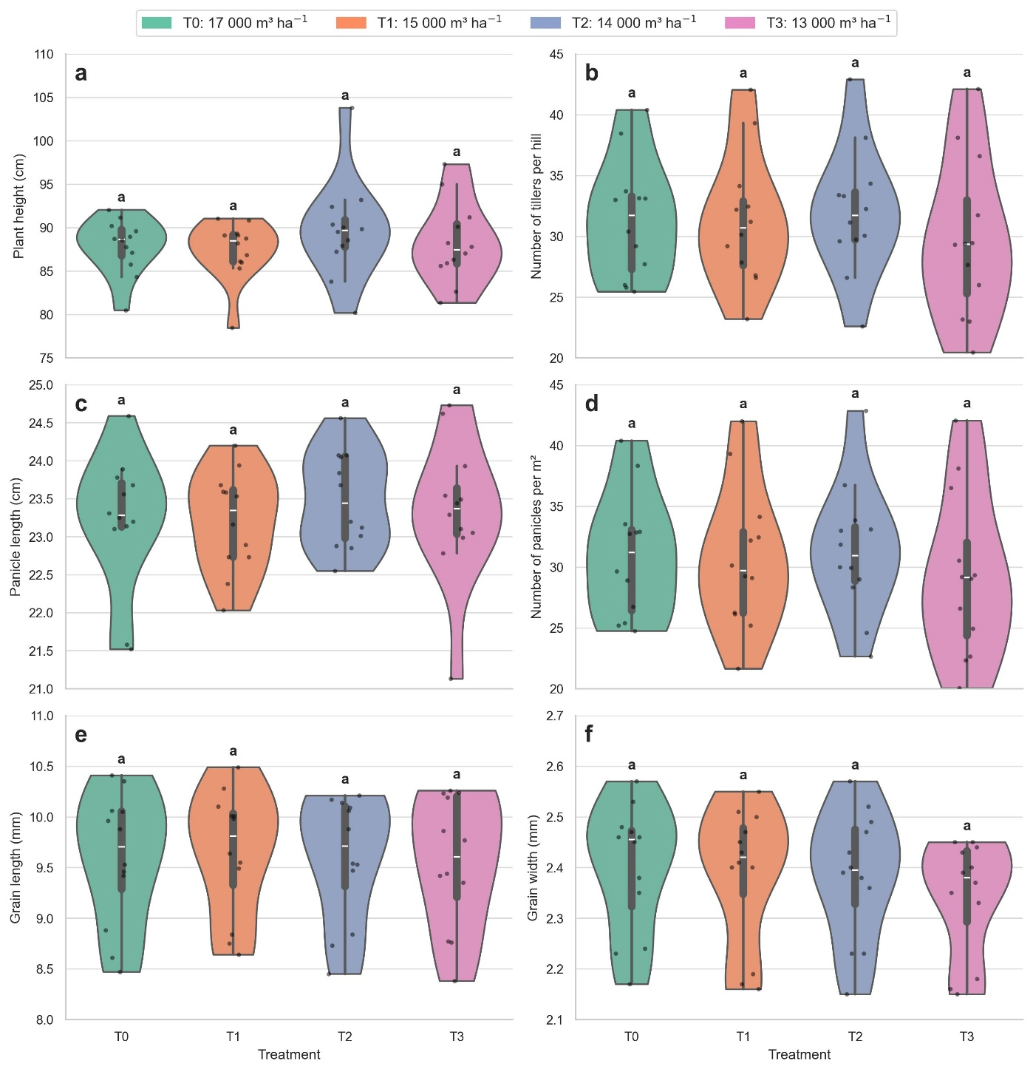
Figure 3: Effect of different irrigation water volumes on agronomic traits of rice (Oryza sativa L.) under Chira Valley conditions, Peru. Each panel represents an agronomic variable evaluated under four irrigation treatments: T0 (17 000 m³ ha⁻¹), T1 (15 000 m³ ha⁻¹), T2 (14 000 m³ ha⁻¹), and T3 (13 000 m³ ha⁻¹): (a) plant height (cm), (b) number of tillers per hill, (c) panicle length (cm), (d) number of panicles per m², (e) grain length (mm), and (f) grain width (mm). Data are presented as violin plots with individual observations and central tendency distribution. Different letters indicate significant differences among irrigation treatments according to Tukey’s test (p < 0.05); treatments sharing the same letter are not significantly different (n = 48).

Influence of irrigation volume on grain quality
Analysis of variance revealed that irrigation volume had no significant effect on the variables associated with milling quality, including head rice percentage, broken rice percentage, percentage of chalky grains, number of unfilled grains per panicle, number of black grains per panicle, and number of filled grains per panicle (p > 0.05). Likewise, the treatment × location interaction was not significant for any of these variables, indicating a relatively stable grain quality response to the evaluated reductions in irrigation volume across the different locations (Table 2).
Figure 4 shows the distribution of the data and the mean values of the milling quality traits under the different irrigation treatments. Head rice percentage averaged 60.83, 61.18, 59.19, and 58.98% for T0, T1, T2, and T3, respectively, whereas broken rice percentage ranged from 8.17% in T0 to 9.71% in T2. Similarly, the percentage of chalky grains varied from 12.67% in T1 to 15.83% in T0, while the number of unfilled grains ranged from 9.31 grains per panicle in T2 to 11.51 grains per panicle in T0.
The mean number of black grains ranged from 5.7 grains per panicle in T2 to 7.7 grains per panicle in T1, whereas the number of filled grains showed relatively higher values, varying between 130.17 grains per panicle in T1 and 144.05 grains per panicle in T2. Although some variables exhibited slight numerical differences among treatments, no consistent trend associated with the progressive reduction in irrigation volume was observed.
The distribution patterns observed in the violin plots revealed similar levels of variability among treatments for most of the evaluated variables, particularly for head rice percentage, broken rice percentage, and number of unfilled grains per panicle. Although minor numerical differences were observed among treatments, no consistent response pattern associated with decreasing irrigation volume was detected.
These findings were consistent with the results of Tukey’s multiple comparison test, in which all treatments belonged to the same statistical group (p > 0.05), confirming that moderate reductions in irrigation volume did not significantly affect the milling and industrial quality of rice grain under the conditions evaluated.
In contrast, location had a significant effect on most milling quality traits (Table 2). Significant differences among locations were observed for head rice percentage (p < 0.001), broken rice percentage (p < 0.001), percentage of chalky grains (p < 0.01), number of unfilled grains per panicle (p < 0.001), and number of black grains per panicle (p < 0.05), highlighting the strong influence of local agroenvironmental conditions on the physical and physiological quality of the grain. In contrast, the number of filled grains per panicle did not differ significantly among locations or irrigation treatments.
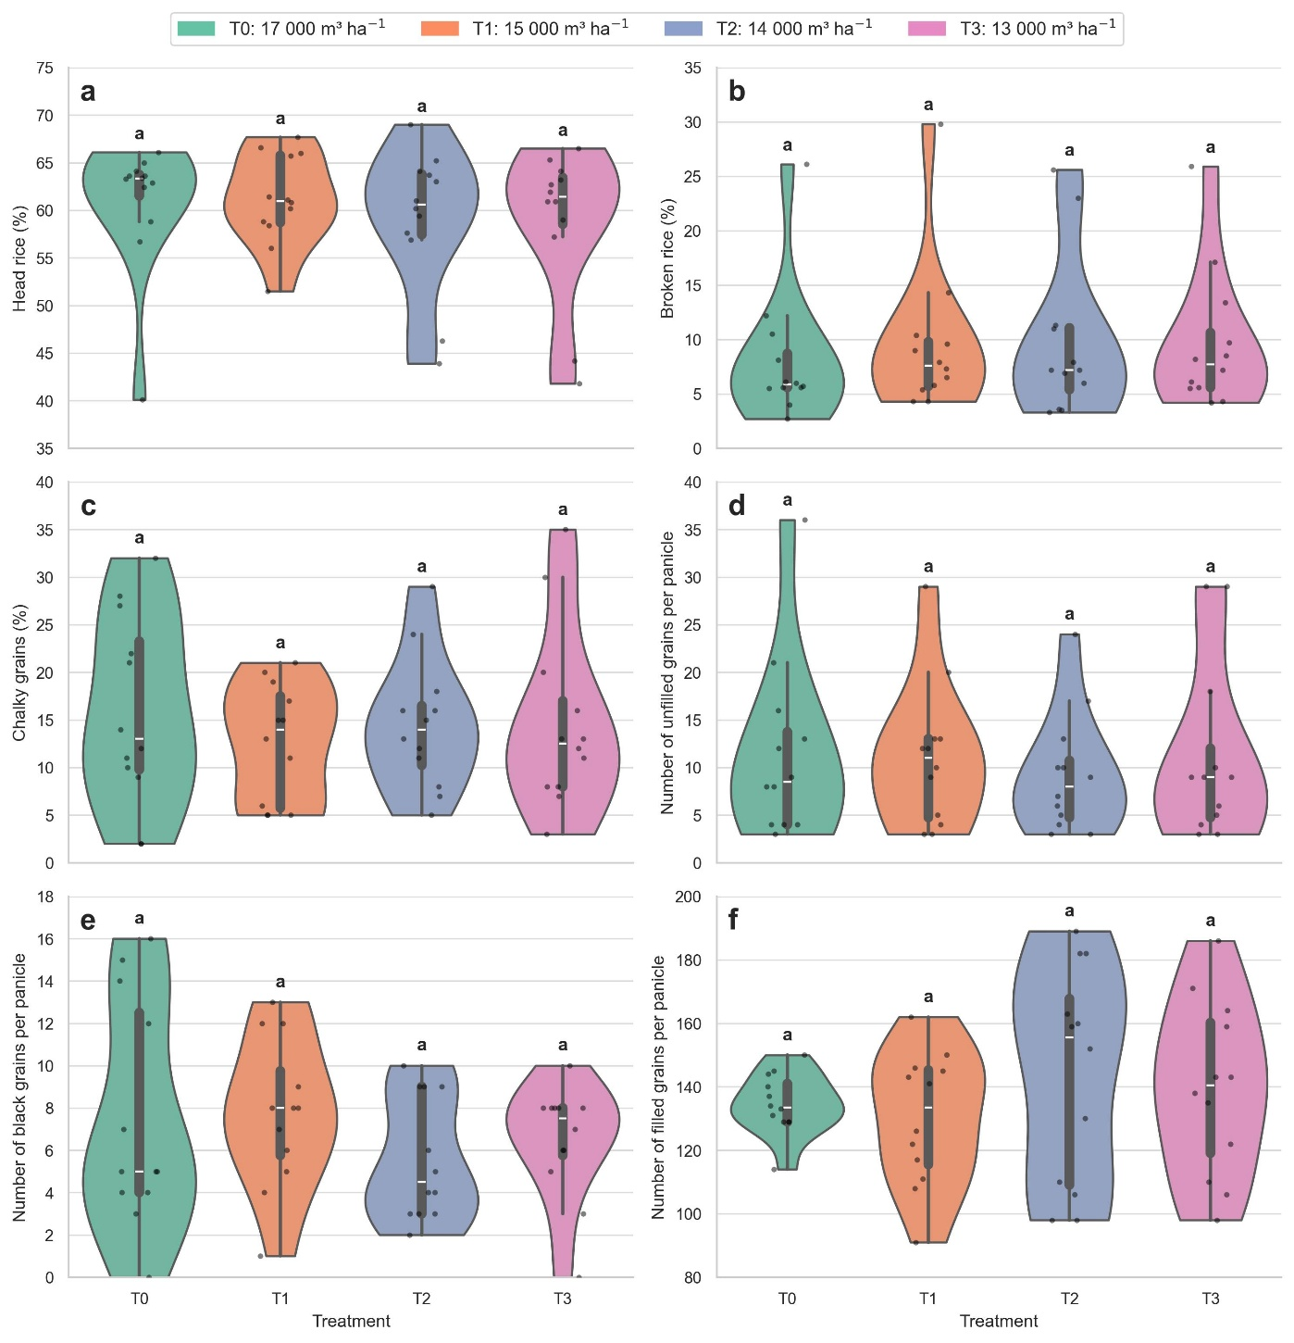
Figure 4: Effect of different irrigation water volumes on grain quality traits of rice (Oryza sativa L.) under Chira Valley conditions, Peru. Each panel represents a grain quality variable evaluated under four irrigation treatments: T0 (17 000 m³ ha⁻¹), T1 (15 000 m³ ha⁻¹), T2 (14 000 m³ ha⁻¹), and T3 (13 000 m³ ha⁻¹): (a) head rice (%), (b) broken rice (%), (c) chalky grains (%), (d) number of unfilled grains per panicle, (e) number of black grains per panicle, and (f) number of filled grains per panicle. Data are presented as violin plots with individual observations and central tendency distribution. Different letters indicate significant differences among irrigation treatments according to Tukey’s test (p < 0.05); treatments sharing the same letter are not significantly different (n = 48).

Water-use efficiency and grain yield
Analysis of variance showed that irrigation volume had no significant effect on grain yield (p > 0.05), a result that was confirmed by Tukey’s multiple comparison test, in which all treatments belonged to the same statistical group (Table 2 y Table 3). Mean grain yield values were 11,673.58, 11,186.33, 11,812.58, and 11,304.42 kg ha⁻¹ for T0, T1, T2, and T3, respectively. Although T2 exhibited the highest mean yield and T1 the lowest, the observed differences among treatments were small, indicating that moderate reductions in irrigation volume did not significantly affect crop productivity under the evaluated conditions. Furthermore, neither location nor the treatment × location interaction had a significant effect on grain yield, indicating a relatively stable yield response across the different irrigation volumes applied (Table 2).
In contrast, water-use efficiency was significantly affected by irrigation volume (p < 0.001), demonstrating that reducing the amount of applied water improved the utilization of water resources without significantly affecting grain yield. Water-use efficiency increased progressively as irrigation volume decreased, reaching mean values of 0.69 ± 0.06 kg m⁻³ in T0, 0.75 ± 0.10 kg m⁻³ in T1, 0.84 ± 0.11 kg m⁻³ in T2, and 0.87 ± 0.12 kg m⁻³ in T3 (Table 3). In relative terms, T2 and T3 exhibited approximately 22% and 26% greater water-use efficiency, respectively, compared with the conventional irrigation treatment (T0), demonstrating more efficient utilization of water resources under conditions of moderate irrigation volume reduction.
The results of Tukey’s multiple comparison test confirmed significant differences among treatments for water-use efficiency, with the highest values observed in treatments receiving the lowest irrigation volumes, particularly T2 and T3 (Table 3).
Table 3: Mean comparison of grain yield and irrigation water-use efficiency under different irrigation water volumes according to Tukey’s test.
Treatment | Grain yield (kg ha⁻¹) | Water-use efficiency (kg m⁻³)
T0 | 11,673.58 ± 1,087.09 a | 0.69 ± 0.06 b
T1 | 11,186.33 ± 1,534.10 a | 0.75 ± 0.10 b
T2 | 11,812.58 ± 1,578.21 a | 0.84 ± 0.11 a
T3 | 11,304.42 ± 1,593.57 a | 0.87 ± 0.12 a

Multivariate analysis
The multivariate analysis allowed the exploration of association patterns among the evaluated agronomic variables and their relative behavior under the different irrigation volumes applied (Figure 5). However, these patterns should be interpreted as relative variations rather than statistically significant differences, given that the analysis of variance (ANOVA) and Tukey’s multiple comparison test did not reveal significant differences among treatments for any of the variables analyzed.
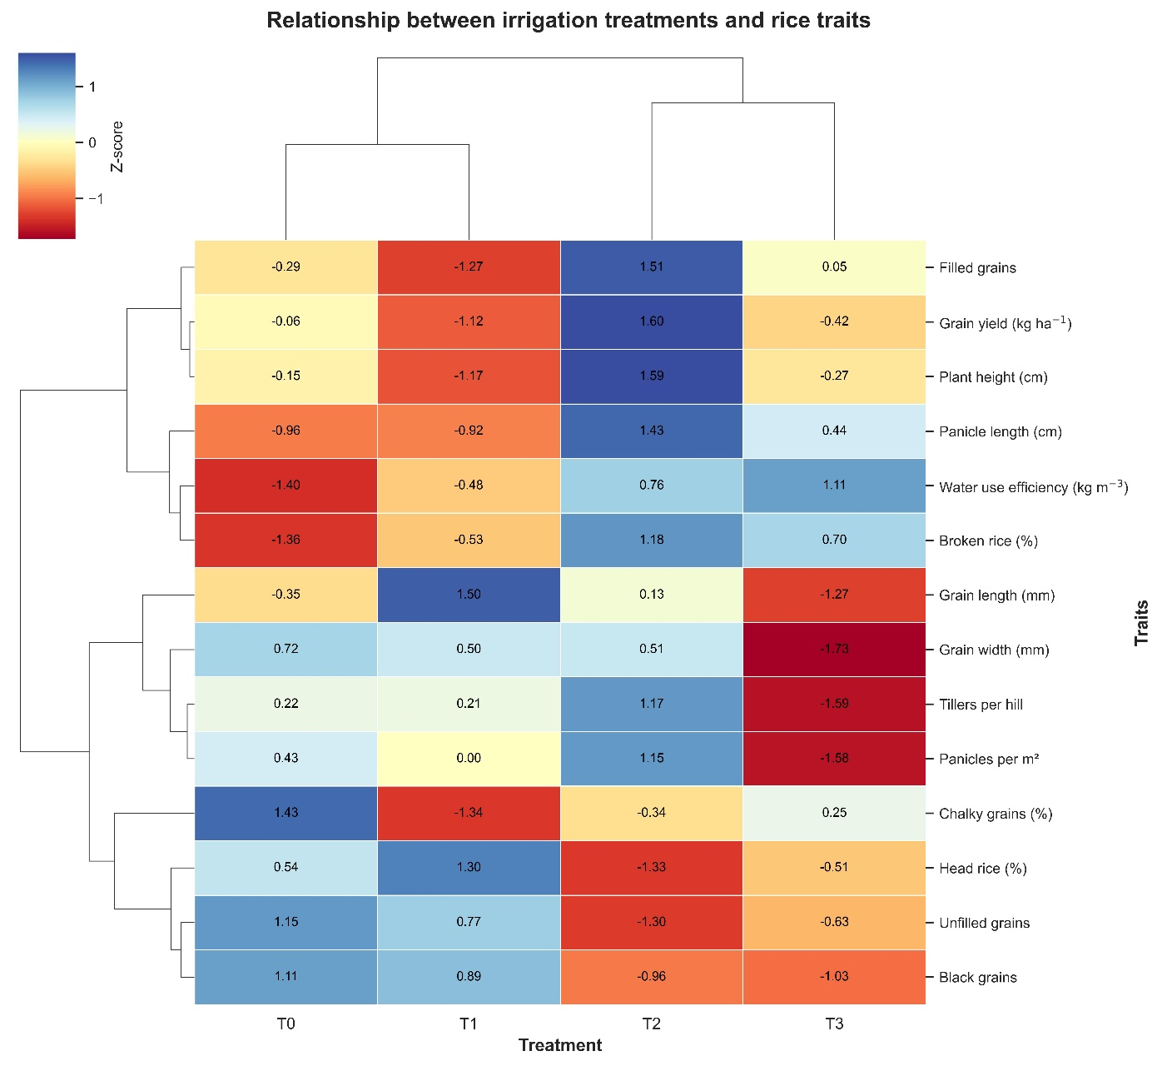
Figure 5: Hierarchical clustering heatmap showing the relationship between irrigation water volumes and agronomic, grain quality, yield, and water-use efficiency traits in rice (Oryza sativa L.). Treatments included T0 (17 000 m³ ha⁻¹), T1 (15 000 m³ ha⁻¹), T2 (14 000 m³ ha⁻¹), and T3 (13 000 m³ ha⁻¹). Color intensity represents standardized Z-score values for each variable, where red and blue indicate higher and lower relative values, respectively. Dendrograms represent similarities among irrigation treatments and evaluated traits.
In this context, treatment T2 exhibited relatively higher standardized values for variables associated with crop agronomic performance, including grain yield, plant height, panicle length, number of panicles per square meter, and number of filled grains per panicle, whereas treatment T3 was characterized by the highest relative values of water-use efficiency. However, these patterns should be interpreted as descriptive trends identified through the multivariate analysis, since the analysis of variance indicated that irrigation volume had no significant effects on agronomic traits, grain quality, or grain yield. In contrast, water-use efficiency was the only variable significantly influenced by irrigation treatment.
Hierarchical clustering of variables revealed associations among structural crop traits, showing a close relationship between grain yield, plant height, panicle length, and the number of filled grains per panicle. In contrast, variables related to milling quality exhibited a distinct pattern relative to the productive components.
Hierarchical clustering also revealed greater similarity between treatments T0 and T1, indicating comparable agronomic performance under these two irrigation regimes across the set of evaluated variables. In contrast, treatments T2 and T3 formed a separate grouping, reflecting relative changes in crop response associated with reduced irrigation volumes. Nevertheless, these differences represent trends identified through multivariate analysis, as the analysis of variance did not detect statistically significant differences among treatments for agronomic traits, grain quality, or grain yield. Therefore, the observed patterns suggest a differential crop response to reduced irrigation volumes; however, this response was not sufficiently consistent to produce statistically significant differences under the conditions evaluated.

DISCUSSION
Increasing pressure on water resources and the impacts of climate change have intensified the need to develop water management strategies capable of maintaining rice productivity while reducing water consumption (Maneepitak et al. 2019; Bertolino et al. 2019). In regions such as the Chira Valley, where rice production is highly dependent on irrigation and climatic conditions generate a high water demand, the adoption of efficient irrigation technologies and management practices is essential to ensure the sustainability of the production system. However, previous studies have shown that water-saving irrigation methods can alter crop water consumption by modifying soil moisture conditions and water depth management (Zhang et al. 2020). In the present study, irrigation volume had no significant effect on rice agromorphological traits or grain quality, while water-use efficiency was improved without significantly compromising crop yield under the agroclimatic conditions of the study area.

Influence of irrigation volume on the agromorphological response of the crop
The results showed that the different irrigation volumes applied did not significantly affect the agromorphological traits of the crop (Table 2, Figure 3). Although treatment T2 (14,000 m³ ha⁻¹) tended to exhibit higher values for some variables associated with agronomic performance (Figure 5), these variations were not statistically significant, indicating that a moderate reduction in irrigation volume can be maintained without compromising crop morphological development. These findings are consistent with those reported by Maneepitak et al., (2019), who also found no significant effects of irrigation volume on variables such as plant height, although differences were observed in the number of panicles per square meter.
Numerous studies have demonstrated that water stress is one of the most important abiotic factors affecting rice growth and development, causing morphological, physiological, and biochemical alterations that reduce photosynthesis, nutrient uptake, cell division, and ultimately crop yield (Akram et al. 2019; Rasheed et al. 2020; Hassan et al. 2023). Likewise, the seedling, vegetative growth, and anthesis stages are recognized as particularly sensitive to water deficit, since limited water availability reduces plant vigor and slows growth (Bhandari et al. 2023). However, in the present study, water supply was adequately managed during the critical growth stages of the crop, even under reduced irrigation volumes, thereby avoiding severe water stress conditions. This finding agrees with Bwire et al., (2024), who reported that water-saving strategies such as alternate wetting and drying (AWD) may not significantly affect rice development when water management is properly planned and implemented.
On the other hand, significant differences among locations were observed for most of the evaluated variables (Table 2). Although climatic conditions were generally similar across locations (Figure 2), the El Chira Agricultural Experimental Station exhibited, overall, the lowest values for the agromorphological traits evaluated. These differences may be partially associated with soil physicochemical properties, as this location showed lower organic matter content and higher pH and electrical conductivity (EC) values. Such conditions may negatively affect nutrient availability, soil structure, and aeration, thereby restricting root development and consequently reducing crop growth and agronomic performance (Neina 2019; Hoffland et al. 2020; Kou et al. 2022).
Previous studies have shown that root morphophysiological characteristics directly influence vegetative growth and grain production in rice (Kim et al. 2020). Likewise, improvements in soil permeability can enhance root physiological activity, increasing nutrient and water uptake capacity and promoting crop development (Xu et al. 2018). This may explain the differences observed at the El Chira Agricultural Experimental Station, where less favorable soil conditions may have impaired root development and consequently affected the morphological performance of rice plants.

Influence of irrigation volume on grain quality
The results showed that the different irrigation volumes applied did not significantly affect grain quality traits (Table 2, Figure 4), indicating that moderate reductions in irrigation volume (11.8–23.5% relative to conventional management) do not compromise the milling quality of rice. These findings are consistent with previous studies in which reductions in soil moisture did not reach critical levels capable of affecting grain quality parameters. Dossou-Yovo and Saito, (2021) reported that traits such as the percentage of filled grains, head rice, and chalky grains did not differ significantly among water management practices under alternate wetting and drying systems, suggesting that factors such as cultivar, plant age, and weed pressure exert a greater influence on these variables. Similarly, Yang et al., (2017) reported that grain quality can remain stable provided that soil moisture does not decline below the critical threshold of soil water potential.
Likewise, Oh and Cho, (2025) found that alternate irrigation can even increase the proportion of well-filled grains and reduce the number of empty grains when water management is properly implemented during critical crop growth stages. However, other studies have reported variable responses depending on the severity of water deficit and varietal sensitivity. Graham-Acquaah et al., (2019) observed that reduced water supply increased the proportion of chalky grains, whereas Hu et al., (2023) reported that certain rice cultivars exhibit high sensitivity to drought during grain filling, negatively affecting grain quality. Furthermore, Yang et al., (2019) indicated that water deficits during stages such as heading and flowering may increase spikelet sterility and reduce grain quality. In this context, it is likely that grain quality was not affected in the present study because the cultivar INIA 515–CAPOTEÑA exhibited good tolerance to moderate water deficit and because water was supplied adequately during the most sensitive developmental stages, thereby preventing soil moisture from falling below critical thresholds.
On the other hand, significant differences among locations were observed for grain quality traits (Table 2). Although climatic conditions were generally similar across locations (Figure 2), the Viviate site exhibited lower values for chalky grains, unfilled grains, and black grains per panicle (Supplementary Material). Fahad et al., (2019) reported that various environmental factors and abiotic stresses can negatively affect milling characteristics and increase grain chalkiness due to alterations in starch accumulation and other storage compounds. Similarly, Han et al., (2004) noted that rice quality is determined by both genetic and environmental factors.
In the present study, Viviate exhibited higher sand and organic matter contents, conditions that may have favored root development and enhanced water and nutrient uptake by improving soil drainage (Miyazaki and Arita 2020; Hoffland et al. 2020). Ishfaq et al., (2021) reported that deeper root systems and greater root physiological activity promote grain filling and photosynthetic activity, thereby contributing to reduced grain chalkiness and improved rice quality. These factors may explain the superior grain quality characteristics observed at this location.

Water-use efficiency and grain yield
The results demonstrated that reducing irrigation volume within the evaluated range significantly improved water-use efficiency without causing significant reductions in grain yield (Table 2, Table 3). Treatments T2 and T3 reduced the volume of applied irrigation water by approximately 17.6% and 23.5%, respectively, compared with the conventional irrigation practice used by local farmers, while maintaining statistically similar grain yields. In addition, water-use efficiency increased by approximately 22% and 26%, respectively, relative to the conventional treatment. These findings indicate that there is considerable potential to optimize water use in rice production systems of the Chira Valley without compromising crop productivity.
The yield stability observed across treatments suggests that the reductions in irrigation volume did not induce critical levels of water stress during the most sensitive stages of crop development. Similar results have been reported by Ramos-Fernández et al., (2024), Haonan et al., (2023), and Zhang et al., (2020), who found that optimized water management strategies can reduce water consumption without significantly affecting crop yield. Likewise, Borrell et al., (1997) demonstrated that continuous flooding is not strictly necessary to maintain high rice productivity, provided that water supply is managed appropriately.
These findings are particularly relevant for the Chira Valley, where rice production relies heavily on irrigation and where water availability is under increasing pressure. Reducing the volume of irrigation water applied could substantially contribute to improving the sustainability of rice production systems and enhancing water resource management at the regional scale. However, the response observed in this study is limited to the cultivar INIA 515–CAPOTEÑA. Therefore, future research should evaluate additional rice cultivars to determine the applicability of these findings under different genetic backgrounds and management conditions (Evans and Sadler 2008; Sajjad et al. 2025).
Overall, the results indicate that water use in rice cultivation can be optimized without significantly compromising crop morphological development, grain quality, or yield, provided that irrigation management accounts for critical growth stages, soil properties, climatic conditions, and the irrigation system employed (Lawlor and Tezara 2009). Therefore, the implementation of optimized water management strategies, such as those evaluated in this study, represents a viable approach to improving the sustainability of rice production systems in the Chira Valley by reducing water consumption while maintaining crop productivity.

Limitations and future perspectives
One limitation of the present study was the land-leveling method used during the establishment of the experiment, which was based on traditional puddling practices. This condition may have caused slight variations in the distribution and uniformity of the applied irrigation water among plots, potentially influencing crop response and irrigation efficiency. In addition, the study was conducted exclusively using the cultivar INIA 515–CAPOTEÑA; therefore, the results should be extrapolated to other rice cultivars with caution, considering that responses to reduced irrigation volumes may vary according to the genetic and physiological characteristics of each cultivar. Another limitation was that physiological variables associated with plant responses to water stress, such as leaf water potential, stomatal conductance, and root biomass, were not evaluated. The inclusion of these variables could provide a better understanding of the mechanisms underlying crop responses under different levels of water availability.
Future studies should consider the use of laser land leveling, as this technology enables more uniform water distribution, improves irrigation efficiency, and reduces water losses through runoff and percolation. In addition, evaluating different rice cultivars and complementing agronomic assessments with physiological measurements would allow a more comprehensive characterization of crop responses to irrigation management. Likewise, future research should explore complementary water management strategies, such as alternate wetting and drying (AWD), due to their potential to reduce water consumption without significantly affecting crop yield, thereby contributing to a more sustainable management of water resources in rice production systems of the Chira Valley.

CONCLUSIONS
Moderate reductions in irrigation volume did not significantly affect the agronomic performance or grain quality of rice (Oryza sativa L.) under the conditions of the Chira Valley, Peru. These findings indicate that irrigation water allocations can be reduced relative to conventional management practices without compromising crop productivity. In contrast, water-use efficiency increased significantly as irrigation volume decreased, with treatments receiving lower irrigation volumes showing significant improvements compared with the conventional irrigation treatment.
The differences observed among locations highlight the potential influence of edaphoclimatic conditions on crop response and emphasize the importance of considering spatial variability when implementing irrigation management strategies. Overall, the results demonstrate that moderate reductions in irrigation volume represent a viable approach for optimizing water use in rice production systems in northern Peru while maintaining crop productivity and grain quality.

REFERENCES
Akram R, Fahad S, Masood N, et al (2019) Plant Growth and Morphological Changes in Rice Under Abiotic Stress. In: Advances in Rice Research for Abiotic Stress Tolerance. Woodhead Publishing, pp 69–85
Arouna A, Dzomeku IK, Shaibu A-G, Nurudeen AR (2023) Water Management for Sustainable Irrigation in Rice (Oryza sativa L.) Production: A Review. Agronomy 13:1522. https://doi.org/10.3390/agronomy13061522
Aydin I, Altan-Sakarya AB, Sisman C (2011) Discharge formula for rectangular sharp-crested weirs. Flow Measurement and Instrumentation 22:144–151. https://doi.org/10.1016/j.flowmeasinst.2011.01.003
Bertolino LT, Caine RS, Gray JE (2019) Impact of Stomatal Density and Morphology on Water-Use Efficiency in a Changing World. Front Plant Sci 10:. https://doi.org/10.3389/fpls.2019.00225
Bhandari U, Gajurel A, Khadka B, et al (2023) Morpho-physiological and biochemical response of rice (Oryza sativa L.) to drought stress: A review. Heliyon 9:. https://doi.org/10.1016/j.heliyon.2023.e13744
Borrell A, Garside A, Fukai S (1997) Improving efficiency of water use for irrigated rice in a semi-arid tropical environment. Field Crops Research 52:231–248. https://doi.org/10.1016/S0378-4290(97)00033-6
Bwire D, Saito H, Sidle RC, Nishiwaki J (2024) Water Management and Hydrological Characteristics of Paddy-Rice Fields under Alternate Wetting and Drying Irrigation Practice as Climate Smart Practice: A Review. Agronomy 14:1421. https://doi.org/10.3390/agronomy14071421
Chen H, Wu Y-C, Cheng C-C, Teng C-Y (2023) Effect of climate change-induced water-deficit stress on long-term rice yield. PLoS One 18:e0284290. https://doi.org/10.1371/journal.pone.0284290
Djaman K, Irmak S, Koudahe K, Allen S (2021) Irrigation Management in Potato (Solanum tuberosum L.) Production: A Review. Sustainability 13:1504. https://doi.org/10.3390/su13031504
Dossou-Yovo ER, Saito K (2021) Impact of management practices on weed infestation, water productivity, rice yield and grain quality in irrigated systems in Côte d’Ivoire. Field Crops Research 270:108209. https://doi.org/10.1016/j.fcr.2021.108209
Evans RG, Sadler EJ (2008) Methods and technologies to improve efficiency of water use. Water Resources Research 44:. https://doi.org/10.1029/2007WR006200
Fahad S, Noor M, Adnan M, et al (2019) Abiotic Stress and Rice Grain Quality. In: Advances in Rice Research for Abiotic Stress Tolerance. Woodhead Publishing, pp 571–583
FAO F and AO of the UN (2026) AQUASTAT - FAO’s Global Information System on Water and Agriculture. https://www.fao.org/aquastat/en/. Accessed 20 Apr 2026
Goigochea-Pinchi D, Justino-Pinedo M, Vega-Herrera SS, et al (2024) Yield Prediction Models for Rice Varieties Using UAV Multispectral Imagery in the Amazon Lowlands of Peru. AgriEngineering 6:2955–2969. https://doi.org/10.3390/agriengineering6030170
Graham-Acquaah S, Siebenmorgen TJ, Reba ML, et al (2019) Impact of alternative irrigation practices on rice quality. Cereal Chemistry 96:815–823. https://doi.org/10.1002/cche.10182
Han Y, Xu M, Liu X, et al (2004) Genes coding for starch branching enzymes are major contributors to starch viscosity characteristics in waxy rice (Oryza sativa L.). Plant Science 166:357–364. https://doi.org/10.1016/j.plantsci.2003.09.023
Haonan Q, Jie W, Shihong Y, et al (2023) Current status of global rice water use efficiency and water-saving irrigation technology recommendations. Journal of Agronomy and Crop Science 209:734–746. https://doi.org/10.1111/jac.12655
Hassan MA, Dahu N, Hongning T, et al (2023) Drought stress in rice: morpho-physiological and molecular responses and marker-assisted breeding. Front Plant Sci 14:. https://doi.org/10.3389/fpls.2023.1215371
He G, Wang Z, Cui Z (2020) Managing irrigation water for sustainable rice production in China. Journal of Cleaner Production 245:118928. https://doi.org/10.1016/j.jclepro.2019.118928
Hoffland E, Kuyper TW, Comans RNJ, Creamer RE (2020) Eco-functionality of organic matter in soils. Plant Soil 455:1–22. https://doi.org/10.1007/s11104-020-04651-9
Hu J, Zhang S, Yang S, et al (2023) Effects of Irrigation and Fertilization Management on Yield and Quality of Rice and the Establishment of a Quality Evaluation System. Agronomy 13:2034. https://doi.org/10.3390/agronomy13082034
Instituto Nacional de Innovación Agraria I (2020) Variedad de Arroz INIA 515 – Capoteña
Ishfaq M, Akbar N, Zulfiqar U, et al (2021) Influence of water management techniques on milling recovery, grain quality and mercury uptake in different rice production systems. Agricultural Water Management 243:106500. https://doi.org/10.1016/j.agwat.2020.106500
Islam SF, Sander BO, Quilty JR, et al (2020) Mitigation of greenhouse gas emissions and reduced irrigation water use in rice production through water-saving irrigation scheduling, reduced tillage and fertiliser application strategies. Science of The Total Environment 739:140215. https://doi.org/10.1016/j.scitotenv.2020.140215
Kim Y, Chung YS, Lee E, et al (2020) Root Response to Drought Stress in Rice (Oryza sativa L.). International Journal of Molecular Sciences 21:1513. https://doi.org/10.3390/ijms21041513
Kou X, Han W, Kang J (2022) Responses of root system architecture to water stress at multiple levels: A meta-analysis of trials under controlled conditions. Front Plant Sci 13:. https://doi.org/10.3389/fpls.2022.1085409
Kumar A, Sarangi A (2022) Flow measuring devices in surface irrigation for enhancing agricultural water productivity. Current Science 122:1135. https://doi.org/10.18520/cs/v122/i10/1135-1144
Lan K, Chen X, Ridoutt BG, et al (2021) Closing yield and harvest area gaps to mitigate water scarcity related to China’s rice production. Agricultural Water Management 245:106602. https://doi.org/10.1016/j.agwat.2020.106602
Lawlor DW, Tezara W (2009) Causes of decreased photosynthetic rate and metabolic capacity in water-deficient leaf cells: a critical evaluation of mechanisms and integration of processes. Ann Bot 103:561–579. https://doi.org/10.1093/aob/mcn244
Mallareddy M, Thirumalaikumar R, Balasubramanian P, et al (2023) Maximizing Water Use Efficiency in Rice Farming: A Comprehensive Review of Innovative Irrigation Management Technologies. Water 15:1802. https://doi.org/10.3390/w15101802
Maneepitak S, Ullah H, Paothong K, et al (2019) Effect of water and rice straw management practices on yield and water productivity of irrigated lowland rice in the Central Plain of Thailand. Agricultural Water Management 211:89–97. https://doi.org/10.1016/j.agwat.2018.09.041
Masseroni D, Moller P, Tyrell R, et al (2018) Evaluating performances of the first automatic system for paddy irrigation in Europe. Agricultural Water Management 201:58–69. https://doi.org/10.1016/j.agwat.2017.12.019
Ministerio de Desarrollo Agrario y Riego M (2025) Sistema Integrado de Estadísticas Agrarias. https://siea.midagri.gob.pe/portal/. Accessed 10 Apr 2025
Miyazaki A, Arita N (2020) Deep rooting development and growth in upland rice NERICA induced by subsurface irrigation. Plant Production Science 23:211–219. https://doi.org/10.1080/1343943X.2020.1732829
Mohidem NA, Hashim N, Shamsudin R, Che Man H (2022) Rice for Food Security: Revisiting Its Production, Diversity, Rice Milling Process and Nutrient Content. Agriculture 12:741. https://doi.org/10.3390/agriculture12060741
Monaco F, Sali G, Ben Hassen M, et al (2016) Water Management Options for Rice Cultivation in a Temperate Area: A Multi-Objective Model to Explore Economic and Water Saving Results. Water 8:336. https://doi.org/10.3390/w8080336
Nawaz A, Rehman AU, Rehman A, et al (2022) Increasing sustainability for rice production systems. Journal of Cereal Science 103:103400. https://doi.org/10.1016/j.jcs.2021.103400
Neina D (2019) The Role of Soil pH in Plant Nutrition and Soil Remediation. Applied and Environmental Soil Science 2019:5794869. https://doi.org/10.1155/2019/5794869
Oh S, Cho Y-S (2025) Effects of Water Management Practices on Rice Grain Quality and Pest-Disease Incidence in Environmentally Friendly Cultivation Systems. Agriculture 15:2244. https://doi.org/10.3390/agriculture15212244
Python Software Foundation (2026) Python
Ramos-Fernández L, Peña-Amaro R, Huanuqueño-Murillo J, et al (2024) Water Use Efficiency in Rice Under Alternative Wetting and Drying Technique Using Energy Balance Model with UAV Information and AquaCrop in Lambayeque, Peru. Remote Sensing 16:3882. https://doi.org/10.3390/rs16203882
Rasheed A, Hassan MU, Aamer M, et al (2020) A critical review on the improvement of drought stress tolerance in rice (Oryza sativa L.). Notulae Botanicae Horti Agrobotanici Cluj-Napoca 48:1756–1788. https://doi.org/10.15835/nbha48412128
Sajjad M, Hussain K, Hakki EE, et al (2025) Impact of Irrigation Techniques on Water-Use Efficiency, Economic Returns, and Productivity of Rice. Sustainability 17:7712. https://doi.org/10.3390/su17177712
Seabold S, Perktold J (2010) Statsmodels: Econometric and Statistical Modeling with Python. SciPy 2010. https://doi.org/10.25080/Majora-92bf1922-011
Secretaría de Medio Ambiente y Recursos Naturales (SEMARNAT) (2002) Official Mexican Standard NOM-021-RECNAT-2000. Establishing specifications for soil fertility, salinity and classification. Studies, sampling and analysis, Official Gazette of the Federation. Mexico City, Mexico.
Servicio Nacional de Meteorología e Hidrología del Perú S (2026) Datos Hidrometeorológicos en Piura. https://www.senamhi.gob.pe/main.php?dp=piura&p=estaciones. Accessed 8 Apr 2026
Shao G, Cui J, Yu S, et al (2015) Impacts of controlled irrigation and drainage on the yield and physiological attributes of rice. Agricultural Water Management 149:156–165. https://doi.org/10.1016/j.agwat.2014.11.002
U.S. Department of Agriculture, Foreign Agricultural Service (2026) Rice | USDA Foreign Agricultural Service. https://www.fas.usda.gov/data/production/0422110. Accessed 6 Apr 2026
Virtanen P, Gommers R, Oliphant TE, et al (2020) SciPy 1.0: fundamental algorithms for scientific computing in Python. Nat Methods 17:261–272. https://doi.org/10.1038/s41592-019-0686-2
Waskom ML (2021) seaborn: statistical data visualization. Journal of Open Source Software 6:3021. https://doi.org/10.21105/joss.03021
White M, Heros E, Graterol E, et al (2020) Balancing Economic and Environmental Performance for Small-Scale Rice Farmers in Peru. Front Sustain Food Syst 4:. https://doi.org/10.3389/fsufs.2020.564418
Wu M, Cui S, Qiu L, et al (2024) Assessment of Blue Water Migration and Efficiency in Water-Saving Irrigation Paddy Rice Fields Using the Water Flow Tracking Method. Agronomy 14:166. https://doi.org/10.3390/agronomy14010166
Wu XH, Wang W, Yin CM, et al (2017) Water consumption, grain yield, and water productivity in response to field water management in double rice systems in China. PLoS One 12:e0189280. https://doi.org/10.1371/journal.pone.0189280
Xu G, Lu D-K, Wang H-Z, Li Y (2018) Morphological and physiological traits of rice roots and their relationships to yield and nitrogen utilization as influenced by irrigation regime and nitrogen rate. Agricultural Water Management 203:385–394. https://doi.org/10.1016/j.agwat.2018.02.033
Yang J, Zhou Q, Zhang J (2017) Moderate wetting and drying increases rice yield and reduces water use, grain arsenic level, and methane emission. The Crop Journal 5:151–158. https://doi.org/10.1016/j.cj.2016.06.002
Yang X, Wang B, Chen L, et al (2019) The different influences of drought stress at the flowering stage on rice physiological traits, grain yield, and quality. Sci Rep 9:3742. https://doi.org/10.1038/s41598-019-40161-0
Zahra N, Hafeez MB, Nawaz A, Farooq M (2022) Rice production systems and grain quality. Journal of Cereal Science 105:103463. https://doi.org/10.1016/j.jcs.2022.103463
Zhang S, Rasool G, Guo X, et al (2020) Effects of Different Irrigation Methods on Environmental Factors, Rice Production, and Water Use Efficiency. Water 12:2239. https://doi.org/10.3390/w12082239

