Design and Verification of Digital Systems
Complete the design shown in picture 1. Then complete the pin planner and all processes needed to get the sof file and download it to the FPGA. Test it as shown in picture 2:

Notes:
- Clock and reset signals are expected to be implemented and connected to sequential modules following design standard.
- All inputs (A_in, B_in and Disable) must be connected to either switches or push buttons.
- All outputs must be connected to LEDs.

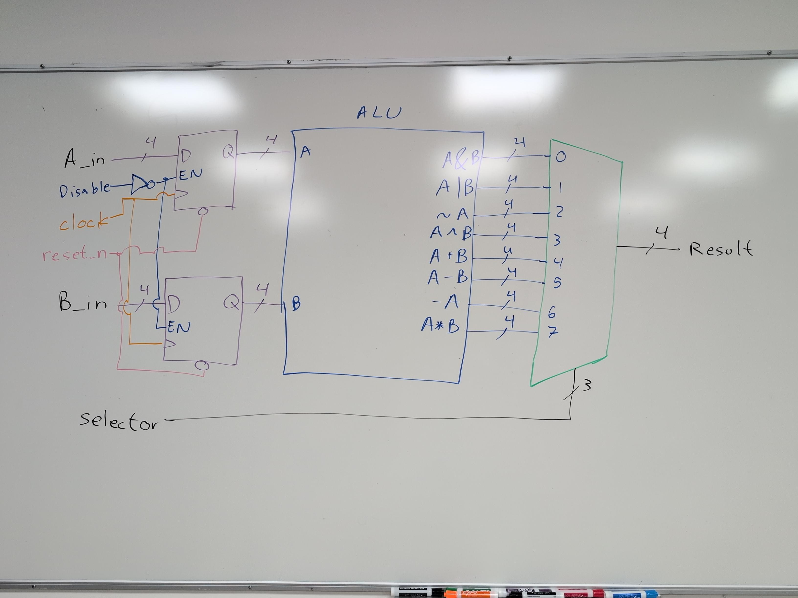

Picture 1. Module to be implemented

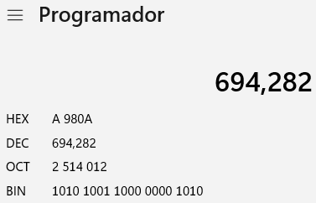
Picture 2. Translating student’s number to binary.

Using the binary value of your student’s number follow and fill table 1 to do 8 tests (use proper values, not e.g. values):

Test number | A value | B value | Selector | Expected result | Actual result
1 | Bits 3:0 (e.g. 1010) | Bits 7:4 (e.g. 0000) | 7
2 | Bits 11:8 (e.g. 1000) | Bits 15:12 (e.g. 1001) | 6
3 | Bits 19:16 (e.g. 1010) | Bits 3:0 (e.g. 1010) | 5
4 | Bits 7:4 (e.g. 0000) | Bits 11:8 (e.g. 1000) | 4
5 | Bits 15:12 (e.g. 1001) | Bits 19:16 (e.g. 1010) | 3
6 | Bits 3:0 (e.g. 1010) | Bits 7:4 (e.g. 0000) | 2
7 | Bits 11:8 (e.g. 1000) | Bits 15:12 (e.g. 1001) | 1
8 | Bits 19:16 (e.g. 1010) | Bits 3:0 (e.g. 1010) | 0

Table 1. Test to be executed

Deliverables:
Upload a picture for each test showing actual result. Everything must be updated in individual repository and tagged with proper format

Extra points: 30% if any testbench is executed in Questa Sim and screenshots are attached.

