José Sebastián González Ortega

BCD decoder
Based on learnings of combinational design in SystemVerilog, create a module that implements BCD conversion algorithm. It should support showing any 8-bits unsigned number (0 to 255).

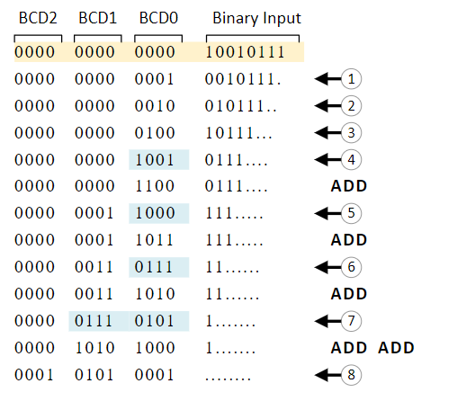
Result must be shown in 7-segment displays (create and additional module that converts a 4-bit data to 7-segments format i.e., 0 to F).
Module implementation must be structural, instantiating multiple times a basic module.
This basic module should implement in behavioral design a single step of the algorithm.

Example of how the architecture looks like:

…
Bin to 7 segments
BCD step
BCD step
BDC step
BCD step

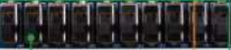
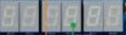
Bin to 7 segments

Bin to 7 segments

Extra points: Explain why this algorithm works. (10% extra)
References
https://www.realdigital.org/doc/6dae6583570fd816d1d675b93578203d

Propuesta para los 7 segmentos
case(num)
4'b0000: seg = 7'b1000000;
4'b0001: seg = 7'b1111001;
4'b0010: seg = 7'b0100100;
4'b0011: seg = 7'b0110000;
4'b0100: seg = 7'b0011001;
4'b0101: seg = 7'b0010010;
4'b0110: seg = 7'b0000010;
4'b0111: seg = 7'b1111000;
4'b1000: seg = 7'b0000000;
4'b1001: seg = 7'b0011000;
4'b1010: seg = 7'b0001000;
4'b1011: seg = 7'b0000011;
4'b1100: seg = 7'b0100111;
4'b1101: seg = 7'b0100001;
4'b1110: seg = 7'b0000110;
4'b1111: seg = 7'b0001110;
default: seg = 7'b0000000;
endcase

