SCHOOL EXAM ANALYTICS REPORT

Prepared for | Stakeholders
Prepared by | Sebastian Saverino
Organization / Course | Fake Organization
Date | 10/12/2026
Technical repository | https://github.com/Sebastian-Saverino/school-analytics-report-practice.git

1. Performance Snapshot

AVERAGE TEST SCORE | STUDENT COUNT | AVERAGE ATTENDANCE
67.25 | 6,378 students | 80

Snapshot Interpretation
For our snapshot the intent is to show our average test score, which is is unsatifiactory, and per data analysis, we gathered that attendance which you can see is on average of the 6,378 students they average an average attendance of 80%, so they make it to 80% of their classes has a massive correlcation, and something as a school we could focus on policing more effectively.

2. Introduction

Introduction Draft
We spoke on in the previous section, the intent is to bring analysis of exam related data, then bring helpful insights, then base our decision making off of said data. We want to find better ways to increase attendance within our school.

3. Focus Point
The big focus point, we’re focusing on is attendance, as this is both a variable, we can make an effort to enforce as the

4. Data Findings and Visual Evidence

4.1 Attendance

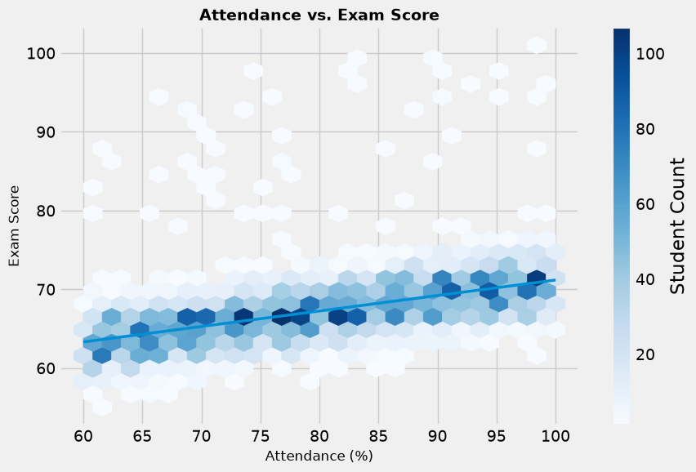

Attendance out of all of our survey factors has the largest correlation meaning, higher attendance = higher exam score = higher quality education. This could also signify that the exams are too strong, but as the graph shows, students are statically rewarded for there attendance through the grade.

4.2 Studied Hours
Key question: [How do exam outcomes differ across peer-influence groups?]
VISUAL 2 - Resources and Exam Performance
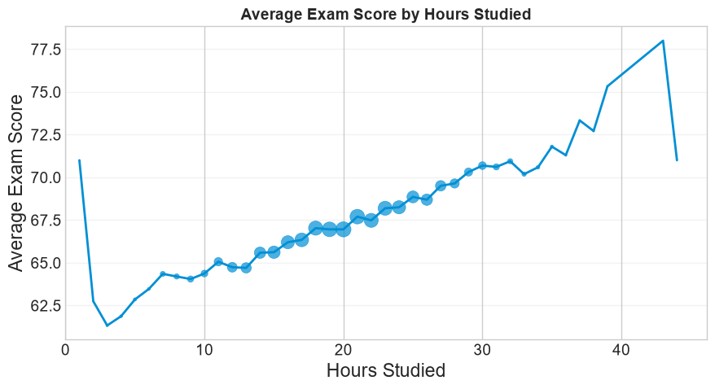

This is another massive correlation we can observe through our data which is the impact of hours studied can not be underminded.

[Paste chart/image exported from Python, Excel, or another visualization tool]

4.3 Hours Studying Variable

VISUAL 3 - Additional Controllable Factor

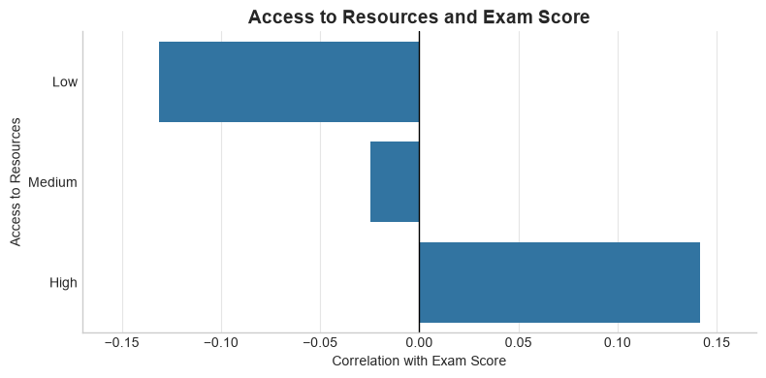

As we can tell through this chart is that there is a massive difference in correlation between High-Medium-Low access to resources. This meaning as our access to resources goes down so does our grades massively.

5. Three Improvement Opportunities

5.1 Improvement Opportunity 1: Attendance
Our data tells us the problem in regards to exam scores is attendance.This is further solidified through attendance.orgs article on facts regarding school attendance stating that “Students who missed 2 to 4 days in September were 5 times more likely than those who missed fewer than 2 days to be chronically absent for the year.” This highlights the fact that yes, there grades go down, but this can become an overwhelming snowball effect. The California Department of Education highlighting the importance of making everyone in the school system aware of the attendance on its great positive and negative effects. My proposed actions is to take more focus on problems that could be surrounding attendance, as well as making it more aware in each class to show up to class but to go one step further and show the why you need to show up to school.

School Attendance Improvement Strategies - Child Welfare & Attendance (CA Dept of Education)
10 Facts About School Attendance - Attendance Works

5.2 Improvement Opportunity 2: Hours Studied
Data shows that hours studied is a massive factor in the exam score showing a marginal increase in exam score as our hours studied goes up. This does come with drawbacks as quality and quantity are two different metrics when trying to measure hours studied. There are different ways of approaching this kind of problem which is both using a class dedicated to studying so a study hall as well as making students aware of different study habits. The university of UNC, as many great tips and tricks in regards to how to improve both hours studied and how those hours are spent. As you can tell from the chart, there are cases where a student studied a lot but still had a poor score, which this could be deduced to poor study habits or lack of honesty on the test.

Studying 101: Study Smarter Not Harder – The Learning Center

5.3 Improvement Opportunity 3: Access to Resources
The chart to the correlation we have to our exam scores to the resources they have access to, standford speaks to the deficit that lack of resources can create, so using tips from stanfords report we can have the students ask themselves what is the best resources they have access to, may it be through the school or elsewhere, gather this data then can we try to figure how we can better stragize our resources to best fit the students who both need it while being more efficient.
Studying more strategically equals improved exam scores | Stanford Report
7. Closing Remarks
MAIN MESSAGE is that we can only do so much as a schools faculty, that being said we can make an impact through making these key insights aware to everyone, this goes past the faculty but the students. Students are constantly told to make sure to show up, but why? Giving an answer through the data can add an answer and give reason to why we do certain things.

The next step is to increase awareness of attendance and study habits, adding more time for studying within classes, and then gaining more funding to help assist the students where resources may be a lower.

This is of course using fictious data so this can’t lead to anything, as well when the data only paints a small part of the picture, as to be able to make real change we must understand what is the school doing currently to help assist when solving these issues. The data can be the start then as we hone in on specific problems we can gain grainularity in regards to the problems at hand to truly diagnose the best course of action.

Template use note: Replace all bracketed text, remove instructional prompts before final delivery, and keep detailed technical work in the linked GitHub repository.

