SCHOOL EXAM ANALYTICS REPORT

Prepared for | Stakeholders
Prepared by | Sebastian Saverino
Organization / Course | Fake Organization
Date | 10/12/2026
Technical repository | https://github.com/Sebastian-Saverino/school-analytics-report-practice.git

1. Performance Snapshot

AVERAGE TEST SCORE | STUDENT COUNT | AVERAGE ATTENDANCE
67.25 | 6,378 students | 80

Snapshot Interpretation
For our snapshot the intent is to show our average test score, which is is unsatifiactory, and per data analysis, we gathered that attendance which you can see is on average of the 6,378 students they average an average attendance of 80%, so they make it to 80% of their classes has a massive correlcation, and something as a school we could focus on policing more effectively.

2. Introduction

Introduction Draft
We spoke on in the previous section, the intent is to bring analysis of exam related data, then bring helpful insights, then base our decision making off of said data. We want to find better ways to increase attendance within our school.

3. Focus Point
The big focus point, we’re focusing on is attendance, as this is both a variable, we can make an effort to enforce as the

4. Data Findings and Visual Evidence

4.1 Attendance

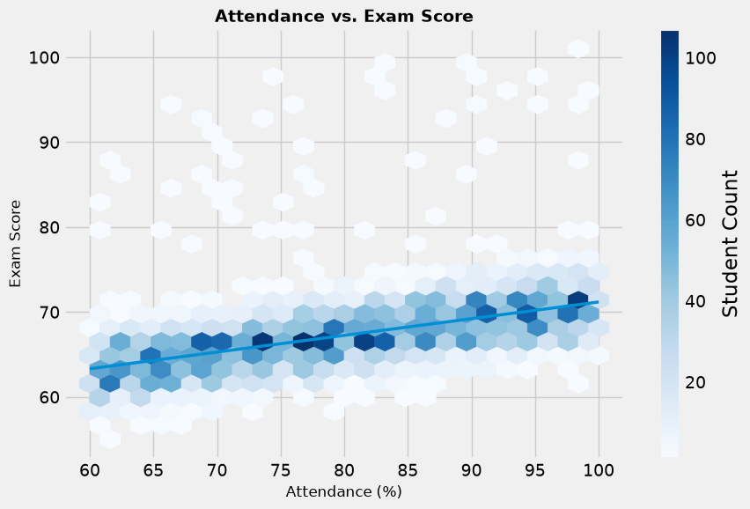

Attendance out of all of our survey factors has the largest correlation meaning, higher attendance = higher exam score = higher quality education. This could also signify that the exams are too strong, but as the graph shows, students are statically rewarded for there attendance through the grade.

4.2 Studied Hours
Key question: [How do exam outcomes differ across peer-influence groups?]
VISUAL 2 - Resources and Exam Performance
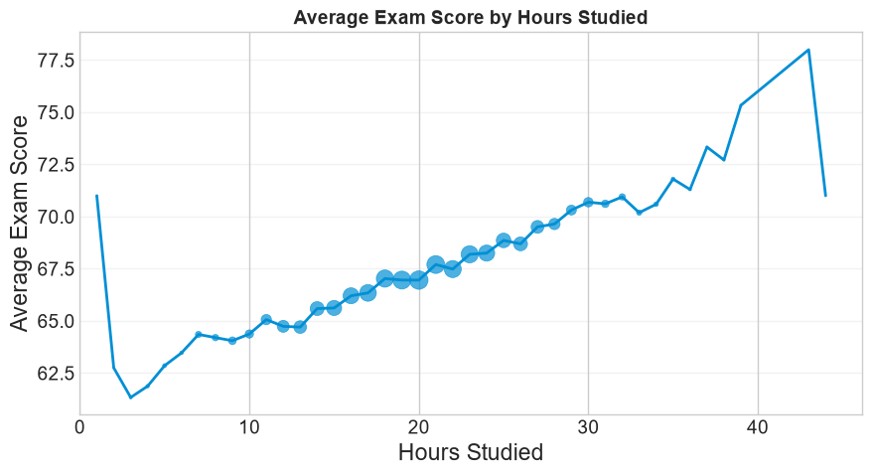

[Paste chart/image exported from Python, Excel, or another visualization tool]

4.3 Hours Studying Variable

VISUAL 3 - Additional Controllable Factor

[Paste chart/image exported from Python, Excel, or another visualization tool]

TAKEAWAY
________________________________________________________________________________
________________________________________________________________________________
________________________________________________________________________________

5. Three Improvement Opportunities
For each recommendation, connect your data finding to outside research. Separate what your dataset suggests from what published research supports.

5.1 Improvement Opportunity 1: [Short Action Title]
WHAT THE DATA SUGGESTS
________________________________________________________________________________
________________________________________________________________________________
________________________________________________________________________________
WHAT THE RESEARCH SAYS
_______________School Attendance Improvement Strategies - Child Welfare & Attendance (CA Dept of Education)_________________________________________________________________
________________________________________________________________________________
________________________________________________________________________________
________________________________________________________________________________
PROPOSED ACTION
________________________________________________________________________________
________________________________________________________________________________
________________________________________________________________________________
HOW SUCCESS WOULD BE MEASURED
________________________________________________________________________________
________________________________________________________________________________
________________________________________________________________________________
SOURCE / CITATION
[Author / organization, year, title, link or reference]

5.2 Improvement Opportunity 2: [Short Action Title]
WHAT THE DATA SUGGESTS
________________________________________________________________________________
________________________________________________________________________________
________________________________________________________________________________
WHAT THE RESEARCH SAYS
________________________________________________________________________________
________________________________________________________________________________
________________________________________________________________________________
________________________________________________________________________________
PROPOSED ACTION
________________________________________________________________________________
________________________________________________________________________________
________________________________________________________________________________
HOW SUCCESS WOULD BE MEASURED
________________________________________________________________________________
________________________________________________________________________________
________________________________________________________________________________
SOURCE / CITATION
[Author / organization, year, title, link or reference]

5.3 Improvement Opportunity 3: [Short Action Title]
WHAT THE DATA SUGGESTS
________________________________________________________________________________
________________________________________________________________________________
________________________________________________________________________________
WHAT THE RESEARCH SAYS
________________________________________________________________________________
________________________________________________________________________________
________________________________________________________________________________
________________________________________________________________________________
PROPOSED ACTION
________________________________________________________________________________
________________________________________________________________________________
________________________________________________________________________________
HOW SUCCESS WOULD BE MEASURED
________________________________________________________________________________
________________________________________________________________________________
________________________________________________________________________________
SOURCE / CITATION
[Author / organization, year, title, link or reference]

6. Methodology for Continuous Process Improvement
1. Establish the baseline
[What metrics should be recorded before a change is made?]
2. Select an intervention
[Which evidence-based change will be tested?]
3. Define success measures
[Which outcome and process metrics will determine whether the change worked?]
4. Collect follow-up data
[What data should be collected, how often, and from whom?]
5. Compare results
[How will post-intervention performance be compared with the baseline?]
6. Refine and repeat
[What would trigger continuation, modification, or replacement of the intervention?]

7. Closing Remarks
Close with the main decision-making message. Reinforce how data can help identify where to focus, measure progress, and improve the process over time.
MAIN MESSAGE
________________________________________________________________________________
________________________________________________________________________________
________________________________________________________________________________
________________________________________________________________________________
NEXT STEP
________________________________________________________________________________
________________________________________________________________________________
________________________________________________________________________________
FINAL CAVEAT / LIMITATION
________________________________________________________________________________
________________________________________________________________________________
________________________________________________________________________________

Optional References
List research sources cited in the improvement-opportunity section. Use the citation style appropriate for your audience or course.
[1. Reference]
[2. Reference]
[3. Reference]
[4. Reference]

Template use note: Replace all bracketed text, remove instructional prompts before final delivery, and keep detailed technical work in the linked GitHub repository.

