**SebMedia Documentation**

# Introduction

## Purpose

* What is the problem or the opportunity that the project is investigating?

Almost all social media platforms today are constantly gathering as much data as they can on their users

* Why is this problem valuable to address?

Privacy is a fundamental human right and giant tech corporations shouldn’t get to exploit their users’ data for money.

* What is the current state (e.g. unsatisfied users, lost revenue)?

Almost all social media platforms are gathering as much data as they can on their users. They’re listening in on your conversations, tracking you across the web, and know a lot about you. User’s privacy is slipping away, and it needs to stop.

* What is the desired state?

To create a social media platform that doesn’t track users. Users get to control their data and how it’s used and shared.

* Has this problem been addressed by other projects? What were the outcomes?

Yes. Users loved the other projects as they were privacy-focused, but the other projects are also not well known.

## Industry/ domain

* What is the industry/ domain?

Social Media / Technology

* What is the current state of this industry? (e.g. challenges from startups)

All of the major players in the industry track their users. There are some startups focusing on privacy and security, but they aren’t very well known. For example, Minds has 2.5 million registered users (as of May 2020). Compared to Facebook’s 2.934 billion (as of July 2022) that is 0.08%.

* What is the overall industry value-chain?

The social media industry makes money by getting users to register for a social media platform, and then view other users’ posts and in between those posts the user would sometimes see ads. The ads are what make the industry their money.

* What are the key concepts in the industry?

1. Get as many users to register as possible
2. The more users you can get to join your platform, the more ads you can display
3. The more ads you can display, the more profit is earnt
4. Stay ahead of trends or create new trends to prevent losing marketshare

* Is the project relevant to other industries?

Yes. SebMedia is relevant to the communication industry as posting things is a way of communication.

## Stakeholders

* Who are the stakeholders? (be as specific as possible as to who would have access to the software)

Anyone who uses social media

* Why do they care about this software?

It’s just like the social media platforms they’re used to using but with the added benefit of protecting their privacy

* What are the stakeholders’ expectations?

They expect SebMedia to be easy to use and understand, and to not track them or gather data on them.

# Product Description

## Architecture Diagram

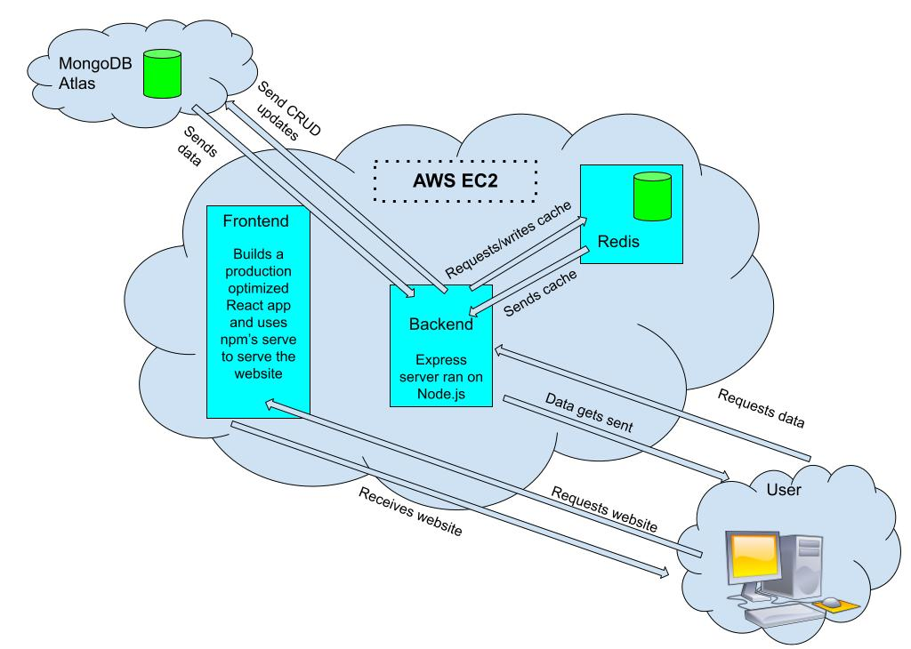

## User Stories

|  |  |  |  |  |
| --- | --- | --- | --- | --- |
| # | User Story Title | User Story Description | Priority | Additional Notes |
| 1 | Privacy | As a user, I want to not have my data be collected or for me to get tracked so that I can enjoy my favourite services and still have some privacy. | High |  |
| 2 | Finding Friends’ Posts | As a user, I want to be able to find my friends’ profiles and view and like the posts they share so that I can see what my friends are up too | High |  |
| 3 | Signing Up | As a user, I want to be able to sign up so that I can use SebMedia | High |  |
| 4 | Logging in | As a user, I want to be able to login so that I can use my SebMedia account on separate devices | High |  |
| 5 | Following a user / friend | As a user, I want to be able to follow my friends and users that I like so that I can show my appreciation for them and have their posts show up in my home feed | High |  |
| 6 | Creating a post | As a user, I want to be able to create a post so that I can share my life and opinions with other people | High |  |
| 7 | Editing a post | As a user, I want to be able to edit my posts so that if I have a typo or false/outdated information in my post, I can easily update it without having to delete and make a new post. | Medium |  |

## User Flow

**Onboarding Process -**

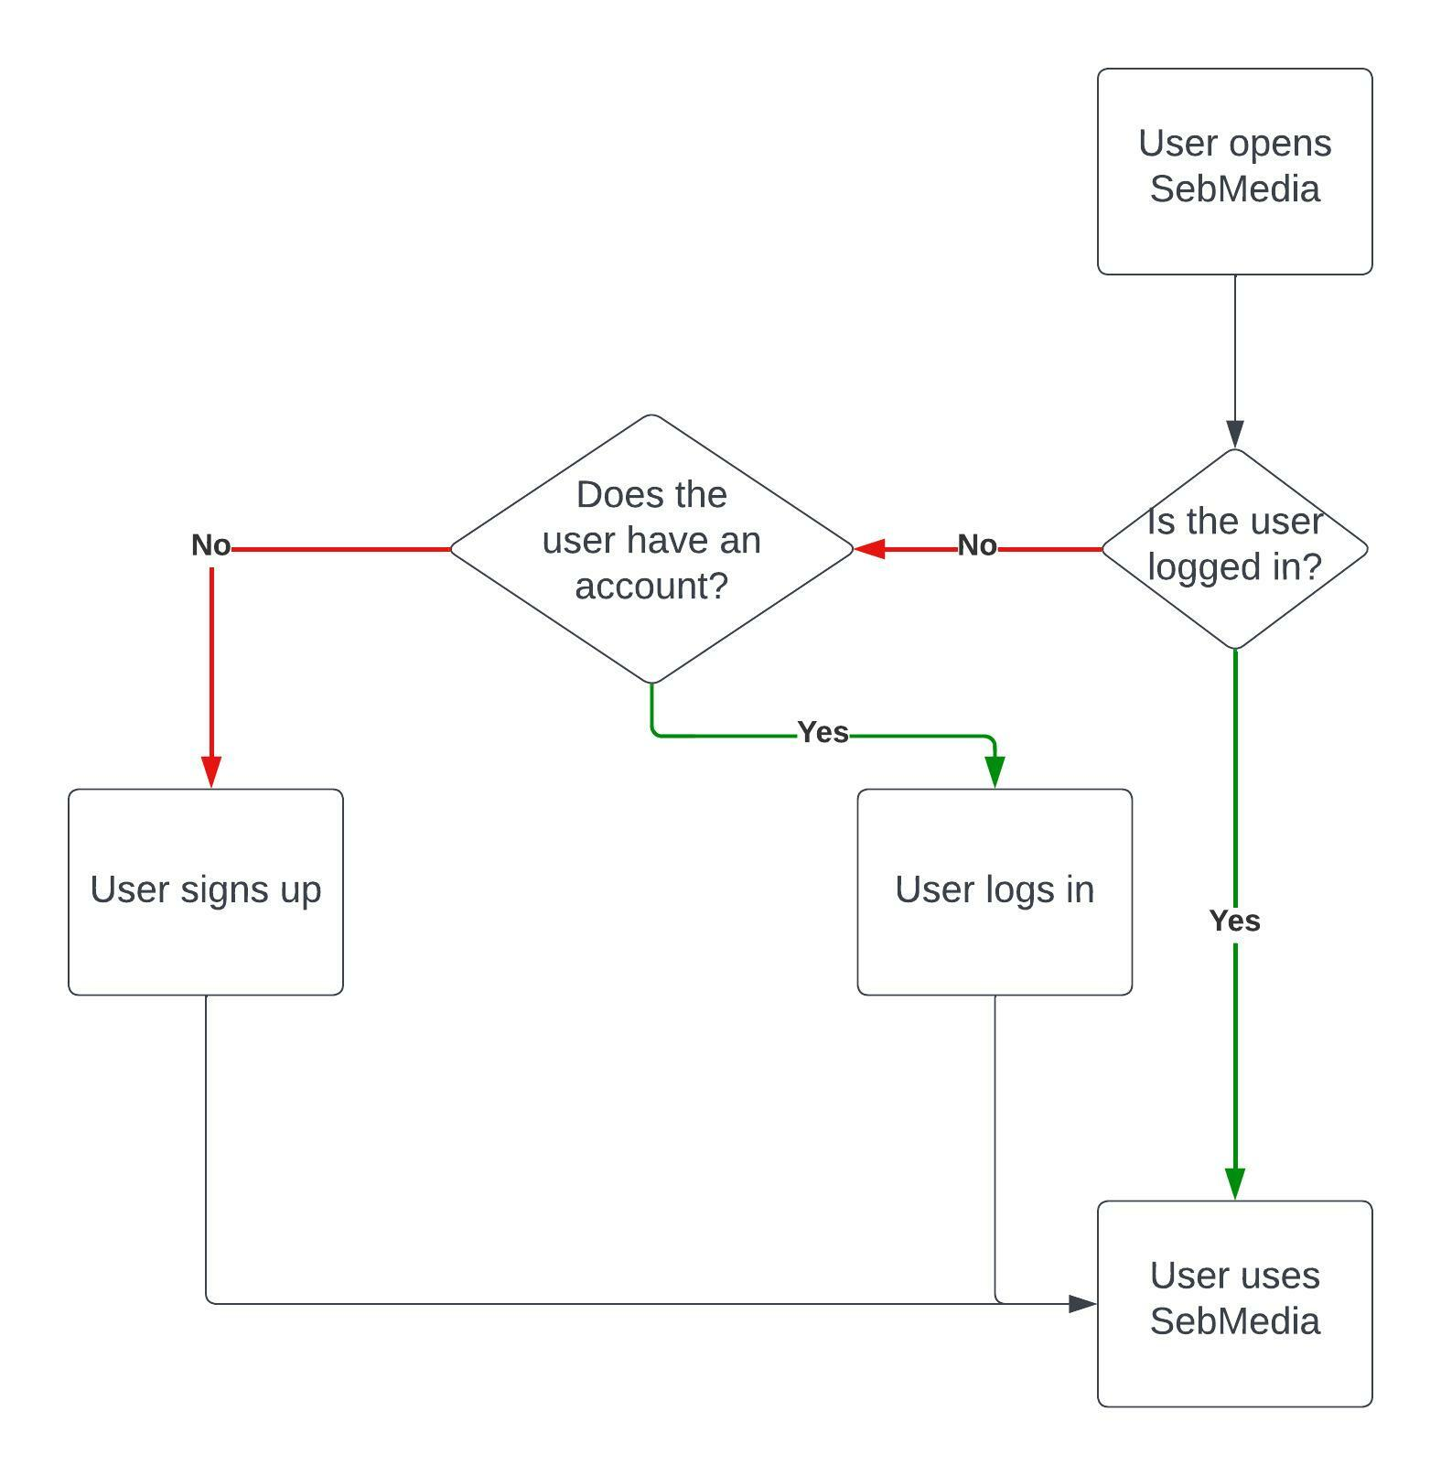

**Post Creation Process –**

**Finding your friend on SebMedia process –**

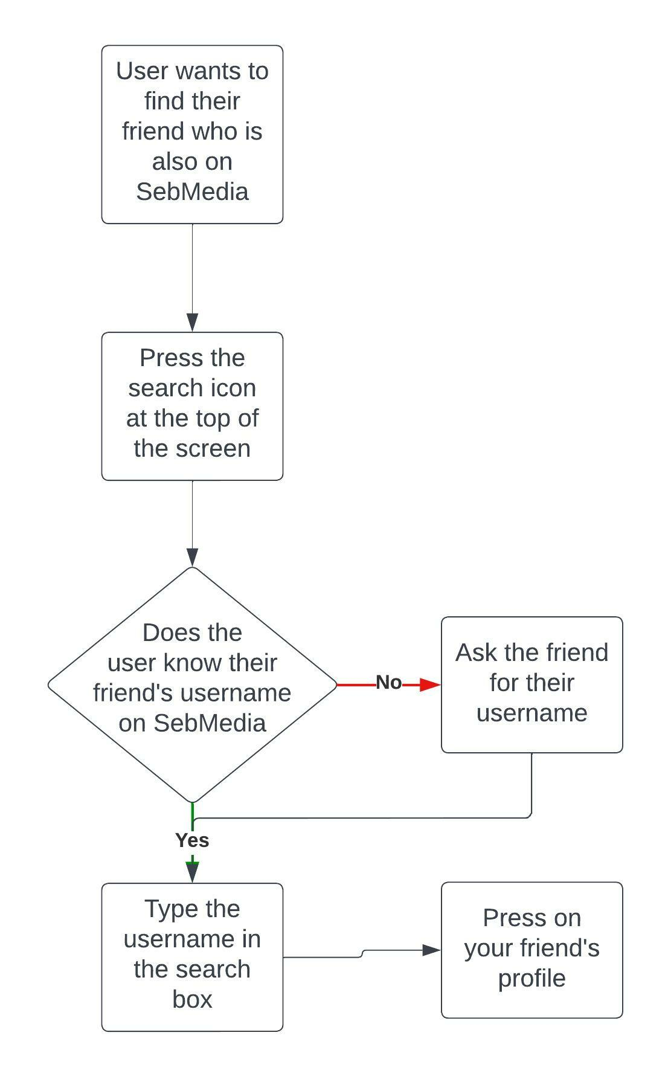

## Wireframe Design

**Home Screen –**

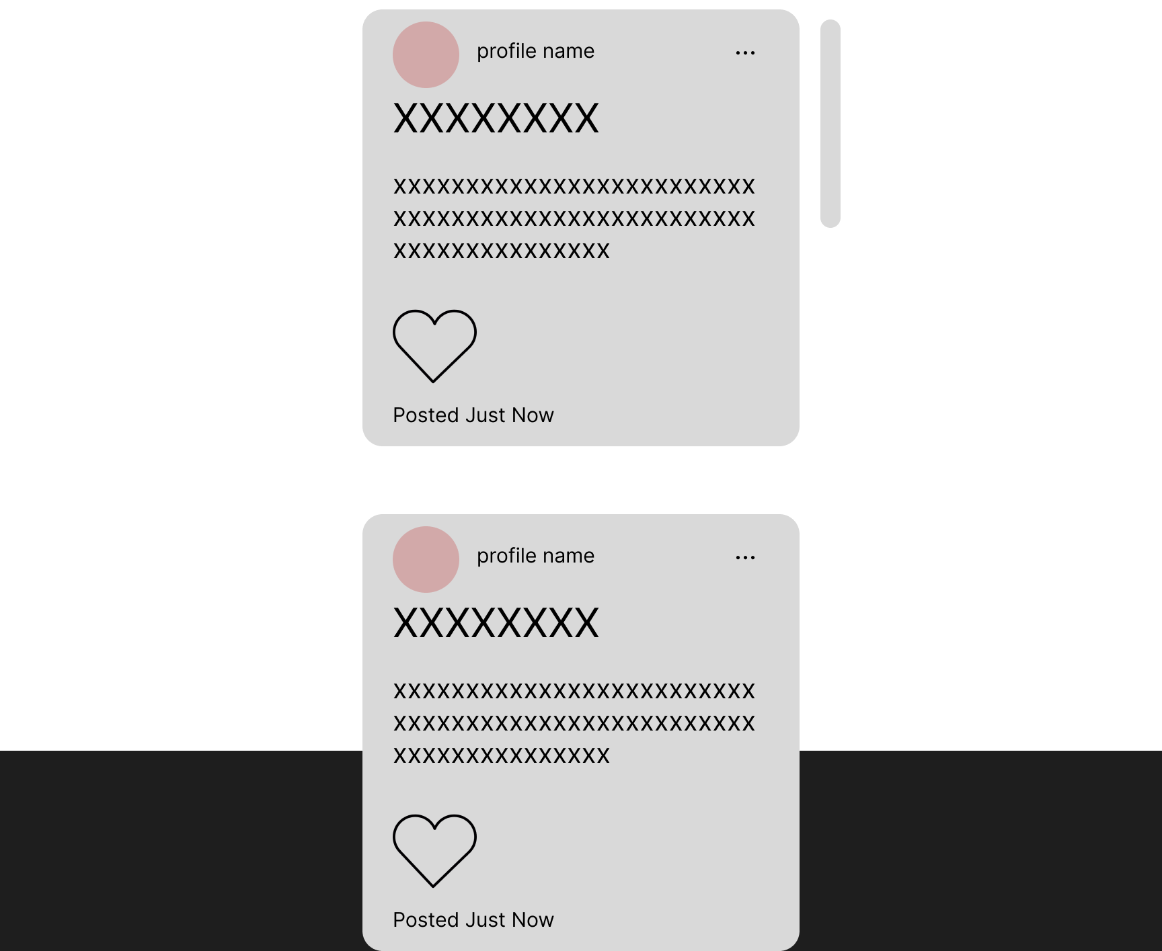

**(The gray bar is a scroll bar to represent that the Home Screen is a scrollable list of posts)**

**Search Screen –**

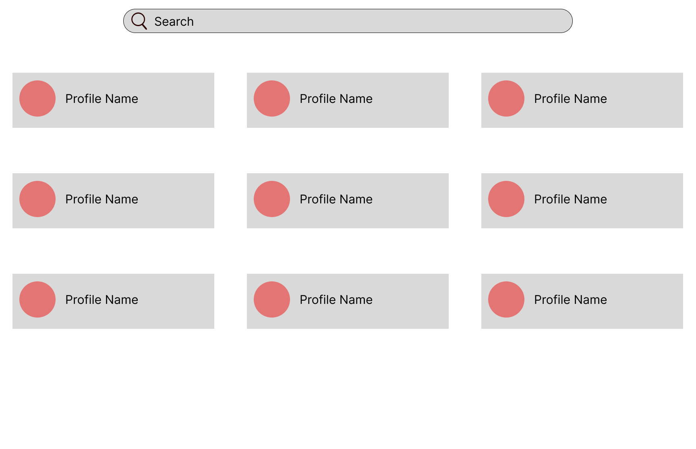

**Profile Screen –**

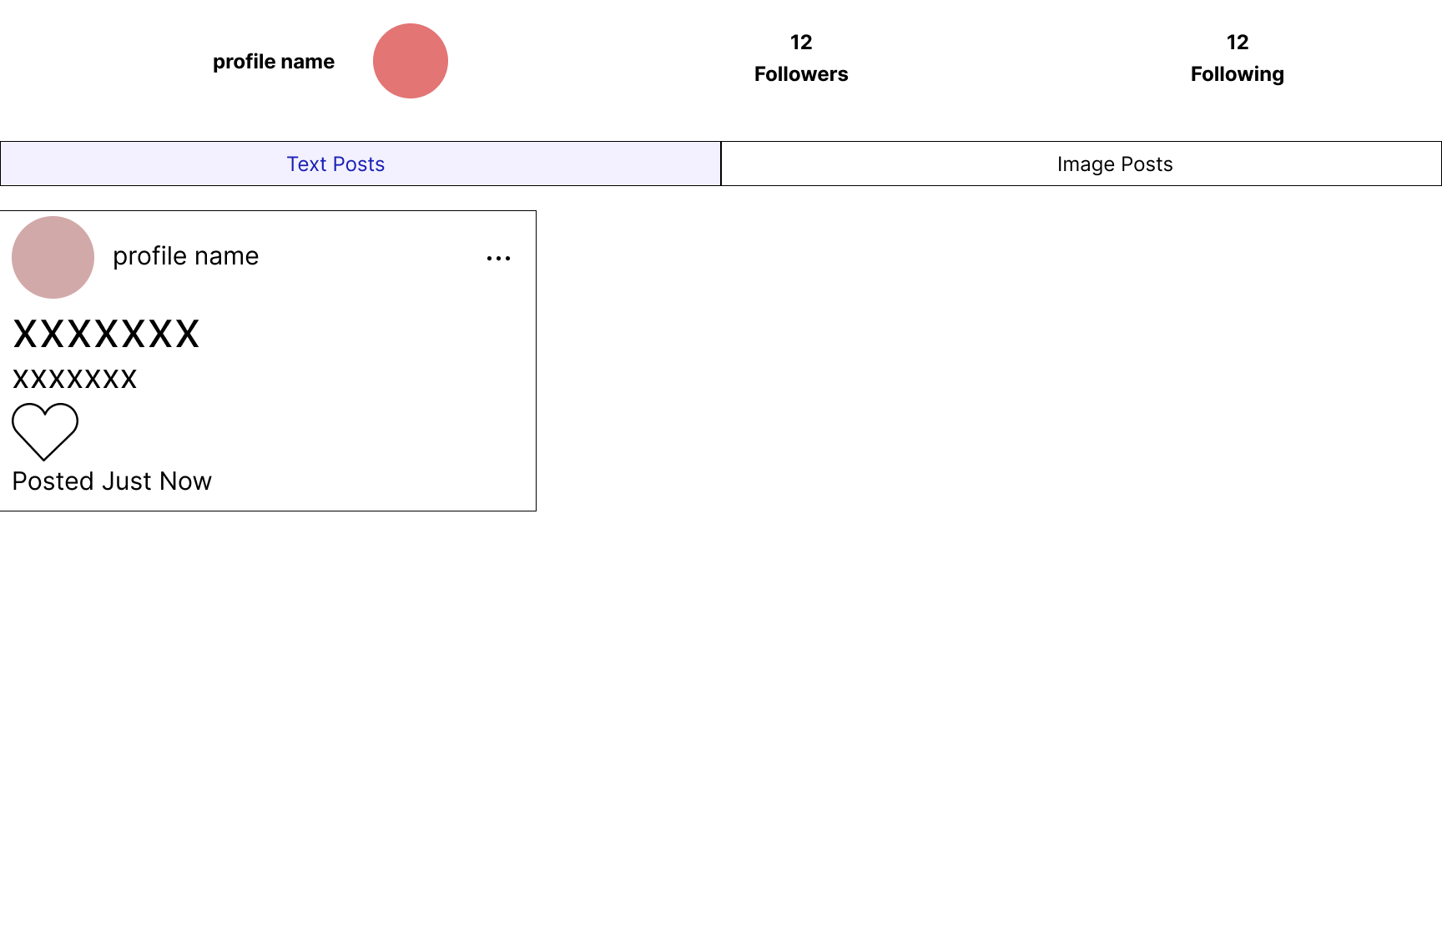

**Create Post Screen –**

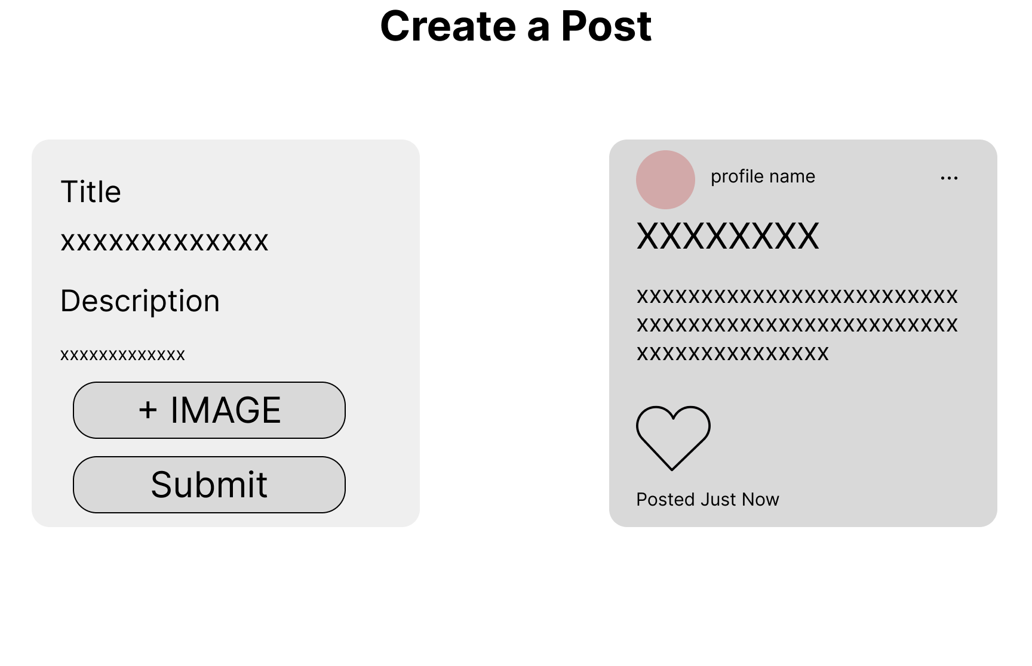

**Settings –**

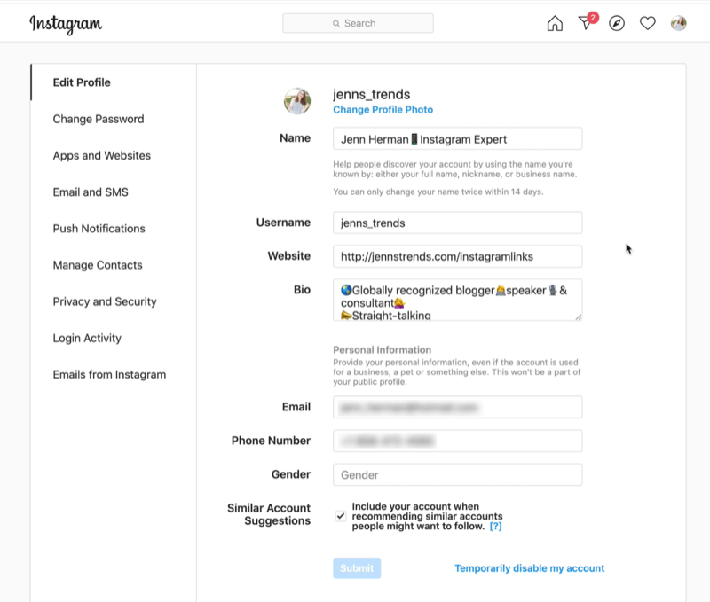

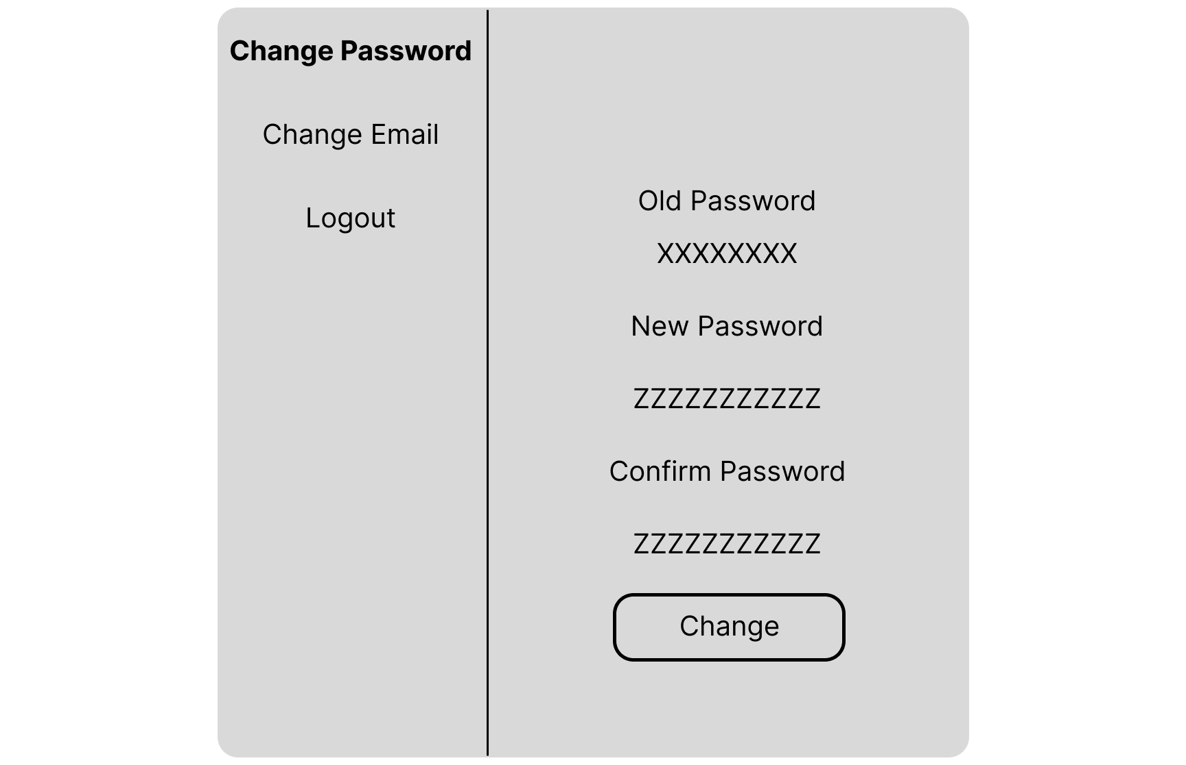

## Open Questions/Out of Scope

* What features are considered out of scope?
  + Encryption / HTTPS
  + Image compression
  + Optimization for mobile
  + Redux implementation (would be in scope if I had more time)

## Non-functional Requirements

* What are the key security requirements? (e.g. login, storage of personal details, inactivity timeout, data encryption)

Users signup with a username, email, and password. The username and email gets stored in the database as plain text. All passwords go through 2^16 (65536) hashing rounds and then get stored in the database. Since the passwords get stored in the database as hashes instead of plaintext passwords, if anyone got unauthorized access to the database they wouldn’t have access to a user’s password.

SebMedia will store usernames, emails, passwords (hashed instead of plaintext), profile pictures, and post content (text and images)

Data encryption is out of scope

* How many transactions should be enabled at peak time?

2000 a minute

* How easy to use does the software need to be?

Very easy. People of any age and of any technology skill level should be able to use this software.

* How quickly should the application respond to user requests?

As fast as possible (except in cases to protect user security, such as password hashing)

* How reliable must the application be? (e.g. mean time between failures)

SebMedia needs to have as close to a 100% uptime as possible. All social media platforms need incredibly high uptime as users around the world rely on the service at any point in time.

* Does the software conform to any technical standards to ease maintainability?
  + Backend
    - MVC Structure
  + Frontend
    - Custom Hooks implement shared functionality
    - Common elements like Profile Items are in separate files and are used by many different parts of the application

# Project Planning

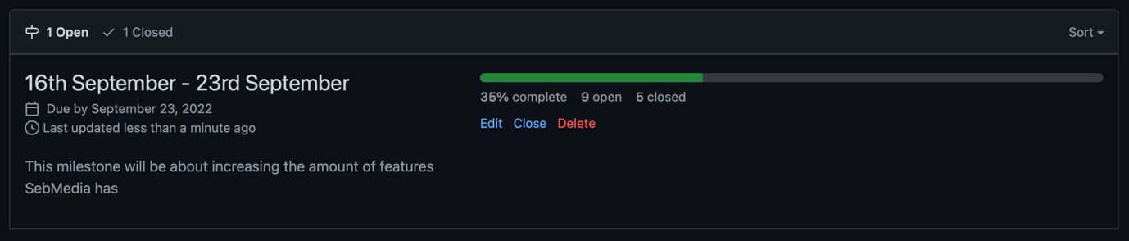

I chose to use GitHub issues to track what I needed to get done because it integrates directly into my GitHub repository and also I can link branches to an issue so stakeholders can view what is being done to fix the issue or add a new feature.

I chose to use GitHub milestones to track what to get done by a certain time because it integrates directly with my GitHub repository and also it’s easy to see what has been done and what still needs to get done within a certain timeframe. It also allows stakeholders to easily view what code changes were made to implement a feature or fix.

# Testing Strategy

* What were steps undertaken to achieve product quality?
  + Checked to make sure application looked like Figma design
  + Ran multiple automated and manual tests
  + Code is cleanly written; easy to identify issues and make changes
  + Application and it’s code is well documented
* How was each feature of the application tested?
  + Some features were tested with GitHub Actions running 9 different instances
    - Ubuntu running Node 16
    - Windows running Node 16
    - macOS running Node 16
    - Ubuntu running Node 17
    - Windows running Node 17
    - macOS running Node 17
    - Ubuntu running Node 18
    - Windows running Node 18
    - macOS running Node 18
  + Other features were tested manually by hand
* How did you handle edge cases?
  + I put console.log’s in every step of the failing process and checked for any abnormalities.

# Implementation

* What were the considerations for deploying the software?
  + Using AWS EC2 with docker-compose (3 docker images: frontend, backend, redis)

# End-to-end solution

* How well did the software meet its objectives?
  + Great! SebMedia is a functioning social media platform that protects user’s privacy.

# References

* Where is the code used in the project? (link to GitHub)
  + GitHub repo (<https://github.com/Sebastian-Webster/Capstone-Project>)
* What are the resources used in the project? (libraries, APIs, databases, tools, etc)
  + MongoDB Atlas - <https://www.mongodb.com/atlas/database>
  + Redis - <https://redis.io>
  + Docker - <https://www.docker.com>
  + AWS EC2 - <https://aws.amazon.com/ec2/>