Part A
I
A
B
C
D
E
F
G
Objective : Name and decribe each component
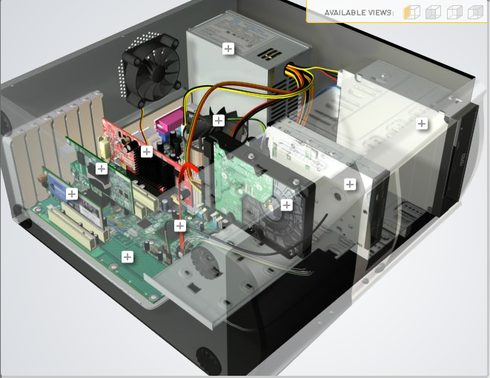
H
Download http://tinyurl.com/CW208-CAG-SIM PC Build Simulator.
Go through steps of building a PC, as you complete the simulation find and describe in detail components A to I. To run simulator first install http://www.swffileplayer.com/ and open RootMovie.swf using SWF player. Alternatively install Macromedia Flashplayer . Ideally use a simulator as listed in class.
Label | Name each component | Description
A | RAM | Computer memory or random access memory (RAM) is your system's short-term data storage; it stores the information your computer is actively using so that it can be accessed quickly.
B | GPU | Graphics processing unit, a specialized processor originally designed to accelerate graphics rendering. GPUs can process many pieces of data simultaneously, making them useful for machine learning, video editing, and gaming applications.
C | CPU | is the electronic circuitry that executes instructions comprising a computer program. The CPU performs basic arithmetic, logic, controlling, and input/output (I/O) operations specified by the instructions in the program.
D | PSU | the purpose of a power supply unit (PSU) is to supply power to all of your PC components.
E | CD Disk drive | is a device that lets you access a compact disc from a computer
F | Hard Drive | The hard drive is where all your permanent computer data is stored.
G | SSD | is a new generation of storage device used in computers. SSDs use flash-based memory
H
I | Motherboard | The motherboard is the backbone that ties the computer's components together at one spot and allows them to talk to each other.

Part B
Objective
Compare a pre-assembled system and the components that could be assembled to build a comparable system. After completing this practical, you should be able to:
- Identify the components of a pre-assembled system
- Locate prices for components needed to assemble a comparable system
- Compare the cost of a pre-assembled system and a self-assembled system.
If you can’t find exact match for components, find the closest possible substitute. Use the Internet and available computer-related publications as your sources for information. Examples of websites for computer parts www.komplett.ie, www.dell.ie, www.custompc.ie www.amazon.de
MAKE SURE TO INCLUDE VALID LINKS TO WEB REFERENCES
 | Pre-Assembled Computer Package | Computer Package  Components
CPU | AMD Ryzen 7 3700x | CPU
Storage / Memory
 | 1TB | Ram  Hard drive
  RAM
  Hard Drive
  16GB 3200mhz
Input/Output
 | Razer BlackWidow V3 Pro  Razer DeathAdder V2 Pro - Optical  Acer NITRO XV3 XV253QP - 24.5"  -  - | Keyboard  Mouse  monitor
  Keyboard
  Pointing Device
  Monitor
  Speakers
  Network Adapter
Bundled Software  (Including Operating System) | Windows 10 | windows 10
Total Cost | 2067.99 | 902.47

Part C
Objective
You have been asked by a family friend to assist them with a computer purchase. They’re unfamiliar with technology and the terms used and have presented you with two alternatives machine choices. They would like to be able to write word documents, surf internet and play Minecraft © Mojang and Half-Life © Valve Software. They are considering playing Fortnight but are not sure yet, as it depends on machine cost and if they can extract some money from their Bitcoin wallet.
Compare Personal Computer Option A and B in relation to each of the side headings and recommend a system and any alterations.

 | Personal Computer  Option A | Personal Computer  Option B
CPU | 2.2 GHz Intel Celeron 450 | 3.2 GHz Intel Core i5
Memory
  Cache
  RAM
  Hard Drive
  CD-ROM/DVD
  512 KB Cache
  4 GB RAM
  320 GB Hard Drive
  DVD+/-RW drive
  4 MB Cache
  8 GB RAM
  1 TB Hard Drive
  DVD+/-RW drive
Input/Output
  Keyboard
  Pointing Device
  Screen
  Speakers
  Network Adapter
  USB multifunction keyboard
  USB optical mouse
  20’’ HD flatscreen monitor
  Multimedia Speaker System
  Integrated 10/100/1000 Ethernet
  wireless multifunction keyboard
  wireless optical mouse
  25’’ HD flatscreen monitor
  Dolby Surround Sound Speakers
  Integrated 10/100/1000 Ethernet

Recommendations
Option B is Significantly better than option A therefore I would be inclined to purchase that option for example the machine has more ram and bigger hard drive storage

Your Recommend System
Personal Computer
Recommendation
CPU | - AMD Ryzen 7 3700X processor
Memory

  RAM
  Hard Drive
  SSD Drive
  - 16 G 16GB RAM
  - 512 512GB NVMe SSD
Input/Output

  Keyboard
  Pointing Device
  Screen
  Speakers
  Network Adapter
  GPU
  -
  -
  -
  -
  -
  RTX 2070

Hand up this practical report at the end of session and ensure it has been checked
Student Name | Sebastian Wisniewski | Student Number | C00262904
Date | 27/10/2021 | Checked
Group | A / B

