Learner Name: Sebastian Archer

BTEC First Diploma in Information and Creative Technology
Unit(s) A Technology Business | Unit code: 21  Unit credit:
Assessor: Karl Evans  Assessment IV: | Date issued:  Final deadline:

Approval of Assignment Brief
Name of IV approving brief:  Signature of IV: | Date assignment brief approved: 13/09/2021

Assignment Resubmission (if applicable) Yes / No
Name of Lead IV approving resubmission:  Signature of Lead IV: | Date assignment resubmission approved:



Unit 21 – A Technology Business
Assignment 1
Scenario

A website technology business wants to release a new technology-based product or service. The director of the company would like you to investigate suitable successful technology-based products and services.

Products – This is a physical item offered for sale. Every product is made at a cost and sold at a price. Examples of technology-based products include devices such as hearing aids, computers, games consoles, mobile phones, modems, digital cameras and printers, amongst many others.

Services – Services are transactions which do not involve physical goods. They are often open ended and involve a series of processes and systems, more often than use using the Internet. Examples of technology-based services include Youtube, Spotify, Internet Service Providers, Virtual Private Networks, Google Maps, email services, Office 365 and Moodle.

Learning Outcomes
Learning Outcome A - Understand the principles of marketing and investigate successful technology-based product(s) and service(s)

Assignment Tasks

Task 1 | - Write a report that explains six features and six functions of at least one successful technology-based product and one successful technology-based product service, giving examples of how they are used and what they are used for.  - Use at least one of the following technology-based products:  - A mobile phone  - A computer  - A games console/ computer game  - One of the following technology-based services:  - A web application/website  - A mobile application  - A desktop-based application
Task 2 | - Review the benefits of the product and the service.  - Discuss in detail one chosen successful product or service you have been investigating, consider its unique selling point and compare it with other at least two similar products or services offered by competitors.

Reading List:
See canvas

Assessment Evidence:
One written report.

Criteria:

To achieve a Pass grade the evidence must show that the learner is able to: | To achieve a Merit grade the evidence must show that, in addition to the Pass criteria, the learner is able to: | To achieve a Distinction grade the evidence must show that, in addition to the Merit criteria, the learner is able to:
P1 Explain the features and functions of at least one successful technology-based product and service. | M1 Review the benefits of at least one successful product and service. | D1 Discuss the unique selling point(s) of at least one successful product or service.

Learner Declaration:
I certify that the work submitted for this assignment is my own and research sources are fully acknowledged.

Learner signature: Date:

Learner Feedback on Completing Assignment

Assessment feedback is available on Moodle.

Assessment Results
Grading Criteria | Achieved? (Y/N)
P1 Explain the features and functions of at least one successful technology-based product and service
M1 Review the benefits of at least one successful product and service
D1 Discuss the unique selling point (s) of at least one successful product or service

Assessor Comments

Assessor Declaration:
I certify that the evidence provided is authentic and is the learner’s own work, and has been assessed in line with BTEC and Coleg Gwent assessment policies and procedures.

Assessor signature: Date:

Tesla

Features of Tesla:
- They only have one touchscreen.

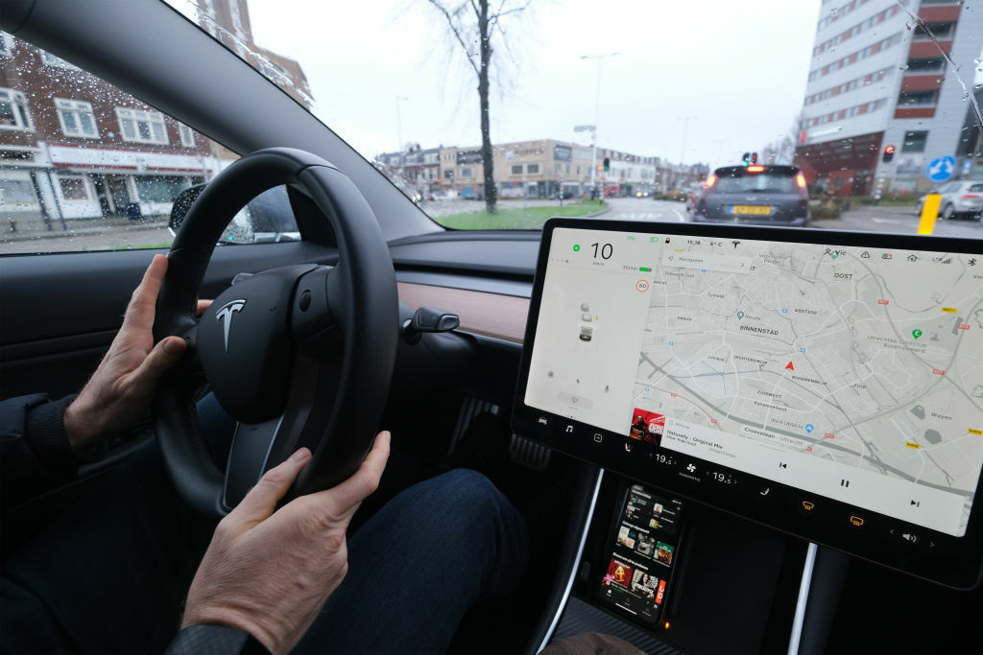
- They use Autopilot for Autonomous Driving.

- Supercharging is used to quickly charge the car battery.

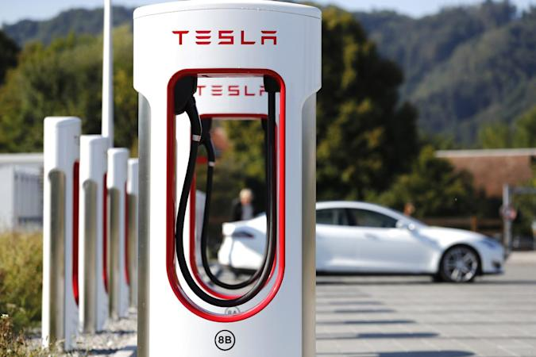

- Keycard access allows you to enter your car with only a card.

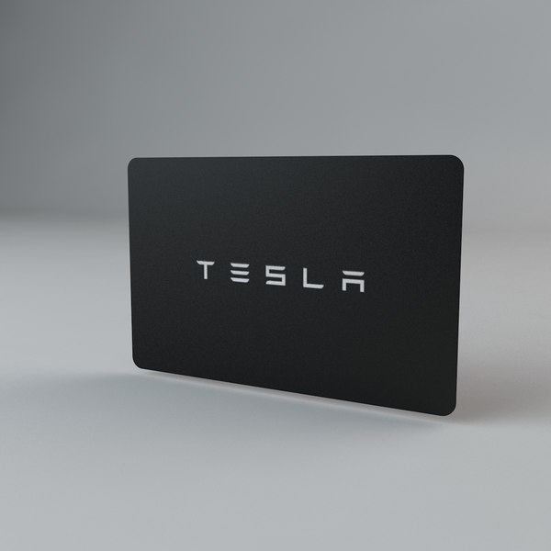
- Fart Mode, where you can make your Tesla make fart noises when different actions are made like indicating or steering.
(https://www.youtube.com/watch?v=seEVSFq3FmE)

