Parametric Tool for Automated Slot Insulation Insertion in Small-Scale Electric Motor Stator Production

Valentin Henrich  
Institute for Factory Automation and Production Systems (FAPS)  
Friedrich-Alexander-Universität Erlangen-Nürnberg (FAU)

Marcel Baader  
Institute for Factory Automation and Production Systems (FAPS)  
Friedrich-Alexander-Universität Erlangen-Nürnberg (FAU)Alen Sebastian  
Institute for Factory Automation and Production Systems (FAPS)  
Friedrich-Alexander-Universität Erlangen-Nürnberg (FAU)

Florian Risch  
Institute for Factory Automation and Production Systems (FAPS)  
Friedrich-Alexander-Universität Erlangen-Nürnberg (FAU)Andreas Morello  
Institute for Factory Automation and Production Systems (FAPS)  
Friedrich-Alexander-Universität Erlangen-Nürnberg (FAU)

Jörg Franke  
Institute for Factory Automation and Production Systems (FAPS)  
Friedrich-Alexander-Universität Erlangen-Nürnberg (FAU)

*Abstract -* The customer specific manufacturing of stators for electric motors in small-scale production is based on a time-consuming and expensive process chain. For this reason, the Institute for Factory Automation and Production Systems (FAPS) from Friedrich-Alexander University Erlangen-Nuremberg (FAU) is researching on solutions centered on the flexible automation of these processes. This paper presents a parametric mechanical tool designed for the robotic-based insertion of slot insulation paper in electric motors. While this task is predominantly performed manually in small-scale production, the proposed tool offers a flexible solution for automation. The parametric funnel enables rapid adaptation to different stator slot geometries by generating customized insertion tools. Given the limited profit margin, the cost-efficiency of the solution is a key factor in its development. The main goal is to improve flexibility in assembling different variants, small batch sizes and customer specifications.

Keywords - electric drive manufacturing; slot insulation insertion; flexible automation; robotic assembly; small-scale production

# Introduction

The production of electric motors is undergoing a profound transformation in order to meet the rapidly growing demand in a wide range of applications. While highly standardized and automated processes are used in large-scale production, e.g. in the automotive sector [1], small-scale production is still widespread in industries such as marine propulsion, where motors are often customized according to application-specific requirements. [2]

Despite the differences in size, the basic structure of electric motors remains the same. A typical motor consists of three main components: the stator, the rotor and the housing. The housing is usually manufactured using a die-casting process with subsequent precision machining. The stator and rotor core are formed from laminated electrical steel sheets, produced by punching or laser cutting and joined together using methods such as riveting or gluing. After stacking the laminations, the slot liners, are inserted into the stator slots, followed by the copper windings. The winding phases are then insulated, formed and joined together. Finally, the wire ends are joined by soldering or welding, and finishing steps such as taping, electrical testing and vacuum impregnation are carried out to complete the stator. [1]

In electric motor stators, the slot liners, serve both as electrical insulation for the windings and as a thermal interface to the stator core. Improving their thermal conductivity without compromising dielectric strength can improve the efficiency and service life of the motor. For customized small series, however, it is not economically feasible to use a separate machine for each stator type. Therefore, this step is often performed manually, which leads to quality variations due to operator dependency and is physically demanding, repetitive and costly - especially in high-wage regions. Figure 1 shows typical insulation elements in a stator, including slot liner, interphase insulation and wedges. Among these elements, the slot liner is particularly critical as it must be accurately positioned to ensure reliable insulation and avoid interference during coil insertion. [3, 4]

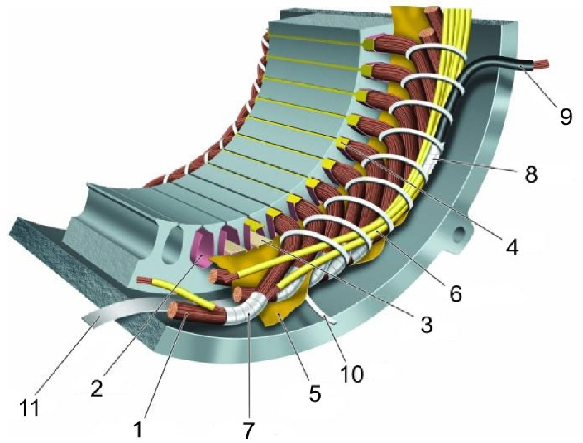

Fig. 1. Overview of materials in a low-voltage insulation system: 1 turn

insulation, 2 slot liner, 3 slot separator, 4 wedge, 5 phase separator, 6 lead

sleeving, 7 coil-nose tape, 8 connection tape, 9 cable, 10 tie cord, and 11

bracing [3]

To overcome these limitations, this paper proposes a flexible automation approach that combines a parametric mechanical tool with a general-purpose industrial robot or collaborative robot (Cobot). When equipped with the parametric tool, the robot system can perform slot insulation insertion for a variety of stator geometries without requiring extensive hardware changes for each variant. This enables a consistent and repeatable process, improving operational efficiency and providing the flexibility required in high-variety, low-volume production environments. At the same time, the system is designed to minimize programming effort and allow for quick reconfiguration between different stator types to ensure overall cost efficiency, especially in high labor cost environments. Potential application scenarios, advantages and limitations of robot-assisted automation solutions have been explored and discussed in previous research work, e.g. Kühl et al. [5], Mahr et al. [6] or Henrich et al. [7].

# State of the Art

Add a small chapter introduction sentence here as you cannot have to headlines directly in line.

## Solutions for large scale production

Automated slot insulation processes have become established in the large-scale production of electric motors, particularly for stators with distributed windings. These systems insert pre-formed insulation profiles into the stator slots using coordinated steps such as creasing, folding, cutting and positioning. High insertion speeds, precise paper overhang and repeatable quality make them ideal for mass production. To accommodate different stator types, such machines typically allow parameterized adjustments for slot length, insulation width, and forming geometry. Some systems also feature programmable functions to skip specific slots or adapt to different winding layouts. Tooling changes and modular components further support a certain degree of flexibility, enabling the production of various motor types within a defined design envelope. [src]

Despite the claimed applicability for smaller batch sizes, such systems are usually associated with high investment costs and optimized for repetitive, standardized processes. In high variance and low volume environments, frequent reconfigurations, longer set-up times and limited adaptability to manual or semi-automated downstream steps reduce their economic viability. [src]

## Solutions for small scale production

Despite significant advancements in automation, manual insertion of slot liners remains the standard practice in the small-scale manufacture of electric motors. In such setups, operators typically cut, fold, and insert the slot liners entirely by hand, or use machines for cutting and folding as shown in Fig. 2, while performing the insertion manually with simple jigs. This process relies heavily on visual inspection and tactile feedback to ensure proper alignment. However, with the growing demand for electric motors, the need for scalable and streamlined production is increasing. In this context, automation becomes a better alternative, not because manual methods are ineffective, but because they are difficult to integrate into digital workflows, challenging to scale, and not easily documented for consistent reproduction. [Source]

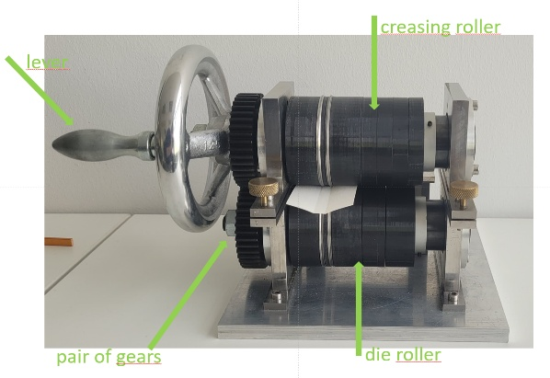

Fig. 2. Adjustable grooving module with two gear-coupled rotating shafts; Process principle: groove depth and width are controlled by roller spacing and track design, forming precise grooves on 0.2 mm thick slot liners [6].

## Automation Principles

This Chapter needs to contain the overall principles of automation, keep in mind that this is still state of the art and has no information about our robot cell. Keep it short, also there is a nice Paper somewhere for sure with maybe a nice graph about automation.

* Define principles for flexible small-scale automation
* Significant less work for worker, more for automation tool.
* Cost efficient alternative to high end machines
* Easy configuration to new variants to keep effective in small scale
* **Scope for expansion –** The system architecture supports modular upgrades. Code and hardware setup remain modular to accommodate future feedback loops or dynamic planning
* Stable processes
* (only a brainstorming by me, if u find a nice source take those information you find)
* Scalability

## Design for flexible automation

This Chapter contains the fundamentals in process design when planning to create a flexible automated process. Keep it short again.

* Parametric tooling for flexibility with different variants. CAD based funnel models are parametrically defined to allow quick adaptation to different geometries and sizes. Advantages – low cost and low lead times when changing configurations
* Robots and standard tools for flexibility
* Potential for modular improvements / adjustments / enlargements like vision feedback or other sensors
* Smart Systems (Digital (like environment knowhow or trajectory commands instead of movement flexible Goal-Poses of robots) or Hardware) for stable adjustment adaptions
* Scalability (also here, as bigger charges are part of flexibility)

## Variety in Electric Motor Stator Designs

Maybe we can include a chapter of typical stator types, like sizes, slot shapes, number of slots, etc. and maybe we even find a graph/picture about the diameter distribution of stators/motors or similar

## Derivation of consequences

This needs to be again a quite short chapter where we show that we need flexibility and an easy configuration setup to match the state of the art

* Actuator (Robot): Flexible in size & movement, cheap, easy programmable (parametric), standard Tools (Gripper)
* Tool: Parametric, cheap in manufacturing, easy to configure
* Process: robust, fast, hardware to software feedback against robot tolerances (searching algorithms, FT-Sensors)

# Hardware Setup for flexible slot liner insertion

The hardware setup is centered around a modular robotic cell designed to support flexible and precise slot liner insertion in the stator of electric motors. This cell integrates a collaborative robot, adaptive gripping tools, and a feedback sensor, all coordinated through a compute box that enables real-time control and adaptability. The main components of the setup include a UR10e robot, an HEX Force-Torque sensor and an RG2 adaptive gripper.

Fig. 3. OnRobot Gripper [src and more precise description, Maybe Change Foto to Image with Gripper mounted on Robot, than you don’t need a source too, even better]

The UR10e robot provides programmable motion control, enabling precise and repeated insertion tasks. The HEX Force-Torque sensor is mounted on the wrist of the robot for measuring interaction Forces during operation. This sensor plays a critical role in monitoring contact conditions and enabling responsive behavior during the insertion process. The RG2 gripper is attached to the Force-Torques sensor, which allows for secure handling of slot liners and funnels of varying sizes and geometries. Together, these components form a highly responsive system capable of adapting to different slot shapes and insertion conditions. The robot, in combination with the HEX sensor and gripper, provides a robust platform for implementing advanced control strategies, improving insertion accuracy, and handling variable stator geometries, typically encountered in small-batch electric motor production.

To address the variation in stator designs, the hardware setup incorporates modular and interchangeable tools. Customized funnels for guiding slot liners are created using parametric CAD models, whereby rapid adaptation to different motor designs are achieved by changing just two or three core variables. These tools are easily fabricated through 3D printing, which significantly reduces lead time and cost for new configurations

Sensor-assisted modularity further enhances system performance. The integrated force-torque sensor enables real-time monitoring of contact forces during funnel insertion, providing valuable force-based feedback to ensure proper positioning and to avoid excessive forces or potential misalignment. This capability enhances the robustness of the system, especially during the initial setup phase. Moreover, the presence of the force sensor opens possibilities for future development, such as closed-loop force-feedback control, which could further refine insertion precision under varying mechanical tolerances.

# Parametric Tool For Flexible Slot Liner Insertion

Although general design principles exist for stator slot configurations, the specific geometry is often customized to meet targeted performance requirements such as, electromagnetic efficiency, torque output, thermal management and harmonic mitigation. As a result, slot dimensions and shapes can vary depending on the motor’s intended application [8]. For instance, [9] reports stator slots with a height of 30 mm and a slot width of 20 mm. In contrast the stators used in the present study feature smaller dimensions: One stator has a slot height of 20 mm and a slot width of 8 mm, while the other has a slightly larger slot height of 22 mm but retains the same slot width. This variation highlights the need for parametric tools that can adapt to different geometries to support flexible and efficient insertion of slot liners without requiring extensive manual reconfiguration.

Parametric tooling enables rapid adaptation to new stator geometries by allowing designers to adjust key dimensions through a set of predefined parameters. This flexibility is crucial in supporting efficient and repeatable slot liner insertion across a wide range of motor designs, especially in small-batch or custom manufacturing environments.

## Selection of required adjustable Parameters

The parameters selected for the adjustment - Slot width, Slot height and Slot angle - have a direct influence on the geometry of the funnel and therefore on the success of the insertion of the slot liner. These parameters vary between different stator designs due to different electromagnetic and mechanical performance requirements. By determining and adjusting these key dimensions, the insertion tool can be effectively adapted to a wide range of stator topologies. The selected parameters and their respective roles are as follows:

* Slot-Width - governs the base opening and determines the maximum liner width that can be inserted.
* Slot-Height - dictates the depth of insertion required and impacts on the structural dimensions of the funnel.

Fig. 5. Key parameters of the funnel design, including slot width, slot height, slot angle, and slot thickness. These parameters define the funnel geometry and limit the allowable dimensions and travel path of the slot liner during insertion.

* A close-up of a grey object

  AI-generated content may be incorrect.Slot-angle - affects the taper or curvature at the slot entrance, which is critical for guiding the liner during insertion without mechanical interference.

## Fundamental Tool design

To ensure reliable and flexible slot liner insertion in small batch electric motor production, a custom design funnel tool was developed and integrated with the robot, gripper and HEX FT sensor. The funnel serves as a mechanically guided insertion aid that aligns the slot liner with the stator slot. The design is parametric, allowing rapid customization for different stator geometries and insertion requirements.

The tool features an enclosed rectangular body with an internal tapered channel that converges towards the stator slot. The inner surface is shaped with two gently curved guiding walls, which direct the slot liner into the correct slot while maintaining central alignment. At the core of the design is a central opening that allows the liner to pass through, effectively preventing twisting during insertion. A Tapered profile along the insertion path provides slight compression of the slot liner, which helps it retain its shape and improves positioning accuracy as it enters the stator. To ensure vertical alignment, the front face of thefunnel includes an inner guiderail that extends towards the stator’s slot profile. This rail serves as a continuous reference surface and guides the liner along the internal geometry of the slot, ensuring consistent insertion height and repeatability.

The rear of the tool also features a guide rail that helps in maintaining proper alignment between the funnel and the stator during setup and operation. Side slots on the guide rails enhance positional locking, ensuring a firm fit and preventing unintentional movement or misalignment during insertion. The inlet of the funnel is widened to introduce a tolerance margin, accommodating minor misalignments and improving ease of use in practical conditions. The dimensions of the inlet are also parametrically linked to the slot height – as the slot height increases, the funnel inlet automatically scales in size. This preserves insertion reliability across various configurations.

The funnel is lightweight, and 3D printed using Poly Lactic Acid (PLA), a cost-effective material that supports rapid design iterations and economical production for small-scale applications. Design considerations were also made for robotic handling: the side faces are flat with a standard width of 20 mm to facilitate secure gripping. Additionally, the tail of the tool is extended to 50 mm, intentionally shifting the center of gravity rearward to prevent forward tilting during handling, which could otherwise cause misalignment. To enhance the insertion process, a 1mm clearance is maintained between the bottom opening of the funnel and the end of the inner-guide rail. This gap allows for smoother slot liner insertion. The ends of the rail are tapered to minimize the chance of the slot liner being pulled back with the funnel during retraction.

## Fitting Adjustable parameters for specific use cases

To validate the adaptability of the parametric funnel design, two stators with different slot geometries were selected as representative use cases. The first stator, with a diameter of [insert diameter], had a slot height of 20 mm, while the second stator, with a diameter of [insert diameter], had a slot height of 22 mm. The funnel geometry was modified in CAD by adjusting predefined parameters-specifically, the entry height. This change was implemented without altering the core design, demonstrating the rapid configurability of the tool.

Following the adjustments, the customized funnels were fabricated using 3D printing and prepared for integration with the robot. These configurations were employed in the validation phase to assess the repeatability of the insertion process and the accuracy of alignment across stators with varying geometries

# Parametric Slot Liner Insertion Pipeline

(In the following sub-chapters, add photos of Funnel, funnel platform and slot liner platform and the robot and the clamp, even add Fotos from the Process, e.g. in the Moment of Slotliner insertion)

Reliable and flexible slot liner insertion is essential for small-batch electric motor production. To meet this need, a modular automation pipeline was developed that integrates a a tool positioning platform, a slot liner handling platform, the robot and the funnel. These components work together to perform the insertion process through multiple defined stages, with sensor feedback enhancing both precision and safety during critical operations such as funnel alignment. The pipeline was designed with scalability and adaptability in mind. Its parametric nature allows for quick adjustments to accommodate various stator geometries with minimal hardware or software modifications. By combining mechanical guidance with sensor-assisted control, the setup balances process flexibility, insertion accuracy, and operator safety. The following sub-chapters detail the pipeline architecture, key components, and parametric adaptability.

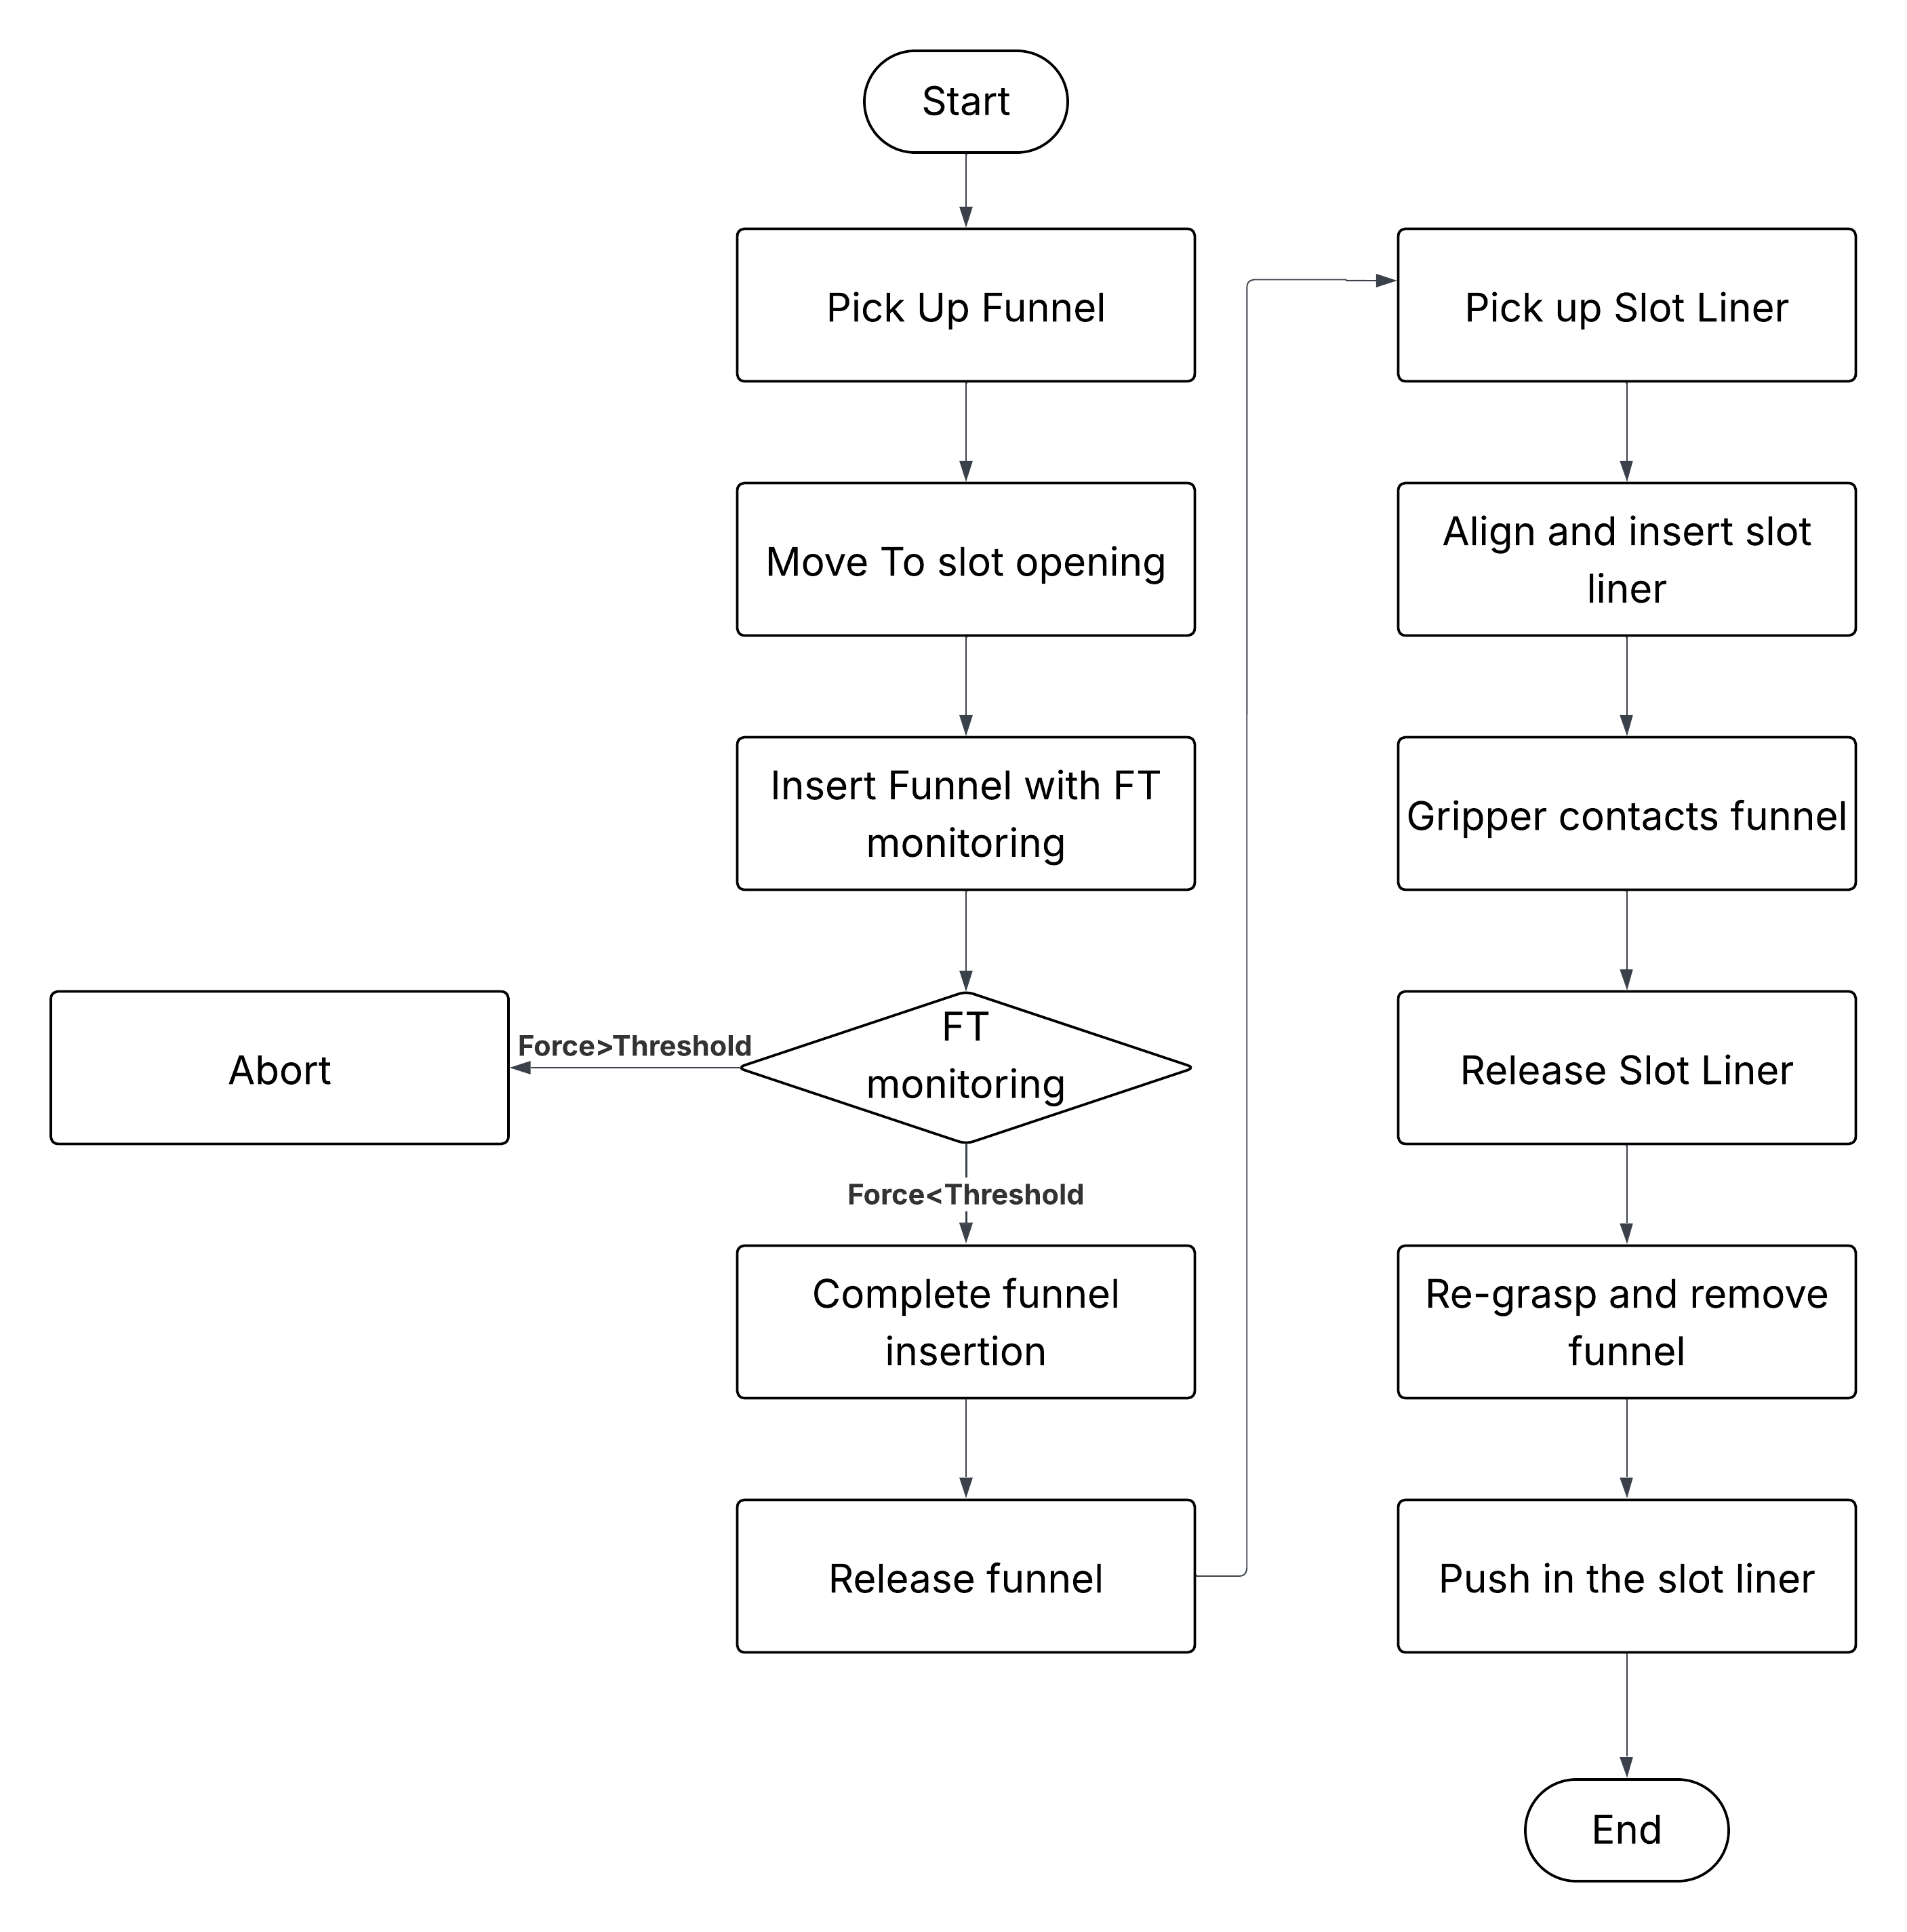

Fig. 7. Process Pipeline: The slot liner insertion process follows a structured pipeline divided into two main phases. The first focuses on inserting the funnel and the second handles slot liner insertion. The pipeline is repeated in coordination with clamp rotation to insert slot liners into each stator slot.

## Parametric Application Pipeline

In a potential sensor-assisted configuration, a UR Script-driven robot combined with the HEX- FT sensor can be used to dynamically detect contact points and adjust alignment in real time. For example, the robot could lower the funnel until contact is detected at the funnel tail, using force feedback to establish correct vertical alignment before proceeding with insertion. After vertical alignment is complete, the force is continuously measured during insertion. When the required threshold is reached, meaning the funnel has properly contacted the stator, the gripper releases the funnel, completing the insertion. While this capability was not the focus of the current validation, the modular design allows for such extensions, enabling scalable deployment across a wide range of motor designs in future implementations. This approach enables the pipeline to adapt to different stator topologies with minimal hardware changes, providing a flexible foundation for scalable deployment

## Funnel Application

## For the validation process, the funnel was inserted following a structured robotic sequence that ensures precision and repeatability. The robot after gripping the Funnel, positions it over the stator slot. It then lowers the funnel until its end touches the stator surface. Once positioned vertically, the robot inserts the funnel into the stator until the internal guiding notch was properly aligned with the stator slots. This step ensured that the funnel was not just aligned in height, but also axially positioned to match the slot geometry. Only after this full alignment was achieved, the robot releases the funnel by opening the gripper, leaving it securely seated on the stator and ready for the subsequent slot liner insertion.

## Slot Liner Positioning and Partial Insertion

Following the placement of the funnel, the positioning and insertion of slot liner takes place.The robot moves to the slot liner platform and picks up the slot liner. It then aligns the liner with the funnel’s inlet for insertion. During this step, force feedback is not utilized, as improper alignment of the slot liner causes it to slip from the gripper, which in turn automatically triggers a safety stop to halt the robot operation due to loss of grip

The robot inserts the slot liner through the funnel until the gripper meets the funnel’s front opening, typically achieving approximately three-quarters of the total insertion depth. At this stage, the slot liner is released inside the funnel, leaving it seated within the stator slot but with a portion still protruding from the slot. Subsequently, the robot retracts to begin the funnel removal process

## Final Liner Insertion

After the partial insertion of the slot liner, the robot initiates the funnel removal process. It re-grasps the funnel and performs a start-and-stop retraction motion, carefully withdrawing the funnel in small increments. This discontinuous movement helps minimize the risk of the slot liner being unintentionally pulled back due to friction or an imperfect fit within the stator slot. Once the funnel is fully removed, the robot repurposes it as a pushing tool to complete the liner insertion. By applying gentle forward pressure with the funnel, the robot ensures that the slot liner is fully seated and flush with the stator surface. This final step confirms proper alignment and secure placement of the liner, completing the automated insertion process.

# Tool Process Testing and Validation

To evaluate the effectiveness of the proposed funnel design and the automated insertion process, a series of insertion tests were conducted on two stators with different geometries. The stators differed in slot height and number of slots: one had a slot height of 20 mm with 36 slots, the other had a slot height of 22 mm with 42 slots. Slot liners of two different thicknesses- 0.28 mm and 0.34 mm - made of polyester fleece impregnated on both sides were used in the tests. For each stator, the funnel design was parametrically adapted to the respective slot height. These customized funnel variants were then manufactured using 3D printing and integrated into the test setup for evaluation.

The test environment was designed for repeatable and efficient automated insertions and consisted of the following main components:

* Funnel platform: A custom-made 3D-printed platform was developed to securely position the funnel in a fixed and repeatable position. This ensured reliable and consistent gripping by the robot during each insertion cycle.
* Slot liner platform: A separate platform was developed to hold a single pre-folded slot liner in a predefined orientation, enabling precise pickup by the robot. Although manual reloading was required after each cycle, the fixed positioning enabled consistent operation.
* Rotatable clamp for stator mounting: The stator was mounted on a mechanical rotary clamp designed to rotate through an angle specified by the user. This allowed the stator to be rotated incrementally to align each slot with the funnel after each successful insertion. The rotation step size was adjusted to the number of slots in each stator - for instance, 10° per step for a stator with 36 slots and approximately 8.57° per step for a stator with 42 slots - enabling fully automatic insertion of multiple slots without manual repositioning.

## Testing Results

The reliability and repeatability of the slot liner insertion process were further evaluated through a total of 220 insertion tests on two stators designated as Stator A and Stator B. Stator A (20 mm slot height) underwent 100 tests, including 40 preliminary tests and 60 optimized tests, after implementation of corrective measures. Stator B (22 mm slot height) was tested in 120 tests, including 60 preliminary tests and 60 optimized tests. Both stators had identical slot geometry parameters, a slot angle of 85° and a slot thickness of 8 mm. A total of 10 slot liners were used in the preliminary runs out of with 3 were selected for the optimized runs. During all tests, the success rates, the occurrence of defects, and the corresponding failure modes were documented. The average process cycle time was measured at 1 minute and 3 seconds, despite the lack of path planning or motion optimization.

**Stator A Validation**

The stator A was subjected to 100 insertion attempts – 40 preliminary and 60 optimized. The results, which are summarized in Fig. 8, show an improvement in the success rate from 80% in the preliminary tests to 97% after the process optimizations.

A total of eight errors were identified during the preliminary tests. Six of these were caused by the slot liner being pulled back together with the insertion funnel during funnel extraction. This problem was attributed to the incorrect side of the slot liner being inserted. By standardizing the alignment of the slot lining during loading, this type of error was significantly reduced in subsequent tests. The two remaining errors were caused by the improper placement of the slot liner on the insertion platform, which led to misalignment during insertion. In the Preliminary tests 10 different slot liners were used. Based on their performance, slot liners with a more favorable and consistent profile were selected for the Optimized trials and contributed significantly to the increased success rate.

To improve insertion reliability and eliminate the observed failure modes, the following corrective measures were implemented:

* Selection of optimal slot liners: Following the tests, three slot liners that consistently showed lower error rates were selected for further use. This selection played a key role in improving the overall success rate.
* Consistent alignment of slot liners: The insertion procedure was standardized so that the same side of each slot liner was always used, reducing variations due to inconsistent liner behavior.
* Deeper insertion using grippers: The inner finger of the RG2 gripper was used to push the slot liner deeper into the gripper before extraction. This reduced friction when retracting the gripper and improved the overall insertion quality.
* Precise placement of slot liners on the platform: Care was taken to ensure the slot liner was perfectly aligned on the platform before each run, minimizing insertion errors related to misalignment

After implementing these changes, an optimized test run with 60 trials was carried out, which led to an increase in the success rate from 80% to 97%. Although the error of the slot liner being pulled back with the funnel was significantly reduced, it was not eliminated, resulting in the residual 3% error

**Stator B Validation**

Stator B, which has a slightly larger slot height of 22 mm but retains the same slot width and slot angle as stator A, underwent a total of 120 insertion attempts – 60 preliminary and 60 optimized. In contrast to the tests for Stator A, the slot liners used here were not pre-folded. Therefore, the focus during the preliminary runs was on adapting the slot liners to the required insertion profile through repeated use.

The same optimization strategies used in the validation of Stator A were also used in this case. As a result, the problem previously observed, whereby the slot liner was pulled back with the funnel during retraction, did not occur in the tests with stator B. However, a total of 14 errors were observed in the preliminary phase. Of these, 11 of which resulted from improper insertion due to the slot liners not yet having the required profile. One error was due to misalignment caused by the funnel not being positioned correctly on the platform. The remaining two errors were triggered by safety stops initiated by the robot during insertion. These were caused by the new slot liners being rigid, exerting pressure on the gripper and occasionally triggering the robot's safety mechanism. A success rate of 77% was achieved in the preliminary tests.

After the preliminary tests, three slot liners with the most favorable and consistent profiles were selected for further testing. The optimized run, consisting of 60 attempts, resulted in a success rate of 97%, mirroring the performance achieved with Stator A. The two errors that occurred during this phase were again due to safety stops triggered by the obstruction of the gripper during Slot Liner insertion.

# Result Discussion

The process for inserting the slot liners was validated on two stators with different configurations: Stator A with 36 slots and Stator B with 42 slots. This means that for each complete stator, either 36 or 42 successful insertions are required to achieve complete slot lining.

One of the most important results of this validation was the 97% success rate in the optimized tests for both the stators, demonstrating a high degree of repeatability and process reliability. Compared to conventional, fully manual insertion methods, the robot-assisted approach offers several advantages:

The robot-assisted assembly significantly reduces labor and associated costs. Once optimized, the automated process also ensures consistent placement performance, thus minimizing the variability and human error that occur with manual operations. Furthermore, the system has demonstrated high flexibility and can be effectively adapted to different stator types without the need for specialized machines for each variant. This adaptability simplifies logistics and reduces investment costs, creating a scalable solution for diverse manufacturing requirements. By minimizing or eliminating manual intervention during placement, this approach increases workplace safety and reduces the risk of operator injury and fatigue.

However, a key drawback to the process is the sensitivity of the process to the slot liner’s profile and condition. During the preliminary trials with Stator B, the slot liners were not pre-folded, leading to several insertion errors due to improper profiles. This highlights the need for either preformed slot liners or a pre-treatment step to ensure uniform geometry prior to robot-assisted insertion.

In terms of cycle time, the process currently runs at a constant duration of 1 minute and 3 seconds per insertion operation. It should be noted that no specific optimization of the process, path planning or timing has been carried out. With appropriate motion planning and trajectory optimization, significant reductions in cycle time can be achieved, thereby improving throughput and production efficiency.

In summary, robot-assisted insertion of slot liners using a parametric funnel has great potential as a scalable, flexible, and cost-effective solution. With minor improvements in the preparation of the slot liners and optimization of cycle times, it can serve as a robust alternative to conventional manual methods in stator assembly.

# Outlook

The Parametric slot liner insertion process has proven to be very promising, as it has a high success rate and can be adapted to different Stator types. However, the current system does not automate the entire preparation cycle for slot liners – in particular, grooving, folding, and cutting. By integrating pre-folding tools and a slot lining dispenser mechanism, robustness and consistency could be significantly improved and a fully automated workflow enabled. These additions would reduce dependence on manual preparation steps and improve process reliability, especially when working with non-pre-folded inserts.

To further reduce errors, a simple image-based quality control system could be introduced to verify the alignment and profile of each slot liner before insertion. This could be enhanced by AI-powered vision systems and machine learning, allowing real-time detection of profile deviations or misalignments and dynamic adjustment of insertion paths. Altogether, expanding the system with pre-processing automation, vision-based inspection, and intelligent feedback mechanisms would transform the current setup into a more autonomous, scalable, and efficient solution suitable for industrial applications.

References

[1] A. Mayr *et al.,* "Electric Motor Production 4.0 – Application Potentials of Industry 4.0 Technologies in the Manufacturing of Electric Motors," in pp. 1–13.

[2] J. F. Hansen and F. Wendt, "History and State of the Art in Commercial Electric Ship Propulsion, Integrated Power Systems, and Future Trends," *Proc. IEEE*, no. 12, pp. 2229–2242, 2015, doi: 10.1109/JPROC.2015.2458990.

[3] M. Chapman, N. Frost, and R. Bruetsch, "Insulation Systems for Rotating Low-Voltage Machines," in *Conference record of the 2008 IEEE International Symposium on Electrical Insulation: Vancouver, BC, Canada, 9 - 12 June 2008*, Vancouver, BC, 2008, pp. 257–260.

[4] BEN Buchele, *BEN Buchele Elektromotorenwerke GmbH in Nürnberg.* [Online]. Available: https://​www.benbuchele.de​/​ (accessed: May 27 2025).

[5] A. Kuehl *et al.,* "Robot-based Production of Electric Motors with Hairpin Winding Technology," *Proceedings of the World Congress on Engineering and Computer Science 2019*, vol. 2019, 2019.

[6] A. Mahr, P. Mathea, A. Vogel, A. Morello, J. Franke, and A. Kühl, "Robotic based Assembly of insulating Sleeves onto Winding Coil Ends of Electric Drive Stators," in *2023 13th International Electric Drives Production Conference (EDPC)*, Regensburg, Germany, 2023, pp. 1–7.

[7] V. Henrich, A. Vogel, M. Baader, J. Franke, and A. Kühl, "Vision-Based Pose Estimation of Superimposed Enameled Wire Ends for Robotic Handling of Powerdense Flat Wire Stators," in *2024 14th International Electric Drives Production Conference (EDPC)*, Regensburg, Germany, 2024, pp. 1–9.

[8] M. J. Akhtar and R. K. Behera, "Optimal design of stator and rotor slot of induction motor for electric vehicle applications," *IET Electrical Systems in Transportation*, vol. 9, no. 1, pp. 35–43, 2019, doi: 10.1049/iet-est.2018.5050.

[9] A. Tokat, T. Thiringer, and E. Jansson, "Impact of stator slot geometry on the performance of a permanent magnet synchronous generator for wave energy converters," in *2020 International Conference on Electrical Machines (ICEM)*, Gothenburg, Sweden, 2020, pp. 1910–1916.