Parametric Tool for Automated Slot Insulation Insertion in Small-Scale Electric Motor Stator Production

Valentin Henrich  
Institute for Factory Automation and Production Systems (FAPS)  
Friedrich-Alexander-Universität Erlangen-Nürnberg (FAU)

Marcel Baader  
Institute for Factory Automation and Production Systems (FAPS)  
Friedrich-Alexander-Universität Erlangen-Nürnberg (FAU)Alen Sebastian  
Institute for Factory Automation and Production Systems (FAPS)  
Friedrich-Alexander-Universität Erlangen-Nürnberg (FAU)

Florian Risch  
Institute for Factory Automation and Production Systems (FAPS)  
Friedrich-Alexander-Universität Erlangen-Nürnberg (FAU)Andreas Morello  
Institute for Factory Automation and Production Systems (FAPS)  
Friedrich-Alexander-Universität Erlangen-Nürnberg (FAU)

Jörg Franke  
Institute for Factory Automation and Production Systems (FAPS)  
Friedrich-Alexander-Universität Erlangen-Nürnberg (FAU)

*Abstract -* The customer specific manufacturing of stators for electric motors in small-scale production is based on a time-consuming and expensive process chain. For this reason, the Institute for Factory Automation and Production Systems (FAPS) from Friedrich-Alexander University Erlangen-Nuremberg (FAU) is researching on solutions centered on the flexible automation of these processes. This paper presents a parametric mechanical tool designed for the robotic-based insertion of slot insulation paper in electric motors. While this task is predominantly performed manually in small-scale production, the proposed tool offers a flexible solution for automation. The tool enables rapid adaptation to different stator configurations by generating customized insertion tools. Given the limited profit margin, the cost-efficiency of the solution is a key factor in its development. The main goal is to improve flexibility in assembling different variants, small batch sizes and customer specifications.

Keywords - electric drive manufacturing; slot insulation insertion; flexible automation; robotic assembly; small-scale production

# Introduction

The production of electric motors is undergoing a profound transformation in order to meet the rapidly growing demand in a wide range of applications. While highly standardized and automated processes are used in large-scale production, e.g. in the automotive sector [1], small-scale production is still widespread in industries such as marine propulsion, where motors are often customized according to application-specific requirements. [2]

Despite the differences in size and configuration, the basic structure of electric motors remains the same. A typical motor consists of three main components: the stator, the rotor and the housing. The housing is usually manufactured using a die-casting process with subsequent precision machining. The stator and rotor core are formed from laminated electrical steel sheets, produced by punching or laser cutting and joined together using methods such as riveting or gluing. After stacking the laminations, the slot liners are inserted into the stator slots for insulating the in the following inserted copper windings. The slot liners serve both as electrical insulation for the windings and as a thermal interface to the stator core. Improving the thermal conductivity without compromising the dielectric strength can improve the efficiency and service life of the motor. The winding phases are then insulated, formed and joined together. Finally, the wire ends are joined by soldering or welding, and finishing steps such as taping, electrical testing and vacuum impregnation are carried out to complete the stator. [1, 3]

While in large-scale production of electric motors most of the tasks are fully automated, it is not economically feasible in customized small-scale production to use a separate machine for each stator type. Therefore, this step is often performed manually, which leads to quality variations due to operator dependency and is physically demanding, repetitive and expensive - especially in high-wage regions. Figure 1 shows typical insulation elements in a stator, including slot liner, interphase insulation and wedges. [3, 4]

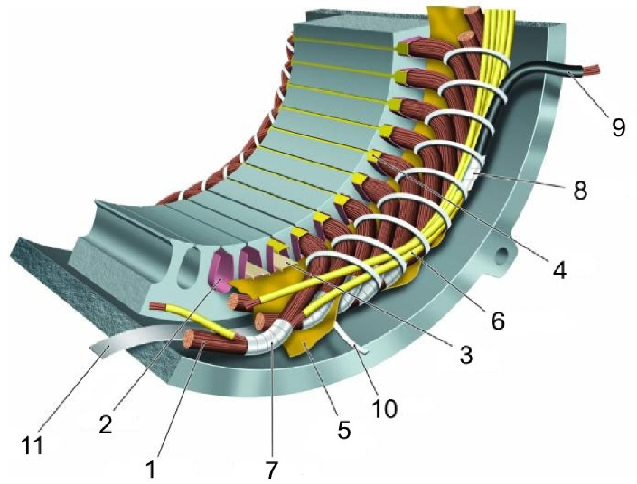

Fig. 1. Overview of insulating and supporting parts in a low-voltage insulation system: 1 turn insulation, 2 slot liner, 3 slot separator, 4 wedge, 5 phase separator, 6 lead sleeving, 7 coil-nose tape, 8 connection tape, 9 cable, 10 tie cord, and 11 bracing. [3]

To overcome these limitations, this paper proposes a flexible automation approach that combines a parametric mechanical tool with a general-purpose industrial robot or collaborative robot (Cobot). When equipped with the parametric tool, the robot system can perform slot insulation insertion for a variety of stator geometries without requiring extensive hardware changes for each variant. This enables a consistent and repeatable process, improving operational efficiency and providing the flexibility required in high-variety, low-volume production environments. At the same time, the system is designed to minimize programming effort and allow for quick reconfiguration between different stator types to ensure overall cost efficiency, especially in high labor cost environments. Potential application scenarios, advantages and limitations of robot-assisted automation solutions have been explored and discussed in previous research work, e.g. Kühl et al. [5], Mahr et al. [6] or Henrich et al. [7].

# State of the Art

To provide the necessary context for the subsequent content, this chapter clarifies key aspects of electric motor stator production, including automation strategies, the use of flexible tooling, and the specific challenges faced in small-series manufacturing environments.

## Solutions for large scale production

Automated slot insulation processes have become established in the large-scale production of electric motors, particularly for stators with distributed windings. These systems insert pre-formed insulation profiles into the stator slots using coordinated steps such as creasing, folding, cutting and positioning. High insertion speeds, precise paper overhang and repeatable quality make them ideal for mass production. To accommodate different stator types, such machines typically allow parameterized adjustments for slot length, insulation width, and forming geometry. Some systems also feature programmable functions to skip specific slots or adapt to different winding layouts. Tooling changes and modular components further support a certain degree of flexibility, enabling the production of various motor types within a defined design envelope. [8]

Despite the claimed applicability for smaller batch sizes, such systems are usually associated with high investment costs and optimized for repetitive, standardized processes. In high variance and low volume environments, frequent reconfigurations, longer set-up times and limited adaptability to manual or semi-automated downstream steps reduce their economic viability.

## Solutions for small scale production

Despite significant advancements in automation, manual insertion of slot liners remains the standard practice in the small-scale manufacture of electric motors. In such setups, operators typically cut, fold, and insert the slot liners entirely by hand, or use machines for cutting and folding as shown in figure 2, while performing the insertion manually with simple jigs. This process relies heavily on visual inspection and tactile feedback to ensure proper alignment. However, with the growing demand for electric motors, the need for scalable and streamlined production is increasing. In this context, automation becomes a promising alternative, not because manual methods are ineffective, but because they are difficult to integrate into digital workflows, challenging to scale, and not easily documented for consistent reproduction. [Source]

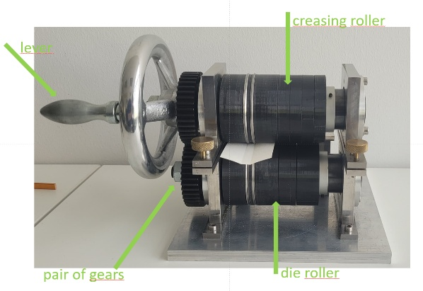

Fig. 2. Adjustable grooving module with two gear-coupled rotating shafts; Process principle: groove depth and width are controlled by roller spacing and track design, forming precise grooves on 0.2 mm thick slot liners. [source] [Fotos will be updated for the final draft!]

## Automation Principles

In modern manufacturing, especially for small batch sizes with a high number of variants, automation solutions must be both flexible and economical. A key principle is to transfer repetitive and physically demanding tasks from human operators to automated tools to improve consistency and reduce workload. To remain cost-effective in low-volume environments, such systems should allow easy configuration for new product variants, minimizing programming and set-up efforts. In addition, a modular system architecture-in both hardware and software-allows for incremental expansion and integration of advanced features, such as real-time process adjustments or data-driven optimizations. Stable processes form the basis for reliable production results, while scalability ensures that automation can grow with evolving production requirements. Together, these principles create a framework for the transition from purely manual assembly to flexible and economically sustainable automation in a high variety product field. [9]

## Design for flexible automation

Flexible automation in small batch production requires process designs that can efficiently accommodate frequent changes in product geometries and batch sizes. A key element in achieving this flexibility is parametric tool design, where CAD-based models are defined using parameterized design principles. This approach enables rapid adaptation to different shapes and sizes of stator slots with minimal lead times and low costs, so that tool changes do not become a bottleneck in production. [10]

Robots and standard end effectors further contribute to process flexibility, allowing automated systems to perform different tasks without extensive retooling. Modular system architectures create a foundation for future enhancements, such as vision feedback systems or sensor-based adaptations that can improve process reliability and adaptability in real time. Intelligent systems that use digital models, environment-specific knowledge and trajectory-based movement commands support stable and responsive adaptation to variable production scenarios. Finally, scalability remains a key aspect of flexible automation. Even with increasing batch sizes, modular upgrades and reconfigurable system components help to maintain efficiency and make production processes economical. [10]

## Variety in Stator Design for Slot Liner insertion

Electric motor stators have a considerable variety of geometric and structural designs due to application-specific performance requirements and space constraints. Key variations include the diameter, axial length (stack length), the number of slots and the geometry of the slots themselves. The stator diameter, for example, ranges from small precision motors in consumer electronics to large industrial drives in heavy machinery. The number of slots typically varies from 12 to 72 or more, depending on factors such as the desired number of pole pairs and electromagnetic performance targets. The shape of the slots also varies. Common profiles include e.g. rectangular and trapezoidal designs, each offering specific advantages in terms of winding technology, fill factor and magnetic performance. [11, 12]

In view of this wide range of geometries, this paper focuses specifically on medium-sized stators, which are often used in industrial applications and are equipped with U-shaped slot liners. This slot liner shape is widely used in these stators as it provides a reliable balance between mechanical protection of the windings and simple insertion processes. In addition to the U-shaped liners, other common forms of slot liners such as L-shaped configurations are also adapted to specific stator geometries and winding techniques. By focusing on this segment, a clear scope for the analysis and optimization of insertion techniques for slot liners is ensured, while at the same time taking into account the practical challenges of variant management in low-volume production. [13]

## Derivation of consequences

From the requirements described in the previous sections, it is clear that flexibility and ease of configuration are crucial to meet the current state of the art in low volume, high variance production environments. The choice of actuator is crucial: industrial robots and Cobots are well suited for these tasks due to their inherent flexibility in terms of size and motion, their cost efficiency compared to specialized machines and their ability to work with standard end effectors such as grippers. Such actuators are also highly programmable, especially when combined with parametric models that simplify adaptation to different stator geometries. Equally important is the tool design, which must be easy to configure and cost-effective to manufacture in order to ensure cost-effectiveness in small-batch production. Adaptive tools support fast retooling and reduce downtime when switching between product variants. Finally, the overall process must be robust and fast while incorporating feedback mechanisms between hardware and software to compensate for robot tolerances and maintain precision. This includes the use of search algorithms and force/torque sensors to adapt to slight variations during the placement process to ensure reliable operation and consistent quality across different stator designs.

# Hardware Setup for flexible slot liner insertion

The hardware setup is centered around a modular robotic cell designed to support flexible and precise stator production for electric motors. This cell integrates a Universal Robots UR10e Cobot, an OnRobot RG2 Gripper and a HEX Force-Torque (FT) sensor as shown in Fig.3, all coordinated through a central compute box that enables real-time control and adaptability. The stator is mounted vertically in a motor-driven clamp to enable accurate angular positioning of the slots. To support the insertion process, the system also includes dedicated platforms for positioning both the insertion tool and slot liner. Together, these components improve the overall accuracy and consistency of the insertion process.

The Cobot provides programmable motion control, enabling repeatable execution of the insertion tasks. The FT-sensor is mounted on the wrist of the robot for measuring interaction forces during operation. The gripper is attached to the FT-sensor, which allows for secure and flexible handling of the slot liners and funnels of varying sizes and geometries. The robot in combination with the FT-sensor and gripper forms a versatile platform for implementing advanced control strategies, improving insertion accuracy, and handling different stator geometries, typically encountered in small-batch electric motor production.

To address the variation in stator designs, the hardware setup incorporates modular and interchangeable tools. Customized tools for guiding slot liners were created using parametric CAD models, whereby rapid adaptation to different motor designs can be achieved by changing just a few core variables. These tools are easily fabricated through 3D printing, which significantly reduces lead time and cost for new configurations.

Sensor-assisted modularity further enhances system performance. The integrated FT-sensor enables real-time monitoring of contact forces during the insertion process, providing valuable force-based feedback to ensure proper positioning and to avoid excessive forces or potential misalignment. This capability enhances the robustness of the system, especially during the initial setup phase. Moreover, the presence of the FT-sensor opens possibilities for future development, such as closed-loop feedback control, which could further refine insertion precision under varying mechanical tolerances.A close-up of a device

Customized 3D-printed platforms, shown in fig.5, were also designed for the parametric tool and slot liners to ensure secure and repeatable positioning. The tool platform enables reliable and consistent gripping by the robot during each insertion cycle, minimizing alignment errors and improving process stability. Similarly, the slot liner platform held a single pre-folded slot liner in a predefined orientation, enabling precise and repeatable pickup. Although manual reloading was required after each cycle, the secure positioning significantly improved the repeatability and consistency of the entire process.

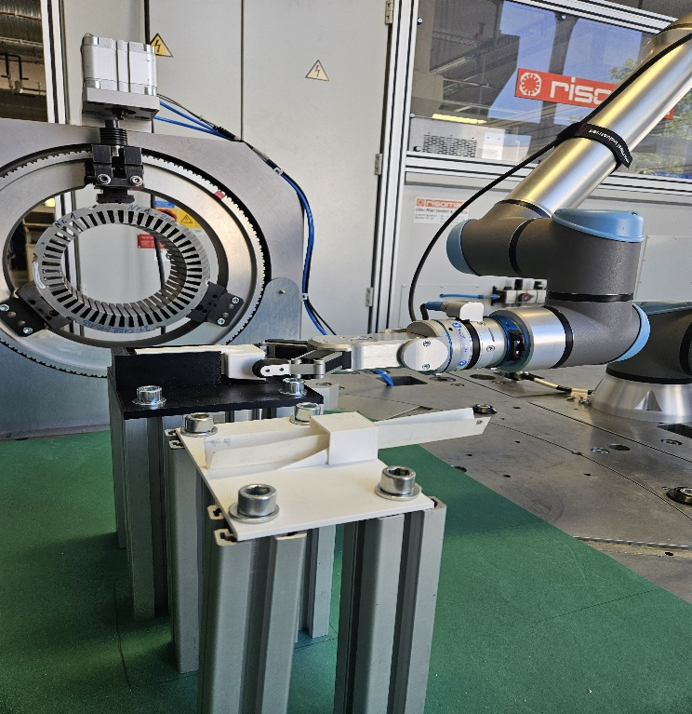The stator itself was mounted on a mechanical rotary clamp that could rotate through an angle specified by the user. This rotary mechanism made it possible to adjust the stator incrementally so that each slot was aligned with the funnel after every successful insertion. The rotation step size was configured based on the number of slots in the stator, ensuring the system to perform fully automatic insertions across multiple slots without the need for manual repositioning.

# Parametric Tool For Flexible Slot Liner Insertion

Although general design principles exist for stator slot configurations, the specific geometry is often customized to meet targeted performance requirements such as electromagnetic efficiency, torque output, thermal management and harmonic mitigation. As a result, slot dimensions and shapes can vary depending on the motor’s intended application [14]. For instance, [15] reports stator slots with a height of 30 mm and a slot width of 20 mm. In contrast the stators used in the present study feature smaller dimensions: The first stator has a slot height of 20 mm and a slot width of 8 mm, while the second has a slightly larger slot height of 22 mm. This variation highlights the need for adaptable solutions that can rapidly conform to different geometries to support flexible and efficient insertion of slot liners without requiring extensive manual reconfiguration. To address this problem, a parametric tool designed in the form of a “Funnel” was developed to guide the slot liners into the stator slot. Its design and various views are shown in Fig.4.

## Selection of required adjustable Parameters

The parameters selected for adjusting the funnel to specific stator configurations, as shown in Fig.6, are the slot width, the slot height, and the slot angle. These parameters have a direct influence on the geometry of the funnel, and therefore on the success of the insertion of the slot liner. By determining and adjusting these key dimensions, the insertion tool can be effectively adapted to a wide range of stator topologies. The slot-width governs the base opening and determines the maximum liner width that can be inserted. The slot-height dictates the depth of the slot liner that can be inserted and A close-up of a grey object
impacts the structural dimensions of the funnel. Lastly, the slot-angle affects the taper or curvature at the slot entrance, which is critical for guiding the liner during insertion without A diagram of a slot angle
mechanical interference.

## Fundamental Tool design

The funnel serves as a mechanically guided insertion aid positioned between the stator and the gripper during slot liner insertion. It helps shape and align the slot liner, simplifying the process and enhancing insertion accuracy.

The body of the funnel is rectangular in shape with an internal tapered channel that converges towards the stator slot. The inner surface is shaped with two gently curved guiding walls, which direct the slot liner into the correct slot while maintaining central alignment. At the core of the design is a central opening that allows the slot liner to pass through, effectively preventing twisting during insertion. A tapered profile along the insertion path provides slight compression of the slot liner, which helps it retain its shape and improves positioning accuracy as it enters the stator. To ensure vertical alignment, the front face of thefunnel includes an inner guiderail that extends towards the stator’s slot profile. This rail serves as a continuous reference surface and guides the liner along the internal geometry of the slot, ensuring consistent insertion height and repeatability. The ends of the rail are tapered to minimize the chance of the slot liner being pulled back with the funnel during retraction.

The rear of the tool also features an external guide rail that helps maintain proper alignment between the funnel and the stator during setup and operation. The grooves on the guide rail, as shown in Fig.7, enhance positional locking, ensuring a firm fit and preventing unintentional movement or misalignment during insertion. The funnel inlet is widened to introduce a tolerance margin, accommodating minor misalignments and improving ease of use in practical conditions. The dimensions of the inlet are also parametrically linked to the slot height - as the slot height increases, the funnel inlet automatically scales in size. This preserves insertion reliability across various configurations

The funnel is lightweight, and 3D printed using Poly Lactic Acid (PLA), a cost-effective material that supports rapid design iterations and economical production for small-scale applications. Design considerations were also made for robotic handling: the side faces are flat with a standard width of 20 mm to facilitate secure gripping. Additionally, the tail of the tool is extended to 50 mm, intentionally shifting the center of gravity rearward, to prevent forward tilting during handling, which could otherwise cause misalignment. To enhance the insertion process, a 1mm clearance is maintained between the bottom opening of the funnel and the end of the inner-guide rail. This gap allows for smoother slot liner insertion.

The process begins with the robot picking up the funnel from the funnel platform and inserting it into the stator slot. Once positioned, the robot retrieves the slot liner from the platform and inserts it through the funnel into the stator slot. This procedure ensures accurate alignment and reliable slot liner placement.

## Fitting Adjustable parameters for specific use cases

To validate the adaptability of the parametric funnel design, two stators, both with an outer diameter of 240 mm but different slot geometries, were selected as representative use cases. The first stator has a slot height of 20 mm, while the second has a slot height of 22 mm. The funnel geometry was modified in CAD by adjusting predefined parameters, particularly the slot height. In both cases, the slot height of the funnel was deliberately set slightly lower than the actual stator slot height, to avoid possible interference during insertion. For example, the funnel slot height was parameterized to 19.50 mm for the first stator and 21.50 mm for the second. After the adjustments, the customized funnels were developed using 3D printing and prepared for integration with the robot. These configurations were then used in the validation phase to evaluate the repeatability of the insertion process and the alignment accuracy across both the stators.

# Parametric Slot Liner Insertion Pipeline

Reliable and flexible slot liner insertion is essential for small-batch electric motor production. To meet this need, a modular automation pipeline was developed. The pipeline was designed with scalability and adaptability in mind. Its parametric nature and sensor feedback implementation allows for quick adjustments to accommodate various stator geometries with minimal hardware or software modifications. By combining mechanical guidance with sensor-assisted control, the setup balances process flexibility, insertion accuracy, and operator safety. The following sub-chapters detail the pipeline architecture, key components, and parametric adaptability.

## Funnel Application

## A diagram of a flowchart AI-generated content may be incorrect.The robot picks up the funnel from the designated funnel platform and starts the insertion process. With the help of the FT sensor, it lowers the funnel until its end touches the stator, thus ensuring precise vertical alignment through force feedback. Subsequently, the robot continues with horizontal insertion, bringing slot profiles of the funnel and stator into perfect alignment and positioning the rear end of the funnel firmly against the stator to ensure correct axial placement. The insertion force is continuously monitored, and when a predefined threshold is reached, signaling that the funnel is fully seated, the gripper releases it, completing the process and preparing for the insertion of the slot liner. This method enables repeatable and precise placement of the funnel on a wide variety of stator designs irrespective of the height or width.

Fig. 8. Process Pipeline: The slot liner insertion process follows a structured pipeline divided into two main phases. The first focuses on inserting the funnel and the second handles slot liner insertion. The pipeline is repeated in coordination with clamp rotation to insert slot liners into each stator slot.

## Slot Liner Positioning and Partial Insertion

With the funnel in place, the robot moves to the slot liner platform to pick up a slot liner. It then aligns the slot liner precisely with the funnel inlet and initiates the insertion. The slot liner is pushed in until the gripper contacts the front opening of the funnel, achieving almost three-quarters of the total insertion depth. At this point, the gripper releases the slot liner, which remains partially inserted in the stator slot, with a portion protruding slightly from the funnel’s opening. The robot then retracts to initiate the funnel removal process.

## Final Liner Insertion

Once the partial insertion is completed, the robot regrasps the funnel and retracts it from the stator. After the funnel is fully removed, the robot repurposes it as a pushing tool to complete the liner insertion. By applying gentle forward pressure with the funnel, the robot ensures that the slot liner is fully seated and flush with the stator surface. This final step confirms proper alignment and secure placement of the liner, completing the automated insertion process. The motor-driven clamp then rotates the stator to align the next slot for insertion, enabling continuous and automated processing of all stator slots. The complete slot liner insertion procedure is illustrated in Fig. 8.

# Tool Process Testing and Validation

To evaluate the effectiveness of the proposed funnel design and automated insertion process, a series of insertion tests were performed on two stators with different geometries - namely, slot height and number of slots. One had a height of 20 mm with 36 slots, while the other had a slot height of 22 mm with 48 slots. For ease of reference, the stator with the slot height of 20 mm is referred to as stator A and the one with the slot height of 22 mm as stator B. The tests used polyester fleece slot liners which were impregnated on both sides. For each stator, the funnel design was parametrically adapted to the respective slot configuration. These customized funnel variants were then produced using 3D printing and integrated into the test setup. The slot angle (85°) and slot width (8 mm) remained the same for both stators. After each insertion cycle, the motorized clamp rotates the stator to align the next slot for insertion. For the stator with 36 slots, the clamp rotates in 10° increments, while for the one with 48 slots, it rotates in 7.5° increments.

## Testing Results

The reliability and repeatability of the slot liner insertion process were evaluated through a total of 200 insertion tests on the two stators. Both the Stators underwent 100 trials each, which includes 40 preliminary trials and 60 optimized trials. During all tests, the success rates, the occurrence of defects, and the corresponding failure modes were documented. The average process cycle time was measured at 39.8 seconds at 30% speed, despite the lack of path planning or motion optimization.

Fig. 10. Error Frequency and causes in the preliminary trials for stator A. The slot liner being pulled back with the funnel accounted for 6 errors whereas slot liner misplacement caused 2 errors.

For stator A, results summarized in fig. 8 indicate an improvement in success rate from 80% in the preliminary phase to 97% following the applied process optimizations.

A total of eight errors were identified during the preliminary tests. Six of these were caused by the slot liner being pulled back together with the funnel during funnel extraction. The two remaining errors were caused by the improper placement of the slot liner on the insertion platform, which led to misalignment during insertion. An overview of the error distribution can be seen in fig 10.

To improve insertion reliability and eliminate the observed failure modes, several corrective measures were implemented. Firstly, the insertion procedure was standardized to ensure precise gripping and consistent alignment of the slot liners. Next, the insertion depth was increased by using the inner finger of the gripper to push the slot liner deeper into the funnel before pulling the funnel out. This technique reduced friction when retracting the funnel and improved the overall quality of the insertion. Finally, the funnel removal motion was changed from a continuous pull to a start-stop sequence. Continuous retraction often caused the funnel to become stuck or dislodge the partially inserted liner. In contrast, withdrawing the funnel in small increments reduced the likelihood of the liner being pulled back, thereby improving consistency and success rates.

After implementing these changes, the optimized test runs were carried out, which led to an increase in the success rate from 80 % to 97 %. Although the error of the slot liner being pulled back with the funnel was significantly reduced, it was not eliminated, resulting in a residual 3% error.

Stator B, which has a slightly larger slot height of 22 mm, was also subjected to a total of 100 insertion attempts. The increased slot height results in a slight narrowing at the upper end of the slot, making the insertion process more sensitive to the profile of the slot liner and its alignment. A total of 10 errors were identified in the preliminary tests. Of these, 9 were attributed to improper insertion. During the initial runs, the slot liners often failed to enter the slot correctly, primarily due to the slot liners not conforming to the required slot profile. One additional error occurred due to misalignment of the funnel on the platform; the graphical representation of the errors can be seen in fig. 11. Care was taken to ensure that the slot liners remained consistently aligned during each test. A success rate of 77% was achieved in the preliminary tests.

In the optimized phase, the same improvements as for Stator A, such as discontinuous retraction and deeper insertion with the gripper were applied. Interestingly, the problem observed in earlier tests with Stator A, where the slot liner was pulled back with the funnel during retraction, did not occur at all with Stator B. This may be explained not only by the optimizations made, but possibly also due to the narrower upper part of the slot, which allowed the slot liner to sit more securely and resist displacement when the funnel was retracted. In addition, repeated trials and controlled folding techniques resulted in improved profiles of the slot liner, which played a crucial role in improving insertion performance. The improved geometry and consistent alignment significantly increased the insertion success rate to 97 %, confirming the effectiveness of the optimizations made for the more geometrically constrained slots of stator B.

# Result Discussion

The process for inserting the slot liners was validated on two stators with different configurations: Stator A with 36 slots and Stator B with 42 slots. This means that for each complete stator, either 36 or 42 successful insertions are required to achieve complete slot lining. One of the most important results of this validation was the 97 % success rate in the optimized tests for both the stators, demonstrating a high degree of repeatability and process reliability. Compared to conventional, fully manual insertion methods, the robot-assisted approach offers several advantages.

The robot-assisted assembly significantly reduces labor and associated costs. Once optimized, the automated process also ensures consistent placement performance, thus minimizing the variability and human error that occur with manual operations. Furthermore, the system has demonstrated high flexibility and can be effectively adapted to different stator types without the need for specialized machines for each variant. This adaptability simplifies logistics and reduces investment costs, creating a scalable solution for diverse manufacturing requirements. By minimizing or eliminating manual intervention during placement, this approach increases workplace safety and reduces the risk of operator injury and fatigue.

However, a key drawback to the process is the sensitivity of the process to the slot liner’s profile and condition. During the preliminary trials with Stator B, the slot liners were insufficiently pre-folded, leading to several insertion errors due to improper profiles. This highlights the need for either precisely preformed slot liners or a pre-treatment step to ensure uniform geometry prior to robot-assisted insertion.

In terms of cycle time, the process currently runs at a constant duration of 39.8 seconds per insertion operation. It should be noted that no specific optimization of the process, path planning or timing has been carried out. With appropriate motion planning and trajectory optimization, significant reductions in cycle time can be achieved, thereby improving throughput and production efficiency.

In summary, robot-assisted insertion of slot liners using a parametric funnel has great potential as a scalable, flexible, and cost-effective solution. With minor improvements in the preparation of the slot liners and optimization of cycle times, it can serve as a robust alternative to conventional manual methods in stator assembly.

# Outlook

The Parametric slot liner insertion process has proven to be very promising, as it has a high success rate and can be adapted to different Stator types. However, the current system does not automate the entire preparation cycle for slot liners – in particular, grooving, folding, and cutting. By integrating pre-folding tools and a slot lining dispenser mechanism, robustness and consistency could be significantly improved and a fully automated workflow enabled. These additions would reduce dependence on manual preparation steps and improve process reliability, especially when working with non-pre-folded inserts.

To further reduce errors, a simple image-based quality control system could be introduced to verify the alignment and profile of each slot liner before insertion. This could be enhanced by AI-powered vision systems and machine learning, allowing real-time detection of profile deviations or misalignments and dynamic adjustment of insertion paths. Altogether, expanding the system with pre-processing automation, vision-based inspection, and intelligent feedback mechanisms would transform the current setup into a more autonomous, scalable, and efficient solution suitable for industrial applications.

References

[1] A. Mayr *et al.,* "Electric Motor Production 4.0 – Application Potentials of Industry 4.0 Technologies in the Manufacturing of Electric Motors," in pp. 1–13.

[2] J. F. Hansen and F. Wendt, "History and State of the Art in Commercial Electric Ship Propulsion, Integrated Power Systems, and Future Trends," *Proc. IEEE*, no. 12, pp. 2229–2242, 2015, doi: 10.1109/JPROC.2015.2458990.

[3] M. Chapman, N. Frost, and R. Bruetsch, "Insulation Systems for Rotating Low-Voltage Machines," in *Conference record of the 2008 IEEE International Symposium on Electrical Insulation: Vancouver, BC, Canada, 9 - 12 June 2008*, Vancouver, BC, 2008, pp. 257–260.

[4] BEN Buchele, *BEN Buchele Elektromotorenwerke GmbH in Nürnberg.* [Online]. Available: https://​www.benbuchele.de​/​ (accessed: May 27 2025).

[5] A. Kuehl *et al.,* "Robot-based Production of Electric Motors with Hairpin Winding Technology," *Proceedings of the World Congress on Engineering and Computer Science 2019*, vol. 2019, 2019.

[6] A. Mahr, P. Mathea, A. Vogel, A. Morello, J. Franke, and A. Kühl, "Robotic based Assembly of insulating Sleeves onto Winding Coil Ends of Electric Drive Stators," in *2023 13th International Electric Drives Production Conference (EDPC)*, Regensburg, Germany, 2023, pp. 1–7.

[7] V. Henrich, A. Vogel, M. Baader, J. Franke, and A. Kühl, "Vision-Based Pose Estimation of Superimposed Enameled Wire Ends for Robotic Handling of Powerdense Flat Wire Stators," in *2024 14th International Electric Drives Production Conference (EDPC)*, Regensburg, Germany, 2024, pp. 1–9.

[8] Elmotec Statomat, *Slot Insulation - Elmotec Statomat.* [Online]. Available: https://​www.elmotec-statomat.eu​/​en/​manufacturing-​process/​slot-​insulation/​ (accessed: May 30 2025).

[9] Automation International, *Flexibility and Efficiency in Small Batch Production through Automation.* [Online]. Available: https://​www.automation-mag.com​/​news/​91746-​flexibility-​and-​efficiency-​in-​small-​batch-​production-​through-​automation (accessed: May 30 2025).

[10] Y. Koren *et al.,* "Reconfigurable Manufacturing Systems," *CIRP Annals*, vol. 48, no. 2, pp. 527–540, 1999, doi: 10.1016/S0007-8506(07)63232-6.

[11] L. L. Wang, J. X. Shen, P. Luk, W. Z. Fei, C. F. Wang, and H. Hao, "Development of a Magnetic-Geared Permanent-Magnet Brushless Motor," *IEEE Trans. Magn.*, vol. 45, no. 10, pp. 4578–4581, 2009, doi: 10.1109/TMAG.2009.2023071.

[12] I. Chasiotis, Y. Karnavas, and F. Scuiller, "Effect of Rotor Bars Shape on the Single-Phase Induction Motors Performance: An Analysis toward Their Efficiency Improvement," *Energies*, vol. 15, no. 3, p. 717, 2022, doi: 10.3390/en15030717.

[13] J. Pijor, "Generator Slot Liner Selection Guide," Mar. 2024. Accessed: May 30 2025. [Online]. Available: https://​thegundcompany.com​/​generator-​slot-​liner-​selection-​guide/​

[14] M. J. Akhtar and R. K. Behera, "Optimal design of stator and rotor slot of induction motor for electric vehicle applications," *IET Electrical Systems in Transportation*, vol. 9, no. 1, pp. 35–43, 2019, doi: 10.1049/iet-est.2018.5050.

[15] A. Tokat, T. Thiringer, and E. Jansson, "Impact of stator slot geometry on the performance of a permanent magnet synchronous generator for wave energy converters," in *2020 International Conference on Electrical Machines (ICEM)*, Gothenburg, Sweden, 2020, pp. 1910–1916.