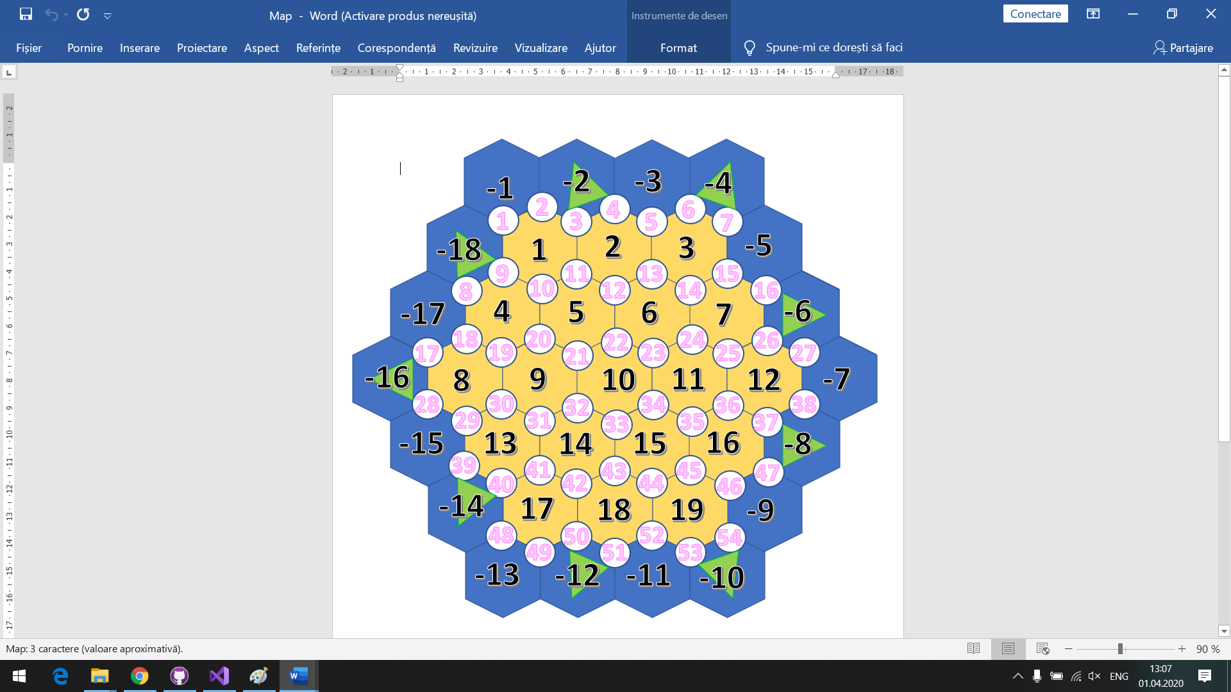

**Node**

**name** // *1*-3*1*

**neighborNodeList**

**roadList**

**neighborHexagonList**

**hasPort**

**portType** //simple,wool, clay

**hasPlayer**

**player** //pointer

**settlementType** //none, village, city

**Player**

**nickname**

**ID**

**skin**

**points**

**settlementNodeList**

**remainingCities**

**remainingRoads**

**remainingVillages**

**cardList**

**longestRoad**

**biggestArmy**

**Hexagon**

**name** //1,2,3,4,-5

**resource**

**diceNumber**

**hasRobber**

**Road**

**Node1**

**Node2**

**Player**

**Card**

**Type**

**InitializeGame(hardcode)**

**\* Get winningPoints**

**\* Get gameType**

**\* Populate Hexagons**

**\* Randomize Hexagon Resources**

**\* Specify Hexagon with Robber**

**\* Populate Node Names**

**\* Populate Node Neighbors**

**\* Populate Node Hexagons**

**\* Specify Nodes with Ports**

**\* Randomize Port Types**