HW 8: RMS with Resources – Sebastian Aybar – 1273441

(a)
T¹(5; 15; 2; 2) - exec=5, period=15, allocR=2, userR=2
T²(2; 10; 1; 1) - exec=2, period=10, allocR=1, userR=1
T³(7; 23; 1; 2) - exec=7, period=23, allocR=1, userR=2
T² (Period=10) - höchste Priorität
T¹ (Period=15) - mittlere Priorität
T³ (Period=23) - niedrigste Priorität
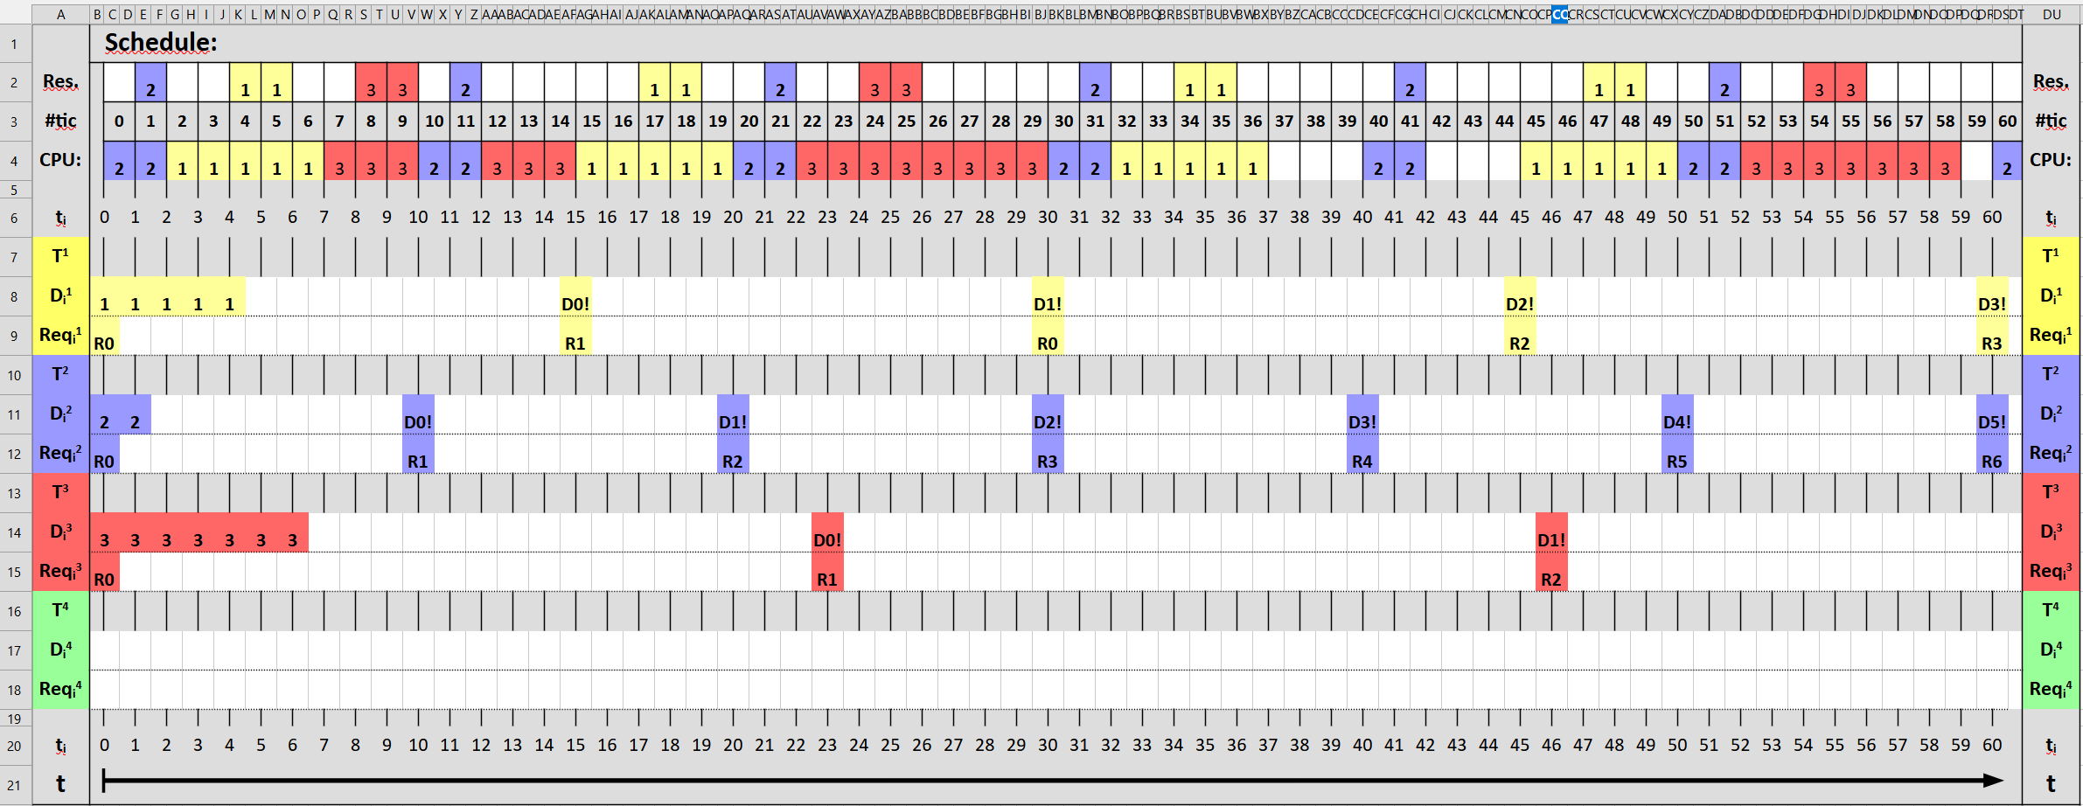

(b)
T¹(4; 14; 1; 2) - exec=4, period=14, allocR=1, userR=2
T²(2; 10; 0; 0) - exec=2, period=10, allocR=0, userR=0 (keine Ressource)
T³(7; 30; 3; 4) - exec=7, period=30, allocR=3, userR=4
T² (Period=10) - höchste Priorität
T¹ (Period=14) - mittlere Priorität
T³ (Period=30) - niedrigste Priorität
Necessity Test: 4/14 + 2/10 + 7/30 = 0,7190 < 1 => Test bestanden
Schedubility Test: 3 * (2^(1/3) - 1) = 0,780
U <= Treshhold => scheduble
