**Aufgabe 1.1 -** Kombinatorische Schaltungen und Minimierung

**unsigned**

|  |  |  |  |  |  |  |  |  |  |  |  |
| --- | --- | --- | --- | --- | --- | --- | --- | --- | --- | --- | --- |
| **x3** | **x2** | **x1** | **x0** |  | **y3** | **y2** | **y1** | **y0** |  |  |  |
| 0 | 0 | 0 | 0 |  | 0 | 0 | 0 | 0 |  |  |  |
| 0 | 0 | 0 | 1 |  | 0 | 0 | 0 | 0 |  |  |  |
| 0 | 0 | 1 | 0 |  | 0 | 0 | 0 | 0 |  |  |  |
| 0 | 0 | 1 | 1 |  | 0 | 0 | 0 | 0 |  |  |  |
| 0 | 1 | 0 | 0 |  | 0 | 0 | 0 | 0 |  |  |  |
| 0 | 1 | 0 | 1 |  | 0 | 0 | 0 | 1 |  |  |  |
| 0 | 1 | 1 | 0 |  | 0 | 0 | 1 | 0 |  |  |  |
| 0 | 1 | 1 | 1 |  | 0 | 0 | 1 | 1 |  |  |  |
| 1 | 0 | 0 | 0 |  | 0 | 0 | 0 | 0 |  |  |  |
| 1 | 0 | 0 | 1 |  | 0 | 0 | 1 | 0 |  |  |  |
| 1 | 0 | 1 | 0 |  | 0 | 1 | 0 | 0 |  |  |  |
| 1 | 0 | 1 | 1 |  | 0 | 1 | 1 | 0 |  |  |  |
| 1 | 1 | 0 | 0 |  | 0 | 0 | 0 | 0 |  |  |  |
| 1 | 1 | 0 | 1 |  | 0 | 0 | 1 | 1 |  |  |  |
| 1 | 1 | 1 | 0 |  | 0 | 1 | 1 | 0 |  |  |  |
| 1 | 1 | 1 | 1 |  | 1 | 0 | 0 | 1 |  |  |  |

**signed**

|  |  |  |  |  |  |  |  |  |  |  |  |  |
| --- | --- | --- | --- | --- | --- | --- | --- | --- | --- | --- | --- | --- |
| **int** | **x3** | **x2** | **int** | **x1** | **x0** |  | **y3** | **y2** | **y1** | **y0** | **Ergebnisint** |  |
| 0 | 0 | 0 | 0 | 0 | 0 |  | 0 | 0 | 0 | 0 | 0 |  |
| 0 | 0 | 0 | 1 | 0 | 1 |  | 0 | 0 | 0 | 0 | 0 |  |
| 0 | 0 | 0 | -2 | 1 | 0 |  | 0 | 0 | 0 | 0 | 0 |  |
| 0 | 0 | 0 | -1 | 1 | 1 |  | 0 | 0 | 0 | 0 | 0 |  |
| 1 | 0 | 1 | 0 | 0 | 0 |  | 0 | 0 | 0 | 0 | 0 |  |
| 1 | 0 | 1 | 1 | 0 | 1 |  | 0 | 0 | 0 | 1 | 1 |  |
| 1 | 0 | 1 | -2 | 1 | 0 |  | 1 | 1 | 1 | 0 | -2 |  |
| 1 | 0 | 1 | -1 | 1 | 1 |  | 1 | 1 | 1 | 1 | -1 |  |
| -2 | 1 | 0 | 0 | 0 | 0 |  | 0 | 0 | 0 | 0 | 0 |  |
| -2 | 1 | 0 | 1 | 0 | 1 |  | 1 | 1 | 1 | 0 | -2 |  |
| -2 | 1 | 0 | -2 | 1 | 0 |  | 0 | 1 | 0 | 0 | 4 |  |
| -2 | 1 | 0 | -1 | 1 | 1 |  | 0 | 0 | 1 | 0 | 2 |  |
| -1 | 1 | 1 | 0 | 0 | 0 |  | 0 | 0 | 0 | 0 | 0 |  |
| -1 | 1 | 1 | 1 | 0 | 1 |  | 1 | 1 | 1 | 1 | -1 |  |
| -1 | 1 | 1 | -2 | 1 | 0 |  | 0 | 0 | 1 | 0 | 2 |  |
| -1 | 1 | 1 | -1 | 1 | 1 |  | 0 | 0 | 0 | 1 | 1 |  |

**unsigned**

|  |  |  |  |  |
| --- | --- | --- | --- | --- |
|  | **x1, x0** |  |  |  |
| **x3, x2** | 00 | 01 | 11 | 10 |
| 00 |  |  |  |  |
| 01 |  | 1 | 1 |  |
| 11 |  | 1 | 1 |  |
| 10 |  |  |  |  |

y0 = x2 ∧ x0

|  |  |  |  |  |
| --- | --- | --- | --- | --- |
|  | **x1, x0** |  |  |  |
| **x3, x2** | 00 | 01 | 11 | 10 |
| 00 |  |  |  |  |
| 01 |  |  | 1 | 1 |
| 11 |  | 1 |  | 1 |
| 10 |  | 1 | 1 |  |

y1 = (x3 ∧ ¬x1 ∧ x0) ∨ (x3 ∧ ¬x2 ∧ x0) ∨ (¬x3 ∧ x2 ∧ x1) ∨ (x1 ∧ ¬x0)

|  |  |  |  |  |
| --- | --- | --- | --- | --- |
|  | **x1, x0** |  |  |  |
| **x3, x2** | 00 | 01 | 11 | 10 |
| 00 |  |  |  |  |
| 01 |  |  |  |  |
| 11 |  |  |  | 1 |
| 10 |  |  | 1 | 1 |

y2 = (x3 ∧ x1 ∧ ¬x0) ∨ (x3 ∧ ¬x2 ∧ x1)

|  |  |  |  |  |
| --- | --- | --- | --- | --- |
|  | **x1, x0** |  |  |  |
| **x3, x2** | 00 | 01 | 11 | 10 |
| 00 |  |  |  |  |
| 01 |  |  |  |  |
| 11 |  |  | 1 |  |
| 10 |  |  |  |  |

y3 = (x3 ∧ x2 ∧ x1 ∧ x0)

**signed**

|  |  |  |  |  |
| --- | --- | --- | --- | --- |
|  | **x1, x0** |  |  |  |
| **x3, x2** | 00 | 01 | 11 | 10 |
| 00 |  |  |  |  |
| 01 |  | 1 | 1 |  |
| 11 |  | 1 | 1 |  |
| 10 |  |  |  |  |

y0 = x2 ∧ x0

|  |  |  |  |  |
| --- | --- | --- | --- | --- |
|  | **x1, x0** |  |  |  |
| **x3, x2** | 00 | 01 | 11 | 10 |
| 00 |  |  |  |  |
| 01 |  |  | 1 | 1 |
| 11 |  | 1 |  | 1 |
| 10 |  | 1 | 1 |  |

y1 = (x3 ∧ ¬x1 ∧ x0) ∨ (x3 ∧ ¬x2 ∧ x0) ∨ (¬x3 ∧ x2 ∧ x1) ∨ (x1 ∧ ¬x0)

|  |  |  |  |  |
| --- | --- | --- | --- | --- |
|  | **x1, x0** |  |  |  |
| **x3, x2** | 00 | 01 | 11 | 10 |
| 00 |  |  |  |  |
| 01 |  |  | 1 | 1 |
| 11 |  | 1 |  |  |
| 10 |  | 1 |  | 1 |

y2 = (¬x1 ∧ x0 ∧ x3) ∨ (¬x3 ∧ x2 ∧ x1) ∨ (x3 ∧ ¬x2 ∧ x1 ∧ ¬x0)

|  |  |  |  |  |
| --- | --- | --- | --- | --- |
|  | **x1, x0** |  |  |  |
| **x3, x2** | 00 | 01 | 11 | 10 |
| 00 |  |  |  |  |
| 01 |  |  | 1 | 1 |
| 11 |  | 1 |  |  |
| 10 |  | 1 |  |  |

y3 = (¬x1 ∧ x0 ∧ x3) ∨ (¬x3 ∧ x2 ∧ x1)

**Schaltungen für unsigned**

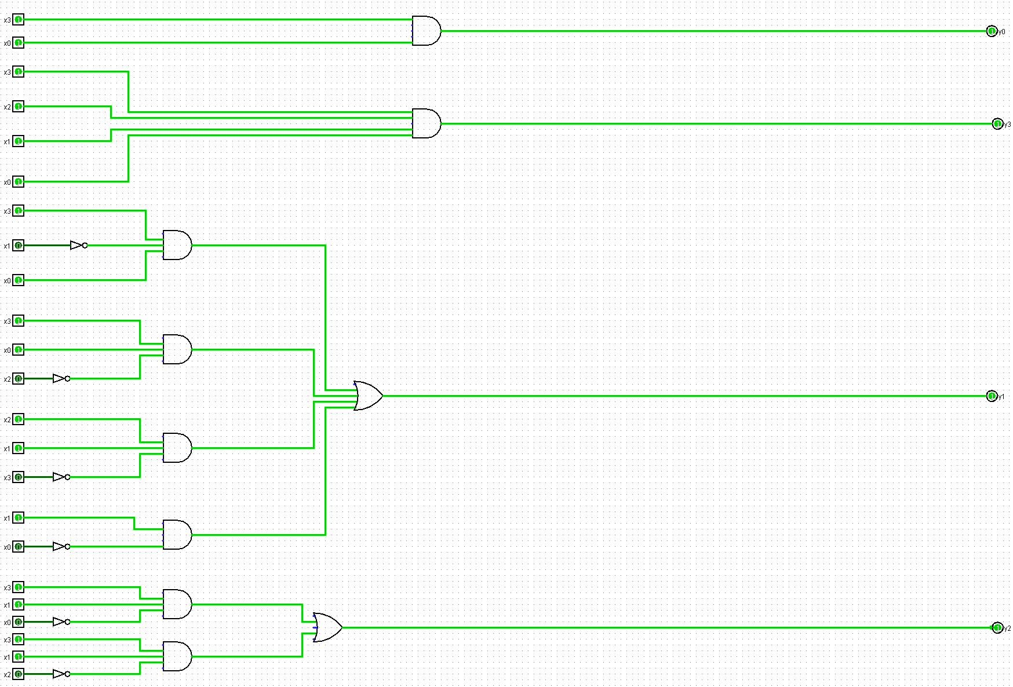

**Schaltungen signed (nur y2 und y3 da y1 und y0 gleich geblieben sind)**

