Aufgabe 2.2
unsigned
x3 | x2 | x1 | x0 |  | Funktion
0 | 0 | 0 | 0 |  | 1
0 | 0 | 0 | 1 |  | 1
0 | 0 | 1 | 0 |  | 0
0 | 0 | 1 | 1 |  | 0
0 | 1 | 0 | 0 |  | 1
0 | 1 | 0 | 1 |  | 1
0 | 1 | 1 | 0 |  | 0
0 | 1 | 1 | 1 |  | 0
1 | 0 | 0 | 0 |  | 0
1 | 0 | 0 | 1 |  | 1
1 | 0 | 1 | 0 |  | 0
1 | 0 | 1 | 1 |  | 1
1 | 1 | 0 | 0 |  | 0
1 | 1 | 0 | 1 |  | 1
1 | 1 | 1 | 0 |  | 0
1 | 1 | 1 | 1 |  | 1

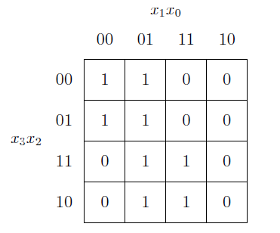
a) 0101(1) -> 0111(0) => kein Hazard möglich
b) 1010(0) -> 0010 (0) -> 0011 (0)
1010 (0) -> 1011(1) -> 0011 (0) => Hazard
c) 1101(1) -> 0101(1) -> 0111(0) -> 0110(0)
1101(1) -> 1111(1) -> 0111(0) -> 0110(0)
1101(1) -> 1111(1) -> 1110(0) -> 0110(0)
1101(1) -> 0101(1) -> 0100(1) -> 0110(0)
1101(1) -> 1100(0) -> 1110(0) -> 0110(0)
1101(1) -> 1100(0) -> 0100(1) -> 0110(0) => Hazard
d) 0000(1) -> 0001(1) -> 0101(1)
0000(1) -> 0100(1) -> 0101(1)
e) 0101 -> 1101 => kein Hazard möglich

Aufgabe 2.3
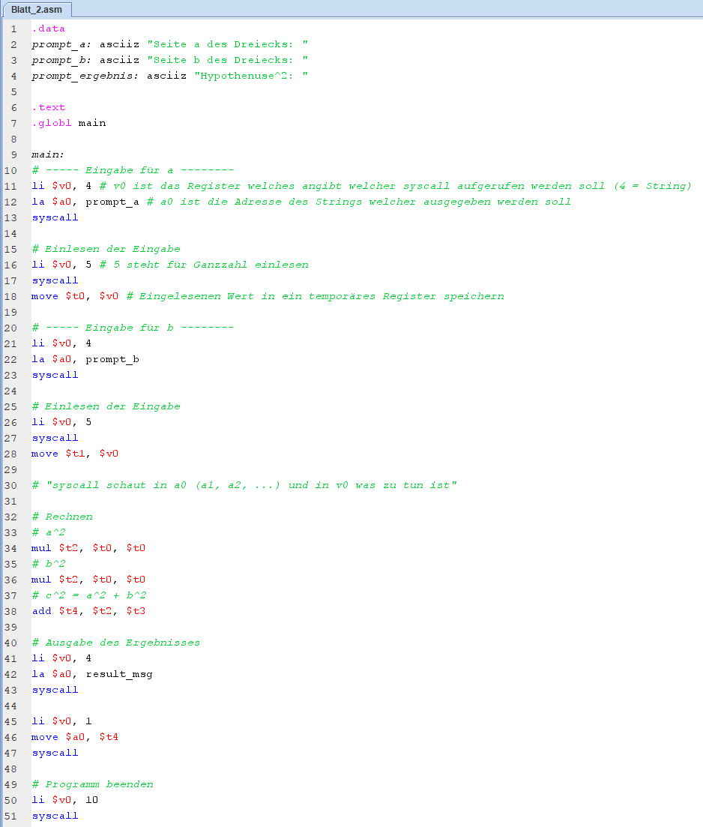

Aufgabe 2.1 - unsigned

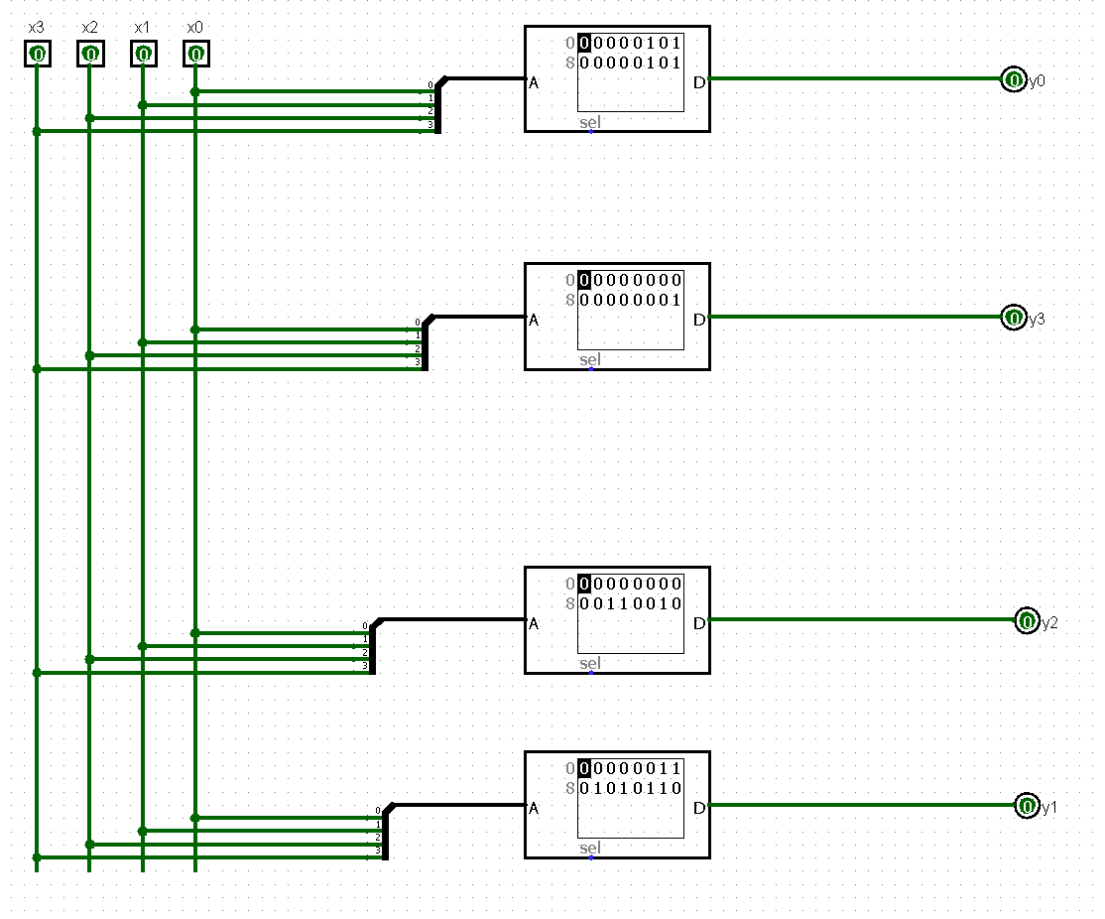

signed

