Aufgabe 1.1 - Kombinatorische Schaltungen und Minimierung
unsigned
x3 | x2 | x1 | x0 |  | y3 | y2 | y1 | y0
0 | 0 | 0 | 0 |  | 0 | 0 | 0 | 0
0 | 0 | 0 | 1 |  | 0 | 0 | 0 | 0
0 | 0 | 1 | 0 |  | 0 | 0 | 0 | 0
0 | 0 | 1 | 1 |  | 0 | 0 | 0 | 0
0 | 1 | 0 | 0 |  | 0 | 0 | 0 | 0
0 | 1 | 0 | 1 |  | 0 | 0 | 0 | 1
0 | 1 | 1 | 0 |  | 0 | 0 | 1 | 0
0 | 1 | 1 | 1 |  | 0 | 0 | 1 | 1
1 | 0 | 0 | 0 |  | 0 | 0 | 0 | 0
1 | 0 | 0 | 1 |  | 0 | 0 | 1 | 0
1 | 0 | 1 | 0 |  | 0 | 1 | 0 | 0
1 | 0 | 1 | 1 |  | 0 | 1 | 1 | 0
1 | 1 | 0 | 0 |  | 0 | 0 | 0 | 0
1 | 1 | 0 | 1 |  | 0 | 0 | 1 | 1
1 | 1 | 1 | 0 |  | 0 | 1 | 1 | 0
1 | 1 | 1 | 1 |  | 1 | 0 | 0 | 1

signed
int | x3 | x2 | int | x1 | x0 |  | y3 | y2 | y1 | y0 | Ergebnisint
0 | 0 | 0 | 0 | 0 | 0 |  | 0 | 0 | 0 | 0 | 0
0 | 0 | 0 | 1 | 0 | 1 |  | 0 | 0 | 0 | 0 | 0
0 | 0 | 0 | -2 | 1 | 0 |  | 0 | 0 | 0 | 0 | 0
0 | 0 | 0 | -1 | 1 | 1 |  | 0 | 0 | 0 | 0 | 0
1 | 0 | 1 | 0 | 0 | 0 |  | 0 | 0 | 0 | 0 | 0
1 | 0 | 1 | 1 | 0 | 1 |  | 0 | 0 | 0 | 1 | 1
1 | 0 | 1 | -2 | 1 | 0 |  | 1 | 1 | 1 | 0 | -2
1 | 0 | 1 | -1 | 1 | 1 |  | 1 | 1 | 1 | 1 | -1
-2 | 1 | 0 | 0 | 0 | 0 |  | 0 | 0 | 0 | 0 | 0
-2 | 1 | 0 | 1 | 0 | 1 |  | 1 | 1 | 1 | 0 | -2
-2 | 1 | 0 | -2 | 1 | 0 |  | 0 | 1 | 0 | 0 | 4
-2 | 1 | 0 | -1 | 1 | 1 |  | 0 | 0 | 1 | 0 | 2
-1 | 1 | 1 | 0 | 0 | 0 |  | 0 | 0 | 0 | 0 | 0
-1 | 1 | 1 | 1 | 0 | 1 |  | 1 | 1 | 1 | 1 | -1
-1 | 1 | 1 | -2 | 1 | 0 |  | 0 | 0 | 1 | 0 | 2
-1 | 1 | 1 | -1 | 1 | 1 |  | 0 | 0 | 0 | 1 | 1

unsigned

 | x1, x0
x3, x2 | 00 | 01 | 11 | 10
00
01 |  | 1 | 1
11 |  | 1 | 1
10
y0 = x2 ∧ x0

 | x1, x0
x3, x2 | 00 | 01 | 11 | 10
00
01 |  |  | 1 | 1
11 |  | 1 |  | 1
10 |  | 1 | 1
y1 = (x3 ∧ ¬x1 ∧ x0) ∨ (x3 ∧ ¬x2 ∧ x0) ∨ (¬x3 ∧ x2 ∧ x1) ∨ (x1 ∧ ¬x0)

 | x1, x0
x3, x2 | 00 | 01 | 11 | 10
00
01
11 |  |  |  | 1
10 |  |  | 1 | 1
y2 = (x3 ∧ x1 ∧ ¬x0) ∨ (x3 ∧ ¬x2 ∧ x1)

 | x1, x0
x3, x2 | 00 | 01 | 11 | 10
00
01
11 |  |  | 1
10
y3 = (x3 ∧ x2 ∧ x1 ∧ x0)

signed
 | x1, x0
x3, x2 | 00 | 01 | 11 | 10
00
01 |  | 1 | 1
11 |  | 1 | 1
10
y0 = x2 ∧ x0

 | x1, x0
x3, x2 | 00 | 01 | 11 | 10
00
01 |  |  | 1 | 1
11 |  | 1 |  | 1
10 |  | 1 | 1
y1 = (x3 ∧ ¬x1 ∧ x0) ∨ (x3 ∧ ¬x2 ∧ x0) ∨ (¬x3 ∧ x2 ∧ x1) ∨ (x1 ∧ ¬x0)

 | x1, x0
x3, x2 | 00 | 01 | 11 | 10
00
01 |  |  | 1 | 1
11 |  | 1
10 |  | 1 |  | 1
y2 = (¬x1 ∧ x0 ∧ x3) ∨ (¬x3 ∧ x2 ∧ x1) ∨ (x3 ∧ ¬x2 ∧ x1 ∧ ¬x0)

 | x1, x0
x3, x2 | 00 | 01 | 11 | 10
00
01 |  |  | 1 | 1
11 |  | 1
10 |  | 1
y3 = (¬x1 ∧ x0 ∧ x3) ∨ (¬x3 ∧ x2 ∧ x1)

Schaltungen für unsigned
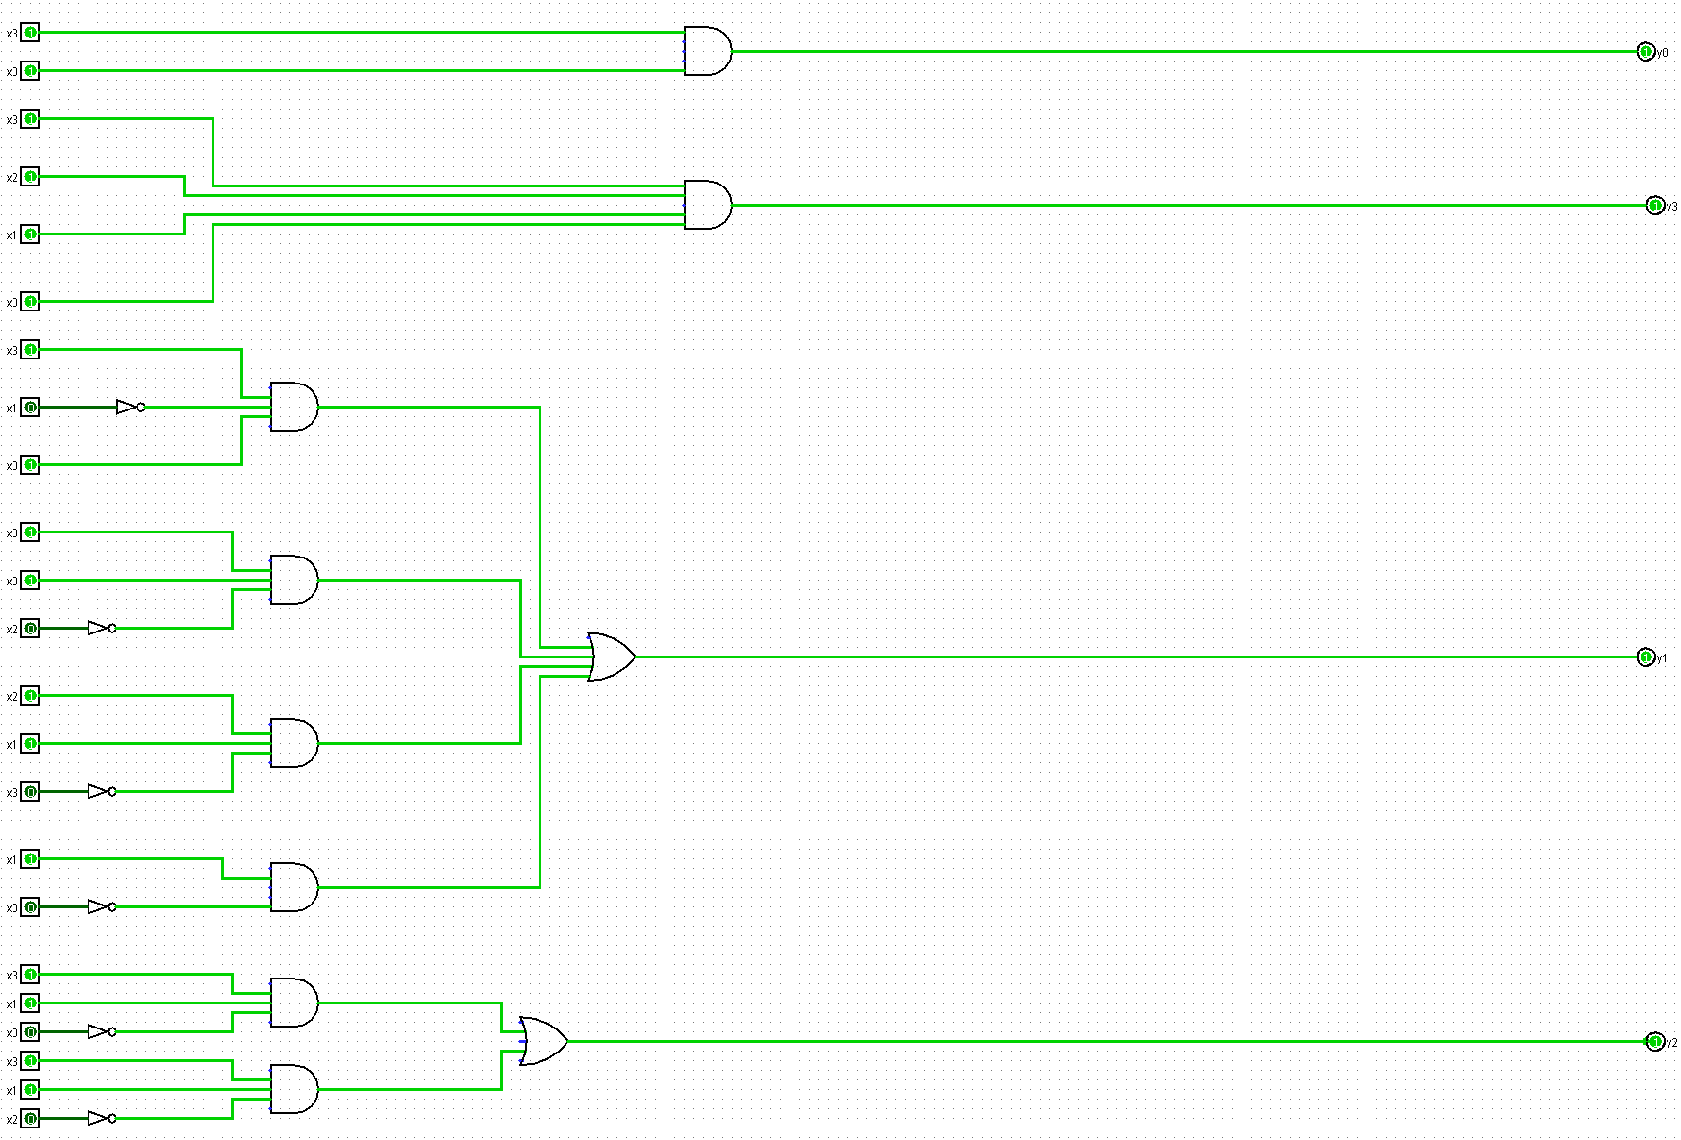

Schaltungen signed (nur y2 und y3 da y1 und y0 gleich geblieben sind)
