After we load the data in PowerBI, the first thing we need to do is cleaning and transforming the data, like transform L size to more readable words like Large. We can do this by clicking on the Transform Data from Home tab.

A new transforming window will appear and here we can to all the transformation necessary.

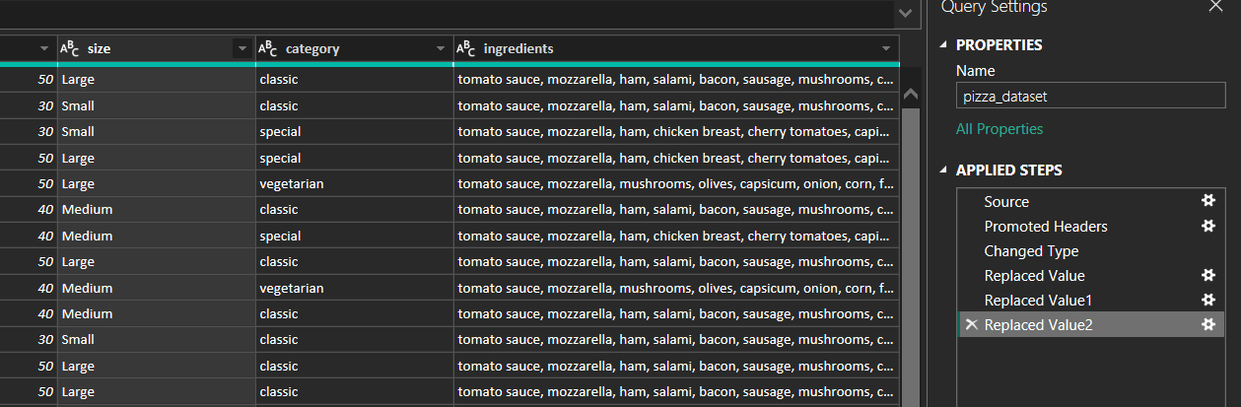

All of the changes made can be saw at the right window.

After we done all the modifications we can close and apply the changes to the document and we can build the KPI’s before making the visuals.

We will use some DAX ( Data Analysis Expressions ) functions that are formula expression language used in Analysis Services, Power BI, and Power Pivot in Excel. DAX formulas include functions, operators, and values to perform advanced calculations and queries on data in related tables and columns in tabular data models.

We will make only 5 expressions.











The DAX functions that we make here are similar with the ones that we used in the SQL part. ( example: Total Orders, Total pizzas sold, etc ).

After we build our expressions we are good to go and build our visuals.

Here is the results after we finish building all the visuals and buttons ( the buttons are also interactive and you can switch the 2 pages and also chose the category, date, etc ).

