The first thing we need to do is importing the database in PostgreSQL. We will use pgAdmin4.

We need to create the table for the database then we will import the dataset from our CSV file.

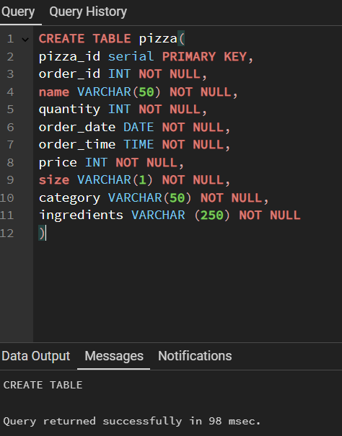

After we make the table we will right click on the table then import/export data, chose the file that we want to import, the right format and click “OK”.

The results will be shows as follow:

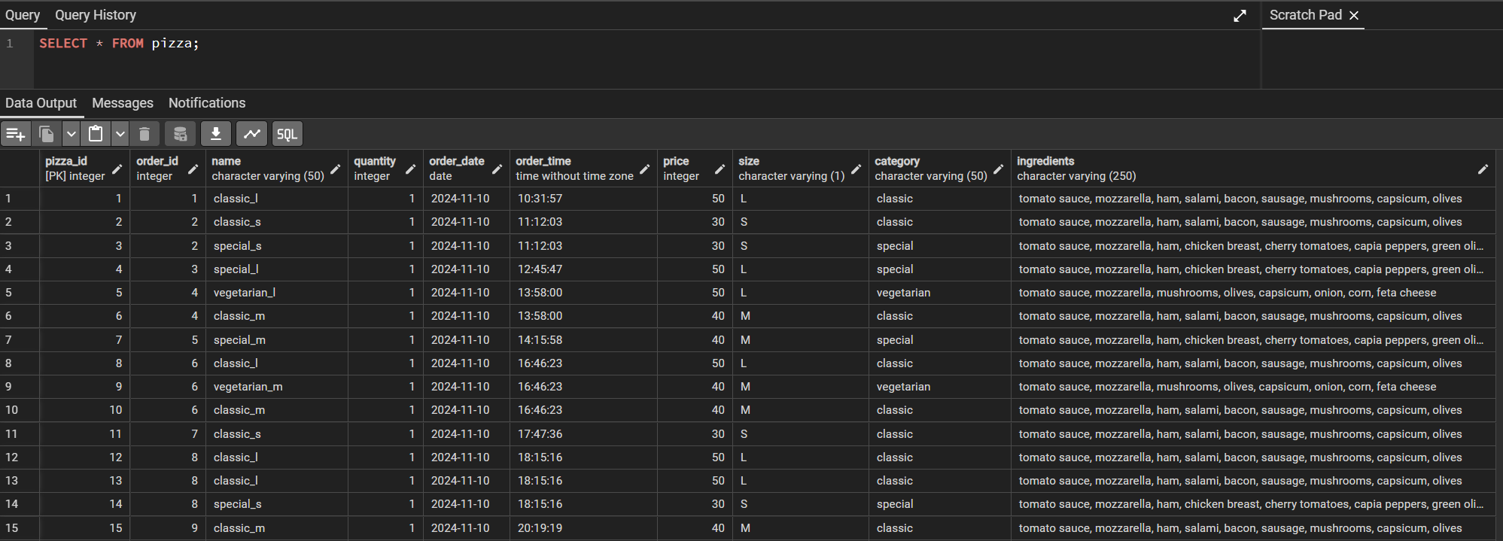

SQL querries and the results for our data analysis business questions:

1. Total revenue

SELECT SUM(price) AS "Total_Revenue" FROM pizza;

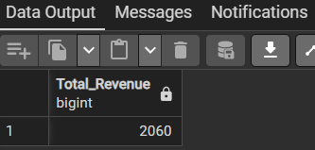

2. Average orders value

( In our database, we have duplicates orders and that means that one person chose at least one type of pizza and we need to count them like one order. In this case, we need to use the DISTINCT statement )

SELECT SUM(price) / COUNT(DISTINCT order_id) AS "Avg_Orders" FROM pizza;

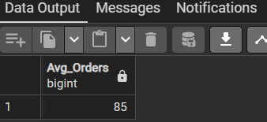

3. Total pizzas sold

SELECT SUM(quantity) AS "Total_Pizza_Sold" FROM pizza;

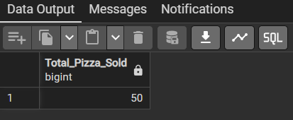

4. Total orders

SELECT COUNT(DISTINCT order_id) AS "Total_Orders" FROM pizza;

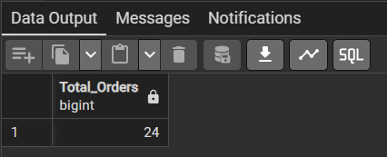

5. Average pizzas per order

( As SQL will round the result, we need to call the CAST statement to transform the result to decimals )

SELECT CAST(CAST(SUM(quantity) AS DECIMAL(10,2))/

CAST(COUNT(DISTINCT order_id) AS DECIMAL(10,2)) AS DECIMAL(10,2))

AS "Avg_Pizza_Per_Order" FROM pizza;

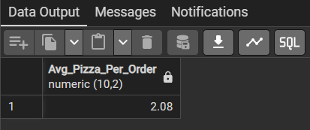

6. Total orders by date

SELECT order_date AS "Order_Date",

COUNT(DISTINCT order_id) AS "Total_Orders" FROM pizza

GROUP BY order_date;

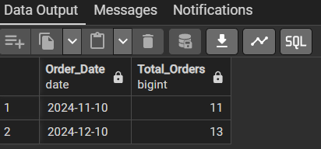

7. Total sales by size

SELECT size, SUM(price) AS "Total_Sales" FROM PIZZA

GROUP BY size;

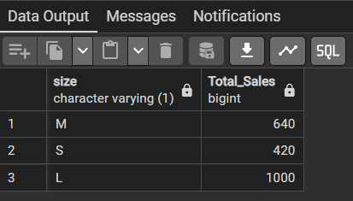

8. Most sold pizzas by sales

SELECT name, SUM(quantity) AS "Total_Pizzas_Sold" FROM PIZZA

GROUP BY name

ORDER BY SUM(quantity) DESC;

