TBMI26 – Computer Assignment Reports
Reinforcement Learning
Deadline – Mars 12 2018

Author/-s:

In order to pass the assignment you will need to answer the following questions and upload the document to LISAM. If you meet the deadline we correct the report within one week after the deadline. Otherwise we give no guarantees when we have time.

- Define the V- and Q-function given an arbitrary policy as well as a given optimal policy (See lectures/classes).

Optimal:
Q*(s,a) = r(s,a) +gamma* V*(s')
where
V*(s) = max a Q(s,a)

Arbitrary:
Q(s,a) = (1-alpha)*Q(s,a) +alpha*(r(s,a) +gamma* max b Q(s',b))
V(s) = (1-alpha)*V(s) + alpha*(r(s) + gamma*V(s'))

- Define a learning rule for the Q-function (Theory, see lectures/classes).
Q(s,a) = (1-alpha)*Q(s,a) + alpha*(r(s,a) + gamma*V(s'))?????

- Describe your implementation, especially how you hinder the robot from exiting through the borders of a world.
By adding -inf as the Q value of actions in states that would move through the borders.

- Describe the differences between the worlds explored by the robot. Any surprises?
The first implementation assumed that the chosen action would always be performed, which caused the agent to never converge on the fourth world until the implementation was changed.

- For each world: Plot the V-function, i.e. how do you get to the goal from each position.
Here we have plotted the policy for each world, after training. The V function can be seen by following the arrows from each starting point.

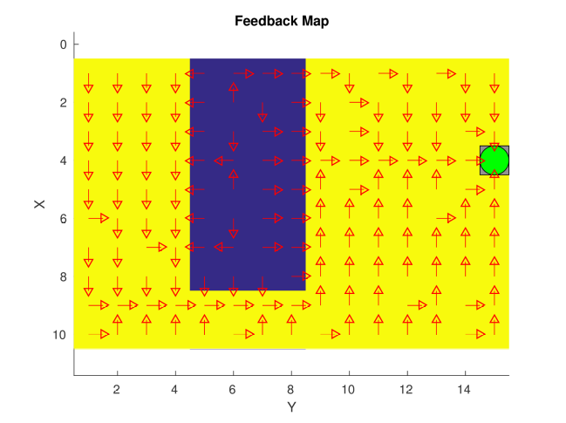

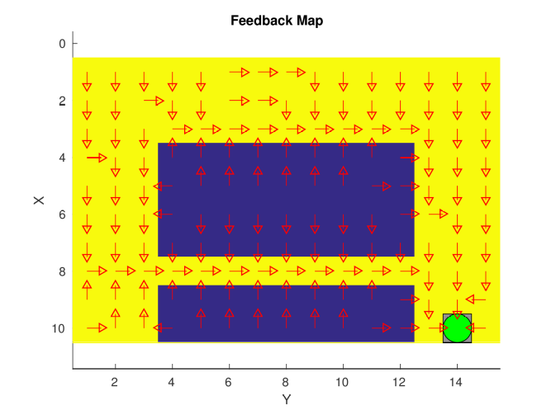

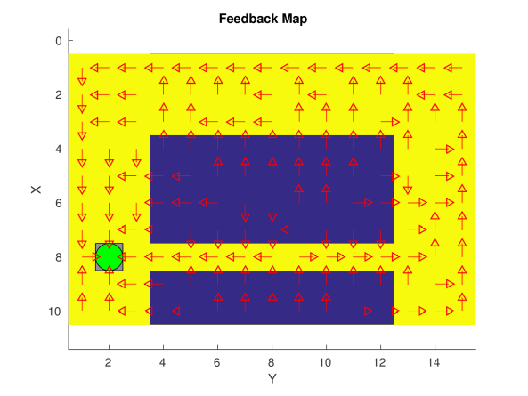

- For each “world”: describe the key observations you have made with respect to parameter choices. Provide “documentation” of the parameters you have used for each figure! A “good rule” is to provide each figure with a caption. Plot policies and the V-function for appropriate worlds to the extent you find appropriate in order to explain what you have done and learned during the assignment.
It was found in general that decreasing epsilon with time was beneficial. This may be because initially it is very important that the agent explores a lot of different actions, and later it becomes important to exploit the knowledge obtained to find optimal solutions.

For the worlds tested a low alpha worked well, around ~0.2.

Gamma was set high at around ~0.9 in all worlds. In world 4 especially, increasing gamma was very beneficially to performance as illustrated in the 3 plots below.
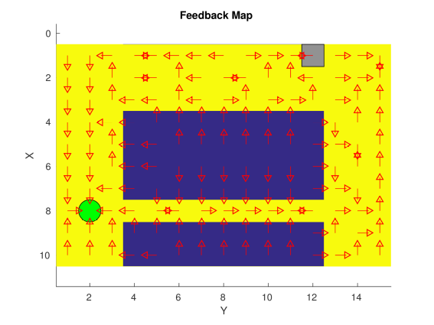Gamma = 0.2
Gamma = 0.95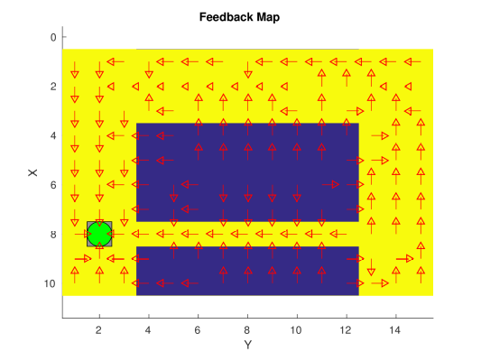

Gamma = 0.999

- What would happen if we where to only use Dijkstra's shortest path finding algorithm in the ''Suddenly Irritating blob'' world? What about in the static ''Irritating blob'' world?
It would work fine in a static world with no random elements. It would not learn to avoid areas heavily influenced by randomness though, like the “bridge” in the fourth world.

- Include an in-depth description of the to/from HG worlds (world 3 and 4). What happens on the way from HG? How and why can this problem be solved with Q-learning? Which path does the robot prefer, and why?
On the way from HG the agent can make a random move at a 30% chance. By propagating the “badness” from the times it fell into the “water“ to nearby tiles Q-learning learns to associate them with failure, making tiles further away more appealing. It learns that the area around the water is dangerous (because a random move causes it to end up in the water) and prefers the long way around where it doesn't matter if it takes a random step or not.

- Can you think of any application where reinforcement learning could be of “practical” use? A hint is to use the “Internet”.
For motor skills in robots reinforcement learning can be very effective, since modeling this is very difficult and a clear reward signal is possible.

- How does the different parameters ($η,γ…$) influence “learning” and appearance of the Q- and V-functions?
Gamma: Weighs future reward vs instant reward, increasing gamma increases focus on getting rewards further away.
Epsilon: Exploitation vs exploration. For high values of epsilon a random action will often be selected, this makes the agent “explore” more. Lower values makes the agent “exploit” its knowledge, i.e. select moves that it thinks are optimal more often.
Alpha: The alpha term defines the learning rate, i.e. how much the agent believes its current Q values are accurate. For low values of alpha the agent is very certain of its Q, for high values the agent adapt its values rapidly from recent events.

