TBMI26 – Computer Assignment Report
Supervised Learning
Deadline – February 12 2018

Author/-s:
Sebastian Callh
Johan Edstedt

In order to pass the assignment you will need to answer the following questions and upload the document to LISAM. If you meet the deadline we correct the report within one week after the deadline. Otherwise we give no guarantees when we have time.

- Give an overview of the data from a machine learning perspective. Consider if you need linear or non-linear classifiers etc.
The first data set is linearly separable, so a linear classifier (i.e. the one layered neural network) can correctly learn the pattern and classify it. The other datasets are not linearly separable and needs non-linear classifiers to be able to classify it.

- Explain why the down sampling of the OCR data (done as pre-processing) result in a more robust feature representation. See http://archive.ics.uci.edu/ml/datasets/Optical+Recognition+of+Handwritten+Digits
The dimensionality is reduced, lowering the computational overhead. The noice sensitivity is also reduced.

- Give a short summery of how you implemented the kNN algorithm.
First a distance map was created for all data points to be classified to the training data. It was then sorted to get the indicies of the closest neighbours. The classification was made by majority voting of the k nearest neighbours.

- Explain how you handle draws in kNN, e.g. with two classes (k = 2)?
We take the index with the lowest value, e.g. if we have [2,1,1,2] we get the index 1.

- Explain how you selected the best k for each dataset using cross validation. Include the accuracy and images of your results for each dataset.
Cross validation was done with 5 bins, and run 10 times for k = 1,2..,25. The model with the lowest validation error was selected.
When doing the cross validation, the parameter “numSamplesPerLabelPerBin” to the function “selectTrainingSamples” was set to “inf” to use as much data as possible. When doing this models trained using k = 1 was consistently performing the best, which is probably because the data is so easily separable with no real noise of extreme outliers. In the general case k = 1 is very noise sensitive and will not perform as well.

Dataset 1:
Accuracy: 98.8%
Best k: k = 1
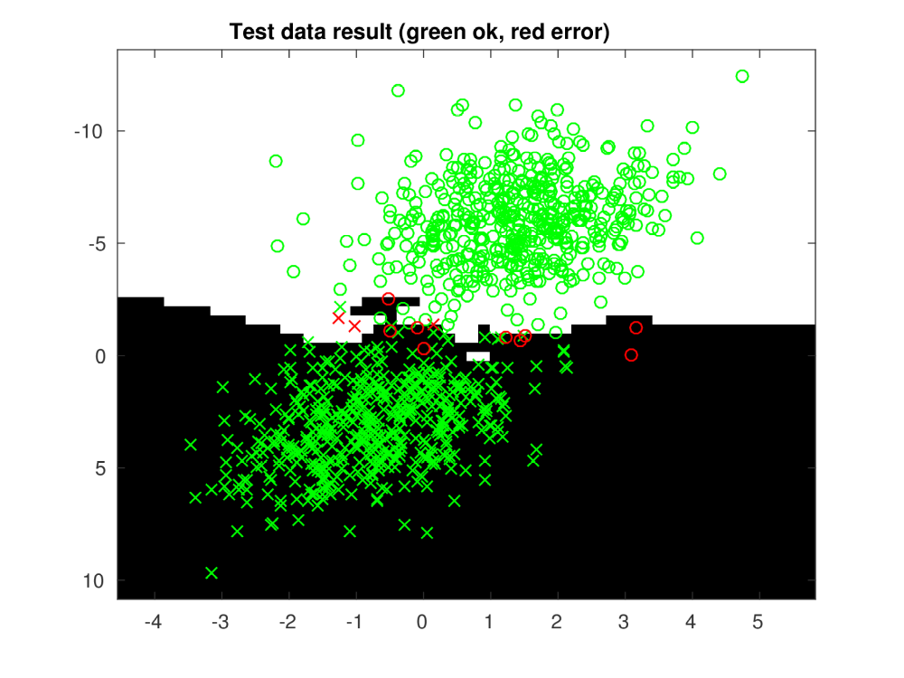
Dataset 2:
Accuracy: 99.8% (On the test data)
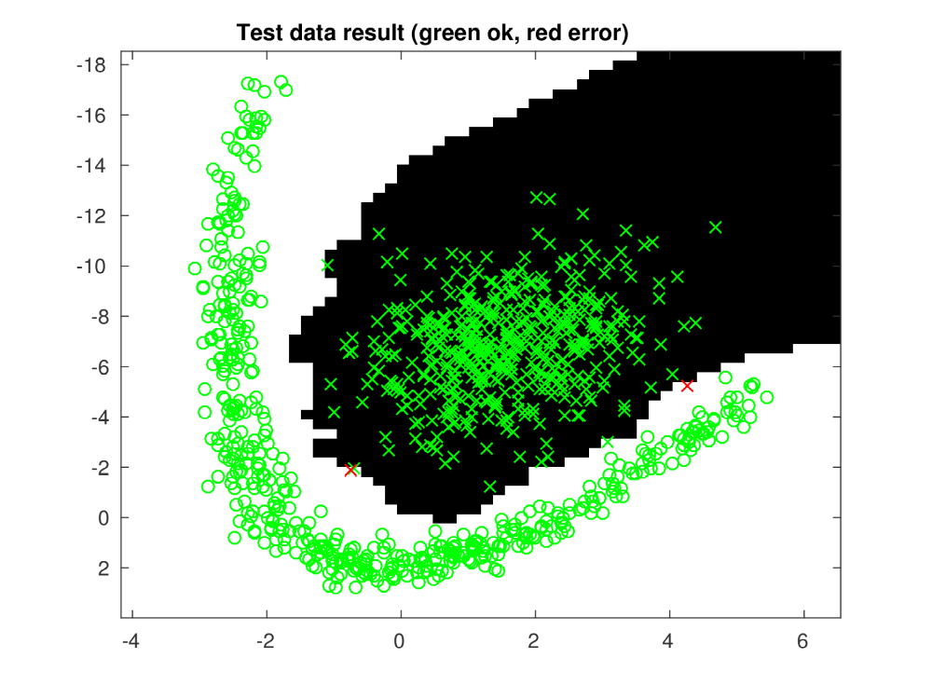
Best k: k=1

Dataset 3:
Accuracy:99.8%
Best k: k = 1
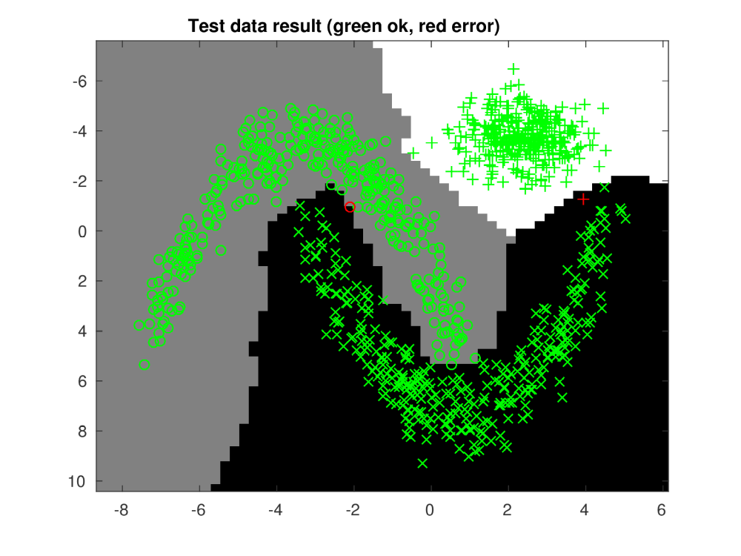
Dataset 4:
Accuracy:98.4%
Best k: k =1
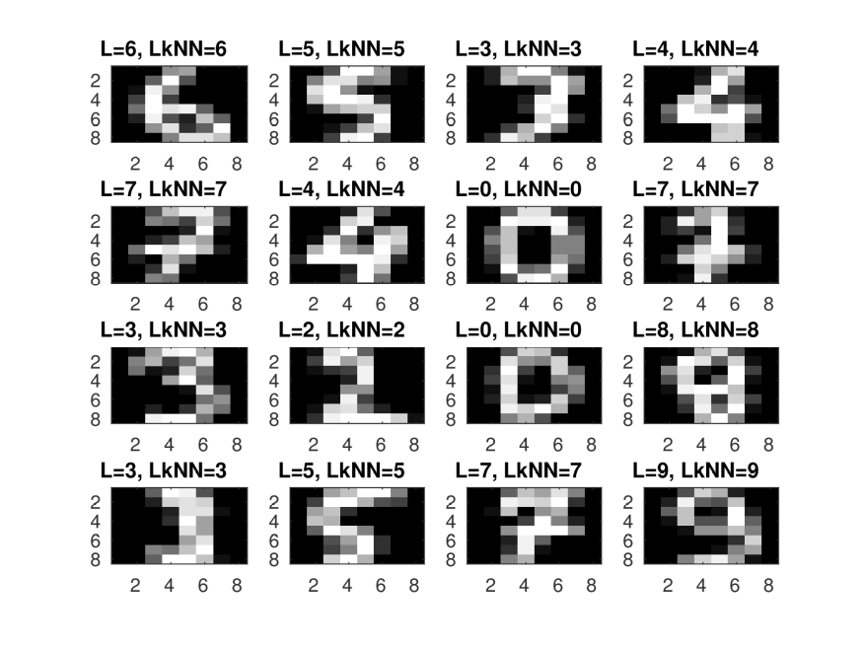

- Give a short summery of your backprop network implementations (single + multi). You do not need to derive the update rules.
For both cases a forward pass was made, saving the neuron activations. Updating the output layer and the hidden layer was done according to the compendium assignment 3.8.

- Present the results from the backprop training and how you reached the accuracy criteria for each dataset. Motivate your choice of network for each dataset. Explain how you selected good values for the learning rate, iterations and number of hidden neurons. Include images of your best result for each dataset, including parameters etc.

Single Layer:
Dataset 1:
Accuracy: 0.99
Learning rate: 0.001

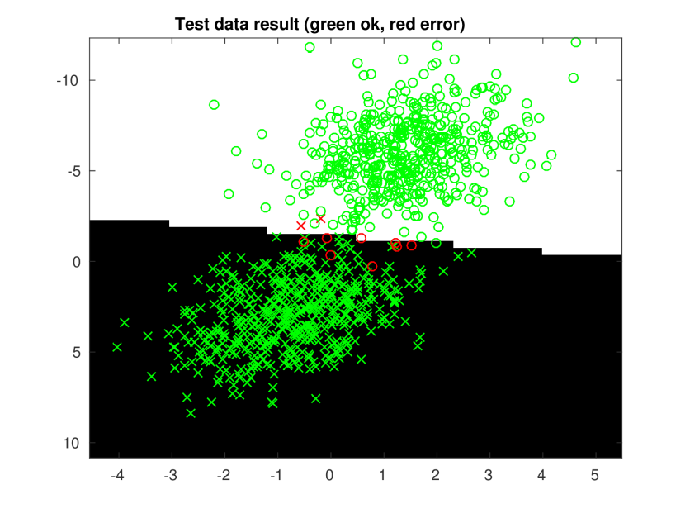

Dataset 2:
Accuracy: 0.825
Learning rate: 0.001
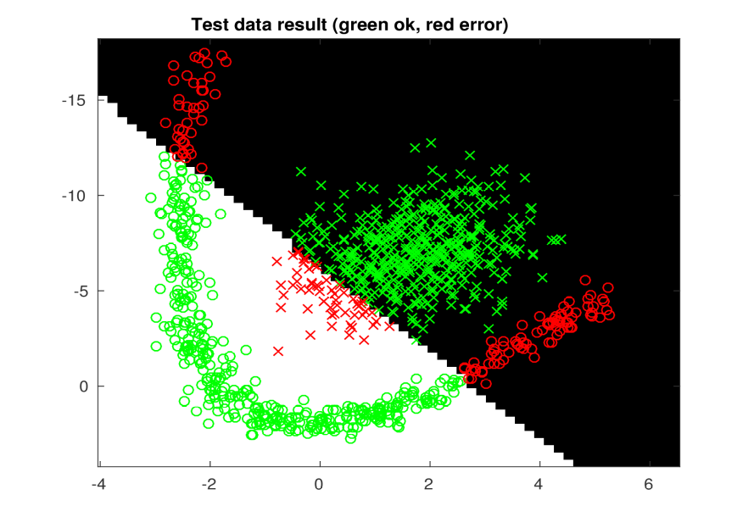

For datasets 3 and 4 similar results as dataset 2 were received, since none of these were linearly seperable. Therefore presentation of those results were skipped.

Multi Layer:
Dataset 1:
Accuracy: 0.995
Neruons: 20
Learning rate: 0.005
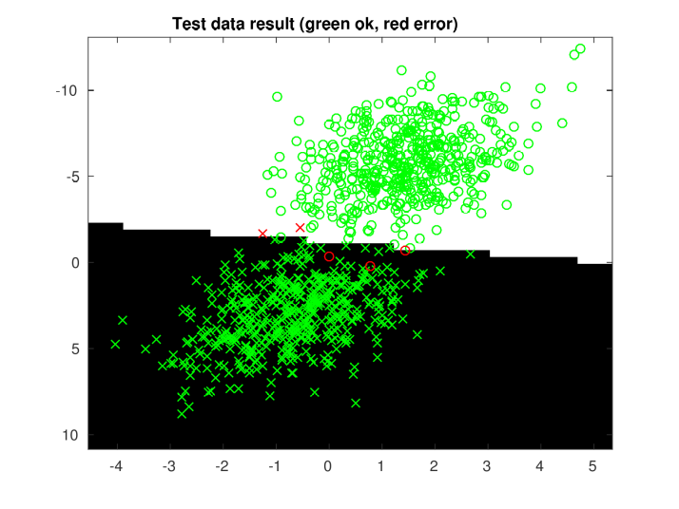

Dataset 2:
Accuracy: 0.999
Neurons: 30
Learning Rate: 0.005

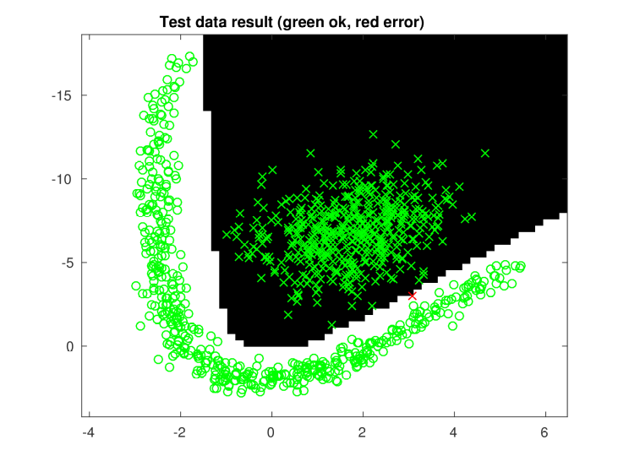

Dataset 3:
Accuracy: 0.998
Neurons: 30
Learning Rate: 0.005

Dataset 4:
Accuracy: 96.7%
Neurons: 64
Learning Rate: 0.005
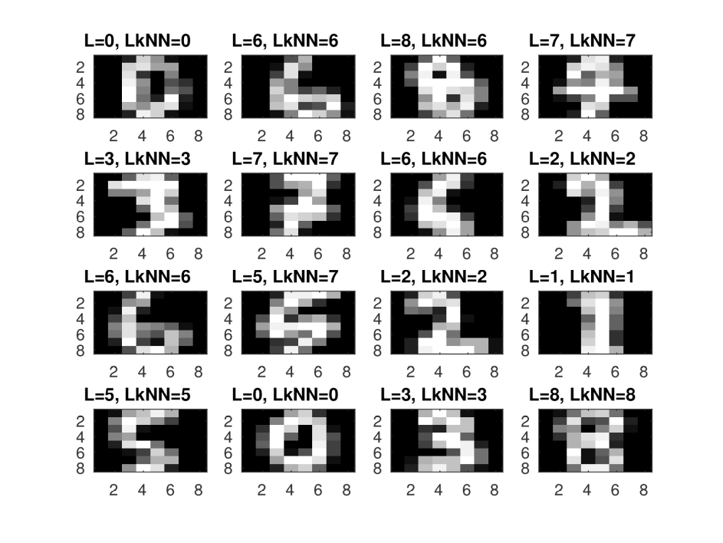

For the first dataset the single layer network was sufficient since the two classes were directly linearly seperable, but for all other data sets a multi-layered network was needed. The final multi layered network function uses tanh in both the hidden layer (to introduce non-linearities) and in the output layer (to squash the output to the interval [-1, 1]). The number of neurons needed to fit the data increased from the first data set to the last, since the patterns became increasingly complex. When it was observed that the model was not flexible enough in the scatter plots the number of neurons was increased. The number of iterations was initially chosen as a very high number (20 000) and lowered by continuously printing the validation error during training and observing when it stopped decreasing. Finally the learning rate was chosen as 0.005 simply by trying out different values. This value together with added gradient momentum gave sufficient performance.

- Present the results, including images, of your example of a non-generalizable backprop solution. Explain why this example is non-generalizable.

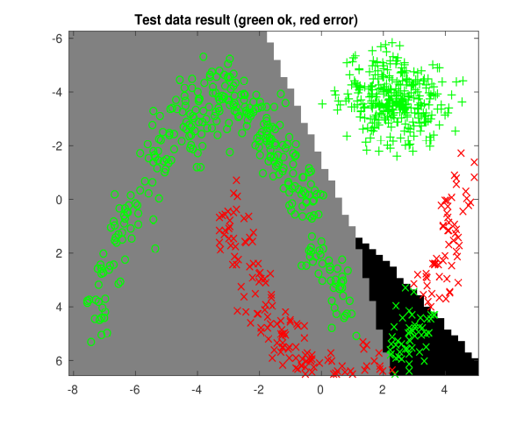
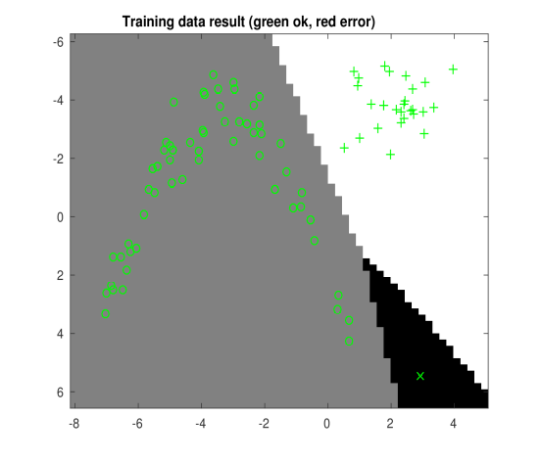
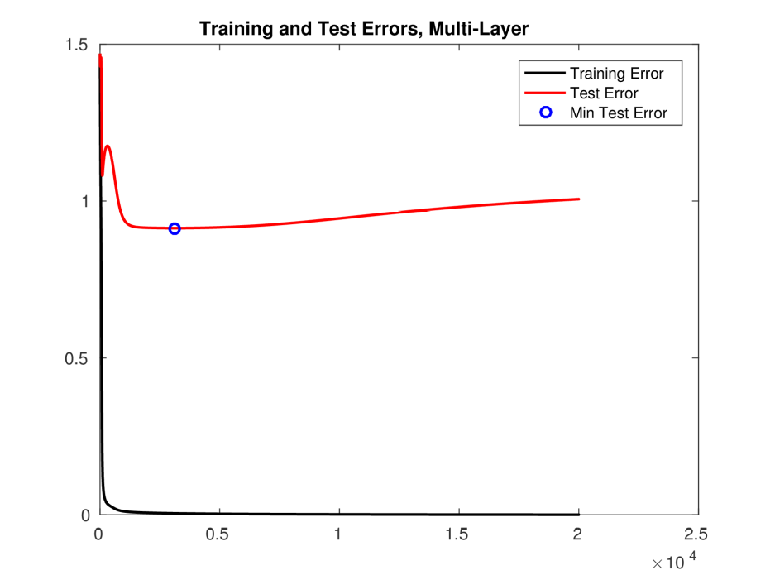
In the example shown above the network has been trained on too few points to successfully approximate the target function. The error plot shows that the network quickly learns the pattern in the training data (it was done using 30 hidden neurons which is way more complex than needed) but that the test error starts to increase after a while. This indicates that the training data is not enough to capture the target function. In this case it happens because of a lack of data, but can typically happen if the model is too complex for a too small data set, leading to it learning the noise in the data. In this data set there is almost no noise, so it is hard to reproduce a case where the model fits to it without manually picking out data points.

- Give a final discussion and conclusion where you explain the differences between the performances of the different classifiers. Pros and cons etc.

KNN:
KNN is easy to implement and requires no training, making it a good choice for a benchmark implementation to compare other models to. It does however require access to all the training data for every new classification when it compares the new data to all old data, making classifications computationally expensive. KNN also requires some definition of a distance, which can be troublesome in higher dimensions.

Artificial Neural Network (ANN):
Training an ANN is computationally expensive since one needs to rely on iterative methods and finding a global minimum does not realistically happen. Never the less a good enough solution can usually be found. Compared to KNN the data does not need to be stored after the network is trained and classification is done using matrix multiplications instead of exhaustive search.

- Do you think there is something that can improve the results? Pre-processing, algorithm-wise etc.
Regarding data sets 1, 2 and 3 there is not much that can be done to improve performance. The data looks like it is generated from the same distribution making it easy to achieve high performance and hard to over fit. To achieve better performance on data set 4 a deeper network could be used, which would of course highly increase the training time. When pre-processing one thing to consider is that the dimensionality is already quite low, so simply reducing the resolution might lead to too big a loss of information. Perhaps some latent features can be found using PCA/ICA that would allow for additional dimensionality reduction.

