Section 8: Simple SQL Exercises

How many records are in the nyc_streets table?
Maybe Count()?

How many streets in New York have names that start with ‘B’?
Pattern matching in SQL uses the LIKE keyword and '%' as the match-all character

What is the population of New York city?
The “nyc_census_blocks” table includes a “popn_total” field which is the number of people in each block.

What is the population of the “The Bronx”?
The “nyc_census_blocks” table includes a “boroname” field which is the borough each block is in.
‘The Bronx’ is a borough.

How many "neighborhoods" are in each borough?
The “nyc_neighborhoods” table includes a “boroname” field and a "name" field. Group by!

For each borough, what percentage of the population is "white"?
The “nyc_census_blocks” table includes a “popn_white” field that is the number of self-identified white people in each block.

Data Dictionary

Useful columns in the “nyc_census_blocks” table:

blkid | A 15-digit code that uniquely identifies every census block. Eg: 360050001009000
popn_total | Total number of people in the census block
popn_white | Number of people self-identifying as “white” in the block
popn_black | Number of people self-identifying as “black” in the block
popn_nativ | Number of people self-identifying as “native american” in the block
popn_asian | Number of people self-identifying as “asian” in the block
popn_other | Number of people self-identifying with other categories in the block
boroname | Name of the New York borough: Manhattan, The Bronx, Brooklyn, Staten Island, Queens
geom | MultiPolygon boundary of the block

Useful Functions

Count(*) | An aggregate function that returns the number of records in the query.
GROUP BY [field] | A SQL statement the performs aggregations based on the distinct values of the provided field.
[field] LIKE ‘V%’ | A SQL pattern matching operator, where the field is matched against a pattern and ‘%’ is the ‘global match’ character. The example returns all field values starting with ‘V’.
Sum([field]) | An aggregate function that returns the total value of the field over all records in the query.
Avg([field]) | An aggregate function that returns the average value of the field over all records in the query.

Section 10: Geometry Exercises

What is the area of the ‘West Village’ neighborhood?
What are the units of your answer?
The “nyc_neighborhoods” table includes a “name” field.

What is the geometry type of ‘Pelham St’?
How long is it?
The “nyc_streets” table includes a “name” field.

What is the GeoJSON representation of the ‘Broad St’ subway station?
The “nyc_subway_stations” table includes a “name” field.

What is the total length of streets (in kilometers) in New York City?
You can use an aggregate function like Sum(). There are 1000 meters in a kilometer.

What is the area of Manhattan in acres?
The “nyc_census_blocks” table is an area geometry and has a “boroname” column.
There are 4047 square meters in an acre.

What is the most westerly subway station?
Try using “ORDER” and “LIMIT”. Consider which values of X are "west" and which are "east".

Data Dictionary

Useful columns in the “nyc_streets” table:

name | Common name of the street
oneway | Is this a one-way street?
type | What kind of street is this?
geom | MultiLinestring geometry of the street

Useful columns in the “nyc_subway_stations” table:

name | Common name of the station
routes | Comma-separated list of routes that serve this station
geom | Point geometry of the street

Useful Functions

Sum([field]) | An aggregate function that returns the total value of the field over all records in the query.
LIMIT n | Restrict the query to return only the first “n” rows.
ORDER BY [field] | Return the query in order sorted by the field.
ORDER BY [field] DESC  ORDER BY [field] ASC | Return the query in descending/ascending order sorted by the field.
ST_X(point) | Returns the X coordinate of the point
ST_Y(point) | Returns the Y coordinate of the point
ST_Length(geometry) | Returns the length of the geometry
ST_Area(geometry) | Returns the area of the geometry
ST_StartPoint(line) | Returns the first point in the line
ST_EndPoint(line) | Returns the last point in the line
ST_NumPoints(line) | Returns the number of vertices in a linestring
ST_NumInteriorRings(polygon) | Returns the number of interior rings (holes) in a polygon
ST_NumGeometries(collection) | Returns the number of sub-geometries in any geometry collection (MULTIPOINT, MULTILINESTRING, MULTIPOLYGON, GEOMETRYCOLLECTION)
ST_GeometryN(geometry, n) | Returns the n’th geometry in the collection (starting from 1)
ST_AsGML(geometry) | Returns the GML representation
ST_AsKML(geometry) | Returns the KML representation
ST_AsGeoJSON(geometry) | Returns the GeoJSON representation
ST_AsText(geometry) | Returns the well-known-text representation

Section 12: Spatial Relationship Exercises

What is the well-known text for the street ‘Atlantic Commons’?

In what neighborhood is POINT(586782 4504202) (aka, the start of Atlantic Commons)?
Don't forget to include SRID 26918 when you construct your geometry.
The “nyc_neighborhoods” table includes a "name” field.

How many people live within 50 meters of POINT(586782 4504202)?
The “nyc_census_blocks” table includes a “popn_total” field.

For ‘LINESTRING(0 0, 2 2)’ and ‘POINT(1 1)’ which of these relationships are true? Intersects, Touches, Contains, Disjoint, Overlaps, Crosses, Within.
A sub-query might make this terser to type.

How far apart are ‘Columbus Cir’ and ‘Fulton Ave’?
For SQL experts only!

Useful Functions

Sum([field]) | An aggregate function that Returns the total value of the field over all records in the query.
ST_Contains(A, B) | Returns true if geometry A contains geometry B
ST_Crosses(A, B) | Returns true if geometry A crosses geometry B
ST_Disjoint(A, B) | Returns true if the geometries do not “spatially intersect”
ST_Distance(A, B) | Returns the minimum distance between geometry A and geometry B
ST_DWithin(A, B, d) | Returns true if geometry A is distance or less from geometry B
ST_Equals(A, B) | Returns true if geometry A is the same as geometry B
ST_Intersects(A, B) | Returns true if geometry A intersects geometry B
ST_Overlaps(A, B) | Returns true if geometry A and geometry B share space, but are not completely contained by each other
ST_Touches(A, B) | Returns true if geometry A and geometry B share space, but are not completely contained by each other
ST_Within(A, B) | Returns true if geometry A is within geometry B

Section 14: Spatial Joins Exercises

What subway station is in the ‘Little Italy’ neighborhood?

What are all the neighborhoods served by the 6 train?
The “nyc_subway_stations” table has a “routes” column with values like ‘A,C,6’ and ‘5,6,Q’.

After 9/11, the ‘Battery Park’ neighborhood was off limits for several days. How many people had to be evacuated?
The “nyc_census_blocks” table has a “popn_total” column.

What neighborhood has the highest population density (persons/km²)?
There are 1,000,000 m² in a km².

Useful SQL

The pattern for a spatial join is commonly

SELECT a.field, b.field
FROM table_a AS a
JOIN table_b AS b
ON ST_Something(a.geom, b.geom)
WHERE a.field = ‘SOMETHING’;

For spatial joins that aggregate results over the whole set, the pattern is commonly

SELECT Sum(a.field), b.field
FROM table_a AS a
JOIN table_b AS b
ON ST_Something(a.geom, b.geom)
WHERE a.field = ‘SOMETHING’
GROUP BY b.field;

Note the aggregate function around one term and the grouping on the other.

Useful Functions

strpos(str, char) | Returns the character position of the character in the string or 0 if the character is not in the string.
field LIKE ‘%thing%’ | Returns true if ‘thing’ is appears within a string in the field
Sum(field) | An aggregate function that Returns the total value of the field over all records in the query.
ST_Area(geometry) | Returns the area of the geometry in square units
ST_Contains(A, B) | Returns true if geometry A contains geometry B
ST_Crosses(A, B) | Returns true if geometry A crosses geometry B
ST_Disjoint(A, B) | Returns true if the geometries do not “spatially intersect”
ST_Distance(A, B) | Returns the minimum distance between geometry A and geometry B
ST_DWithin(A, B, d) | Returns true if geometry A is distance or less from geometry B
ST_Equals(A, B) | Returns true if geometry A is the same as geometry B
ST_Intersects(A, B) | Returns true if geometry A intersects geometry B
ST_Overlaps(A, B) | Returns true if geometry A and geometry B share space, but are not completely contained by each other
ST_Touches(A, B) | Returns true if geometry A and geometry B share space, but are not completely contained by each other
ST_Within(A, B) | Returns true if geometry A is within geometry B

Section 17: Projection Exercises

What is the SRID of the nyc_streets table?
What projection does that SRID represent?

What is the total length of all streets in New York, as measured in UTM 18N?
See the question above!

What is the total length of all streets in New York, as measured in Stateplane Long Island (EPSG 2831)?
Why is the answer different from above?!

How many streets cross the 74th meridian?
The data run from about -73.5 to -74.5 longitude and 40.5 to 40.9 latitude.
Streets can have multiple rows with the same name.

Useful Metadata

The “spatial_ref_sys” table contains all the information about SRID values in the database. It is user-configurable, but is loaded by default with all the values from the EPSG database.

srid | Unique identifier for this spatial reference system
auth_name | Authority that defined this system (usually EPSG)
auth_srid | Identifier used by the authority (note that this does not have to be the same as the value used for the internal database SRID)
srtext | “well known text” definition of the spatial reference system. The same format as used in “prj” files.
proj4text | Proj4 text definition of the spatial reference system. Used by the PostGIS re-projection engine in ST_Transform calls.

Useful Functions

DISTINCT | Returns only unique rows (all values the same)
Sum(field) | An aggregate function that Returns the total value of the field over all records in the query.
ST_Transform(A, srid) | Returns a geometry in the requested spatial reference system, transforming the coordinates of the geometry.
ST_SRID(A) | Returns the SRID value of the geometry
ST_SetSRID(A, srid) | Updates the SRID value of a geometry, does not alter the coordinates.
ST_GeomFromText(text, srid) | Create a new geometry from a well-known text form and set the SRID value at the same time.
ST_XMin(A) | Returns the minimum value of the X coordinate of a geometry.
ST_XMax(A) | Returns the maximum value of the X coordinate of a geometry.
ST_Intersects(A, B) | Returns true of geometry A and geometry B intersect, false if they are disjoint.

Section 18: Geography Exercises

How far is New York from Seattle? What are the units of the answer?
New York = POINT(-74.0064 40.7142) , Seattle = POINT(-122.3331 47.6097)

What is the total length of all streets in New York, calculated on the spheroid?
You can cast geometry to geography using the “::geography” syntax or the “geography(geometry)” function.

Does ‘POINT(1 2.0001)’ intersect with ‘POLYGON((0 0, 0 2, 2 2, 2 0, 0 0))’ in geography? In geometry? Why the difference?
ST_GeomFromText and ST_GeogFromText are helpful here.

Casting Types

You can convert values from one PostgreSQL type to another using the “::type” syntax.

-- Converts text to geometry
SELECT ‘POINT(0 0)’::geometry;

-- Converts text to geography to geometry
SELECT ‘POINT(0 0)’::geography::geometry

Useful Functions

Sum(field) | An aggregate function that Returns the total value of the field over all records in the query.
ST_Transform(geom, srid) | Returns a geometry in the requested spatial reference system, transforming the coordinates of the geometry.
ST_GeomFromText(text, srid) | Create a new geometry from a well-known text form and set the SRID value at the same time.
ST_Distance(geog1, geog2) | Returns the shortest distance in meters between two geographies.
ST_Length(geog) | Returns the length in meters of a geography.
ST_GeogFromText(text) | Create a new geography from a well-known text form.

Section 21: Geometry Constructing Exercises

How many census blocks don’t contain their own centroid?

Union all the census blocks into a single output. What kind of geometry is it? How many parts does it have?

What is the area of a one unit buffer around the origin? How different is it from what you would expect? Why?
The value of π can be accessed with the pi() function.
There is a three-parameter variant of ST_Buffer(geom, radius, n) What do you think the third parameter controls?

The Brooklyn neighborhoods of ‘Park Slope’ and ‘Carroll Gardens’ are going to war! Construct a polygon delineating a 100 meter wide DMZ on the border between the neighborhoods. What is the area of the DMZ?
Hint. A self-join will be required. Buffer and then intersect.

Useful Functions

Count(field) | An aggregate function that returns the number of rows in the query result set.
ST_Intersection(A, B) | Returns a geometry that covers the area shared by geometries A and B.
ST_Centroid(A) | Returns a point at the center of mass of geometry A.
ST_PointOnSurface(A) | Returns a point guaranteed to be within the boundary of geometry A.
ST_Union(A, B) | Returns a geometry that covers all the area covered by geometry A or geometry B.
ST_Contains(A, B) | Returns true if geometry A contains geometry B.
ST_Union([geometryset]) | Aggregate function returns a geometry that covers all the area covered by all elements of the input geometry set.
ST_GeometryType(A) | Returns the geometry type of geometry A.
ST_NumGeometries(A) | Returns the number of sub-geometries in a geometry collection.
Pi() | Returns the value of pi.
ST_Buffer(A, d) | Returns a polygonal geometry that covers all the area within a radius d of geometry A and all the area within A itself.

Section 24: Validity Exercises

Create an invalid geometry. Verify it is invalid and why the system thinks it is invalid.
The rules: Interior rings inside exterior, no ring intersections except at a single point, no ring self-intersections, no multi-polygons with intersecting parts.
Here is some graph paper to make it easier!

Try to repair your invalid geometry. What is the result?

Useful Functions

ST_GeomFromText(wkt, srid) | Create a geometry from a well-known text representation.
ST_IsValid(geometry) | Returns true if the geometry is constructed according to validity rules.
ST_IsValidReason(geometry) | Returns a string describing the invalidity of a geometry or NULL if the geometry is valid.
ST_IsValidDetail(geometry) | Returns a composite object including a validity string and a point location where the invalidity occurs, or NULL if the geometry is valid.
ST_Buffer(geometry, 0) | Rebuilds (often) a valid version of an invalid input polygon.
ST_Perimeter(geometry) | Returns the total length of line work in a polygon boundary, unaffected by invalidities.
ST_Area(geometry) | Returns the area of a geometry, may be affected by invalidity (in particular inverted ring sections).

Section 28: DE9IM Exercises

Fill in the DE9IM matrix for this geometry interaction.
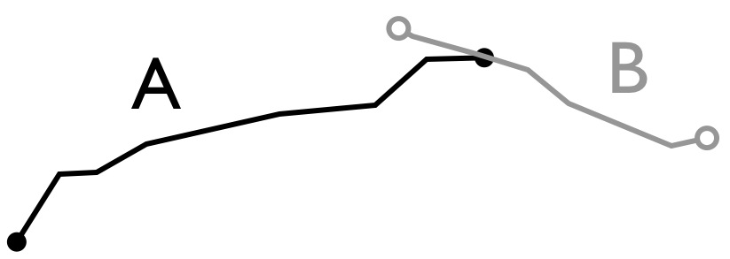
 |  | B
 |  | I | B | E
A | I
 | B
 | E

Fill in the DE9IM matrix for this geometry interaction.

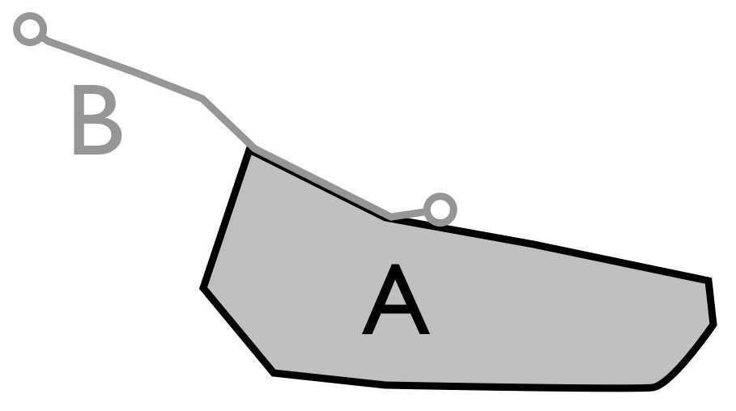
 |  | B
 |  | I | B | E
A | I
 | B
 | E

