JavaScript Assignment #1

**Part 1: About Me**

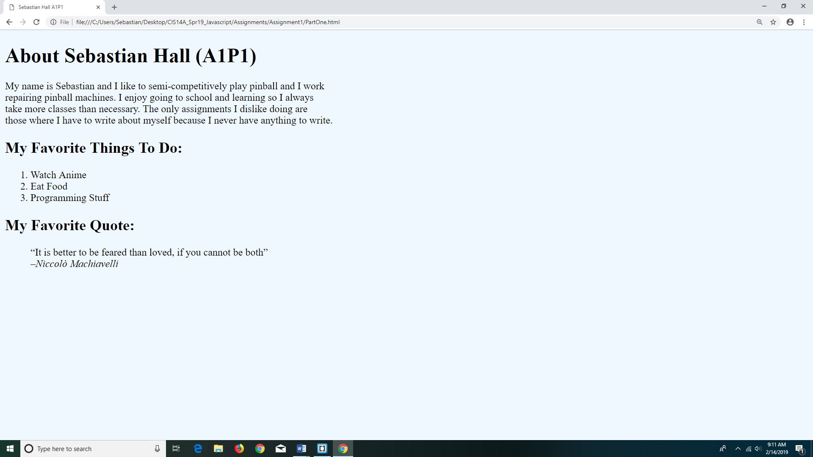

<!DOCTYPE html>

<html lang="en">

<head>

<meta charset="utf-8"/>

<title>Sebastian Hall A1P1</title>

<style>

body {

background-color: aliceblue;

}

</style>

</head>

<body>

<h1>About Sebastian Hall (A1P1)</h1>

<p>My name is Sebastian and I like to semi-competitively play pinball and I work<br>

repairing pinball machines. I enjoy going to school and learning so I always <br/>

take more classes than necessary. The only assignments I dislike doing are <br/>

those where I have to write about myself because I never have anything to write.

</p>

<h2>My Favorite Things To Do:</h2>

<ol>

<li>Watch Anime</li>

<li>Eat Food</li>

<li>Programming Stuff</li>

</ol>

<h2>My Favorite Quote:</h2>

<blockquote>

<q>It is better to be feared than loved, if you cannot be both</q><br>

<cite>–Niccolò Machiavelli</cite>

</blockquote>

</body>

</html>

**Part 2: About Document.Write**

<!DOCTYPE html>

<html lang="en">

<head>

<meta charset="utf-8"/>

<title>Sebastian Hall A1P2</title>

<style>

body {

background-color: aliceblue;

}

</style>

</head>

<body>

<h1>About Sebastian Hall (A1P2)</h1>

<p>My name is Sebastian and I like to semi-competitively play pinball and I work<br>

repairing pinball machines. I enjoy going to school and learning so I always <br/>

take more classes than necessary. The only assignments I dislike doing are <br/>

those where I have to write about myself because I never have anything to write.

</p>

<script>

document.write("<h2>My Favorite Things To Do:</h2>\

<ol>\

<li>Watch Anime</li>\

<li>Eat Food</li>\

<li>Programming Stuff</li>\

</ol>\

<h2>My Favorite Quote:</h2>\

<blockquote>\

<q>It is better to be feared than loved, if you cannot be both</q><br>\

<cite>–Niccolò Machiavelli</cite>\

</blockquote>");

</script>

</body>

</html>

**Part 3: Temperature Conversion**

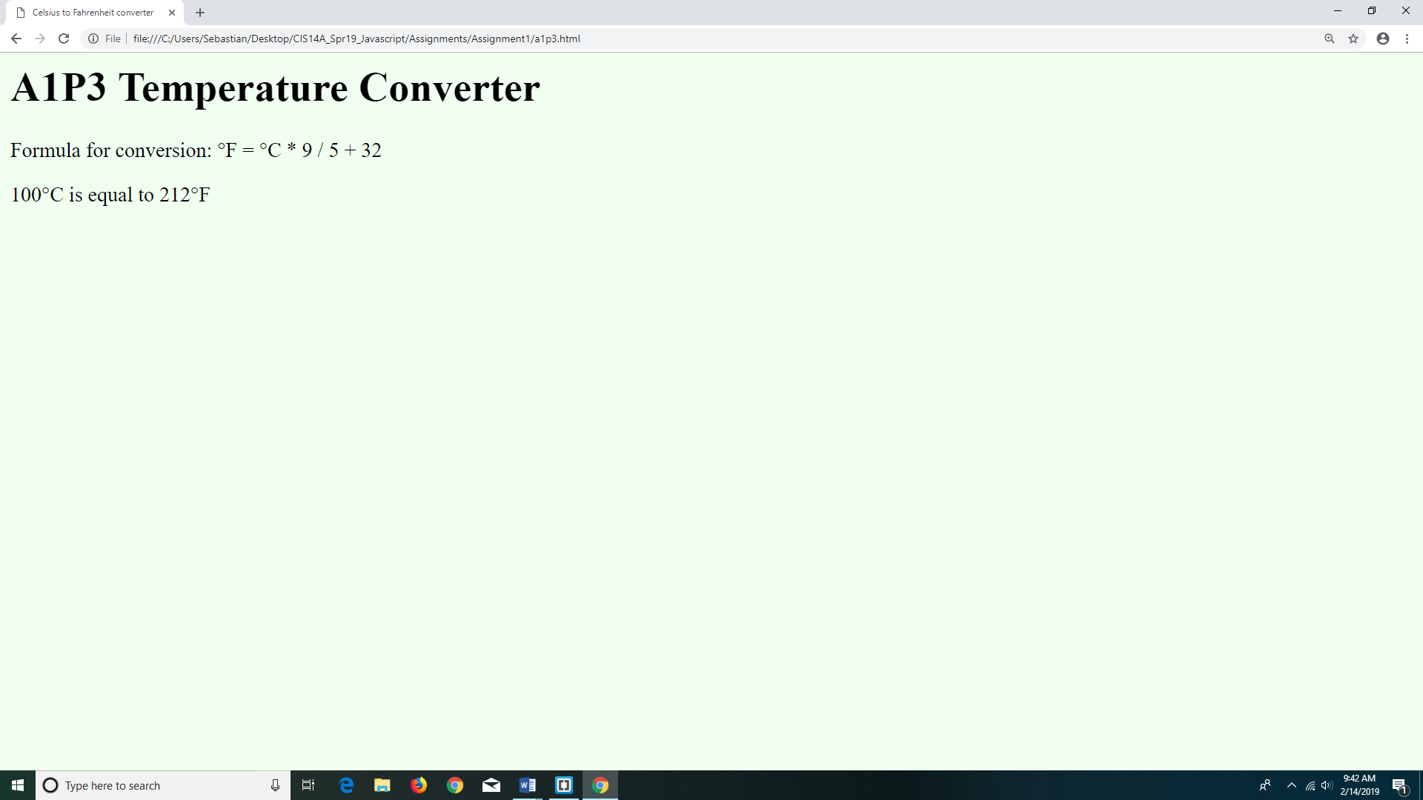

<!DOCTYPE html>

<html lang="en">

<head>

<title>Celsius to Fahrenheit converter</title>

</head>

<body style="background-color:honeydew">

<h1>A1P3 Temperature Converter</h1>

<p>Formula for conversion: °F = °C * 9 / 5 + 32</p>

<script type="text/javascript">

//Declare variables

var c, f;//Degrees Celsius and Fahrenheit

//Get user input for temp

c = window.prompt("Enter a temperature in Celsius to convert to Fahrenheit");

//Convert Celsius to Fahrenheit

f = c * 9 / 5 + 32;

//Output results

document.write(c + "°C is equal to " + f + "°F");

</script>

</body>

</html>

**Part 4: Alert -- It’s Freezing in Here!**

<!DOCTYPE html>

<html lang="en">

<head>

<title>Celsius to Fahrenheit converter A1P4</title>

</head>

<body style="background-color:honeydew">

<h1>A1P4 Temperature Converter</h1>

<p>Formula for conversion: °F = °C * 9 / 5 + 32</p>

<script type="text/javascript">

//Declare variables

var c, f;//Degrees Celsius and Fahrenheit

var output;//Output string

//Get user input for temp

c = window.prompt('Enter a temperature in Celsius to convert to Fahrenheit');

//Convert Celsius to Fahrenheit

f = c * 9 / 5 + 32;

//Make output string

output = c + "°C is equal to " + f + "°F! ";

if(f <= 32) {

output += "And that is freezing cold!";

}

//Output results

setTimeout("window.alert(output)",50);

</script>

</body>

</html>