JavaScript Assignment #2

**Part 1: What’s Your GPA**

**<!DOCTYPE html>**

**<html lang="en-US">**

**<head>**

**<meta charset="utf-8" />**

**<title>Sebastian Hall A2P1</title>**

**<style>**

**body {**

**background-color:aquamarine;**

**}**

**</style>**

**</head>**

**<body>**

**<h1>Sebastian Hall A2P1</h1>**

**<script>**

**//Declare variables**

**var fName;//First name**

**var gpa;//GPA**

**var grade;//Final grade**

**var output;//Output string for name and grade**

**//Prompt user for first name**

**fName = window.prompt("Enter your first name");**

**fName = fName.trim();//Remove unnecessary whitespace if necessary**

**//Prompt user for GPA**

**gpa = window.prompt("Enter your GPA, " + fName);**

**gpa = parseFloat(gpa);//Convert type from string to float**

**//Determine grade based on GPA**

**if(!isNaN(gpa)) {**

**grade = getGrade(gpa);**

**} else {**

**grade = "F because a GPA is a number";**

**}**

**//Output grade and name**

**output = "<p>" + fName + ", your GPA of " + gpa + " results in a " +**

**grade + " grade.</p>";**

**document.write(output);**

**function getGrade(gpa) {**

**//Declare variables**

**var grade;//Letter grade**

**//Determine grade based on GPA**

**if(gpa >= 3.7) {**

**grade = "A";**

**} else if(gpa >= 2.7) {**

**grade = "B";**

**} else if(gpa >= 1.7) {**

**grade = "C";**

**} else if(gpa >= 0.7) {**

**grade = "D";**

**} else {**

**grade = "F";**

**}**

**//Return the grade**

**return grade;**

**}**

**</script>**

**</body>**

**</html>**

**Part 2: Gimme Some Products**

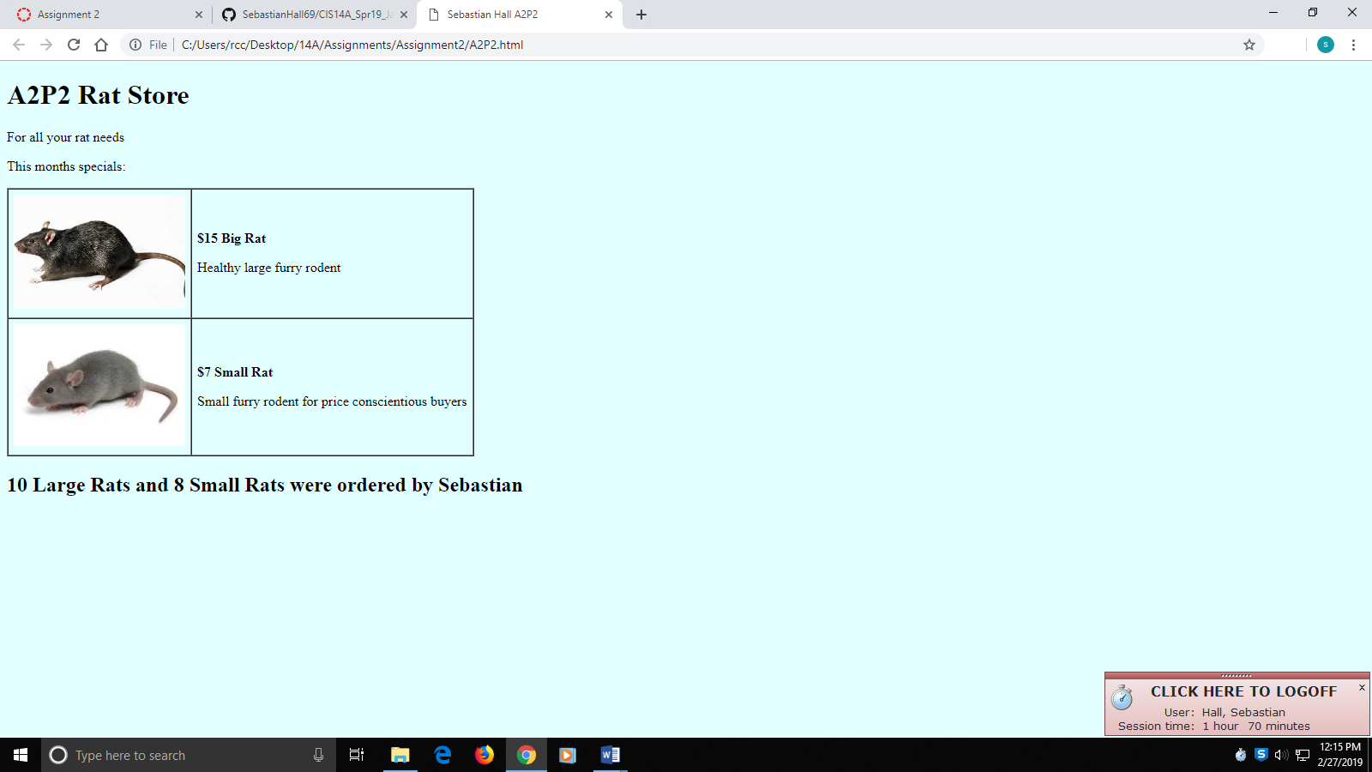

**<!DOCTYPE html>**

**<html lang="en-US">**

**<head>**

**<meta charset="utf-8" />**

**<title>Sebastian Hall A2P2</title>**

**<style>**

**body {**

**background-color:lightcyan;**

**}**

**p.prodName {**

**font-weight: bold;**

**}**

**img.prodImg {**

**width: 200px;**

**}**

**</style>**

**</head>**

**<body>**

**<h1>A2P2 Rat Store</h1>**

**<p>For all your rat needs</p>**

**<p>This months specials:</p>**

**<table border="1" cellspacing="0" cellpadding="6"**

**summary="Table of product images and prices and descriptions">**

**<tbody>**

**<tr>**

**<td><img src="bigRat.jpg" alt="Big Rat" class="prodImg" /></td>**

**<td>**

**<p class="prodName">$15 Big Rat</p>**

**<p>Healthy large furry rodent</p>**

**</td>**

**</tr>**

**<tr>**

**<td><img src="smallRat.jpg" alt="Small Rat" class="prodImg"/></td>**

**<td>**

**<p class="prodName">$7 Small Rat</p>**

**<p>Small furry rodent for price conscientious buyers</p>**

**</td>**

**</tr>**

**</tbody>**

**</table>**

**<h2 id="prodSum"></h2>**

**<script>**

**function stuff() {**

**//Declare variables**

**var fName;//First name**

**var amounts = [];//Array of order amounts**

**var order = "";//Final order summary message**

**//Prompt user to enter name**

**fName = window.prompt("Welcome to the Rat Store. What is your name?");**

**//Prompt user to buy product one**

**amounts[0] = window.prompt(fName + ", how many Large Rats " +**

**"would you like to buy?");**

**//Prompt user to buy product two**

**amounts[1] = window.prompt(fName + ", how many Small Rats " +**

**"would you like to buy?");**

**//Set information into order summary part of page**

**order = (amounts[0] + " Large Rats and " + amounts[1] +**

**" Small Rats were ordered by " + fName);**

**document.getElementById("prodSum").innerHTML = order;**

**}**

**window.onload = stuff;**

**</script>**

**</body>**

**</html>**

**Part 3: Receipt This!**

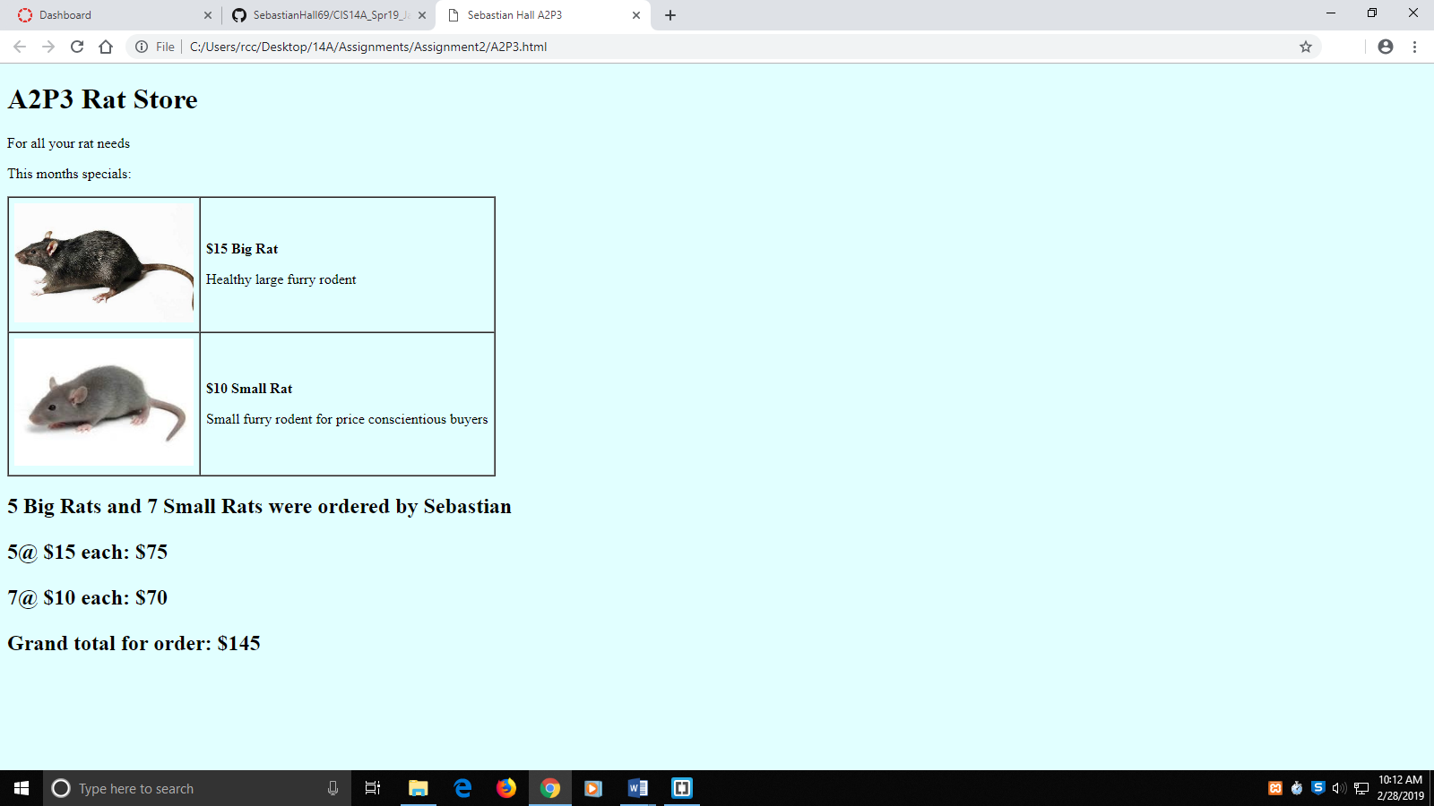

**<!DOCTYPE html>**

**<html lang="en-US">**

**<head>**

**<meta charset="utf-8" />**

**<title>Sebastian Hall A2P3</title>**

**<style>**

**body {**

**background-color:lightcyan;**

**}**

**p.prodName {**

**font-weight: bold;**

**}**

**img.prodImg {**

**width: 200px;**

**}**

**</style>**

**</head>**

**<body>**

**<h1>A2P3 Rat Store</h1>**

**<p>For all your rat needs</p>**

**<p>This months specials:</p>**

**<table border="1" cellspacing="0" cellpadding="6"**

**summary="Table of product images and prices and descriptions">**

**<tbody>**

**<tr>**

**<td><img src="bigRat.jpg" alt="Big Rat" class="prodImg" /></td>**

**<td>**

**<p class="prodName">$15 Big Rat</p>**

**<p>Healthy large furry rodent</p>**

**</td>**

**</tr>**

**<tr>**

**<td><img src="smallRat.jpg" alt="Small Rat" class="prodImg"/></td>**

**<td>**

**<p class="prodName">$10 Small Rat</p>**

**<p>Small furry rodent for price conscientious buyers</p>**

**</td>**

**</tr>**

**</tbody>**

**</table>**

**<h2 id="prodSum"></h2>**

**<script>**

**function stuff() {**

**//Declare variables**

**var fName;//First name**

**var amounts = [];//Array of order amounts**

**var order = "";//Final order summary message**

**var ttlOne;**

**var ttlTwo;**

**//Prompt user to enter name**

**fName = window.prompt("Welcome to the Rat Store. What is your name?");**

**//Prompt user to buy product one**

**amounts[0] = window.prompt(fName + ", how many Big Rats " +**

**"would you like to buy?");**

**//Prompt user to buy product two**

**amounts[1] = window.prompt(fName + ", how many Small Rats " +**

**"would you like to buy?");**

**//Set information into order summary part of page**

**order = (amounts[0] + " Big Rats and " + amounts[1] +**

**" Small Rats were ordered by " + fName);**

**//Get totals and output**

**ttlOne = amounts[0] * 15;**

**ttlTwo = amounts[1] * 10;**

**order += "<p>" + amounts[0] + "@ $15 each: $" + ttlOne + "</p>";**

**order += "<p>" + amounts[1] + "@ $10 each: $" + ttlTwo + "</p>";**

**order += "<p>Grand total for order: $" + (ttlTwo + ttlOne) + "</p>";**

**document.getElementById("prodSum").innerHTML = order;**

**}**

**window.onload = stuff;**

**</script>**

**</body>**

</html>

**Part 4: If it Don’t Make Dollar$, it Don’t Make ¢ents!**

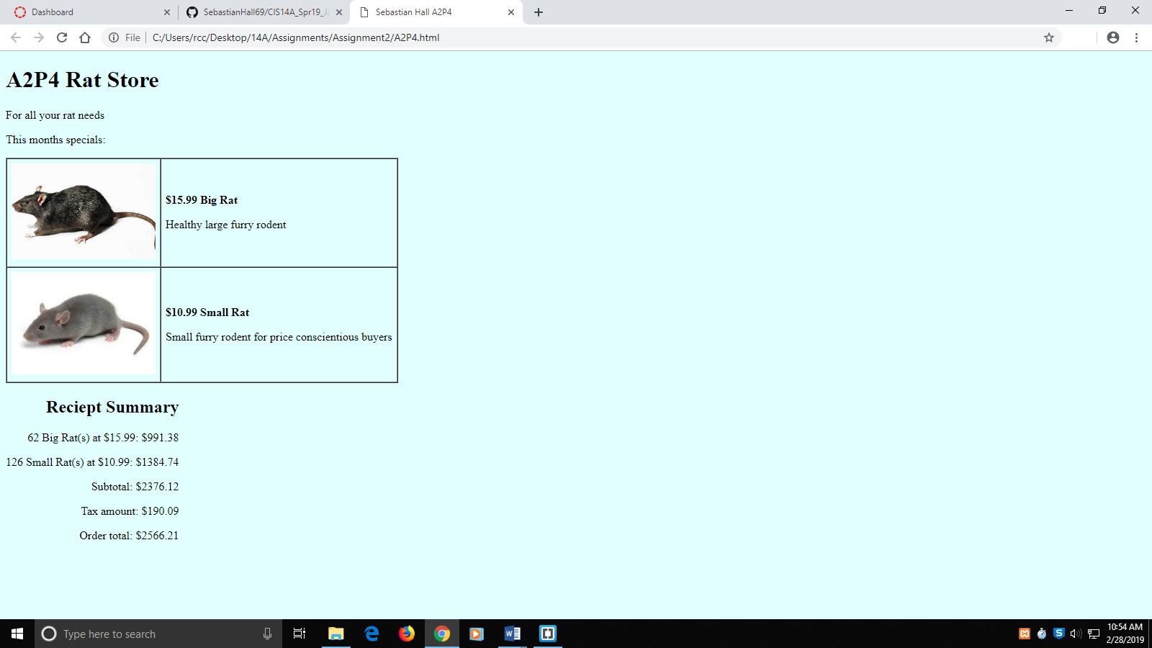

**<!DOCTYPE html>**

**<html lang="en-US">**

**<head>**

**<meta charset="utf-8" />**

**<title>Sebastian Hall A2P4</title>**

**<style>**

**body {**

**background-color:lightcyan;**

**}**

**p.prodName {**

**font-weight: bold;**

**}**

**img.prodImg {**

**width: 200px;**

**}**

**div#prodSum {**

**float: left;**

**text-align: right;**

**}**

**</style>**

**</head>**

**<body>**

**<h1>A2P4 Rat Store</h1>**

**<p>For all your rat needs</p>**

**<p>This months specials:</p>**

**<table border="1" cellspacing="0" cellpadding="6"**

**summary="Table of product images and prices and descriptions">**

**<tbody>**

**<tr>**

**<td><img src="bigRat.jpg" alt="Big Rat" class="prodImg" /></td>**

**<td>**

**<p class="prodName">$15.99 Big Rat</p>**

**<p>Healthy large furry rodent</p>**

**</td>**

**</tr>**

**<tr>**

**<td><img src="smallRat.jpg" alt="Small Rat" class="prodImg"/></td>**

**<td>**

**<p class="prodName">$10.99 Small Rat</p>**

**<p>Small furry rodent for price conscientious buyers</p>**

**</td>**

**</tr>**

**</tbody>**

**</table>**

**<div id="prodSum"></div>**

**<script>**

**function stuff() {**

**//Declare variables**

**var fName;//First name**

**var products = ["Big Rat", "Small Rat"];//Contains product names**

**var prodPrc = [15.99, 10.99];//Product prices**

**var amounts = [];//Array of order amounts**

**var prodTtl = [];//Total of each product bought**

**var output = "";//Final order summary message**

**var subTtl = 0;//Subtotal on order**

**var taxAmt = 0;//Amount of tax on the order**

**const TAX_RATE = 0.08;//8% tax on products**

**const NUM_PROD = 2;//Number of products available**

**//Prompt user to enter name**

**fName = window.prompt("Welcome to the Rat Store. What is your name?");**

**//Prompt user to buy products and calculate totals**

**for(var i = 0; i < NUM_PROD; ++i) {**

**amounts[i] = window.prompt(fName + ", how many " + products[i] +**

**" would you like to purchase?");**

**//Check for non numerical and negative amounts**

**if(isNaN(amounts[i]) || amounts[i] < 0) {**

**window.alert("Your order for " + products[i] + " could not be placed");**

**} else {**

**//Calculate total**

**amounts[i] = parseInt(amounts[i]);**

**prodTtl[i] = prodPrc[i] * amounts[i];**

**subTtl += prodTtl[i];**

**//Append to output string**

**if(amounts[i] > 0) {//If an amount was selected**

**output += "<p>" + amounts[i] + " " + products[i] + "(s) at $" + prodPrc[i].toFixed(2) + ": $" + prodTtl[i].toFixed(2) + "</p>";**

**}**

**}**

**}**

**//Add subtotal, tax, and total to order**

**taxAmt = subTtl * TAX_RATE;//Calculate tax**

**output += "<p>Subtotal: $" + subTtl.toFixed(2) + "</p>";**

**output += "<p>Tax amount: $" + taxAmt.toFixed(2) + "</p>";**

**output += "<p>Order total: $" + (subTtl + taxAmt).toFixed(2) + "</p>";**

**//Output order to summary section of page**

**document.getElementById("prodSum").innerHTML =**

**"<h2>Reciept Summary</h2>" + output;**

**}**

**window.onload = stuff;**

**</script>**

**</body>**

**</html>**

**Part 5: What The Function?**

**<!DOCTYPE html>**

**<html lang="en-US">**

**<head>**

**<meta charset="utf-8" />**

**<title>Sebastian Hall A2P5</title>**

**<style>**

**body {**

**background-color:lightcyan;**

**}**

**p.prodName {**

**font-weight: bold;**

**}**

**img.prodImg {**

**width: 200px;**

**}**

**div#prodSum {**

**float: left;**

**text-align: right;**

**}**

**</style>**

**<script>**

**//Global variables**

**const NUM_PROD = 2;//Number of products available**

**const TAX_RATE = 0.08;//8% tax on products**

**var products = ["Big Rat", "Small Rat"];//Contains product names**

**var prodPrc = [15.99, 10.99];//Product prices**

**function stuff() {**

**//Declare variables**

**var fName;//First name**

**var amounts = [];//Array of order amounts**

**var prodTtl = [];//Total of each product bought**

**var subTtl = 0;//Subtotal on order**

**//Prompt user to enter name**

**fName = window.prompt("Welcome to the Rat Store. What is your name?");**

**//Prompt user to buy products and calculate totals**

**for(var i = 0; i < NUM_PROD; ++i) {**

**amounts[i] = window.prompt(fName + ", how many " + products[i] +**

**" would you like to purchase?");**

**//Check for non numerical and negative amounts**

**if(isNaN(amounts[i]) || amounts[i] < 0) {**

**window.alert("Your order for " + products[i] + " could not be placed");**

**} else {**

**//Calculate total**

**amounts[i] = parseInt(amounts[i]);**

**prodTtl[i] = prodPrc[i] * amounts[i];**

**subTtl += prodTtl[i];**

**}**

**}**

**//Print reciept**

**reciept(amounts, products, prodPrc, prodTtl, subTtl);**

**}**

**function reciept(amounts, products, prodPrc, prodTtl, subTtl) {**

**var taxAmt = 0;//Amount of tax on the order**

**var output = "";//Output string**

**//Append to output string**

**for(var i = 0; i < NUM_PROD; ++i){**

**if(amounts[i] > 0) {//If an amount was selected**

**output += "<p>" + amounts[i] + " " + products[i] + "(s) at $" + prodPrc[i].toFixed(2) + ": $" + prodTtl[i].toFixed(2) + "</p>";**

**}**

**}**

**//Add subtotal, tax, and total to order**

**taxAmt = subTtl * TAX_RATE;//Calculate tax**

**output += "<p>Subtotal: $" + subTtl.toFixed(2) + "</p>";**

**output += "<p>Tax amount: $" + taxAmt.toFixed(2) + "</p>";**

**output += "<p>Order total: $" + (subTtl + taxAmt).toFixed(2) + "</p>";**

**//Output order to summary section of page**

**document.getElementById("prodSum").innerHTML =**

**"<h2>Reciept Summary</h2>" + output;**

**}**

**window.onload = stuff;**

**</script>**

**</head>**

**<body>**

**<!--Store title-->**

**<h1>A2P5 Rat Store</h1>**

**<p>For all your rat needs</p>**

**<p>This months specials:</p>**

**<!--Table of products-->**

**<table border="1" cellspacing="0" cellpadding="6"**

**summary="Table of product images and prices and descriptions">**

**<tbody>**

**<tr>**

**<td><img src="bigRat.jpg" alt="Big Rat" class="prodImg" /></td>**

**<td>**

**<p class="prodName">$15.99 Big Rat</p>**

**<p>Healthy large furry rodent</p>**

**</td>**

**</tr>**

**<tr>**

**<td><img src="smallRat.jpg" alt="Small Rat" class="prodImg"/></td>**

**<td>**

**<p class="prodName">$10.99 Small Rat</p>**

**<p>Small furry rodent for price conscientious buyers</p>**

**</td>**

**</tr>**

**</tbody>**

**</table>**

**<!--Reciept Area-->**

**<div id="prodSum"></div>**

**</body>**

**</html>**