JavaScript Assignment #3

**Part 1: What’s your name? Using a Products Form**

[Paste your part 1 screen shot below]

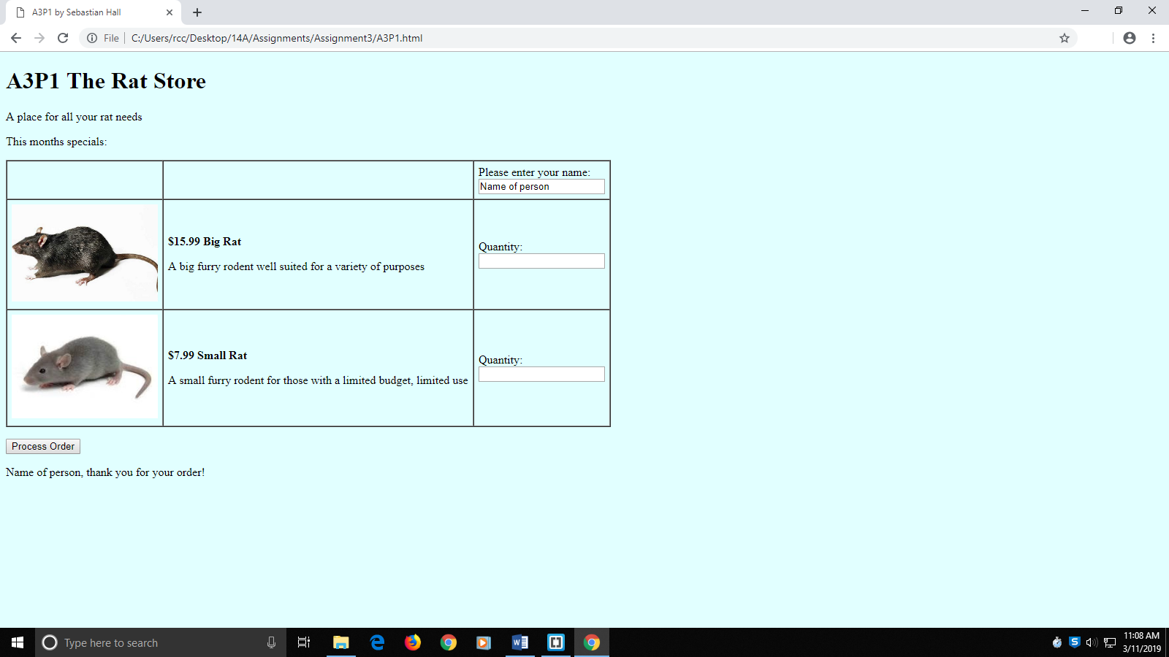

[Paste your part 1 Code below]

**<!DOCTYPE html>**

**<html lang="en">**

**<head>**

**<meta charset="utf-8">**

**<title>A3P1 by Sebastian Hall</title>**

**<style>**

**body {**

**background-color:lightcyan;**

**}**

**p.prodName {**

**font-weight: bold;**

**}**

**img.prodImg {**

**width: 200px;**

**}**

**div#prodSum {**

**float: left;**

**text-align: right;**

**}**

**</style>**

**</head>**

**<body>**

**<h1>A3P1 The Rat Store</h1>**

**<p>A place for all your rat needs</p>**

**<p>This months specials:</p>**

**<form>**

**<table border="1" cellspacing="0" cellpadding="6" summary="Table of product images, prices & descriptions">**

**<tbody>**

**<tr>**

**<td>&nbsp;</td>**

**<td>&nbsp;</td>**

**<td>Please enter your name:<br><input type="text" id="txtName" name="txtName">**

**</td>**

**</tr>**

**<tr>**

**<td><img class="prodImg" src="bigRat.jpg" alt="Big Rat" /></td>**

**<td>**

**<p class="prodName">$15.99 Big Rat </p>**

**<p>A big furry rodent well suited for a variety of purposes</p>**

**</td>**

**<td>Quantity:<br><input type="text" id="txtQ1" name="txtQ1"></td>**

**</tr>**

**<tr>**

**<td><img class="prodImg" src="smallRat.jpg" alt="Small Rat" /></td>**

**<td>**

**<p class="prodName">$7.99 Small Rat</p>**

**<p>A small furry rodent for those with a limited budget, limited use</p>**

**</td>**

**<td>Quantity:<br><input type="text" id="txtQ2" name="txtQ2"></td>**

**</tr>**

**</tbody>**

**</table>**

**<p>**

**<input type="button" value="Process Order" id="btnProcess" onClick="document.getElementById('receipt').innerHTML = document.getElementById('txtName').value + ', thank you for your order!';">**

**</p>**

**</form>**

**<div id="receipt">&nbsp;</div>**

**</body>**

**</html>**

**Part 2: Make it Functional!**

[Paste your part 2 screen shot below]

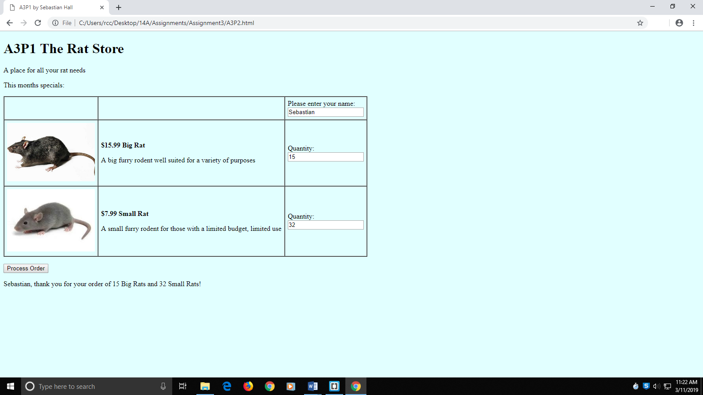

[Paste your part 2 Code below]

**<!DOCTYPE html>**

**<html lang="en">**

**<head>**

**<meta charset="utf-8">**

**<title>A3P1 by Sebastian Hall</title>**

**<style>**

**body {**

**background-color:lightcyan;**

**}**

**p.prodName {**

**font-weight: bold;**

**}**

**img.prodImg {**

**width: 200px;**

**}**

**div#prodSum {**

**float: left;**

**text-align: right;**

**}**

**</style>**

**<script>**

**const PRICE_BR = 15.99;**

**const PRICE_SR = 7.99;**

**function processOrder() {**

**var fName = document.getElementById("txtName").value;**

**var q1 = document.getElementById("txtQ1").value;**

**var q2 = document.getElementById("txtQ2").value;**

**var output = "<p>" + fName + ", thank you for your order of " +**

**q1 + " Big Rats and " + q2 + " Small Rats!";**

**document.getElementById("receipt").innerHTML = output;**

**}**

**</script>**

**</head>**

**<body>**

**<h1>A3P1 The Rat Store</h1>**

**<p>A place for all your rat needs</p>**

**<p>This months specials:</p>**

**<form>**

**<table border="1" cellspacing="0" cellpadding="6" summary="Table of product images, prices & descriptions">**

**<tbody>**

**<tr>**

**<td>&nbsp;</td>**

**<td>&nbsp;</td>**

**<td>Please enter your name:<br><input type="text" id="txtName" name="txtName">**

**</td>**

**</tr>**

**<tr>**

**<td><img class="prodImg" src="bigRat.jpg" alt="Big Rat" /></td>**

**<td>**

**<p class="prodName">$<script>document.write(PRICE_BR)</script> Big Rat </p>**

**<p>A big furry rodent well suited for a variety of purposes</p>**

**</td>**

**<td>Quantity:<br><input type="text" id="txtQ1" name="txtQ1"></td>**

**</tr>**

**<tr>**

**<td><img class="prodImg" src="smallRat.jpg" alt="Small Rat" /></td>**

**<td>**

**<p class="prodName">$<script>document.write(PRICE_SR)</script> Small Rat</p>**

**<p>A small furry rodent for those with a limited budget, limited use</p>**

**</td>**

**<td>Quantity:<br><input type="text" id="txtQ2" name="txtQ2"></td>**

**</tr>**

**</tbody>**

**</table>**

**<p>**

**<input type="button" value="Process Order" id="btnProcess" onClick="processOrder();">**

**</p>**

**</form>**

**<div id="receipt">&nbsp;</div>**

**</body>**

**</html>**

**Part 3: You Receive A Receipt!**  
 [Page Your part 3 Screenshot below]

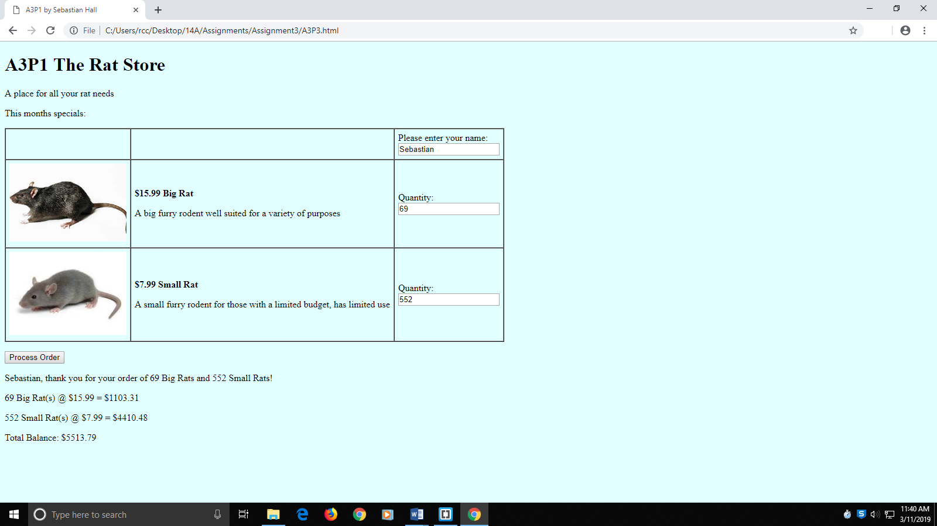

[Paste your part 3 Code Below your screen shot]

**<!DOCTYPE html>**

**<html lang="en">**

**<head>**

**<meta charset="utf-8">**

**<title>A3P1 by Sebastian Hall</title>**

**<style>**

**body {**

**background-color:lightcyan;**

**}**

**p.prodName {**

**font-weight: bold;**

**}**

**img.prodImg {**

**width: 200px;**

**}**

**div#prodSum {**

**float: left;**

**text-align: right;**

**}**

**</style>**

**<script>**

**const PRICE_BR = 15.99;**

**const PRICE_SR = 7.99;**

**function processOrder() {**

**var fName = document.getElementById("txtName").value;**

**var q1 = document.getElementById("txtQ1").value;**

**var q2 = document.getElementById("txtQ2").value;**

**var sub1 = q1 * PRICE_BR;**

**var sub2 = q2 * PRICE_SR;**

**var total = sub2 + sub1;**

**var output = "<p>" + fName + ", thank you for your order of " +**

**q1 + " Big Rats and " + q2 + " Small Rats!</p>";**

**output += "<p>" + q1 + " Big Rat(s) @ $" + PRICE_BR + " = $" +**

**sub1.toFixed(2); + "</p>";**

**output += "<p>" + q2 + " Small Rat(s) @ $" + PRICE_SR + " = $" +**

**sub2.toFixed(2) + "</p>";**

**output += "<p>Total Balance: $" + total.toFixed(2) + "</p>";**

**document.getElementById("receipt").innerHTML = output;**

**}**

**</script>**

**</head>**

**<body>**

**<h1>A3P1 The Rat Store</h1>**

**<p>A place for all your rat needs</p>**

**<p>This months specials:</p>**

**<form>**

**<table border="1" cellspacing="0" cellpadding="6" summary="Table of product images, prices & descriptions">**

**<tbody>**

**<tr>**

**<td>&nbsp;</td>**

**<td>&nbsp;</td>**

**<td>Please enter your name:<br><input type="text" id="txtName" name="txtName">**

**</td>**

**</tr>**

**<tr>**

**<td><img class="prodImg" src="bigRat.jpg" alt="Big Rat" /></td>**

**<td>**

**<p class="prodName">$<script>document.write(PRICE_BR)</script> Big Rat </p>**

**<p>A big furry rodent well suited for a variety of purposes</p>**

**</td>**

**<td>Quantity:<br><input type="text" id="txtQ1" name="txtQ1"></td>**

**</tr>**

**<tr>**

**<td><img class="prodImg" src="smallRat.jpg" alt="Small Rat" /></td>**

**<td>**

**<p class="prodName">$<script>document.write(PRICE_SR)</script> Small Rat</p>**

**<p>A small furry rodent for those with a limited budget, has limited use</p>**

**</td>**

**<td>Quantity:<br><input type="text" id="txtQ2" name="txtQ2"></td>**

**</tr>**

**</tbody>**

**</table>**

**<p>**

**<input type="button" value="Process Order" id="btnProcess" >**

**</p>**

**</form>**

**<div id="receipt">&nbsp;</div>**

**<script>**

**document.getElementById("btnProcess").addEventListener("click", processOrder);**

**</script>**

**</body>**

**</html>**

**Part 4: Change Your Prices and Pay Your Taxes!**

[Page Your part 4 Screenshot below]

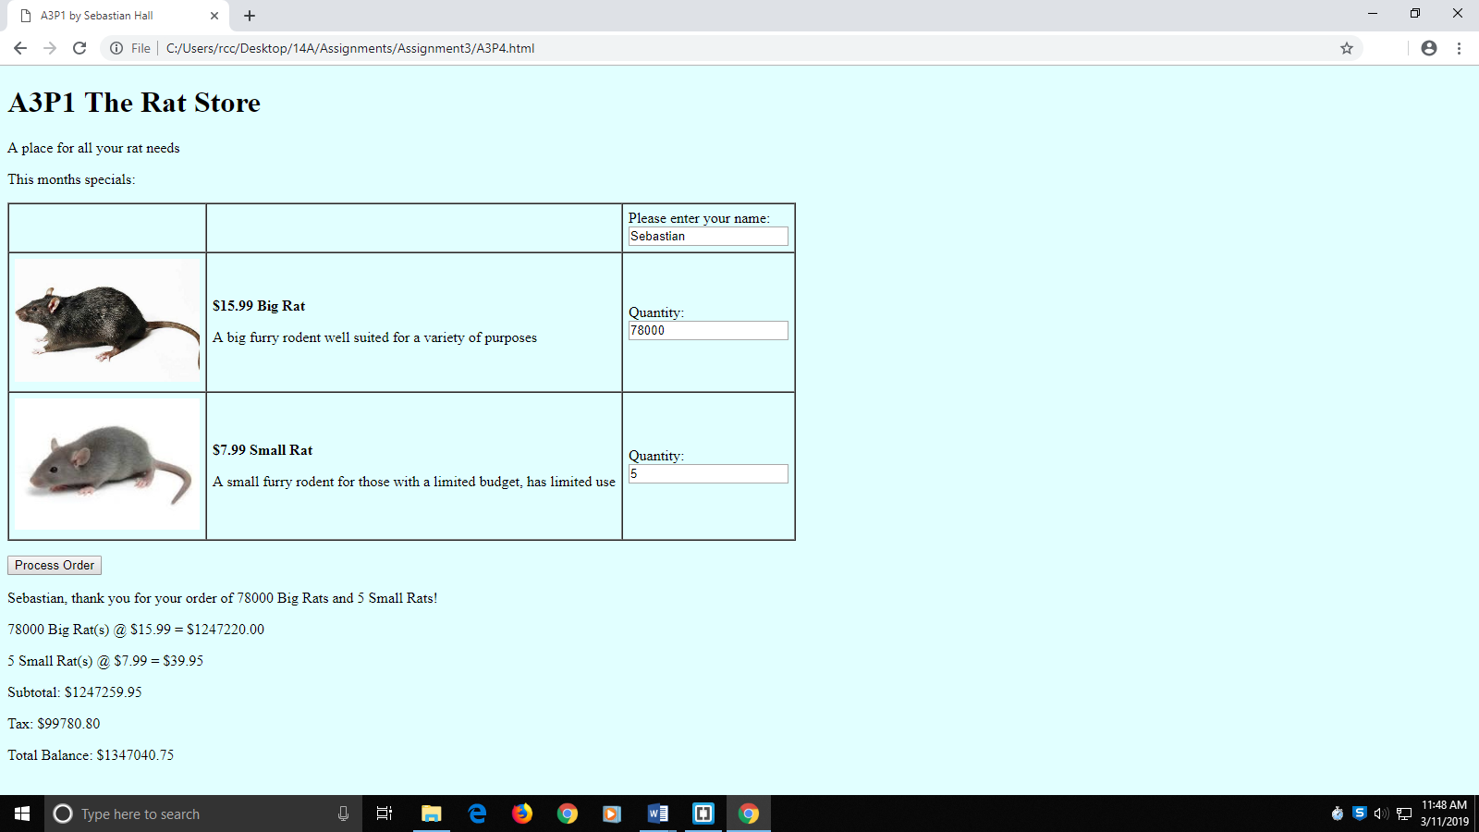

[Paste your part 4 Code Below your screen shot]

**<!DOCTYPE html>**

**<html lang="en">**

**<head>**

**<meta charset="utf-8">**

**<title>A3P1 by Sebastian Hall</title>**

**<style>**

**body {**

**background-color:lightcyan;**

**}**

**p.prodName {**

**font-weight: bold;**

**}**

**img.prodImg {**

**width: 200px;**

**}**

**div#prodSum {**

**float: left;**

**text-align: right;**

**}**

**</style>**

**<script>**

**const PRICE_BR = 15.99;//Price of Big Rat**

**const PRICE_SR = 7.99;//Price of Small Rat**

**const TAXRATE = 0.08;//Taxrate of 8%**

**function processOrder() {**

**var fName = document.getElementById("txtName").value;**

**var q1 = document.getElementById("txtQ1").value;**

**var q2 = document.getElementById("txtQ2").value;**

**var sub1 = q1 * PRICE_BR;**

**var sub2 = q2 * PRICE_SR;**

**var subtotal = sub1 + sub2;**

**var tax = subtotal * TAXRATE;**

**var total = subtotal + tax;;**

**var output = "<p>" + fName + ", thank you for your order of " +**

**q1 + " Big Rats and " + q2 + " Small Rats!</p>";**

**output += "<p>" + q1 + " Big Rat(s) @ $" + PRICE_BR + " = $" +**

**sub1.toFixed(2); + "</p>";**

**output += "<p>" + q2 + " Small Rat(s) @ $" + PRICE_SR + " = $" +**

**sub2.toFixed(2) + "</p>";**

**output +="<p>Subtotal: $" + subtotal.toFixed(2) + "</p>";**

**output +="<p>Tax: $" + tax.toFixed(2) + "</p>";**

**output += "<p>Total Balance: $" + total.toFixed(2) + "</p>";**

**document.getElementById("receipt").innerHTML = output;**

**}**

**</script>**

**</head>**

**<body>**

**<h1>A3P1 The Rat Store</h1>**

**<p>A place for all your rat needs</p>**

**<p>This months specials:</p>**

**<form>**

**<table border="1" cellspacing="0" cellpadding="6" summary="Table of product images, prices & descriptions">**

**<tbody>**

**<tr>**

**<td>&nbsp;</td>**

**<td>&nbsp;</td>**

**<td>Please enter your name:<br><input type="text" id="txtName" name="txtName">**

**</td>**

**</tr>**

**<tr>**

**<td><img class="prodImg" src="bigRat.jpg" alt="Big Rat" /></td>**

**<td>**

**<p class="prodName">$<script>document.write(PRICE_BR)</script> Big Rat </p>**

**<p>A big furry rodent well suited for a variety of purposes</p>**

**</td>**

**<td>Quantity:<br><input type="text" id="txtQ1" name="txtQ1"></td>**

**</tr>**

**<tr>**

**<td><img class="prodImg" src="smallRat.jpg" alt="Small Rat" /></td>**

**<td>**

**<p class="prodName">$<script>document.write(PRICE_SR)</script> Small Rat</p>**

**<p>A small furry rodent for those with a limited budget, has limited use</p>**

**</td>**

**<td>Quantity:<br><input type="text" id="txtQ2" name="txtQ2"></td>**

**</tr>**

**</tbody>**

**</table>**

**<p>**

**<input type="button" value="Process Order" id="btnProcess" >**

**</p>**

**</form>**

**<div id="receipt">&nbsp;</div>**

**<script>**

**document.getElementById("btnProcess").addEventListener("click", processOrder);**

**</script>**

**</body>**

**</html>**