JavaScript Assignment #4

**Part 1: Feeling Loopy**Start with A2P2 and check for bad input & re-prompt as needed using while loop

No screen shot needed.

Part 1 and Part 2 have the same code because I didn’t know that we were supposed to not use functions for the first part before I wrote it

**<!DOCTYPE html>**

**<html lang="en-US">**

**<head>**

**<meta charset="utf-8" />**

**<title>Sebastian Hall A2P2</title>**

**<style>**

**body {**

**background-color:lightcyan;**

**}**

**p.prodName {**

**font-weight: bold;**

**}**

**img.prodImg {**

**width: 200px;**

**}**

**</style>**

**</head>**

**<body>**

**<h1>A2P2 Rat Store</h1>**

**<p>For all your rat needs</p>**

**<p>This months specials:</p>**

**<table border="1" cellspacing="0" cellpadding="6"**

**summary="Table of product images and prices and descriptions">**

**<tbody>**

**<tr>**

**<td><img src="bigRat.jpg" alt="Big Rat" class="prodImg" /></td>**

**<td>**

**<p class="prodName">$15 Big Rat</p>**

**<p>Healthy large furry rodent</p>**

**</td>**

**</tr>**

**<tr>**

**<td><img src="smallRat.jpg" alt="Small Rat" class="prodImg"/></td>**

**<td>**

**<p class="prodName">$7 Small Rat</p>**

**<p>Small furry rodent for price conscientious buyers</p>**

**</td>**

**</tr>**

**</tbody>**

**</table>**

**<h2 id="prodSum"></h2>**

**<script>**

**//Does the stuff the wepage is supposed to**

**function stuff() {**

**//Declare variables**

**var fName;//First name**

**var amounts = [];//Array of order amounts**

**var receipt = "";//Final order summary message**

**var min = 0;//Minimum amount to be ordered**

**var max = 1000;//Maximum amount to be ordered**

**//Prompt user to enter name**

**fName = window.prompt("Welcome to the Rat Store. What is your name?");**

**while(!isGoodString(fName)) {**

**fName = window.prompt(fName + " is not a cool name, enter another");**

**}**

**//Prompt user to buy product one**

**amounts[0] = order("Large Rats", min, max);**

**//Prompt user to buy product two**

**amounts[1] = order("Small Rats", min, max);**

**//Set information into order summary part of page**

**receipt = (amounts[0] + " Large Rats and " + amounts[1] +**

**" Small Rats were ordered by " + fName);**

**document.getElementById("prodSum").innerHTML = receipt;**

**}**

**//Gets a product order amount with bounds checking**

**function order(product, min, max) {**

**//Gather input**

**var input = window.prompt("How many " + product + " would you like to buy?");**

**var amount = parseInt(input);**

**//Validate input**

**while(isNaN(amount) || !isInBounds(amount, min, max)) {**

**input = window.prompt("Sorry, " + input + " is not a valid amount\n" +**

**"Please Enter a valid number range [" + min +","**

**+ max + "]");**

**amount = parseInt(input);**

**}**

**//Return amount ordered**

**return amount;**

**}**

**//Checks the bounds of a number, inclusive**

**function isInBounds(amount, min, max) {**

**return (amount>=min&&amount<=max)?true:false;**

**}**

**//Checks for valid null and empty strings**

**function isGoodString(val) {**

**return (val!=""&&val!=null)?true:false;**

**}**

**//Do initial stuff once the DOM is loaded**

**window.onload = stuff;**

**</script>**

**</body>**

**</html>**

**Part 2: While Writing A Function…**Same as part 1 but use a function to validate input and call it once for each product

No screen shot needed.

**<!DOCTYPE html>**

**<html lang="en-US">**

**<head>**

**<meta charset="utf-8" />**

**<title>Sebastian Hall A2P2</title>**

**<style>**

**body {**

**background-color:lightcyan;**

**}**

**p.prodName {**

**font-weight: bold;**

**}**

**img.prodImg {**

**width: 200px;**

**}**

**</style>**

**</head>**

**<body>**

**<h1>A2P2 Rat Store</h1>**

**<p>For all your rat needs</p>**

**<p>This months specials:</p>**

**<table border="1" cellspacing="0" cellpadding="6"**

**summary="Table of product images and prices and descriptions">**

**<tbody>**

**<tr>**

**<td><img src="bigRat.jpg" alt="Big Rat" class="prodImg" /></td>**

**<td>**

**<p class="prodName">$15 Big Rat</p>**

**<p>Healthy large furry rodent</p>**

**</td>**

**</tr>**

**<tr>**

**<td><img src="smallRat.jpg" alt="Small Rat" class="prodImg"/></td>**

**<td>**

**<p class="prodName">$7 Small Rat</p>**

**<p>Small furry rodent for price conscientious buyers</p>**

**</td>**

**</tr>**

**</tbody>**

**</table>**

**<h2 id="prodSum"></h2>**

**<script>**

**//Does the stuff the wepage is supposed to**

**function stuff() {**

**//Declare variables**

**var fName;//First name**

**var amounts = [];//Array of order amounts**

**var receipt = "";//Final order summary message**

**var min = 0;//Minimum amount to be ordered**

**var max = 1000;//Maximum amount to be ordered**

**//Prompt user to enter name**

**fName = window.prompt("Welcome to the Rat Store. What is your name?");**

**while(!isGoodString(fName)) {**

**fName = window.prompt(fName + " is not a cool name, enter another");**

**}**

**//Prompt user to buy product one**

**amounts[0] = order("Large Rats", min, max);**

**//Prompt user to buy product two**

**amounts[1] = order("Small Rats", min, max);**

**//Set information into order summary part of page**

**receipt = (amounts[0] + " Large Rats and " + amounts[1] +**

**" Small Rats were ordered by " + fName);**

**document.getElementById("prodSum").innerHTML = receipt;**

**}**

**//Gets a product order amount with bounds checking**

**function order(product, min, max) {**

**//Gather input**

**var input = window.prompt("How many " + product + " would you like to buy?");**

**var amount = parseInt(input);**

**//Validate input**

**while(isNaN(amount) || !isInBounds(amount, min, max)) {**

**input = window.prompt("Sorry, " + input + " is not a valid amount\n" +**

**"Please Enter a valid number range [" + min +","**

**+ max + "]");**

**amount = parseInt(input);**

**}**

**//Return amount ordered**

**return amount;**

**}**

**//Checks the bounds of a number, inclusive**

**function isInBounds(amount, min, max) {**

**return (amount>=min&&amount<=max)?true:false;**

**}**

**//Checks for valid null and empty strings**

**function isGoodString(val) {**

**return (val!=""&&val!=null)?true:false;**

**}**

**//Do initial stuff once the DOM is loaded**

**window.onload = stuff;**

**</script>**

**</body>**

**</html>**

**Part 3: For Looping…**Start with A3P4, then add a button to display a for-loop generated discount pricing list

[Paste your part 3 Screenshot(s) below. Make sure all of your page displays. Use 2 screenshots as needed.]

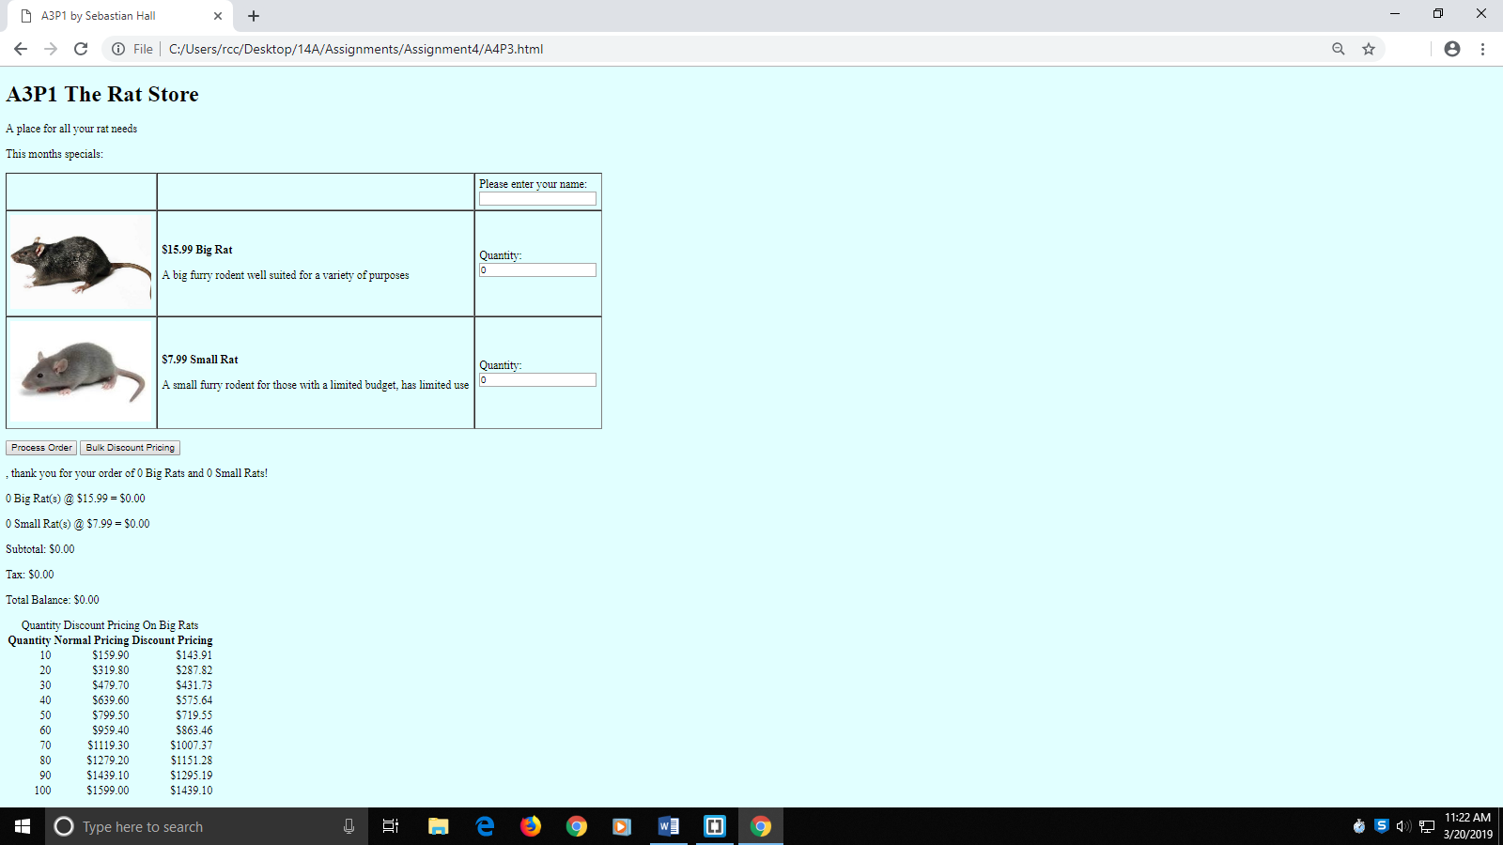

[Paste your part 3 code below your screen shot. Make sure that ALL code is visible between this page's margins]

**<!DOCTYPE html>**

**<html lang="en">**

**<head>**

**<meta charset="utf-8">**

**<title>A3P1 by Sebastian Hall</title>**

**<style>**

**body {**

**background-color:lightcyan;**

**}**

**p.prodName {**

**font-weight: bold;**

**}**

**img.prodImg {**

**width: 200px;**

**}**

**div#prodSum {**

**float: left;**

**text-align: right;**

**}**

**#discTable {**

**text-align: right;**

**}**

**</style>**

**<script>**

**const PRICE_BR = 15.99;//Price of Big Rat**

**const PRICE_SR = 7.99;//Price of Small Rat**

**const TAXRATE = 0.08;//Taxrate of 8%**

**const DISCOUNT = 0.9;//Discount rate**

**function processOrder() {**

**var fName = document.getElementById("txtName").value;**

**var q1 = document.getElementById("txtQ1").value;**

**var q2 = document.getElementById("txtQ2").value;**

**var sub1 = q1 * PRICE_BR;**

**var sub2 = q2 * PRICE_SR;**

**var subtotal = sub1 + sub2;**

**var tax = subtotal * TAXRATE;**

**var total = subtotal + tax;;**

**var output = "<p>" + fName + ", thank you for your order of " +**

**q1 + " Big Rats and " + q2 + " Small Rats!</p>";**

**output += "<p>" + q1 + " Big Rat(s) @ $" + PRICE_BR + " = $" +**

**sub1.toFixed(2); + "</p>";**

**output += "<p>" + q2 + " Small Rat(s) @ $" + PRICE_SR + " = $" +**

**sub2.toFixed(2) + "</p>";**

**output +="<p>Subtotal: $" + subtotal.toFixed(2) + "</p>";**

**output +="<p>Tax: $" + tax.toFixed(2) + "</p>";**

**output += "<p>Total Balance: $" + total.toFixed(2) + "</p>";**

**document.getElementById("receipt").innerHTML = output;**

**}**

**function displayDiscounts() {**

**var output = "<table id='discTable' style='border:none;'><caption>Quantity Discount Pricing On Big Rats</caption><tbody><tr><th>Quantity</th><th>Normal Pricing</th><th>Discount Pricing</th></tr>";**

**for(var i=10; i<=100; i+=10) {**

**output += "<tr><td>" + i + "</td>";**

**output += "<td>$" + (i*PRICE_BR).toFixed(2) + "</td>";**

**output += "<td>$" + (i*PRICE_BR*DISCOUNT).toFixed(2) + "</td></tr>";**

**}**

**output += "</tbody></table>";**

**document.getElementById("discountPricing").innerHTML = output;**

**}**

**</script>**

**</head>**

**<body>**

**<h1>A3P1 The Rat Store</h1>**

**<p>A place for all your rat needs</p>**

**<p>This months specials:</p>**

**<form>**

**<table border="1" cellspacing="0" cellpadding="6" summary="Table of product images, prices & descriptions">**

**<tbody>**

**<tr>**

**<td>&nbsp;</td>**

**<td>&nbsp;</td>**

**<td>Please enter your name:<br><input type="text" id="txtName" name="txtName">**

**</td>**

**</tr>**

**<tr>**

**<td><img class="prodImg" src="bigRat.jpg" alt="Big Rat" /></td>**

**<td>**

**<p class="prodName">$<script>document.write(PRICE_BR)</script> Big Rat </p>**

**<p>A big furry rodent well suited for a variety of purposes</p>**

**</td>**

**<td>Quantity:<br><input type="text" id="txtQ1" name="txtQ1" value="0" /></td>**

**</tr>**

**<tr>**

**<td><img class="prodImg" src="smallRat.jpg" alt="Small Rat" /></td>**

**<td>**

**<p class="prodName">$<script>document.write(PRICE_SR)</script> Small Rat</p>**

**<p>A small furry rodent for those with a limited budget, has limited use</p>**

**</td>**

**<td>Quantity:<br><input type="text" id="txtQ2" name="txtQ2" value="0" /></td>**

**</tr>**

**</tbody>**

**</table>**

**<p>**

**<input id="btnProcess" type="button" value="Process Order" />**

**<input id="pricingBtn" type="button" value="Bulk Discount Pricing" />**

**</p>**

**</form>**

**<div id="receipt">&nbsp;</div>**

**<div id="discountPricing">&nbsp;</div>**

**<script>**

**document.getElementById("btnProcess").addEventListener("click", processOrder);**

**document.getElementById("pricingBtn").addEventListener("click", displayDiscounts);**

**</script>**

**</body>**

**</html>**

**Part 4: Display Table …**Start with A4P3, then modify code to calculate quantity discounts on the receipt and also display the discount pricing list with table formatting

[Paste your part 4 Screenshot(s) below. Make sure all of your page displays. Use 2 screenshots as needed.]

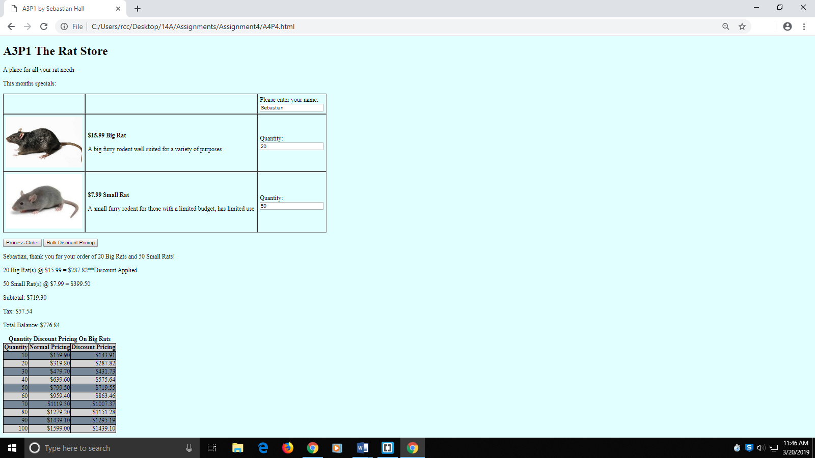

[Paste your part 4 code below your screen shot. Make sure that ALL code is visible between this page's margins]

**<!DOCTYPE html>**

**<html lang="en">**

**<head>**

**<meta charset="utf-8">**

**<title>A3P1 by Sebastian Hall</title>**

**<style>**

**body {**

**background-color:lightcyan;**

**}**

**p.prodName {**

**font-weight: bold;**

**}**

**img.prodImg {**

**width: 200px;**

**}**

**div#prodSum {**

**float: left;**

**text-align: right;**

**}**

**#discTable {**

**text-align: right;**

**border: 1px solid black;**

**border-collapse: collapse;**

**}**

**#discTable tr:nth-child(odd) {**

**background-color: lightgrey;**

**}**

**#discTable tr:nth-child(even) {**

**background-color: lightslategrey;**

**}**

**#discTable td, th {**

**border: 2px solid black;**

**}**

**caption {**

**font-weight: bold;**

**}**

**</style>**

**<script>**

**const PRICE_BR = 15.99;//Price of Big Rat**

**const PRICE_SR = 7.99;//Price of Small Rat**

**const TAXRATE = 0.08;//Taxrate of 8%**

**const DISCOUNT = 0.9;//Discount rate**

**function processOrder() {**

**var fName = document.getElementById("txtName").value;**

**var q1 = document.getElementById("txtQ1").value;**

**var q2 = document.getElementById("txtQ2").value;**

**var sub1 = q1 * PRICE_BR;**

**var sub2 = q2 * PRICE_SR;**

**var subtotal = sub1 + sub2;**

**var tax = subtotal * TAXRATE;**

**var total = subtotal + tax;**

**var output = "<p>" + fName + ", thank you for your order of " +**

**q1 + " Big Rats and " + q2 + " Small Rats!</p>";**

**output += "<p>" + q1 + " Big Rat(s) @ $" + PRICE_BR + " = $";**

**if(q1>=10) {**

**sub1 *= DISCOUNT;**

**output += sub1.toFixed(2) + "**Discount Applied</p>";**

**} else {**

**output += sub1.toFixed(2) + "</p>";**

**}**

**output += "<p>" + q2 + " Small Rat(s) @ $" + PRICE_SR + " = $" +**

**sub2.toFixed(2) + "</p>";**

**output +="<p>Subtotal: $" + subtotal.toFixed(2) + "</p>";**

**output +="<p>Tax: $" + tax.toFixed(2) + "</p>";**

**output += "<p>Total Balance: $" + total.toFixed(2) + "</p>";**

**document.getElementById("receipt").innerHTML = output;**

**}**

**function displayDiscounts() {**

**var output = "<table id='discTable'><caption>Quantity Discount Pricing On Big Rats</caption><tbody><tr><th>Quantity</th><th>Normal Pricing</th><th>Discount Pricing</th></tr>";**

**for(var i=10; i<=100; i+=10) {**

**output += "<tr><td>" + i + "</td>";**

**output += "<td>$" + (i*PRICE_BR).toFixed(2) + "</td>";**

**output += "<td>$" + (i*PRICE_BR*DISCOUNT).toFixed(2) + "</td></tr>";**

**}**

**output += "</tbody></table>";**

**document.getElementById("discountPricing").innerHTML = output;**

**}**

**</script>**

**</head>**

**<body>**

**<h1>A3P1 The Rat Store</h1>**

**<p>A place for all your rat needs</p>**

**<p>This months specials:</p>**

**<form>**

**<table border="1" cellspacing="0" cellpadding="6" summary="Table of product images, prices & descriptions">**

**<tbody>**

**<tr>**

**<td>&nbsp;</td>**

**<td>&nbsp;</td>**

**<td>Please enter your name:<br><input type="text" id="txtName" name="txtName">**

**</td>**

**</tr>**

**<tr>**

**<td><img class="prodImg" src="bigRat.jpg" alt="Big Rat" /></td>**

**<td>**

**<p class="prodName">$<script>document.write(PRICE_BR)</script> Big Rat </p>**

**<p>A big furry rodent well suited for a variety of purposes</p>**

**</td>**

**<td>Quantity:<br><input type="text" id="txtQ1" name="txtQ1" value="0" /></td>**

**</tr>**

**<tr>**

**<td><img class="prodImg" src="smallRat.jpg" alt="Small Rat" /></td>**

**<td>**

**<p class="prodName">$<script>document.write(PRICE_SR)</script> Small Rat</p>**

**<p>A small furry rodent for those with a limited budget, has limited use</p>**

**</td>**

**<td>Quantity:<br><input type="text" id="txtQ2" name="txtQ2" value="0" /></td>**

**</tr>**

**</tbody>**

**</table>**

**<p>**

**<input id="btnProcess" type="button" value="Process Order" />**

**<input id="pricingBtn" type="button" value="Bulk Discount Pricing" />**

**</p>**

**</form>**

**<div id="receipt">&nbsp;</div>**

**<div id="discountPricing">&nbsp;</div>**

**<script>**

**document.getElementById("btnProcess").addEventListener("click", processOrder);**

**document.getElementById("pricingBtn").addEventListener("click", displayDiscounts);**

**</script>**

**</body>**

**</html>**