JavaScript Assignment #5

**Part 1: Hooray for Arrays**Intro to Arrays as a discounted price list – using A4P4 as a starting point

[Paste your part 1 Screenshot(s) below. Make sure all of your page displays. Use 2 screenshots as needed.]

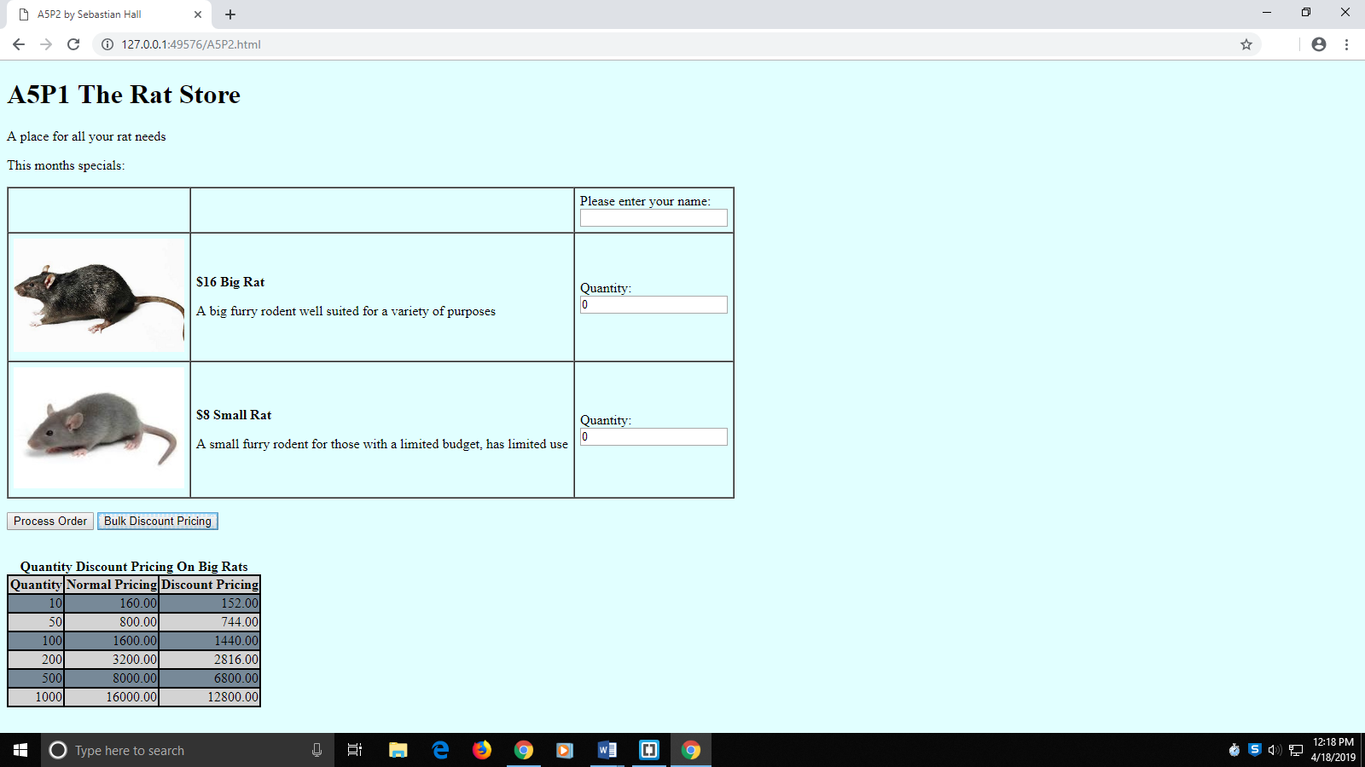

[Paste your part 1 Code below – Make sure that ALL of your code is visible between the margins of this page]

**<!DOCTYPE html>**

**<html lang="en">**

**<head>**

**<meta charset="utf-8">**

**<title>A5P1 by Sebastian Hall</title>**

**<style>**

**body {**

**background-color:lightcyan;**

**}**

**p.prodName {**

**font-weight: bold;**

**}**

**img.prodImg {**

**width: 200px;**

**}**

**div#prodSum {**

**float: left;**

**text-align: right;**

**}**

**#discTable {**

**text-align: right;**

**border: 1px solid black;**

**border-collapse: collapse;**

**}**

**#discTable tr:nth-child(odd) {**

**background-color: lightgrey;**

**}**

**#discTable tr:nth-child(even) {**

**background-color: lightslategrey;**

**}**

**#discTable td, th {**

**border: 2px solid black;**

**}**

**caption {**

**font-weight: bold;**

**}**

**</style>**

**<script>**

**const PRICE_BR = 16;//Price of Big Rat**

**const PRICE_SR = 8;//Price of Small Rat**

**const TAXRATE = 0.08;//Taxrate of 8**

**var discounts = [0.95, 0.93, 0.9, 0.88, 0.85, 0.8];**

**var quantities = [10, 50, 100, 200, 500, 1000];**

**function processOrder() {**

**var fName = document.getElementById("txtName").value;**

**var q1 = document.getElementById("txtQ1").value;**

**var q2 = document.getElementById("txtQ2").value;**

**disc = getDisc(q1);**

**var sub1 = q1 * PRICE_BR;**

**var sub2 = q2 * PRICE_SR;**

**var subtotal = sub1 + sub2;**

**var tax = subtotal * TAXRATE;**

**var total = subtotal + tax;**

**var output = "<p>" + fName + ", thank you for your order of " +**

**q1 + " Big Rats and " + q2 + " Small Rats!</p>";**

**output += "<p>" + q1 + " Big Rat(s) @ $" + PRICE_BR + " = $";**

**if(q1>=10) {**

**sub1 *= disc;**

**output += sub1.toFixed(2) + "**Discount Applied</p>";**

**} else {**

**output += sub1.toFixed(2) + "</p>";**

**}**

**output += "<p>" + q2 + " Small Rat(s) @ $" + PRICE_SR + " = $" +**

**sub2.toFixed(2) + "</p>";**

**output +="<p>Subtotal: $" + subtotal.toFixed(2) + "</p>";**

**output +="<p>Tax: $" + tax.toFixed(2) + "</p>";**

**output += "<p>Total Balance: $" + total.toFixed(2) + "</p>";**

**document.getElementById("receipt").innerHTML = output;**

**}**

**function displayDiscounts() {**

**var output = "<table id='discTable'><caption>Quantity Discount Pricing On Big Rats</caption><tbody><tr><th>Quantity</th><th>Normal Pricing</th><th>Discount Pricing</th></tr>";**

**for(var i = 0; i < quantities.length; ++i) {**

**var price = quantities[i] * PRICE_BR;**

**output += "<tr><td>" + quantities[i] + "</td>";**

**output += "<td>" + price.toFixed(2) + "</td>";**

**output += "<td>" + (price * discounts[i]).toFixed(2) + "</td></tr>";**

**}**

**output += "</tbody></table>";**

**document.getElementById("discountPricing").innerHTML = output;**

**}**

**</script>**

**</head>**

**<body>**

**<h1>A5P1 The Rat Store</h1>**

**<p>A place for all your rat needs</p>**

**<p>This months specials:</p>**

**<form>**

**<table border="1" cellspacing="0" cellpadding="6" summary="Table of product images, prices & descriptions">**

**<tbody>**

**<tr>**

**<td>&nbsp;</td>**

**<td>&nbsp;</td>**

**<td>Please enter your name:<br><input type="text" id="txtName" name="txtName">**

**</td>**

**</tr>**

**<tr>**

**<td><img class="prodImg" src="bigRat.jpg" alt="Big Rat" /></td>**

**<td>**

**<p class="prodName">$<script>document.write(PRICE_BR)</script> Big Rat </p>**

**<p>A big furry rodent well suited for a variety of purposes</p>**

**</td>**

**<td>Quantity:<br><input type="text" id="txtQ1" name="txtQ1" value="0" /></td>**

**</tr>**

**<tr>**

**<td><img class="prodImg" src="smallRat.jpg" alt="Small Rat" /></td>**

**<td>**

**<p class="prodName">$<script>document.write(PRICE_SR)</script> Small Rat</p>**

**<p>A small furry rodent for those with a limited budget, has limited use</p>**

**</td>**

**<td>Quantity:<br><input type="text" id="txtQ2" name="txtQ2" value="0" /></td>**

**</tr>**

**</tbody>**

**</table>**

**<p>**

**<input id="btnProcess" type="button" value="Process Order" />**

**<input id="pricingBtn" type="button" value="Bulk Discount Pricing" />**

**</p>**

**</form>**

**<div id="receipt">&nbsp;</div>**

**<div id="discountPricing">&nbsp;</div>**

**<script>**

**document.getElementById("btnProcess").addEventListener("click", processOrder);**

**document.getElementById("pricingBtn").addEventListener("click", displayDiscounts);**

**</script>**

**</body>**

**</html>**

**Part 2: Stop That False Advertising!**Start using your discounted price list when selling products!

[Paste your part 2 Screenshot(s) below. Make sure all of your page displays. Use 2 screenshots as needed.]

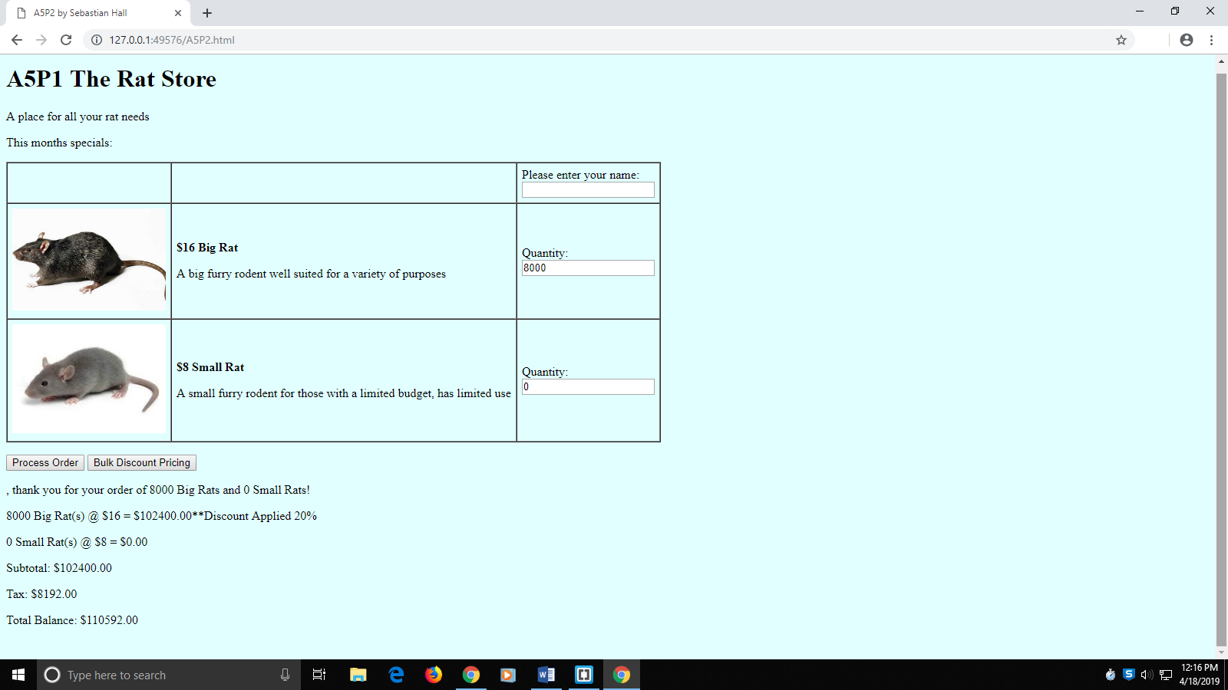

[Paste your part 2 Code below – Make sure that ALL of your code is visible between the margins of this page]

**<!DOCTYPE html>**

**<html lang="en">**

**<head>**

**<meta charset="utf-8">**

**<title>A5P2 by Sebastian Hall</title>**

**<style>**

**body {**

**background-color:lightcyan;**

**}**

**p.prodName {**

**font-weight: bold;**

**}**

**img.prodImg {**

**width: 200px;**

**}**

**div#prodSum {**

**float: left;**

**text-align: right;**

**}**

**#discTable {**

**text-align: right;**

**border: 1px solid black;**

**border-collapse: collapse;**

**}**

**#discTable tr:nth-child(odd) {**

**background-color: lightgrey;**

**}**

**#discTable tr:nth-child(even) {**

**background-color: lightslategrey;**

**}**

**#discTable td, th {**

**border: 2px solid black;**

**}**

**caption {**

**font-weight: bold;**

**}**

**</style>**

**<script>**

**const PRICE_BR = 16;//Price of Big Rat**

**const PRICE_SR = 8;//Price of Small Rat**

**const TAXRATE = 0.08;//Taxrate of 8**

**var discounts = [0.95, 0.93, 0.9, 0.88, 0.85, 0.8];**

**var quantities = [10, 50, 100, 200, 500, 1000];**

**function processOrder() {**

**var fName = document.getElementById("txtName").value;**

**var q1 = document.getElementById("txtQ1").value;**

**var q2 = document.getElementById("txtQ2").value;**

**var disc = getDiscount(q1);**

**var sub1 = q1 * PRICE_BR * disc;**

**var sub2 = q2 * PRICE_SR;**

**var subtotal = sub1 + sub2;**

**var tax = subtotal * TAXRATE;**

**var total = subtotal + tax;**

**var output = "<p>" + fName + ", thank you for your order of " +**

**q1 + " Big Rats and " + q2 + " Small Rats!</p>";**

**output += "<p>" + q1 + " Big Rat(s) @ $" + PRICE_BR + " = $";**

**if(q1>=10) {**

**output += sub1.toFixed(2) + "**Discount Applied " + (100*(1-disc)).toFixed(0) + "%</p>";**

**} else {**

**output += sub1.toFixed(2) + "</p>";**

**}**

**output += "<p>" + q2 + " Small Rat(s) @ $" + PRICE_SR + " = $" +**

**sub2.toFixed(2) + "</p>";**

**output +="<p>Subtotal: $" + subtotal.toFixed(2) + "</p>";**

**output +="<p>Tax: $" + tax.toFixed(2) + "</p>";**

**output += "<p>Total Balance: $" + total.toFixed(2) + "</p>";**

**document.getElementById("receipt").innerHTML = output;**

**}**

**function getDiscount(q) {**

**var disc = 1.0;**

**for(var i = 0; i < discounts.length; ++i)**

**if(q >= quantities[i])**

**disc = discounts[i];**

**return disc;**

**}**

**function displayDiscounts() {**

**var output = "<table id='discTable'><caption>Quantity Discount Pricing On Big Rats</caption><tbody><tr><th>Quantity</th><th>Normal Pricing</th><th>Discount Pricing</th></tr>";**

**for(var i = 0; i < quantities.length; ++i) {**

**var price = quantities[i] * PRICE_BR;**

**output += "<tr><td>" + quantities[i] + "</td>";**

**output += "<td>" + price.toFixed(2) + "</td>";**

**output += "<td>" + (price * discounts[i]).toFixed(2) + "</td></tr>";**

**}**

**output += "</tbody></table>";**

**document.getElementById("discountPricing").innerHTML = output;**

**}**

**</script>**

**</head>**

**<body>**

**<h1>A5P1 The Rat Store</h1>**

**<p>A place for all your rat needs</p>**

**<p>This months specials:</p>**

**<form>**

**<table border="1" cellspacing="0" cellpadding="6" summary="Table of product images, prices & descriptions">**

**<tbody>**

**<tr>**

**<td>&nbsp;</td>**

**<td>&nbsp;</td>**

**<td>Please enter your name:<br><input type="text" id="txtName" name="txtName">**

**</td>**

**</tr>**

**<tr>**

**<td><img class="prodImg" src="bigRat.jpg" alt="Big Rat" /></td>**

**<td>**

**<p class="prodName">$<script>document.write(PRICE_BR)</script> Big Rat </p>**

**<p>A big furry rodent well suited for a variety of purposes</p>**

**</td>**

**<td>Quantity:<br><input type="text" id="txtQ1" name="txtQ1" value="0" /></td>**

**</tr>**

**<tr>**

**<td><img class="prodImg" src="smallRat.jpg" alt="Small Rat" /></td>**

**<td>**

**<p class="prodName">$<script>document.write(PRICE_SR)</script> Small Rat</p>**

**<p>A small furry rodent for those with a limited budget, has limited use</p>**

**</td>**

**<td>Quantity:<br><input type="text" id="txtQ2" name="txtQ2" value="0" /></td>**

**</tr>**

**</tbody>**

**</table>**

**<p>**

**<input id="btnProcess" type="button" value="Process Order" />**

**<input id="pricingBtn" type="button" value="Bulk Discount Pricing" />**

**</p>**

**</form>**

**<div id="receipt">&nbsp;</div>**

**<div id="discountPricing">&nbsp;</div>**

**<script>**

**document.getElementById("btnProcess").addEventListener("click", processOrder);**

**document.getElementById("pricingBtn").addEventListener("click", displayDiscounts);**

**</script>**

**</body>**

**</html>**

Part 3: Getting to know your new friend "Dom"  
Required Fields with Error Messaging and getElementsByClassName

3 Screen shots + Code (see last page for code)

[Paste your **Screenshot #1** below -- .Just after filling out name but no quantities & Processing Order ]

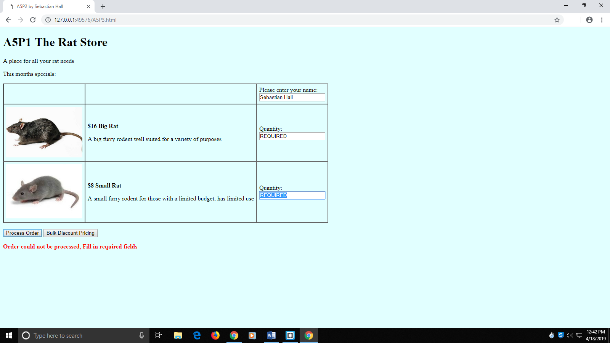

[Paste your **Screenshot #2** below -- .Continue from previous screenshot, order 2 of product 1 & Process Order ]

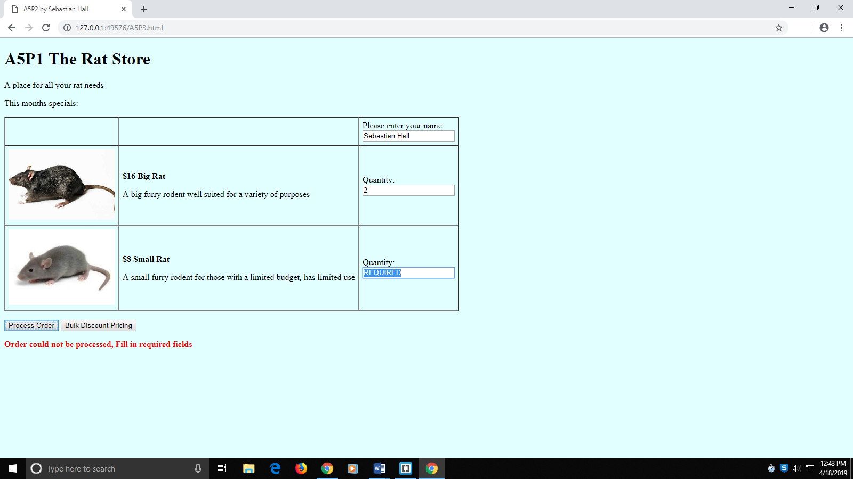

[Paste your **Screenshot #3** below -- .Continue from previous screenshot, order 1 of product 2 & Process Order ]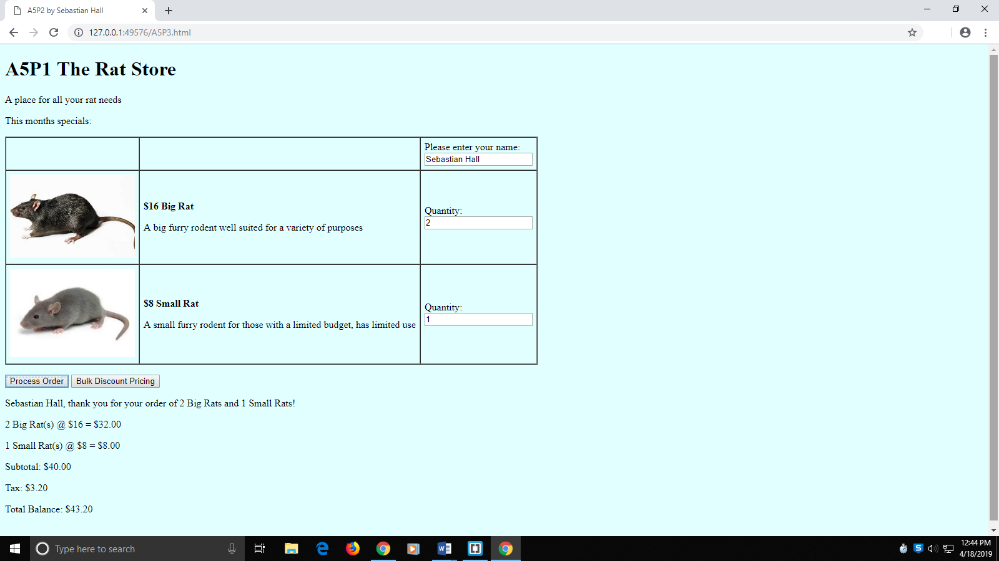

[Paste **your part 3 Code** below – Make sure that ALL of your code is visible between the margins of this page]

**<!DOCTYPE html>**

**<html lang="en">**

**<head>**

**<meta charset="utf-8">**

**<title>A5P2 by Sebastian Hall</title>**

**<style>**

**body {**

**background-color:lightcyan;**

**}**

**p.prodName {**

**font-weight: bold;**

**}**

**img.prodImg {**

**width: 200px;**

**}**

**div#prodSum {**

**float: left;**

**text-align: right;**

**}**

**#discTable {**

**text-align: right;**

**border: 1px solid black;**

**border-collapse: collapse;**

**}**

**#discTable tr:nth-child(odd) {**

**background-color: lightgrey;**

**}**

**#discTable tr:nth-child(even) {**

**background-color: lightslategrey;**

**}**

**#discTable td, th {**

**border: 2px solid black;**

**}**

**caption {**

**font-weight: bold;**

**}**

**</style>**

**<script>**

**const PRICE_BR = 16;//Price of Big Rat**

**const PRICE_SR = 8;//Price of Small Rat**

**const TAXRATE = 0.08;//Taxrate of 8**

**var discounts = [0.95, 0.93, 0.9, 0.88, 0.85, 0.8];**

**var quantities = [10, 50, 100, 200, 500, 1000];**

**function processOrder() {**

**//Declare variables**

**var fName = document.getElementById("txtName").value;**

**var q1 = document.getElementById("txtQ1").value;**

**var q2 = document.getElementById("txtQ2").value;**

**var disc = getDiscount(q1);**

**var sub1 = q1 * PRICE_BR * disc;**

**var sub2 = q2 * PRICE_SR;**

**var subtotal = sub1 + sub2;**

**var tax = subtotal * TAXRATE;**

**var total = subtotal + tax;**

**var output = "";**

**if(validate()) {**

**//Build output**

**output = "<p>" + fName + ", thank you for your order of " +**

**q1 + " Big Rats and " + q2 + " Small Rats!</p>";**

**output += "<p>" + q1 + " Big Rat(s) @ $" + PRICE_BR + " = $";**

**if(q1>=10) {**

**output += sub1.toFixed(2) + "**Discount Applied " + (100*(1-disc)).toFixed(0) + "%</p>";**

**} else {**

**output += sub1.toFixed(2) + "</p>";**

**}**

**output += "<p>" + q2 + " Small Rat(s) @ $" + PRICE_SR + " = $" +**

**sub2.toFixed(2) + "</p>";**

**output +="<p>Subtotal: $" + subtotal.toFixed(2) + "</p>";**

**output +="<p>Tax: $" + tax.toFixed(2) + "</p>";**

**output += "<p>Total Balance: $" + total.toFixed(2) + "</p>";**

**document.getElementById("receipt").style.color = "black";**

**document.getElementById("receipt").style.fontWeight = "normal";**

**} else {**

**output = "<p>Order could not be processed, Fill in required fields</p>";**

**document.getElementById("receipt").style.color = "red";**

**document.getElementById("receipt").style.fontWeight = "bold";**

**}**

**document.getElementById("receipt").innerHTML = output;**

**}**

**function validate() {**

**var arr = document.getElementsByClassName("req");**

**var isValid = true;**

**for(var i = 0; i < arr.length; ++i)**

**if(isNaN(arr[i].value) || arr[i].value == "") {**

**isValid = false;**

**arr[i].value = "REQUIRED";**

**arr[i].select();**

**}**

**return isValid;**

**}**

**function getDiscount(q) {**

**var disc = 1.0;**

**for(var i = 0; i < discounts.length; ++i)**

**if(q >= quantities[i])**

**disc = discounts[i];**

**return disc;**

**}**

**function displayDiscounts() {**

**var output = "<table id='discTable'><caption>Quantity Discount Pricing On Big Rats</caption><tbody><tr><th>Quantity</th><th>Normal Pricing</th><th>Discount Pricing</th></tr>";**

**for(var i = 0; i < quantities.length; ++i) {**

**var price = quantities[i] * PRICE_BR;**

**output += "<tr><td>" + quantities[i] + "</td>";**

**output += "<td>" + price.toFixed(2) + "</td>";**

**output += "<td>" + (price * discounts[i]).toFixed(2) + "</td></tr>";**

**}**

**output += "</tbody></table>";**

**document.getElementById("discountPricing").innerHTML = output;**

**}**

**</script>**

**</head>**

**<body>**

**<h1>A5P1 The Rat Store</h1>**

**<p>A place for all your rat needs</p>**

**<p>This months specials:</p>**

**<form>**

**<table border="1" cellspacing="0" cellpadding="6" summary="Table of product images, prices & descriptions">**

**<tbody>**

**<tr>**

**<td>&nbsp;</td>**

**<td>&nbsp;</td>**

**<td>Please enter your name:<br><input type="text" id="txtName" name="txtName">**

**</td>**

**</tr>**

**<tr>**

**<td><img class="prodImg" src="bigRat.jpg" alt="Big Rat" /></td>**

**<td>**

**<p class="prodName">$<script>document.write(PRICE_BR)</script> Big Rat </p>**

**<p>A big furry rodent well suited for a variety of purposes</p>**

**</td>**

**<td>Quantity:<br><input class="req" type="text" id="txtQ1" name="txtQ1" value="0" required /></td>**

**</tr>**

**<tr>**

**<td><img class="prodImg" src="smallRat.jpg" alt="Small Rat" /></td>**

**<td>**

**<p class="prodName">$<script>document.write(PRICE_SR)</script> Small Rat</p>**

**<p>A small furry rodent for those with a limited budget, has limited use</p>**

**</td>**

**<td>Quantity:<br><input class="req" type="text" id="txtQ2" name="txtQ2" value="0" required /></td>**

**</tr>**

**</tbody>**

**</table>**

**<p>**

**<input id="btnProcess" type="button" value="Process Order" />**

**<input id="pricingBtn" type="button" value="Bulk Discount Pricing" />**

**</p>**

**</form>**

**<div id="receipt">&nbsp;</div>**

**<div id="discountPricing">&nbsp;</div>**

**<script>**

**document.getElementById("btnProcess").addEventListener("click", processOrder);**

**document.getElementById("pricingBtn").addEventListener("click", displayDiscounts);**

**</script>**

**</body>**

**</html>**

**Part 4: More Form Work with getElementsByClassName and Arrays**Work with the given "Buy My Stuff Now!" page.

[Paste your part 4 Screenshot(s) below. Make sure all of your page displays. Use 2 screenshots as needed.]

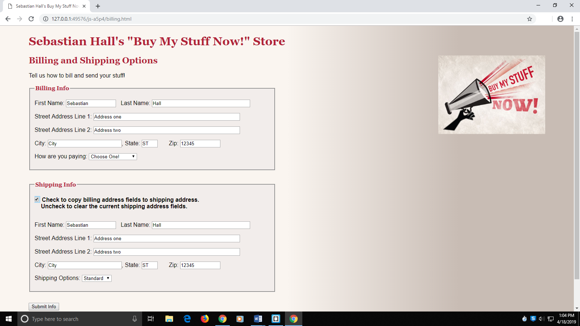

[Paste your part 2 Code below – Make sure that ALL of your code is visible between the margins of this page]

**<!DOCTYPE html>**

**<html lang="en">**

**<head>**

**<meta charset="utf-8">**

**<title>Sebastian Hall's Buy My Stuff Now!</title>**

**<link rel="stylesheet" href="site.css">**

**<link rel="stylesheet" href="form.css">**

**<script>**

**function copy() {**

**//Declare variables**

**var bAddr = document.getElementsByClassName("billingAddress");**

**var sAddr = document.getElementsByClassName("shippingAddress");**

**var cBox = document.getElementById("same");**

**//Set values in shipping address area**

**if(cBox.checked)**

**for(var i = 0; i < bAddr.length; ++i)**

**sAddr[i].value = bAddr[i].value;**

**else**

**for(var i = 0; i < sAddr.length; ++i)**

**sAddr[i].value = "";**

**}**

**</script>**

**</head>**

**<body>**

**<header>**

**<h1>Sebastian Hall's "Buy My Stuff Now!" Store</h1>**

**<p><img class="floatright" src="buymystuff.jpg" width="295" height="217" alt="Buy My Stuff Now!"></p>**

**</header>**

**<h2>Billing and Shipping Options</h2>**

**<p>Tell us how to bill and send your stuff!</p>**

**<form method="get">**

**<fieldset id="billinginfo">**

**<legend>Billing Info</legend>**

**<p><label for="bfirstname">First Name: </label><input type="text" name="bfirstname" id="bfirstname" class="billingAddress"> &nbsp;**

**<label for="blastname">Last Name: </label><input type="text" name="blastname" id="blastname" class="billingAddress">**

**</p>**

**<p><label for="bstreet1">Street Address Line 1: </label><input type="text" name="bstreet1" id="bstreet1" class="billingAddress">**

**</p>**

**<p><label for="bstreet2">Street Address Line 2: </label><input type="text" name="bstreet2" id="bstreet2" class="billingAddress">**

**</p>**

**<p><label for="bcity">City: </label><input type="text" name="bcity" id="bcity" class="billingAddress">,**

**<label for="bstate">State: </label><input type="text" name="bstate" id="bstate" class="billingAddress">**

**<label for="bzip">Zip: </label><input type="text" name="bzip" id="bzip" class="billingAddress">**

**</p>**

**<p><label for="paytype">How are you paying:</label>**

**<select name="paytype" id="paytype">**

**<option value="">Choose One!</option>**

**<option value="visa">Visa</option>**

**<option value="master">MasterCard</option>**

**<option value="american">American Express</option>**

**<option value="paypal">Pay Pal</option>**

**</select>**

**</p>**

**</fieldset>**

**<fieldset id="shippinginfo">**

**<legend>Shipping Info</legend>**

**<p id="samep"><input type="checkbox" id="same" name="same" onclick="copy();">**

**Check to copy billing address fields to shipping address.<br> &nbsp; &nbsp;**

**Uncheck to clear the current shipping address fields.**

**</p>**

**<p><label for="sfirstname">First Name: </label><input type="text" name="sfirstname" id="sfirstname" class="shippingAddress"> &nbsp;**

**<label for="slastname">Last Name: </label><input type="text" name="slastname" id="slastname" class="shippingAddress">**

**</p>**

**<p><label for="sstreet1">Street Address Line 1: </label><input type="text" name="sstreet1" id="sstreet1" class="shippingAddress">**

**</p>**

**<p><label for="sstreet2">Street Address Line 2: </label><input type="text" name="sstreet2" id="sstreet2" class="shippingAddress">**

**</p>**

**<p><label for="scity">City: </label><input type="text" name="scity" id="scity" class="shippingAddress">,**

**<label for="sstate">State: </label><input type="text" name="sstate" id="sstate" class="shippingAddress">**

**<label for="szip">Zip: </label><input type="text" name="szip" id="szip" class="shippingAddress">**

**</p>**

**<p><label for="shiptype">Shipping Options:</label>**

**<select name="shiptype" id="shiptype">**

**<option value="overnight">Overnight</option>**

**<option value="nextday">Next Day</option>**

**<option value="2-day">2-day</option>**

**<option value="standard" selected>Standard</option>**

**</select>**

**</p>**

**</fieldset>**

**<p><input type="submit" value="Submit Info"></p>**

**</form>**

**<footer>**

**<p>Copyright Sebastian Hall, all rights reserved.</p>**

**</footer>**

**</body>**

**</html>**