JavaScript Assignment #6

**Part 1: Listen to the Radio (Buttons) and Get a Date!  
Shipping Options for your Store & a Date for your receipt** – use A5P3 as a start point

[Paste your part 1 **Screenshot**(s) below. Make sure all of your page displays. Use 2 screenshots as needed.]

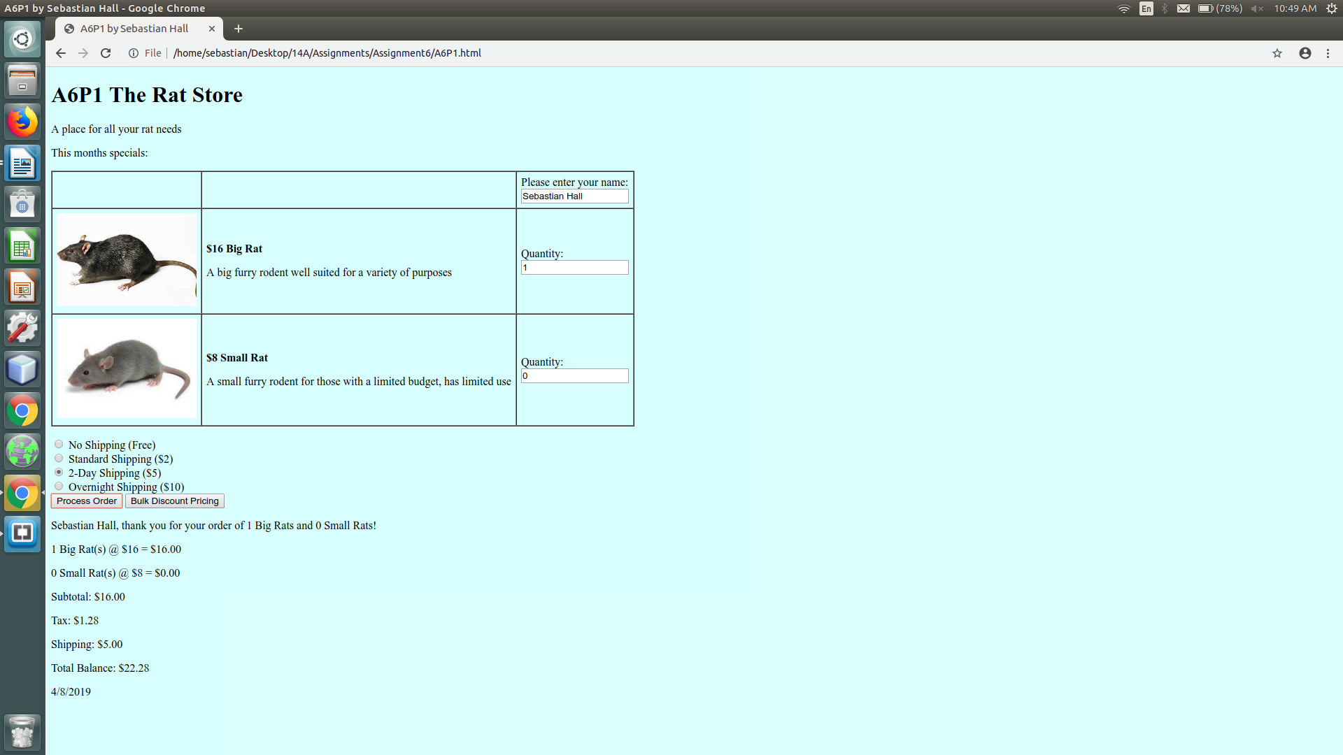

[Paste your part 1 **Code** below – Make sure that ALL of your code is visible between the margins of this page]

**<!DOCTYPE html>**

**<html lang="en">**

**<head>**

**<meta charset="utf-8">**

**<title>A6P1 by Sebastian Hall</title>**

**<style>**

**body {**

**background-color:lightcyan;**

**}**

**p.prodName {**

**font-weight: bold;**

**}**

**img.prodImg {**

**width: 200px;**

**}**

**div#prodSum {**

**float: left;**

**text-align: right;**

**}**

**#discTable {**

**text-align: right;**

**border: 1px solid black;**

**border-collapse: collapse;**

**}**

**#discTable tr:nth-child(odd) {**

**background-color: lightgrey;**

**}**

**#discTable tr:nth-child(even) {**

**background-color: lightslategrey;**

**}**

**#discTable td, th {**

**border: 2px solid black;**

**}**

**caption {**

**font-weight: bold;**

**}**

**</style>**

**<script>**

**const PRICE_BR = 16;//Price of Big Rat**

**const PRICE_SR = 8;//Price of Small Rat**

**const TAXRATE = 0.08;//Taxrate of 8**

**var discounts = [0.95, 0.93, 0.9, 0.88, 0.85, 0.8];**

**var quantities = [10, 50, 100, 200, 500, 1000];**

**function processOrder() {**

**//Declare variables**

**var fName = document.getElementById("txtName").value;**

**var q1 = document.getElementById("txtQ1").value;**

**var q2 = document.getElementById("txtQ2").value;**

**var disc = getDiscount(q1);**

**var sub1 = q1 * PRICE_BR * disc;**

**var sub2 = q2 * PRICE_SR;**

**var subtotal = sub1 + sub2;**

**var tax = subtotal * TAXRATE;**

**var shipCost = parseInt(getShipCost());**

**var total = subtotal + tax + shipCost;**

**var d = new Date();**

**var date = d.getMonth() + "/" + d.getDate() + "/" + d.getFullYear();**

**var output = "";**

**if(validate()) {**

**//Build output**

**output = "<p>" + fName + ", thank you for your order of " +**

**q1 + " Big Rats and " + q2 + " Small Rats!</p>";**

**output += "<p>" + q1 + " Big Rat(s) @ $" + PRICE_BR + " = $";**

**if(q1>=10) {**

**output += sub1.toFixed(2) + "**Discount Applied " + (100*(1-disc)).toFixed(0) + "%</p>";**

**} else {**

**output += sub1.toFixed(2) + "</p>";**

**}**

**output += "<p>" + q2 + " Small Rat(s) @ $" + PRICE_SR + " = $" +**

**sub2.toFixed(2) + "</p>";**

**output += "<p>Subtotal: $" + subtotal.toFixed(2) + "</p>";**

**output += "<p>Tax: $" + tax.toFixed(2) + "</p>";**

**output += "<p>Shipping: $" + shipCost.toFixed(2) + "</p>";**

**output += "<p>Total Balance: $" + total.toFixed(2) + "</p>";**

**output += "<p>" + date + "</p>";**

**document.getElementById("receipt").style.color = "black";**

**document.getElementById("receipt").style.fontWeight = "normal";**

**} else {**

**output = "<p>Order could not be processed, Fill in required fields</p>";**

**document.getElementById("receipt").style.color = "red";**

**document.getElementById("receipt").style.fontWeight = "bold";**

**}**

**document.getElementById("receipt").innerHTML = output;**

**}**

**function validate() {**

**var arr = document.getElementsByClassName("req");**

**var isValid = true;**

**for(var i = 0; i < arr.length; ++i)**

**if(isNaN(arr[i].value) || arr[i].value == "") {**

**isValid = false;**

**arr[i].value = "REQUIRED";**

**arr[i].select();**

**}**

**return isValid;**

**}**

**function getDiscount(q) {**

**var disc = 1.0;**

**for(var i = 0; i < discounts.length; ++i)**

**if(q >= quantities[i])**

**disc = discounts[i];**

**return disc;**

**}**

**function displayDiscounts() {**

**var output = "<table id='discTable'><caption>Quantity Discount Pricing On Big Rats</caption><tbody><tr><th>Quantity</th><th>Normal Pricing</th><th>Discount Pricing</th></tr>";**

**for(var i = 0; i < quantities.length; ++i) {**

**var price = quantities[i] * PRICE_BR;**

**output += "<tr><td>" + quantities[i] + "</td>";**

**output += "<td>" + price.toFixed(2) + "</td>";**

**output += "<td>" + (price * discounts[i]).toFixed(2) + "</td></tr>";**

**}**

**output += "</tbody></table>";**

**document.getElementById("discountPricing").innerHTML = output;**

**}**

**function getShipCost() {**

**var arr = document.getElementsByClassName("shipOpt");**

**for(var i = 0; i < arr.length; ++i)**

**if(arr[i].checked)**

**return arr[i].value;**

**}**

**</script>**

**</head>**

**<body>**

**<h1>A6P1 The Rat Store</h1>**

**<p>A place for all your rat needs</p>**

**<p>This months specials:</p>**

**<form>**

**<table border="1" cellspacing="0" cellpadding="6" summary="Table of product images, prices & descriptions">**

**<tbody>**

**<tr>**

**<td>&nbsp;</td>**

**<td>&nbsp;</td>**

**<td>Please enter your name:<br><input type="text" id="txtName" name="txtName">**

**</td>**

**</tr>**

**<tr>**

**<td><img class="prodImg" src="bigRat.jpg" alt="Big Rat" /></td>**

**<td>**

**<p class="prodName">$<script>document.write(PRICE_BR)</script> Big Rat </p>**

**<p>A big furry rodent well suited for a variety of purposes</p>**

**</td>**

**<td>Quantity:<br><input class="req" type="text" id="txtQ1" name="txtQ1" value="0" required /></td>**

**</tr>**

**<tr>**

**<td><img class="prodImg" src="smallRat.jpg" alt="Small Rat" /></td>**

**<td>**

**<p class="prodName">$<script>document.write(PRICE_SR)</script> Small Rat</p>**

**<p>A small furry rodent for those with a limited budget, has limited use</p>**

**</td>**

**<td>Quantity:<br><input class="req" type="text" id="txtQ2" name="txtQ2" value="0" required /></td>**

**</tr>**

**</tbody>**

**</table>**

**<p>**

**<input class="shipOpt" id="noship" type="radio" name="shipping" value="0" checked="checked"/>**

**<label for="noship">No Shipping (Free)</label><br/>**

**<input class="shipOpt" id="stdship" type="radio" name="shipping" value="2" />**

**<label for="stdship">Standard Shipping ($2)</label><br/>**

**<input class="shipOpt" id="2dayship" type="radio" name="shipping" value="5" />**

**<label for="2dayship">2-Day Shipping ($5)</label><br/>**

**<input class="shipOpt" id="nightship" type="radio" name="shipping" value="10" />**

**<label for="nightship">Overnight Shipping ($10)</label><br/>**

**<input id="btnProcess" type="button" value="Process Order" />**

**<input id="pricingBtn" type="button" value="Bulk Discount Pricing" />**

**</p>**

**</form>**

**<div id="receipt">&nbsp;</div>**

**<div id="discountPricing">&nbsp;</div>**

**<script>**

**document.getElementById("btnProcess").addEventListener("click", processOrder);**

**document.getElementById("pricingBtn").addEventListener("click", displayDiscounts);**

**</script>**

**</body>**

**</html>**

**Part 2: How are you ever going to pay for this?  
(Adding Payment Methods in a Select List, using A6P1 as a starting point)**

[Paste your part 2 **Screenshot**(s) below. Make sure all of your page displays. Use 2 screenshots as needed.]

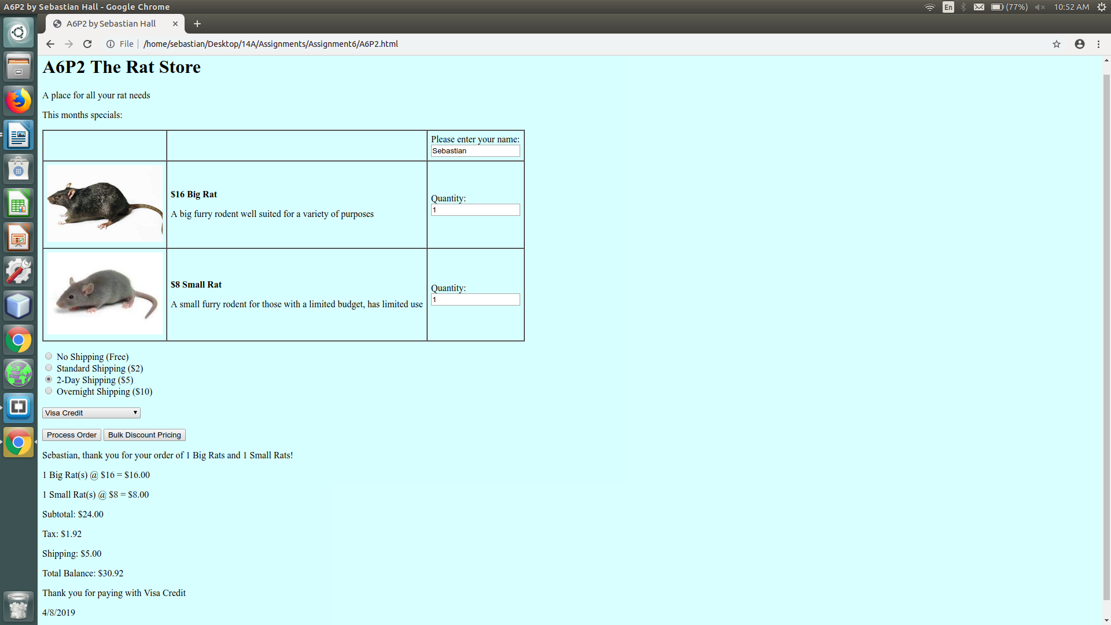

[Paste your part 2 **Code** below – Make sure that ALL of your code is visible between the margins of this page]

**<!DOCTYPE html>**

**<html lang="en">**

**<head>**

**<meta charset="utf-8">**

**<title>A6P2 by Sebastian Hall</title>**

**<style>**

**body {**

**background-color:lightcyan;**

**}**

**p.prodName {**

**font-weight: bold;**

**}**

**img.prodImg {**

**width: 200px;**

**}**

**div#prodSum {**

**float: left;**

**text-align: right;**

**}**

**#discTable {**

**text-align: right;**

**border: 1px solid black;**

**border-collapse: collapse;**

**}**

**#discTable tr:nth-child(odd) {**

**background-color: lightgrey;**

**}**

**#discTable tr:nth-child(even) {**

**background-color: lightslategrey;**

**}**

**#discTable td, th {**

**border: 2px solid black;**

**}**

**caption {**

**font-weight: bold;**

**}**

**</style>**

**<script>**

**const PRICE_BR = 16;//Price of Big Rat**

**const PRICE_SR = 8;//Price of Small Rat**

**const TAXRATE = 0.08;//Taxrate of 8**

**var discounts = [0.95, 0.93, 0.9, 0.88, 0.85, 0.8];**

**var quantities = [10, 50, 100, 200, 500, 1000];**

**function processOrder() {**

**//Declare variables**

**var fName = document.getElementById("txtName").value;**

**var q1 = document.getElementById("txtQ1").value;**

**var q2 = document.getElementById("txtQ2").value;**

**var disc = getDiscount(q1);**

**var sub1 = q1 * PRICE_BR * disc;**

**var sub2 = q2 * PRICE_SR;**

**var subtotal = sub1 + sub2;**

**var tax = subtotal * TAXRATE;**

**var shipCost = parseInt(getShipCost());**

**var total = subtotal + tax + shipCost;**

**var d = new Date();**

**var date = d.getMonth() + "/" + d.getDate() + "/" + d.getFullYear();**

**var payOpt = document.getElementById("payOpt").value;**

**var output = "";**

**if(validate()) {**

**//Build output**

**output = "<p>" + fName + ", thank you for your order of " +**

**q1 + " Big Rats and " + q2 + " Small Rats!</p>";**

**output += "<p>" + q1 + " Big Rat(s) @ $" + PRICE_BR + " = $";**

**if(q1>=10) {**

**output += sub1.toFixed(2) + "**Discount Applied " + (100*(1-disc)).toFixed(0) + "%</p>";**

**} else {**

**output += sub1.toFixed(2) + "</p>";**

**}**

**output += "<p>" + q2 + " Small Rat(s) @ $" + PRICE_SR + " = $" +**

**sub2.toFixed(2) + "</p>";**

**output += "<p>Subtotal: $" + subtotal.toFixed(2) + "</p>";**

**output += "<p>Tax: $" + tax.toFixed(2) + "</p>";**

**output += "<p>Shipping: $" + shipCost.toFixed(2) + "</p>";**

**output += "<p>Total Balance: $" + total.toFixed(2) + "</p>";**

**output += "<p>Thank you for paying with " + payOpt + "</p>";**

**output += "<p>" + date + "</p>";**

**document.getElementById("receipt").style.color = "black";**

**document.getElementById("receipt").style.fontWeight = "normal";**

**} else {**

**output = "<p>Order could not be processed, Fill in required fields</p>";**

**document.getElementById("receipt").style.color = "red";**

**document.getElementById("receipt").style.fontWeight = "bold";**

**}**

**document.getElementById("receipt").innerHTML = output;**

**}**

**function validate() {**

**var arr = document.getElementsByClassName("req");**

**var isValid = true;**

**for(var i = 0; i < arr.length; ++i)**

**if(isNaN(arr[i].value) || arr[i].value == "") {**

**isValid = false;**

**arr[i].value = "REQUIRED";**

**arr[i].select();**

**}**

**return isValid;**

**}**

**function getDiscount(q) {**

**var disc = 1.0;**

**for(var i = 0; i < discounts.length; ++i)**

**if(q >= quantities[i])**

**disc = discounts[i];**

**return disc;**

**}**

**function displayDiscounts() {**

**var output = "<table id='discTable'><caption>Quantity Discount Pricing On Big Rats</caption><tbody><tr><th>Quantity</th><th>Normal Pricing</th><th>Discount Pricing</th></tr>";**

**for(var i = 0; i < quantities.length; ++i) {**

**var price = quantities[i] * PRICE_BR;**

**output += "<tr><td>" + quantities[i] + "</td>";**

**output += "<td>" + price.toFixed(2) + "</td>";**

**output += "<td>" + (price * discounts[i]).toFixed(2) + "</td></tr>";**

**}**

**output += "</tbody></table>";**

**document.getElementById("discountPricing").innerHTML = output;**

**}**

**function getShipCost() {**

**var arr = document.getElementsByClassName("shipOpt");**

**for(var i = 0; i < arr.length; ++i)**

**if(arr[i].checked)**

**return arr[i].value;**

**}**

**</script>**

**</head>**

**<body>**

**<h1>A6P2 The Rat Store</h1>**

**<p>A place for all your rat needs</p>**

**<p>This months specials:</p>**

**<form>**

**<table border="1" cellspacing="0" cellpadding="6" summary="Table of product images, prices & descriptions">**

**<tbody>**

**<tr>**

**<td>&nbsp;</td>**

**<td>&nbsp;</td>**

**<td>Please enter your name:<br><input type="text" id="txtName" name="txtName">**

**</td>**

**</tr>**

**<tr>**

**<td><img class="prodImg" src="bigRat.jpg" alt="Big Rat" /></td>**

**<td>**

**<p class="prodName">$<script>document.write(PRICE_BR)</script> Big Rat </p>**

**<p>A big furry rodent well suited for a variety of purposes</p>**

**</td>**

**<td>Quantity:<br><input class="req" type="text" id="txtQ1" name="txtQ1" value="0" required /></td>**

**</tr>**

**<tr>**

**<td><img class="prodImg" src="smallRat.jpg" alt="Small Rat" /></td>**

**<td>**

**<p class="prodName">$<script>document.write(PRICE_SR)</script> Small Rat</p>**

**<p>A small furry rodent for those with a limited budget, has limited use</p>**

**</td>**

**<td>Quantity:<br><input class="req" type="text" id="txtQ2" name="txtQ2" value="0" required /></td>**

**</tr>**

**</tbody>**

**</table>**

**<p>**

**<input class="shipOpt" id="noship" type="radio" name="shipping" value="0" checked="checked"/>**

**<label for="noship">No Shipping (Free)</label><br/>**

**<input class="shipOpt" id="stdship" type="radio" name="shipping" value="2" />**

**<label for="stdship">Standard Shipping ($2)</label><br/>**

**<input class="shipOpt" id="2dayship" type="radio" name="shipping" value="5" />**

**<label for="2dayship">2-Day Shipping ($5)</label><br/>**

**<input class="shipOpt" id="nightship" type="radio" name="shipping" value="10" />**

**<label for="nightship">Overnight Shipping ($10)</label><br/><br/>**

**<select id="payOpt">**

**<option value="Visa Credit">Visa Credit</option>**

**<option value="MasterCard Credit">MasterCard Credit</option>**

**<option value="American Express Credit">American Express Credit</option>**

**<option value="Debit Credit">Debit Credit</option>**

**<option value="Pay Pal">Pay Pal</option>**

**</select>**

**<br/><br/>**

**<input id="btnProcess" type="button" value="Process Order" />**

**<input id="pricingBtn" type="button" value="Bulk Discount Pricing" />**

**</p>**

**</form>**

**<div id="receipt">&nbsp;</div>**

**<div id="discountPricing">&nbsp;</div>**

**<script>**

**document.getElementById("btnProcess").addEventListener("click", processOrder);**

**document.getElementById("pricingBtn").addEventListener("click", displayDiscounts);**

**</script>**

**</body>**

**</html>**

**Part 3: Silly Strings!  
(Using String Methods and Properties to Process text box input)**

[Paste your part 3 **Screenshot**(s) below. **Form should show result of bad account number input**.  
Make sure all of your page displays. Use 2 screenshots as needed.]

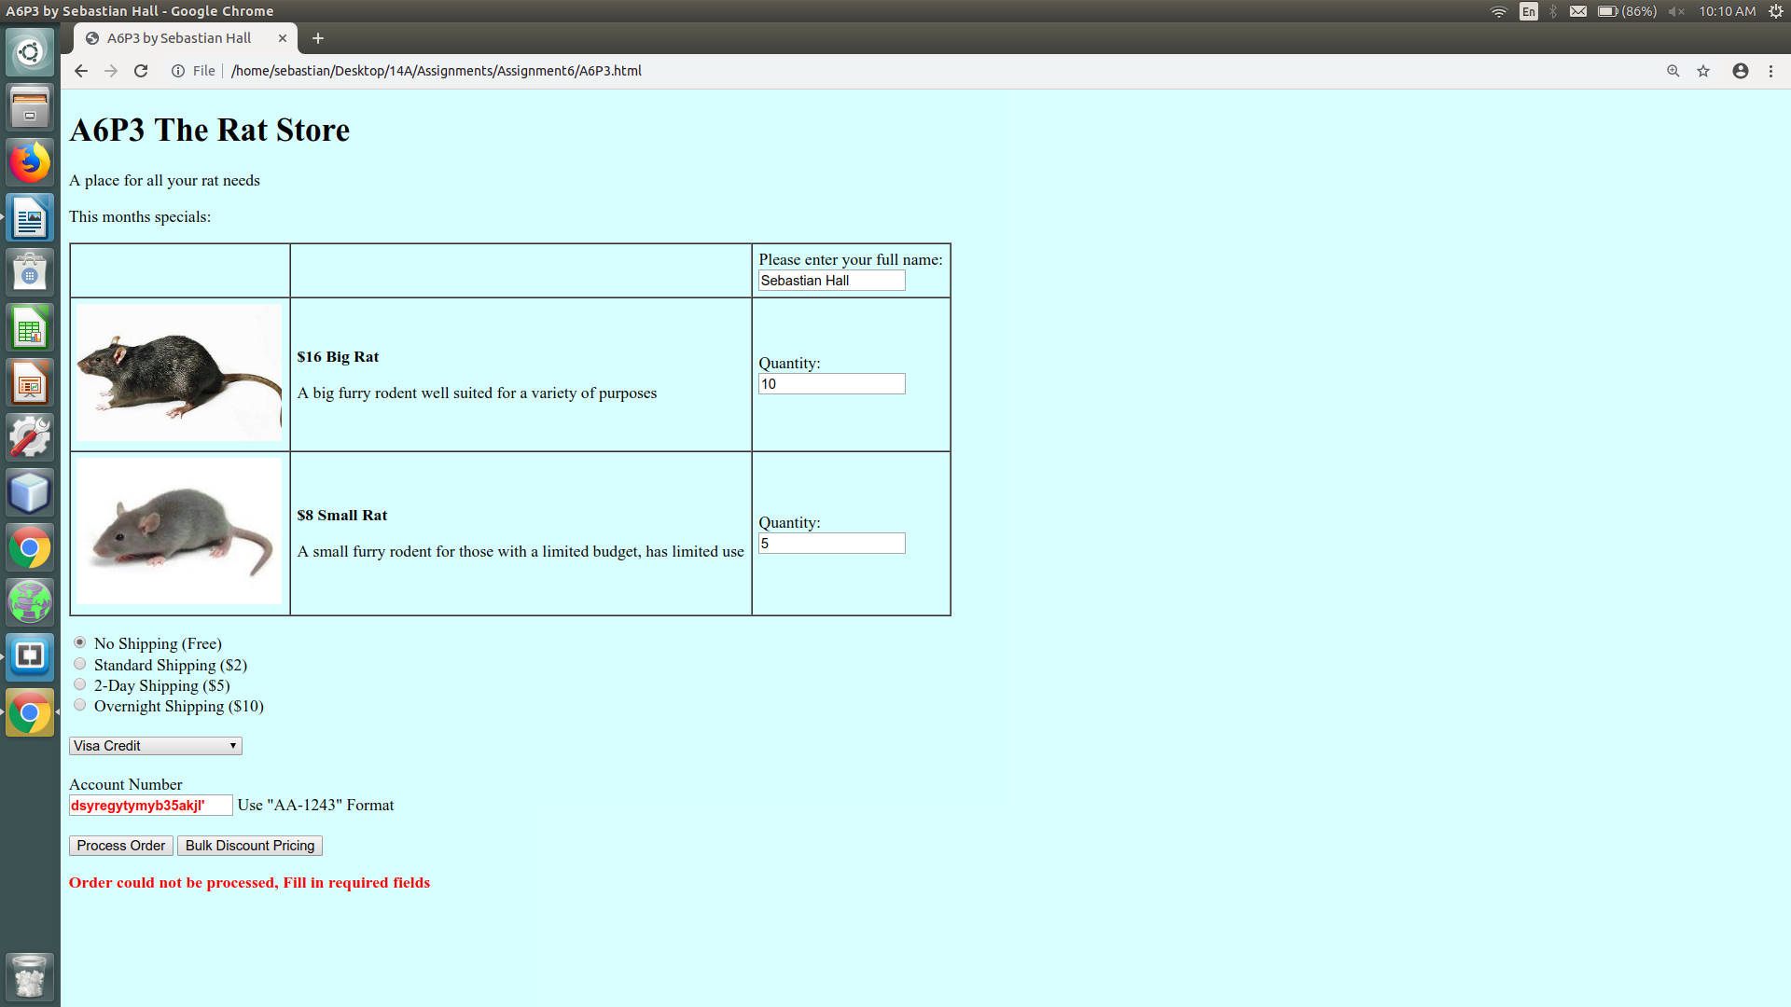

[Paste your part 3 **Code** below – Make sure that ALL of your code is visible between the margins of this page]

**<!DOCTYPE html>**

**<html lang="en">**

**<head>**

**<meta charset="utf-8">**

**<title>A6P3 by Sebastian Hall</title>**

**<style>**

**body {**

**background-color:lightcyan;**

**}**

**p.prodName {**

**font-weight: bold;**

**}**

**img.prodImg {**

**width: 200px;**

**}**

**div#prodSum {**

**float: left;**

**text-align: right;**

**}**

**#discTable {**

**text-align: right;**

**border: 1px solid black;**

**border-collapse: collapse;**

**}**

**#discTable tr:nth-child(odd) {**

**background-color: lightgrey;**

**}**

**#discTable tr:nth-child(even) {**

**background-color: lightslategrey;**

**}**

**#discTable td, th {**

**border: 2px solid black;**

**}**

**caption {**

**font-weight: bold;**

**}**

**</style>**

**<script>**

**const PRICE_BR = 16;//Price of Big Rat**

**const PRICE_SR = 8;//Price of Small Rat**

**const TAXRATE = 0.08;//Taxrate of 8**

**var discounts = [0.95, 0.93, 0.9, 0.88, 0.85, 0.8];**

**var quantities = [10, 50, 100, 200, 500, 1000];**

**function processOrder() {**

**//Declare variables**

**var name = document.getElementById("txtName").value;**

**name.trim();**

**name = name.split(" ");**

**var fName = name[0];**

**var q1 = document.getElementById("txtQ1").value;**

**var q2 = document.getElementById("txtQ2").value;**

**var disc = getDiscount(q1);**

**var sub1 = q1 * PRICE_BR * disc;**

**var sub2 = q2 * PRICE_SR;**

**var subtotal = sub1 + sub2;**

**var tax = subtotal * TAXRATE;**

**var shipCost = parseInt(getShipCost());**

**var total = subtotal + tax + shipCost;**

**var d = new Date();**

**var date = d.getMonth() + "/" + d.getDate() + "/" + d.getFullYear();**

**var payOpt = document.getElementById("payOpt").value;**

**var output = "";**

**if(validate()) {**

**//Build output**

**output = "<p>" + fName + ", thank you for your order of " +**

**q1 + " Big Rats and " + q2 + " Small Rats!</p>";**

**output += "<p>" + q1 + " Big Rat(s) @ $" + PRICE_BR + " = $";**

**if(q1>=10) {**

**output += sub1.toFixed(2) + "**Discount Applied " + (100*(1-disc)).toFixed(0) + "%</p>";**

**} else {**

**output += sub1.toFixed(2) + "</p>";**

**}**

**output += "<p>" + q2 + " Small Rat(s) @ $" + PRICE_SR + " = $" +**

**sub2.toFixed(2) + "</p>";**

**output += "<p>Subtotal: $" + subtotal.toFixed(2) + "</p>";**

**output += "<p>Tax: $" + tax.toFixed(2) + "</p>";**

**output += "<p>Shipping: $" + shipCost.toFixed(2) + "</p>";**

**output += "<p>Total Balance: $" + total.toFixed(2) + "</p>";**

**output += "<p>Thank you for paying with " + payOpt + "</p>";**

**output += "<p>" + date + "</p>";**

**document.getElementById("receipt").style.color = "black";**

**document.getElementById("receipt").style.fontWeight = "normal";**

**} else {**

**output = "<p>Order could not be processed, Fill in required fields</p>";**

**document.getElementById("receipt").style.color = "red";**

**document.getElementById("receipt").style.fontWeight = "bold";**

**}**

**document.getElementById("receipt").innerHTML = output;**

**}**

**function validate() {**

**var arr = document.getElementsByClassName("req");**

**var isValid = true;**

**var accNum = document.getElementById("accNum").value;**

**accNum = accNum.toUpperCase();**

**var badAcc = false;**

**//Validate all required fields**

**for(var i = 0; i < arr.length; ++i)**

**if(isNaN(arr[i].value) || arr[i].value == "") {**

**isValid = false;**

**arr[i].value = "REQUIRED";**

**arr[i].select();**

**}**

**//Validate account number**

**if(accNum.length != 7) {**

**badAcc = true;**

**}**

**for(var i = 0; i < 2; ++i){**

**if(accNum[i] < 'A' || accNum[i] > 'Z'){**

**badAcc = true;**

**}**

**}**

**if(accNum[2] != '-') {**

**badAcc = true;**

**}**

**for(var i = 3; i < accNum.length; ++i) {**

**if(accNum[i] < '0' || accNum[i] > '9') {**

**badAcc = true;**

**}**

**}**

**if(badAcc) {**

**var elem = document.getElementById("accNum");**

**elem.style.color = "red";**

**elem.style.fontWeight = "bold";**

**elem.focus();**

**elem.select();**

**document.getElementById("accErr").innerHTML = 'Use "AA-1243" Format';**

**isValid = false;**

**} else {**

**var elem = document.getElementById("accNum");**

**elem.style.color = "black";**

**elem.style.fontWeight = "normal";**

**document.getElementById("accErr").innerHTML = "";**

**}**

**return isValid;**

**}**

**function getDiscount(q) {**

**var disc = 1.0;**

**for(var i = 0; i < discounts.length; ++i)**

**if(q >= quantities[i])**

**disc = discounts[i];**

**return disc;**

**}**

**function displayDiscounts() {**

**var output = "<table id='discTable'><caption>Quantity Discount Pricing On Big Rats</caption><tbody><tr><th>Quantity</th><th>Normal Pricing</th><th>Discount Pricing</th></tr>";**

**for(var i = 0; i < quantities.length; ++i) {**

**var price = quantities[i] * PRICE_BR;**

**output += "<tr><td>" + quantities[i] + "</td>";**

**output += "<td>" + price.toFixed(2) + "</td>";**

**output += "<td>" + (price * discounts[i]).toFixed(2) + "</td></tr>";**

**}**

**output += "</tbody></table>";**

**document.getElementById("discountPricing").innerHTML = output;**

**}**

**function getShipCost() {**

**var arr = document.getElementsByClassName("shipOpt");**

**for(var i = 0; i < arr.length; ++i)**

**if(arr[i].checked)**

**return arr[i].value;**

**}**

**</script>**

**</head>**

**<body>**

**<h1>A6P3 The Rat Store</h1>**

**<p>A place for all your rat needs</p>**

**<p>This months specials:</p>**

**<form>**

**<table border="1" cellspacing="0" cellpadding="6" summary="Table of product images, prices & descriptions">**

**<tbody>**

**<tr>**

**<td>&nbsp;</td>**

**<td>&nbsp;</td>**

**<td>Please enter your full name:<br><input type="text" id="txtName" name="txtName">**

**</td>**

**</tr>**

**<tr>**

**<td><img class="prodImg" src="bigRat.jpg" alt="Big Rat" /></td>**

**<td>**

**<p class="prodName">$<script>document.write(PRICE_BR)</script> Big Rat </p>**

**<p>A big furry rodent well suited for a variety of purposes</p>**

**</td>**

**<td>Quantity:<br><input class="req" type="text" id="txtQ1" name="txtQ1" value="0" required /></td>**

**</tr>**

**<tr>**

**<td><img class="prodImg" src="smallRat.jpg" alt="Small Rat" /></td>**

**<td>**

**<p class="prodName">$<script>document.write(PRICE_SR)</script> Small Rat</p>**

**<p>A small furry rodent for those with a limited budget, has limited use</p>**

**</td>**

**<td>Quantity:<br><input class="req" type="text" id="txtQ2" name="txtQ2" value="0" required /></td>**

**</tr>**

**</tbody>**

**</table>**

**<p>**

**<input class="shipOpt" id="noship" type="radio" name="shipping" value="0" checked="checked"/>**

**<label for="noship">No Shipping (Free)</label><br/>**

**<input class="shipOpt" id="stdship" type="radio" name="shipping" value="2" />**

**<label for="stdship">Standard Shipping ($2)</label><br/>**

**<input class="shipOpt" id="2dayship" type="radio" name="shipping" value="5" />**

**<label for="2dayship">2-Day Shipping ($5)</label><br/>**

**<input class="shipOpt" id="nightship" type="radio" name="shipping" value="10" />**

**<label for="nightship">Overnight Shipping ($10)</label><br/><br/>**

**<select id="payOpt">**

**<option value="Visa Credit">Visa Credit</option>**

**<option value="MasterCard Credit">MasterCard Credit</option>**

**<option value="American Express Credit">American Express Credit</option>**

**<option value="Debit Credit">Debit Credit</option>**

**<option value="Pay Pal">Pay Pal</option>**

**</select>**

**<br/><br/>**

**<label for="accNum">Account Number</label><br/>**

**<input type="text" id="accNum" placeholder="AA-1234"/>**

**<span id="accErr"></span>**

**<br/><br/>**

**<input id="btnProcess" type="button" value="Process Order" />**

**<input id="pricingBtn" type="button" value="Bulk Discount Pricing" />**

**</p>**

**</form>**

**<div id="receipt">&nbsp;</div>**

**<div id="discountPricing">&nbsp;</div>**

**<script>**

**document.getElementById("btnProcess").addEventListener("click", processOrder);**

**document.getElementById("pricingBtn").addEventListener("click", displayDiscounts);**

**</script>**

**</body>**

**</html>**

**Part 4: Regular Expressions (OMG!) and Rounding Up for Charity!   
(Using Regular Expressions to test String Patterns & intro to the Math Object)**

[Paste your part 4 **Screenshot**(s) below**. Form should show result of bad phone number input**.   
 Make sure all of your page displays. Use 2 screenshots as needed.]

Does not have phone number or rounding, only regex for name and account number



[Paste your part 4 **Code** below – Make sure that ALL of your code is visible between the margins of this page]

Does not have phone number or rounding, only regex for name and account number

**<!DOCTYPE html>**

**<html lang="en">**

**<head>**

**<meta charset="utf-8">**

**<title>A6P4 by Sebastian Hall</title>**

**<style>**

**body {**

**background-color:lightcyan;**

**}**

**p.prodName {**

**font-weight: bold;**

**}**

**img.prodImg {**

**width: 200px;**

**}**

**div#prodSum {**

**float: left;**

**text-align: right;**

**}**

**#discTable {**

**text-align: right;**

**border: 1px solid black;**

**border-collapse: collapse;**

**}**

**#discTable tr:nth-child(odd) {**

**background-color: lightgrey;**

**}**

**#discTable tr:nth-child(even) {**

**background-color: lightslategrey;**

**}**

**#discTable td, th {**

**border: 2px solid black;**

**}**

**caption {**

**font-weight: bold;**

**}**

**</style>**

**<script>**

**const PRICE_BR = 16;//Price of Big Rat**

**const PRICE_SR = 8;//Price of Small Rat**

**const TAXRATE = 0.08;//Taxrate of 8**

**var discounts = [0.95, 0.93, 0.9, 0.88, 0.85, 0.8];**

**var quantities = [10, 50, 100, 200, 500, 1000];**

**function processOrder() {**

**//Declare variables**

**var name = document.getElementById("txtName").value;**

**var fName = /\w+/.exec(name);**

**var q1 = document.getElementById("txtQ1").value;**

**var q2 = document.getElementById("txtQ2").value;**

**var disc = getDiscount(q1);**

**var sub1 = q1 * PRICE_BR * disc;**

**var sub2 = q2 * PRICE_SR;**

**var subtotal = sub1 + sub2;**

**var tax = subtotal * TAXRATE;**

**var shipCost = parseInt(getShipCost());**

**var total = subtotal + tax + shipCost;**

**var d = new Date();**

**var date = d.getMonth() + "/" + d.getDate() + "/" + d.getFullYear();**

**var payOpt = document.getElementById("payOpt").value;**

**var output = "";**

**if(validate()) {**

**//Build output**

**output = "<p>" + fName + ", thank you for your order of " +**

**q1 + " Big Rats and " + q2 + " Small Rats!</p>";**

**output += "<p>" + q1 + " Big Rat(s) @ $" + PRICE_BR + " = $";**

**if(q1>=10) {**

**output += sub1.toFixed(2) + "**Discount Applied " + (100*(1-disc)).toFixed(0) + "%</p>";**

**} else {**

**output += sub1.toFixed(2) + "</p>";**

**}**

**output += "<p>" + q2 + " Small Rat(s) @ $" + PRICE_SR + " = $" +**

**sub2.toFixed(2) + "</p>";**

**output += "<p>Subtotal: $" + subtotal.toFixed(2) + "</p>";**

**output += "<p>Tax: $" + tax.toFixed(2) + "</p>";**

**output += "<p>Shipping: $" + shipCost.toFixed(2) + "</p>";**

**output += "<p>Total Balance: $" + total.toFixed(2) + "</p>";**

**output += "<p>Thank you for paying with " + payOpt + "</p>";**

**output += "<p>" + date + "</p>";**

**document.getElementById("receipt").style.color = "black";**

**document.getElementById("receipt").style.fontWeight = "normal";**

**} else {**

**output = "<p>Order could not be processed, Fill in required fields</p>";**

**document.getElementById("receipt").style.color = "red";**

**document.getElementById("receipt").style.fontWeight = "bold";**

**}**

**document.getElementById("receipt").innerHTML = output;**

**}**

**function validate() {**

**var arr = document.getElementsByClassName("req");**

**var isValid = true;**

**var accNum = document.getElementById("accNum").value;**

**accNum = accNum.toUpperCase();**

**var badAcc = false;**

**//Validate all required fields**

**for(var i = 0; i < arr.length; ++i)**

**if(isNaN(arr[i].value) || arr[i].value == "") {**

**isValid = false;**

**arr[i].value = "REQUIRED";**

**arr[i].select();**

**}**

**//Validate account number**

**var regex = /^[a-zA-Z]{2}-\d{4}$/;**

**badAcc = !accNum.match(regex);**

**if(badAcc) {**

**var elem = document.getElementById("accNum");**

**elem.style.color = "red";**

**elem.style.fontWeight = "bold";**

**elem.focus();**

**elem.select();**

**document.getElementById("accErr").innerHTML = 'Use "AA-1243" Format';**

**isValid = false;**

**} else {**

**var elem = document.getElementById("accNum");**

**elem.style.color = "black";**

**elem.style.fontWeight = "normal";**

**document.getElementById("accErr").innerHTML = "";**

**}**

**return isValid;**

**}**

**function getDiscount(q) {**

**var disc = 1.0;**

**for(var i = 0; i < discounts.length; ++i)**

**if(q >= quantities[i])**

**disc = discounts[i];**

**return disc;**

**}**

**function displayDiscounts() {**

**var output = "<table id='discTable'><caption>Quantity Discount Pricing On Big Rats</caption><tbody><tr><th>Quantity</th><th>Normal Pricing</th><th>Discount Pricing</th></tr>";**

**for(var i = 0; i < quantities.length; ++i) {**

**var price = quantities[i] * PRICE_BR;**

**output += "<tr><td>" + quantities[i] + "</td>";**

**output += "<td>" + price.toFixed(2) + "</td>";**

**output += "<td>" + (price * discounts[i]).toFixed(2) + "</td></tr>";**

**}**

**output += "</tbody></table>";**

**document.getElementById("discountPricing").innerHTML = output;**

**}**

**function getShipCost() {**

**var arr = document.getElementsByClassName("shipOpt");**

**for(var i = 0; i < arr.length; ++i)**

**if(arr[i].checked)**

**return arr[i].value;**

**}**

**</script>**

**</head>**

**<body>**

**<h1>A6P4 The Rat Store</h1>**

**<p>A place for all your rat needs</p>**

**<p>This months specials:</p>**

**<form>**

**<table border="1" cellspacing="0" cellpadding="6" summary="Table of product images, prices & descriptions">**

**<tbody>**

**<tr>**

**<td>&nbsp;</td>**

**<td>&nbsp;</td>**

**<td>Please enter your full name:<br><input type="text" id="txtName" name="txtName">**

**</td>**

**</tr>**

**<tr>**

**<td><img class="prodImg" src="bigRat.jpg" alt="Big Rat" /></td>**

**<td>**

**<p class="prodName">$<script>document.write(PRICE_BR)</script> Big Rat </p>**

**<p>A big furry rodent well suited for a variety of purposes</p>**

**</td>**

**<td>Quantity:<br><input class="req" type="text" id="txtQ1" name="txtQ1" value="0" required /></td>**

**</tr>**

**<tr>**

**<td><img class="prodImg" src="smallRat.jpg" alt="Small Rat" /></td>**

**<td>**

**<p class="prodName">$<script>document.write(PRICE_SR)</script> Small Rat</p>**

**<p>A small furry rodent for those with a limited budget, has limited use</p>**

**</td>**

**<td>Quantity:<br><input class="req" type="text" id="txtQ2" name="txtQ2" value="0" required /></td>**

**</tr>**

**</tbody>**

**</table>**

**<p>**

**<input class="shipOpt" id="noship" type="radio" name="shipping" value="0" checked="checked"/>**

**<label for="noship">No Shipping (Free)</label><br/>**

**<input class="shipOpt" id="stdship" type="radio" name="shipping" value="2" />**

**<label for="stdship">Standard Shipping ($2)</label><br/>**

**<input class="shipOpt" id="2dayship" type="radio" name="shipping" value="5" />**

**<label for="2dayship">2-Day Shipping ($5)</label><br/>**

**<input class="shipOpt" id="nightship" type="radio" name="shipping" value="10" />**

**<label for="nightship">Overnight Shipping ($10)</label><br/><br/>**

**<select id="payOpt">**

**<option value="Visa Credit">Visa Credit</option>**

**<option value="MasterCard Credit">MasterCard Credit</option>**

**<option value="American Express Credit">American Express Credit</option>**

**<option value="Debit Credit">Debit Credit</option>**

**<option value="Pay Pal">Pay Pal</option>**

**</select>**

**<br/><br/>**

**<label for="accNum">Account Number</label><br/>**

**<input type="text" id="accNum" placeholder="AA-1234"/>**

**<span id="accErr"></span>**

**<br/><br/>**

**<input id="btnProcess" type="button" value="Process Order" />**

**<input id="pricingBtn" type="button" value="Bulk Discount Pricing" />**

**</p>**

**</form>**

**<div id="receipt">&nbsp;</div>**

**<div id="discountPricing">&nbsp;</div>**

**<script>**

**document.getElementById("btnProcess").addEventListener("click", processOrder);**

**document.getElementById("pricingBtn").addEventListener("click", displayDiscounts);**

**</script>**

**</body>**

**</html>**