Sebastian Hall: HTML Spring 2019 Assignment #1

**Part 1: Your "Brackets and Live Preview" Screen shot**

[Paste your part 1 screen shot here. It should show both your Brackets window (with code showing) and your Live Preview window (with the heading showing) together in one screen shot. Resize or crop your image as needed for best grading purposes here in Word.]   
Paste your part 1 screen shot BELOW THIS LINE!]

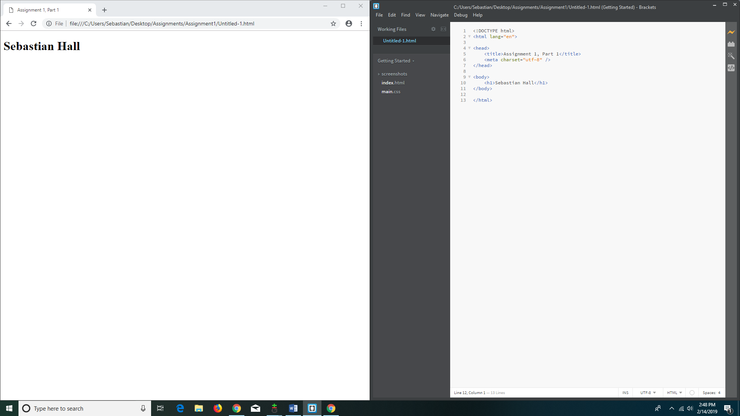

Paste your part 1 screen shot ABOVE THIS LINE!   
After pasting, then scroll down to the next page to paste your part 2 items.

**Part 2: Your "Resume" Screen shot(s)**

[Paste your part 2 screen shot(s) here. It should show your entire resume within the browser window (not in Brackets). If you need more than 1 screen shot to capture the whole resume, that is fine. If it takes multiple pages in Word to contain them, that is fine too -- do not reduce their size just to fit them all on one page only to have them be unreadable for grading purposes.]   
Paste your part 2 screen shot(s) BELOW THIS LINE!]

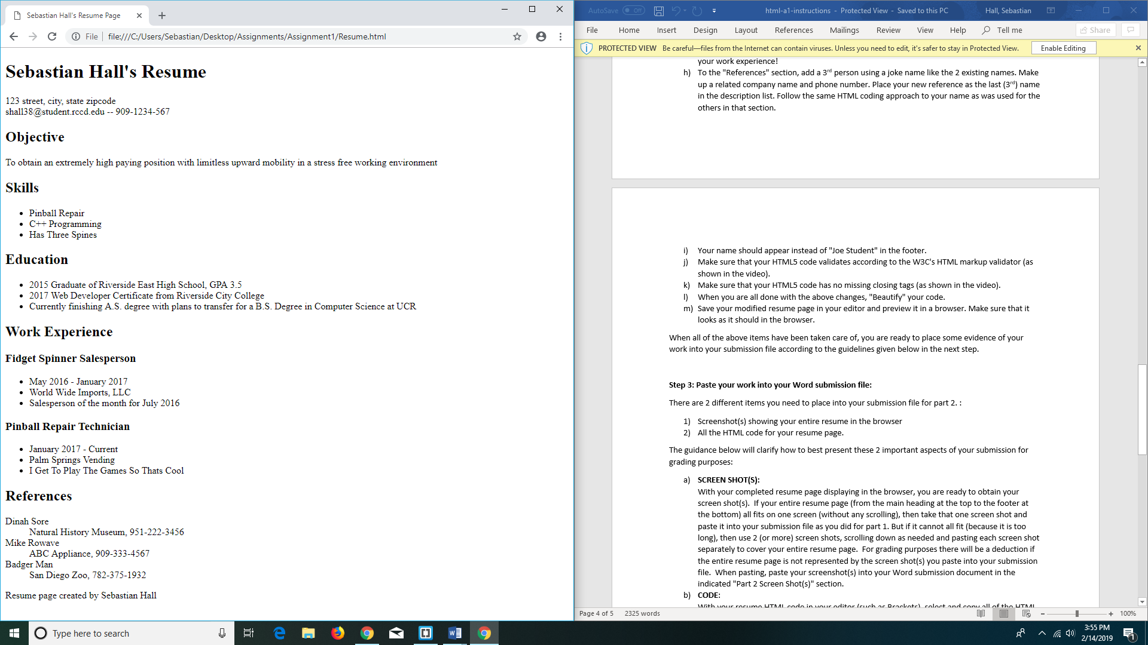

Paste your part 2 screen shot(s) ABOVE THIS LINE!   
After pasting, then scroll down to the next page to paste your part 2 code.

**Part 2: Your Resume Page Code**

[Paste your Resume Code below – Be sure to copy and paste ALL of the HTML code for the page (it is ok if it takes multiple pages here in Word. Do NOT paste screen shots of your code – paste the actual code from within Brackets (or other editor). After pasting, select the code and bold it here in Word. Then change the font to “Courier New” (or another monospace font) to make your code more readable. ]  
Paste your part 2 CODE BELOW THIS LINE!]

**<!DOCTYPE html>**

**<html lang="en">**

**<head>**

**<meta charset="utf-8" />**

**<title>Sebastian Hall's Resume Page</title>**

**</head>**

**<body>**

**<header>**

**<h1>Sebastian Hall's Resume</h1>**

**<p>123 street, city, state zipcode <br />**

**shall38@student.rccd.edu -- 909-1234-567**

**</p>**

**</header>**

**<section>**

**<h2>Objective</h2>**

**<p>To obtain an extremely high paying position with limitless upward**

**mobility in a stress free working environment**

**</p>**

**</section>**

**<section>**

**<h2>Skills</h2>**

**<ul>**

**<li>Pinball Repair</li>**

**<li>C++ Programming</li>**

**<li>Has Three Spines</li>**

**</ul>**

**</section>**

**<section>**

**<h2>Education</h2>**

**<ul>**

**<li>2015 Graduate of Riverside East High School, GPA 3.5</li>**

**<li>2017 Web Developer Certificate from Riverside City College</li>**

**<li>Currently finishing A.S. degree with plans to transfer for a**

**B.S. Degree in Computer Science at UCR</li>**

**</ul>**

**</section>**

**<section>**

**<h2>Work Experience</h2>**

**<h3>Fidget Spinner Salesperson</h3>**

**<ul>**

**<li>May 2016 - January 2017</li>**

**<li>World Wide Imports, LLC</li>**

**<li>Salesperson of the month for July 2016</li>**

**</ul>**

**<h3>Pinball Repair Technician</h3>**

**<ul>**

**<li>January 2017 - Current</li>**

**<li>Palm Springs Vending</li>**

**<li>I Get To Play The Games So Thats Cool</li>**

**</ul>**

**</section>**

**<section>**

**<h2>References</h2>**

**<dl>**

**<dt>Dinah Sore</dt>**

**<dd>Natural History Museum, 951-222-3456</dd>**

**<dt>Mike Rowave</dt>**

**<dd>ABC Appliance, 909-333-4567</dd>**

**<dt>Badger Man</dt>**

**<dd>San Diego Zoo, 782-375-1932</dd>**

**</dl>**

**</section>**

**<footer>**

**<p>Resume page created by Sebastian Hall</p>**

**</footer>**

**</body>**

**</html>**

Paste your part 2 CODE ABOVE THIS LINE!   
After pasting, save the page and exit Word. Then go to Blackboard to submit it.