Sebastian Hall HTML Spring 2019 Assignment #2

**Part 1: Answer the 7 questions** below, covering the "Links" video, by selecting the correct answer and **bolding and changing its text highlight color to yellow just like this text!** …

1. What HTML tag is used in the video to create links?

a) <nav> b) <link> **c)** <a> d) <www> e) <http>

2. In the video, the links that go to Google and Dog Pile are surrounded by what tag?

a) <ul> b) <li> c) <dd> **d)** <dt> e) <nav>

3. Links that are supposed to launch an email when clicked are created in HTML by placing what characters at the start of the link's “href” value?

a) email: b) email-to- c) mail: **d)** mailto: e) send:

4. How many actual working links are there in the “links.htm” page when shown in the video around the 7th minute?

**a)** 0 b) 1 c) 2 d) 5 e) 10

5. How many actual working links are there in the “links.htm” page at the very end of the video?

a) 0 b) 5 c) 9 d) 12 **e)** 15

6. Which one of the following links would actually work to get to the web site ebay?

a) <a href=ebay.com>ebay</a>

b) <a href=”#ebay.com”>ebay</a>

c) <a href=”www.ebay.com”>ebay</a>

**d)** <a href=”http://www.ebay.com”>ebay</a>

e) <a href=”mailto:www.ebay.com”>ebay</a>

7. How many email links (links that will initiate an email when clicked) are there within the completed “links.htm” page (at the end of the video)?

a) 0 **b)** 1 c) 2 d) 3 e) 5

**Part 2: Your Favorite Links Web Page Screenshot**

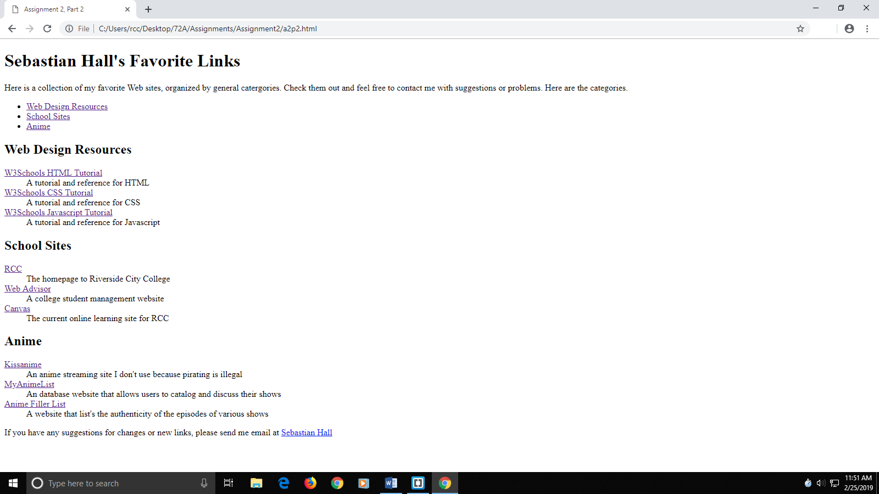

**Part 2: Your Favorite Links Web Page Code**

**<!DOCTYPE html>**

**<html lang="en">**

**<head>**

**<meta charset="utf-8">**

**<title>Assignment 2, Part 2</title>**

**</head>**

**<body>**

**<header>**

**<h1>Sebastian Hall's Favorite Links</h1>**

**<p>**

**Here is a collection of my favorite Web sites, organized by**

**general catergories. Check them out and feel free to contact**

**me with suggestions or problems. Here are the categories.**

**</p>**

**</header>**

**<section>**

**<ul>**

**<li><a href="#webDesign">Web Design Resources</a></li>**

**<li><a href="#schoolSites">School Sites</a></li>**

**<li><a href="#anime">Anime</a></li>**

**</ul>**

**<h2 id="webDesign">Web Design Resources</h2>**

**<dl>**

**<dt><a href="https://www.w3schools.com/html/default.asp">W3Schools HTML Tutorial</a></dt>**

**<dd>A tutorial and reference for HTML</dd>**

**<dt><a href="https://www.w3schools.com/css/default.asp">W3Schools CSS Tutorial</a></dt>**

**<dd>A tutorial and reference for CSS</dd>**

**<dt><a href="https://www.w3schools.com/js/default.asp">W3Schools Javascript Tutorial</a></dt>**

**<dd>A tutorial and reference for Javascript</dd>**

**</dl>**

**<h2 id="schoolSites">School Sites</h2>**

**<dl>**

**<dt><a href="https://www.rcc.edu">RCC</a></dt>**

**<dd>The homepage to Riverside City College</dd>**

**<dt><a href="https://wa.rccd.edu/RCCD/RCCD">Web Advisor</a></dt>**

**<dd>A college student management website</dd>**

**<dt><a href="https://rccd.instructure.com">Canvas</a></dt>**

**<dd>The current online learning site for RCC</dd>**

**</dl>**

**<h2 id="anime">Anime</h2>**

**<dl>**

**<dt><a href="https://www.kissanime.ru">Kissanime</a></dt>**

**<dd>An anime streaming site I don't use because pirating is illegal**

**</dd>**

**<dt><a href="https://myanimelist.net">MyAnimeList</a></dt>**

**<dd>An database website that allows users to catalog and discuss their shows</dd>**

**<dt><a href="https://www.animefillerlist.com">Anime Filler List</a></dt>**

**<dd>A website that list's the authenticity of the episodes of various shows</dd>**

**</dl>**

**</section>**

**<footer>**

**<p>**

**If you have any suggestions for changes or new links, please send**

**me email at <a href="mailto:shall38@student.rccd.edu">Sebastian Hall</a>**

**</p>**

**</footer>**

**</body>**

**</html>**

**Part 3: Your Rock Climbing Web Page Screenshot**

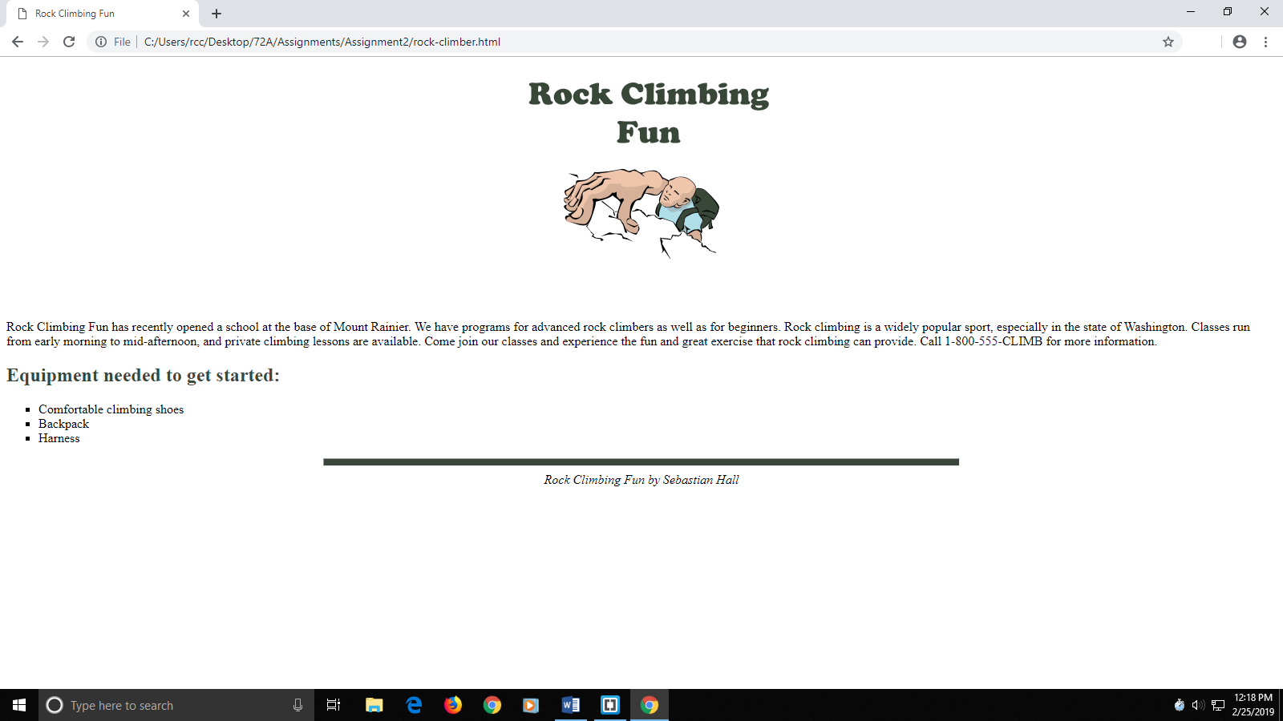

**Part 3: Your Rock Climbing Web Page Code**

**<!DOCTYPE html>**

**<html lang="en">**

**<head>**

**<meta charset="utf-8" />**

**<title>Rock Climbing Fun</title>**

**</head>**

**<body>**

**<header style="text-align:center">**

**<img src="rockclimber.jpg" width="450" height="300" alt="Rock climber" />**

**</header>**

**<section>**

**<article>**

**<p>Rock Climbing Fun has recently opened a school at the base of Mount Rainier. We have programs for advanced rock climbers as well as for beginners. Rock climbing is a widely popular sport, especially in the state of Washington. Classes run from early morning to mid-afternoon, and private climbing lessons are available. Come join our classes and experience the fun and great exercise that rock climbing can provide. Call 1-800-555-CLIMB for more information.</p>**

**<h2 style="color:#384738">Equipment needed to get started:</h2>**

**<ul style="list-style-type:square;">**

**<li>Comfortable climbing shoes</li>**

**<li>Backpack</li>**

**<li>Harness</li>**

**</ul>**

**</article>**

**</section>**

**<hr style="height:8px; background-color:#384738; width:50%;" />**

**<footer style="text-align:center; font-style:italic;">**

**Rock Climbing Fun by Sebastian Hall**

**</footer>**

**</body>**

**</html>**