Your Name Goes Here!!! **HTML Spring 2019 Assignment #3**

**Part 1 Screenshot: Your Coffee House “About Us” Page Screenshot**

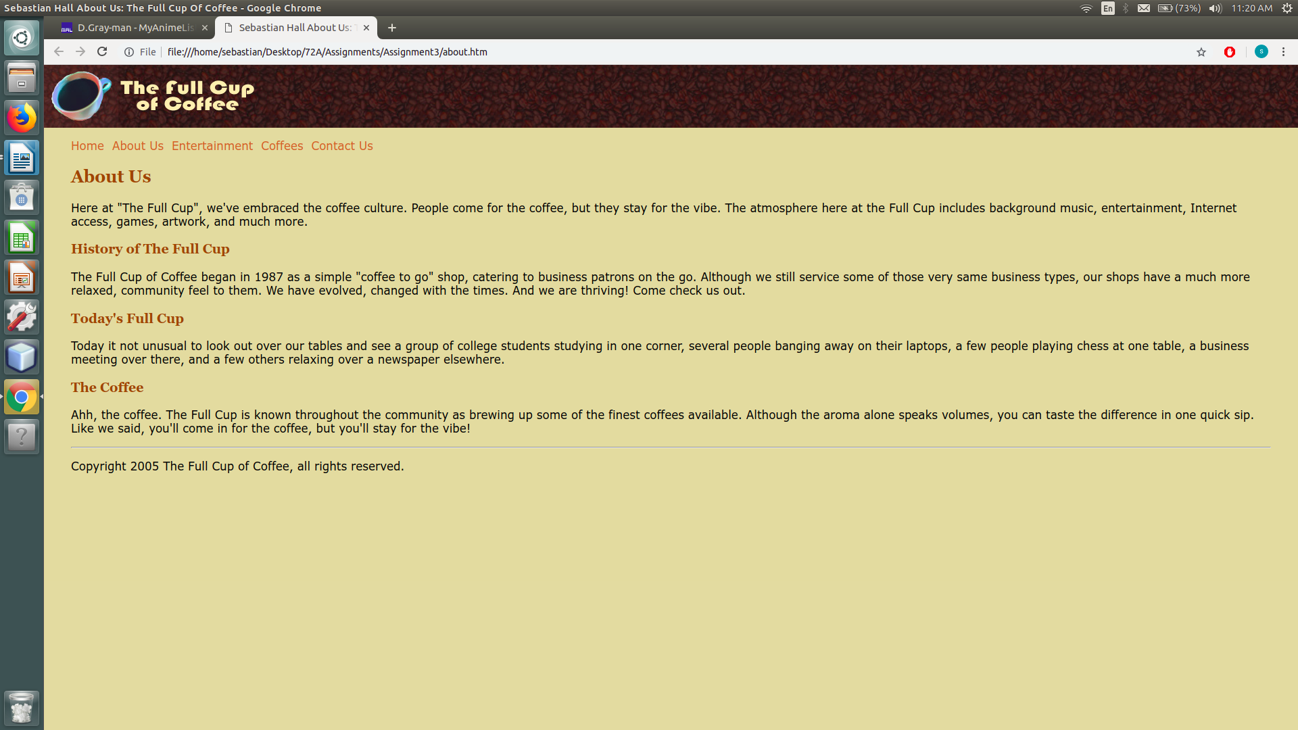

**Part 1 CSS Code: Your “main.css” CSS Code**

**/* Full Cup of Coffee main styles**

**Author: Sebastian Hall**

**Description:**

**\*/**

**body {**

**margin: 0 40px;**

**font: 105%/1.2 Verdana, Arial, sans-serif;**

**background-color: #E6D5A4;**

**color: black;**

**}**

**h1 {**

**background: url("bg_coffeebeans.jpg");**

**margin: 0 -40px;**

**}**

**h2, h3 {**

**font-family: Georgia, Times serif;**

**color: #994818;**

**}**

**a {**

**color: #cc6633;**

**text-decoration: none;**

**}**

**ul {**

**list-style-image: url("bean_bullet.gif");**

**}**

**Part 2:** Answer the questions below, covering the “IDs and Classes” video, by selecting the correct answer and **bolding and changing its text highlight color to yellow just like this text!**

**1. How many style sheets are affecting the coffee house site shown in the video?**

a) none b) 1 **c) 2**  d) 3 e) 4

**2. What is the background color being used for the links across the top of each page?**

a) #EEBBAA b) #E6D5A4 c) rgb(76,39,31) d) #774818 **e) #BB9966**

**3. What is the font size of the copyright area after it is styled with CSS?**

a) 12pt b) 12px **c) 80%**  d) h2

**4. The navigation bar paragraph and the copyright paragraph are both styled using an ID.**

**a) True** b) False

**5. Use a "class" instead of an "id" whenever the item you are styling may exist...**

a) at the very top of the page  
b) at the very bottom of the page  
c) on more than one page  
**d)** more than once on the same page  
e) on a page requiring high security such as an e-commerce transaction page

**Part 3 HTML Code: Your “Underwatertours.html” Page Code (from your Ch 3 textbook work)**

[Paste your “HTML” Code text from your “**Underwatertours.html**” pagebelow – Be sure to paste ALL of the code for the file. No screen shots! Use “Courier New” or another monospace font to make your code more readable. Bold the code too if that helps make it more readable. ]

**Part 3 Screenshot: Your “Underwatertours.html” Page Screenshot**

[Paste your part 1 “**Underwatertours.html**” page screenshot here. Use 2 screenshots if necessary to show the whole page.]

**Part 3 HTML Code: Code for the "Samplephotos.html" page (from your Ch 3 textbook work)**

[Paste your “HTML” Code from your “**Samplephotos.html**” pagebelow – Be sure to paste ALL of the code for the file. **No screen shots here!** Use “Courier New” or another monospace font to make your code more readable. Bold the code too if that helps make it more readable. ]

**Part 4:** Answer the questions below, covering the “HTML5 and CSS3” longer YouTube video, by selecting the correct answer and **bolding and changing its text highlight color to yellow just like this text!**

**1. On the 3 page web site shown in the YouTube video, what HTML tag is shown in the video as having an "id"?**

a) body b) h2 c) header d) nav e) section

**2. What 2 different background colors are set with CSS and shown in the video for use on the "body" of the page?**

a) aqua and silver  
b) aqua and beige  
c) silver and brown  
d) yellow and white  
e) goldenrod and milktoast

**3. What code editor is used to modify the HTML and CSS code of the site shown in the video?**

a) Notepad b) Brackets c) Dreamweaver d) Text Edit e) BB Edit

**4. What is the height of the header area as set in the video's CSS code?**

a) 150px b) 20% c) 175px d) 15% e) 200px

**5. When an image being used for a background is too big to properly fit within the given width and height of an object it is being applied to with CSS, consider using the CSS property ________ and using a property value of "cover" or "contain", as shown in the "header" area of the pages in the video.**

a) background-repeat b) background-image c) background-size d) none of these

**6. What CSS property is used in the video to create a 3D effect for the text of the main heading on each page?**

a) h1 b) text-align c) text-decoration d) text-indent e) text-shadow

**7. What is the width of the left hand column (where the links are) in the layout of the pages in the video?**

a) 15% b) 20% c) 150px d) 200px e) 175px

**8. When you want to write a CSS style that will affect only links that are inside the "nav" area of a page, which selector was shown in the video as being successful?**

a) a b) a:hover c) nav a d) a hover e) nav hover

**9. As part of "de-emphasizing" the copyright area of the pages, what kind of margin was placed on the footer in the video?**

a) left and right b) top and bottom c) bottom only d) top only e) all 4 sides were set

**10. What is the name of the class given to the 2 skateboard images that appear on the "boards" page in the video?**

a) boards b) skateboard c) productpic d) product e) main