Sebastian Hall HTML Spring 2019 Assignment #4

**Part 1 Screenshot: Your “Groceries Table Page” Screenshot**

[Paste your part 1 Groceries Table page screenshot below. 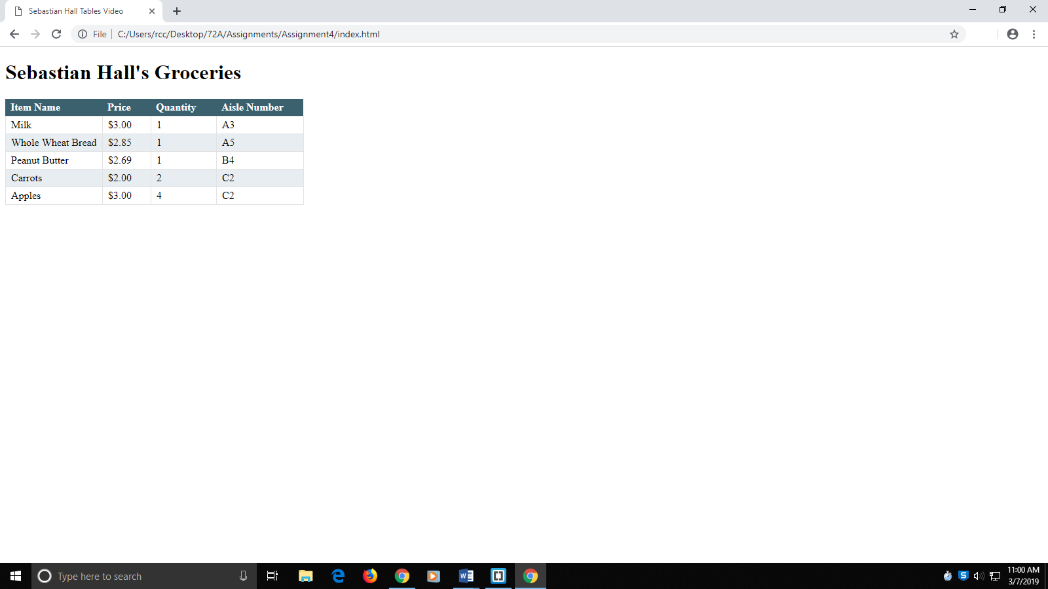

**Part 1 HTML Code: Your “index.html” Groceries Table page HTML Code**

[Paste your “index.html” HTML Code below

**<!DOCTYPE html>**

**<html lang="en-US">**

**<head>**

**<meta charset="utf-8" />**

**<title>Sebastian Hall Tables Video</title>**

**<link rel="stylesheet" type="text/css" href="main.css" />**

**</head>**

**<body>**

**<h1>Sebastian Hall's Groceries</h1>**

**<table>**

**<tr>**

**<th>Item Name</th>**

**<th>Price</th>**

**<th>Quantity</th>**

**<th>Aisle Number</th>**

**</tr>**

**<tr>**

**<td>Milk</td>**

**<td>$3.00</td>**

**<td>1</td>**

**<td>A3</td>**

**</tr>**

**<tr>**

**<td>Whole Wheat Bread</td>**

**<td>$2.85</td>**

**<td>1</td>**

**<td>A5</td>**

**</tr>**

**<tr>**

**<td>Peanut Butter</td>**

**<td>$2.69</td>**

**<td>1</td>**

**<td>B4</td>**

**</tr>**

**<tr>**

**<td>Carrots</td>**

**<td>$2.00</td>**

**<td>2</td>**

**<td>C2</td>**

**</tr>**

**<tr>**

**<td>Apples</td>**

**<td>$3.00</td>**

**<td>4</td>**

**<td>C2</td>**

**</tr>**

**</table>**

**</body>**

**</html>**

**Part 1 CSS Code: Your “main.css” Groceries Table page CSS Code**

[Paste your “main.css” CSS Code below

**table {**

**border-collapse: collapse;**

**}**

**table th {**

**text-align: left;**

**background-color: #3a6070;**

**color: #FFF;**

**padding: 4px 30px 4px 8px;**

**}**

**table td {**

**border: 1px solid #e3e3e3;**

**padding: 4px 8px;**

**}**

**table tr:nth-child(odd) td {**

**background-color: #e7edf0;**

**}**

**Part 2 Screenshot: Your “Oceanside.html” page displaying in the browser.**

[Paste your part 2 Oceanside.html page browser screenshot below. 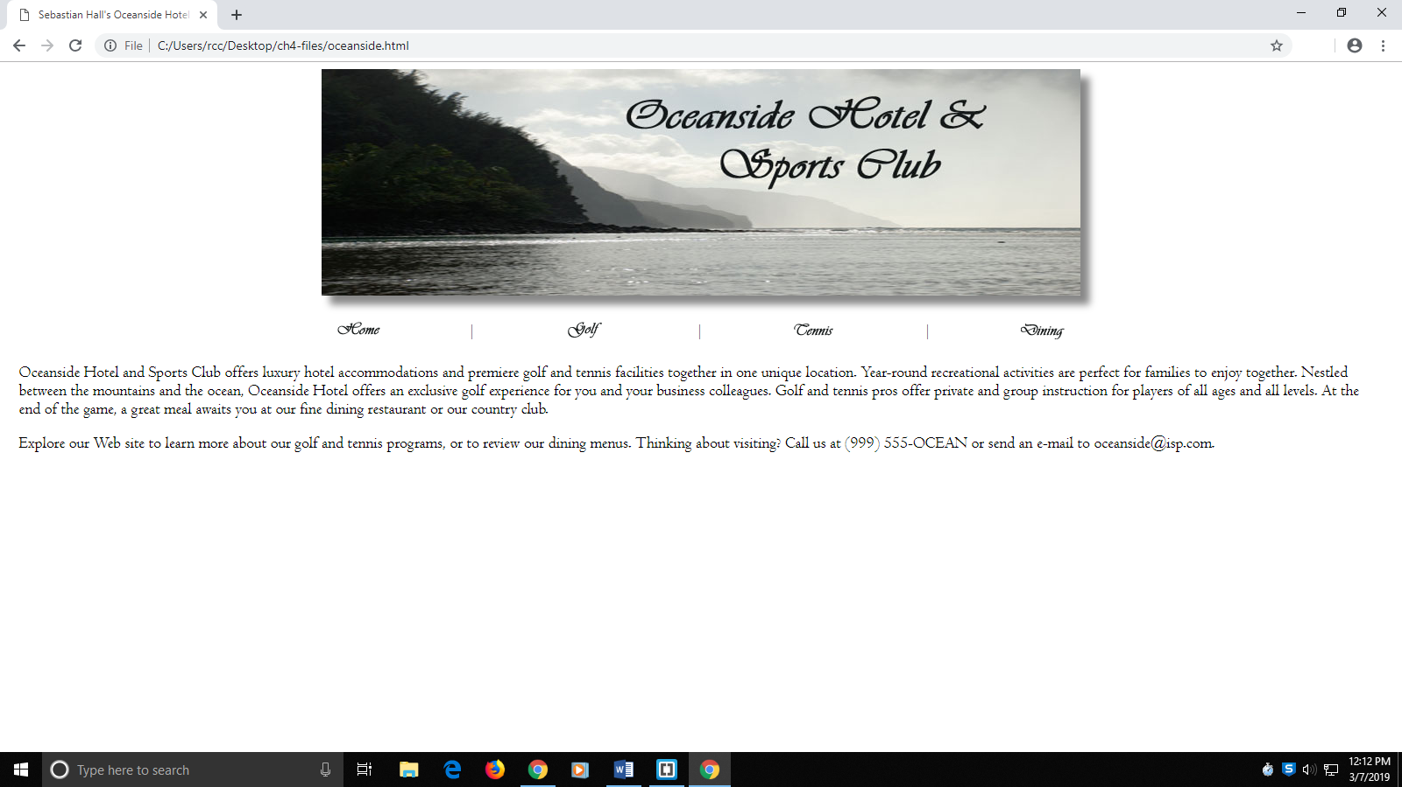

**Part 2 HTML Code #1: Your Oceanside.html HTML Code:**

[Paste your Oceanside.html page Code below

**<!DOCTYPE html>**

**<html lang="en-US">**

**<head>**

**<meta charset="utf-8">**

**<meta name="keywords" content="oceanside hotel, sports club, golf, tennis" />**

**<meta name="description" content="Oceanside luxury hotel, golf, tennis for family." />**

**<title>Sebastian Hall's Oceanside Hotel and Sports Club</title>**

**<link rel="stylesheet" type="text/css" href="stylesch4.css" />**

**</head>**

**<body>**

**<div style="text-align:center;" >**

**<img src="oceansidelogo.jpg" width="866" height="259" alt="Oceanside logo" style="box-shadow: 10px 10px 12px #888888;" />**

**</div>**

**<br/>**

**<table class="menu" style="border-style: none;">**

**<tr>**

**<td class="menuicon"><a href="oceanside.html"><img src="home.gif" width="50" height="21" alt="Home" /></a></td>**

**<td class="menupipe">|</td>**

**<td class="menuicon"><a href="golf.html"><img src="golf.gif" width="50" height="21" alt="Golf" /></a></td>**

**<td class="menupipe">|</td>**

**<td class="menuicon"><a href="tennis.html"><img src="tennis.gif" width="50" height="21" alt="Tennis" /></a></td>**

**<td class="menupipe">|</td>**

**<td class="menuicon"><a href="dining.html"><img src="dining.gif" width="50" height="21" alt="Dining" /></a></td>**

**</tr>**

**</table>**

**<p>**

**Oceanside Hotel and Sports Club offers luxury hotel accommodations and**

**premiere golf and tennis facilities together in one unique location.**

**Year-round recreational activities are perfect for families to enjoy**

**together. Nestled between the mountains and the ocean, Oceanside Hotel**

**offers an exclusive golf experience for you and your business**

**colleagues. Golf and tennis pros offer private and group instruction**

**for players of all ages and all levels. At the end of the game, a great**

**meal awaits you at our fine dining restaurant or our country club.**

**</p>**

**<p>**

**Explore our Web site to learn more about our golf and tennis programs,**

**or to review our dining menus. Thinking about visiting? Call us at**

**(999) 555-OCEAN or send an e-mail to <a href=”mailto:oceanside@isp.com”>**

**<span style=”text-decoration: underline”>oceanside@isp.com</span></a>.**

**</p>**

**</body>**

**</html>**

**Part 2 Code #2: Your “Oceanside Style Sheet” CSS Code:**

[Paste your “Oceanside” CSS style sheet code

**/*Assignment 4 Part 2 Sebastian Hall */**

**body {**

**font-family: Centaur, "Century Gothic", Arial;**

**font-size: 14pt;**

**}**

**p {**

**margin-left: 10pt;**

**margin-right: 10pt;**

**}**

**a {**

**text-decoration: none;**

**color: black;**

**}**

**img {**

**border-color: transparent;**

**}**

**table {**

**width: 65%;**

**margin-left: auto;**

**margin-right: auto;**

**border-color: #545859;**

**border-style: ridge;**

**border-width: 10px;**

**}**

**.menu {**

**text-align: center;**

**}**

**.menuicon {**

**width: 23%;**

**}**

**.menupipe {**

**width: 1%;**

**}**

**th {**

**color: white;**

**background-color: #757775;**

**}**

**tr.stripe {**

**background-color: #d8d8ce;**

**}**

**tr.bolder {**

**font-weight: bold;**

**}**

**caption {**

**caption-side: bottom;**

**font-style: italic;**

**}**

**Part 3 Screenshot: Your “Entertainment” page displaying in the browser.**

[Paste your part 3 Entertainment page browser screenshot below.

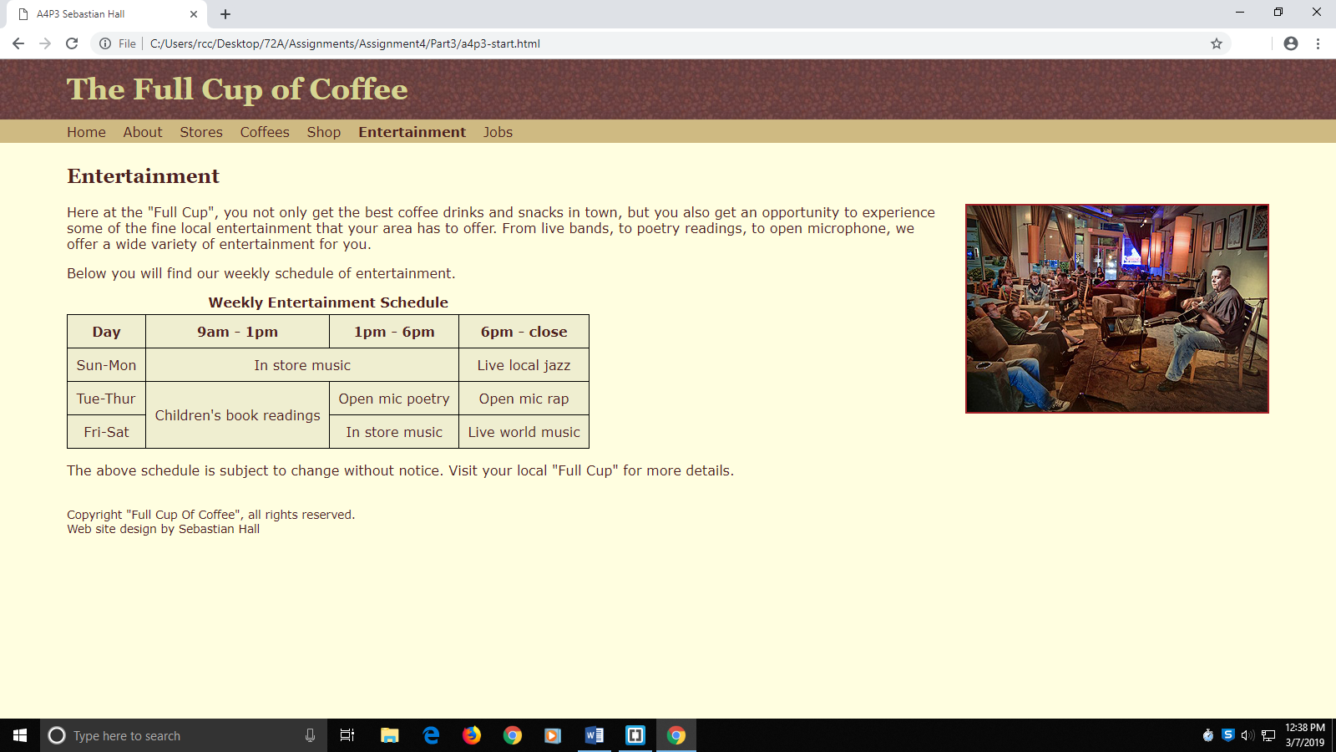

**Part 3 HTML Code: Your a4p3.html Entertainment page HTML Code:**

[Paste your a4p3.html Entertaiment page HTML Code below

**<!DOCTYPE html>**

**<html lang="en-US">**

**<head>**

**<meta charset="utf-8">**

**<meta name="description" content="The Full Cup of Coffee drinks, snacks, and live entertainment" />**

**<title>A4P3 Sebastian Hall</title>**

**<link href="a4p3.css" type="text/css" rel="stylesheet">**

**</head>**

**<body>**

**<header>**

**<h1>The Full Cup of Coffee</h1>**

**<nav>**

**<a href="#" title="Home">Home</a>**

**<a href="#" title="About">About</a>**

**<a href="#" title="Stores">Stores</a>**

**<a href="#" title="Coffees">Coffees</a>**

**<a href="#" title="Shop">Shop</a>**

**<a id="thispage" href="#" title="Entertainment">Entertainment</a>**

**<a href="#" title="Jobs">Jobs</a>**

**</nav>**

**</header>**

**<h2>Entertainment</h2>**

**<p><img id="musicpic" src="musicncoffee.jpg" alt="Musical entertainment at the coffee house">Here at the "Full Cup", you not only get the best coffee drinks and snacks in town, but you also get an opportunity to experience some of the fine local entertainment that your area has to offer. From live bands, to poetry readings, to open microphone, we offer a wide variety of entertainment for you.</p>**

**<p>Below you will find our weekly schedule of entertainment.</p>**

**<!-- Place your table below -->**

**<table id="datatable">**

**<caption>Weekly Entertainment Schedule</caption>**

**<tr>**

**<th>Day</th>**

**<th>9am - 1pm</th>**

**<th>1pm - 6pm</th>**

**<th>6pm - close</th>**

**</tr>**

**<tr>**

**<td>Sun-Mon</td>**

**<td colspan="2">In store music</td>**

**<td>Live local jazz</td>**

**</tr>**

**<tr>**

**<td>Tue-Thur</td>**

**<td rowspan="2">Children's book readings</td>**

**<td>Open mic poetry</td>**

**<td>Open mic rap</td>**

**</tr>**

**<tr>**

**<td>Fri-Sat</td>**

**<td>In store music</td>**

**<td>Live world music</td>**

**</tr>**

**</table>**

**<p>The above schedule is subject to change without notice. Visit your local "Full Cup" for more details.</p>**

**<footer>Copyright "Full Cup Of Coffee", all rights reserved.<br />Web site design by Sebastian Hall</footer>**

**</body>**

**</html>**