Sebastian Hall HTML Fall 2019 Assignment #5

**Part 1 Screenshot: Your “Feedback Form Page” in the browser (after the HTML 5 Forms YouTube Video)**

[Paste your part 1 Feedback form page screenshot here. 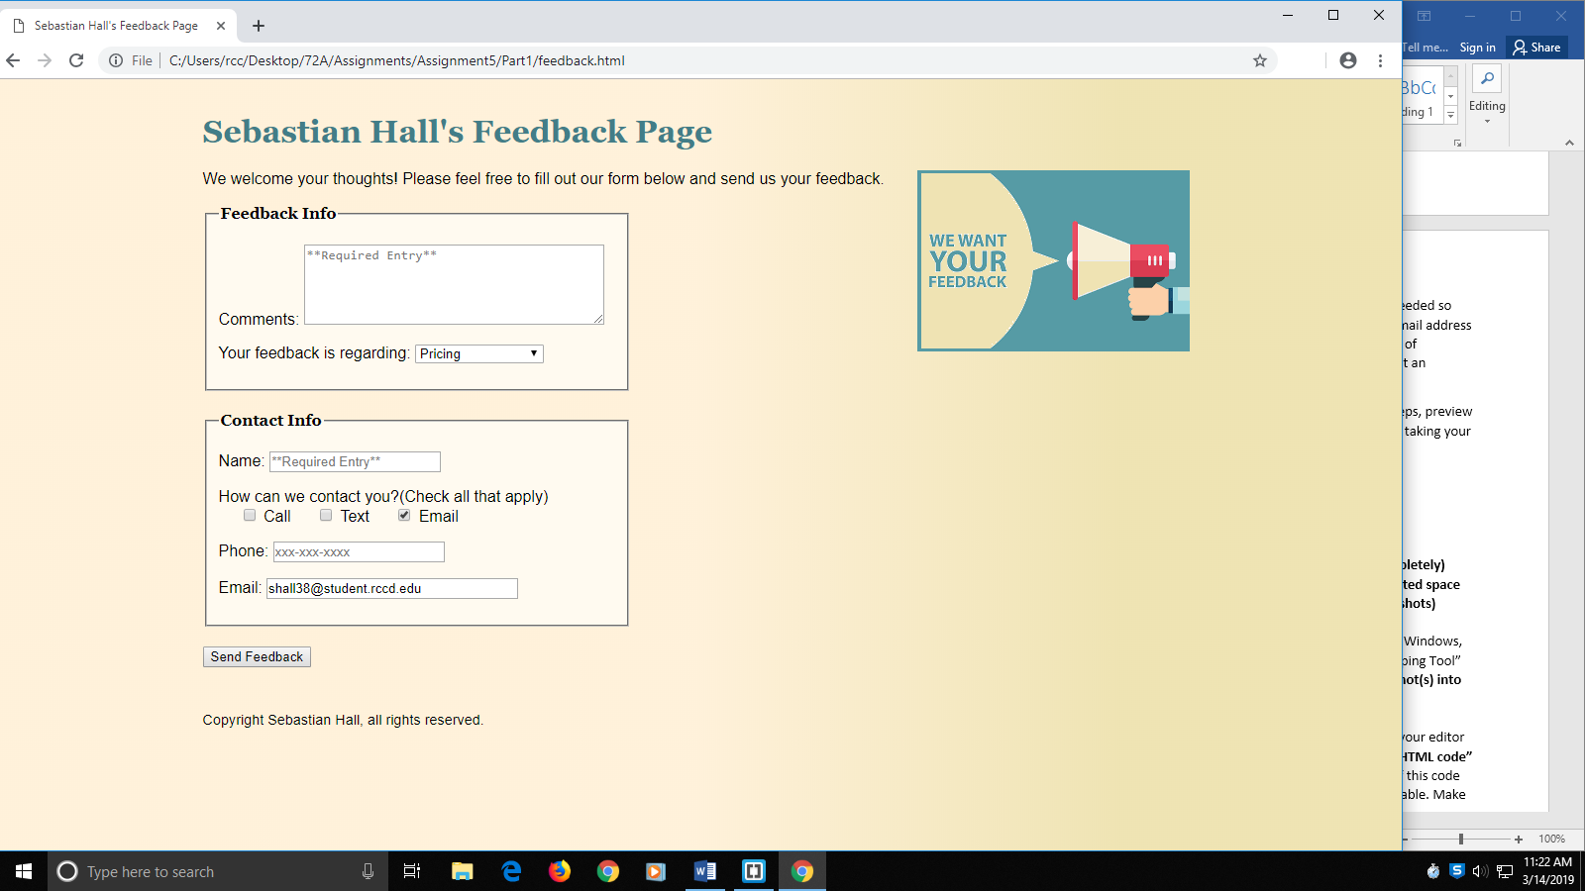

**Part 1 HTML Code: Your “feedback.html” HTML 5 Forms Feedback form page HTML Code**

[Paste your “feedback.html” HTML Code below

**<!DOCTYPE html>**

**<html lang="en">**

**<head>**

**<meta charset="utf-8">**

**<title>Sebastian Hall's Feedback Page</title>**

**<link rel="stylesheet" href="site.css" />**

**<link rel="stylesheet" type="text/css" href="form.css" />**

**</head>**

**<body>**

**<!--Page Header-->**

**<header>**

**<h1>Sebastian Hall's Feedback Page</h1>**

**<p><img class="floatright" src="want-feedback.png" alt="Want Feedback"></p>**

**</header>**

**<p>We welcome your thoughts! Please feel free to fill out our form below and send us your feedback.</p>**

**<!--Customer feedback form-->**

**<form action="response.html" method="get">**

**<!--Feedback section-->**

**<fieldset is="feedbackinfo">**

**<legend>Feedback Info</legend>**

**<!--Comments textarea-->**

**<p>**

**<label for="comments">Comments: </label>**

**<textarea id="comments" rows="5" cols="40" name="comments" required="reqiured" placeholder="**Required Entry**" ></textarea>**

**</p>**

**<!--Comment topic input-->**

**<p>**

**<label for="re">Your feedback is regarding: </label>**

**<select name="re" is="re">**

**<option value="none">Choose One!</option>**

**<option value="products">Products</option>**

**<option value="cust-serv">Customer Service</option>**

**<option value="site">Web Site</option>**

**<option value="shipping">Shipping</option>**

**<option value="pricing">Pricing</option>**

**<option value="other">Other</option>**

**</select>**

**</p>**

**</fieldset>**

**<!--Contact information section-->**

**<fieldset id="contactinfo">**

**<legend>Contact Info</legend>**

**<!--Name input-->**

**<p>**

**<label for="nameTxt">Name: </label>**

**<input id="name" type="text" name="name" required="required" placeholder="**Required Entry**" />**

**</p>**

**<!--Contact options input-->**

**<p>**

**How can we contact you?(Check all that apply)<br/>**

**<input type="checkbox" name="call" id="call" />**

**<label for="call"> Call</label>**

**<input type="checkbox" name="text" id="text" />**

**<label for="text"> Text</label>**

**<input type="checkbox" name="email" id="email" />**

**<label for="email"> Email</label>**

**</p>**

**<!--Phone number input-->**

**<p>**

**<label for="phonenum">Phone: </label>**

**<input type="tel" name="phonenum" id="phonenum" pattern="\d{3}[\-]\d{3}[\-]\d{4}" placeholder="xxx-xxx-xxxx" title="xxx-xxx-xxxx" />**

**</p>**

**<!--Email address input-->**

**<p>**

**<label for="emailaddy">Email: </label>**

**<input type="email" name="emailaddy" id="emailaddy" />**

**</p>**

**</fieldset>**

**<!--Form submission-->**

**<p><input type="submit" value="Send Feedback" /></p>**

**</form>**

**<!--Page footer-->**

**<footer>**

**<p>Copyright Sebastian Hall, all rights reserved.</p>**

**</footer>**

**</body>**

**</html>**

**Part 2 Screenshot: Your “Blue Wav Music” textbook form page displaying in the browser.**

[Paste your part 2 “Blue Wav Music” textbook form page screenshot here.

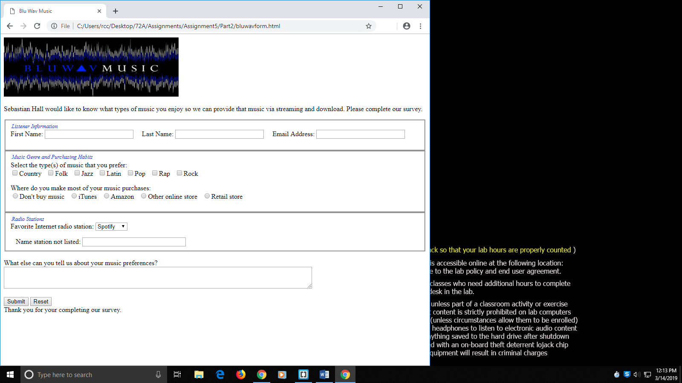

**Part 2 HTML Code: Your “Blue Wav Music” textbook form page HTML Code:**

[Paste your “Blue Wav Music” page (“bluwavform.html”) HTML Code below

**<!DOCTYPE HTML>**

**<html lang="en-US">**

**<head>**

**<meta charset="utf-8" />**

**<title>Blu Wav Music</title>**

**<style>**

**legend {**

**float: left;**

**color: #0000f3;**

**font-style: italic;**

**font-size: small;**

**}**

**</style>**

**</head>**

**<body>**

**<form method="post" action="mailto:bluwav@isp.com">**

**<header>**

**<img src="bluwavlogo.jpg" width="410" height="139" alt="Blu Wav logo" />**

**</header>**

**<p>**

**Sebastian Hall would like to know what types of music you enjoy so**

**we can provide that music via streaming and download. Please**

**complete our survey.**

**</p>**

**<!--Listener Information-->**

**<fieldset>**

**<legend>Listener Information</legend>**

**<p>**

**First Name: <input name="firstname" type="text" size="25" /> &nbsp; &nbsp; Last Name: <input name="lastname" type="text" size="25" /> &nbsp; &nbsp; Email Address: <input name="email" type="text" size="25" />**

**</p>**

**</fieldset>**

**<!--Music Information-->**

**<fieldset>**

**<legend>Music Genre and Purchasing Habits</legend>**

**<br />Select the type(s) of music that you prefer:**

**<br /><input name="musictype" type="checkbox" value="country" />Country &nbsp;**

**<input name="musictype" type="checkbox" value="folk" />Folk &nbsp;**

**<input name="musictype" type="checkbox" value="jazz" />Jazz &nbsp;**

**<input name="musictype" type="checkbox" value="latin" />Latin &nbsp;**

**<input name="musictype" type="checkbox" value="pop" />Pop &nbsp;**

**<input name="musictype" type="checkbox" value="rap" />Rap &nbsp;**

**<input name="musictype" type="checkbox" value="rock" />Rock &nbsp;**

**<p>**

**Where do you make most of your music purchases: <br />**

**<input name="purchases" type="radio" value="none" />Don't buy music &nbsp;**

**<input name="purchases" type="radio" value="itunes" />iTunes &nbsp;**

**<input name="purchases" type="radio" value="amazon" />Amazon &nbsp;**

**<input name="purchases" type="radio" value="online" />Other online store &nbsp;**

**<input name="purchases" type="radio" value="retail" />Retail store &nbsp;**

**</p>**

**</fieldset>**

**<!--Radio Information-->**

**<fieldset>**

**<legend>Radio Stations</legend>**

**<p>**

**Favorite Internet radio station:**

**<select name="station">**

**<option>Google</option>**

**<option>Live 365</option>**

**<option>Pandora</option>**

**<option>Slacker</option>**

**<option>Spotify</option>**

**</select>**

**</p>**

**&nbsp; &nbsp;Name station not listed:**

**<input name="additstation" type="text" size="30" maxlength="30" />**

**</fieldset>**

**<br />What else can you tell us about your music preferences?**

**<br /><textarea name="other" rows="3" cols="100"></textarea>**

**<!--Submit/Reset form-->**

**<p>**

**<input type="submit" value="Submit" />**

**<input type="reset" value="Reset" />**

**<br />Thank you for your completing our survey.**

**</p>**

**</form>**

**</body>**

**</html>**