Your Name Goes Here!!! CSS Spring 2019 Assignment #1

150 Points

**Part 1:** HTML for CSS (5 Questions from Chapter 1, 20 points):   
**Bold and highlight in yellow the correct answers just like this text!**

1. What are the proper roles for HTML and CSS to play in the making of Web pages today?

a) HTML should provide the look of your Web site and CSS should provide the structure and meaning of the site's content.

b) HTML provides the display of the pages' images and layout, CSS provides the display of the text.

**c)** HTML provides the structure for the site's content and CSS provides the formatting of the content.

d) HTML played the role of writing Web page content in the past, but now it is the role of CSS.

2. In figure 1-3 on page 11, the banner (top) area was most likely created by using either a surrounding "div" tag or a surrounding "header" tag.

**True**  or False

3. When deciding between using an "h2" tag or an "h3" tag for a heading, the decision should be based on...

a) how many other headings are above this one.

b) how many other headings are below this one.

**c)** what role the heading plays relative to other text on the page

d) how big you want this text to be displayed on the page

4. A "span" tag differs from a "div" tag in that...

a) CSS can be used to format a "div" tag but not to format a "span" tag

b) A "span" tag is new in HTML5 whereas a "div" tag has been used in earlier versions of HTML

c) A "div" tag will create a visible border around itself in the browser but a "span" tag will not

**d)** "Div" tags can be used to surround blocks of page content but "span" tags cannot.

5. Where should a "doctype" statement be placed?

a) Anywhere within the HTML file.

**b)** At the top of the HTML file.

c) At the bottom of the HTML file.

d) Anywhere within the CSS file.

e) At the top of the CSS file.

**Part 2**: Creating Styles and Style Sheets (5 Questions from the video or Chapter 2, 20 Points)   
**Bold and highlight in yellow the correct answers just like this text!**

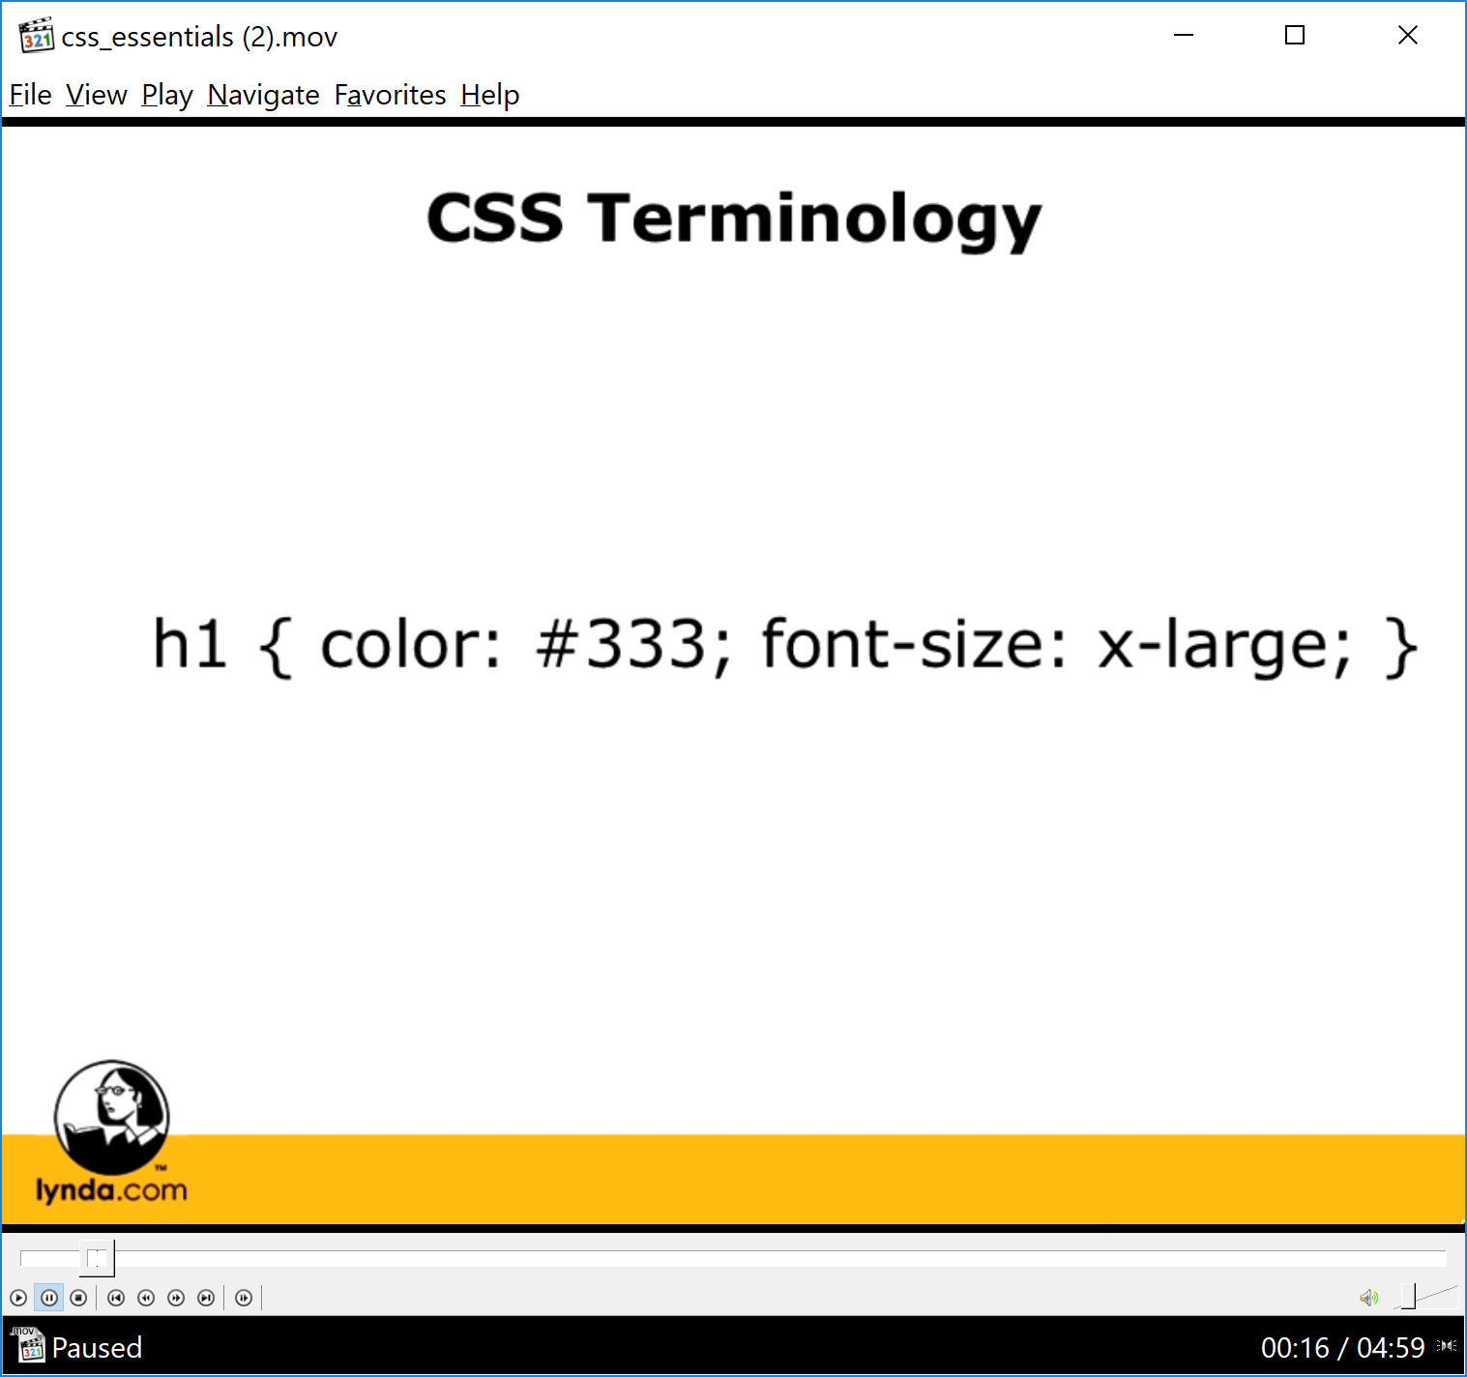

1. In the sample CSS code shown above, how many declarations are there?

a) 0

b) 1

**c) 2**

d) 4

e) 5

2. In that same sample CSS code shown above, the "#333" is being used as a…

a) selector

**b) value**

c) property

d) declaration

3. The <style> tag is an HTML tag that belongs only inside the "head" section of an HTML file, not in an external style sheet (.css) file.

**True** or False

4. The W3C's Web site can be used for validating HTML code as well as for validating CSS code.

**True**  or False

5. Using an external style sheet can be better than using internal style sheets because...

a) an external style sheet decreases the effort required to change site-wide styles in the future

b) an external style sheet decreases the amount of coding inside the HTML files in the site

**c)** both of the above are benefits of using an external style sheet

d) none of the above are benefits of using an external style sheet

**Part 3**: HTML 5 and CSS 3 Video Work (60 Points)

[1. Paste your Boards page Screen Shot below]

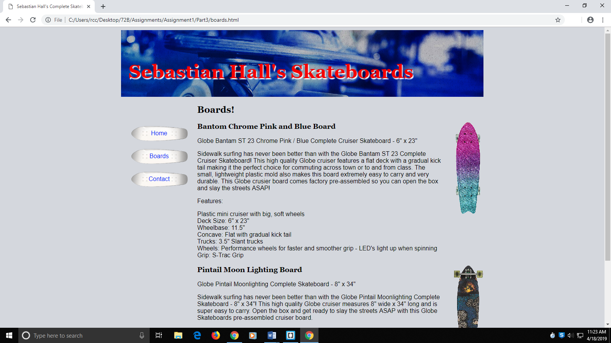

[2. Paste your "styles.css" CSS Code (not a screen shot) from the boards site below]

**body {**

**background-color: #D4D7DD;**

**margin-left: 20%;**

**margin-right: 20%;**

**font-family: sans-serif;**

**}**

**header {**

**height: 175px;**

**background-image: url("bg-banner.jpg");**

**background-repeat: no-repeat;**

**background-size: cover;**

**}**

**h1,**

**h2,**

**h3 {**

**font-family: Georgia, Times, serif;**

**}**

**h1 {**

**color: #F8070B;**

**font-size: 50px;**

**text-shadow: 2px 3px 2px white;**

**padding-top: 80px;**

**text-indent: 20px;**

**margin-top: 1px;**

**}**

**nav {**

**width: 200px;**

**float: left;**

**margin-top: 50px;**

**}**

**#main {**

**padding-left: 200px;**

**}**

**nav a {**

**width: 200px;**

**height: 60px;**

**background: url("bg-links.gif") no-repeat center;**

**;**

**float: left;**

**background-size: 150px 45px;**

**text-align: center;**

**line-height: 60px;**

**text-decoration: none;**

**color: blue;**

**}**

**nav a:hover {**

**color: red;**

**}**

**ul {**

**list-style-image: url("skateboard-bullet.gif");**

**margin-left: 35px;**

**}**

**.productpic {**

**float: right;**

**margin-left: 30px;**

**}**

**footer {**

**text-align: center;**

**color: gray;**

**margin-top: 35px;**

**}**

**Part 4**: Beyond the Video (More work with the Boards Site), 50 Points)

[1. Paste your "Contact" page Screen Shot (taken within the browser) below]

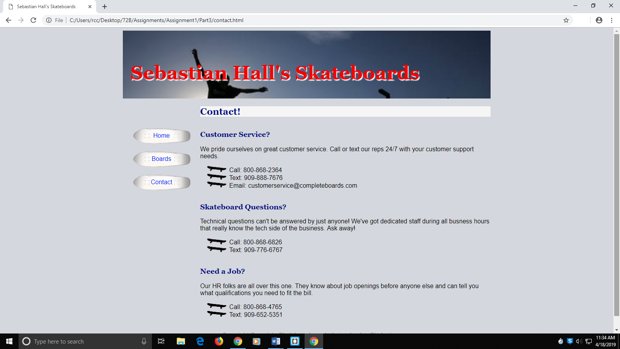

[2. Paste your modified "styles.css" CSS Code below (not a screen shot) ]

**body {**

**background-color: #D4D7DD;**

**margin-left: 20%;**

**margin-right: 20%;**

**font-family: sans-serif;**

**}**

**header {**

**height: 175px;**

**background-image: url("bg-banner2.jpg");**

**background-repeat: no-repeat;**

**background-size: cover;**

**}**

**h1,**

**h2,**

**h3 {**

**font-family: Georgia, Times, serif;**

**}**

**h1 {**

**color: #F8070B;**

**font-size: 50px;**

**text-shadow: 2px 3px 2px white;**

**padding-top: 80px;**

**text-indent: 20px;**

**margin-top: 1px;**

**}**

**nav {**

**width: 200px;**

**float: left;**

**margin-top: 50px;**

**}**

**#main {**

**padding-left: 200px;**

**}**

**nav a {**

**width: 200px;**

**height: 60px;**

**background: url("bg-links.gif") no-repeat center;**

**;**

**float: left;**

**background-size: 150px 45px;**

**text-align: center;**

**line-height: 60px;**

**text-decoration: none;**

**color: blue;**

**}**

**nav a:hover {**

**color: red;**

**}**

**ul {**

**list-style-image: url("skateboard-bullet.gif");**

**margin-left: 35px;**

**}**

**.productpic {**

**float: right;**

**margin-left: 30px;**

**}**

**footer {**

**text-align: center;**

**color: gray;**

**margin-top: 35px;**

**}**

**/*Beyond the Video by Sebastian Hall*/**

**h2 {**

**background-color: whitesmoke;**

**color: darkblue;**

**}**

**h3 {**

**margin-top: 35px;**

**color: darkblue;**

**}**